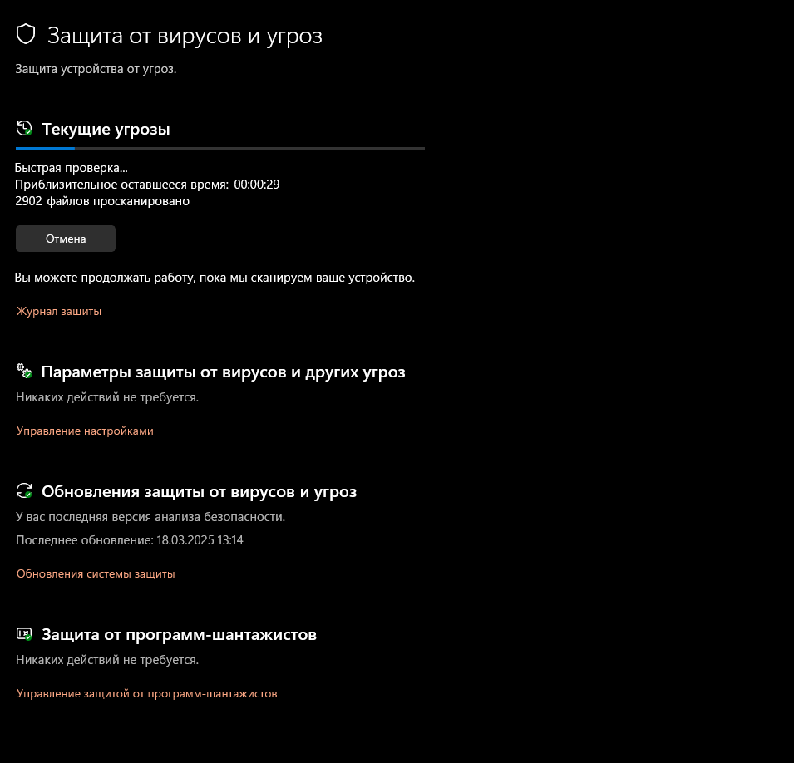
2. Changes Made to Security Settings and Scan Schedules:
Security Settings Configuration:
- Real-Time Protection: Enabled (Real-time protection ensures that the system is continuously monitored for threats as they appear.)
- Sensitivity Levels: Adjusted to a balanced setting, ensuring good protection without too much system resource consumption.
- Threat Notifications: Configured to notify the user immediately if any threats are detected, ensuring timely actions can be taken to mitigate risks.
Scan Schedules Configuration:
- Scheduled Scans:
  - Configured a weekly scan for the system drive (C:) and critical folders (e.g., Downloads, Documents).
  - Offline Scan: Ensured that scheduled scans will run even if the computer is offline. This guarantees that scans are performed without requiring an internet connection.

