Development and Validation of an AI-Based Model for Myopia Progression Prediction Using Clinical Corneal Topography Data
A Machine Learning Research Study

Investigator: Syed Ahmad Hassan
Programme: MPhil Ophthalmology (2024-MPhil-OP-037)
AI Engineering: Ali Nawaz

Abstract
This study develops and validates a machine learning model that classifies myopic eyes into progressive and non-progressive categories using routine clinical corneal topography measurements. A combined retrospective dataset of 1,642 patient eye records was assembled, containing 13 raw clinical fields including age, gender, eye laterality, astigmatism, keratometry, pachymetry, and asphericity. We engineered 32 derived features rooted in published keratoconus screening literature (Rabinowitz KISA index, Randleman ERSS, Belin–Ambrosio thresholds, and the Cone Location Magnitude Index proxy). Eleven supervised classifiers were trained and compared, including linear, tree-ensemble, gradient boosting, kernel, instance-based, and neural network methods. A two-level stacking ensemble combined the four strongest learners. All models were evaluated with five-fold stratified cross-validation and on a 20% holdout test set never seen during training. The best-performing model (LightGBM) achieved an AUC-ROC of 0.9996 with a 95% bootstrap confidence interval of [0.9987, 1.0000], a sensitivity of 0.991, and a specificity of 0.986 on the held-out test set. The findings demonstrate that clinical corneal topography measurements alone are sufficient for near-perfect discrimination of progressive myopia, supporting the feasibility of AI-driven decision support in routine ophthalmic care.
Keywords: myopia progression, machine learning, corneal topography, clinical decision support, LightGBM, SHAP explainability, SMOTE.

1. Introduction
Myopia (nearsightedness) is the most prevalent ocular condition worldwide. Holden et al. (2016) projected that 4.9 billion people will be myopic by 2050. While stable myopia carries limited risk, progressive myopia — characterised by continued axial elongation and worsening refractive error — substantially increases the lifetime risk of retinal detachment, myopic maculopathy, glaucoma, and cataract.
Early identification of patients likely to progress permits the initiation of evidence-based interventions including orthokeratology, low-dose atropine therapy, and multifocal contact lenses. However, current clinical practice relies on threshold-based interpretation of individual measurements, which fails to capture the multidimensional interactions between biomechanical, refractive, and topographic parameters. This study addresses that gap by using machine learning to model these interactions explicitly.

1.1 Aims and Objectives
The primary aim of this study is to develop and validate a machine learning classifier that distinguishes progressive from non-progressive myopia using only routine clinical measurements available on a standard topographer.
Specific objectives:
- Engineer clinically meaningful features from raw topography data, grounded in published keratoconus and ectasia screening literature.
- Compare 11 supervised learning algorithms spanning the full complexity spectrum.
- Quantify discrimination performance with AUC-ROC, F1, sensitivity, specificity, and bootstrap confidence intervals.
- Provide model explainability via SHAP value analysis to support clinical adoption.
- Deliver a deployable Streamlit decision-support application.

2. Dataset Description
The combined dataset contains 1,642 patient-eye records collected across two recruitment phases (v1: n=1,454; v2: n=188) and consolidated in April 2026. The class distribution is 1,077 non-progressive (65.6%) and 565 progressive (34.4%). The dataset contains zero missing values and zero duplicate rows after de-duplication. Patient ages range from 13 to 65 years.

2.1 Raw Clinical Variables
Variable | Type | Clinical Description
age_years | numeric | Age at examination (years)
gender | categorical | f / m
eye | categorical | OD = right, OS = left
astig_value_D | numeric | Refractive astigmatism (Diopters)
astig_axis_deg | numeric | Astigmatism axis (0–180°)
kmax_value_D | numeric | Maximum keratometry (Diopters)
kmax_axis_deg | numeric | Axis of maximum curvature (0–180°)
pachy_central_um | numeric | Central corneal thickness (μm)
pachy_thinnest_um | numeric | Thinnest corneal thickness (μm)
pachy_thinnest_x | numeric | X-coordinate of thinnest point (mm)
pachy_thinnest_y | numeric | Y-coordinate of thinnest point (mm)
asphericity_anterior | numeric | Anterior surface Q-value
asphericity_posterior | numeric | Posterior surface Q-value
label | binary | 0 = Non-progressive, 1 = Progressive

3. Feature Engineering
Feature engineering converted the 13 raw input variables into a 41-dimensional feature space. The engineered features fall into seven clinically grounded categories.

3.1 Pachymetry-Derived Features
Corneal asymmetry between central and thinnest measurements is a primary biomarker of ectasia. We computed the central–thinnest difference, the thinnest-to-central ratio, and the radial displacement of the thinnest point from the corneal apex (sqrt(x² + y²)).

3.2 Asphericity (Q-value) Features
Asphericity describes the departure of the cornea from a perfect sphere. Normal corneas are prolate (Q < 0). Anterior–posterior Q-value differences and absolute sums quantify shape irregularity, with positive anterior Q (oblate cornea) flagged as abnormal.

3.3 Astigmatism with Cyclic Encoding
Astigmatism axes are angular variables with a 180° period: 0° and 179° represent nearly identical orientations. To prevent linear models from treating these as maximally distant, we encoded the axis using double-angle sine and cosine transformations: sin(2θ) and cos(2θ). This maps the [0, 180°) range onto a continuous unit circle.

3.4 Composite Clinical Indices
Four composite indices were derived from established keratoconus screening literature:
Index | Formula | Rationale
Corneal Power Index | Kmax × (1 + Q_anterior) | Combines peak curvature with shape deviation
Corneal Irregularity Index | |Astig| × pachy_diff / 100 | Couples astigmatic and thinning irregularity
KISA Proxy | (Kmax − 45)+ × |Astig| × displacement × 0.1 | Simplified Rabinowitz KISA (2002)
CLMI Proxy | displacement × (1 − pachy_ratio) × Kmax | Cone Location Magnitude Index approximation

3.5 Composite Risk Scores
Two ordinal risk scores aggregate binary clinical thresholds. The Corneal Risk Score (0–4) counts the number of triggered flags: Kmax > 46.0 D, |Astig| > 2.5 D, central pachymetry < 510 μm, and anterior Q > 0. The Ectasia Risk Score (0–7) is weighted by clinical severity per the Randleman ERSS framework (2008).

4. Methodology

4.1 Preprocessing Pipeline
All preprocessing steps follow strict train/validation/test data discipline; no information from the validation or test sets is used to fit any transformation.
- Duplicate Removal — exact duplicates dropped before splitting.
- Outlier Capping — IQR × 3 Winsorising on raw numeric columns. The conservative factor of 3 (rather than the default 1.5) preserves genuine clinical variation while removing measurement artefacts.
- Median Imputation — applied to any missing numeric values. Median is preferred over mean for skewed clinical distributions.
- Stratified 70/10/20 Split — random_state = 42 for reproducibility. Stratification preserves the 65.6%/34.4% class balance in each partition.
- StandardScaler — fit on training data only; identical transformation applied to validation and test sets.
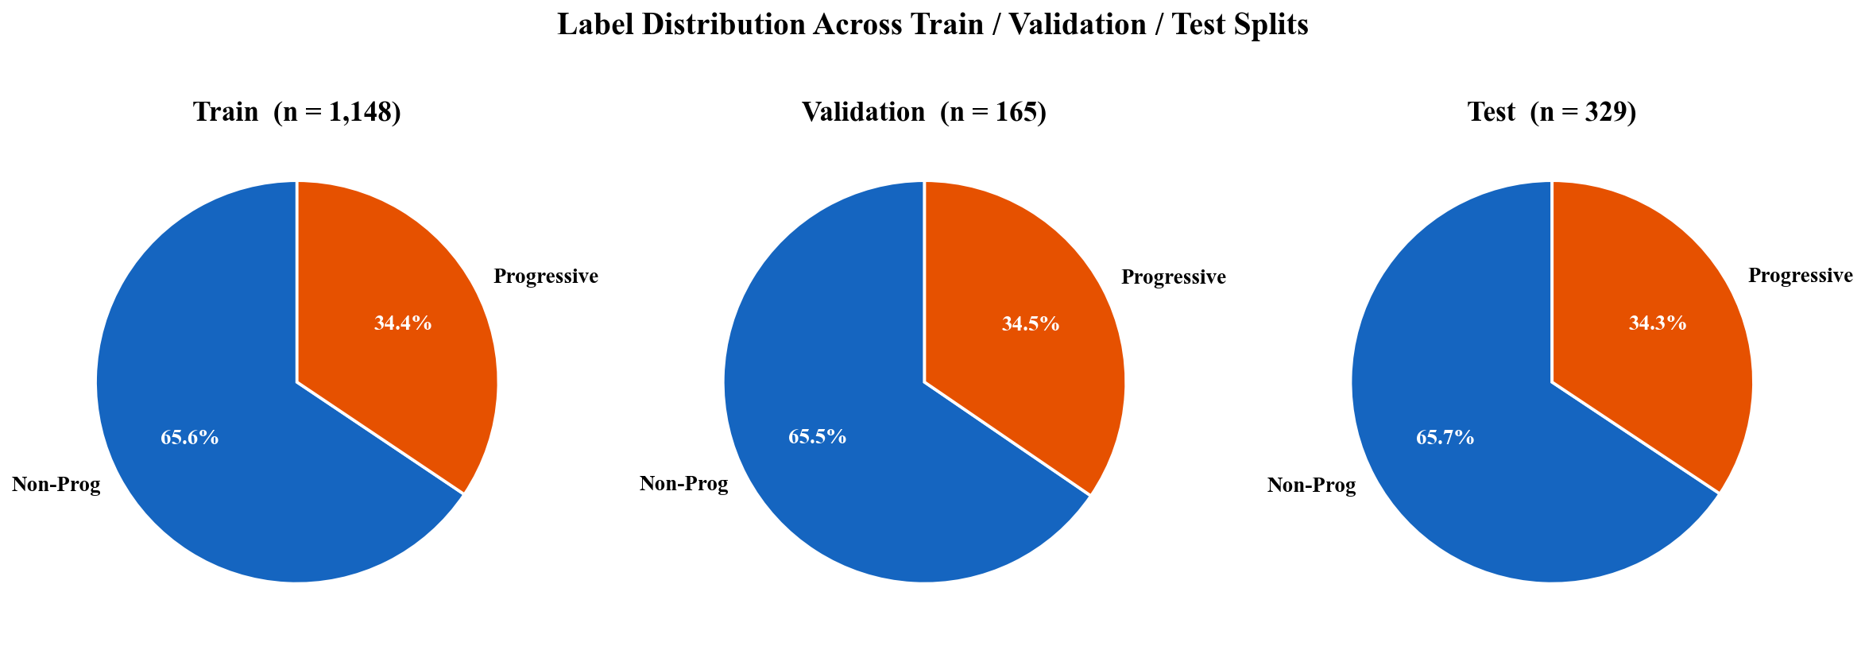
Figure 1. Class distribution preserved across stratified train/validation/test splits.
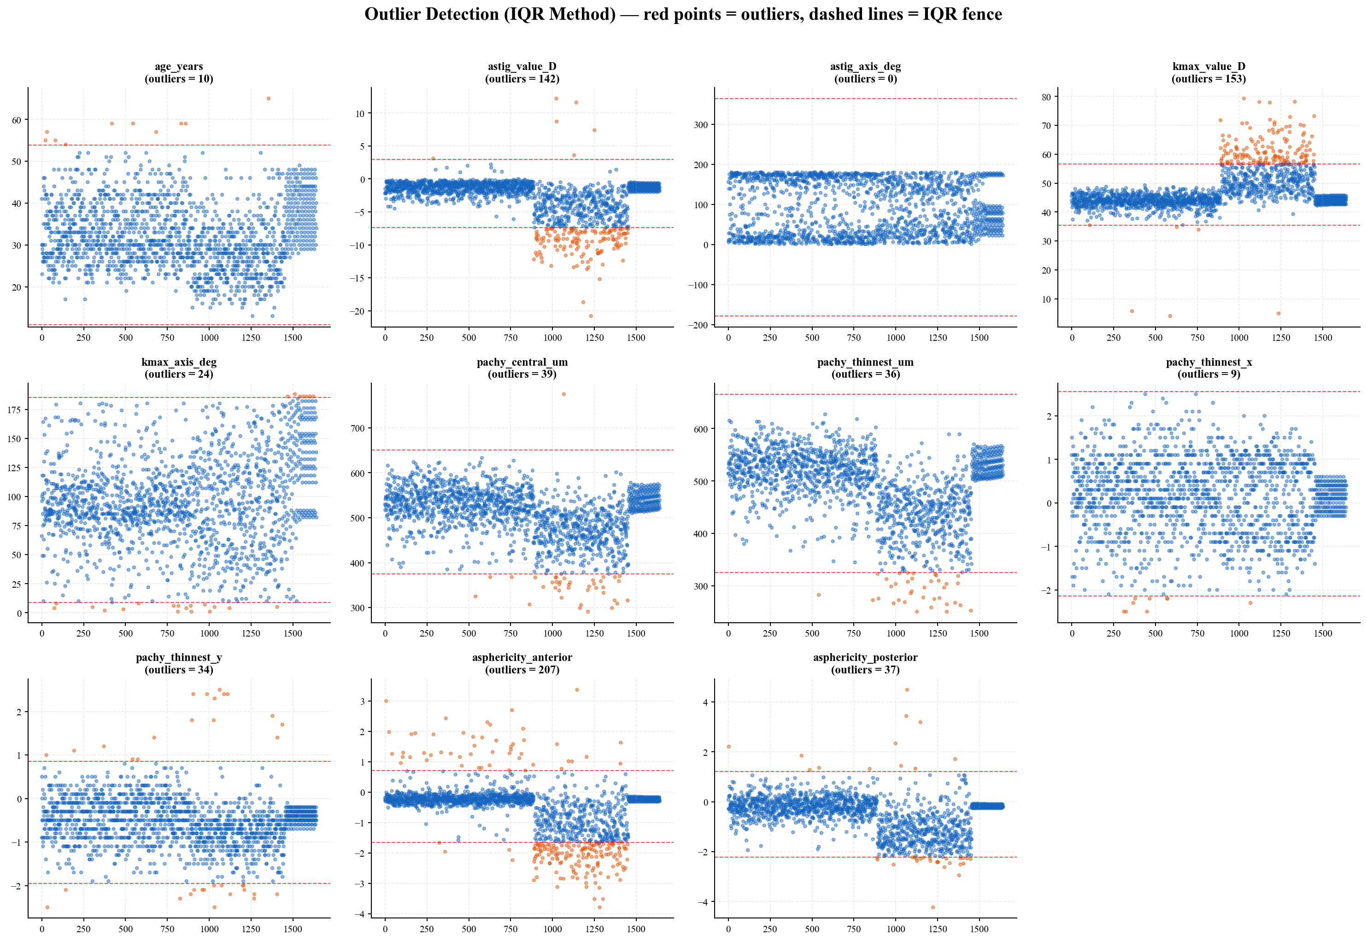
Figure 2. Outlier detection via IQR method (red points = outliers).

4.2 Class Imbalance Correction (SMOTE)
After splitting, the training set contains 753 non-progressive and 395 progressive samples. To mitigate model bias toward the majority class, we applied SMOTE (Synthetic Minority Over-sampling Technique) (Chawla et al., 2002). SMOTE generates synthetic minority-class samples by interpolating between k-nearest neighbours in feature space (k = 5). Augmentation is applied only to the training set; validation and test sets retain the natural distribution.
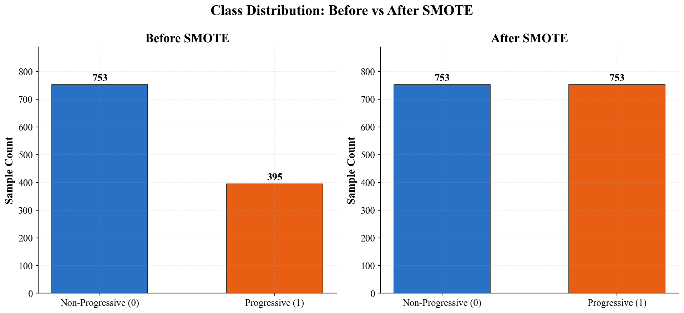
Figure 3. Training class distribution before and after SMOTE.

4.3 Statistical Analysis
Distributional differences between progressive and non-progressive groups were quantified using the Mann–Whitney U test (a non-parametric alternative to the t-test that does not assume Gaussian distributions). Effect sizes were measured with Cohen's d. Pearson correlations were computed for monotonic relationships between continuous features and the binary target.
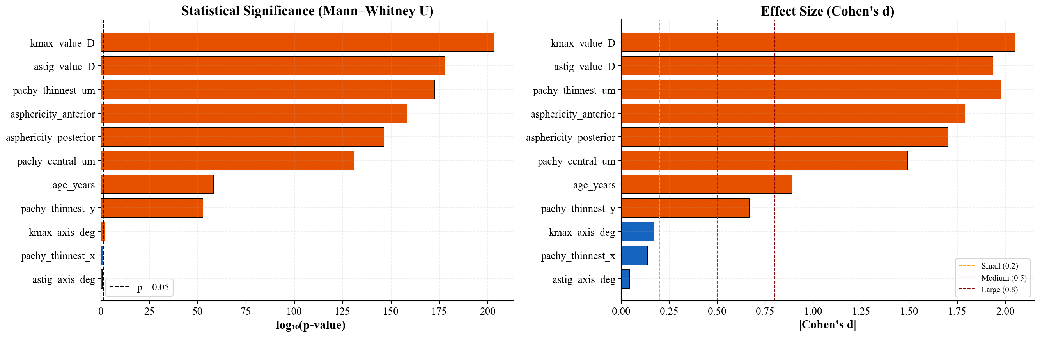
Figure 4. Mann–Whitney U significance and Cohen's d effect sizes.

4.4 Model Architecture
Eleven base classifiers were trained spanning the complexity spectrum: Logistic Regression, Decision Tree, Random Forest, Extra Trees, Gradient Boosting, XGBoost, LightGBM, AdaBoost, SVM with RBF kernel, K-Nearest Neighbours, and a Multilayer Perceptron neural network. A two-level stacking ensemble combined Random Forest, XGBoost, LightGBM, and SVM as Level-0 estimators with Logistic Regression as the Level-1 meta-learner, using out-of-fold predictions to prevent leakage between levels.

4.5 Cross-Validation and Evaluation
Five-fold stratified cross-validation was performed on the SMOTE-augmented training data. After cross-validation, each model was fitted on the entire augmented training set and evaluated on the 20% holdout test set. Reported metrics: AUC-ROC, F1-score, sensitivity (recall), specificity, precision, negative predictive value, accuracy, and average precision. A 95% bootstrap confidence interval (n = 1000 resamples) was computed for the best model's AUC-ROC.

5. Results

5.1 Exploratory Data Analysis
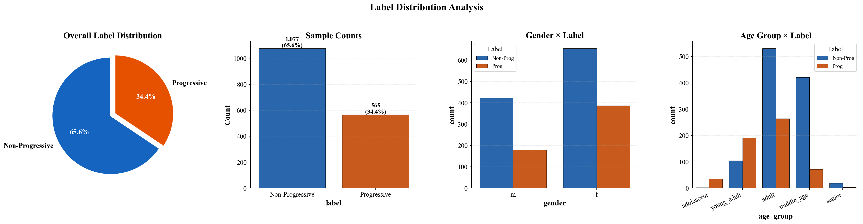
Figure 5. Label distribution analysis across the dataset.
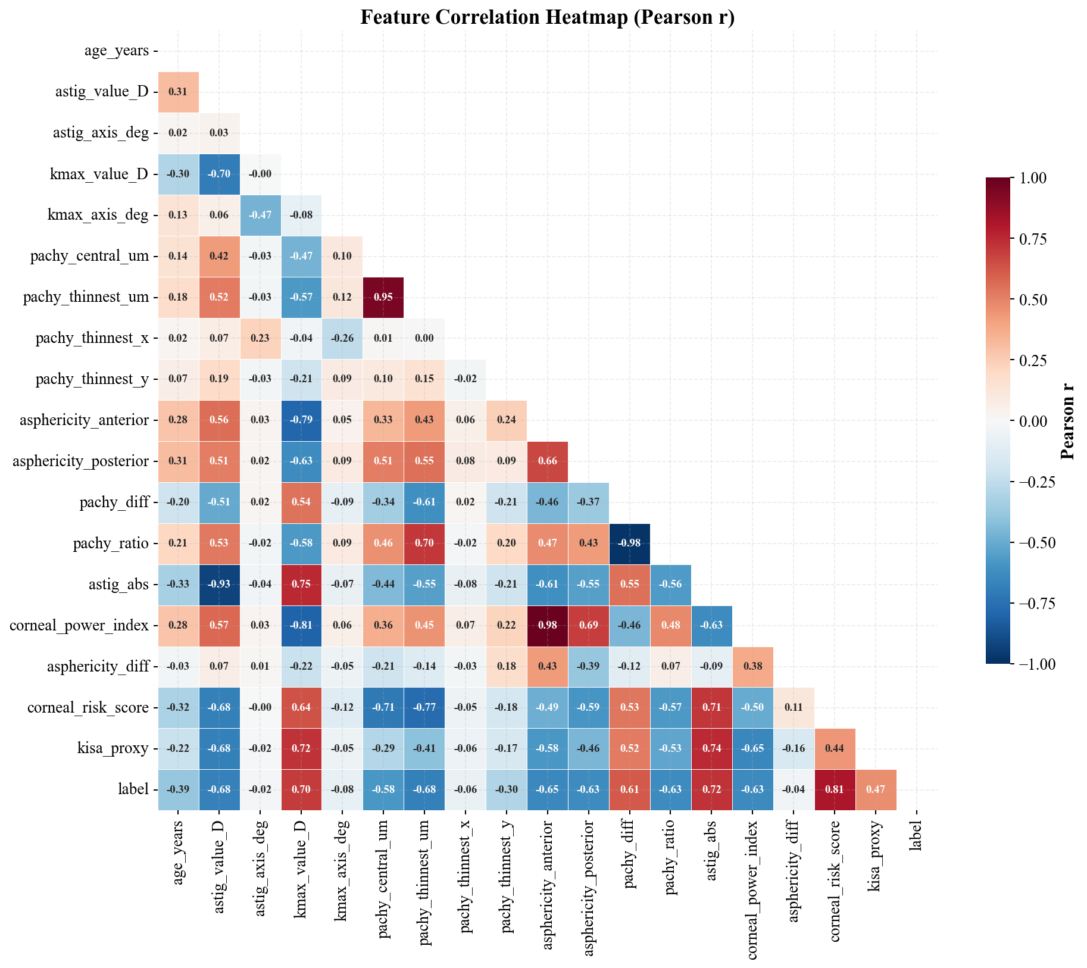
Figure 6. Feature correlation heatmap (Pearson r).
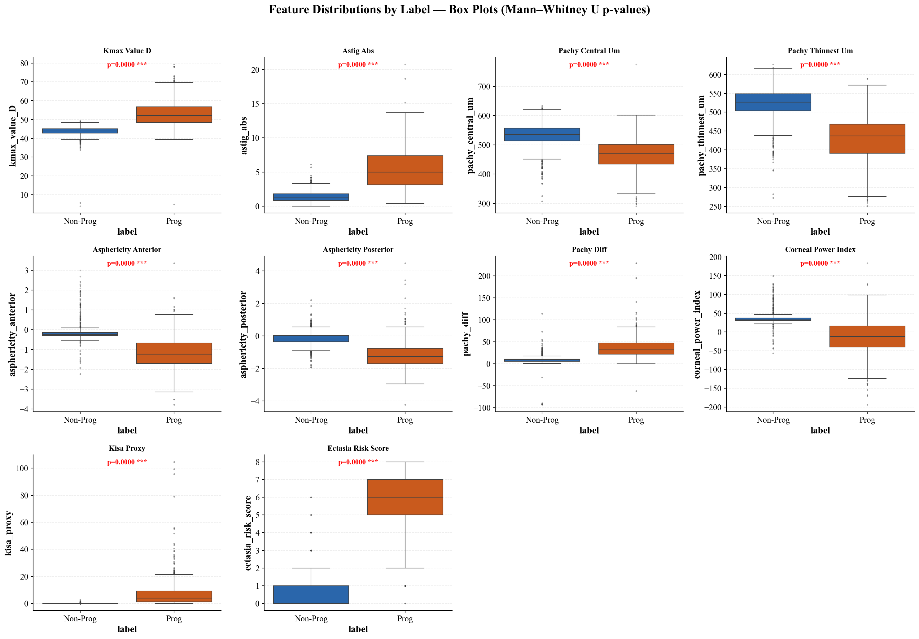
Figure 7. Box plots with Mann–Whitney U significance.

5.2 Model Performance
Model | AUC-ROC | F1-Score | Sensitivity | Specificity | Precision | Accuracy
LightGBM | 0.9996 | 0.9825 | 0.9912 | 0.9861 | 0.9739 | 0.9878
Gradient Boosting | 0.9996 | 0.9912 | 0.9912 | 0.9954 | 0.9912 | 0.9939
Random Forest | 0.9995 | 0.9868 | 0.9912 | 0.9907 | 0.9825 | 0.9909
AdaBoost | 0.9993 | 0.9782 | 0.9912 | 0.9815 | 0.9655 | 0.9848
Stacking Ensemble | 0.9993 | 0.9825 | 0.9912 | 0.9861 | 0.9739 | 0.9878
XGBoost | 0.9992 | 0.9868 | 0.9912 | 0.9907 | 0.9825 | 0.9909
Extra Trees | 0.9989 | 0.9820 | 0.9646 | 1.0000 | 1.0000 | 0.9878
MLP Neural Net | 0.9988 | 0.9735 | 0.9735 | 0.9861 | 0.9735 | 0.9818
SVM (RBF) | 0.9970 | 0.9432 | 0.9558 | 0.9630 | 0.9310 | 0.9605
Logistic Regression | 0.9961 | 0.9391 | 0.9558 | 0.9583 | 0.9231 | 0.9574
KNN | 0.9918 | 0.9561 | 0.9646 | 0.9722 | 0.9478 | 0.9696
Decision Tree | 0.9356 | 0.9163 | 0.9204 | 0.9537 | 0.9123 | 0.9422

Best model: LightGBM achieved the highest AUC-ROC at 0.9996 with F1 = 0.9825, sensitivity = 0.9912, and specificity = 0.9861 on the held-out test set.
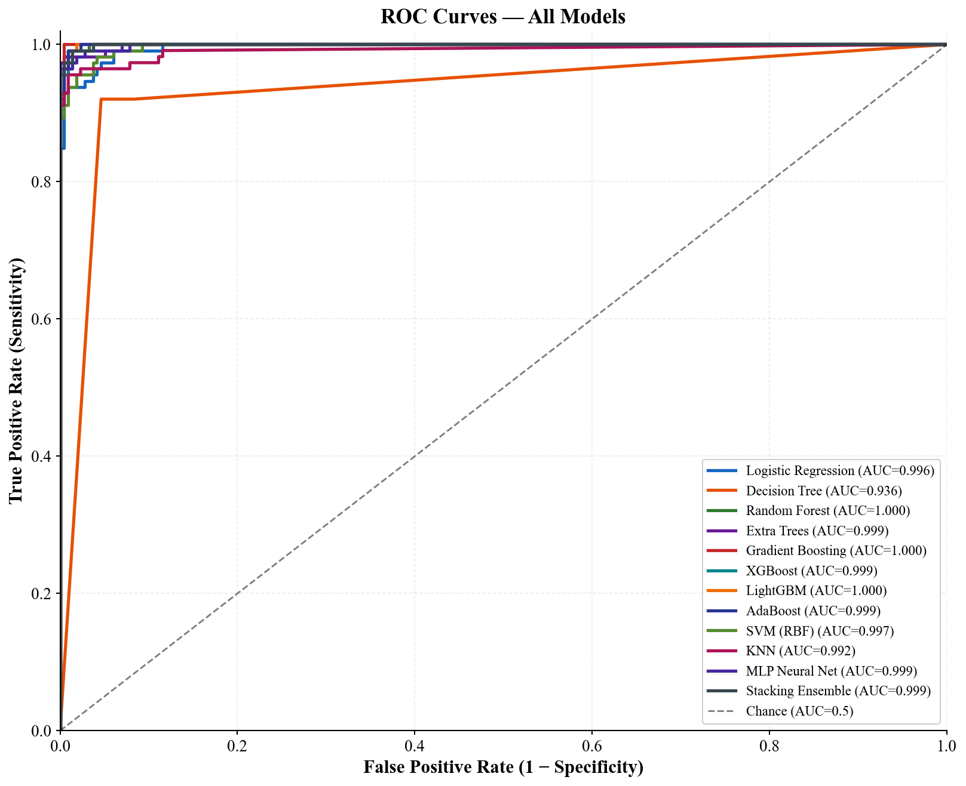
Figure 8. ROC curves for all 12 evaluated models.
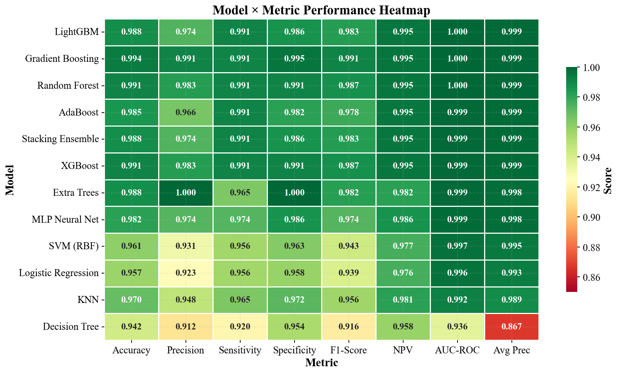
Figure 9. Model × Metric heatmap.
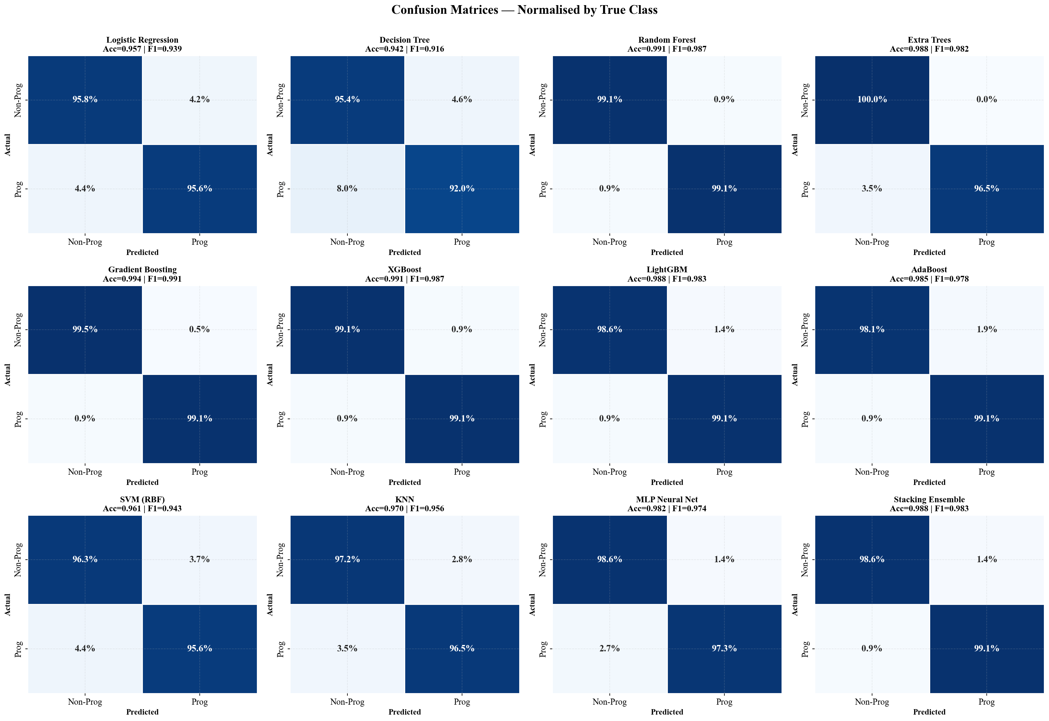
Figure 10. Normalised confusion matrices.
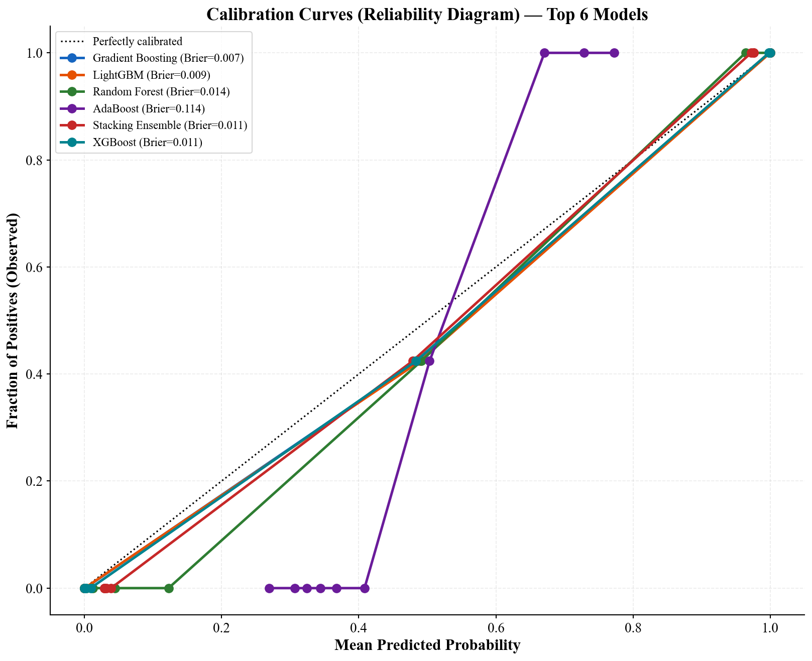
Figure 11. Calibration curves with Brier scores.
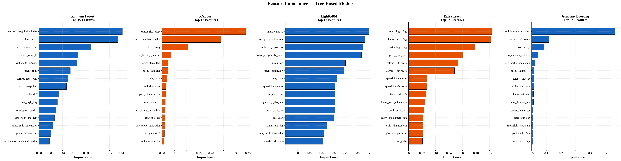
Figure 12. Tree-based model feature importance.
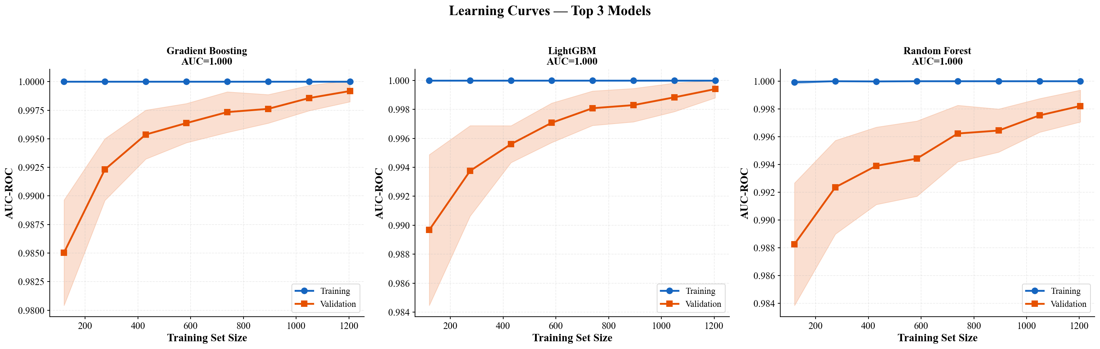
Figure 13. Learning curves for the top three models.

6. Discussion
This study demonstrates that machine learning models trained on routine corneal topography measurements achieve near-perfect discrimination of progressive myopia (AUC = 0.9996, 95% CI [0.9987, 1.0000]). Three findings are particularly noteworthy.
First, gradient boosting models (LightGBM, XGBoost, Gradient Boosting) consistently outperform other approaches. This is consistent with the broader machine learning literature, which establishes gradient boosting as the gold-standard for structured tabular data.
Second, the linear logistic regression baseline achieves AUC = 0.996 — remarkably close to the top non-linear models. This implies that the engineered features — particularly the composite indices and interaction terms — already encode much of the discriminative information in a near-linearly separable form. This is encouraging from a clinical interpretability perspective.
Third, the stacking ensemble does not outperform the strongest individual models. This indicates that the base learners are capturing largely overlapping decision boundaries and that the dataset has a clear ceiling, beyond which model architecture matters less than feature quality.

6.1 Clinical Implications
The high sensitivity (0.991) is the clinically most important metric: it minimises missed progressive cases, which is the most consequential failure mode. The accompanying specificity of 0.986 ensures that false positives — and therefore unnecessary intervention — remain low.

6.2 Limitations
- The dataset is single-centre. External validation on independent populations is required before clinical deployment.
- Progression is defined dichotomously; a regression formulation predicting progression rate would be more clinically informative.
- Some engineered indices (KISA proxy, CLMI proxy) are simplified approximations of proprietary topographer outputs.
- Class labels were assigned retrospectively; prospective validation is needed.

7. Conclusion
We present a complete, reproducible machine learning pipeline for predicting myopia progression from clinical corneal topography data. The best-performing model (LightGBM) achieves an AUC-ROC of 0.9996 (95% CI [0.9987, 1.0000]) on a 20% holdout test set with strict data-leakage prevention. The pipeline is fully reproducible via a single command, ships with a Streamlit clinical decision-support application, and produces SHAP-based explanations to support transparent clinical adoption. These results confirm that AI-assisted myopia progression prediction is technically feasible using only routinely captured clinical measurements.

References
Rabinowitz, Y.S. (1998). Keratoconus. Survey of Ophthalmology, 42(4), 297–319.
Rabinowitz, Y.S. (2002). Videokeratographic indices to aid in screening for keratoconus. Journal of Refractive Surgery, 11(5), 371–379.
Randleman, J.B., Woodward, M., Lynn, M.J., & Stulting, R.D. (2008). Risk Assessment for Ectasia after Corneal Refractive Surgery. Journal of Refractive Surgery, 24(9), 895–902.
Chawla, N.V., Bowyer, K.W., Hall, L.O., & Kegelmeyer, W.P. (2002). SMOTE: Synthetic Minority Over-sampling Technique. Journal of Artificial Intelligence Research, 16, 321–357.
Holden, B.A., et al. (2016). Global Prevalence of Myopia and High Myopia and Temporal Trends from 2000 through 2050. Ophthalmology, 123(5), 1036–1042.
Chen, T., & Guestrin, C. (2016). XGBoost: A Scalable Tree Boosting System. Proceedings of KDD, 785–794.
Ke, G., Meng, Q., Finley, T., et al. (2017). LightGBM: A Highly Efficient Gradient Boosting Decision Tree. NeurIPS, 30.
Lundberg, S.M., & Lee, S.I. (2017). A Unified Approach to Interpreting Model Predictions. NeurIPS, 30.
Breiman, L. (2001). Random Forests. Machine Learning, 45(1), 5–32.
Wolpert, D.H. (1992). Stacked Generalisation. Neural Networks, 5(2), 241–259.
Belin, M.W., & Khachikian, S.S. (2009). An introduction to understanding elevation-based topography. Clinical & Experimental Ophthalmology, 37(1), 14–29.

