PROJECT PROPOSAL
FIA Smart ACR / PER
Management System
Proposal for design, development, and on-premises deployment

Prepared For | Federal Investigation Agency (FIA)
Document Type | Revised Project Proposal
Version | 2.0
Date | April 1, 2026
Prepared By | Ali Nawaz

Prepared to support FIA’s transition from manual ACR handling to a secure, trackable, role-based digital workflow for BPS 1–16 employees.

Delivery Model  End-to-end build | Indicative Timeline  3/4 weeks | Commercial Basis  $15/hour | Estimated Effort  120 hours

1. Executive Summary
This proposal presents a revised, client-ready approach for the FIA Smart ACR / PER Management System. The document has been updated to reflect the latest confirmed operating model: ACRs for BPS 1–16 employees are initiated by the designated clerk of the relevant office or wing, then routed to the Reporting Officer, then to the Countersigning Officer, and finally to the Secret Branch for controlled archival and retrieval.
The primary objective is to replace manual ACR movement with a secure digital workflow that improves visibility, timeliness, accountability, and record keeping. The proposed solution is designed for on-premises deployment and includes role-based dashboards, internal notifications, SMS-based alerts, overdue monitoring, priority handling, searchable archives, and complete audit trails.
Client Need | Proposed Response
Replace paper-based ACR movement with a controlled digital process. | Digitize initiation, routing, review, signing, archival, and status tracking in a single portal.
Reduce backlog and silent delays in officer queues. | Apply due dates, overdue flags, alerts, dashboards, and escalation visibility.
Create a central searchable record for all finalized ACRs. | Store final records in Secret Branch archive with indexed retrieval and audit history.

2. Confirmed Process Understanding
The revised proposal is based on the latest business understanding received from FIA and the project team. The following points are treated as the current operating baseline for proposal and architecture purposes:
- Scope covers ACR / PER handling for employees in BPS 1 to BPS 16.
- ACR initiation will be performed by the designated clerk of the concerned office or wing, not by the employee.
- The system routes each ACR from Clerk → Reporting Officer → Countersigning Officer → Secret Branch.
- Digital signatures and stamp images will be placed at predefined locations in the approved ACR form layout.
- The solution must support overdue tracking, priority ACRs, role-based dashboards, searchable records, and full logs.
- The final system will be deployed on premises within FIA-controlled infrastructure.

3. End-to-End Workflow Overview
The operational flow below captures the proposed Phase 1 process. It keeps the client workflow simple while creating a strong audit trail and better accountability for pending and overdue ACRs.
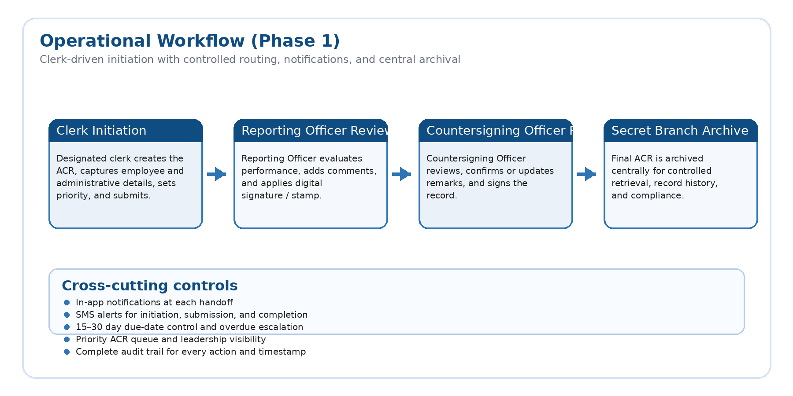
Figure 1. Phase 1 workflow from clerk initiation to Secret Branch archival.

4. Project Scope
In Scope (Phase 1) | Out of Scope / Later Phase
BPS 1–16 ACR / PER workflow automation | BPS 17+ officer evaluation automation
Clerk initiation and officer approval workflow | WhatsApp integration in Phase 1
Role-based dashboards, search, notifications, and overdue tracking | Public-facing or internet-exposed portal
Secret Branch archive, logs, and history management | Full HRMIS replacement

5. Functional Scope and Key Modules
Operational Modules | Business Outcome
Authentication and role-based access | Each user sees only the functions and records allowed for their role and wing.
Clerk initiation and data capture | Initial employee and office details are captured once and routed forward.
Reporting Officer review queue | Pending work, due dates, comments, signature, and stamp insertion in one place.
Countersigning Officer review queue | Second-stage review with approval, remarks, and final sign-off.
Secret Branch archive | Central storage, search, retrieval, and complete historical record of finalized ACRs.
Notification engine | In-app alerts and SMS notifications for handoffs, submissions, and status updates.
Priority and overdue controls | Separate tracking for urgent cases and delayed actions.

6. Role-Based Access and Dashboards
Role | Primary Access | Dashboard Focus
Clerk | Create ACR, enter base data, submit, track status | Initiated, returned, pending, and priority ACRs
Reporting Officer | Review queue, comments, sign, stamp, submit | Pending work, overdue items, average completion time
Countersigning Officer | Review, countersign, return or submit | Approval queue, overdue cases, final submission status
Secret Branch | Archive, retrieve, update status, controlled access | Archive count, incoming records, searchable history
Leadership / DG | Read-only oversight and analytics | Wing-wise trends, completed vs pending, overdue analysis

7. Reference Solution Architecture
The architecture below is intentionally client-friendly. It shows how the portal, workflow services, storage, identity, notifications, and optional future integration points fit together in an on-premises deployment model.
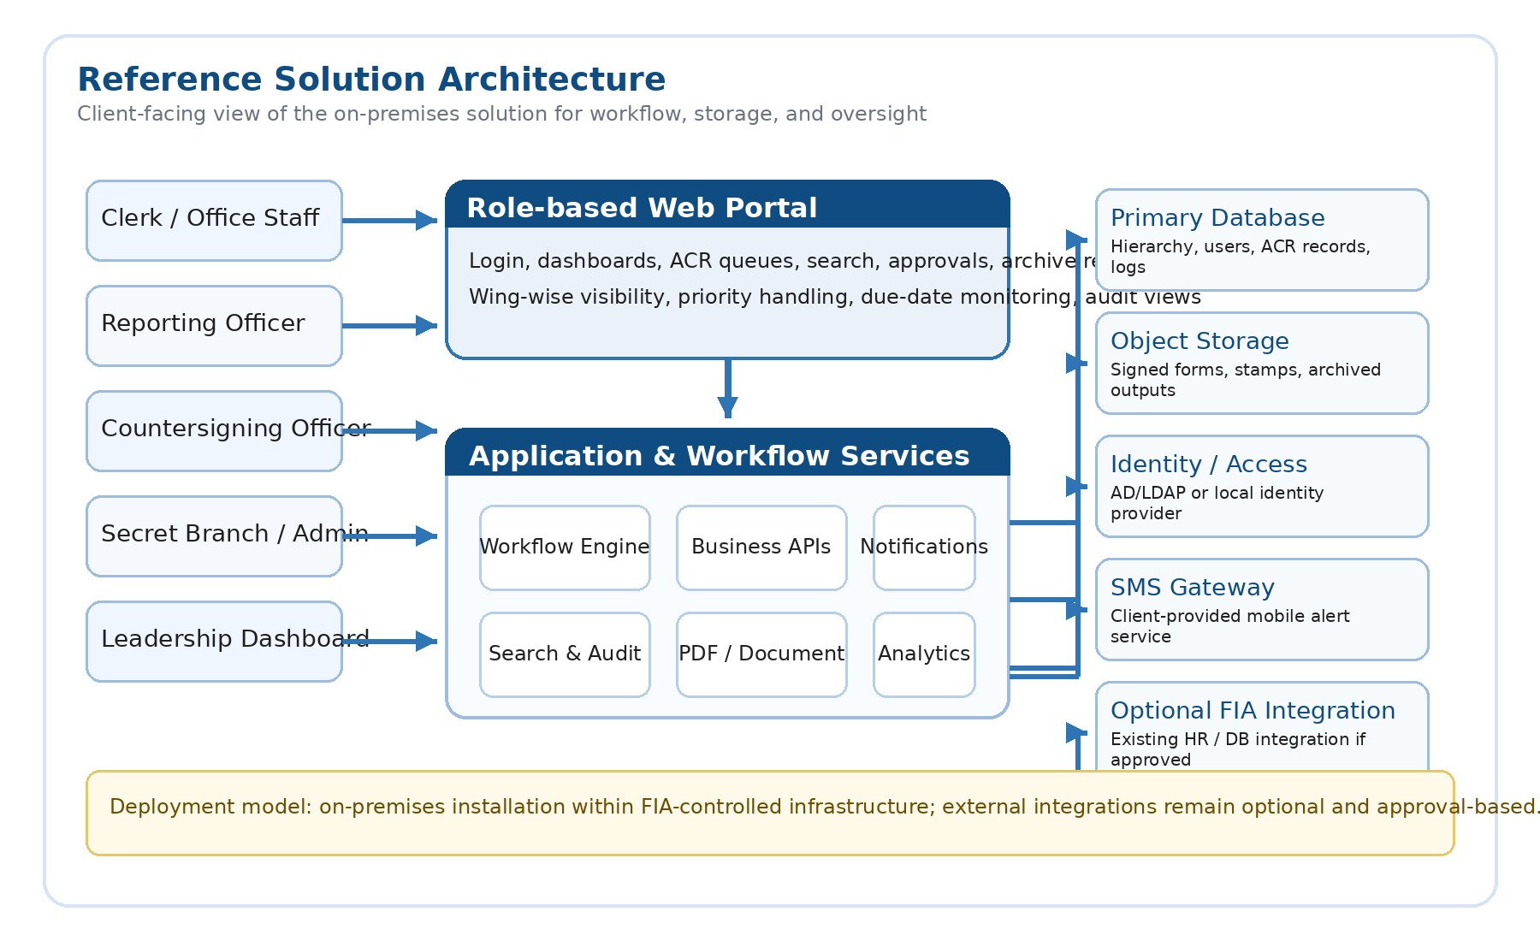
Figure 2. High-level reference architecture for the proposed on-premises solution.
Area | Recommended Technology | Purpose
Frontend | Next.js + TypeScript | Role-based portal, dashboards, forms, queues, and search interfaces
Backend | NestJS services | Business rules, approvals, archive APIs, logs, and integration layer
Workflow | Temporal or equivalent orchestration | Durable routing, timers, overdue control, and escalations
Database | PostgreSQL | Users, hierarchy, ACR records, tasks, queues, and audit data
Storage | On-prem S3-compatible storage | Signed outputs, attachments, stamp images, and archived files
Deployment | Containers / on-prem environment | Controlled internal deployment and maintainable operations

8. Delivery Plan and Timeline
For the currently understood scope, a focused three-week implementation is realistic as a controlled delivery target, provided that FIA promptly confirms form variants, hierarchy mapping, access details, and deployment prerequisites.
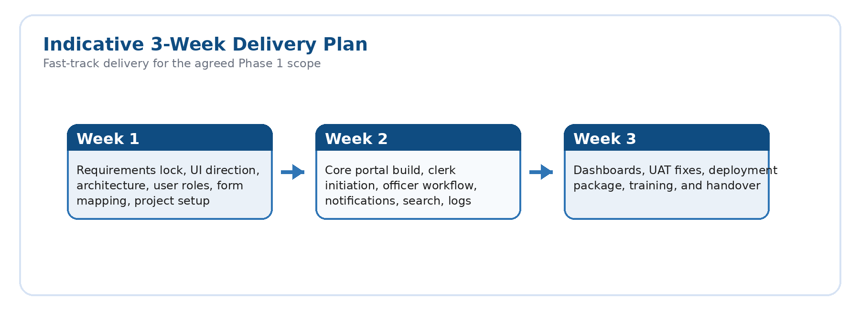
Figure 3. Indicative three-week delivery plan for the agreed Phase 1 scope.
Week | Focus | Primary Output | Client Input Needed
1 | Lock requirements and design | Workflow confirmation, architecture, UI direction, form mapping | Final forms, hierarchy, policy clarifications
2 | Core build | Portal foundation, clerk initiation, approval workflow, notifications, logs | Review of screenshots / demo feedback
3 | Hardening and deployment | Dashboards, QA, UAT fixes, deployment package, handover | UAT participation and environment access

9. Commercial Estimate
Commercial basis: $15/hour × 40 hours/week × 3 weeks = 120 hours = $1,800±
Engagement Model | Who Provides Developers | My Role | Commercial Basis
Client-Supported Delivery | FIA provides frontend/backend developers or technical staff | Solution architecture, planning, supervision, review, coordination, delivery oversight | Reduced consulting/management rate — suggested as $800 total for oversight scope
Full Outsourced Delivery | I provide complete project team | End-to-end design, frontend, backend, database, testing, deployment, handover | Full project rate — $1,800± total (120 hours × $15/hour
If we go with milestone based then these are the cost breakdown.
Option | Description | Effort | Cost (USD)
Option A | Complete end-to-end Phase 1 delivery from design to on-prem deployment and handover | 120 hrs | $1,800
Milestone 1 | Requirements lock, solution design, architecture, and UI / workflow planning | 20 hrs | $300
Milestone 2 | Core portal, clerk initiation, officer workflow, dashboards, notifications, and archive features | 70 hrs | $1,050
Milestone 3 | Deployment support, UAT fixes, training, handover, and launch readiness | 30 hrs | $450
Commercial notes:
- The above estimate is based on the requirements confirmed to date and the current Phase 1 scope.
- Any new modules, policy-driven changes, or additional integrations will be treated as a change request.
- SMS gateway costs, third-party licenses, hosting hardware, and client infrastructure are assumed to be provided or approved by FIA.
- If FIA later requests integration with existing .NET / Java systems or databases, that work should be estimated separately after technical review.

10. Assumptions, Dependencies, and Exclusions
Assumptions | Client Responsibilities | Exclusions in Current Estimate
Clerk initiates the ACR and enters the first data section. | Provide final approved ACR forms, hierarchy rules, and sample records. | No WhatsApp notifications in Phase 1.
Transfer / posting and partial-period ACR rules will follow final FIA policy. | Provide on-prem environment access, security approvals, and testing coordination. | No BPS 17+ evaluation workflow in Phase 1.
Digital stamp / signature approach used in Phase 1 is acceptable to FIA. | Participate in UAT, review cycles, and timely sign-offs. | No full HRMIS replacement or public portal.

11. Items to Lock Before Final SRS
To produce the final SRS and avoid rework, the following items should be confirmed in writing before detailed design is frozen:
Topic | Decision Needed
Due-date rule | Whether the operational rule is fixed at 15 days, 30 days, or configurable by policy.
Separation events | Handling rules for retirement, resignation, death-in-service, or termination before cycle completion.
Integration scope | Whether Phase 1 remains standalone or must integrate with existing FIA data sources.
FIA Database reusability | Need time and effort to integrate/fetch the total record from other deployed system may delay the project

12. Acceptance, Validity, and Approval
This proposal is intended as a revised business and delivery proposal for client review. Once the commercial approach, workflow assumptions, and policy clarifications are accepted, the project team can proceed to finalize the Software Requirements Specification (SRS) and implementation plan.
This proposal remains valid for 30 days from the issue date unless revised in writing.
Name | Role | Signature | Date
Afzal Khan | SSP
Ali Nawaz | Senior AI/ML Engineer | Ali Nawaz | 01/04/2026

