SOFTWARE REQUIREMENTS SPECIFICATION
FIA Smart ACR / PER
Management System
Revised client-ready SRS with functional, architectural, security, deployment, and commercial baselines for on-premises delivery
Prepared for | Federal Investigation Agency (FIA)
Document type | Software Requirements Specification (SRS)
Version | 2.0 - revised draft
Date | April 2026
Prepared by | Ali Nawaz

This revision reflects the latest clarified FIA operating model: clerk-driven initiation, reporting officer review, countersigning officer review, and final archival in the Secret Branch, with overdue monitoring, notifications, dashboards, and full auditability.
Delivery model  End-to-end build | Indicative timeline  3 weeks | Commercial basis  $15/hour | Estimated effort  120 hours

1. Document purpose and status
This SRS defines the latest agreed product direction for the FIA Smart ACR / PER Management System for employees in BPS 1 to BPS 16. It consolidates the updated operating flow, functional and non-functional requirements, solution architecture, deployment baseline, and commercial estimate for client review and scope locking.
This revision supersedes the older assumption that the employee would fill the initial data section. The confirmed base flow is now clerk-driven initiation at office/wing level, followed by Reporting Officer review, Countersigning Officer review, and final archival in the Secret Branch.

2. Executive summary
The FIA Smart ACR / PER Management System will digitize annual confidential report movement from manual paper handling into a controlled, searchable, auditable, role-based internal portal. The system is intended for nationwide use across FIA offices, wings, and zones for BPS 1-16 personnel, while preserving the approved paper form structure as closely as possible in digital form.
• Primary business value: replace slow paper routing with visible digital queues, deadlines, reminders, and archival control
• Operating model: clerk initiates the case; Reporting Officer records the evaluation; Countersigning Officer reviews and finalizes; Secret Branch archives the authoritative copy
• Management value: leadership dashboards expose backlog, overdue cases, completion trends, priority cases, and bottlenecks by office, wing, or zone
• Deployment model: secure on-premises deployment inside FIA-controlled infrastructure
• Delivery approach: phase-1 end-to-end build within an indicative 3-week / 120-hour implementation window, subject to final scope lock and client dependencies

3. Business context, objectives, and scope
FIA publicly operates through headquarters, wings, zones, and nationwide offices, with DG-level and directorate-level leadership roles visible across the organization. The proposed system is therefore designed for role-scoped, wing-scoped, and hierarchy-aware operation rather than a single-office workflow.
Business objective | Why it matters
Replace paper movement | Reduce physical routing delays, lost files, and dependency on manual follow-up.
Enforce timelines | Use due dates, overdue queues, and escalation logic to improve completion discipline.
Improve visibility | Give officers, admins, and leadership controlled insight into pending, completed, and delayed ACRs.
Preserve defensible records | Maintain final archived copies, full audit logs, and searchable metadata.
Standardize nationwide handling | Support common process controls across offices, wings, and zones while respecting hierarchy and visibility boundaries.

In scope (phase 1) | Out of scope / later phase
BPS 1-16 ACR/PER workflow automation | BPS 17+ automation
Clerk initiation, Reporting Officer review, Countersigning review, Secret Branch archival | Public-facing portal
Role-based dashboards, search, overdue control, priority handling, notifications | WhatsApp notifications
On-prem deployment, security baseline, audit history, PDF rendering | Full HRMIS replacement
SMS integration through client-approved gateway | AI-based final scoring or autonomous appraisal decisions
Template-driven support for approved FIA ACR variants | Unapproved future modules and deep integration with unrelated legacy platforms

4. Stakeholders and user roles
Role | Primary responsibility | Visibility / access posture
Clerk / office admin | Initiate ACR, populate initial section, submit to Reporting Officer, track status | Own office / authorized unit only
Reporting Officer | Complete evaluation sections, remarks, signatures/stamps, submit onward | Assigned cases only
Countersigning Officer | Review and countersign, finalize operational decision, submit to Secret Branch | Assigned countersigning cases only
Secret Branch / Secret Cell | Archive final record, search/retrieve, retain authoritative history | Central archive scope subject to authorization
Wing / zonal oversight roles | Monitor queues, overdue cases, completion health, bottlenecks | Scoped to authorized wing/zone
DG / executive viewers | View summary analytics and organization-wide performance indicators | Read-only, highly scoped analytics
Super Admin / IT Ops | Configure templates, hierarchy, users, due dates, integrations, and operational settings | Privileged administrative scope
Employee (limited view) | Status tracking and adverse-remark communication if enabled | Own record/status only

5. Operating model and workflow
The revised business flow is clerk-first, not employee-first. A designated clerk of the office or wing opens the ACR for the relevant employee and reporting period, enters the initial profile/service information, verifies the reporting chain, and submits the case into the Reporting Officer queue.
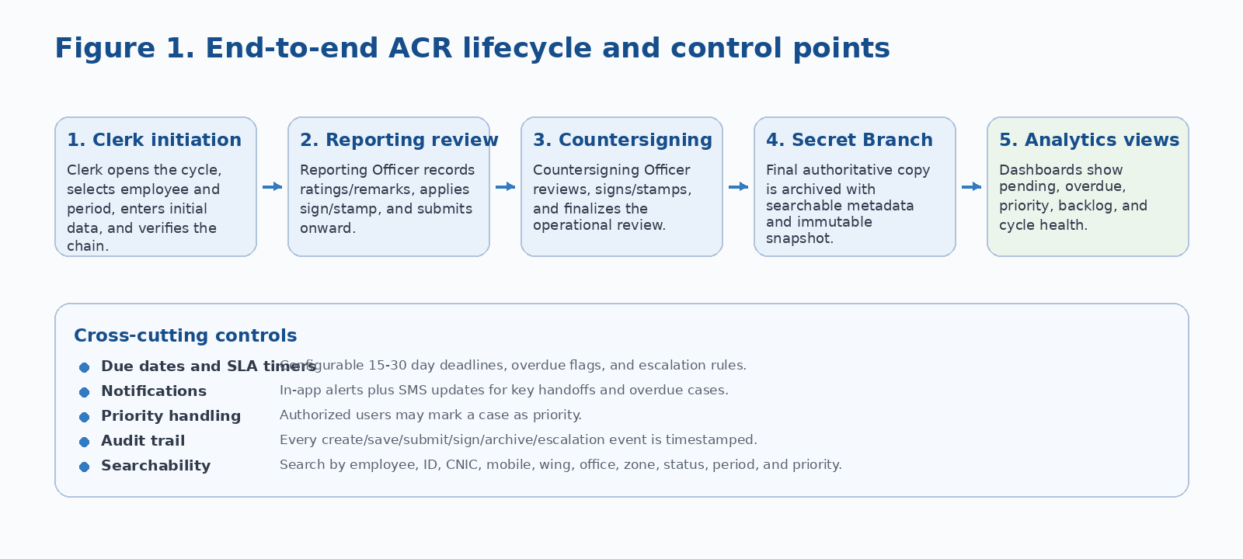
Figure 1. Updated operational workflow with queue handoffs and cross-cutting controls

Workflow principle The portal digitizes movement and control of the approved FIA form; it does not replace the substantive officer evaluation process.

5.1 Standard annual cycle
• A cycle becomes eligible based on FIA-approved annual policy and reporting relationship dates.
• The designated clerk initiates the ACR for the employee and confirms the correct reporting and countersigning chain.
• The Reporting Officer receives the case, completes the evaluation, signs/stamps, and submits it onward.
• The Countersigning Officer reviews, signs/stamps, and submits the case to the Secret Branch.
• The Secret Branch archives the final authoritative record and makes it available for authorized search and retrieval.

5.2 Special and exception scenarios
• Transfer of Reporting Officer: system design must support policy-based handling of partial-year or segment ACRs when an officer is transferred before cycle completion
• Transfer of employee: system must preserve history and route responsibility according to FIA policy
• Priority case: authorized users may mark a case priority, which must surface in dedicated queue widgets and higher-visibility alerts
• Overdue case: breach of stage deadline must move the case into overdue status, dashboard widgets, and escalation logic
• Adverse remarks: if the form or policy requires, the system must support communication, representation, and retention of decisions in the dossier/record trail
• Service separation events: retirement, resignation, death, long leave, or other cycle interruption scenarios remain design targets pending policy confirmation

6. Business rules
• BR-01: The system shall support multiple hierarchy patterns because not every office or wing contains every rank level.
• BR-02: Reporting and countersigning responsibility shall be derived from effective-dated hierarchy and posting data, with manual override only for authorized admins.
• BR-03: A final archived ACR shall be immutable except through formally authorized amendment procedures.
• BR-04: Wing-wise and role-wise visibility shall prevent unauthorized cross-wing or cross-office access.
• BR-05: Due dates shall be configurable by stage; the current working assumption is 15-30 days for officer actions.
• BR-06: The digitally rendered form shall mirror the approved physical form structure as closely as practical.
• BR-07: Signature and stamp placement shall be controlled, consistently rendered, and logged as part of the final document history.
• BR-08: All workflow state changes must be timestamped and attributable to a user, role, or system event.

7. Functional requirements

FR-01 Identity and access control
• Secure login for all internal users.
• Role-based access control with wing, zone, office, hierarchy, and task-level scoping.
• Support for privileged roles such as Super Admin, Secret Branch administrators, and executive viewers.
• Future-ready support for MFA on privileged accounts.

FR-02 Organization, hierarchy, and posting model
• Maintain organization units including headquarters, wings, zones, departments, branches, and offices.
• Maintain effective-dated reporting and countersigning chains.
• Preserve posting history so the correct chain can be reconstructed for each ACR period.

FR-03 Employee master and search
• Store employee identifiers such as employee ID/service number, name, CNIC, mobile number, rank, designation, wing, office, and posting data.
• Support search by name, ID, rank, CNIC, mobile, status, office, wing, zone, reporting officer, countersigning officer, period, and priority.
• Track service status events such as transfer, retirement, resignation, separation, or death when policies are finalized.

FR-04 Clerk initiation
• Allow authorized clerks/admins to initiate an ACR for a selected employee and period.
• Capture initial personal and administrative fields based on approved form design.
• Validate hierarchy before submission and prevent routing if mandatory chain data is missing.
• Log creation time, initiating user, office, and initial submission time.

FR-05 Reporting Officer workflow
• Provide pending, draft, overdue, completed, and priority queues.
• Support entry of ratings, remarks, pen-picture, general assessment, promotion suitability, and any form-specific sections relevant to the approved template.
• Allow draft save, reopen, sign/stamp, and final submit actions subject to permissions.
• Track workload metrics including pending count and average completion time.

FR-06 Countersigning Officer workflow
• Provide countersigning queues with priority and overdue indicators.
• Support remarks, review decision, sign/stamp application, and final submission to Secret Branch.
• Optionally support send-back / correction flow if FIA policy confirms it.

FR-07 Secret Branch workflow
• Receive final authoritative ACR record and preserve immutable archive copy.
• Search and retrieve finalized ACRs and view full case history.
• Filter records by zone, wing, office, rank, employee, period, and completion status.
• Restrict export/download actions to authorized roles and log all such activity.

FR-08 Notifications and alerts
• Support in-application notifications for all workflow handoffs.
• Support SMS notifications for configured status milestones and overdue actions using a client-approved gateway.
• Log delivery attempts, failures, retries, and final dispatch outcome.

FR-09 Due dates, overdue control, and escalation
• Start stage timers upon queue handoff or policy-defined event.
• Mark items overdue when SLA is breached.
• Move overdue items into dedicated queue widgets, list filters, and dashboard summaries.
• Escalate to configured higher authority or monitoring role as per FIA policy.

FR-10 Priority handling
• Allow authorized users to mark or unmark a case as priority.
• Support priority filters, queue flags, and dashboard counts.
• Allow combined filtering such as priority plus overdue plus zone/wing.

FR-11 Dashboards and analytics
• Provide role-based dashboards for clerk, Reporting Officer, Countersigning Officer, Secret Branch, leadership, and executive viewers.
• Support counts by status, backlog, cycle time, completion rate, overdue rate, and priority volume.
• Provide wing-wise, zone-wise, office-wise, and trend reporting for authorized viewers.

FR-12 Document rendering and form fidelity
• Generate a rendered ACR document that resembles the approved physical form for the relevant rank/category.
• Support template versions for different approved form variants.
• Render signature and stamp images into controlled positions with final PDF generation.

FR-13 Audit trail and history
• Log all create, edit, save, submit, sign, countersign, archive, notification, search, export, overdue, escalation, and configuration events.
• Show case timeline/history where authorized.
• Maintain immutable audit events for forensic review and compliance reporting.

FR-14 Adverse remarks and representation
• Support adverse-remark communication flow if required by the approved FIA form/policy.
• Allow representation capture, review notes, and resulting decision storage.
• Retain communication and decisions in the case history and archived record where policy requires.

FR-15 Administration and configuration
• Manage users, roles, hierarchy rules, templates, due dates, notification rules, and lookup masters.
• Support template versioning and future addition of approved FIA ACR variants.
• Support operational parameters without requiring code changes for every policy update.

8. Role-based dashboards and reporting needs
Role | Minimum dashboard content
Clerk | Initiated today, pending submission, returned items, due/overdue counts, search shortcuts for own office.
Reporting Officer | Pending cases, drafts, overdue items, priority items, completed this period, average completion time.
Countersigning Officer | Pending review, overdue review, priority items, completion trend, cases by office/wing.
Secret Branch | Received finalized ACRs, archive counts, pending receipt anomalies, search/retrieval widgets.
Director / oversight roles | Backlog by unit, overdue distribution, bottleneck officers, completion rate, trend analysis.
DG / executive viewer | National totals, zone-wise and wing-wise comparisons, backlog health, cycle-time indicators, high-level charts.

The dashboard layer must remain formal and uncluttered. Senior-view dashboards should emphasize health indicators, distribution charts, overdue hotspots, and trend lines rather than operational detail overload.

9. Data model direction
• Users, roles, permissions, and user-to-office mappings
• Employees, ranks, designations, identifiers, and current/historical postings
• Organization structure: wings, zones, departments, branches, offices
• Reporting and countersigning hierarchy with effective dates
• ACR templates and template versions
• ACR instances, sections, workflow tasks, status history, and SLA timers
• Notification events and delivery logs
• Signature/stamp assets and rendered PDF/document snapshots
• Secret Branch archive metadata and retention tags
• Audit events, export logs, search logs, and configuration changes
Data governance principle Finalized ACRs must be immutable records. Draft and workflow data may remain editable until final submission, but all changes must remain auditable.

10. Non-functional requirements
Category | Requirement baseline
Security | On-prem deployment, strong RBAC, scoped access, encrypted transport, secure secret handling, tamper-aware final records, privileged access controls, centralized audit logs.
Availability | Production availability target to be finalized with FIA infrastructure team; failure in optional integrations must not cause loss of case state or audit data.
Performance | Responsive queues/search for nationwide usage; efficient dashboard aggregates; bulk initiation and notifications handled through background processing.
Scalability | Support thousands of employees and concurrent users across wings/zones, with horizontally scalable web/API/workflow components.
Maintainability | Modular services, versioned APIs, configuration-driven templates/hierarchy rules, auditable deployments, and clear environment separation.
Usability | Clean, formal, non-noisy interface with high readability, clear status tags, and search-first workflow screens.
Compliance and retention | Retention and archive behavior to follow FIA policy; export/download controls must be logged and limited to authorized roles.
Observability | Centralized logs, metrics, traces, operational alerts, and audit review tooling for support and incident analysis.

11. Solution architecture
The solution is intentionally modular but not needlessly complex. A single internal web portal serves all roles, while backend services separate identity, workflow, documents, notifications, archive, and analytics concerns. This supports clearer ownership, easier change management, and safer long-running workflow control.
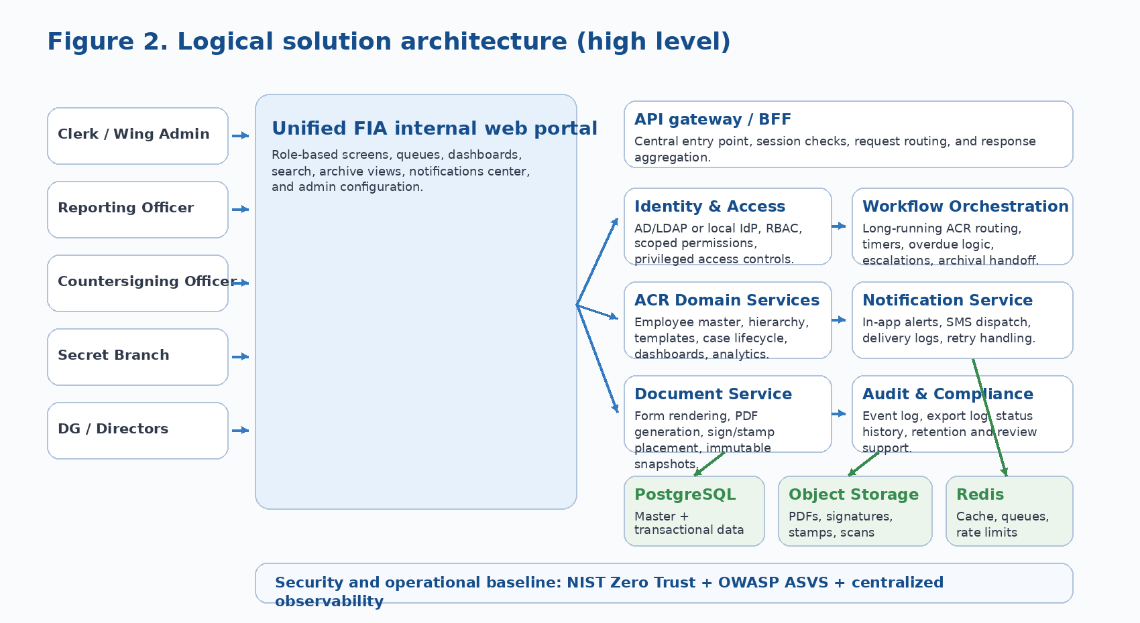
Figure 2. Logical application architecture for the proposed on-prem solution

11.1 Architectural style
• Unified internal web portal for all authorized roles
• API-first backend with bounded services
• Durable workflow orchestration for long-running routing and timers
• Shared observability and audit pipeline
• On-prem containerized deployment with controlled ingress and persistent storage

11.2 Core modules
Module | Purpose
Identity and access service | Authentication, session management, RBAC, office/wing/role scoping.
Employee master service | Employee profile, identifiers, current and historical postings.
Hierarchy service | Reporting and countersigning chain resolution with effective dates.
Template service | Approved ACR variants, versions, and rendering rules.
ACR lifecycle service | Case creation, status transitions, due dates, business validation.
Workflow orchestration service | Timers, retries, overdue logic, escalations, archival handoff.
Document rendering service | Rendered form/PDF generation and signature/stamp application.
Notification service | In-app alerts, SMS dispatch, retry, and delivery status tracking.
Archive service | Secret Branch search, retrieval, retention metadata, and immutable final copy handling.
Analytics and reporting service | Dashboard aggregates, trends, bottlenecks, and executive summaries.
Audit and compliance service | Activity timeline, export logging, administrative change logs, and review support.

12. On-prem deployment architecture
The deployment baseline assumes FIA-controlled infrastructure, internal network access, containerized services, managed database backups, and controlled integration with directory services and SMS gateway endpoints.
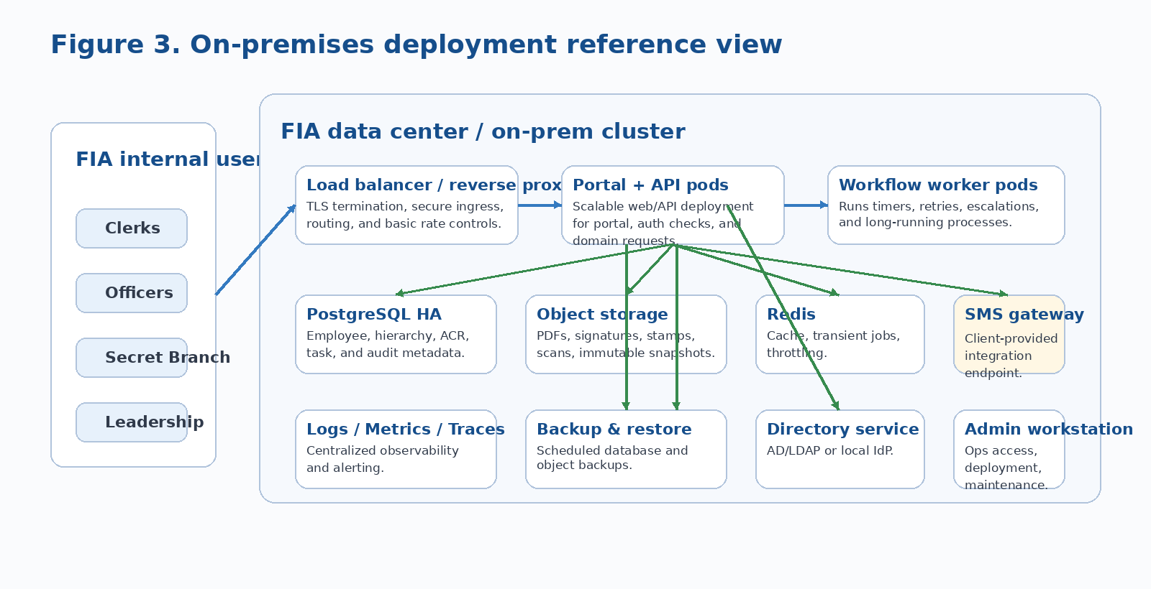
Figure 3. Reference on-prem deployment view for production planning

Area | Recommended direction | Purpose
Frontend portal | Next.js + TypeScript | Role-based portal, queues, search, forms, dashboards.
Backend services | NestJS / TypeScript services | Business APIs, workflow coordination, archive and analytics services.
Workflow engine | Temporal or equivalent durable orchestration | Long-running workflows, timers, retries, escalations, and archival handoff.
Primary database | PostgreSQL | Transactional data for employees, hierarchy, ACRs, tasks, and audit metadata.
Cache / queue | Redis | Caching, rate control, transient jobs, transient workload smoothing.
Object storage | On-prem S3-compatible storage | Rendered PDFs, signature/stamp images, scanned uploads, immutable snapshots.
Identity | AD/LDAP preferred; local IdP fallback | Single sign-on / centralized identity and access governance.
Observability | OpenTelemetry + centralized logs/metrics/traces | Operational support, performance monitoring, and troubleshooting.
Deployment | Containers on on-prem Kubernetes or equivalent orchestration | Resilience, scaling, and controlled operations in FIA infrastructure.

13. Security, compliance, and engineering baseline
Because the system handles confidential personnel records and internal routing history, the engineering baseline should align with a zero-trust approach for access control, a recognized web-application security verification baseline, and strong observability for operational assurance.
Control area | Baseline direction
Access model | No implicit trust based solely on network location; explicit authentication and authorization before access to protected resources.
Application security verification | Adopt OWASP ASVS as the minimum control reference for secure design, implementation, and verification.
Identity | Prefer FIA directory integration; support local IdP fallback if directory integration is delayed.
Secrets and keys | Store in secured secrets management or protected configuration; avoid hard-coded secrets in code or images.
Auditability | All privileged actions, exports, and configuration changes must be logged and reviewable.
Document integrity | Final archived copies should be immutable and protected against unauthorized alteration.
Operational visibility | Use logs, metrics, and traces for security monitoring, reliability, and root-cause analysis.

14. UI / UX requirements
• Design tone: formal, clean, high-contrast, uncluttered, and suitable for government enterprise use
• Primary screens: login, clerk initiation, officer queues, countersigning queue, archive search, dashboard pages, notification center, admin configuration
• Status model: Draft, Pending Reporting, Pending Countersigning, Submitted to Secret Branch, Archived, Overdue, Priority, Returned/Correction if approved
• Search-first behavior: archive and operational lists should prioritize fast filtering by employee, office, wing, period, and status
• Accessibility: clear typography, obvious status tags, straightforward navigation, and minimal cognitive overload for non-technical staff

15. Acceptance criteria and test focus
• Users can authenticate and access only the screens and records allowed for their role and organizational scope.
• A clerk can initiate an ACR and route it to the correct Reporting Officer based on approved hierarchy.
• The Reporting Officer and Countersigning Officer can complete their respective sections, sign/stamp, and move the case forward.
• The Secret Branch receives the final record, can retrieve it through search, and can view the full history of the case.
• Overdue items are visibly flagged, counted, and escalated according to configured rules.
• Role-based dashboards show correct counts and trend data for the test dataset.
• Rendered forms preserve approved structure and show sign/stamp placement correctly.
• Audit history captures all major events end-to-end.

16. Delivery plan and commercial estimate
Week | Focus | Primary outputs
Week 1 | Scope lock, form review, architecture, setup | Confirmed workflow, template mapping, hierarchy assumptions, UI direction, environment checklist.
Week 2 | Core build | Portal foundation, auth, clerk initiation, employee master, hierarchy, reporting/countersigning workflow, notifications baseline.
Week 3 | Hardening and deployment | Archive/search, overdue controls, dashboards, QA/UAT fixes, deployment package, handover.

Commercial option | Effort / basis | Estimated cost (USD)
End-to-end phase 1 build | 120 hours @ $15/hour over 3 weeks | $1,800
Milestone 1 - requirements lock + architecture + UI baseline | 20 hours | $300
Milestone 2 - core portal + ACR workflow + notifications | 70 hours | $1,050
Milestone 3 - archive, dashboards, QA, deployment, handover | 30 hours | $450

Commercial notes: third-party SMS, infrastructure, server provisioning, certificates, and any paid tools/services are assumed to be provided or approved by the client. Additional requirements, major policy changes, or integration requests outside this document will be treated as change requests.

17. Assumptions, client responsibilities, and exclusions
Assumptions | Client responsibilities | Exclusions in current estimate
Approved paper forms will be provided and locked for digital mapping. | Provide finalized forms, hierarchy rules, policy clarifications, and test users/data. | WhatsApp notifications are excluded in phase 1.
Clerk-driven initiation is the confirmed base flow for this revision. | Provide or approve on-prem infrastructure, network access, SMS gateway route, and deployment dependencies. | BPS 17+ automation is excluded.
Image-based sign/stamp is acceptable initially unless FIA mandates digital signatures at this stage. | Participate in reviews, UAT, and timely approvals. | Full HRMIS replacement and unrelated legacy integration are excluded.
Transfer/partial-year handling will follow FIA policy once confirmed. | Confirm retention, visibility, and escalation rules in writing before final build lock. | AI-based scoring/decisioning is excluded.

18. Open policy decisions to lock before final build
Decision area | Current position / question
Form variants | Which approved forms apply to which rank/category, and whether any special variants exist by office or service group.
Partial-year ACR rules | How to handle reporting-officer transfer, employee transfer, or split periods during the year.
Employee visibility | Whether employees can view only status, adverse-remark communication, or the final full ACR content.
Return / correction flow | Whether a countersigning officer can return a case for correction and how that should be logged.
Signatures | Whether image-based sign/stamp is sufficient initially or PKI/digital-signature integration is mandatory.
Retention and export | Retention duration, archive classifications, and which roles may export or print completed records.
Escalation chain | Exact hierarchy for overdue escalation at reporting and countersigning stages.
Integration scope | Whether phase 1 remains standalone or must integrate with specific FIA databases or legacy applications.

19. External reference standards and public sources consulted
The following public sources were used to validate the architecture/security baseline and to align terminology with FIA’s publicly visible organizational context. They are included as reference inputs for this draft and do not override final FIA policy or legal requirements.
Ref | Source | Why it is relevant
R1 | FIA public contact and wings pages | Confirms DG, zones, nationwide offices, and wing-oriented public organizational framing.
R2 | NIST SP 800-207 (Zero Trust Architecture) | Supports explicit authentication/authorization and resource-focused access control baseline.
R3 | OWASP Application Security Verification Standard (ASVS) | Provides a recognized baseline for web-application security requirements and verification.
R4 | Temporal documentation | Supports durable long-running workflow orchestration for timers, retries, and crash-proof process continuation.
R5 | OpenTelemetry documentation | Supports unified logs, metrics, and traces for observability.
R6 | Keycloak / identity documentation | Supports local IAM fallback if directory integration is delayed.
R7 | MinIO S3 compatibility documentation | Supports on-prem S3-compatible object storage direction for PDFs and snapshots.
R8 | Kubernetes production environment guidance | Supports resilient on-prem container orchestration planning for critical workloads.

R1 https://fia.gov.pk/contact and https://fia.gov.pk/wing
R2 https://csrc.nist.gov/pubs/sp/800/207/final
R3 https://owasp.org/www-project-application-security-verification-standard/
R4 https://docs.temporal.io/
R5 https://opentelemetry.io/
R6 https://www.keycloak.org/
R7 https://www.min.io/product/aistor/s3-api
R8 https://kubernetes.io/docs/setup/production-environment/

20. Approval
This document should be treated as the working scope baseline for client presentation and requirement locking. Final build commitment should follow written confirmation of open policy decisions, approved form variants, infrastructure readiness, and accepted commercials.
Name | Role | Signature | Date
 | Prepared by | Ali Nawaz | 01/04/2026
 | Reviewed by
 | Client approval

