JSC «International Information Technology University»
Faculty of Business, Media and Management · Department of Information Systems
LABORATORY WORK No. 7
Developing a REST API: CRUD operations on a resource, DTOs and mappers, correct HTTP status codes, error handling, documentation with OpenAPI/Swagger UI
Item | Value
Course | RWPSF 3305 — Web Application Development with Spring Framework
Educational programme | 6B06105 — Information Systems, year 3
Students (pair work) | Altai Ali (IT1-2409IS)  Kalmyrza Gulim
Variant | 1 — paging of the collection
Lecturer | Yemberdiyeva Aknur, Senior Lector
Repository | github.com/Alilishka3/spring-lab-01, branch lab07
Date | 16 October 2026
Almaty, 2026

1. Aim of the work
To turn the book controller of laboratory work no. 5 into a REST API that another team could use: one resource with five operations, a request DTO and a response DTO with a mapper between them, a deliberately chosen status code for every outcome, errors returned as RFC 9457 problem details from one place, and an OpenAPI document generated from the code and rendered by Swagger UI.
Repository: https://github.com/Alilishka3/spring-lab-01/tree/lab07
The work was done in the same project as labs 1–6 (Spring Boot 4.1.1, Java 25). All results below were captured on 16 October 2026 by running the application and sending the requests with curl.

2. The contract of the resource
Method and URI | Request body | Success | Errors | Response body
GET /api/books?author= | — | 200 | — | BookResponse[]
GET /api/books?page=&size=  (variant 1) | — | 200 | 400 | PageResponse<BookResponse>
GET /api/books/search?title= | — | 200 | — | BookResponse[]
GET /api/books/{id} | — | 200 | 404 | BookResponse
POST /api/books | BookRequest | 201 + Location | 400, 409 | BookResponse
PUT /api/books/{id} | BookRequest | 200 | 400, 404, 409 | BookResponse
DELETE /api/books/{id} | — | 204 | 404 | —
Table 1. URIs, methods, bodies and status codes
Every error answer has the media type application/problem+json and is produced by one class, ApiExceptionHandler.

3. DTOs and the mapper
BookRequest carries only what a client is allowed to send (no id, no createdAt) and keeps the validation annotations of lab 6, including our own @Isbn constraint. BookResponse carries what the contract promises. BookMapper is the only place that knows both shapes and the domain record Book.
Task 1.4. If the controller accepted the Book record directly, a client could set id and createdAt itself (mass assignment) and overwrite server-owned data. If a field were renamed in storage, every client parsing that JSON would break, because the internal name would be the public contract.
package kz.iitu.springlab.web.dto;

import jakarta.validation.constraints.*;
import kz.iitu.springlab.catalog.Genre;
import kz.iitu.springlab.web.Isbn;

/** What a client is allowed to send: no id, no createdAt — those belong to the server. */
public record BookRequest(
@NotBlank @Size(max = 120) String title,
@NotBlank String author,
@Min(1450) @Max(2100) int year,
@NotNull Genre genre,
@Isbn String isbn) { }
Listing 1. web/dto/BookRequest.java
package kz.iitu.springlab.web.dto;

import kz.iitu.springlab.catalog.Genre;

import java.time.Instant;

/** What the contract promises to return. */
public record BookResponse(
Long id,
String title,
String author,
int year,
Genre genre,
String isbn,
Instant createdAt) { }
Listing 2. web/dto/BookResponse.java
package kz.iitu.springlab.web.dto;

import kz.iitu.springlab.catalog.Book;
import org.springframework.stereotype.Component;

import java.time.Instant;
import java.util.List;

/** The one place that knows both shapes. */
@Component
public class BookMapper {

public Book toDomain(BookRequest request) {
return new Book(null, request.title(), request.author(),
request.year(), request.genre(), blankToNull(request.isbn()), Instant.now());
}

public BookResponse toResponse(Book book) {
return new BookResponse(book.id(), book.title(), book.author(),
book.year(), book.genre(), book.isbn(), book.createdAt());
}

public List<BookResponse> toResponseList(List<Book> books) {
return books.stream().map(this::toResponse).toList();
}

private static String blankToNull(String value) {
return value == null || value.isBlank() ? null : value.trim();
}
}
Listing 3. web/dto/BookMapper.java

4. The REST controller
The controller holds the service, the mapper and AppProperties (for the variant). It speaks only DTOs: conversion code lives in the mapper. A missing id is not checked in the controller — the service throws BookNotFoundException and the advice answers 404.
package kz.iitu.springlab.web;

import io.swagger.v3.oas.annotations.Operation;
import io.swagger.v3.oas.annotations.Parameter;
import io.swagger.v3.oas.annotations.media.Content;
import io.swagger.v3.oas.annotations.media.Schema;
import io.swagger.v3.oas.annotations.responses.ApiResponse;
import io.swagger.v3.oas.annotations.responses.ApiResponses;
import io.swagger.v3.oas.annotations.tags.Tag;
import jakarta.validation.Valid;
import jakarta.validation.constraints.Max;
import jakarta.validation.constraints.Min;
import kz.iitu.springlab.catalog.Book;
import kz.iitu.springlab.catalog.BookService;
import kz.iitu.springlab.config.AppProperties;
import kz.iitu.springlab.web.dto.BookMapper;
import kz.iitu.springlab.web.dto.BookRequest;
import kz.iitu.springlab.web.dto.BookResponse;
import kz.iitu.springlab.web.dto.PageResponse;
import org.springframework.http.ProblemDetail;
import org.springframework.http.ResponseEntity;
import org.springframework.web.bind.annotation.*;

import java.net.URI;
import java.util.List;

@Tag(name = "Books", description = "The catalogue of books")
@RestController
@RequestMapping("/api/books")
public class BookApiController {

private final BookService service;
private final BookMapper mapper;
private final AppProperties props;

public BookApiController(BookService service, BookMapper mapper, AppProperties props) {
this.service = service;
this.mapper = mapper;
this.props = props;
}

@Operation(summary = "List all books, optionally filtered by author")
@GetMapping // 200
public List<BookResponse> list(@RequestParam(required = false) String author) {
return mapper.toResponseList(service.findAll(author));
}

@Operation(summary = "One page of the catalogue (variant 1)",
description = "Selected when the page parameter is present. "
+ "The default and the maximum size come from app.pagination (lab 3).")
@GetMapping(params = "page") // 200 or 400
public PageResponse<BookResponse> page(
@Parameter(description = "Page number, starting at 0", example = "0")
@RequestParam @Min(0) int page,
@Parameter(description = "Page size", example = "5")
@RequestParam(required = false) @Min(1) @Max(500) Integer size) {
int effectiveSize = Math.min(size != null ? size : props.pagination().defaultSize(),
props.pagination().maxSize());
long total = service.count();
int totalPages = (int) Math.ceil((double) total / effectiveSize);
return new PageResponse<>(
mapper.toResponseList(service.findPage(page, effectiveSize)),
page, effectiveSize, total, totalPages);
}

@Operation(summary = "Search by a fragment of the title (lab 5, variant 1)")
@GetMapping("/search") // 200, [] if nothing
public List<BookResponse> search(@RequestParam(defaultValue = "") String title) {
return mapper.toResponseList(service.searchByTitle(title));
}

@Operation(summary = "Find a book by its identifier")
@ApiResponses({
@ApiResponse(responseCode = "200", description = "The book was found"),
@ApiResponse(responseCode = "404", description = "No book with this id",
content = @Content(schema = @Schema(implementation = ProblemDetail.class)))
})
@GetMapping("/{id}") // 200 or 404
public BookResponse find(
@Parameter(description = "Identifier of the book", example = "42")
@PathVariable long id) {
return mapper.toResponse(service.get(id));
}

@Operation(summary = "Create a book")
@ApiResponses({
@ApiResponse(responseCode = "201", description = "Created; the Location header holds the new URI"),
@ApiResponse(responseCode = "400", description = "The body breaks a validation rule"),
@ApiResponse(responseCode = "409", description = "The same title by the same author exists")
})
@PostMapping // 201 + Location
public ResponseEntity<BookResponse> create(@Valid @RequestBody BookRequest request) {
Book saved = service.create(mapper.toDomain(request));
return ResponseEntity
.created(URI.create("/api/books/" + saved.id()))
.body(mapper.toResponse(saved));
}

@Operation(summary = "Replace a book")
@PutMapping("/{id}") // 200 or 404
public BookResponse update(@PathVariable long id,
@Valid @RequestBody BookRequest request) {
return mapper.toResponse(service.update(id, mapper.toDomain(request)));
}

@Operation(summary = "Delete a book")
@ApiResponses({
@ApiResponse(responseCode = "204", description = "Deleted"),
@ApiResponse(responseCode = "404", description = "No book with this id (also on a repeated DELETE)")
})
@DeleteMapping("/{id}") // 204 or 404
public ResponseEntity<Void> delete(@PathVariable long id) {
service.delete(id);
return ResponseEntity.noContent().build();
}
}
Listing 4. web/BookApiController.java

4.1 Six requests and the observed answers (task 2.3)
Request | Status | What is in the response
curl -i localhost:8080/api/books | 200 | JSON array of BookResponse
curl -i localhost:8080/api/books/1 | 200 | one BookResponse (Effective Java)
curl -i localhost:8080/api/books/999 | 404 | problem detail «Book not found»
curl -i -X POST … /api/books | 201 | Location: /api/books/15 and the created book
curl -i -X DELETE …/api/books/1 | 204 | empty body
the same DELETE a second time | 404 | problem detail «No book with id 1»
Table 2. Observed results
The second DELETE. Our API answers 404: the resource no longer exists and the service reports it as not found. The state of the server does not change after the first call, so DELETE stays idempotent; what is never acceptable is a 500. Additionally, PUT /api/books/15 answered 200 and kept the original createdAt while changing the year to 2004.
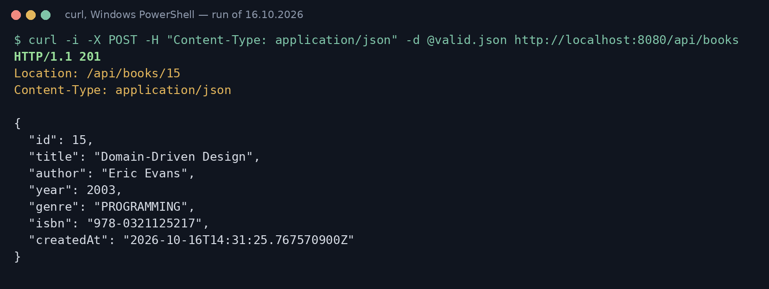
Figure 1. 201 Created with the Location header
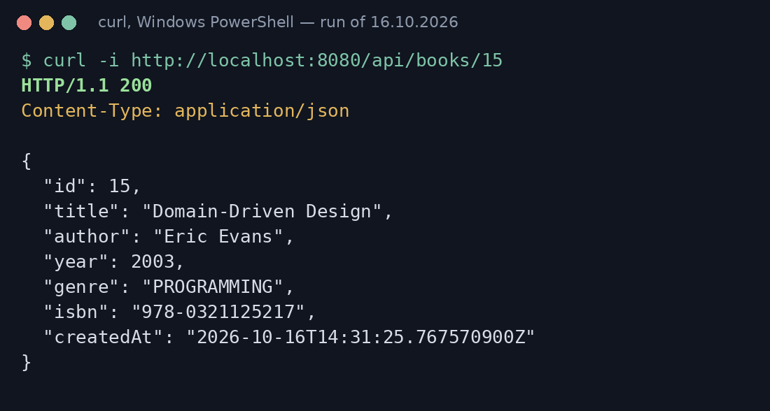
Figure 2. Following the Location header: the resource is really there
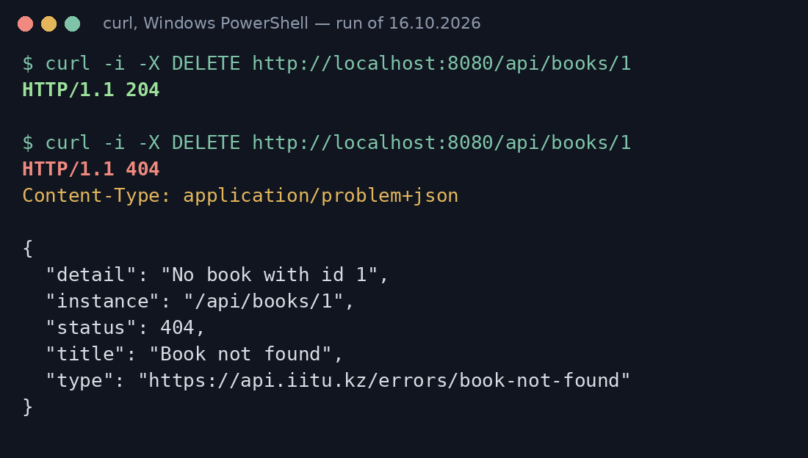
Figure 3. DELETE twice: 204, then 404 as a problem detail

5. Errors as problem details
BookNotFoundException and DuplicateTitleException live in the service package. The service throws DuplicateTitleException when a book with the same title and author already exists. ApiExceptionHandler is scoped with annotations = RestController.class, so the HTML pages of lab 6 keep their own error page; because @RestController is itself meta-annotated with @Controller, the API advice also has @Order(HIGHEST_PRECEDENCE) to win for REST controllers. Extending ResponseEntityExceptionHandler gives problem details for the standard failures for free; we only add the list of rejected fields.
package kz.iitu.springlab.web;

import kz.iitu.springlab.service.BookNotFoundException;
import kz.iitu.springlab.service.DuplicateTitleException;
import org.springframework.core.Ordered;
import org.springframework.core.annotation.Order;
import org.springframework.http.HttpHeaders;
import org.springframework.http.HttpStatus;
import org.springframework.http.HttpStatusCode;
import org.springframework.http.ProblemDetail;
import org.springframework.http.ResponseEntity;
import org.springframework.web.bind.MethodArgumentNotValidException;
import org.springframework.web.bind.annotation.ExceptionHandler;
import org.springframework.web.bind.annotation.RestController;
import org.springframework.web.bind.annotation.RestControllerAdvice;
import org.springframework.web.context.request.WebRequest;
import org.springframework.web.servlet.mvc.method.annotation.ResponseEntityExceptionHandler;

import java.net.URI;
import java.util.LinkedHashMap;
import java.util.Map;

/**
* One class where exceptions become RFC 9457 problem details.
* Scoped to @RestController, so the page controllers keep their HTML error pages.
* @RestController is itself annotated with @Controller, so the page advice would match
* REST controllers too; HIGHEST_PRECEDENCE makes this advice win for them.
*/
@RestControllerAdvice(annotations = RestController.class)
@Order(Ordered.HIGHEST_PRECEDENCE)
public class ApiExceptionHandler extends ResponseEntityExceptionHandler {

@ExceptionHandler(BookNotFoundException.class)
public ProblemDetail handleNotFound(BookNotFoundException ex) {
ProblemDetail problem = ProblemDetail.forStatusAndDetail(
HttpStatus.NOT_FOUND, ex.getMessage());
problem.setType(URI.create("https://api.iitu.kz/errors/book-not-found"));
problem.setTitle("Book not found");
return problem;
}

@ExceptionHandler(DuplicateTitleException.class)
public ProblemDetail handleDuplicate(DuplicateTitleException ex) {
ProblemDetail problem = ProblemDetail.forStatusAndDetail(
HttpStatus.CONFLICT, ex.getMessage()); // 409
problem.setType(URI.create("https://api.iitu.kz/errors/duplicate-title"));
problem.setTitle("Duplicate title");
problem.setProperty("bookTitle", ex.getTitle()); // an extra field
return problem;
}

/** The base class already answers 400 with a problem detail; we add which fields failed. */
@Override
protected ResponseEntity<Object> handleMethodArgumentNotValid(
MethodArgumentNotValidException ex, HttpHeaders headers,
HttpStatusCode status, WebRequest request) {
Map<String, String> errors = new LinkedHashMap<>();
ex.getBindingResult().getFieldErrors()
.forEach(e -> errors.putIfAbsent(e.getField(), e.getDefaultMessage()));
ex.getBody().setProperty("errors", errors);
return super.handleMethodArgumentNotValid(ex, headers, status, request);
}
}
Listing 5. web/ApiExceptionHandler.java
package kz.iitu.springlab.service;

public class DuplicateTitleException extends RuntimeException {

private final String title;

public DuplicateTitleException(String title) {
super("A book titled «" + title + "» by this author already exists");
this.title = title;
}

public String getTitle() { return title; }
}
Listing 6. service/DuplicateTitleException.java

5.1 Three error routes (task 3.3)
Request | Status and Content-Type | Which handler ran
GET /api/books/999 | 404, application/problem+json | handleNotFound (ours)
POST with an empty title | 400, application/problem+json | handleMethodArgumentNotValid of the base class, extended by us with "errors"
POST of a book that already exists | 409, application/problem+json | handleDuplicate (ours)
Table 3. Error routes
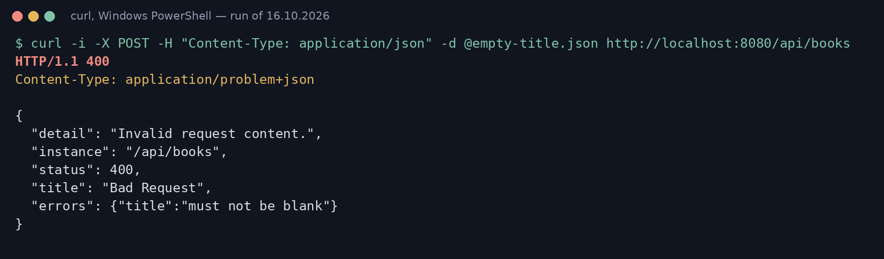
Figure 4. Invalid body: 400 from the base class
Task 3.4. The 400 answer is produced by ResponseEntityExceptionHandler, not written by hand, and already has the type application/problem+json. The standard body only says "Invalid request content."; the rejected property is named by the "errors" field we add: {"title": "must not be blank"}.
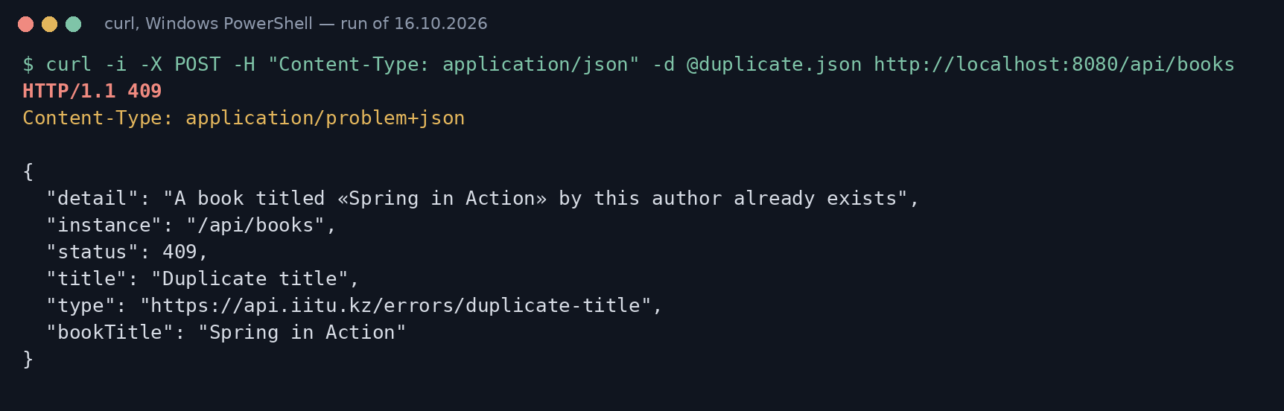
Figure 5. One problem detail in full: 409 Conflict with the extra field bookTitle
No response contains a stack trace or an exception class name: detail is written for the developer of the client, and the stack trace stays in the server log.

6. OpenAPI and Swagger UI
The dependency org.springdoc:springdoc-openapi-starter-webmvc-ui:3.1.1 (the 3.x line is the one for Spring Boot 4) publishes the document at /v3/api-docs and the page at /swagger-ui.html.
Task 4.2 — found in /v3/api-docs without any annotation: 16 paths with their HTTP methods (from the @…Mapping annotations), the parameters (from @PathVariable and @RequestParam), the schema of BookRequest built from the record components with required: author, genre, title (from @NotBlank/@NotNull), maxLength = 120 of title (from @Size(max = 120)) and minimum 1450 / maximum 2100 of year (from @Min/@Max).
Added with annotations: @Tag(name = "Books"), an @Operation summary for every operation, @ApiResponses with the meaning of 200/201/400/404/409, and @Parameter with a description and example = 42 for the path variable. An OpenApiConfig bean adds the title, version and contact.
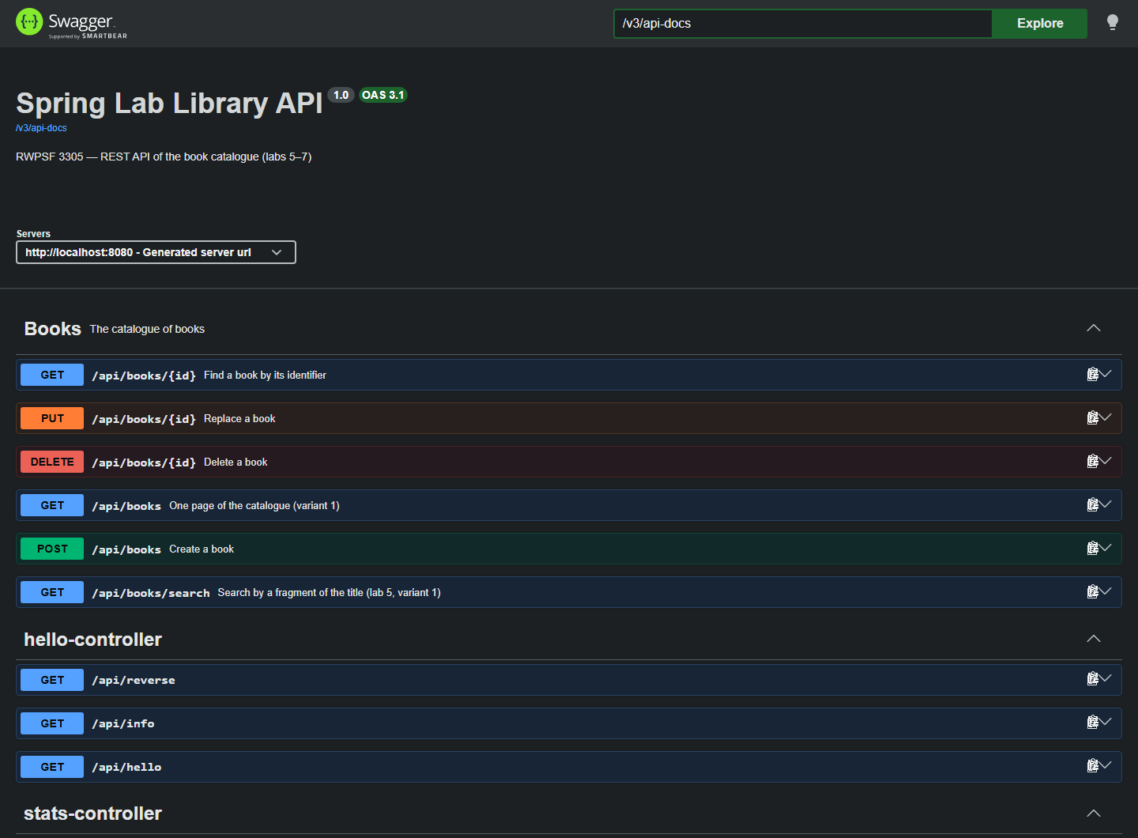
Figure 6. Swagger UI of the application

7. Individual assignment — variant 1: paging
Requirement: ?page=&size= on the collection; the response carries the page, the size and the total count. The paged handler is selected with params = "page", so GET /api/books without page keeps returning a plain array. When size is omitted, the default comes from app.pagination.default-size — the variant setting of laboratory work 3 — and app.pagination.max-size caps it. A negative page breaks @Min(0) and is answered with 400 by the built-in method validation.
package kz.iitu.springlab.web.dto;

import java.util.List;

/** Lab 7, variant 1: a page of the collection together with the paging data. */
public record PageResponse<T>(
List<T> content,
int page,
int size,
long totalElements,
int totalPages) { }
Listing 7. web/dto/PageResponse.java
Request | Status | page | size | total | pages | items
?page=0&size=5 | 200 | 0 | 5 | 13 | 3 | 5
?page=2&size=5 | 200 | 2 | 5 | 13 | 3 | 3
?page=0 (default size) | 200 | 0 | 20 | 13 | 1 | 13
?page=-1&size=5 | 400 | — | — | — | — | —
Table 4. Results of the variant
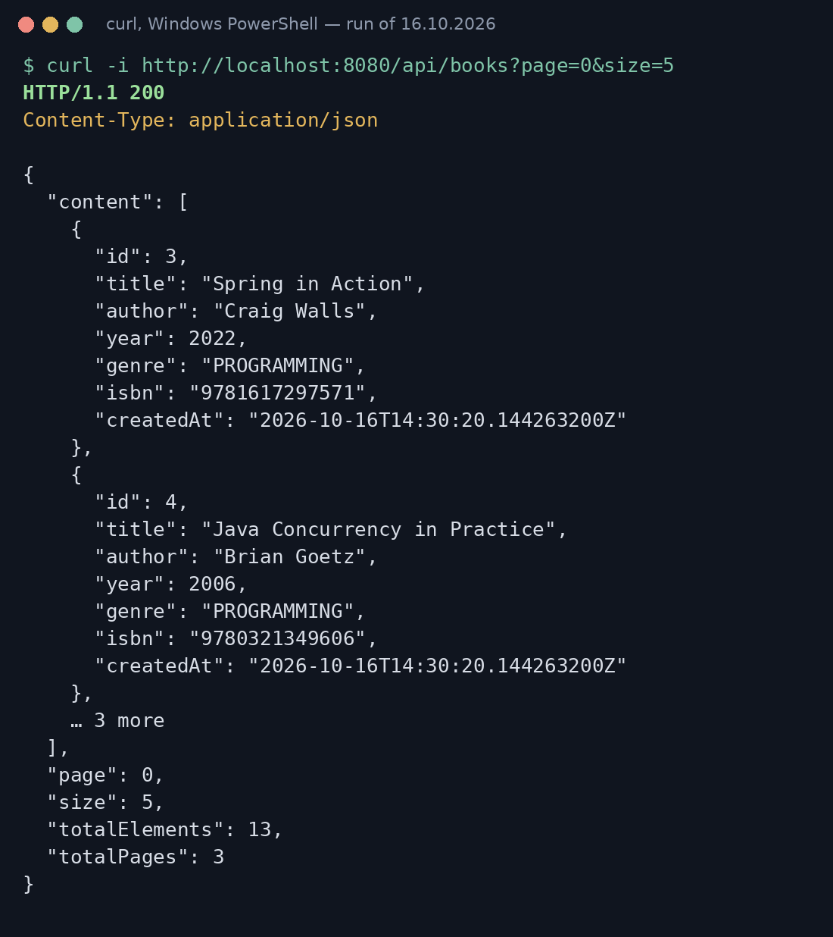
Figure 7. The first page of five books
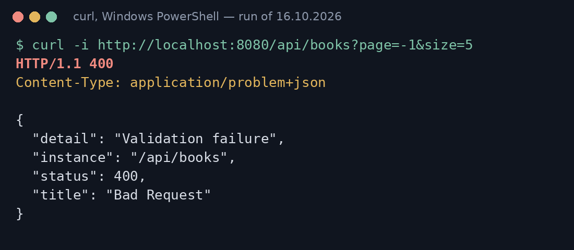
Figure 8. An invalid page number is rejected with 400

8. Conclusions
A DTO layer costs three extra types and a mapper for every resource, and some duplication of fields. In return the API contract no longer depends on how the data is stored: a client cannot set server-owned fields, internal changes do not break it, and validation rules sit exactly where the input arrives. Choosing the status code for each outcome — 201 with Location, 204, 404, 409 — and answering every error with a problem detail from one advice means a client can react to the protocol before it parses any body. The OpenAPI document generated from the same code keeps the documentation in step with the implementation.

Appendix. Answers to the demonstration questions
1. Why is the URI a noun? What is wrong with /api/getBooks?
The URI names the resource; the HTTP method is the verb. /api/getBooks duplicates the verb and breaks the uniform interface.
2. Which endpoints are safe and which idempotent?
Safe: GET (nothing changes). Idempotent: GET, PUT, DELETE. POST is neither.
3. Why 201 for creation? What does Location give?
201 tells the client a resource was created; Location gives its URI so the client can follow it without building URLs.
4. Why does deletion return 204, not 200?
Nothing meaningful is left to return; 204 No Content says success with an empty body.
5. What does a second DELETE answer and why?
404 Not Found as a problem detail. The resource is gone; the server state stays the same, so DELETE is still idempotent.
6. PUT vs PATCH for a field missing from the body?
PUT replaces the whole resource — a missing field is reset/validated as empty; PATCH would leave it unchanged.
7. What is a DTO? Three problems with returning the entity?
A boundary object for the API contract. With the entity: internal fields leak, clients could set id/createdAt (mass assignment), and renaming storage breaks clients.
8. Why separate request and response DTOs?
The request contains only what a client may send (no id, no createdAt); the response contains what the contract promises.
9. Where does the mapper live? Why not in the controller?
BookMapper, a @Component in web.dto — the one place that knows both shapes; the controller only orchestrates.
10. Unparsable body vs valid JSON breaking a rule?
Both 400: HttpMessageNotReadableException for broken JSON, MethodArgumentNotValidException for a rule violation.
11. When 409? Why not 400?
The request is valid, but conflicts with server state — the same title by the same author already exists.
12. Which RFC defines ProblemDetail? Five fields?
RFC 9457 (replaces 7807): type, title, status, detail, instance.
13. Media type of an error response and who sets it?
application/problem+json, set by Spring's message converter when the body is a ProblemDetail.
14. What does ResponseEntityExceptionHandler give?
Ready ProblemDetail responses for all standard MVC exceptions: 400 validation and parsing, 404, 405, 406, 415 and more.
15. How is the advice scoped? Lab 6 pages without it?
@RestControllerAdvice(annotations = RestController.class). Without it the HTML pages would receive JSON problem details.
16. Why must a stack trace never be in a body?
It reveals classes, libraries and versions to attackers and is useless to the client; it belongs in the server log.
17. What in OpenAPI was generated without annotations?
Paths, HTTP methods, parameters, request/response schemas from the records, and constraints such as required and maxLength.
18. Where did maxLength of title come from?
From @Size(max = 120) on BookRequest.title — springdoc translates Bean Validation constraints into the schema.
19. Default URLs of the document and Swagger UI?
/v3/api-docs and /swagger-ui.html (redirects to /swagger-ui/index.html).
20. Why not leave Swagger UI on a public server?
It exposes the whole attack surface and lets anyone send requests. Disable it in prod: springdoc.swagger-ui.enabled=false and springdoc.api-docs.enabled=false, or protect it with security.

