**GROUP MEMBERS**

|  |  |
| --- | --- |
| Student1358037 | Maryam Basheer |
| Student1358047 | Saulat Hussain |
| Student1352101 | Tayyaba Kanwal |

**eproject**

**LAB AUTOMATION**

|  |  |
| --- | --- |
| ***Batch Code***  ***Faculty Name***  ***Project Name*** | **2112D**  **Abrar Ahmad**  **Lab_Automation** |

Content:

**1. Introduction………………………………………………………………………**

**2.** **Front View …………………………………………………………………………**

**3. Login Page…………………………………………………………………………….**

**4. Home Page ……………………………………………………………………………….**

**5. Navbar ………………………………………………………………………………………**

**6. Search …………………………………………………………………………………….**

**7. Product …………………………………………………………………………………….**

**8. Manufacture ……………………………………………………………………….**

**9. Test……………………………………………………………………………….**

**10.Testing …………………………………………………………………………….**

**11.Inventory …………………………………………………………………………….**

**12.Status ………………………………………………………………………………….**

**13. ER Diagram of the DB………………………………………………………………….**

**14. Our Team Performace……………………………………………………….**

## Introduction:

The SRS Electrical appliances are the manufacturers of some electrical products like switch gears, fuses, capacitors, resistors, etc…. These products after manufactured they are sent for testing where the product is subjected to some testing conditions, and then after the testing is successful at their laboratories they are sent to CPRI for further testing process, so that they can get it approved from CPRI and then release the product into the market. If the testing fails, then the product is sent back for re-manufacturing it and then they are again subjected to tests.

**Front-View**

**(Login Page)**

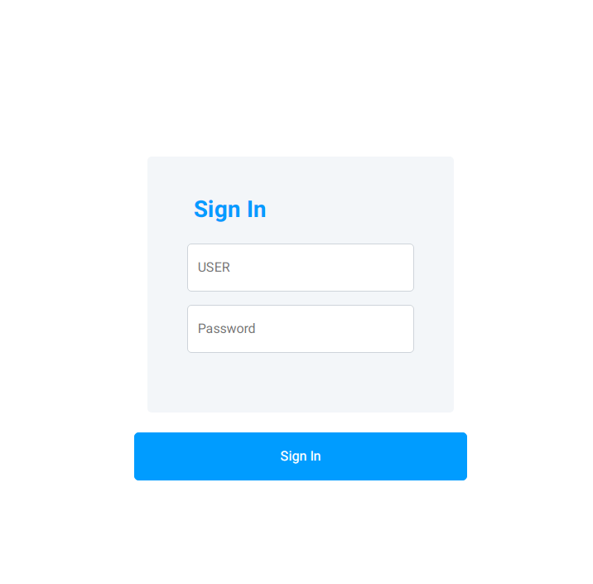

* This web-application is secured and protected by

Authentication.

**Home Page**

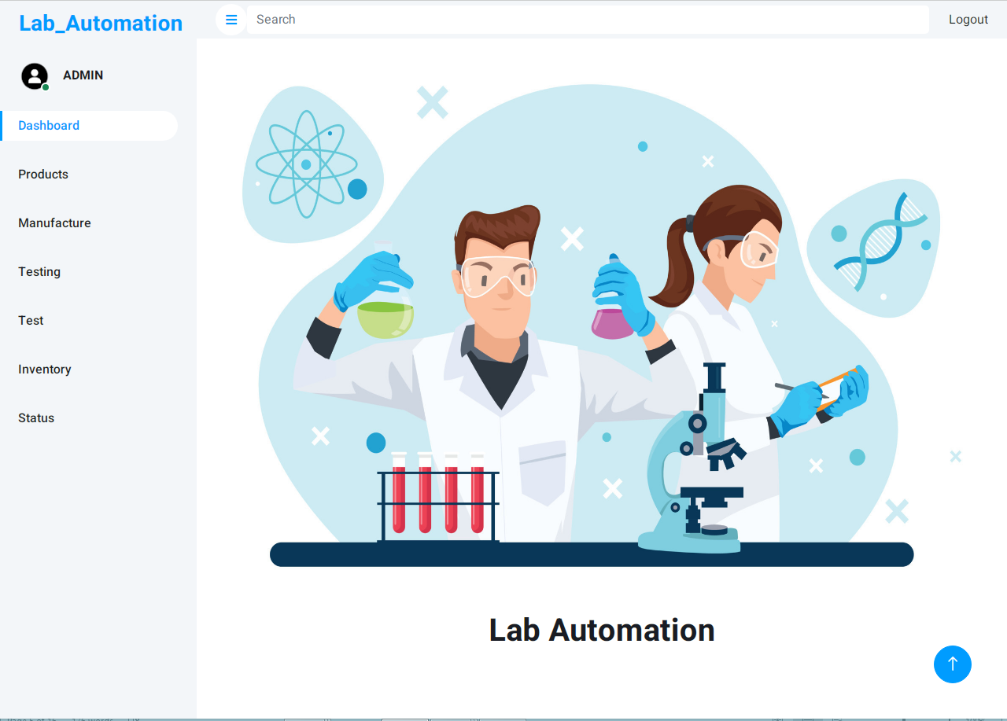

* This is our Home Page

**Navbar**

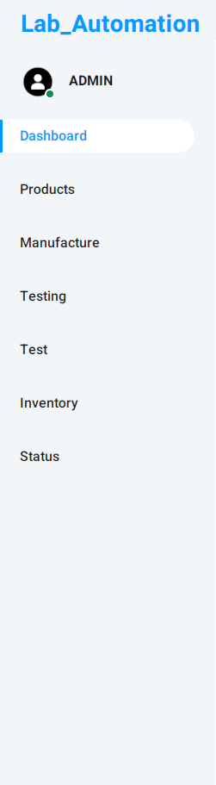

* This is the Side Navbar of this project.
* It helps us to navigate from one page to another.

**Search**

* This input field is search bar that helps us to search the specific item in the table.



* In the right corner there is the logout button which can destroy our sessions and logout the user for security of our web app project.

**Product**

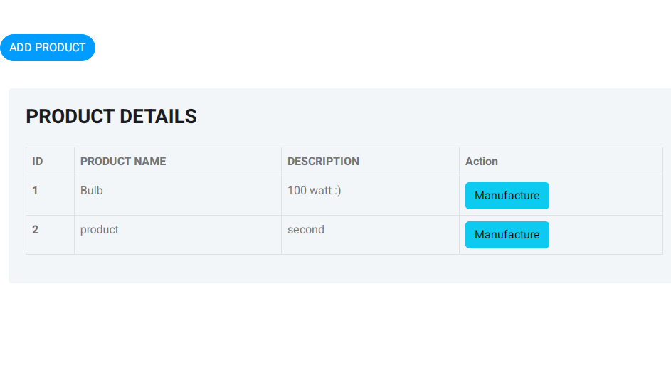

* This Product page shows our all the products which we will test.
* On upper side there’s an ADD Product Button which can insert the new Product in the Table
* On in Action Column the Manufacture button is shown which continue the product test in other step.

**MANUFACTURE**

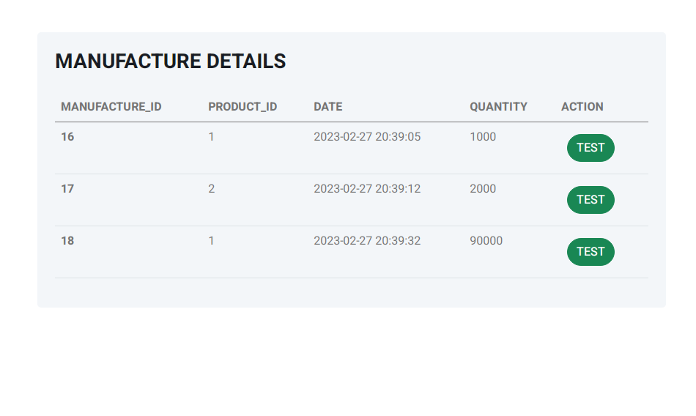

* This is the manufacture details table that shows us all the entries which we insert from product page.
* And in the action column the TEST button is here that continue the testing process to next step.

**TEST**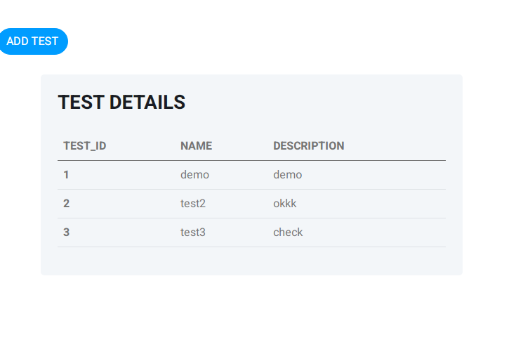

* This table is used to display all the test that they will be test.
* And in the upper side the ADD TEST button is displayed that insert the new test in this table.

**TESTING**

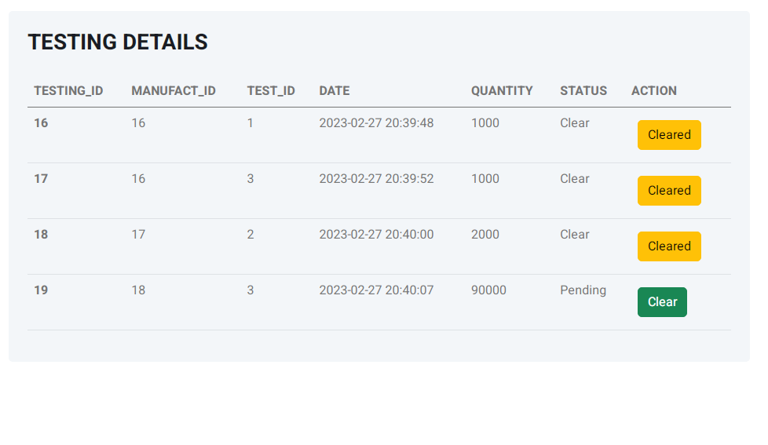

* In this testing details table we display all the data entry that is inserted and there is that total quantity is also display.
* In the action column we have CLEAR button that is used for clear the status of the record and the testing will be on next process.

**INVENTORY**

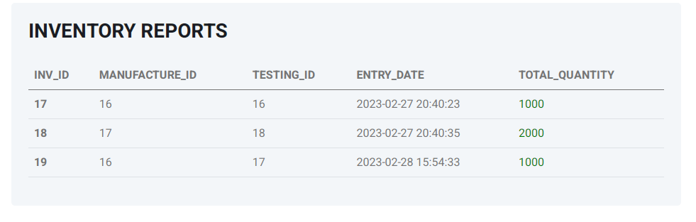

* In this table we have all the records of the test which was taken previously and there is also show the entry date and total quantity of the test.

**STATUS**

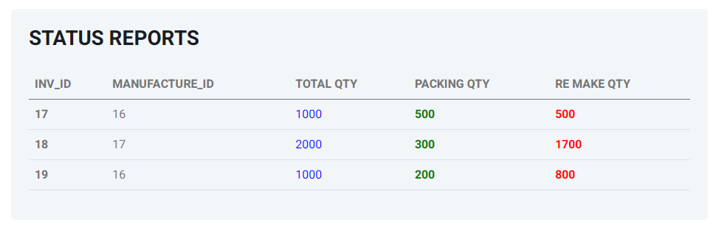

* In this status reports table, we display all the inventory table’s column’s report that show us how many quantity will be going to packing and how many go for re-making and also show the total quantity of the tested product.

E.R DIAGRAM OF THE DB

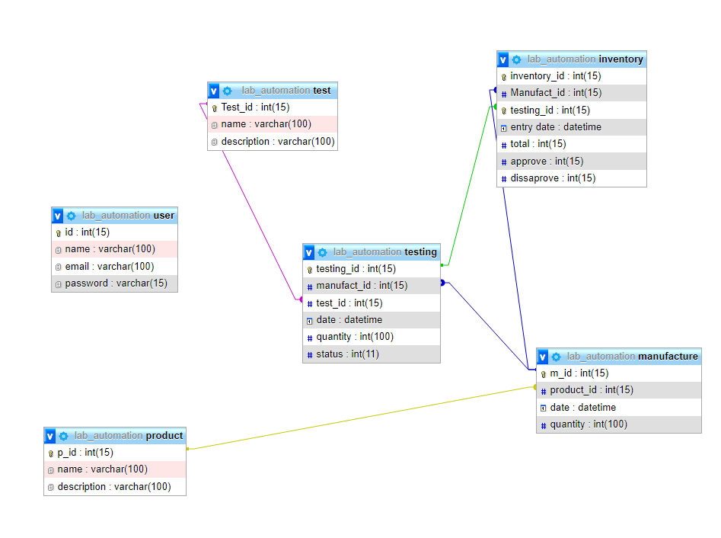

**Our Team Performance**

|  |  |  |
| --- | --- | --- |
| **STUDENT_ID** | **STUDENT_NAME** | **WORKING%** |
| **Student1358037** | **Maryam Basheer** | **45%** |
| **Student1358047** | **Saulat Hussain** | **30%** |
| **Student1352101** | **Tayyaba** | **25%** |