Computer Architecture (CSE-3521)
Consolidated Answer Guide
Covering: Autumn 2025, Spring 2025 and Autumn 2024 Semester Final Question Papers
Source of all answers and figures: Sir's slide deck “MAS_CA_Final.pptx” (Computer Architecture – Final Topics, by Mahir Shadid, Asst. Lecturer, CSE, IIUC)

How to read this document
- Questions from the three papers are grouped by topic/chapter instead of being answered three separate times, since the same topics repeat across all three papers.
- Each answer block starts with a tag line showing which paper(s)/question number(s) it answers.
- Where the topic matches one of Sir's suggested “final suggestion” topics, this is marked as “Sir's Suggestion → Chapter X, point (n)” using your own numbering.
- All content and figures are taken directly from the provided PPTX. Two exam sub-questions (RAID / rotation latency / hot-swapping / standby spares) are NOT covered in the PPTX — these are marked clearly as ‘general reference, not in Sir's slides’.

Chapter 5 – The Processor: Datapath and Control

1. Compare CPI of Single-Cycle, Multi-Cycle and Pipeline Processors
Answers: Autumn 2024 – Q1(a); Autumn 2025 – Q1(a)
- Single-cycle CPI = 1 always, because every instruction – simple or complex – is forced to finish in exactly one clock cycle. The clock period must be as long as the slowest instruction (typically lw), so even fast instructions such as add waste time waiting for the cycle to end.
- Multi-cycle CPI varies by instruction type, because each instruction only takes as many cycles as it needs (e.g. R-type = 4 cycles, lw = 5 cycles, beq = 3 cycles). This lets the clock cycle be much shorter (matched to one simple stage, e.g. an ALU op or a register read) instead of being stretched to fit the slowest instruction.
- Pipeline (ideal) CPI → 1, because a new instruction is started every cycle even though each individual instruction still takes 5 stages (IF, ID, EX, MEM, WB) to complete – the stages of different instructions overlap. In practice CPI can rise slightly above 1 due to stalls from hazards.
- Example: consider add, lw and beq. In single-cycle, all three take 1 cycle each, but that 1 cycle is as long as the lw path (IF+RegRead+ALU+MemAccess+RegWrite). In multi-cycle, add finishes in 4 short cycles, beq in 3, and lw in 5 – the total time for add is less than in single-cycle. In pipelining, add, lw and beq each still pass through 5 stages, but because the stages overlap, a new instruction can be issued every cycle, so on average CPI approaches 1 with a much shorter clock period than single-cycle.
- Summary table:
Design | CPI | Clock Cycle Length | Key Idea
Single-cycle | 1 (fixed) | Long (set by slowest instruction, e.g. lw) | Whole instruction in 1 cycle
Multi-cycle | Varies (3–5 typical) | Short (set by slowest single stage) | Only needed steps/cycles are used per instruction
Pipelined | ≈ 1 (ideal) | Short (matches one pipeline stage) | Multiple instructions overlap, one started per cycle

2. Datapath – Core Concepts, Components and MIPS Operations
Sir's Suggestion → Chapter 5, points (1),(2). Background for all single-cycle datapath questions.
- The datapath is the part of the processor that performs operations on data. It includes the hardware that actually processes instructions: registers, the ALU (Arithmetic Logic Unit), multiplexers (MUXes) and memory access units.
- When executing an instruction, the datapath performs 5 conceptual actions: fetch the instruction from memory (IF), decode what to do (ID), read data from registers (RR), perform computation/memory access (MEX) and write back the result (WB).
- Key components: PC (Program Counter – holds the address of the next instruction), Instruction Memory (stores the program), Register File (32 general-purpose registers, e.g. $t0, $s1), ALU (arithmetic/logic operations), Data Memory (used by lw/sw) and MUXes (select between different data sources).
- MIPS instruction classes the datapath must support:
- Memory-reference instructions (lw, sw): use the ALU to compute the effective address (base + offset), use Data Memory for the actual load/store, and use the register file to read/write data.
- Arithmetic-logical instructions (add, sub, and, or, slt): read two registers, perform an ALU operation, and write the result back to a register.
- Branch instructions (beq, j): beq compares two registers and conditionally updates the PC; j sets the PC directly to a target address – this is what allows loops and conditionals to work.
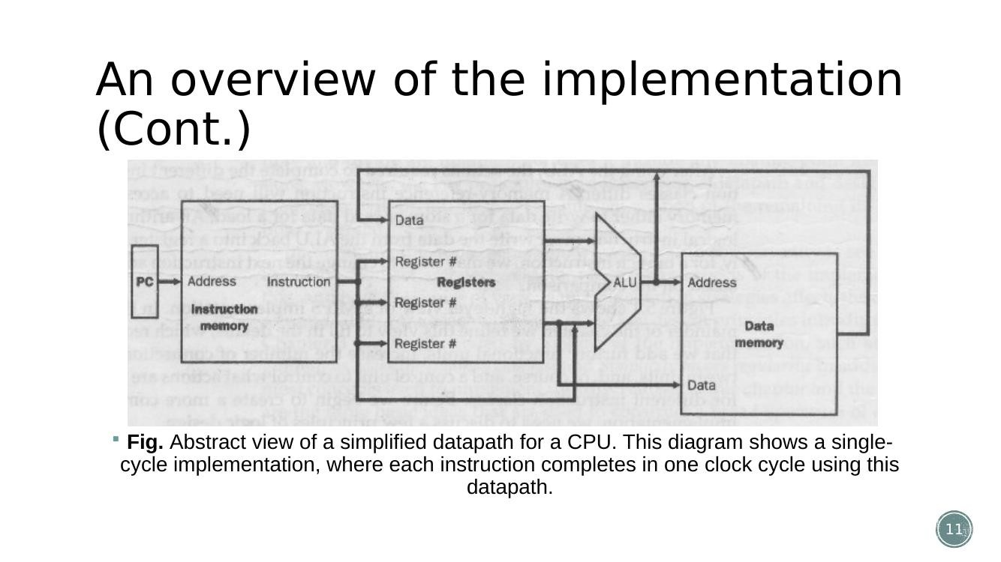
Figure (Slide 11): Abstract view of a simplified single-cycle CPU datapath – every instruction completes in one clock cycle.

3. Single-Cycle Datapath Example – R-type Instruction (e.g. add $s1,$t3,$t4 / sub $t3,$s2,$s3)
Answers: Spring 2025 – Q1(a); Autumn 2024 – Q1(a) OR; Autumn 2025 – Q1(a) OR | Sir's Suggestion → Chapter 5, point (3)
- R-format instructions such as add $s1,$t3,$t4 or sub $t3,$s2,$s3 have the form: op(6) rs(5) rt(5) rd(5) shamt(5) funct(6).
- Step 1 – Instruction Fetch: PC value is sent to Instruction Memory, which returns the 32-bit instruction; PC is simultaneously incremented by 4 (PC+4) to point to the next instruction.
- Step 2 – Register Read: the rs and rt fields of the instruction (bit positions 25–21 and 20–16) select which two registers are read from the Register File – e.g. $t3 and $t4 for add $s1,$t3,$t4.
- Step 3 – ALU Operation: the two register values (Read Data 1 and Read Data 2) go directly into the ALU; the control unit sets the ALU operation (add/sub/and/or/slt) via the 2-bit ALUOp + funct field.
- Step 4 – Write Back: the ALU result is routed through a MUX (selecting the ALU result rather than memory data) and written into the destination register, selected by the rd field (bits 15–11) – $s1 in this example.
- No Data Memory access is needed for R-type instructions, so MemRead = MemWrite = 0, and the RegDst/MemtoReg control signals route the rd field and ALU output correctly.
- The register file is simply a collection of registers where any register can be read from or written to by specifying its number.
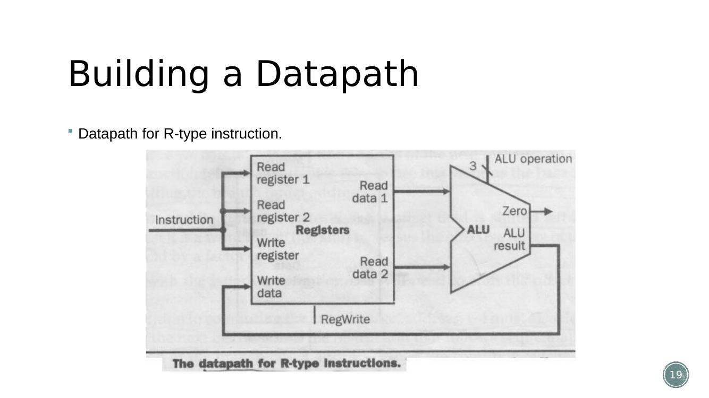
Figure (Slide 19): Datapath used for an R-type instruction (register read → ALU → register write).

4. Single-Cycle Datapath – Load Word (LW) Instruction
Answers: Autumn 2025 – Q1(b) | Sir's Suggestion → Chapter 5, point (3)
- lw $t1, offset($t2) is an I-format instruction: op(6) rs(5) rt(5) address/immediate(16).
- Step 1 – Fetch: PC → Instruction Memory fetches the instruction; PC+4 computed in parallel.
- Step 2 – Register Read: rs ($t2, the base register) is read from the Register File to obtain the base address.
- Step 3 – Sign-extend: the 16-bit offset field is sign-extended to 32 bits (using the Sign-Extend unit).
- Step 4 – Address Calculation: the ALU adds the base register value and the sign-extended offset to produce the effective memory address.
- Step 5 – Memory Access: the ALU result (address) is sent to Data Memory; MemRead is asserted so data is read out.
- Step 6 – Write Back: the data read from memory is selected by the MemtoReg MUX and written into register rt ($t1) in the Register File; RegDst chooses rt (bits 20–16) as the destination – unlike R-type, which uses rd.
- Control actions required for lw: RegDst=0, ALUSrc=1 (use immediate, not second register), MemtoReg=1, RegWrite=1, MemRead=1, MemWrite=0, Branch=0, ALUOp=00 (add).
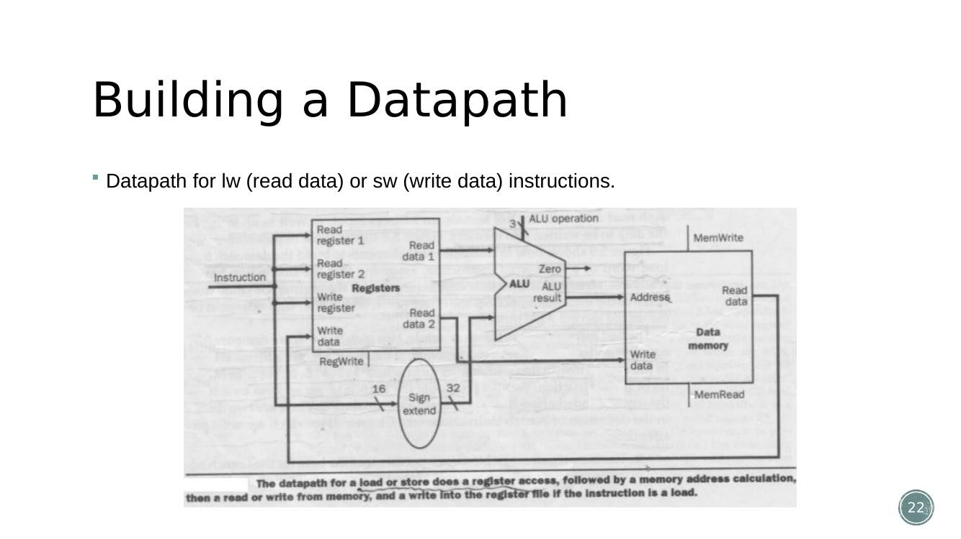
Figure (Slide 22): Datapath for lw (load word)/sw (store word) instructions – base register + sign-extended offset → ALU address → Data Memory.

5. Building the Complete Single-Cycle Datapath (incl. PC and Branching)
Sir's Suggestion → Chapter 5, points (4) branching, (5) PC operation
- The individual pieces (R-type path, lw/sw path, and the branch/PC path) are combined into one datapath that can execute any instruction – the control unit decides which paths are 'active' using control signals.
- PC (Program Counter) operation: on every cycle PC is fed into Instruction Memory and is also incremented by 4 (Add unit) to get the address of the next sequential instruction; this incremented value goes into a MUX.
- Branching (beq): the ALU is used to compare the two registers (by subtraction, checking for the Zero flag); the sign-extended 16-bit offset is shifted left by 2 (<<2, since MIPS instructions are word-aligned / 4 bytes each) and added to PC+4 to compute the branch target address.
- A final MUX chooses between PC+4 (normal case) and the branch target address (PC+4 + offset<<2) based on the AND of the Branch control signal and the ALU's Zero output – this MUX output becomes the new PC.
- The <<2 (shift-left-2) converts an instruction count into a byte distance, because MIPS instructions are 4 bytes each – e.g. 'jump 3 instructions ahead' is actually a jump of 3 × 4 = 12 bytes.
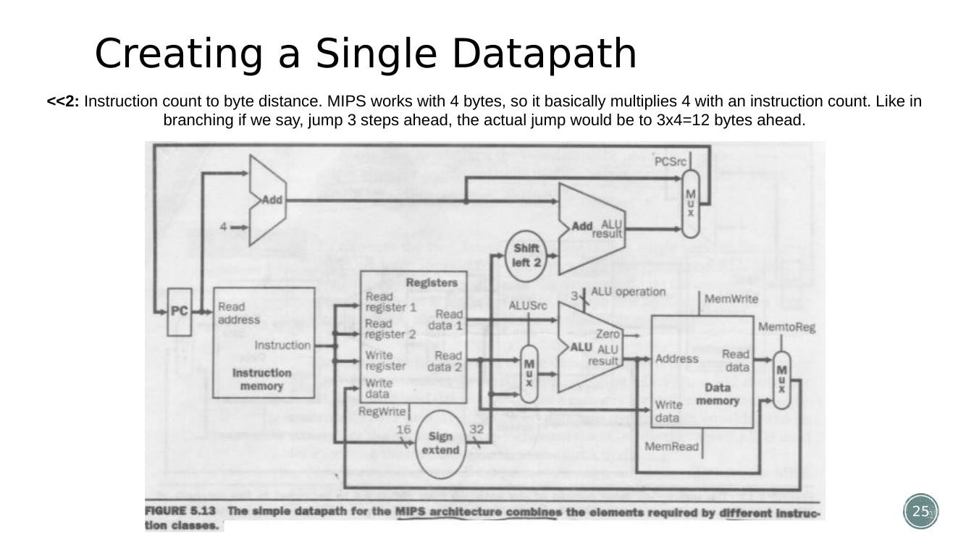
Figure (Slide 25): Building the single-cycle datapath: instruction fetch, PC increment and the shift/add logic used for branch target calculation.

6. Control Unit and Control Signals
Answers: Autumn 2025 – Q2(a) | Sir's Suggestion → Chapter 5, point (6): theoretical idea, control signals and their working
- The Main Control Unit takes the 6-bit opcode field (bits 31–26 of the instruction) as input and generates all the control signals needed to steer the datapath for that instruction type.
- Field positions are fixed across formats, which is what makes single-bit decoding possible: op is always in bits 31–26; the two registers to read are always in bits 25–21 (rs) and 20–16 (rt); the base register for lw/sw is always 25–21; the 16-bit offset for beq/lw/sw is always bits 15–0; the destination register is either bits 20–16 (rt, for lw) or bits 15–11 (rd, for R-type).
- The control unit produces 7 single-bit control lines plus a 2-bit ALUOp signal:
- RegDst – selects rd (R-type) or rt (I-type) as the write register.
- ALUSrc – selects the second ALU input: a register (0) or the sign-extended immediate (1).
- MemtoReg – selects what is written back to the register file: ALU result (0) or memory data (1).
- RegWrite – enables writing to the register file.
- MemRead / MemWrite – enable reading/writing Data Memory.
- Branch – tells the PC-source MUX to consider branching (combined with the ALU Zero flag).
- ALUOp (2 bits) – a coarse operation code passed to a smaller ALU-control unit, which combines ALUOp with the funct field (for R-type) to generate the actual 4-bit ALU operation.
- For each opcode (add, sub, lw, sw, beq, ...), a truth table defines exactly how every control signal should be set – e.g. for lw: RegDst=X, ALUSrc=1, MemtoReg=1, RegWrite=1, MemRead=1, MemWrite=0, Branch=0, ALUOp=00; for beq: RegDst=X, ALUSrc=0, MemtoReg=X, RegWrite=0, MemRead=0, MemWrite=0, Branch=1, ALUOp=01.
- In short: 9 control signals in total can be fully determined just from the 6 opcode bits, because MIPS was deliberately designed with a small, regular set of instruction formats.
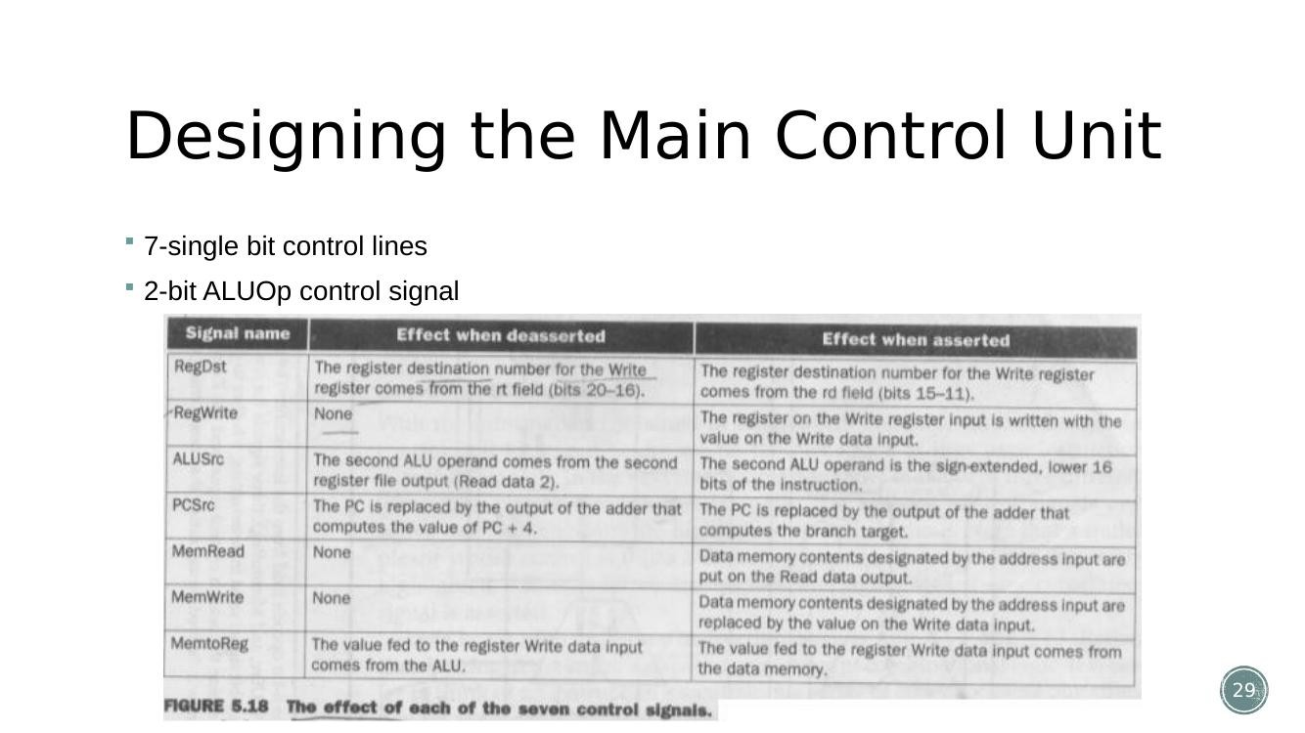
Figure (Slide 29): The 7 single-bit control lines and the 2-bit ALUOp signal generated by the main control unit.
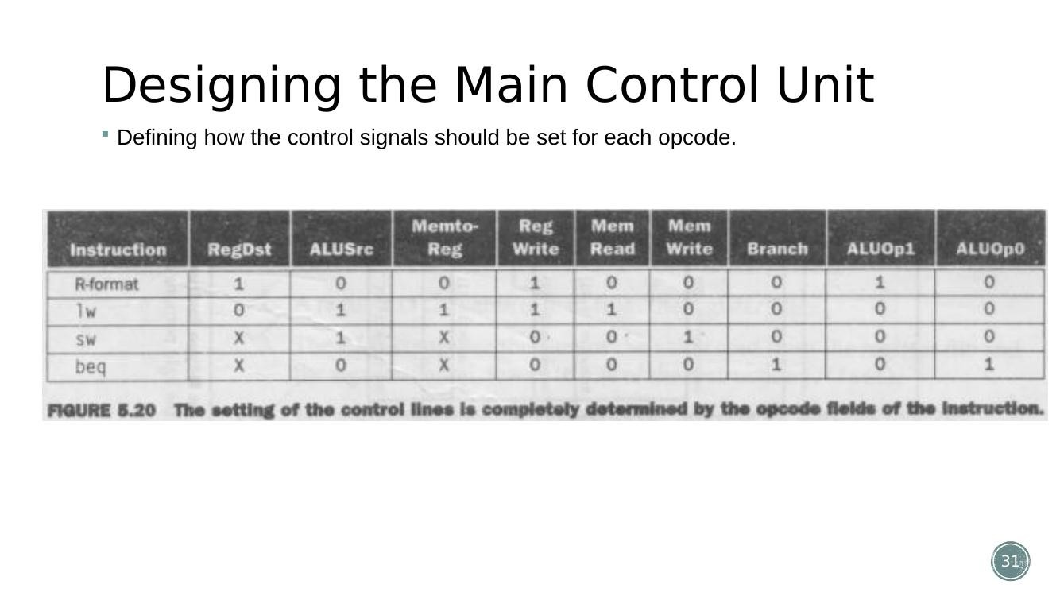
Figure (Slide 31): Truth table defining how each control signal is set for every opcode (add, sub, lw, sw, beq, ...).

7. Datapath Operation – R-type and Branch Example (Walkthrough)
Supports: Spring 2025/Autumn 2024 – Q1(a) figure-based description
- R-type operation (e.g. add): control signals route both register outputs into the ALU, the ALU performs the operation selected by ALUOp+funct, and the highlighted path shows the result flowing back through the MemtoReg MUX into the register file at address rd.
- Branch operation (beq): control signals route the two registers into the ALU configured to subtract; the Zero output, ANDed with the Branch control signal, decides whether the PC-source MUX selects the branch target (PC+4 + sign-extended-offset<<2) instead of PC+4.
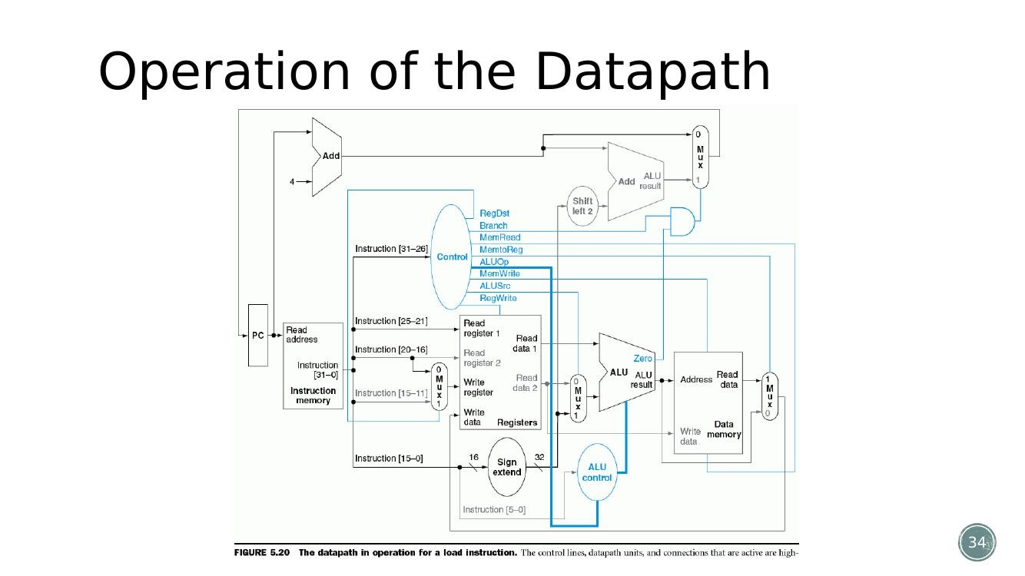
Figure (Slide 34): Highlighted datapath path for an R-type (e.g. add) instruction – register read → ALU → write-back.
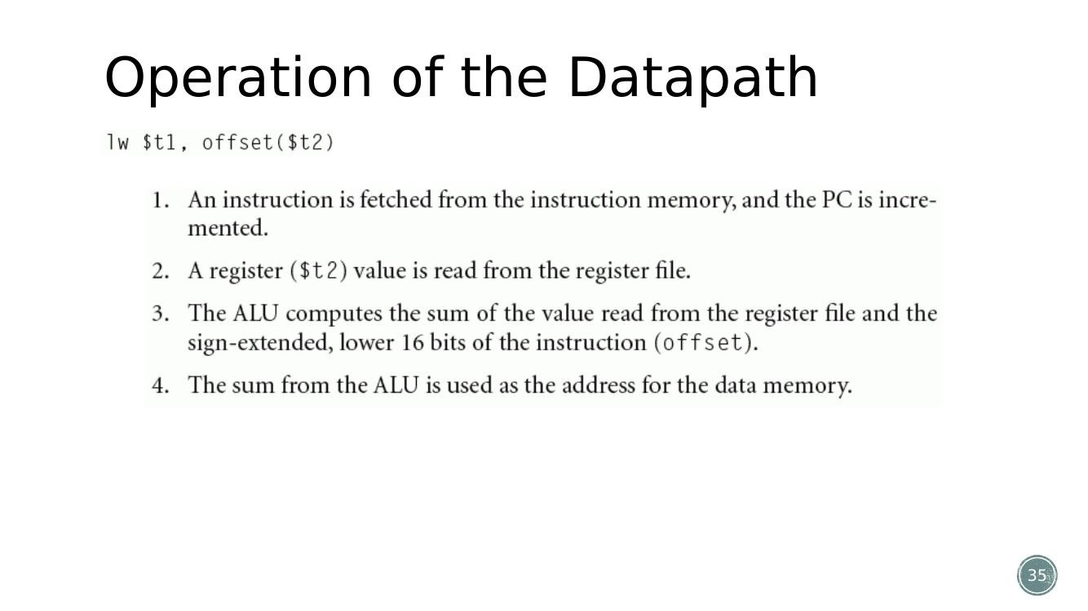
Figure (Slide 35): Highlighted datapath path for a branch (beq) instruction – comparison in ALU, Zero flag gates the branch-target MUX.

8. Multicycle Datapath – Structural Differences and Temporary Registers
Answers: Autumn 2025 – Q1(b) OR; Spring 2025 – Q1(b); Autumn 2024 – Q1(b), Q1(b) OR, Q2(a) | Sir's Suggestion → Chapter 5, point (7)
- Why not single-cycle? In a single-cycle CPU every instruction, simple or complex, must finish in exactly 1 clock cycle, so the cycle length must be as long as the slowest instruction (lw). Faster instructions like add waste time waiting for the cycle to end – the CPU runs at the speed of its slowest instruction.
- Multicycle advantage: each step (fetch, decode, execute, memory access, write-back) gets its own, much shorter, clock cycle, so the clock can run faster; hardware is reused across cycles and only the hardware needed in a given cycle is active.
- Structural differences from single-cycle: the multicycle datapath needs only ONE ALU, ONE memory unit (shared for instructions and data), and ONE adder, because these are now used at different times (different clock cycles) rather than all at once as in the single-cycle design. Single-cycle needed separate/duplicate hardware precisely because everything happens in one cycle.
- Temporary registers (Instruction Register IR, Memory Data Register MDR, A, B, ALUOut) are introduced because a value produced in one cycle (e.g. data read from memory, or a register value) may be needed in a later cycle – without these registers, the value would be lost when the clock ticks and the shared hardware is reused for something else.
- Multiplexer changes needed in multicycle datapath: extra MUXes are added at the ALU inputs (to select between PC, register value, or temporary register A), at the memory address input (to select between PC and ALUOut), and at the PC-write input (to select between ALU result, ALUOut or the jump target) – since the same ALU/memory/PC path is now reused across several different cycles for different purposes.
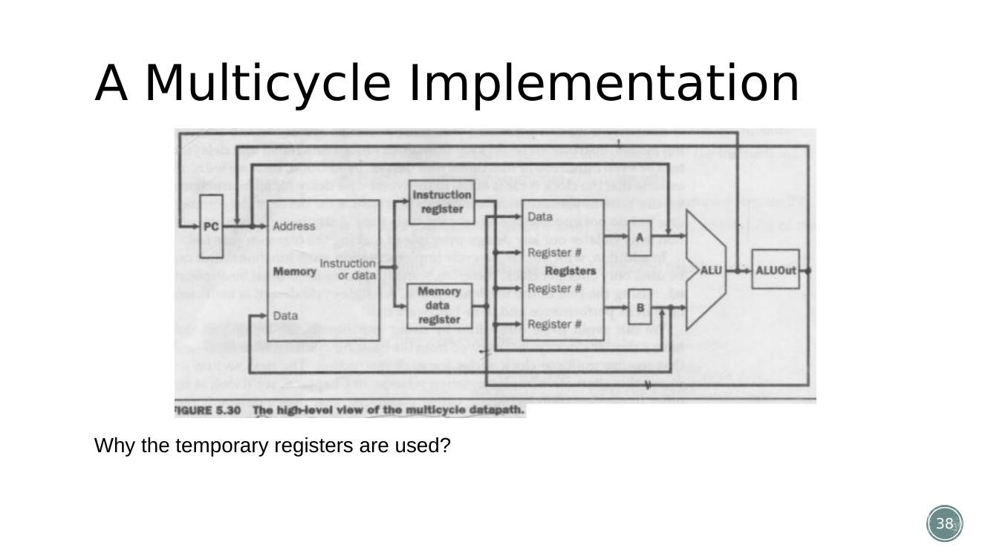
Figure (Slide 38): Multicycle steps and the temporary registers (IR, MDR, A, B, ALUOut) used to hold values between cycles.

9. Multicycle Datapath – Second Diagram (with Additional Multiplexers)
Sir's Suggestion → Chapter 5, point (8): “2nd diagram of multicycle from slide 41”
- This diagram shows the multicycle datapath after the additional multiplexers have been added at the ALU's two inputs and at the memory-address input.
- First ALU-input MUX selects between the PC (used during instruction fetch to compute PC+4) and register A (used during execute, e.g. for add/sub or address calculation).
- Second ALU-input MUX selects between register B, a constant 4 (for PC+4), and the sign-extended/shifted immediate (for address calculation or branch target).
- Memory-address MUX selects between PC (during instruction fetch) and ALUOut (during data memory access for lw/sw) – this is only possible because instruction and data memory now share a single memory unit.
- These extra MUXes are exactly what let one physical ALU and one physical memory serve many different roles across the multiple cycles of an instruction.
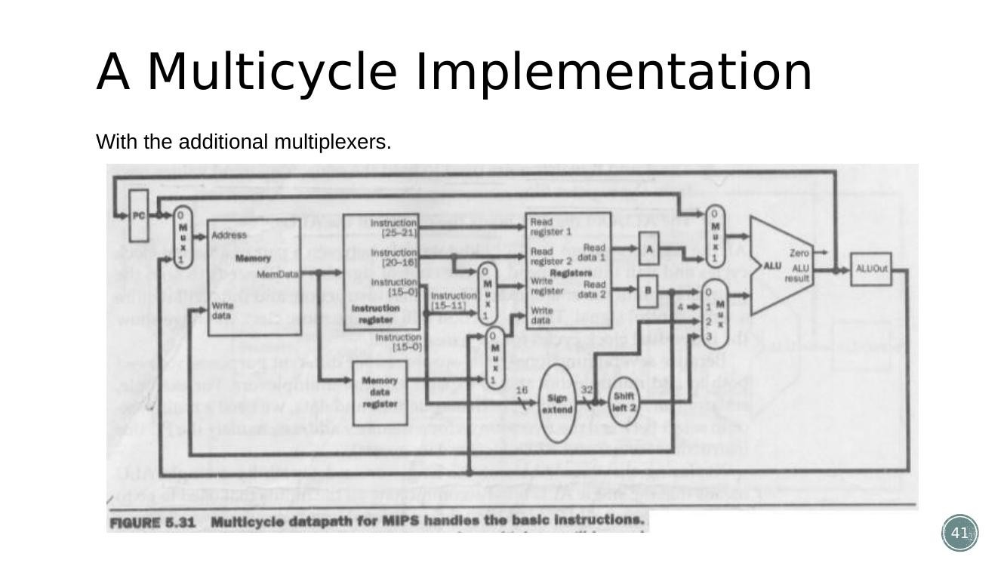
Figure (Slide 41): Multicycle datapath with the additional multiplexers at the ALU inputs and the memory address input.

10. Multicycle Control Signals and How Execution Differs by Instruction Type
Answers: Spring 2025 – Q2(a); Autumn 2024 – Q2(a)
- In multicycle, the control unit is a finite state machine (not a simple combinational truth table as in single-cycle) – the control signals generated in a given cycle depend on both the opcode AND which cycle (state) the instruction is currently in.
- Cycle 1 (Instruction Fetch): identical for every instruction – PC → memory → IR, PC = PC+4.
- Cycle 2 (Decode/Register Fetch): identical for every instruction – read rs, rt into A, B; compute branch target address early (PC+4 + offset<<2) and store it, in case it's needed.
- Cycle 3 onward DIVERGES by instruction type: R-type computes ALUOut = A op B; lw/sw computes ALUOut = A + sign-extended offset; beq compares A and B (subtraction) and, if Zero, loads PC with the pre-computed branch target; jump directly loads PC with the jump target.
- Cycle 4: R-type writes ALUOut into the register file (rd); lw reads Data Memory at address ALUOut into MDR; sw writes register B into Data Memory at address ALUOut (sw finishes here).
- Cycle 5: only lw needs this extra cycle – MDR is written into the register file (rt).
- This is exactly why CPI differs per instruction in multicycle: R-type/beq/jump finish in 3–4 cycles while lw needs all 5 – the control unit's state machine simply takes a different number of states for each type.
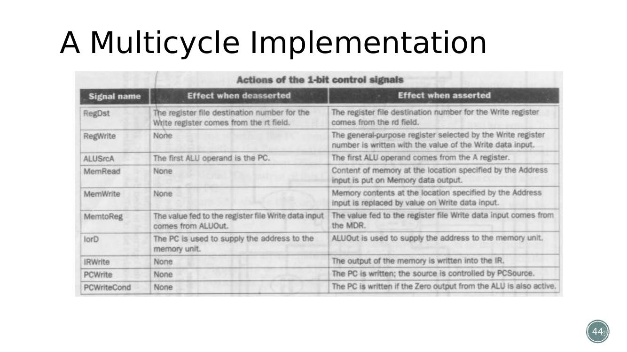
Figure (Slide 44): Final multicycle control/datapath diagram showing the state-dependent control signals for different instruction types.

11. Multicycle CPI / Instruction-Mix Numerical Problems
Answers: Spring 2025 – Q2(b) and Q2(b) OR; Autumn 2024 – Q2(b)
(a) Spring 2025 – Q2(b): Instruction mix 35% ALU, 20% Load, 15% Store, 25% Branch, 5% Jump.
- Typical multicycle cycle counts: ALU (R-type) = 4, Load (lw) = 5, Store (sw) = 4, Branch (beq) = 3, Jump (j) = 3.
- Variable-cycle CPI = Σ(fraction × cycles) = (0.35×4) + (0.20×5) + (0.15×4) + (0.25×3) + (0.05×3)
- = 1.40 + 1.00 + 0.60 + 0.75 + 0.15 = 3.90
- If redesigned with a fixed cycle count of 3 for every instruction → new CPI = 3.0 (by definition, since every instruction now always takes exactly 3 cycles).
- Trade-off discussion: the variable-cycle design (CPI = 3.90) lets simple/short instructions finish quickly and only 'pays' extra cycles for instructions that truly need them (like lw). The fixed-cycle design (CPI = 3.0) looks better on CPI alone here, but only because we assumed a flat 3 cycles for everything – in reality a fixed design must be long enough to cover the slowest instruction (lw normally needs 5), so a fair fixed-cycle CPI would actually be 5, which is worse than the variable design's 3.90. This mirrors exactly why single-cycle (fixed at 1 cycle, but a very long cycle) is slower overall than multicycle for real workloads.
(b) Spring 2025 – Q2(b) OR: clock cycle time = 250 ps; R-type = 60% (4 cycles), lw = 40% (5 cycles); 100,000 instructions.
- Average CPI = (0.60×4) + (0.40×5) = 2.4 + 2.0 = 4.4
- Total CPU time = Instruction count × CPI × Clock cycle time
- = 100,000 × 4.4 × 250 ps = 100,000 × 1100 ps = 110,000,000 ps = 110 μs (0.00011 seconds).
(c) Autumn 2024 – Q2(b): 30% ALU, 25% Load, 10% Store, 30% Branch, 5% Jump; cycles – ALU=1, Load=2, Store=2, Branch=1, Jump=1.
- CPI = (0.30×1) + (0.25×2) + (0.10×2) + (0.30×1) + (0.05×1)
- = 0.30 + 0.50 + 0.20 + 0.30 + 0.05 = 1.35
- Overall CPI = 1.35

Chapter 6 – Pipelining and Pipeline Hazards

1. Pipelining: Concept, Timing Diagrams and Speedup
Answers: Spring 2025 – Q3(a) OR | Sir's Suggestion → Chapter 6, points (1)
- Idea: 'start work as soon as possible, do not waste time' – like a laundry analogy (wash, dry, fold, store), where separate tasks use separate hardware and so can be overlapped for different loads of laundry.
- In single-cycle execution, each lw instruction takes one long cycle (e.g. 8 ns, covering IF+Reg+ALU+Data access+Reg) before the next one starts.
- In pipelined execution, the same 5 stages (IF, Reg, ALU, Data access, Reg) are split so a new instruction enters the pipeline every short cycle (e.g. 2 ns), even though each instruction individually still takes 5 stages to finish – the stages of consecutive instructions overlap in time.
- Pipelining does NOT reduce the latency of a single instruction (it still passes through all 5 stages) – it reduces the total time to execute MANY instructions, by keeping the hardware busy every cycle.
- Pipeline rate is limited by its slowest (longest) stage; potential speedup = number of pipeline stages (ideal case, all stages equal length).
- Unbalanced stage lengths reduce speedup below the ideal; time to fill and drain the pipeline (start-up and wind-down slack, where not all stages are busy) also reduces speedup, especially for short instruction sequences.
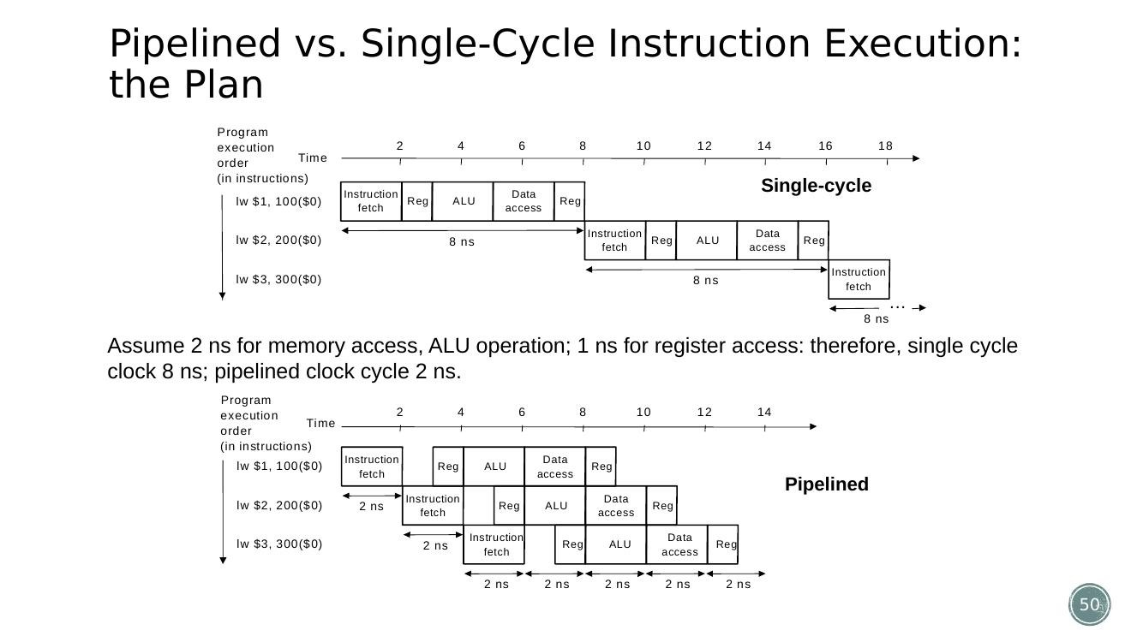
Figure (Slide 50): Pipelined vs single-cycle timing diagram for three lw instructions (single-cycle 8 ns/instr vs pipelined 2 ns/instr).

2. Types of Pipeline Hazards (Structural, Control, Data)
Answers: Autumn 2024 – Q3(a); part of Autumn 2025 – Q3(b) | Sir's Suggestion → Chapter 6, point (2): use timing diagram as example
- Structural hazard: inadequate hardware to simultaneously support all instructions active in the pipeline in the same clock cycle – e.g. if instruction memory and data memory were combined into one memory with a single read port, an lw needing to fetch data in the MEM stage could clash with another instruction's fetch in the IF stage during the same cycle. MIPS pipelines are designed with separate instruction/data memories specifically to avoid this.
- Control hazard: the pipeline needs to make a decision (which instruction to fetch next) based on the result of a previous branch instruction that is still executing in the pipeline (its outcome isn't known yet).
- Solution 1 – Stall the pipeline: simply wait (insert 'bubbles') until the branch outcome is known before fetching the next instruction – this guarantees correctness but wastes cycles.
- Data hazard: an instruction in the pipeline needs data that is still being computed by a previous instruction that hasn't finished (hasn't written back) yet – e.g. add $s0,... followed immediately by sub ...,$s0,... cannot correctly read $s0 until the add has completed its write-back.
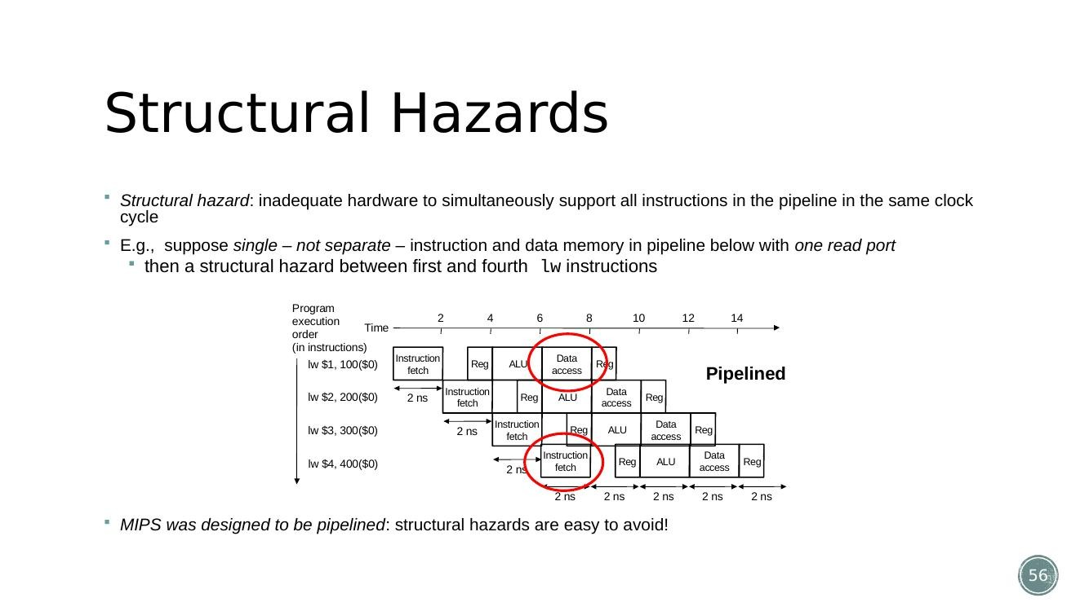
Figure (Slide 56): Structural hazard example – two lw instructions in the pipeline would need the same memory port in the same cycle.
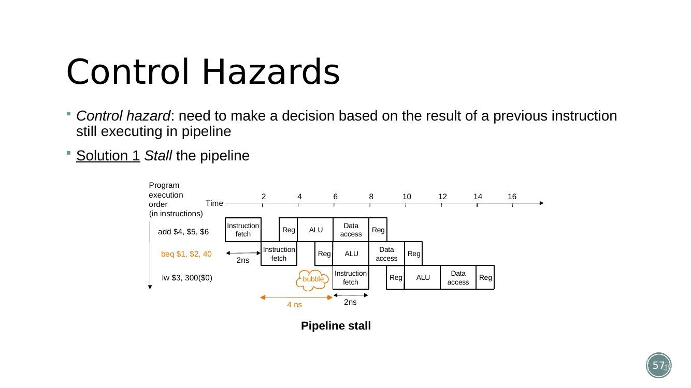
Figure (Slide 57): Control hazard example – pipeline stall (bubble) inserted after a beq instruction until its outcome is known.

3. Data Hazards – Stalling and Forwarding (Solutions), with Reordering
Answers: Autumn 2025 – Q3(a); Spring 2025 – Q3(a) | Sir's Suggestion → Chapter 6, point (3): how to solve hazard – forward and stall
- Cause of the stall: consider lw $1,100($0) followed by sub/and/or instructions that use $1. The value of $1 is only available after the MEM stage of the lw completes and is written back – but a directly-following instruction would need it during its own EX (ALU) stage, before it has been written.
- Technique 1 – Stalling: insert one (or more) 'bubble' cycles so that the dependent instruction waits until the required value is actually available. This guarantees correctness but reduces throughput (adds cycles, raising CPI above 1).
- Technique 2 – Forwarding (bypassing): add extra datapath wires that take the ALU result or the loaded memory value straight from the pipeline register where it was just produced (EX/MEM or MEM/WB) and feed it directly back into the ALU input for a later instruction, without waiting for it to be written back to the register file first. Forwarding removes most stalls, but for a load immediately followed by a dependent instruction, at least ONE stall cycle is still required, because the loaded data is not available until after the MEM stage – forwarding cannot deliver data that hasn't been fetched from memory yet.
- Technique 3 – Reordering code (software solution): the compiler/programmer rearranges independent instructions to fill the gap so the CPU doesn't have to stall at all. Example: lw $t0,0($t1); lw $t2,4($t1); sw $t2,0($t1); sw $t0,4($t1) has a data hazard (sw $t2,0($t1) immediately needs $t2 from the previous lw). Reordering to lw $t0,0($t1); lw $t2,4($t1); sw $t0,4($t1); sw $t2,0($t1) interchanges the two sw instructions so each sw no longer immediately follows the lw that produced its data – removing the stall with no extra hardware.
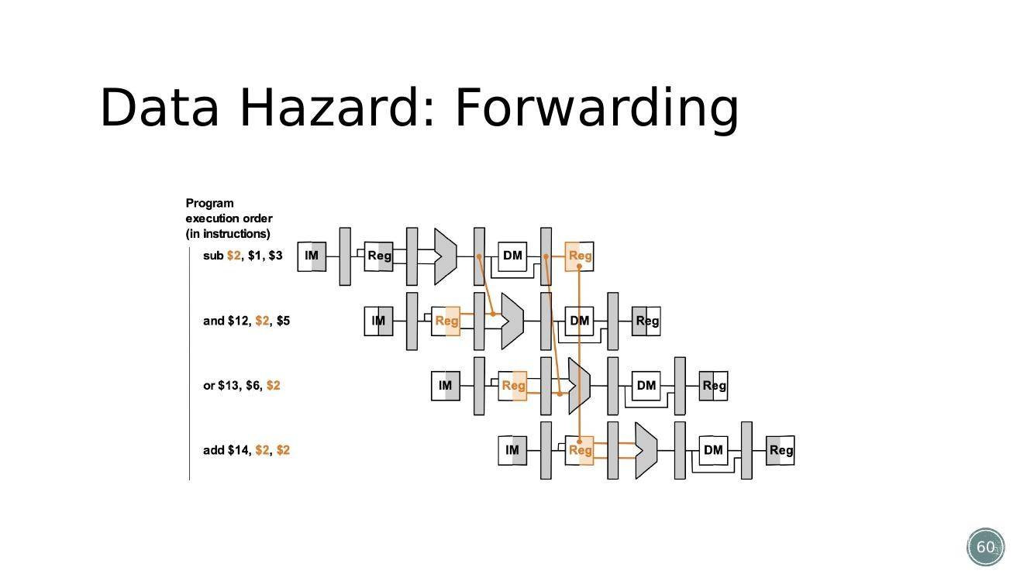
Figure (Slide 60): Data-forwarding paths added to the pipelined datapath.
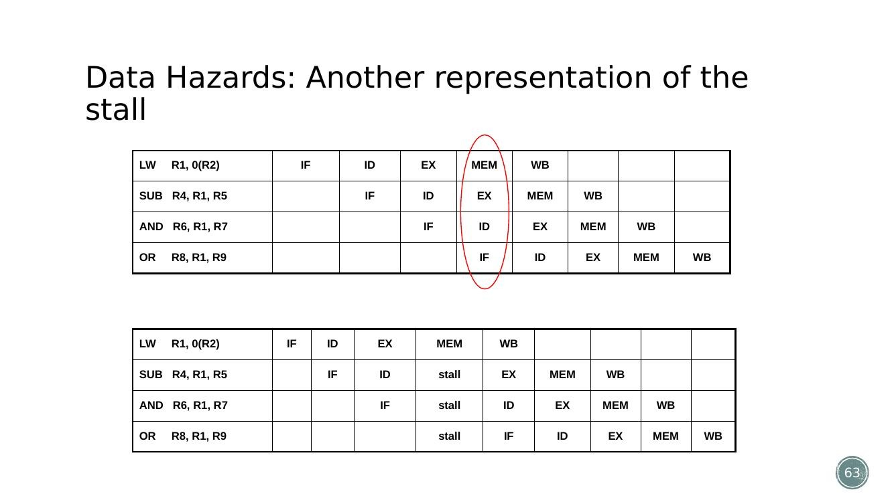
Figure (Slide 63): Representation of a load-use data hazard with a stall cycle inserted (IF/ID/EX/MEM/WB timing).
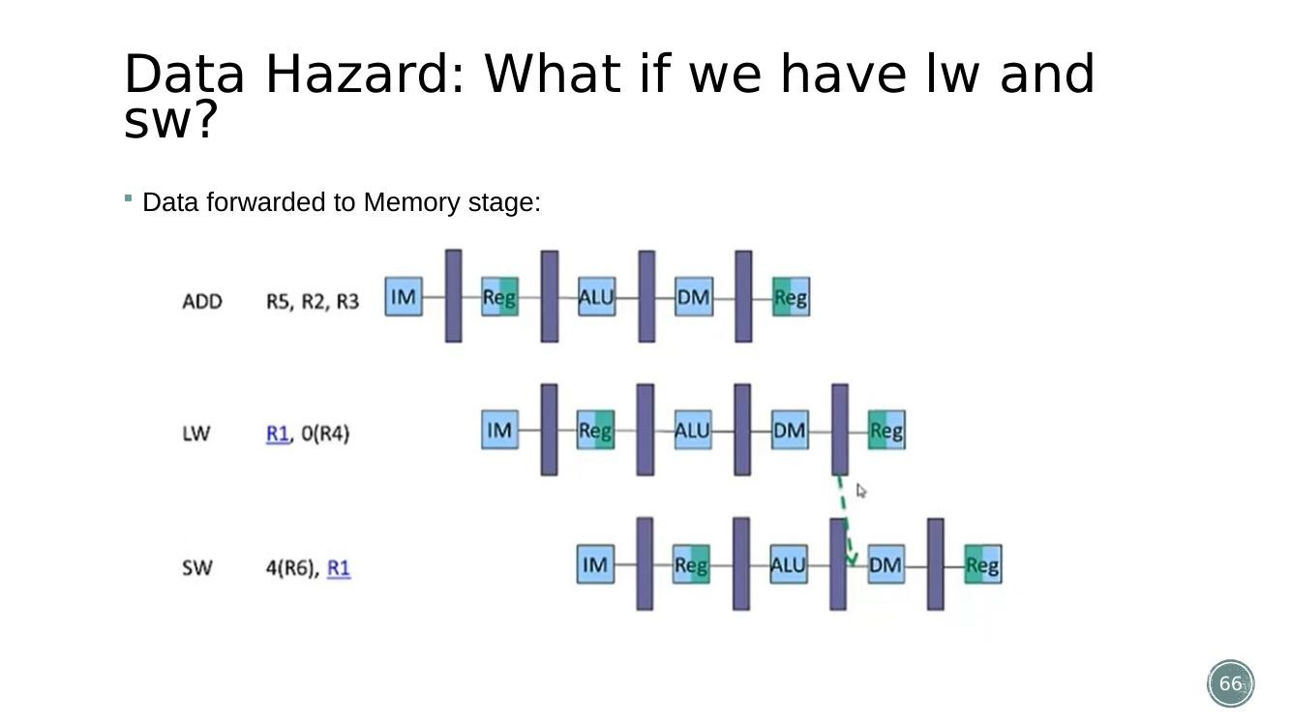
Figure (Slide 66): Forwarding when both lw and sw are involved – data forwarded into the Memory stage.

4. Control Hazards in Pipeline Architecture – Role and Minimization; Branch Handling
Answers: Autumn 2024 – Q3(a), Q3(b)
- Role of control hazards: a branch instruction's outcome (taken/not-taken and target address) is only known after it has progressed partway through the pipeline; meanwhile the pipeline has already started fetching subsequent instructions, which may turn out to be the wrong ones if the branch is taken.
- How a branch instruction works in a pipelined datapath: the branch (beq) is fetched (IF) and decoded (ID) normally; during EX, the ALU compares the two register operands (by subtraction) and produces the Zero flag; in parallel, an adder computes the branch target address (PC+4 + sign-extended offset<<2); if Zero is asserted and Branch is set, a MUX feeds this target back into the PC for the next fetch – otherwise PC+4 is used as normal.
- Because the branch decision is only resolved during/after EX, one or more instructions may already have been fetched incorrectly – these are flushed (turned into bubbles / NOPs) if the prediction was wrong.
- Methods to minimize control hazards: (1) Stall until the branch is resolved (simple but slow); (2) Predict not-taken (or predict-taken) and only flush on a misprediction; (3) Move the branch decision earlier in the pipeline (e.g. resolve it in the ID stage instead of EX, using a dedicated comparator) so fewer wrong instructions are fetched; (4) Delayed branch (let the compiler place a useful instruction in the 'delay slot' that always executes regardless of the branch outcome); (5) Dynamic branch prediction using history bits/branch-prediction buffers.
Figure (Slide 35): Branch (beq) operation: ALU compares operands (Zero flag) while the target address is computed in parallel; the result gates the PC-source MUX.

5. The 5 Stages of the MIPS Pipeline and the Pipelined Datapath
Sir's Suggestion → Chapter 6, points (4) 5-stage pipeline, (5) working principle
- IF – Instruction Fetch & PC increment.
- ID – Instruction Decode and Register Read.
- EX – Execution / address calculation.
- MEM – Memory access.
- WB – Write result into register.
- Review – in the single-cycle processor all 5 steps happen within one clock cycle, with dedicated hardware for each step. The key pipelining idea is: keep this same hardware, but break execution into multiple cycles so a new instruction can start every cycle, executing in parallel with the ones ahead of it.
- Pipeline registers (IF/ID, ID/EX, EX/MEM, MEM/WB) are inserted between each stage to hold all the data (and control signals) that a later stage will need, since the value must survive across a clock edge into the next cycle. These registers must be wide enough to carry everything flowing through: e.g. IF/ID = 64 bits, ID/EX = 97 bits, EX/MEM = 64 bits, MEM/WB = 128 bits in the example shown.
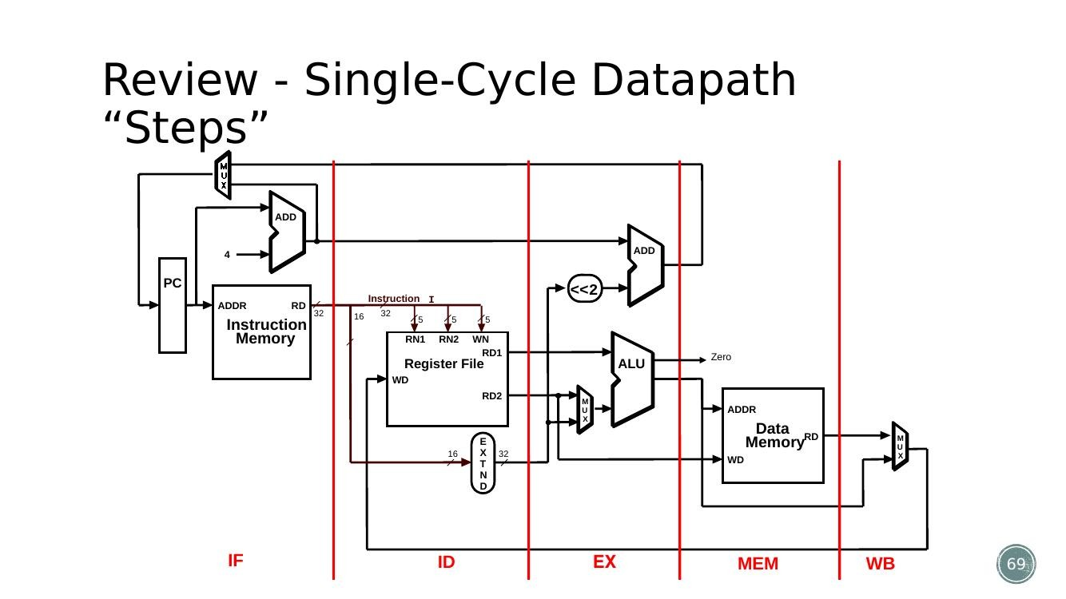
Figure (Slide 69): Single-cycle datapath 'steps' – the same hardware is reused when breaking it into pipeline stages.
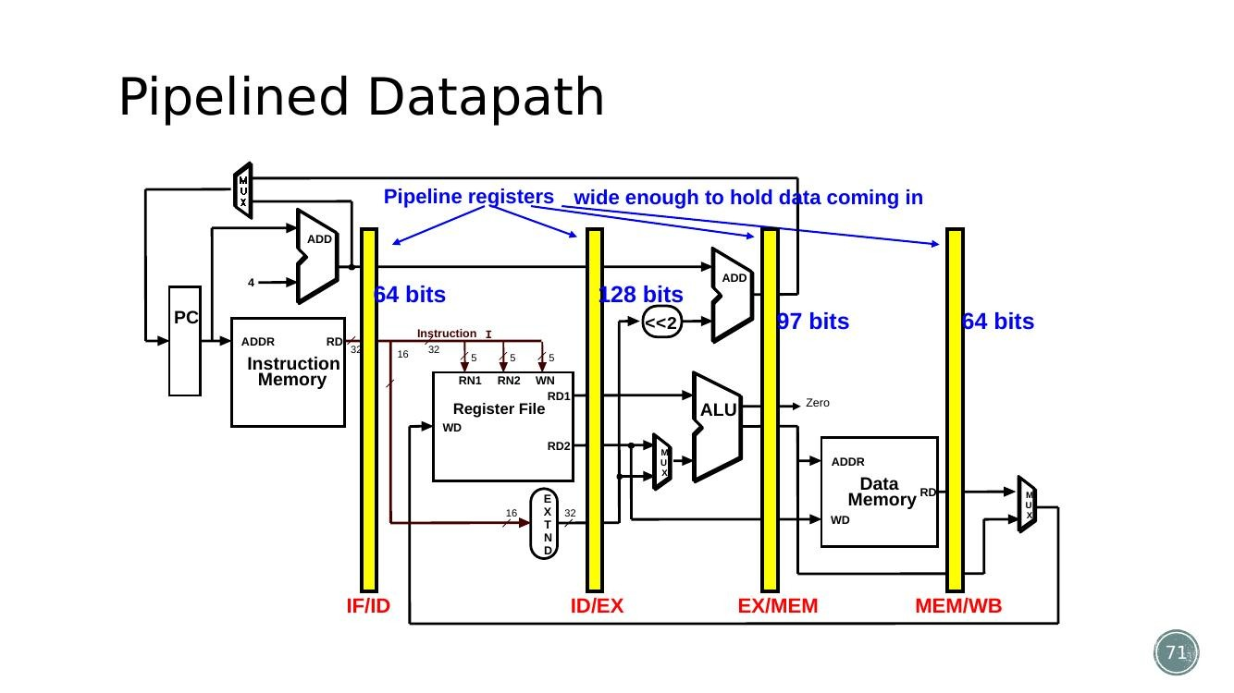
Figure (Slide 71): Pipelined datapath with pipeline registers (IF/ID, ID/EX, EX/MEM, MEM/WB) inserted between the 5 stages.

6. Bug in the Naive Pipelined Datapath and the Corrected Datapath
Sir's Suggestion → Chapter 6, points (6) bug and solve, (7) corrected datapath
- The bug: if the destination register number (rd/rt field) is only carried in the IF/ID pipeline register and used immediately in the ID stage for the register-write address, then by the time an instruction reaches WB, its own destination register number has already been overwritten by a LATER instruction's register number that has since moved into IF/ID – the write happens using the wrong (a later instruction's) register number.
- Root cause: the destination register number must travel WITH its instruction through every pipeline stage (ID/EX, EX/MEM, MEM/WB), not be read fresh from a later instruction sitting in IF/ID.
- The fix (corrected datapath): the destination register number is passed through the ID/EX, EX/MEM and MEM/WB pipeline registers alongside the instruction's own data, making each of those registers 5 bits wider (so the correct register number 'travels' with the correct instruction all the way to the WB stage).
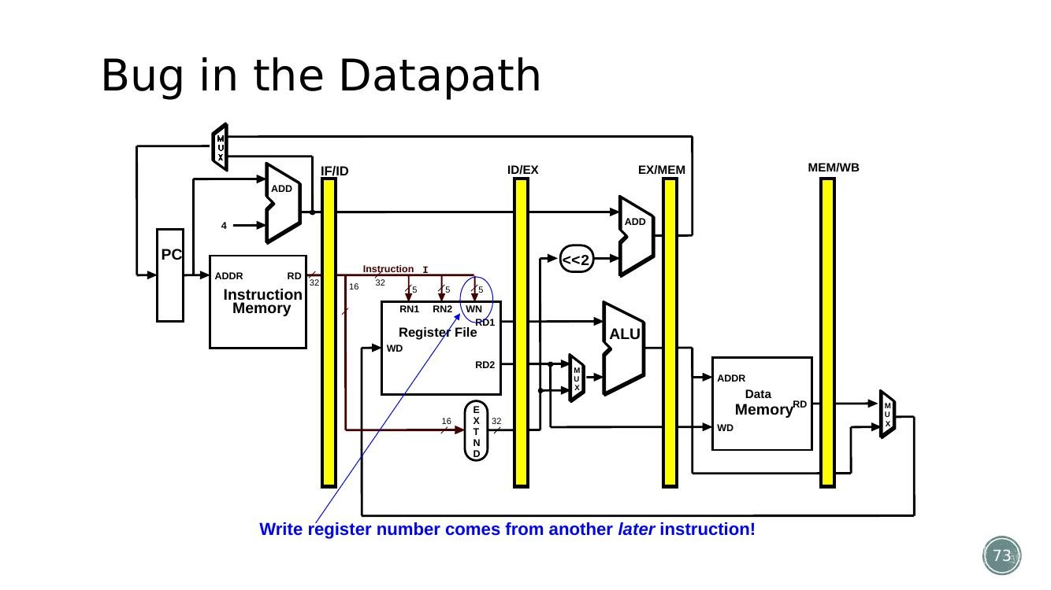
Figure (Slide 73): Bug in the naive pipelined datapath – the write-register number is read from a later instruction still in IF/ID.
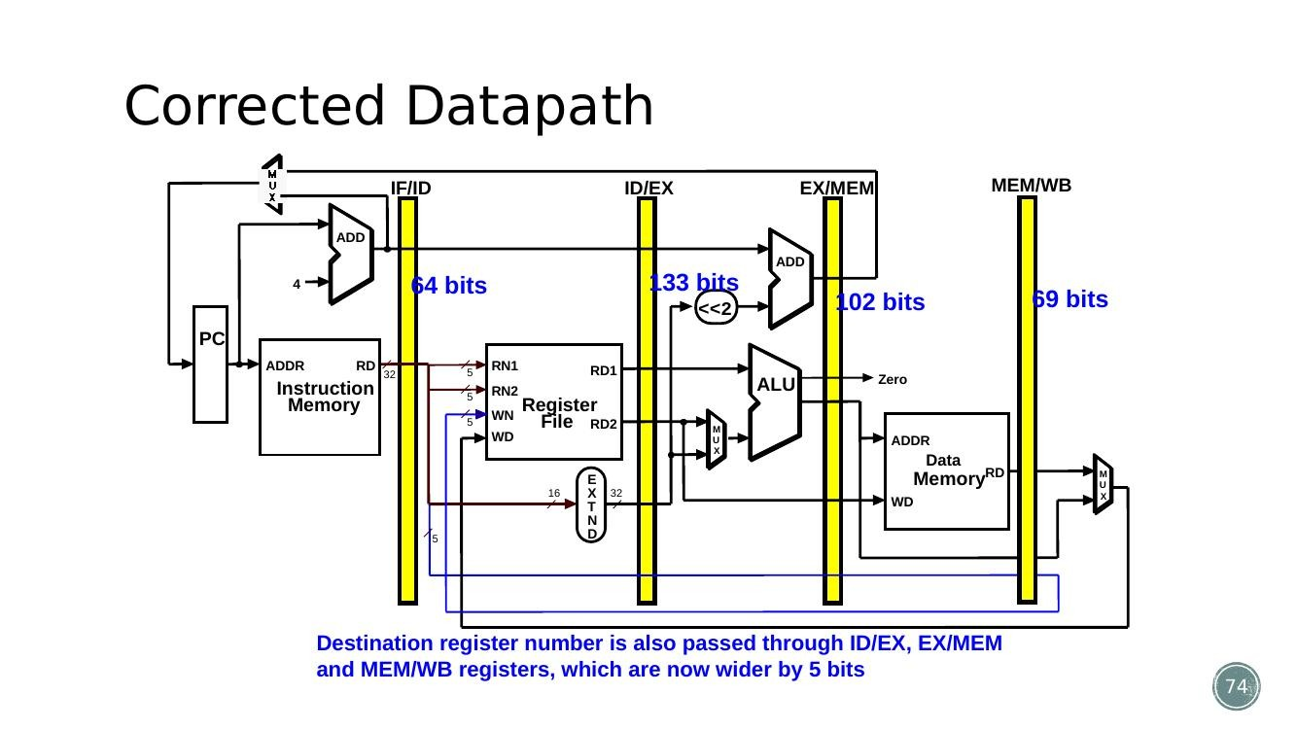
Figure (Slide 74): Corrected datapath – the destination register number is carried forward through ID/EX, EX/MEM, and MEM/WB.

7. Working Example – Pipelined Execution of lw, sw, add, sub
Illustrates the working principle of the pipeline datapath cycle by cycle
- Sequence: lw $t0,10($t1); sw $t3,20($t4); add $t5,$t6,$t7; sub $t8,$t9,$t10.
- Cycle 1: lw is in IF. Cycle 2: lw moves to ID, sw enters IF. Cycle 3: lw → EX, sw → ID, add → IF. Cycle 4: lw → MEM, sw → EX, add → ID, sub → IF. Cycle 5: lw → WB, sw → MEM, add → EX, sub → ID. Cycle 6: sw → WB, add → MEM, sub → EX. Cycle 7: add → WB, sub → MEM. Cycle 8: sub → WB.
- This demonstrates the overlap: 4 independent instructions complete in only 8 cycles instead of 4×5 = 20 cycles that separate (non-overlapped) execution would need.
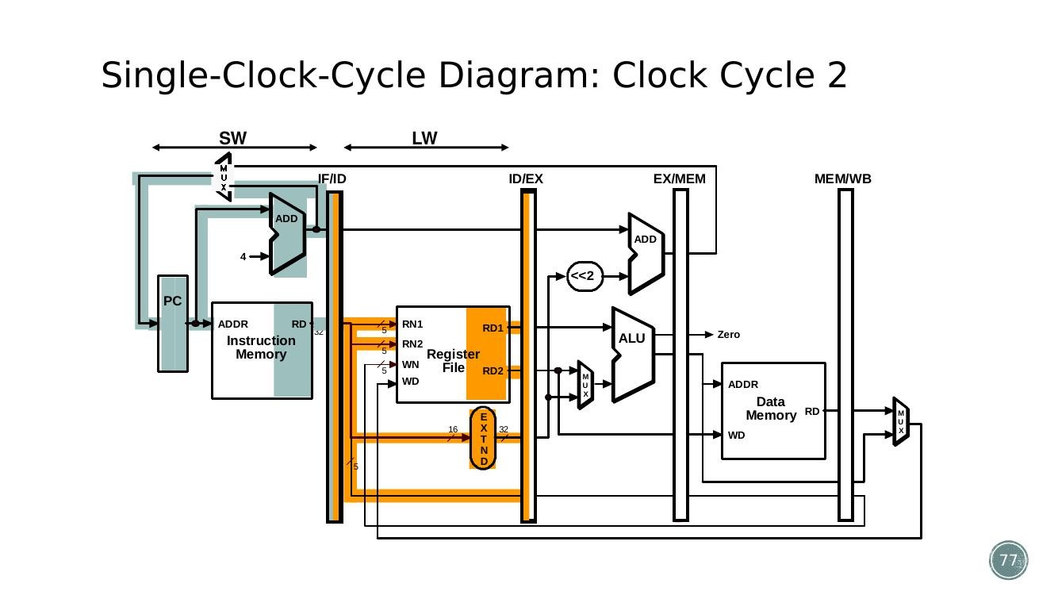
Figure (Slide 77): Clock cycle 2 – lw is in ID while sw enters IF (pipeline stages overlapping).
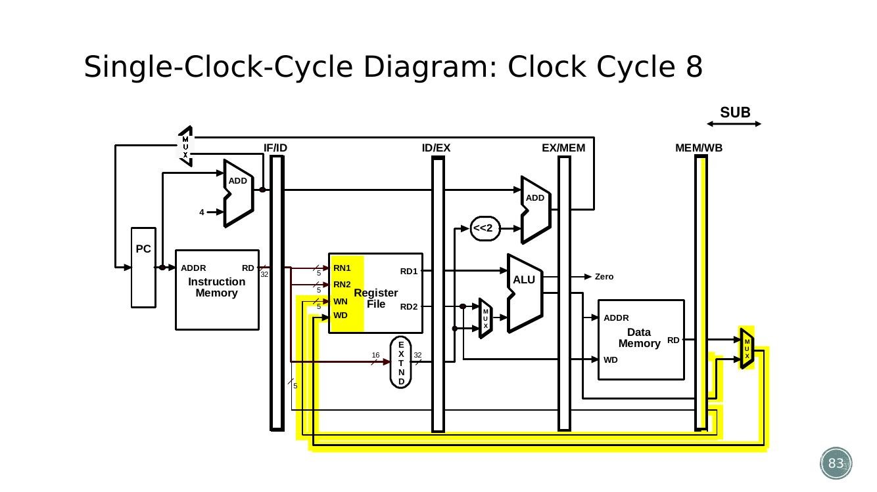
Figure (Slide 83): Clock cycle 8 – the last instruction (sub) reaches WB; all four instructions have completed.

8. Superscalar and Dynamic Pipeline Scheduling
Sir's Suggestion → Chapter 6, point (8): dynamic pipeline schedule
- Super-pipelining: simply use longer pipelines (more stages) – since ideal speedup relates to the number of stages, some processors use 8+ stage pipelines for extra speedup.
- Superscalar: duplicate internal components (e.g. multiple ALUs, multiple decoders) so more than one instruction can be launched in every pipeline stage at once.
- Dynamic pipeline scheduling: extra hardware lets later, independent instructions proceed even if an earlier instruction is stalled, instead of forcing strict in-order execution. It is organized into three units: Instruction fetch & issue unit, Execute units, and a Commit unit.
- In-order completion vs out-of-order completion: dynamic scheduling is more complex than static (in-order) pipelining because instructions can finish out of the original program order, so the commit unit must retire results back in the correct program order (and discard results from instructions that followed a mispredicted branch).
- Dynamic scheduling is typically combined with branch prediction (so wrongly-executed instructions after a mispredicted branch can be discarded) and with superscalar execution (so the unit may issue or commit several instructions per clock cycle).
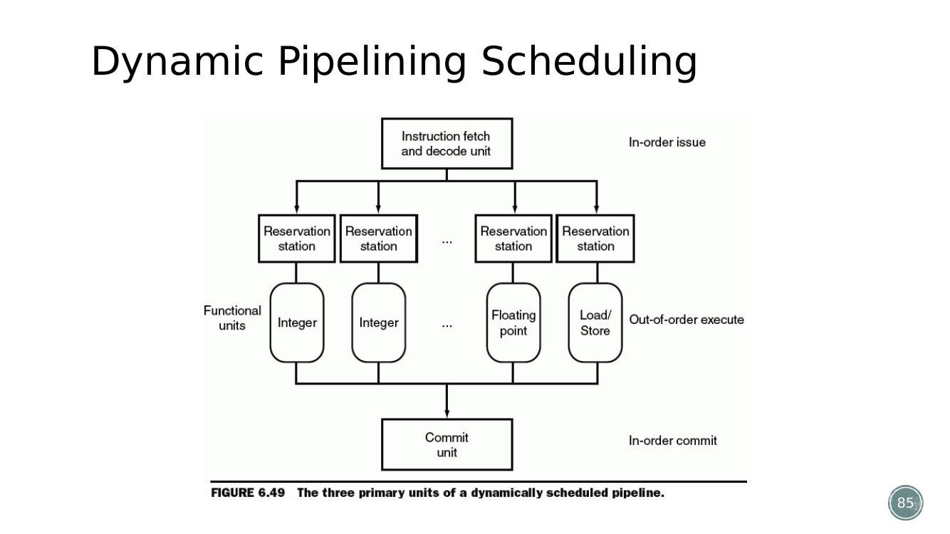
Figure (Slide 85): Dynamic pipeline scheduling: instruction fetch/issue, execute, and commit units.

Chapter 7 – Large and Fast: Exploiting Memory Hierarchy

1. Locality – Temporal and Spatial (with Array/Loop Example)
Answers: Autumn 2025 – Q4(a) OR | Sir's Suggestion → Chapter 7, point (1)
- Locality is the principle that programs access only a small portion of their total address space at any given time – in other words, programs tend to reuse the data and instructions they used recently.
- Temporal locality: items accessed recently are likely to be accessed again soon. Example: a loop re-executes the same instructions (and often the same variables) on every iteration.
- Spatial locality: items located near a recently-accessed item are likely to be accessed soon. Example: an array – accessing element A[i] makes it likely A[i+1] will be accessed next, since arrays are stored in contiguous memory.
- Applying this to the exam scenario ('a program frequently accesses a few recent variables and iterates over large arrays'): the few recently-used variables benefit from TEMPORAL locality (they are reused again and again, so keeping them in a small, fast cache pays off), while the large-array traversal benefits from SPATIAL locality (once one array element is fetched into a cache block, nearby elements in the same block are 'free' hits on the next few accesses).

2. Caches – Hit, Miss, Hit Rate, Miss Rate, Miss Penalty, Tag
Answers: Autumn 2024 – Q4(a) | Sir's Suggestion → Chapter 7, point (2)
- A cache is a small, fast memory that stores copies of frequently used data from main memory, so the CPU can access it faster than going all the way to main memory.
- Cache block/line: the minimum unit of data that is present (or not present) in the cache, and the unit that moves between two adjacent levels of the memory hierarchy.
- Hit: the data requested by the CPU is already present in the upper (faster/closer) level.
- Hit time: the time to determine whether an access is a hit, plus the time to access and deliver that data.
- Hit rate: the fraction of memory accesses that are hits = hits / (hits + misses).
- Miss: the requested data is NOT present in the upper level.
- Miss rate: the fraction of memory accesses that are misses = 1 − hit rate.
- Miss penalty (miss time): the time to determine that it's a miss, plus the time to fetch/replace the block from the lower level, plus the time to deliver it to the CPU – this is typically many times larger than the hit time.
- Tag: the remaining upper (n−m) bits of a memory address (after the cache-index bits are removed) stored alongside each cache block, used to check WHICH memory block currently occupies that cache line. A valid bit is also stored to know whether the cache entry currently holds meaningful data at all.

3. Direct-Mapped Cache – Addressing Scheme and Practice Mathematics
Answers: Autumn 2025 – Q4(b), Q4(b) OR; Spring 2025 – Q4(a); Autumn 2024 – Q5(b) | Sir's Suggestion → Chapter 7, point (3)
- A direct-mapped cache connects every memory block to exactly ONE specific cache block/line using a formula: cache block index = memory block address MOD cache size (in blocks).
- If the cache has 2^m blocks, the cache index is simply the lower m bits of the memory block address; the remaining upper (n − m) bits are stored as the tag, and a valid bit marks whether the line currently holds real data.
- Read hit/miss check: to decide hit vs. miss, the cache (1) uses the index bits of the address to find the candidate line, (2) compares the STORED tag at that line to the tag bits of the requested address, and (3) checks the valid bit – only if the valid bit is set AND the tags match is it a hit.
- Cache Read Hit: data is already in the cache – no further action needed, data is returned directly.
- Cache Read Miss (instruction): CPU asks main memory for the instruction, stalls until it's delivered, stores it in the cache, then restarts the fetch (now a hit) – it must stall because the CPU cannot guess the next instruction.
- Cache Read Miss (data): the CPU can keep working on other instructions that don't need the missing data while memory is fetched, and only stalls once an instruction actually needs that data.
Example calculation (Sir's example): memory block 13 (binary 1101) with an 8-block cache (2^3):
- Cache block = 13 MOD 8 = 5 → stored in cache block 5 (binary 101).
- With 8 blocks (2^3), the lower 3 bits of the address are used directly as the cache block index; the remaining upper bits become the tag.
Autumn 2025 – Q4(b): cache has 64 blocks, block size = 16 bytes. Find the cache block number for byte address 1200.
- Block number of the byte address = floor(byte address / block size) = floor(1200 / 16) = 75.
- Cache block number = memory block number MOD number of cache blocks = 75 MOD 64 = 11.
- So byte address 1200 maps to cache block 11.
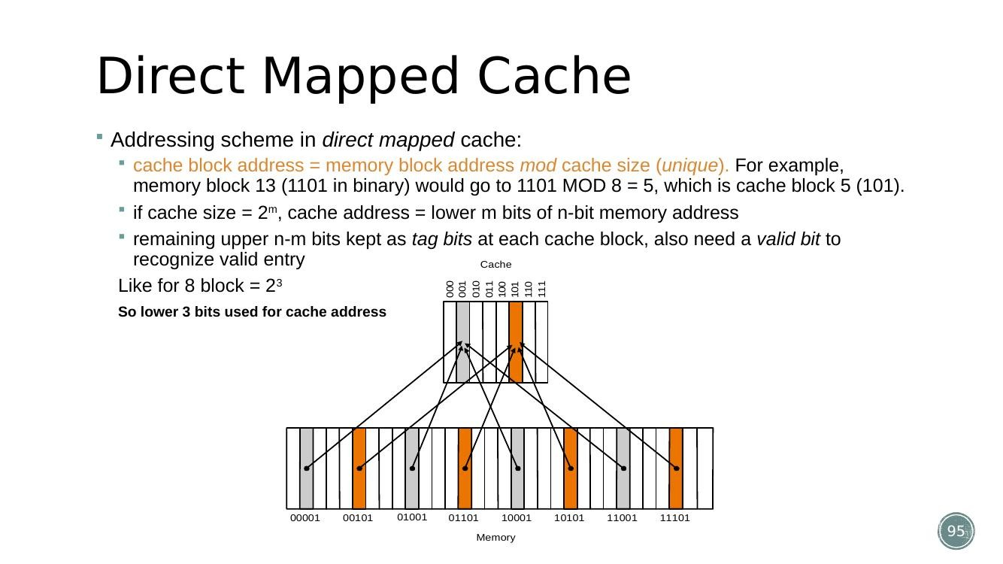
Figure (Slide 95): Direct-mapped cache addressing scheme – lower m bits used as the cache index, remaining upper bits stored as tag.

4. Multi-Level Cache and the 3Cs Model
Answers: Autumn 2025 – Q4(a)
- Multi-level cache: instead of a single cache, processors use a hierarchy of caches (L1, L2, sometimes L3), each level larger and slower than the one closer to the CPU. L1 is small and very fast (checked first); if it misses, L2 (bigger, slower) is checked; only if both miss does the request go to main memory. This reduces the effective average memory access time because most requests are satisfied by a fast, nearby level, while the larger, slower levels still catch most of what the small L1 would miss.
- 3Cs model – classifies WHY a cache miss happens into three categories:
- Compulsory (cold) miss – the very first access to a block; it has never been in the cache before, so a miss is unavoidable no matter how big the cache is.
- Capacity miss – the cache cannot contain all the blocks needed during program execution, so blocks that were previously in the cache are evicted and later re-referenced, causing a miss (would not happen if the cache were infinitely large).
- Conflict miss – in a non-fully-associative cache, multiple blocks map to the same cache location and evict each other even though the cache overall has free space elsewhere (would not happen in a fully-associative cache of the same size).
- Reducing miss rate using associativity (directly relevant to why the 3Cs model matters):
- Direct-mapped: each memory block maps to exactly one cache location – fast (no searching) but high conflict-miss rate.
- Fully associative: a block can go anywhere in the cache; all entries are searched in parallel – lowest miss rate (no forced conflicts) but slow (high hit time) due to the search.
- Set-associative (n-way): the cache is divided into sets; a block maps to one set (by address MOD number of sets) but can occupy any of the n slots within that set – a practical middle ground: lower miss rate than direct-mapped, faster than fully associative.

5. Cache Write Policies (Write-Through vs Write-Back)
- Write-Through: on a write hit, both the cache and main memory are updated immediately, keeping memory always consistent (simple, but slower since every write goes to memory) – often paired with a write buffer so the CPU doesn't have to wait for the write to finish.
- Write-Back: on a write hit, only the cache is updated and the block is marked 'dirty'; memory is updated only later, when that dirty block is evicted/replaced – faster (fewer memory writes) but more complex (needs dirty bits and replacement logic). Virtual memory systems specifically use write-back rather than write-through, because writing to disk on every single write would be far too slow.

6. Virtual Memory – Concept, Pages, Page Table, and Page Faults
Answers: Autumn 2025 – Q5(a); Spring 2025 – Q4(b); Autumn 2024 – Q5(a) OR | Sir's Suggestion → Chapter 7, points (4),(5),(6)
- Why virtual memory: programs often need more memory than is physically available as RAM. Virtual memory uses the hard disk as extra 'slow RAM', so the system can pretend it has more memory than it physically does.
- Key idea: main memory (RAM) effectively acts like a cache for the disk – programs see a large virtual address space, but only the parts actually being used are kept resident in RAM at any moment.
- Pages: memory is divided into fixed-size chunks called pages (typically 4 KB); transfers between disk and RAM always happen in whole pages.
- Page Table: maps virtual addresses (used by the program) to physical addresses (real RAM locations) – it is essentially memory's address book/GPS.
- Page Hit: the requested page is already in RAM (fast). Page Fault: the requested page is only on disk (slow – it must first be loaded into RAM).
- On a page fault: (1) the OS pauses the program, (2) loads the missing page from disk into RAM, (3) updates the page table, and (4) resumes the program (now it is a page hit).
- Why the high cost of a page fault influences virtual memory design (Autumn 2025 – Q5(a)): a page fault's miss penalty is enormous – millions of CPU cycles, since disk access is roughly 100,000× slower than RAM. Because a miss is so catastrophically expensive compared to a cache miss, virtual memory systems are deliberately designed to make misses as rare as possible, even at the cost of extra complexity/hardware: (a) fully-associative placement is used (a page can go anywhere in RAM) to minimize conflict misses; (b) large page sizes (e.g. 32 KB / 64 KB instead of 4 KB) are used so fewer separate 'trips' to disk are needed; (c) a smart replacement policy such as LRU (Least Recently Used, tracked via per-page use bits) is used instead of a simple/arbitrary policy, to avoid evicting a page that will be needed again soon; (d) write-back (not write-through) is used for the same reason as above – writing to disk on every memory write would be prohibitively slow.
- How this is solved in practice: software (the OS) manages the page table and replacement policy (since the penalty is so high, it is worth spending software time to make good decisions); a TLB (see next section) is used to avoid paying the page-table-lookup cost on every single memory access; SSDs help reduce the miss penalty compared to HDDs, though RAM remains far faster than either.
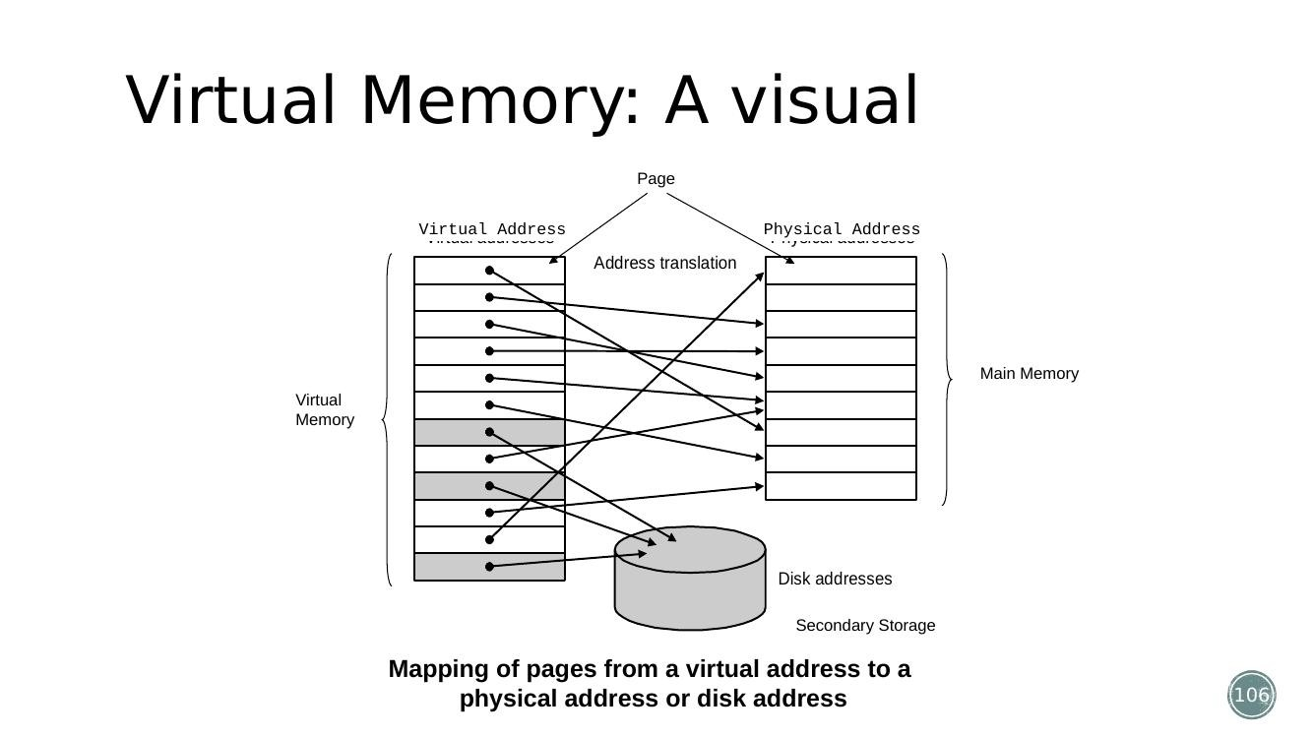
Figure (Slide 106): Virtual memory – mapping of virtual addresses (pages) to physical addresses in main memory or to secondary storage (disk).

7. TLB (Translation Lookaside Buffer) – How It Works and TLB Miss
Answers: Spring 2025 – Q5(a); Autumn 2024 – Q5(a) | Sir's Suggestion → Chapter 7, point (7)
- Problem: virtual memory normally requires checking the page table (which lives in RAM) before every single memory access, which would double the effective memory access time.
- Solution – TLB: a small, very fast cache that stores only the most recently used virtual-to-physical address translations.
- TLB Hit: the translation is already in the TLB – the physical address is obtained instantly, with no need to consult the page table in RAM at all.
- TLB Miss: the translation is NOT in the TLB – the full page table (in RAM) must be consulted (slower), and the resulting translation is then cached in the TLB for future use. (If the page itself also isn't in RAM, this additionally triggers a full page fault.)
- Analogy: the page table is like a phonebook (slow to search every time), while the TLB is like a frequently-called contacts list (fast lookup for addresses used recently).
- Flow (paging + TLB): CPU generates a virtual address → check TLB → if TLB hit, get physical address immediately → if TLB miss, walk the page table in RAM → if the page table entry is valid (page in RAM), cache the translation in the TLB and access memory → if the page table entry says the page is on disk, raise a page fault, let the OS load the page, update the page table AND the TLB, then retry.
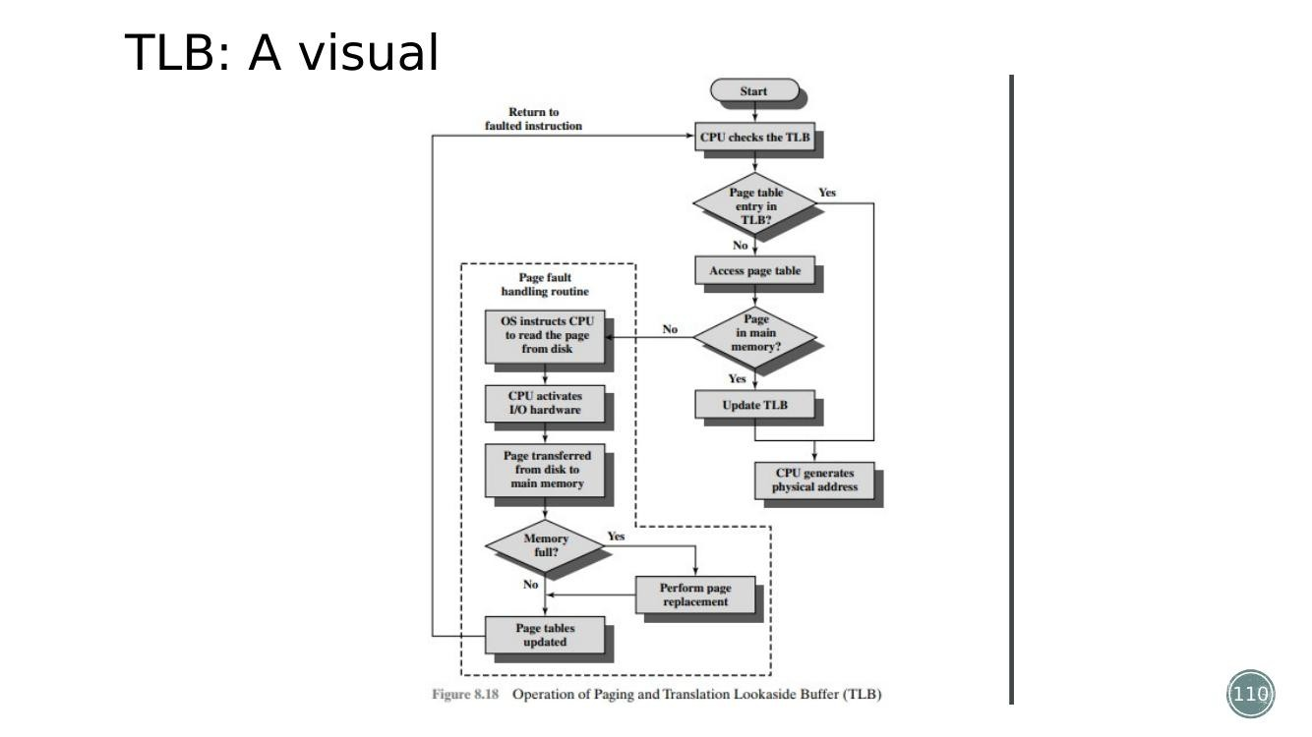
Figure (Slide 110): TLB flow – virtual address checked against the TLB first; only on a TLB miss is the full page table (in RAM) consulted.

Chapter 8 – Interfacing Processors and Peripherals
Sir's suggestion for this chapter is simply “Full”, so every topic in the chapter is covered below, including the bus/handshaking/DMA/I-O-channel items that appear at the end of your Chapter 7 list.

1. Buses – Types and How a Bus Transaction Works
Sir's Suggestion → point (8): types of bus
- A bus is a shared communication link that uses one set of wires to connect multiple subsystems (control lines + data lines). Advantages: versatility and low cost. Disadvantage: it creates a communication bottleneck, since only one transaction can use the bus at a time.
- A bus transaction has two parts: sending the address, then sending/receiving the data. Input operation = data flows from a device into memory; output operation = data flows from memory to a device.
- Traditional classification: Processor-memory buses (short, high-speed, optimized for CPU↔RAM traffic); I/O buses (longer, slower, connect peripherals such as disks and USB devices); Backplane buses (general-purpose, let CPU, memory and I/O devices all share one bus on a motherboard).
- Classification by timing scheme: Synchronous buses use a common clock signal for timing (e.g. PCI); Asynchronous buses use handshaking (request/acknowledge signals) instead of a clock (e.g. USB).
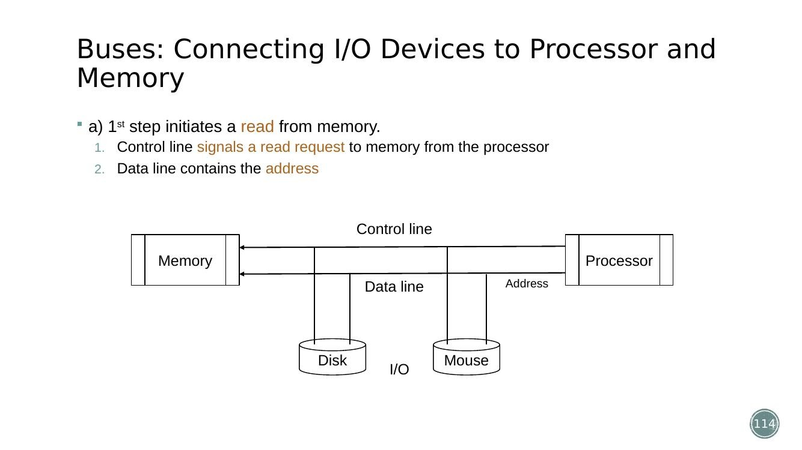
Figure (Slide 114): Step 1 of a memory read bus transaction – processor sends a read request and address over the control/data lines.
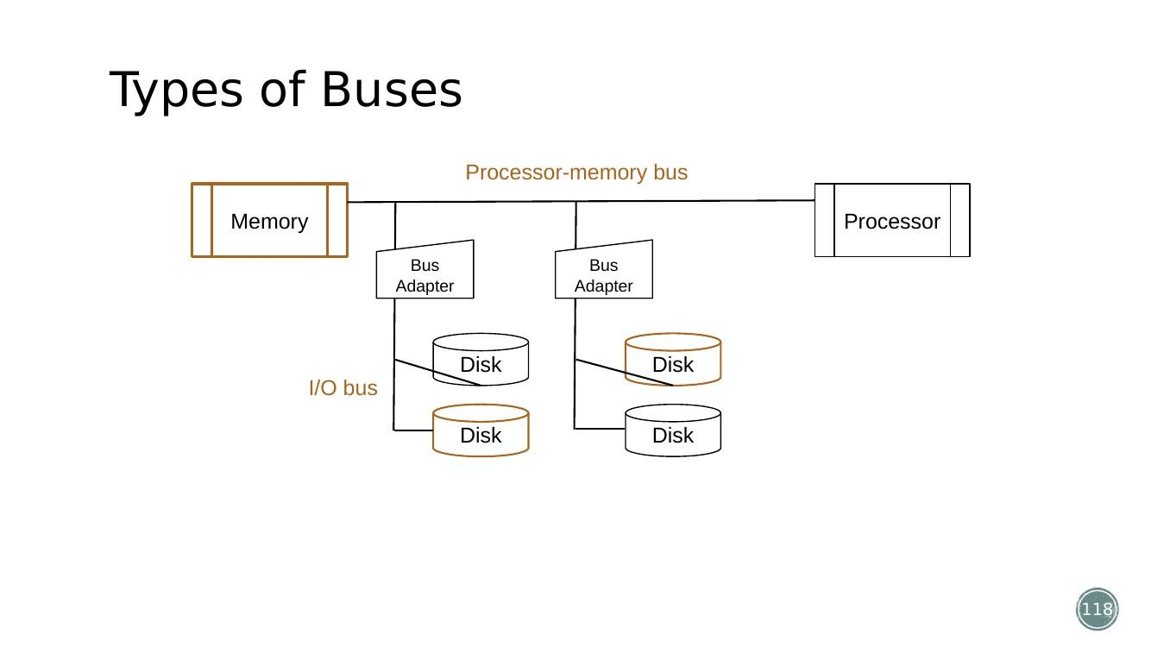
Figure (Slide 118): Processor-memory bus vs I/O bus, connected through a bus adapter.

2. Synchronous vs Asynchronous Bus and the Handshaking Protocol
Answers: Spring 2025 – Q5(b) | Sir's Suggestion → point (9): handshaking protocol
- Synchronous bus: all devices share a common clock; data transfers happen at fixed clock edges; no handshaking is needed because timing is predetermined.
- Asynchronous bus: has no shared clock; instead it relies on handshaking signals ('Ready'/'Request' and 'Acknowledge') so that devices with different speeds can still communicate correctly.
- Handshaking protocol: a method used in asynchronous communication to coordinate a data transfer between two devices (e.g. CPU and an I/O device) without a common clock – it ensures the sender and receiver are synchronized before data is actually exchanged.
- Steps of a handshake for a read request from an I/O device:
- Step 1: the requesting device (e.g. CPU) asserts a 'Request' control signal on the bus, along with the address of the data it wants.
- Step 2: the I/O device notices the Request signal, retrieves/prepares the requested data.
- Step 3: once ready, the I/O device places the data on the data lines and asserts an 'Acknowledge/Ready' signal, indicating the data is valid and available.
- Step 4: the requester reads the data now that Acknowledge is asserted, and then de-asserts its own Request line, signalling the end of the transfer.
- Step 5: the I/O device sees Request go low, and de-asserts its Acknowledge line – both devices are back to idle, ready for the next transaction.
- Because each step only proceeds once the other device has responded, no shared clock is required – devices of very different speeds can still communicate reliably.
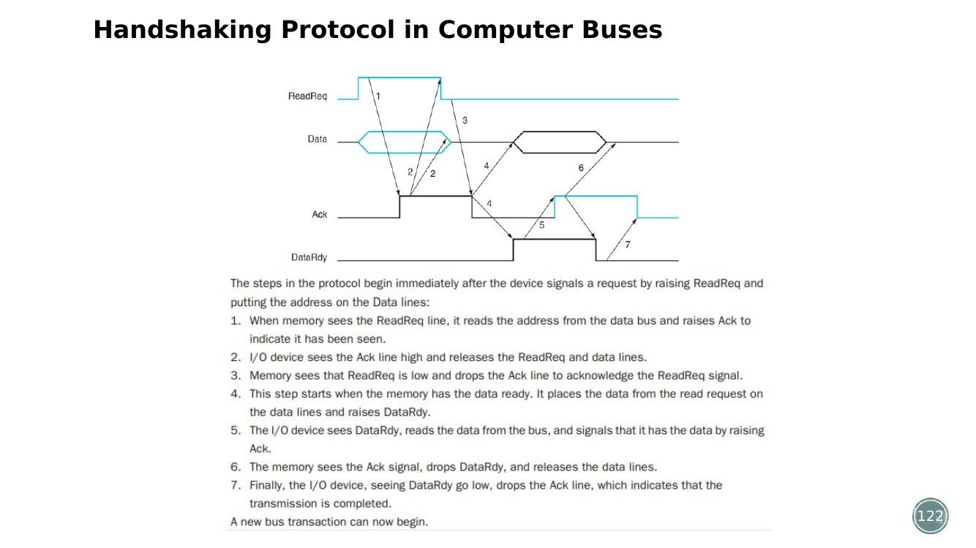
Figure (Slide 122): Handshaking protocol timing – Request and Acknowledge signals coordinate an asynchronous data transfer without a shared clock.

3. Interrupts
- An interrupt lets an external device or internal software temporarily halt the CPU's current execution, handle a time-sensitive task, and then resume normal operation – essential for efficient I/O handling, multitasking and real-time processing.
- Hardware interrupts: generated by external devices – I/O interrupts (e.g. printer out of paper, USB plugged in), timer interrupts (system clock, used for preemptive multitasking), power interrupts (low battery, overheating).
- Software interrupts (exceptions): generated by software – system calls (a program requests OS services such as read()/write()), and exceptions (e.g. division by zero, invalid memory access/segmentation fault).

4. DMA (Direct Memory Access) – What It Is and Controller Configurations
Answers: Autumn 2024 – Q4(b) | Sir's Suggestion → point (10)
- DMA (Direct Memory Access) is a feature that allows peripheral devices (disks, GPUs, network cards) to transfer data directly to/from memory WITHOUT continuous CPU intervention – the CPU just sets up the transfer and is then free to do other work while the DMA controller moves the data.
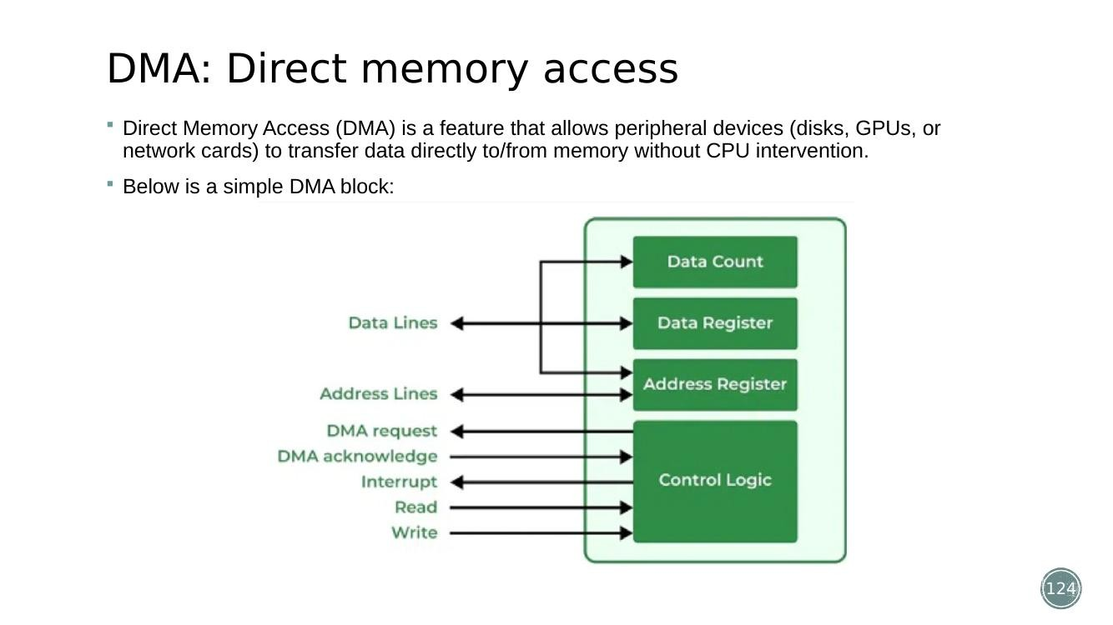
Figure (Slide 124): Basic DMA block – a DMA controller sits between memory and an I/O device, moving data without CPU intervention for every word.
DMA Controller configurations:
- Single Bus, Detached DMA Controller: CPU, memory, I/O, and the DMA controller all share ONE bus; the DMA controller acts as a kind of surrogate/mini-processor for transfers. Simple and cheap to implement, but inefficient (bus contention slows down the CPU) and only one transfer can happen at a time.
- Single Bus, DMA Integrated into the I/O Module: a DMA controller is embedded inside each I/O device (disk, GPU) so each device manages its own transfers. Faster (less bus contention, CPU waits less) but more expensive (a DMA controller is needed in every device) and wiring is more complex.
- Separate I/O Bus: uses TWO buses – a high-speed System Bus for CPU + Memory, and a separate I/O Bus that connects all DMA-enabled devices to a single DMA controller. This is generally the best option, since the CPU rarely has to pause (DMA traffic uses the I/O bus, not the system bus) and it supports many devices without slowing the CPU down.

5. I/O Channels
Sir's Suggestion → point (11): I/O channel
- An I/O Channel is essentially 'DMA with a tiny brain'. Plain DMA only moves data when explicitly told to; an I/O Channel can execute small 'channel programs' to manage an entire, more complex, multi-step transfer on its own.
- How it works: the CPU gives the I/O Channel a 'to-do list' (a channel program) stored in memory; the I/O Channel reads that list and carries out every step of the transfer automatically, leaving the CPU free to do other work in the meantime.
- Selector Channel: controls one high-speed device at a time (e.g. SSD, GPU) – best for devices that need full, dedicated bandwidth with no sharing.
- Multiplexor Channel: a 'time-sharing' channel that handles multiple slower/medium-speed devices (keyboards, printers) at once, switching between them using Time-Division Multiplexing (TDM).

6. Disk / RAID-related Terms (Rotation Latency, RAID, Hot-Swapping, Standby Spares)
Answers: Autumn 2025 – Q5(b); Autumn 2024 – Q5(b) OR | NOTE: these specific terms are NOT covered in Sir's PPTX (the deck ends at I/O Channels, slide 131). The points below are general reference knowledge only, provided so the question isn't left unanswered.
- Rotation latency: for a (mechanical/spinning) hard disk, this is the time the disk has to spin so that the desired sector rotates under the read/write head, after the head has already been positioned on the correct track (seek time). It is an unavoidable delay component of disk-access time for spinning media.
- RAID (Redundant Array of Independent/Inexpensive Disks): a technique that combines multiple physical disks into one logical unit to improve performance and/or reliability through redundancy.
- RAID 0 (striping): data is split evenly across two or more disks with no redundancy – improves speed, but a single disk failure loses all data.
- RAID 1 (mirroring): data is duplicated identically on two disks – provides full redundancy (survives one disk failure) at the cost of double the storage.
- RAID 5 (striping with distributed parity): data and parity information are striped across three or more disks – tolerates a single disk failure (data can be reconstructed from parity) while using less extra storage than mirroring.
- Hot swapping: the ability to remove and replace a failed disk while the system continues running, without powering it down – important for RAID systems so redundancy can be restored without downtime.
- Standby spares: extra, unused disks kept ready in the system so that when an active disk fails, the RAID controller can automatically start rebuilding onto the spare disk immediately, minimizing the time the array runs in a degraded (non-redundant) state.

Quick Question-to-Section Index
Use this table to jump straight to the answer for any specific exam question.
Paper | Question | Where answered
Autumn 2025 | 1(a) | CPI comparison single/multi-cycle (Ch.5 §1)
Autumn 2025 | 1(a) OR | R-type single-cycle datapath, sub $t3,$s2,$s3 (Ch.5 §3)
Autumn 2025 | 1(b) | Single-cycle LW datapath (Ch.5 §4)
Autumn 2025 | 1(b) OR | Multicycle logic elements / edge-triggered clocking (Ch.5 §8)
Autumn 2025 | 2(a) | Multicycle control unit signal generation (Ch.5 §10)
Autumn 2025 | 2(b) | Sign-extend math problem (see calculation below)
Autumn 2025 | 3(a) | Pipeline stalls from dependent instructions + reordering (Ch.6 §3)
Autumn 2025 | 3(b) | Control signal propagation in pipeline / hazards (Ch.6 §4)
Autumn 2025 | 4(a) | Multi-level cache & 3Cs model (Ch.7 §4)
Autumn 2025 | 4(b) | Cache block number math (Ch.7 §3)
Autumn 2025 | 4(a) OR | Locality – temporal/spatial prediction (Ch.7 §1)
Autumn 2025 | 4(b) OR | Direct-mapped cache tag/valid bits (Ch.7 §3)
Autumn 2025 | 5(a) | Page fault cost & virtual memory design (Ch.7 §6)
Autumn 2025 | 5(b) | Rotation latency, RAID, hot-swap, standby, DMA (Ch.8 §4, §6)
Spring 2025 | 1(a) | add $s1,$t3,$t4 datapath (Ch.5 §3)
Spring 2025 | 1(b) | Multicycle datapath design (Ch.5 §8)
Spring 2025 | 2(a) | Execution difference across instruction types (Ch.5 §10)
Spring 2025 | 2(b) | Instruction-mix CPI math (Ch.5 §11a)
Spring 2025 | 2(a) OR | Multiplexer changes for multicycle (Ch.5 §8)
Spring 2025 | 2(b) OR | Multicycle CPU-time math (Ch.5 §11b)
Spring 2025 | 3(a) | Pipeline stalls from data hazards + 2 techniques (Ch.6 §3)
Spring 2025 | 3(b) | Pipeline stages for store instruction (Ch.6 §5)
Spring 2025 | 3(a) OR | Pipelined vs single-cycle timing comparison (Ch.6 §1)
Spring 2025 | 3(b) OR | Pipeline schedule design / hazards (Ch.6 §3)
Spring 2025 | 4(a) | Direct-mapped cache addressing (Ch.7 §3)
Spring 2025 | 4(b) | Virtual memory & page table (Ch.7 §6)
Spring 2025 | 5(a) | TLB & TLB miss (Ch.7 §7)
Spring 2025 | 5(b) | Handshaking protocol (Ch.8 §2)
Autumn 2024 | 1(a) | CPI comparison single/multi/pipeline (Ch.5 §1)
Autumn 2024 | 1(a) OR | add $s1,$t3,$t4 datapath (Ch.5 §3)
Autumn 2024 | 1(b) | Structural differences single vs multicycle (Ch.5 §8)
Autumn 2024 | 1(b) OR | Temporary registers & multiplexer changes (Ch.5 §8)
Autumn 2024 | 2(a) | Single vs multicycle by control signal (Ch.5 §8, §10)
Autumn 2024 | 2(b) | Instruction-mix CPI math (Ch.5 §11c)
Autumn 2024 | 3(a) | Control hazards role & minimization (Ch.6 §4)
Autumn 2024 | 3(b) | Branch instruction in pipelined datapath (Ch.6 §4)
Autumn 2024 | 4(a) | Miss penalty, cache miss, hit rate, tag (Ch.7 §2)
Autumn 2024 | 4(b) | DMA controller & configuration (Ch.8 §4)
Autumn 2024 | 5(a) | TLB & paging flow diagram (Ch.7 §7)
Autumn 2024 | 5(b) | Direct-mapped cache with figure (Ch.7 §3)
Autumn 2024 | 5(a) OR | Virtual memory role & translation diagram (Ch.7 §6)
Autumn 2024 | 5(b) OR | RAID types with example (Ch.8 §6)

Bonus: Sign-Extension Math (Autumn 2025 – Q2(b))
- Given 16-bit immediate: 1011 0000 0000 1101.
- Since the leftmost (sign) bit = 1, this is a negative number, so sign-extension fills the upper 16 bits with 1s: 32-bit value = 1111 1111 1111 1111 1011 0000 0000 1101.
- Decimal value: this is a two's-complement negative number. Taking two's complement of the 16-bit value 1011000000001101: invert bits → 0100111111110010, add 1 → 0100111111110011 = 20,467 (decimal). So the original 16-bit value = −20,467, and the sign-extended 32-bit value represents the same decimal value, −20,467.

