Segment 4: Tools of analysis and design

Process modeling:
- A process model describes business processes—the activities that people do. Process models are developed for the as-is system and/or the to-be system.
- Data and process modeling involves three main tools: data flow diagrams, a data dictionary, and process descriptions.

Data Flow Diagram (DFD):
- A data flow diagram (DFD) uses various symbols to show how the system transforms input data into useful information.
- A data flow diagram (DFD) shows how data moves through an information system but does not show program logic or processing steps.
- A set of DFDs provides a logical model that shows what the system does, not how it does it.

DFD Symbols:
- DFDs use four basic symbols that represent processes, data flows, data stores, and entities.
- There are two type of symbol set. One is Gane and Sarson symbol set. Another popular symbol set is the Yourdon symbol set.
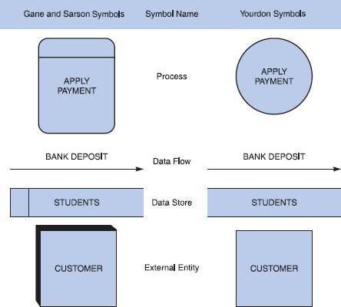

Figure 1: Data flow diagram symbols, symbol names, and examples of the Gane and Sarson and Yourdon symbol sets.

Process Symbol:
- A process receives input data and produces output that has a different content, form, or both. For instance, the process for calculating pay uses two inputs (pay rate and hours worked) to produce one output (total pay).
- Processes contain the business logic, also called business rules that transform the data and produce the required results.
- The process name identifies a specific function and consists of a verb (and an adjective, if necessary) followed by a singular noun. Examples of process names are APPLY RENT PAYMENT, CALCULATE COMMISSION, ASSIGN FINAL GRADE, VERIFY ORDER, and FILL ORDER.
- Processing details are not shown in a DFD. For example, you might have a process named DEPOSIT PAYMENT. The process symbol does not reveal the business logic for the DEPOSIT PAYMENT process. To document the logic, you create a process description.

Data Flow Symbol:
- A data flow is a path for data to move from one part of the information system to another.
- A data flow name consists of a singular noun and an adjective, if needed. Examples of data flow names are DEPOSIT, INVOICE PAYMENT, STUDENT GRADE, ORDER, and COMMISSION.

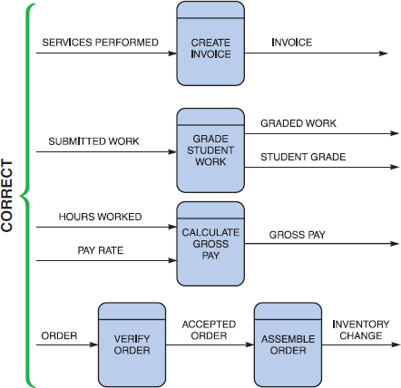

Figure 2: correct examples of data flow and process symbol connections.

Figure 3 shows three data flow and process combinations that you must avoid:
- Spontaneous generation: The APPLY INSURANCE PREMIUM process, for instance, produces output, but has no input data flow. Because it has no input, the process is called a spontaneous generation process.
- Black hole: The CALCULATE GROSS PAY is called a black hole process, which is a process that has input, but produces no output.
- Gray hole: A gray hole is a process that has at least one input and one output, but the input obviously is insufficient to generate the output shown. For example, a date of birth input is not sufficient to produce a final grade output in the CALCULATE GRADE process.
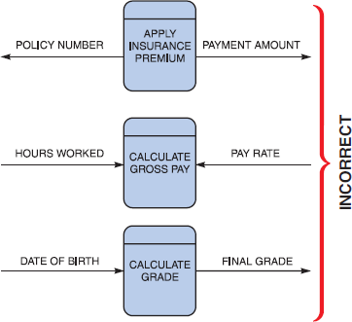
Figure 3: Examples of incorrect combinations of data flow and process symbols.

Data Store Symbol
- A data store is used in a DFD to represent data that the system stores because one or more processes need to use the data at a later time
- A DFD does not show the detailed contents of a data store — the specific structure and data elements are defined in the data dictionary.
- A data store name is a plural name consisting of a noun and adjectives, if needed. Examples of data store names are STUDENTS, ACCOUNTS RECEIVABLE, PRODUCTS, DAILY PAYMENTS.
- In each case, the data store has at least one incoming and one outgoing data flow and is connected to a process symbol with a data flow.
- In some situations, a data store has no input data flow because it contains fixed reference data that is not updated by the system. For example, consider a data store called TAX TABLE, which contains withholding tax data that a company downloads from the Internal Revenue Service.

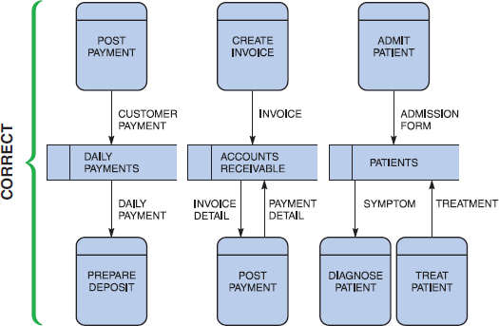

Figure 4: Examples of correct uses of data store symbols in a data flow diagram.

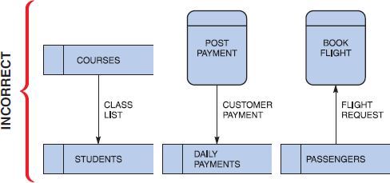
Figure 4 illustrates typical examples of data stores. In each case, the data store has at least one incoming and one outgoing data flow and is connected to a process symbol with a data flow.

Figure 5: Examples of incorrect uses of data store symbols: Two data stores cannot be connected by a data flow without an intervening process, and each data store should have an outgoing and incoming data flow.
Violations of the rule that a data store must have at least one incoming and one outgoing data flow are shown in Figure 5. In the first example, two data stores are connected incorrectly because no process is between them. Also, COURSES has no incoming data flow and STUDENTS has no outgoing data flow. In the second and third examples, the data stores lack either an outgoing or incoming data flow.

Entity Symbol
- A DFD shows only external entities that provide data to the system or receive output from the system.
- DFD entities also are called terminators, because they are data origins or final destinations.

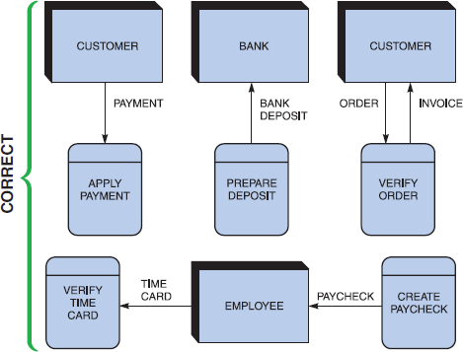
Figure 6: Examples of correct uses of external entities in a data flow diagram.

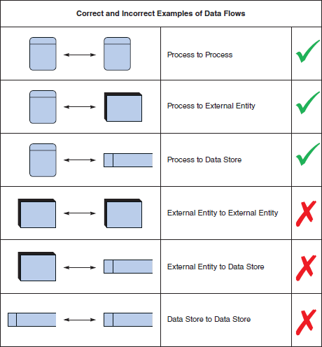
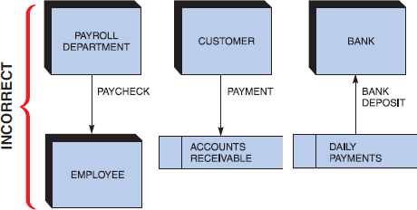
Figure 7: Examples of incorrect uses of external entities. An external entity must be connected by a data flow to a process, and not directly to a data store or to another external entity.

Figure 8 shows a summary of the rules for using DFD symbols.

Guidelines for Drawing DFDs
When you draw a context diagram and other DFDs, you should follow several guidelines:
- Draw the context diagram so it fits on one page.
- Use the name of the information system as the process name in the context diagram. For example, the process name in Figure 9 is GRADING SYSTEM. Notice that the process name is the same as the system name. For processes in lower-level DFDs, you would use a verb followed by a descriptive noun, such as ESTABLISH GRADEBOOK, ASSIGN FINAL GRADE, or PRODUCE GRADE REPORT.
- Use unique names within each set of symbols. For instance, the diagram in below figure shows only one entity named STUDENT and only one data flow named FINAL GRADE. Whenever you see the entity STUDENT on any other DFD in the grading system, you know that you are dealing with the same entity. Whenever the FINAL GRADE data flow appears, you know that you are dealing with the same data flow. The naming convention also applies to data stores.
- Do not cross lines. One way to achieve that goal is to restrict the number of symbols in any DFD. On lower-level diagrams with multiple processes, you should not have more than nine process symbols. Including more than nine symbols usually is a signal that your diagram is too complex and that you should reconsider your analysis.
- Provide a unique name and reference number for each process. Because it is the highest-level DFD, the context diagram contains process 0, which represents the entire information system, but does not show the internal workings. To describe the next level of detail inside process 0, you must create a DFD named diagram 0, which will reveal additional processes that must be named and numbered (See figure 10). As you continue to create lower-level DFDs, you assign unique names and reference numbers to all processes, until you complete the logical model.
- Obtain as much user input and feedback as possible. Your main objective is to ensure that the model is accurate, easy to understand, and meets the needs of its users.
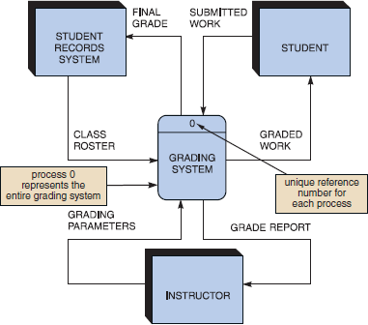
Figure 9: Context diagram DFD for a grading system.

Context diagram
Box represents whole
system boundary
Box represents process

Level 0 DFD

Level 1 DFD

Figure 10: Different levels of DFD

Developing Data Flow Diagrams Step 1: Draw a Context Diagram
A context diagram is a top-level view of an information system that shows the system’s
boundaries and scope. To draw a context diagram, you have to use a single process symbol, and you identify it as process 0.

Example: context diagram for an order system
The context diagram for an order system is shown in Figure 11. Notice that the ORDER SYSTEM process is at the center of the diagram and five entities surround the process. Three of the entities, SALES REP, BANK, and ACCOUNTING, have nine data flow.

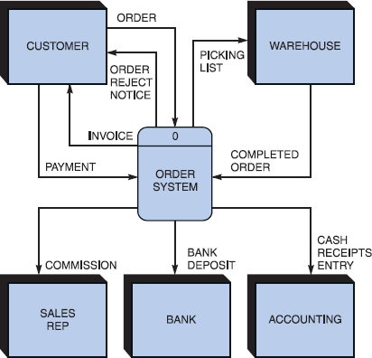

Figure 11: Context diagram DFD for an order system.

Step 2: Draw a Diagram 0 DFD
To show the detail inside the black box, you create DFD diagram 0. Diagram 0 zooms in on the system and shows major internal processes, data flows, and data stores. Diagram 0 also repeats the entities and data flows that appear in the context diagram. When you expand the context diagram into DFD diagram 0, you must retain all the connections that flow into and out of process 0.

Example: Diagram 0 DFD for an order system
Figure 12 shows the diagram 0 for an order system. Process 0 on the order system’s context diagram is exploded to reveal three processes (FILL ORDER, CREATE INVOICE, and APPLY PAYMENT), one data store (ACCOUNTS RECEIVABLE), two additional data flows (INVOICE DETAIL and PAYMENT DETAIL), and one diverging data flow (INVOICE).
The following walkthrough explains the DFD shown in Figure 12:
- A CUSTOMER submits an ORDER. Depending on the processing logic, the FILL ORDER process either sends an ORDER REJECT NOTICE back to the customer or sends a PICKING LIST to the WAREHOUSE.
- A COMPLETED ORDER from the WAREHOUSE is input to the CREATE INVOICE process, which outputs an INVOICE to both the CUSTOMER process and the ACCOUNTS RECEIVABLE data store.
- A CUSTOMER makes a PAYMENT that is processed by APPLY PAYMENT. APPLY PAYMENT requires INVOICE DETAIL input from the ACCOUNTS RECEIVABLE data store along with the PAYMENT. APPLY PAYMENT also outputs PAYMENT DETAIL back to the ACCOUNTS RECEIVABLE data store and outputs COMMISSION to the SALES DEPT, BANK DEPOSIT to the BANK, and CASH RECEIPTS ENTRY to ACCOUNTING.

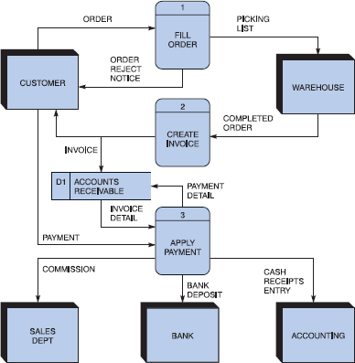
Figure 12: Diagram 0 DFD for the order system.

Step 3: Draw the Lower-Level Diagrams
This set of lower-level DFDs is based on the order system. To create lower-level diagrams, you must use leveling and balancing techniques. Leveling is the process of drawing a series of increasingly detailed diagrams, until all functional primitives are identified. Balancing maintains consistency among a set of DFDs by ensuring that input and output data flows align properly. Leveling and balancing are described in more detail in the following sections.

Leveling examples
Leveling uses a series of increasingly detailed DFDs to describe an information system. For example, a system might consist of dozens, or even hundreds, of separate processes. Using leveling, an analyst starts with an overall view, which is a context diagram with a single process symbol. Next, the analyst creates diagram 0, which shows more detail. The analyst continues to create lower-level DFDs which is the parent. When you explode the FILL ORDER process into diagram 1 DFD, however, you see that three processes (1.1, 1.2, and 1.3) interact with the two data stores, which now are shown.

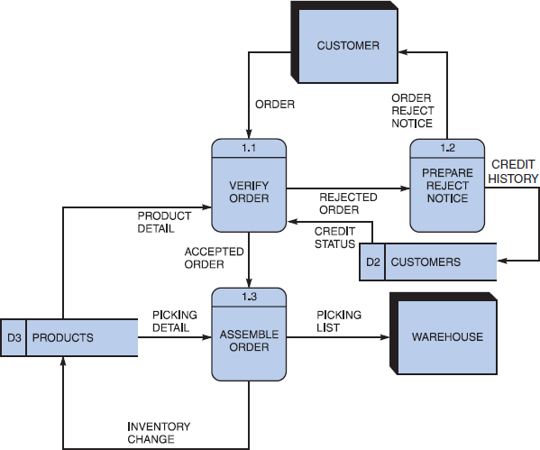
Figure 13: Diagram 1 DFD shows details of the FILL ORDER process in the order system.

Figures 12 and 13 provide an example of leveling. Figure 12 shows diagram 0 for an order system, with the FILL ORDER process labeled as process 1. Now consider Figure 5-17, which provides an exploded view of the FILL ORDER process. Notice that FILL ORDER (process 1) actually consists of three processes: VERIFY ORDER (process 1.1), PREPARE REJECT NOTICE (process 1.2), and ASSEMBLE ORDER (process 1.3).

When you compare Figures 12 and 13, you will notice that Figure 13 (the exploded FILL ORDER process) shows two data stores (CUSTOMERS and PRODUCTS) that do not appear on Figure 5-16, which is the parent DFD. Why not? The answer is based on a simple rule: When drawing DFDs, you show a data store only when two or more processes use that data store. The CUSTOMERS and PRODUCTS data stores were internal to the FILL ORDER process, so the analyst did not show them on diagram 0, which is the parent. When you explode the FILL ORDER process into diagram 1 DFD, however, you see that three processes (1.1, 1.2, and 1.3) interact with the two data stores, which now are shown.

BALANCING EXAMPLES
Balancing ensures that the input and output data flows of the parent DFD are maintained on the child DFD. For example, Figure 14 shows two DFDs: The order system diagram 0 is shown at the top of the figure, and the exploded diagram 3 DFD is shown at the bottom.
The two DFDs are balanced, because the child diagram at the bottom has the same input and output flows as the parent process 3 shown at the top. To verify the balancing, notice that the parent process 3, APPLY PAYMENT, has one incoming data flow from an external entity, and three outgoing data flows to external entities. Now examine the child DFD, which is diagram 3. Now, ignore the internal data flows and count the data flows to and from external entities. You

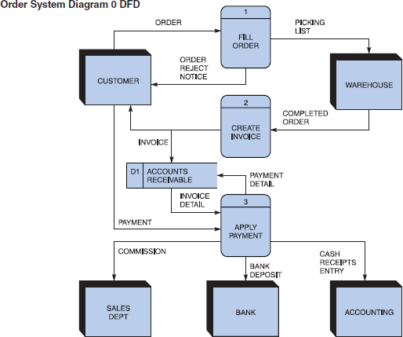
will see that the three processes maintain the same one incoming and three outgoing data flows as the parent process.

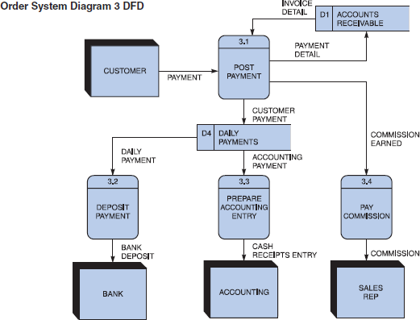
Next

FIGURE 14: The order system diagram 0 is shown at the top of the figure, and exploded diagram 3 DFD (for the APPLY PAYMENT process) is shown at the bottom. The two DFDs are balanced, because the child diagram at the bottom has the same input and output flows as the parent process 3 shown at the top.

DFD EXAMPLE-2

Library Management System

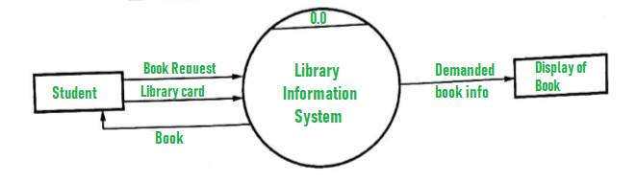
Figure: Context Diagram for Library Information System

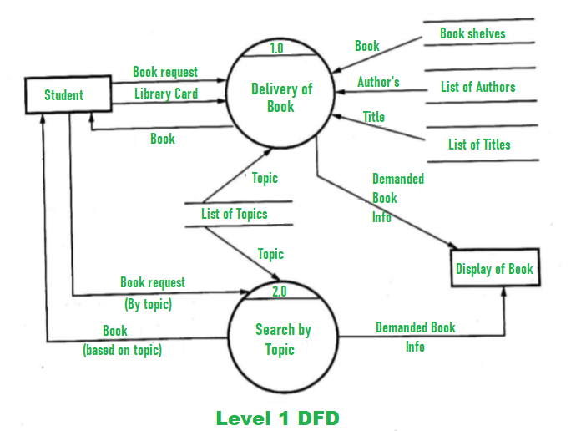
Figure: Level-1 DFD for Library Information System

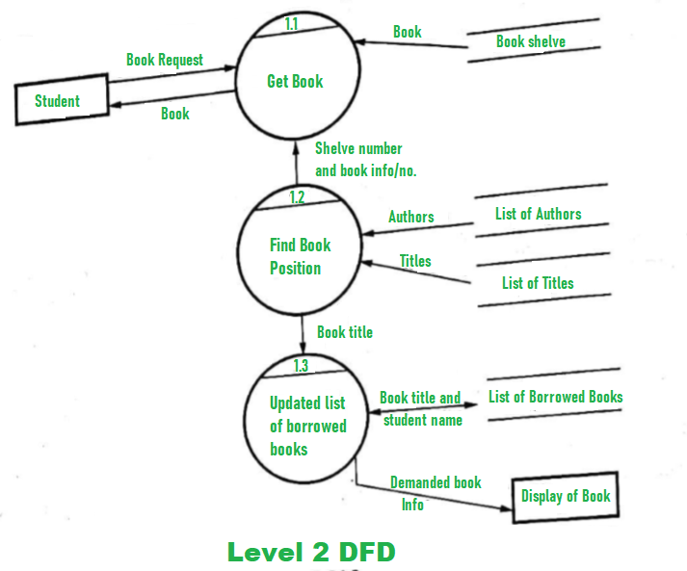

Figure: Level-2 DFD for Library Information System

