Accessibility Snapshot Report
Example Store (Ireland, fashion retail)
WCAG 2.1 Level A and AA · European Accessibility Act

Scan date: 31 October 2026
Pages checked: 7
Tools: axe-core 4.14.0, Chromium 151.0.7922.34, scripted keyboard pass on one page
Prepared by: EAA Audit

Sample report made to test our own process. The shop’s identity has been removed. The shop did not commission this report and has not been contacted.
This is a technical assessment, not legal advice.

1. Summary

Fix first
1. Sort-by control: add its options and a name (critical, level A; 1 element, 2 of 7 pages)
2. Pale text: darken to 4.5:1 (serious, level AA; 16 elements, 3 of 7 pages)
3. Icon links: add a text name (serious, level A; 3 elements, 2 of 7 pages)
How far this report goes. Automated testing checks only about 30–40 % of WCAG criteria. This report therefore does not show that the shop conforms to WCAG 2.1 AA or to the European Accessibility Act. A clean automated result on a criterion is not a pass: everything marked “Manual check required” below has not been tested.
In this scan the automated rules touched 22 of the 50 WCAG 2.1 A and AA criteria (44 %), and most of those only in part: the rules can find a missing image description, but not a wrong one.
The scan of 7 pages found 4 types of problem on 20 distinct elements (25 occurrences across pages) and failed 4 WCAG criteria. Elements that repeat across pages usually come from a shared template, so one fix can solve several pages.
Level | Problem types | Distinct elements | Occurrences on all pages
A | 3 | 4 | 7
AA | 1 | 16 | 18
Total | 4 | 20 | 25

A further 5 rule types on 43 elements could not be decided automatically (see section 3). They are not counted above.

The five most important problems
1. Custom widgets are missing required parts (critical, level A, WCAG 1.3.1; 1 element on 2 of 7 pages)
Who is affected: Screen readers announce the menu or list incorrectly, or not at all.
How to fix: Add the child roles the widget requires, or use native HTML.
In this shop: The sort-by control on category and search pages (search dropdown) is announced as a list box but contains no options that assistive technology can reach.
2. Text is too pale against its background (serious, level AA, WCAG 1.4.3; 16 elements on 3 of 7 pages)
Who is affected: People with low vision, older shoppers and anyone using a phone outdoors struggle to read it.
How to fix: Darken the text or lighten the background until the ratio reaches 4.5:1 (3:1 for large text).
In this shop: Struck-through old prices on the search page are #c5c5c5 on white, a ratio of 1.72:1, and the Home breadcrumb is #9f9f9f on white, 2.64:1. The required ratio is 4.5:1.
3. Links have no readable name (serious, level A, WCAG 2.4.4, 4.1.2; 3 elements on 2 of 7 pages)
Who is affected: Screen reader users hear only 'link', so they cannot tell where it leads.
How to fix: Add visible text or an aria-label, especially to icon and image links.
In this shop: A promotional tile on the home page and two icon links on the product page have no text; the two icon links also have empty aria-label and href attributes.
4. Custom input fields have no readable name (serious, level A, WCAG 4.1.2; 1 element on 2 of 7 pages)
Who is affected: Screen reader users do not know what the field is for.
How to fix: Add an aria-label or aria-labelledby.
In this shop: The same sort-by control also has no name, so a screen reader cannot say that it sorts the products.
5. Keyboard focus goes to places the shopper cannot see (manual finding, WCAG 2.4.3 and 2.4.7 to be confirmed by a person; keyboard pass on 1 page)
Who is affected: Keyboard users lose track of where they are, and must press Tab many extra times to reach the product.
How to fix: Keep focus inside the cookie dialog while it is open, and take closed menus and the closed mini-bag out of the tab order (for example with the inert attribute).
In this shop: From the scripted keyboard pass on the product page, not from automated rules: 18 focus stops were in the closed slide-out menu and the closed mini-bag, outside the visible area. In an earlier pass focus also left the open cookie dialog after 10 stops and moved through the page behind it. WCAG 2.4.3 and 2.4.7 need a person to confirm this.

2. Results by WCAG criterion
Fail: at least one automated rule failed. Needs review: the automated rule could not decide. No automated failure: rules ran and found nothing, but they cover only part of the criterion, so a manual check is still required. Manual only: no automated rule exists.
WCAG | Level | Criterion | Result | Rules | Elements
1.1.1 | A | Non-text Content | No automated failure
1.2.1 | A | Audio-only and Video-only (Prerecorded) | No automated failure
1.2.2 | A | Captions (Prerecorded) | No automated failure
1.2.3 | A | Audio Description or Media Alternative | Manual only
1.3.1 | A | Info and Relationships | Fail | aria-required-children | 1
1.3.2 | A | Meaningful Sequence | Manual only
1.3.3 | A | Sensory Characteristics | Manual only
1.4.1 | A | Use of Color | Needs review | link-in-text-block | 17
1.4.2 | A | Audio Control | No automated failure
2.1.1 | A | Keyboard | No automated failure
2.1.2 | A | No Keyboard Trap | Manual only
2.1.4 | A | Character Key Shortcuts | Manual only
2.2.1 | A | Timing Adjustable | No automated failure
2.2.2 | A | Pause, Stop, Hide | No automated failure
2.3.1 | A | Three Flashes or Below Threshold | Manual only
2.4.1 | A | Bypass Blocks | No automated failure
2.4.2 | A | Page Titled | No automated failure
2.4.3 | A | Focus Order | Manual only
2.4.4 | A | Link Purpose (In Context) | Fail | link-name | 3
2.5.1 | A | Pointer Gestures | Manual only
2.5.2 | A | Pointer Cancellation | Manual only
2.5.3 | A | Label in Name | No automated failure
2.5.4 | A | Motion Actuation | Manual only
3.1.1 | A | Language of Page | No automated failure
3.2.1 | A | On Focus | Manual only
3.2.2 | A | On Input | Manual only
3.3.1 | A | Error Identification | Manual only
3.3.2 | A | Labels or Instructions | No automated failure
4.1.1 | A | Parsing | Manual only
4.1.2 | A | Name, Role, Value | Fail | link-name, aria-input-field-name | 4
1.2.4 | AA | Captions (Live) | Manual only
1.2.5 | AA | Audio Description (Prerecorded) | Manual only
1.3.4 | AA | Orientation | No automated failure
1.3.5 | AA | Identify Input Purpose | No automated failure
1.4.3 | AA | Contrast (Minimum) | Fail | color-contrast | 16
1.4.4 | AA | Resize Text | No automated failure
1.4.5 | AA | Images of Text | Manual only
1.4.10 | AA | Reflow | Manual only
1.4.11 | AA | Non-text Contrast | Manual only
1.4.12 | AA | Text Spacing | No automated failure
1.4.13 | AA | Content on Hover or Focus | Manual only
2.4.5 | AA | Multiple Ways | Manual only
2.4.6 | AA | Headings and Labels | Manual only
2.4.7 | AA | Focus Visible | Manual only
3.1.2 | AA | Language of Parts | No automated failure
3.2.3 | AA | Consistent Navigation | Manual only
3.2.4 | AA | Consistent Identification | Manual only
3.3.3 | AA | Error Suggestion | Manual only
3.3.4 | AA | Error Prevention (Legal, Financial, Data) | Manual only
4.1.3 | AA | Status Messages | Manual only

Findings in detail

Custom widgets are missing required parts
Rule aria-required-children · critical · level A · WCAG 1.3.1 · 1 distinct element, 2 occurrences · pages: category, search
- search dropdown
<div role="listbox">

Text is too pale against its background
Rule color-contrast · serious · level AA · WCAG 1.4.3 · 16 distinct elements, 18 occurrences · pages: category, product, search
- breadcrumb link
<a href="...">Home</a>
- product card > old price
<span> €40.00 </span>
- product card > old price
<span> €35.00 </span>

Links have no readable name
Rule link-name · serious · level A · WCAG 2.4.4, 4.1.2 · 3 distinct elements, 3 occurrences · pages: home, product
- promotional tile link
<a href="...">
- icon link, 4th in its row
<a href="..." aria-label=""> <div> <div> </div> <div> <span></span> </div> </div> </a>
- icon link, 5th in its row
<a href="..." aria-label=""> <div> <div> </div> <div> <span></span> </div> </div> </a>

Custom input fields have no readable name
Rule aria-input-field-name · serious · level A · WCAG 4.1.2 · 1 distinct element, 2 occurrences · pages: category, search
- search dropdown
<div role="listbox">

3. Results by page
# | Page | HTTP | Rules failed A | Rules failed AA | Elements | To review
1 | home | 200 | 1 | 0 | 1 | 28
2 | category | 200 | 2 | 1 | 3 | 17
3 | product | 200 | 1 | 1 | 3 | 18
4 | cart | 200 | 0 | 0 | 0 | 11
5 | search | 200 | 2 | 1 | 18 | 13
6 | contact | 200 | 0 | 0 | 0 | 11
7 | returns | 200 | 0 | 0 | 0 | 11

The home page was scanned with the cookie dialog open and again after closing it with the essential-cookies button. The other pages were scanned with the dialog closed.
On every page 11 header elements stay under “To review”. For 10 menu items the rules report that another layer overlaps them, and the cause is not known. The search box has a changing placeholder, not a value. Measured on a screenshot, the 11 menu words and the placeholder reach at least 6.5:1, above the required 4.5:1. That is an image measurement on one page, not an automated pass.
The sign-in link leads to a page hosted by the e-commerce platform on its own domain. It is not a page of the shop and is not counted here. It showed no automated failures in an earlier pass.
The bag was checked empty. A third-party accessibility widget is present on the pages; results describe the pages as they rendered with it, and it was not opened.
Hidden analytics frames on all 7 pages could not be scanned. They show nothing to the shopper.

Could not be decided automatically
Rule | Level | WCAG | Elements | Why it needs a person
aria-valid-attr-value | A | 4.1.2 | 2 | ARIA attributes must conform to valid values
duplicate-id-aria | A | 4.1.2 | 1 | IDs used in ARIA and labels must be unique
color-contrast | AA | 1.4.3 | 17 | Elements must meet minimum color contrast ratio thresholds
link-in-text-block | A | 1.4.1 | 17 | Links must be distinguishable without relying on color
aria-prohibited-attr | A | 4.1.2 | 6 | Elements must only use permitted ARIA attributes

4. What must be checked by hand
The items below were not done in this snapshot. Each is marked “Manual check required”. Until they are done, the shop’s conformance is unknown.

Keyboard
Done: one scripted pass on the product page with real Tab key presses and nothing bought or submitted. 124 focus stops; Tab presses to reach the main content: 45; to reach Add to bag: 53; stops outside the visible area: 20; stops inside content hidden from screen readers: 0. The pass ended by: repeating stops. This pass did not involve a person with a keyboard.
Skip link “Skip to menu” pressed with Enter: focus moved to a nav element in the main content; the next Tab reached “HOME”.
Skip link “Skip to content” pressed with Enter: focus moved to a main element in the main content; the next Tab reached “HOME”.
Skip link “Skip to footer” pressed with Enter: focus moved to a footer element in the footer; the next Tab reached “FAQ's”.
- With the cookie dialog closed, the pass covered all page content: 115 stops up to the last footer link. Stop 116 was the embedded chat widget, the last item in the tab order.
- Focus stayed on the chat widget for 9 Tab presses in a row, and the script then stopped. A test page of ours with no trap and an embedded frame at the end behaved the same way, so this is probably a side effect of automation, not a keyboard trap. WCAG 2.1.2 still needs a person.
- To be confirmed by a person: 14 stops were in the closed slide-out menu and 4 in the closed mini-bag, including its Checkout button. All 18 are outside the visible area. 2 further stops were in the rotating banner at the top.
- The “Skip to menu” link lands on the breadcrumb navigation, not on the main menu, so its label is misleading. “Skip to content” works: it cuts the way to the main content from 45 Tab presses to 1. “Skip to footer” works too.
- 2 stops showed no visible change on focus: the header search field and the payment widget message. The chat widget showed none either.
- In an earlier pass with the cookie dialog open, Tab left the dialog after 10 stops and moved through the page behind it. To be confirmed by a person.

Keyboard pass, first stop: Tab press 1, Skip to menu


Keyboard pass, no focus ring: Tab press 10, element without a name
Manual check required:
- Operate every control with Enter, Space, arrow keys and Esc (the script pressed Enter on skip links only)
- Open the main menu, filters, size selector and image gallery by keyboard
- Complete the purchase path: product, bag, delivery, payment
- Check focus is kept inside open dialogs and returns to the trigger when they close
- Repeat on all remaining page types
- Confirm visually that focus order follows the visual order

Screen reader
Not done. Manual check required:
- Browse a category and open a product with NVDA or VoiceOver
- Choose a size or colour and hear the selected value announced
- Add a product to the bag and hear the confirmation (4.1.3 Status Messages)
- Open and close the menu, filters, mini-bag and pop-ups; check where focus goes
- Complete the checkout up to the payment step, including error messages
- Check that headings and landmarks allow fast navigation of each page type

Contrast in changing states
Automated contrast rules read one static state of the page. Manual check required:
- Text over photos and video banners, including carousels at each slide
- Hover, focus, active and disabled states of buttons and links
- Error and success messages, sale prices and badges
- Non-text contrast of icons, form borders and focus rings (1.4.11)
- Cookie banner, pop-ups, drop-downs and the mobile menu

All other criteria that automation cannot settle
WCAG | Criterion | Manual check required
1.1.1 | Non-text Content | Check that each alt text actually describes the image
1.2.1 | Audio-only and Video-only (Prerecorded) | Review any audio or silent video
1.2.2 | Captions (Prerecorded) | Watch videos with captions on
1.2.3 | Audio Description or Media Alternative | Review videos for visual-only content
1.3.2 | Meaningful Sequence | Read the page in DOM order with a screen reader
1.3.3 | Sensory Characteristics | Read instructions for 'click the red button' style wording
1.4.1 | Use of Color | Check that errors, links and stock status do not rely on colour alone
1.4.2 | Audio Control | Check any autoplaying sound
2.1.1 | Keyboard | Complete the purchase path with the keyboard only
2.1.2 | No Keyboard Trap | Tab through menus, dialogs and embedded widgets
2.1.4 | Character Key Shortcuts | Look for single-key shortcuts
2.2.1 | Timing Adjustable | Check session and cart time limits
2.2.2 | Pause, Stop, Hide | Check carousels, animations and auto-updating content
2.3.1 | Three Flashes or Below Threshold | Review animated content
2.4.1 | Bypass Blocks | Check that a working skip link or landmarks exist
2.4.2 | Page Titled | Check that titles describe each page
2.4.3 | Focus Order | Follow focus order through dialogs and the checkout
2.5.1 | Pointer Gestures | Check swipe-only or pinch-only controls
2.5.2 | Pointer Cancellation | Check that actions fire on release, not on press
2.5.3 | Label in Name | Compare visible labels with accessible names
2.5.4 | Motion Actuation | Look for shake or tilt features
3.1.1 | Language of Page | Check that the declared language is the real one
3.2.1 | On Focus | Watch for context changes on focus
3.2.2 | On Input | Change filters and selects, watch for unexpected changes
3.3.1 | Error Identification | Submit forms with errors
3.3.2 | Labels or Instructions | Review checkout and account forms
4.1.1 | Parsing | Obsolete in WCAG 2.2, still listed in 2.1; review duplicate IDs
1.2.4 | Captions (Live) | Review live streams, if any
1.2.5 | Audio Description (Prerecorded) | Review videos for visual-only content
1.3.4 | Orientation | Rotate a real device or emulator
1.3.5 | Identify Input Purpose | Review autocomplete on address and payment fields
1.4.4 | Resize Text | Zoom text to 200 %
1.4.5 | Images of Text | Look for banners with text baked into images
1.4.10 | Reflow | View at 320 CSS px wide (400 % zoom)
1.4.11 | Non-text Contrast | Check borders of controls, icons and focus rings
1.4.12 | Text Spacing | Apply the text-spacing bookmarklet
1.4.13 | Content on Hover or Focus | Check tooltips and hover menus
2.4.5 | Multiple Ways | Confirm search, navigation and sitemap exist
2.4.6 | Headings and Labels | Read headings and labels for meaning
2.4.7 | Focus Visible | Tab through the page and watch the focus ring
3.1.2 | Language of Parts | Look for passages in another language
3.2.3 | Consistent Navigation | Compare navigation across pages
3.2.4 | Consistent Identification | Compare icons and controls across pages
3.3.3 | Error Suggestion | Trigger form errors and read the suggestions
3.3.4 | Error Prevention (Legal, Financial, Data) | Review the order confirmation step
4.1.3 | Status Messages | Listen for add-to-bag and error messages in a screen reader

Not covered by this snapshot
- What happens to keyboard focus after the chat widget
- Only one page was checked by keyboard
- The filled bag, checkout and payment steps
- Mobile view and the accessibility statement required by the European Accessibility Act

Appendix: screenshots
Desktop view reduced to its layout. Text and photos are replaced by grey blocks, so nothing here identifies the shop. Only the top of each page is shown.

1. Home
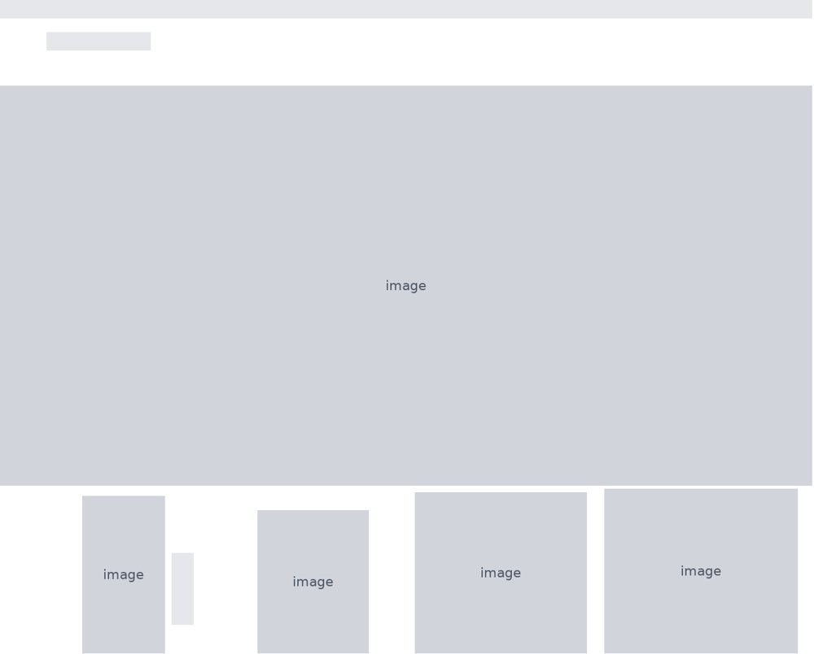

2. Category
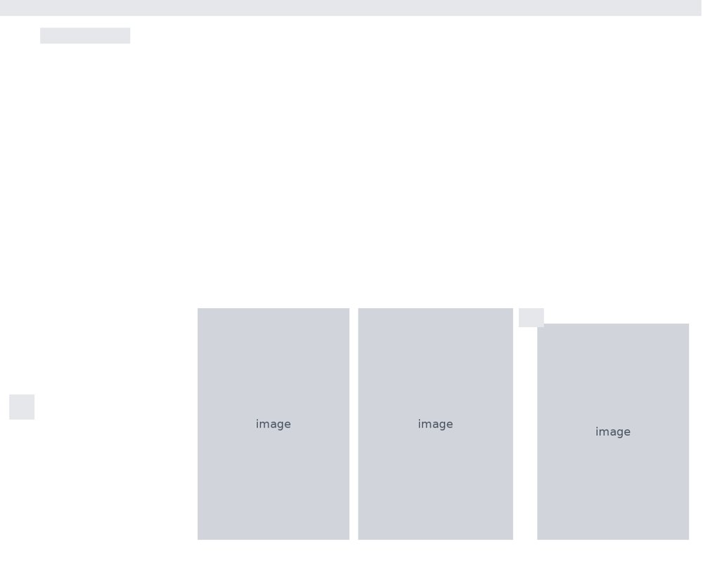

3. Product
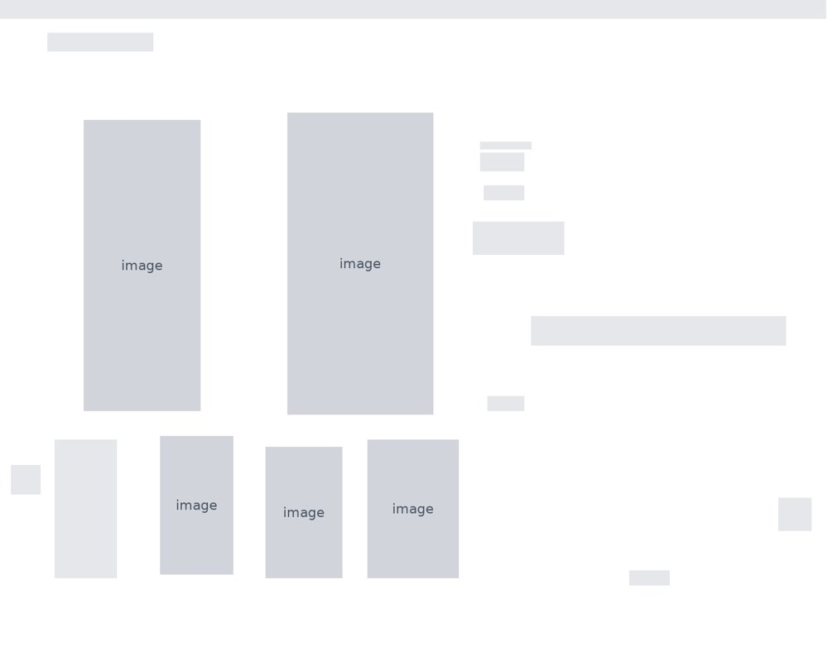

4. Cart
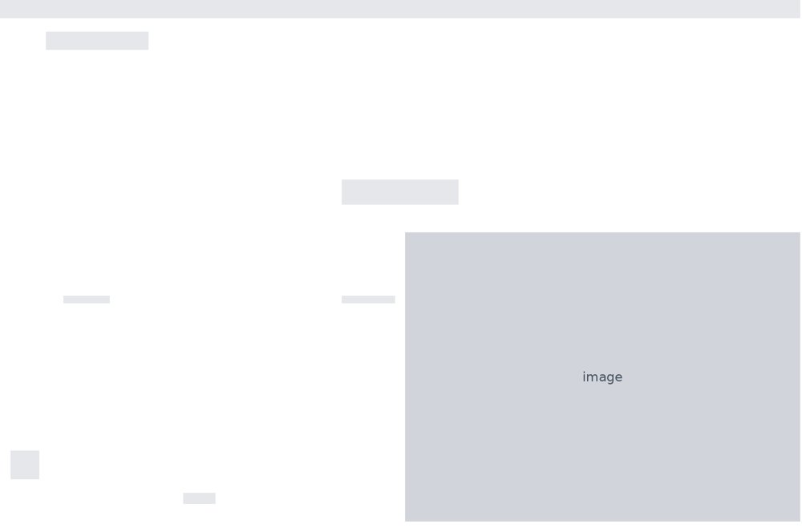

5. Search
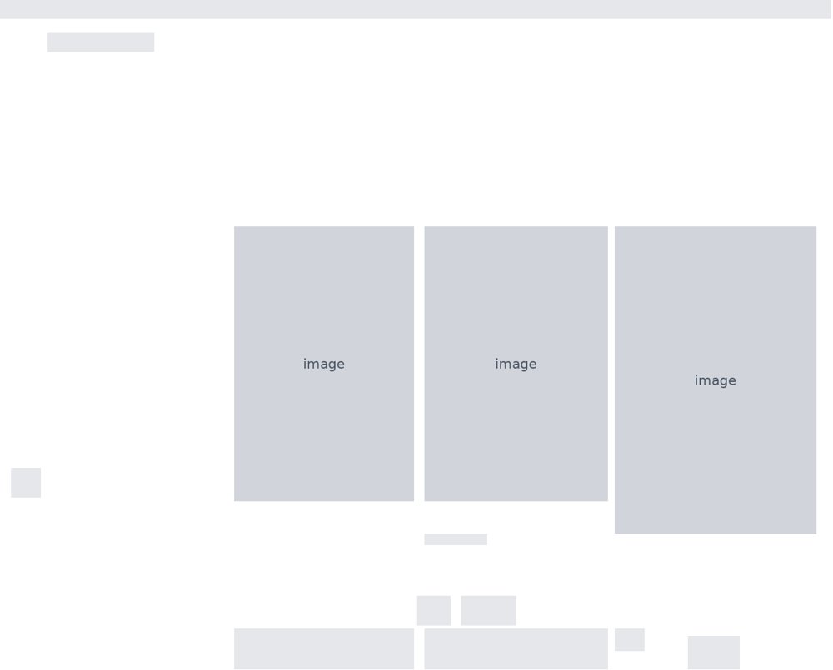

6. Contact
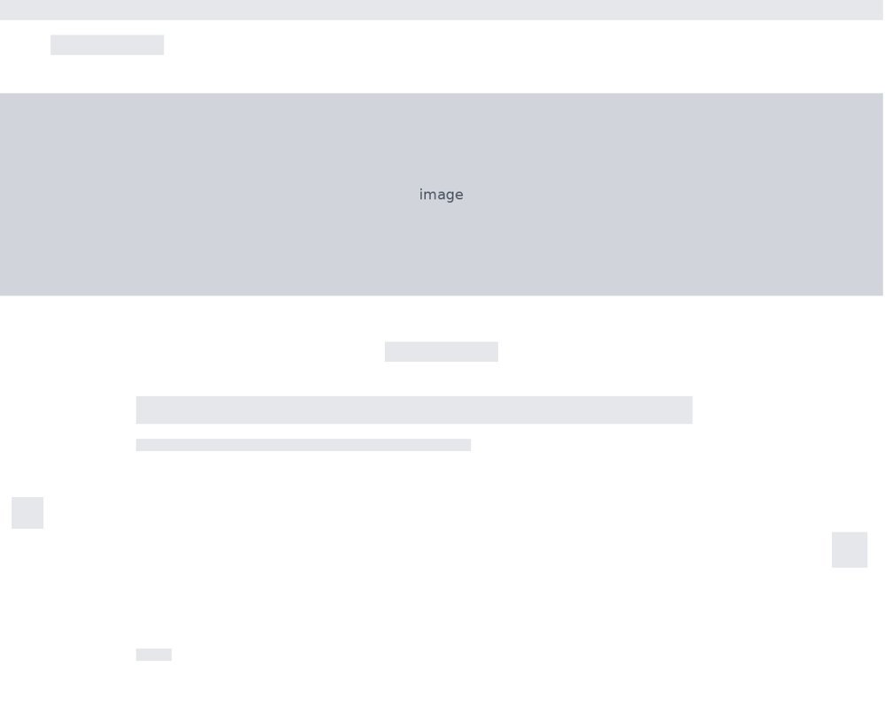

7. Returns


