[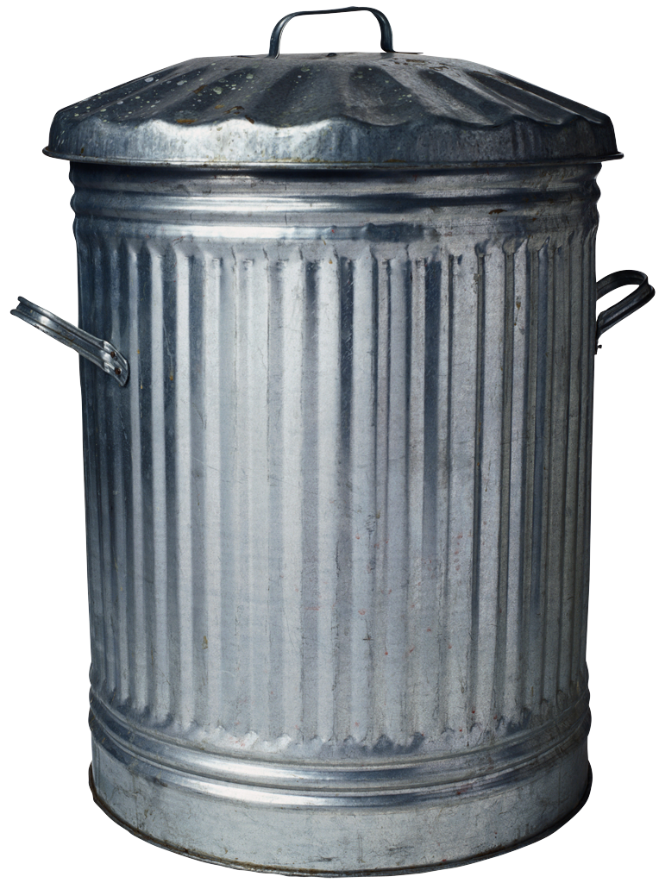](3.8%20to%203.9.docx)

[Works that received a 3.4 to 3.5](3.4%20to%203.5.docx)

[Works that received a 3.5 to 3.6](3.5%20to%203.6.docx)

[Works that received a 3.6 to 3.7](3.6%20to%203.7.docx)

[Works that received a 3.7 to 3.8](3.7%20to%203.8.docx)

[Works that received a 3.8 to 3.9](3.8%20to%203.9.docx)

[Works that received a 3.9 and above](3.9%20and%20above.docx)

$33701.716