EECE 435L — Lab 8: Docker and Containers
Ali Rida Awad | AUB username: awa34 | Github: https://github.com/Aliminium-11929/435L-Lab8-AliRidaAwad

Activity 1 — docker ps -a
docker ps -a
Lists all containers, including running and stopped containers, with their IDs, image references, commands, status, published ports and names.
Activity 1 — docker stop
docker stop lab8-hello
Requests a graceful stop of the running lab8-hello container. Docker sends the configured stop signal (normally SIGTERM), then forcefully terminates it if the timeout expires. The container remains listed by docker ps -a. The argument is a container name or ID; the handout calls it an image name.
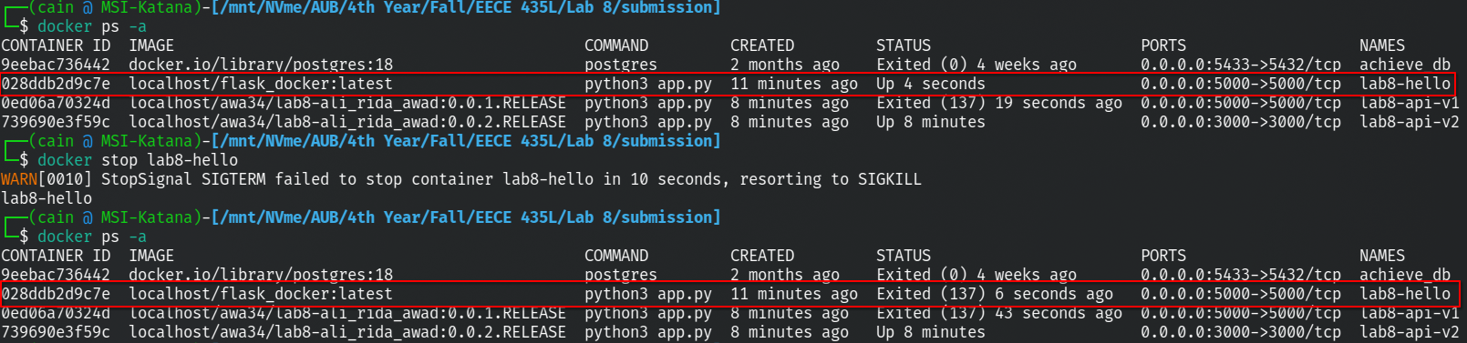
Activity 1 — docker logs
docker logs lab8-hello
Displays the container’s captured standard output and standard error, including Flask startup and request messages. Logs remain available after this container stops. The argument is a container name or ID.
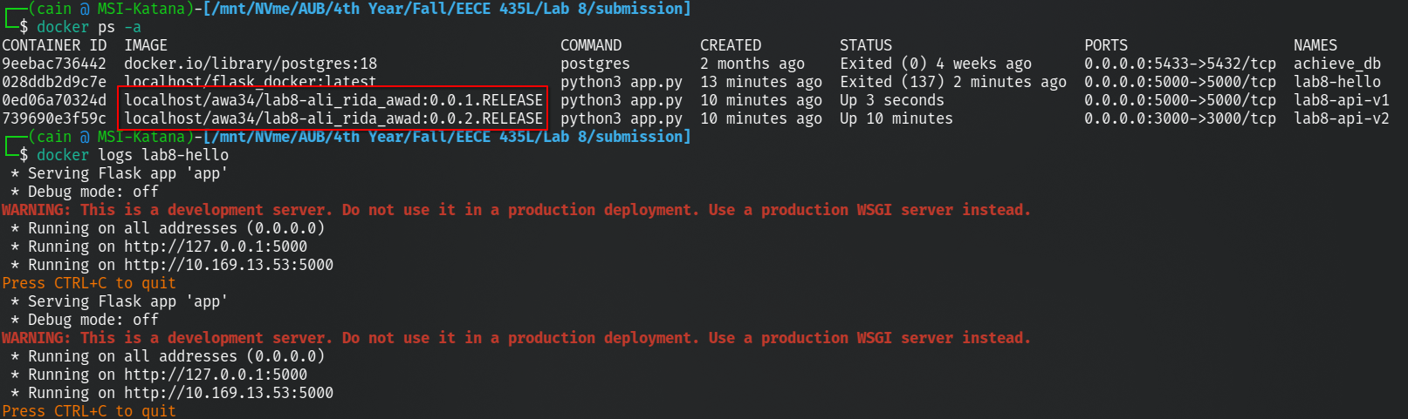
Activity 2 — Lab 5 API image
awa34/lab8-ali_rida_awad:0.0.1.RELEASE
Runs the Lab 5 Flask and SQLite CRUD API on container and host port 5000. Routes: GET /api/users, GET /api/users/<user_id>, POST /api/users/add, PUT /api/users/update, DELETE /api/users/delete/<user_id>.
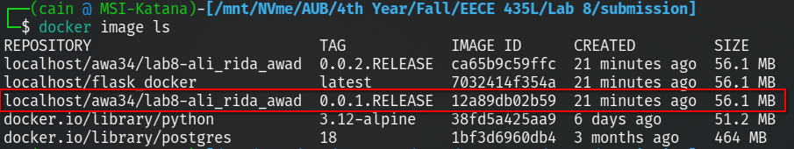
Activity 2 — Names API image
awa34/lab8-ali_rida_awad:0.0.2.RELEASE
Runs Flask on container and host port 3000. GET /get_users queries the users table and returns a JSON array of every user name, ordered by user_id. The submitted database is empty, so the initial response is []. Both containers share the same database when launched with build_and_run.sh.
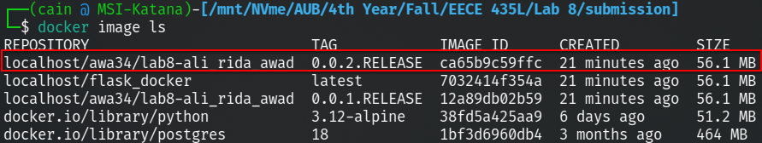
Validation
PASS: hello; Lab 5 create/list/read/update/delete; database-backed names; empty database; GET-only route. Temporary test data removed. Submitted database unchanged. Docker execution is a separate check.
Docker build/run and Docker Desktop screenshots could not be verified in the authoring environment because Docker is backed by Podman with an inaccessible runtime directory. Collect real evidence on a working Docker host using the included instructions. Local Flask tests do not establish Docker build success.
References
Lab 8-Docker,containers, and images.docx (provided handout, including the embedded image-tag example).
Docker image reference format: https://docs.docker.com/reference/cli/docker/image/tag/

