**Table of contents**

**Fieldwork question** 1

**Geographical Context** 1

**Hypothesis** 2

**Method of investigation** 3

**Traffic survey** 3

**Noise survey** 3

**Land use and building height** 3

**Data presentation and analysis** 3

**Hypothesis #1** 3

**Hypothesis #2** 4

**Hypothesis #3** 4

**Conclusion** 5

**Evaluation** 5

**Bibliography** 5

**Appendix** 5

# **Fieldwork question**

To what extent does urban stress change as distance from the centre of Astana increases?

The investigation focuses on urban environmental and social stressors and relates to the syllabus' optional theme G: Urban Environments. Younger populations are drawn to metropolitan regions because of the sophisticated lifestyle there. However, urbanization results in urban stress, a condition of physical, physiological, or emotional tension brought on by city living. Many things, including poor hygiene, traffic congestion, and pollution, might contribute to it. The purpose of this inquiry is to ascertain to what extent Astana experiences urban stress as the distance from its center changes.

# **Geographical Context**

The left side of Astana plays an important role in studying the level of urban stress away from the city center. This district is considered to be the administrative center and is the main administrative and political center of the capital of Kazakhstan. The geographical location and functional importance of the left side have a significant impact on the level of urban stress in the region and its change depending on the distance from the city center.

The left side of the city is a district of strategic importance, where important government agencies, offices, cultural and educational institutions are located. In addition, it has a high population density and developed infrastructure, which can cause tension and stress among residents.

The study of urban stress levels depending on the distance from the city center can reveal interesting trends. It is expected that the level of urban stress decreases with increasing distance from the left side and administrative centers. This can be explained by the calmer and less saturated urban environment, the absence of automobile traffic and noise, and easier access to the natural environment.

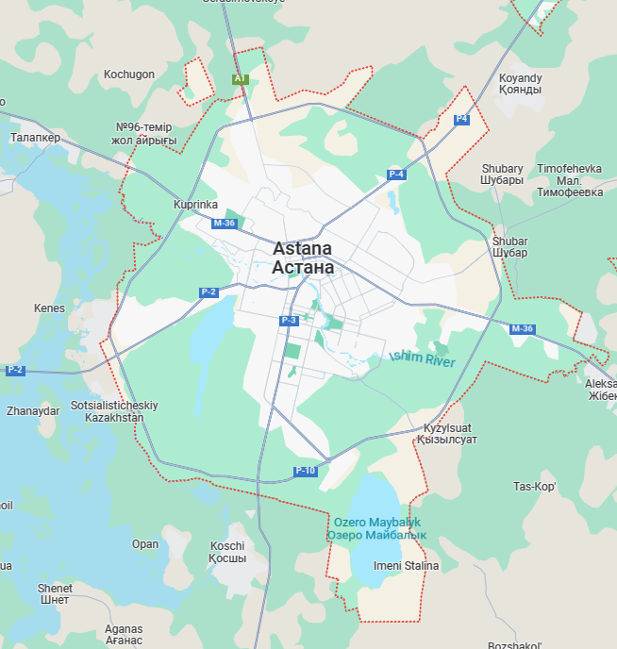

[Map 1. General area of Astana](https://www.google.kz/maps/place/Astana/@51.1400344,71.2216096,10.5z/data=!4m6!3m5!1s0x424580c47db54609:0x97f9148dddb19228!8m2!3d51.1655126!4d71.4272221!16zL20vMGZuMDg?hl=en&entry=ttu)

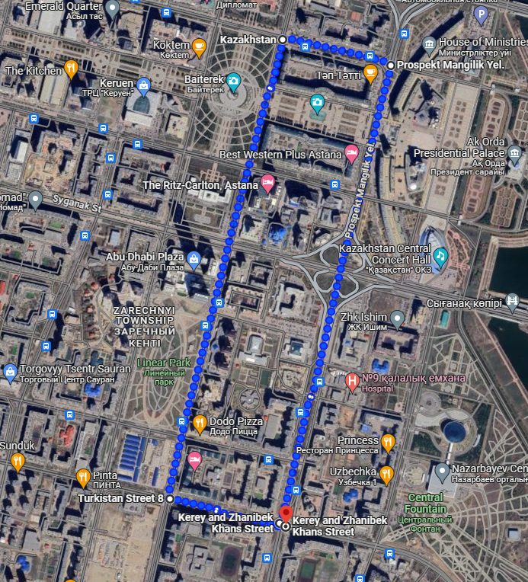

[Map 2. Area of routes](https://www.google.kz/maps/dir/51.1131096,71.4331005/51.1293188,71.4393518/51.1302139,71.4332523/51.1139859,71.4268948/51.113006,71.4334368/@51.1204056,71.4227692,2974m/am=t/data=!3m1!1e3!4m2!4m1!3e2?hl=en&entry=ttu)

# **Hypothesis**

1. As distance from the city centre of Astana will increase, noise pollution levels will decrease.

* Due to the concentration of human activities, including transportation, industry, and commercial facilities, noise pollution is frequently higher in densely populated metropolitan areas. This makes noise pollution a sign of urban stress. As one leaves Astana's city center, the population density and possibility of sources of noise pollution decrease. Therefore, it seems logical to expect that the level of noise pollution will decrease as one walks further away from the city center.

1. As the distance from the city centre of Astana will increase, traffic congestion will decrease.

* Traffic congestion is frequently more common in urban areas due to the higher population density, more economic activity, and more extensive transit networks. As one moves further from Astana's city center, it is projected that traffic intensity will decrease due to reduced population density and less commercial and industrial activity.

1. As the distance from the city centre of Astana will increase the land usage will decrease.

* The center areas of many cities tend to have denser land use since that is where institutional, residential, and commercial activity are concentrated. As one moves out from the city center, Astana's population density lowers and there are often more open areas. Furthermore, compared to the city center, outlying districts usually have more greenery, lower-rise buildings, and bigger home lots. Therefore, it makes sense to anticipate that as distance from the city center grows, land consumption will decrease.

# **Method of investigation**

This paper presents a research methodology used to collect and analyze data on three key aspects of road routes (noise pollution, traffic congestion, and land use) in an urban area. The main objective is to assess and understand the traffic dynamics, vehicle distribution, and congestion patterns along these routes. The study focused on five different road routes named 2a, 2b, 2c, 2d, and 2e.

## **Traffic survey.** A traffic survey is a method of collecting, analyzing, and evaluating data on the movement of vehicles on roads in a defined geographic area.

## **Noise survey.** Noise survey is a method of collecting and analyzing data on noise levels in a defined geographic area.

## **Land use and building height.** Land use and building height survey is a method used to analyze spatial planning and land use in urban environments.

For each route, data were collected sequentially according to the order specified in the route description. In addition, specific observations and non-routine events that occurred during the survey were recorded. These records provide context and valuable research findings on the current status of each route.

# **Data presentation and analysis**

## **Hypothesis #1**

This section analyzes in detail the noise data for the different routes (2a, 2b, 2c, 2d, and 2e). The following parameters are considered: distance (in meters), minimum noise level, maximum noise level, average noise level, and comments on the specific characteristics of each route.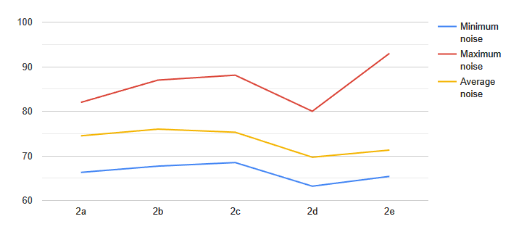

* + Differences in noise levels: noise levels on the different routes are different and have different characteristics. Routes 2c and 2e are characterized by high average noise levels (75.3 and 71.3 decibels, respectively) and Route 2d is characterized by low average noise levels (69.7 decibels).
  + Impact of traffic congestion: Routes 2a and 2d suffer from traffic congestion and have high noise levels. This is due to the idling engines of vehicles idling in traffic.

Proximity of Routes: Route 2e is adjacent to Route 2d, so noise sources on these routes may overlap. The close proximity between Routes 2a and 2c and Routes 2b and 2c may also affect noise levels.

## **Hypothesis #2**

The analysis analyzed the traffic characteristics of the different routes (2a, 2b, 2c, 2d and 2e). The main points are summarized below:

* + Difference in distance: the routes differ in length. Routes 2a and 2b are the longest (2000m and 990m respectively) and routes 2d and 2e are the shortest (140mi 1m respectively). These differences may affect traffic density and congestion levels.
  + Number of passenger vehicles: Route 2e is characterized by a high number of passenger vehicles (391), indicating a high number of car users in the city center. The number of passenger vehicles on other routes is not as high.
  + Public transport: Route 2c has a high number of buses (16), indicating that public transport is actively used in the area. Other routes have far fewer buses.
  + Trucks: Route 2b is characterized by a high number of trucks (16), which may be due to the nature of the road in this section. Routes 2d and 2e are also characterized by a high number of trucks (9 and 7 respectively).
  + City Center: Route 2e, passing through the city center, is characterized by the highest number of vehicles and, consequently, the highest traffic volume.

## **Hypothesis #3**

The hypothesis investigates the change in land use patterns along different routes (2a, 2b, 2c, 2d, and 2e) as distance from the center of Astana.

* Route 2a is characterized by a large number of commercial buildings, especially on the first floor of the Koktem residential complex. There is also a large parking lot, two public transport stops, and a small amount of open space. It should be noted that commercial premises are densely located in the basement of the Koktem residential complex, which creates traffic congestion problems.
* In contrast, Route 2b is characterized by an absence of residential and industrial uses, although some commercial and defense uses are present. The roads along this route are narrow and designed to accommodate both pedestrians and cyclists, which can cause inconvenience and conflicts.
* Route 2c includes commercial and public facilities as well as parking lots and bus parking lots. It is important to note that large parking lots are not efficient as they take up a lot of space and pose a hazard to pedestrians. The cleanliness of the area is assessed as good, however, the number of garbage cans is low.
* Route 2d is characterized by a variety of land uses including public facilities, parks, stops, and parking lots. There are no informal activities along this route. The route runs adjacent to Nurzhol Avenue and is heavily used by pedestrians. Solar panels on benches are a feature of this route, but their effectiveness is limited due to the lack of daylight.
* Route 2e is characterized by the absence of unused land plots. It is located near the center of Astana, where all land plots are used for various purposes, including residential buildings, business centers, parking lots and public transport stops. The development along the highway consists of multi-story buildings. There are no unused land plots along this alignment, but the condition of the buildings is assessed as unsatisfactory and the foundations of some buildings are damaged.

# **Conclusion**

The survey on the example of Astana showed that the level of urban stress varies depending on the distance from the city center. The level of noise pollution, which is one of the characteristics of urban stress, tends to decrease in remote areas. This is due to lower population density and less intensity of noise sources. Traffic congestion, another important element of urban stress, was also found to be less pronounced on remote routes. The land use study showed that the central district of Astana is characterized by denser land use, including residential and commercial buildings, parking lots, and public facilities. As one moves away from the center, building density decreases and open spaces become more abundant.

# **Evaluation**

It is important to note that urban stress has several negative consequences for urban residents. For example, high noise levels and traffic congestion lead to increased physical and mental discomfort and stress. This is especially true for people living or working near the city center, where these stressors are concentrated. On the other hand, areas farthest from the city center tend to be quieter urban environments with lower levels of noise and traffic congestion. However, access to infrastructure and services may be limited. The study also found that land use varies by city location. There is more intense land use near the city center, including many commercial buildings, while land use on the outskirts of the city is less intense and often idle.

Overall, this study provides a better understanding of the relationship between city location and urban stress. The findings will be useful for urban planning and creating a more pleasant urban environment for Astana residents. Further research could extend this analysis and provide a more complete picture of the factors affecting urban stress in modern megacities.