[](http://www.comsol.com/)

Proiect Default

|  |  |
| --- | --- |
| Date | Apr 20, 2020 5:12:19 PM |

Contents

1. Global Definitions

1.1. Parameters 1

2. Model 1 (mod1)

2.1. Definitions

2.2. Geometry 1

2.3. Materials

2.4. Electrostatics (es)

2.5. Mesh 1

3. Study 1

3.1. Stationary

3.2. Solver Configurations

4. Results

4.1. Data Sets

4.2. Plot Groups

1. Global Definitions
   1. Parameters 1

Parameters

| **Name** | **Expression** | **Description** |
| --- | --- | --- |
| l1 | 180 [um] |  |
| d1 | 30 [um] |  |
| h1 | 30 [um] |  |
| d2 | 10 [um] |  |
| l2 | 60 [um] |  |
| l3 | 150 [um] |  |
| wt | 5 [um] |  |
| d | 0 [um] |  |
| tens | 1 [V] |  |

1. Model 1 (mod1)
   1. Definitions
      1. Selections

#### tensiune

| **Selection type** |
| --- |
| Explicit |

| **Selection** |
| --- |
| Boundaries 45, 48–50, 53–55, 58–60, 63–65, 68–70, 73, 99–104, 161–162, 165–167, 170–172, 175–177, 180–182, 185–187, 190, 199, 204, 209, 214, 219 |

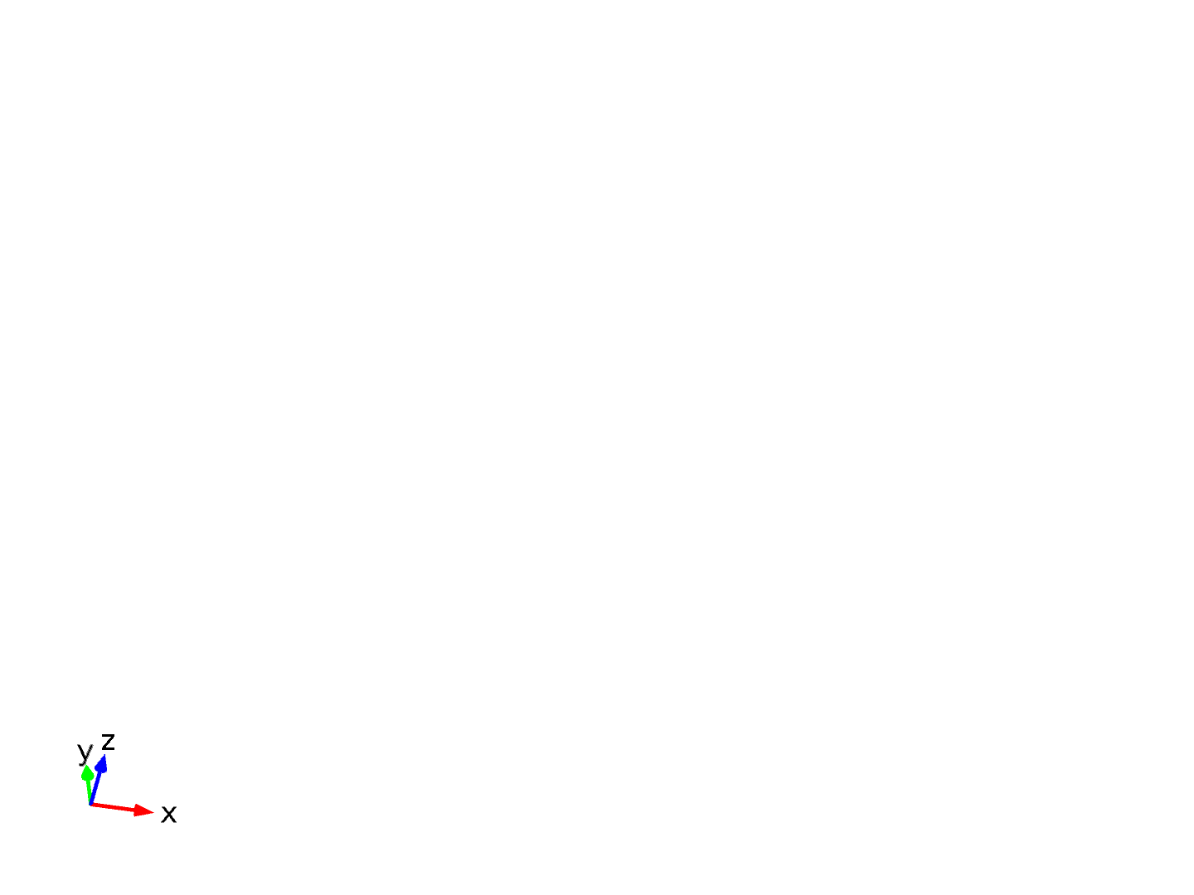

tensiune

#### ground

| **Selection type** |
| --- |
| Explicit |

| **Selection** |
| --- |
| Boundaries 74–75, 78–80, 83–85, 88–90, 93–95, 98, 105–106, 111, 116, 121, 126, 131, 134–136, 139–141, 144–146, 149–151, 154–156, 159–160, 191–195 |



ground

* + 1. Coordinate Systems

#### Boundary System 1

|  |  |
| --- | --- |
| Coordinate system type | Boundary system |
| Identifier | sys1 |

Settings

| **Name** | **Value** |
| --- | --- |
| Coordinate names | {t1, t2, n} |
| Create first tangent direction from | Global Cartesian |

* 1. Geometry 1

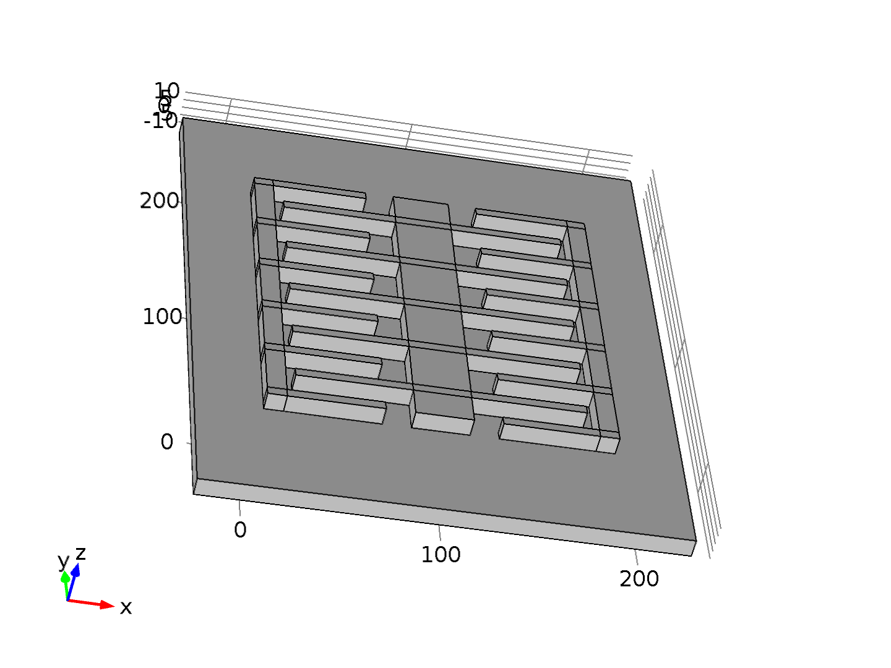

Geometry 1

Units

|  |  |
| --- | --- |
| Length unit | µm |
| Angular unit | deg |

Geometry statistics

| **Property** | **Value** |
| --- | --- |
| Space dimension | 3 |
| Number of domains | 5 |
| Number of boundaries | 237 |
| Number of edges | 472 |
| Number of vertices | 244 |

* + 1. placa (blk1)

Position

| **Name** | **Value** |
| --- | --- |
| Position | {-25, -50, -10} |

Size and shape

| **Name** | **Value** |
| --- | --- |
| Size | {250, 300, 10} |

* + 1. anod1 (blk2)

Position

| **Name** | **Value** |
| --- | --- |
| Position | {10, 10, 0} |

Size and shape

| **Name** | **Value** |
| --- | --- |
| Size | {10, 180, 10} |

* + 1. anod2 (blk3)

Position

| **Name** | **Value** |
| --- | --- |
| Position | {180, 10, 0} |

Size and shape

| **Name** | **Value** |
| --- | --- |
| Size | {10, 180, 10} |

* + 1. anod1_ 1 (blk6)

Position

| **Name** | **Value** |
| --- | --- |
| Position | {10, 10, 0} |

Size and shape

| **Name** | **Value** |
| --- | --- |
| Size | {l2, 5, 10} |

* + 1. anod1_ 2 (blk7)

Position

| **Name** | **Value** |
| --- | --- |
| Position | {10, 10 + 35, 0} |

Size and shape

| **Name** | **Value** |
| --- | --- |
| Size | {l2, 5, 10} |

* + 1. anod1_ 3 (blk8)

Position

| **Name** | **Value** |
| --- | --- |
| Position | {10, 10 + 35*2, 0} |

Size and shape

| **Name** | **Value** |
| --- | --- |
| Size | {l2, 5, 10} |

* + 1. anod1_ 4 (blk9)

Position

| **Name** | **Value** |
| --- | --- |
| Position | {10, 10 + 35*3, 0} |

Size and shape

| **Name** | **Value** |
| --- | --- |
| Size | {l2, 5, 10} |

* + 1. anod1_ 5 (blk10)

Position

| **Name** | **Value** |
| --- | --- |
| Position | {10, 10 + 35*4, 0} |

Size and shape

| **Name** | **Value** |
| --- | --- |
| Size | {l2, 5, 10} |

* + 1. anod1_ 6 (blk11)

Position

| **Name** | **Value** |
| --- | --- |
| Position | {10, 10 + 35*5, 0} |

Size and shape

| **Name** | **Value** |
| --- | --- |
| Size | {l2, 5, 10} |

* + 1. anod2_ 1 (blk13)

Position

| **Name** | **Value** |
| --- | --- |
| Position | {170 - l2 + 20, 10 + 35*0, 0} |

Size and shape

| **Name** | **Value** |
| --- | --- |
| Size | {l2, 5, 10} |

* + 1. anod2_ 2 (blk14)

Position

| **Name** | **Value** |
| --- | --- |
| Position | {170 - l2 + 20, 10 + 35*1, 0} |

Size and shape

| **Name** | **Value** |
| --- | --- |
| Size | {l2, 5, 10} |

* + 1. anod2_ 3 (blk15)

Position

| **Name** | **Value** |
| --- | --- |
| Position | {170 - l2 + 20, 10 + 35*2, 0} |

Size and shape

| **Name** | **Value** |
| --- | --- |
| Size | {l2, 5, 10} |

* + 1. anod2_ 4 (blk16)

Position

| **Name** | **Value** |
| --- | --- |
| Position | {170 - l2 + 20, 10 + 35*3, 0} |

Size and shape

| **Name** | **Value** |
| --- | --- |
| Size | {l2, 5, 10} |

* + 1. anod2_ 5 (blk17)

Position

| **Name** | **Value** |
| --- | --- |
| Position | {170 - l2 + 20, 10 + 35*4, 0} |

Size and shape

| **Name** | **Value** |
| --- | --- |
| Size | {l2, 5, 10} |

* + 1. anod2_ 6 (blk18)

Position

| **Name** | **Value** |
| --- | --- |
| Position | {170 - l2 + 20, 10 + 35*5, 0} |

Size and shape

| **Name** | **Value** |
| --- | --- |
| Size | {l2, 5, 10} |

* + 1. anod_1 (uni1)

Selections of resulting entities

| **Name** | **Value** |
| --- | --- |
| Keep interior boundaries | Off |
| Face | All |

* + 1. anod_2 (uni2)

Selections of resulting entities

| **Name** | **Value** |
| --- | --- |
| Keep interior boundaries | Off |
| Face | All |

* + 1. mobil (blk4)

Position

| **Name** | **Value** |
| --- | --- |
| Position | {100, 100 + d, 5} |
| Base | Center |

Size and shape

| **Name** | **Value** |
| --- | --- |
| Size | {d1, l1, 10} |

* + 1. mobil_ 1 (blk20)

Position

| **Name** | **Value** |
| --- | --- |
| Position | {100, 30 + 35*0 + d, 5} |
| Base | Center |

Size and shape

| **Name** | **Value** |
| --- | --- |
| Size | {l3, wt, 10} |

* + 1. mobil_ 2 (blk21)

Position

| **Name** | **Value** |
| --- | --- |
| Position | {100, 30 + 35*1 + d, 5} |
| Base | Center |

Size and shape

| **Name** | **Value** |
| --- | --- |
| Size | {l3, wt, 10} |

* + 1. mobil_ 3 (blk22)

Position

| **Name** | **Value** |
| --- | --- |
| Position | {100, 30 + 35*2 + d, 5} |
| Base | Center |

Size and shape

| **Name** | **Value** |
| --- | --- |
| Size | {l3, wt, 10} |

* + 1. mobil_ 4 (blk23)

Position

| **Name** | **Value** |
| --- | --- |
| Position | {100, 30 + 35*3 + d, 5} |
| Base | Center |

Size and shape

| **Name** | **Value** |
| --- | --- |
| Size | {l3, wt, 10} |

* + 1. mobil_ 5 (blk24)

Position

| **Name** | **Value** |
| --- | --- |
| Position | {100, 30 + 35*4 + d, 5} |
| Base | Center |

Size and shape

| **Name** | **Value** |
| --- | --- |
| Size | {l3, wt, 10} |

* + 1. Union 3 (uni3)

Selections of resulting entities

| **Name** | **Value** |
| --- | --- |
| Keep interior boundaries | Off |
| Face | All |

* + 1. aer (blk25)

Position

| **Name** | **Value** |
| --- | --- |
| Position | {-25, -50, 0} |

Size and shape

| **Name** | **Value** |
| --- | --- |
| Size | {250, 300, 100} |

* + 1. Difference 1 (dif1)

Selections of resulting entities

| **Name** | **Value** |
| --- | --- |
| Keep input objects | On |
| Keep interior boundaries | Off |
| Face | All |

* 1. Materials
     1. Copper



Copper

Selection

|  |  |
| --- | --- |
| Geometric entity level | Domain |
| Selection | Domains 3–5 |

Material parameters

| **Name** | **Value** | **Unit** |
| --- | --- | --- |
| Relative permittivity | 1 | 1 |

Basic Settings

| **Description** | **Value** |
| --- | --- |
| Relative permeability | {{1, 0, 0}, {0, 1, 0}, {0, 0, 1}} |
| Electrical conductivity | {{5.998e7[S/m], 0, 0}, {0, 5.998e7[S/m], 0}, {0, 0, 5.998e7[S/m]}} |
| Coefficient of thermal expansion | {{17e-6[1/K], 0, 0}, {0, 17e-6[1/K], 0}, {0, 0, 17e-6[1/K]}} |
| Heat capacity at constant pressure | 385[J/(kg*K)] |
| Relative permittivity | {{1, 0, 0}, {0, 1, 0}, {0, 0, 1}} |
| Density | 8700[kg/m^3] |
| Thermal conductivity | {{400[W/(m*K)], 0, 0}, {0, 400[W/(m*K)], 0}, {0, 0, 400[W/(m*K)]}} |

Young's modulus and Poisson's ratio Settings

| **Description** | **Value** |
| --- | --- |
| Young's modulus | 110e9[Pa] |
| Poisson's ratio | 0.35 |

Linearized resistivity Settings

| **Description** | **Value** |
| --- | --- |
| Reference resistivity | 1.72e-8[ohm*m] |
| Resistivity temperature coefficient | 0.0039[1/K] |
| Reference temperature | 298[K] |

* + 1. Silicon



Silicon

Selection

|  |  |
| --- | --- |
| Geometric entity level | Domain |
| Selection | Domain 1 |

Material parameters

| **Name** | **Value** | **Unit** |
| --- | --- | --- |
| Relative permittivity | 11.7 | 1 |

Basic Settings

| **Description** | **Value** |
| --- | --- |
| Relative permittivity | {{11.7, 0, 0}, {0, 11.7, 0}, {0, 0, 11.7}} |
| Thermal conductivity | {{131[W/(m*K)], 0, 0}, {0, 131[W/(m*K)], 0}, {0, 0, 131[W/(m*K)]}} |
| Density | 2329[kg/m^3] |
| Heat capacity at constant pressure | 700[J/(kg*K)] |

Semiconductor material Settings

| **Description** | **Value** |
| --- | --- |
| Band gap | 1.12[V] |
| Electron affinity | 4.05[V] |
| Effective density of states, valence band | (T/300[K])^(3/2)*1.04e19[1/cm^3] |
| Effective density of states, conduction band | (T/300[K])^(3/2)*2.8e19[1/cm^3] |
| Electron mobility | 1450[cm^2/(V*s)] |
| Hole mobility | 500[cm^2/(V*s)] |

Arora mobility model Settings

| **Description** | **Value** |
| --- | --- |
| Electron mobility reference | 1252[cm^2/(V*s)] |
| Hole mobility reference | 407[cm^2/(V*s)] |
| Electron mobility reference minimum | 88[cm^2/(V*s)] |
| Hole mobility reference minimum | 54.3[cm^2/(V*s)] |
| Electron reference impurity concentration | 1.26e17[1/cm^3] |
| Hole reference impurity concentration | 2.35e17[1/cm^3] |
| Alpha coefficient | 0.88 |
| Mobility reference minimum exponent | -0.57 |
| Mobility reference exponent | -2.33 |
| Impurity concentration reference exponent | -2.33 |
| Alpha coefficient exponent | -0.146 |
| Reference temperature | 300[K] |

Power law mobility model Settings

| **Description** | **Value** |
| --- | --- |
| Electron mobility reference | 1448[cm^2/(V*s)] |
| Hole mobility reference | 473[cm^2/(V*s)] |
| Electron exponent | 2.33 |
| Hole exponent | 2.23 |
| Reference temperature | 300[K] |

Auger recombination Settings

| **Description** | **Value** |
| --- | --- |
| Auger recombination factor, electrons | 2.8e-31[cm^6/s] |
| Auger recombination factor, holes | 9.9e-32[cm^6/s] |

Direct recombination Settings

| **Description** | **Value** |
| --- | --- |
| Direct recombination factor | 0[cm^3/s] |

Shockley-Read-Hall recombination Settings

| **Description** | **Value** |
| --- | --- |
| Electron lifetime, SRH | 10[us] |
| Hole lifetime, SRH | 10[us] |

* + 1. Air



Air

Selection

|  |  |
| --- | --- |
| Geometric entity level | Domain |
| Selection | Domain 2 |

Material parameters

| **Name** | **Value** | **Unit** |
| --- | --- | --- |
| Relative permittivity | 1 | 1 |

Basic Settings

| **Description** | **Value** |
| --- | --- |
| Relative permeability | {{1, 0, 0}, {0, 1, 0}, {0, 0, 1}} |
| Relative permittivity | {{1, 0, 0}, {0, 1, 0}, {0, 0, 1}} |
| Dynamic viscosity | eta(T[1/K])[Pa*s] |
| Ratio of specific heats | 1.4 |
| Electrical conductivity | {{0[S/m], 0, 0}, {0, 0[S/m], 0}, {0, 0, 0[S/m]}} |
| Heat capacity at constant pressure | Cp(T[1/K])[J/(kg*K)] |
| Density | rho(pA[1/Pa], T[1/K])[kg/m^3] |
| Thermal conductivity | {{k(T[1/K])[W/(m*K)], 0, 0}, {0, k(T[1/K])[W/(m*K)], 0}, {0, 0, k(T[1/K])[W/(m*K)]}} |
| Speed of sound | cs(T[1/K])[m/s] |

Functions

| **Function name** | **Type** |
| --- | --- |
| eta | Piecewise |
| Cp | Piecewise |
| rho | Analytic |
| k | Piecewise |
| cs | Analytic |

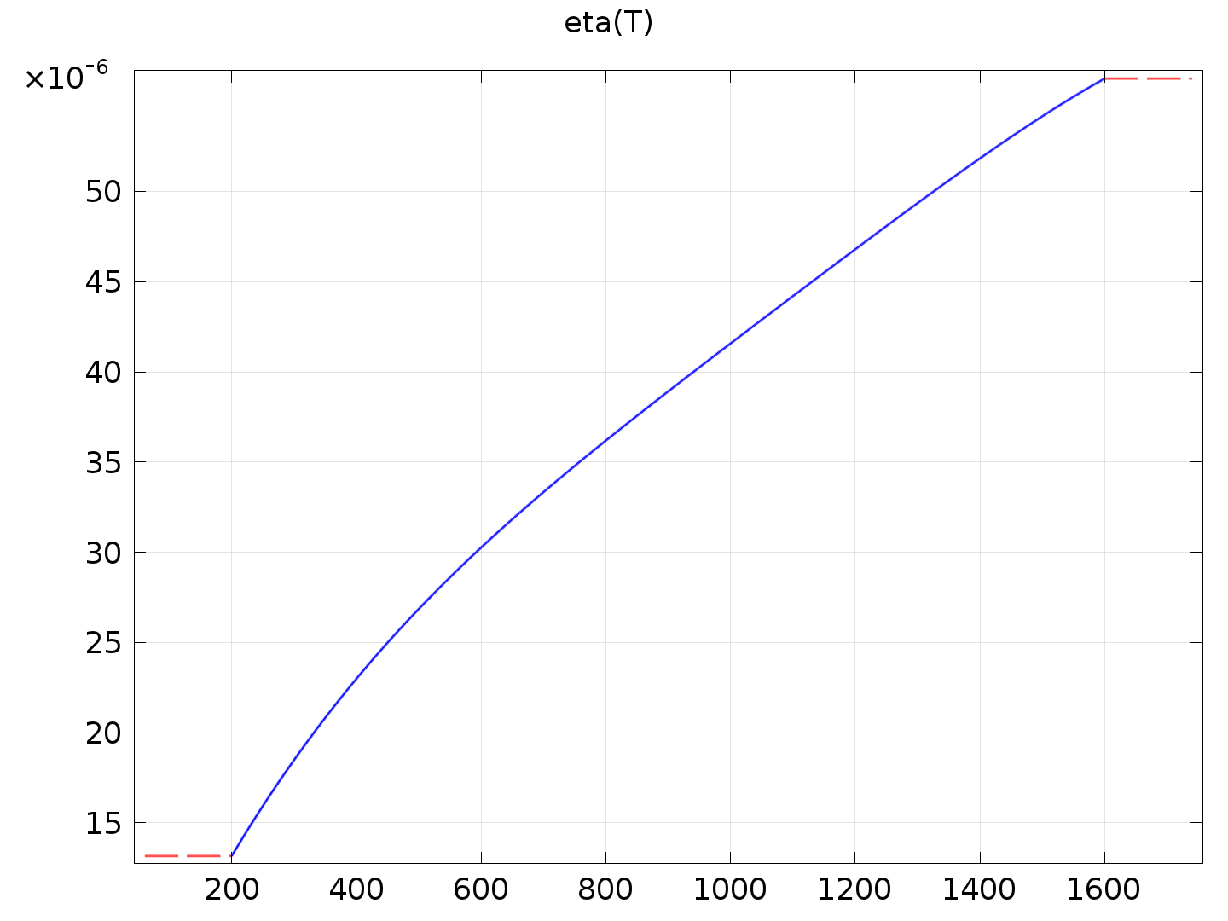

eta

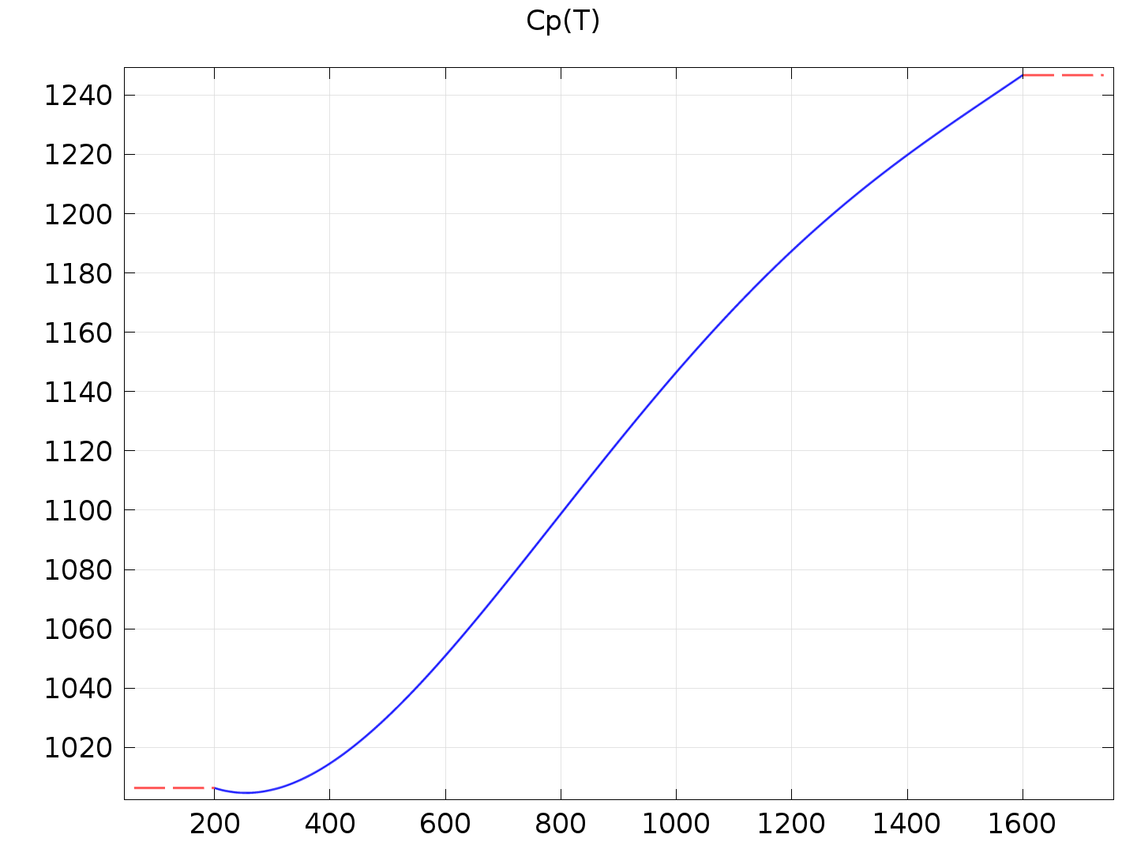

Cp

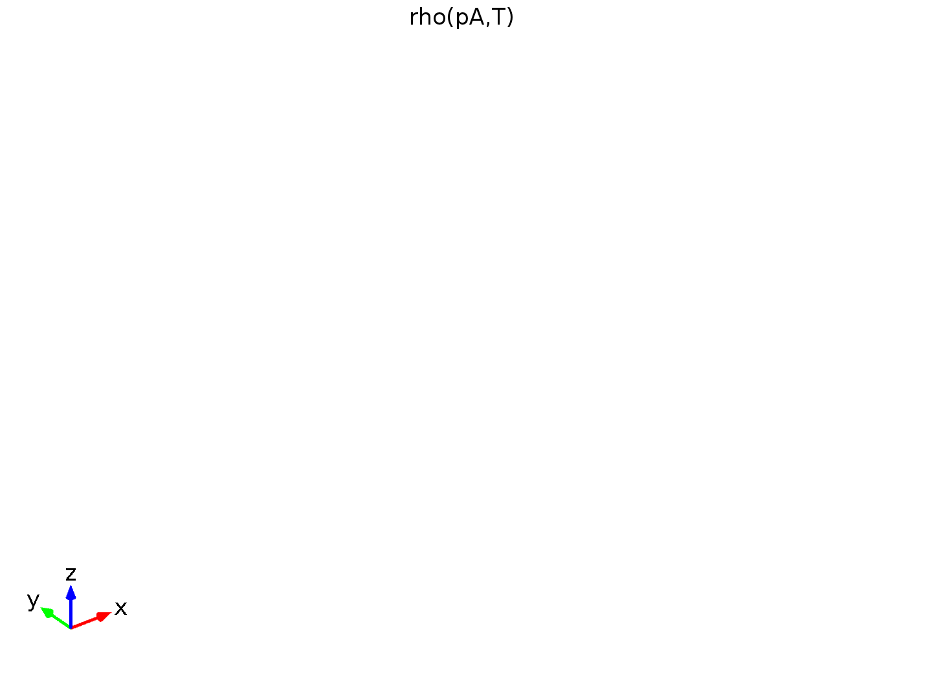

rho

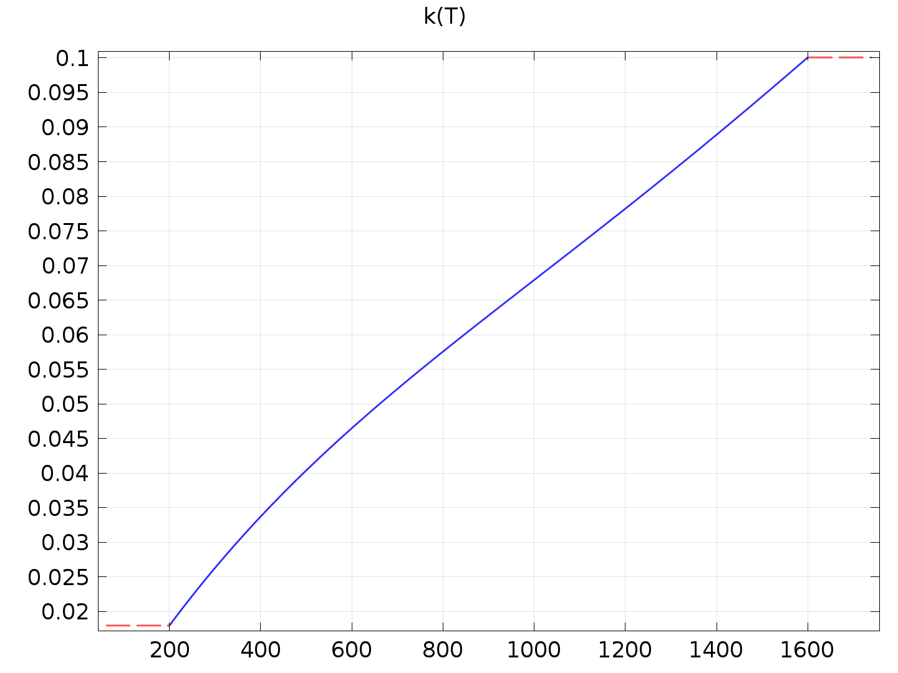

k

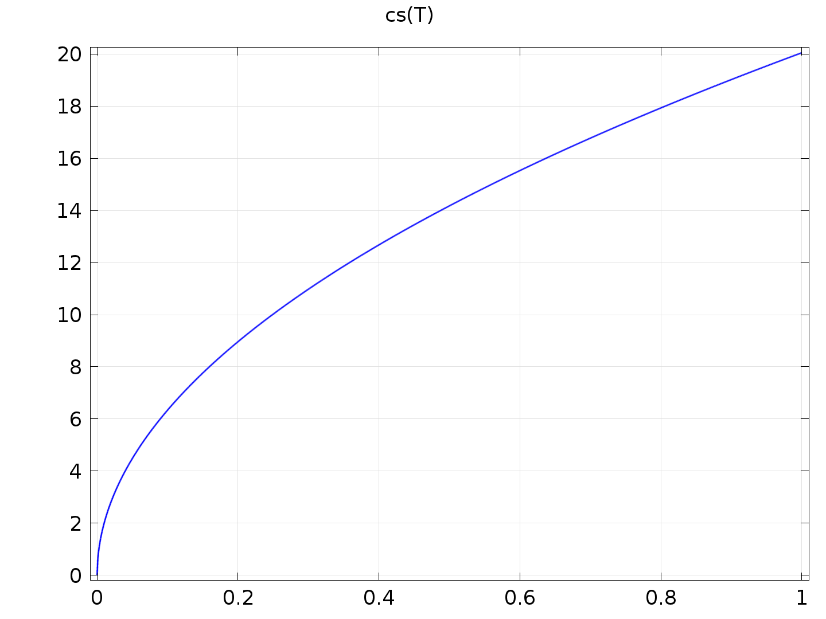

cs

Refractive index Settings

| **Description** | **Value** |
| --- | --- |
| Refractive index | {{1, 0, 0}, {0, 1, 0}, {0, 0, 1}} |
| Refractive index, imaginary part | {{0, 0, 0}, {0, 0, 0}, {0, 0, 0}} |

* 1. Electrostatics (es)



Electrostatics

Selection

|  |  |
| --- | --- |
| Geometric entity level | Domain |
| Selection | Domains 1–5 |

Equations





Settings

| **Description** | **Value** |
| --- | --- |
| Electric potential | Quadratic |
| Value type when using splitting of complex variables | Complex |
| Equation form | Study controlled |
| Activate terminal sweep | 0 |
| Sweep on | Terminals |
| Reference impedance | 50[ohm] |
| Parameter to export | Z |
| Show equation assuming | std1/stat |

Used products

|  |
| --- |
| COMSOL Multiphysics |
| AC/DC Module |

* + 1. Charge Conservation 1



Charge Conservation 1

Selection

|  |  |
| --- | --- |
| Geometric entity level | Domain |
| Selection | Domains 1–5 |

Equations





#### Settings

Settings

| **Description** | **Value** |
| --- | --- |
| Constitutive relation | Relative permittivity |
| Relative permittivity | From material |
| Relative permittivity | {{1, 0, 0}, {0, 1, 0}, {0, 0, 1}} |

#### Used products

|  |
| --- |
| COMSOL Multiphysics |

Properties from material

| **Property** | **Material** | **Property group** |
| --- | --- | --- |
| Relative permittivity | Copper | Basic |
| Relative permittivity | Silicon | Basic |
| Relative permittivity | Air | Basic |

#### Variables

| **Name** | **Expression** | **Unit** | **Description** | **Selection** |
| --- | --- | --- | --- | --- |
| es.unTex | -0.5*es.dnx*(real(up(es.Dx))*real(up(es.Ex))+real(up(es.Dy))*real(up(es.Ey))+real(up(es.Dz))*real(up(es.Ez)))+real(up(es.Dx))*(real(up(es.Ex))*es.dnx+real(up(es.Ey))*es.dny+real(up(es.Ez))*es.dnz) | Pa | Maxwell upward electric surface stress tensor, x component | Boundaries 6, 10–235 |
| es.unTey | -0.5*es.dny*(real(up(es.Dx))*real(up(es.Ex))+real(up(es.Dy))*real(up(es.Ey))+real(up(es.Dz))*real(up(es.Ez)))+real(up(es.Dy))*(real(up(es.Ex))*es.dnx+real(up(es.Ey))*es.dny+real(up(es.Ez))*es.dnz) | Pa | Maxwell upward electric surface stress tensor, y component | Boundaries 6, 10–235 |
| es.unTez | -0.5*es.dnz*(real(up(es.Dx))*real(up(es.Ex))+real(up(es.Dy))*real(up(es.Ey))+real(up(es.Dz))*real(up(es.Ez)))+real(up(es.Dz))*(real(up(es.Ex))*es.dnx+real(up(es.Ey))*es.dny+real(up(es.Ez))*es.dnz) | Pa | Maxwell upward electric surface stress tensor, z component | Boundaries 6, 10–235 |
| es.dnTex | -0.5*es.unx*(real(down(es.Dx))*real(down(es.Ex))+real(down(es.Dy))*real(down(es.Ey))+real(down(es.Dz))*real(down(es.Ez)))+real(down(es.Dx))*(real(down(es.Ex))*es.unx+real(down(es.Ey))*es.uny+real(down(es.Ez))*es.unz) | Pa | Maxwell downward electric surface stress tensor, x component | Boundaries 6, 10–235 |
| es.dnTey | -0.5*es.uny*(real(down(es.Dx))*real(down(es.Ex))+real(down(es.Dy))*real(down(es.Ey))+real(down(es.Dz))*real(down(es.Ez)))+real(down(es.Dy))*(real(down(es.Ex))*es.unx+real(down(es.Ey))*es.uny+real(down(es.Ez))*es.unz) | Pa | Maxwell downward electric surface stress tensor, y component | Boundaries 6, 10–235 |
| es.dnTez | -0.5*es.unz*(real(down(es.Dx))*real(down(es.Ex))+real(down(es.Dy))*real(down(es.Ey))+real(down(es.Dz))*real(down(es.Ez)))+real(down(es.Dz))*(real(down(es.Ex))*es.unx+real(down(es.Ey))*es.uny+real(down(es.Ez))*es.unz) | Pa | Maxwell downward electric surface stress tensor, z component | Boundaries 6, 10–235 |
| es.dnTex | -0.5*es.unx*(real(down(es.Dx))*real(down(es.Ex))+real(down(es.Dy))*real(down(es.Ey))+real(down(es.Dz))*real(down(es.Ez)))+real(down(es.Dx))*(real(down(es.Ex))*es.unx+real(down(es.Ey))*es.uny+real(down(es.Ez))*es.unz) | Pa | Maxwell downward electric surface stress tensor, x component | Boundaries 1–5, 7–9, 236–237 |
| es.dnTey | -0.5*es.uny*(real(down(es.Dx))*real(down(es.Ex))+real(down(es.Dy))*real(down(es.Ey))+real(down(es.Dz))*real(down(es.Ez)))+real(down(es.Dy))*(real(down(es.Ex))*es.unx+real(down(es.Ey))*es.uny+real(down(es.Ez))*es.unz) | Pa | Maxwell downward electric surface stress tensor, y component | Boundaries 1–5, 7–9, 236–237 |
| es.dnTez | -0.5*es.unz*(real(down(es.Dx))*real(down(es.Ex))+real(down(es.Dy))*real(down(es.Ey))+real(down(es.Dz))*real(down(es.Ez)))+real(down(es.Dz))*(real(down(es.Ex))*es.unx+real(down(es.Ey))*es.uny+real(down(es.Ez))*es.unz) | Pa | Maxwell downward electric surface stress tensor, z component | Boundaries 1–5, 7–9, 236–237 |
| es.Ex | -Vx | V/m | Electric field, x component | Domains 1–5 |
| es.Ey | -Vy | V/m | Electric field, y component | Domains 1–5 |
| es.Ez | -Vz | V/m | Electric field, z component | Domains 1–5 |
| es.tEx | -VTx | V/m | Tangential electric field, x component | Boundaries 1–237 |
| es.tEy | -VTy | V/m | Tangential electric field, y component | Boundaries 1–237 |
| es.tEz | -VTz | V/m | Tangential electric field, z component | Boundaries 1–237 |
| es.normE | sqrt(realdot(es.Ex,es.Ex)+realdot(es.Ey,es.Ey)+realdot(es.Ez,es.Ez)) | V/m | Electric field norm | Domains 1–5 |
| es.Jdx | 0 | A/m^2 | Displacement current density, x component | Domains 1–5 |
| es.Jdy | 0 | A/m^2 | Displacement current density, y component | Domains 1–5 |
| es.Jdz | 0 | A/m^2 | Displacement current density, z component | Domains 1–5 |
| es.Jx | es.Jdx | A/m^2 | Current density, x component | Domains 1–5 |
| es.Jy | es.Jdy | A/m^2 | Current density, y component | Domains 1–5 |
| es.Jz | es.Jdz | A/m^2 | Current density, z component | Domains 1–5 |
| es.epsilonrxx | model.input.epsilonr11 | 1 | Relative permittivity, xx component | Domains 3–5 |
| es.epsilonryx | model.input.epsilonr21 | 1 | Relative permittivity, yx component | Domains 3–5 |
| es.epsilonrzx | model.input.epsilonr31 | 1 | Relative permittivity, zx component | Domains 3–5 |
| es.epsilonrxy | model.input.epsilonr12 | 1 | Relative permittivity, xy component | Domains 3–5 |
| es.epsilonryy | model.input.epsilonr22 | 1 | Relative permittivity, yy component | Domains 3–5 |
| es.epsilonrzy | model.input.epsilonr32 | 1 | Relative permittivity, zy component | Domains 3–5 |
| es.epsilonrxz | model.input.epsilonr13 | 1 | Relative permittivity, xz component | Domains 3–5 |
| es.epsilonryz | model.input.epsilonr23 | 1 | Relative permittivity, yz component | Domains 3–5 |
| es.epsilonrzz | model.input.epsilonr33 | 1 | Relative permittivity, zz component | Domains 3–5 |
| es.epsilonrxx | model.input.epsilonr11 | 1 | Relative permittivity, xx component | Domain 1 |
| es.epsilonryx | model.input.epsilonr21 | 1 | Relative permittivity, yx component | Domain 1 |
| es.epsilonrzx | model.input.epsilonr31 | 1 | Relative permittivity, zx component | Domain 1 |
| es.epsilonrxy | model.input.epsilonr12 | 1 | Relative permittivity, xy component | Domain 1 |
| es.epsilonryy | model.input.epsilonr22 | 1 | Relative permittivity, yy component | Domain 1 |
| es.epsilonrzy | model.input.epsilonr32 | 1 | Relative permittivity, zy component | Domain 1 |
| es.epsilonrxz | model.input.epsilonr13 | 1 | Relative permittivity, xz component | Domain 1 |
| es.epsilonryz | model.input.epsilonr23 | 1 | Relative permittivity, yz component | Domain 1 |
| es.epsilonrzz | model.input.epsilonr33 | 1 | Relative permittivity, zz component | Domain 1 |
| es.epsilonrxx | model.input.epsilonr11 | 1 | Relative permittivity, xx component | Domain 2 |
| es.epsilonryx | model.input.epsilonr21 | 1 | Relative permittivity, yx component | Domain 2 |
| es.epsilonrzx | model.input.epsilonr31 | 1 | Relative permittivity, zx component | Domain 2 |
| es.epsilonrxy | model.input.epsilonr12 | 1 | Relative permittivity, xy component | Domain 2 |
| es.epsilonryy | model.input.epsilonr22 | 1 | Relative permittivity, yy component | Domain 2 |
| es.epsilonrzy | model.input.epsilonr32 | 1 | Relative permittivity, zy component | Domain 2 |
| es.epsilonrxz | model.input.epsilonr13 | 1 | Relative permittivity, xz component | Domain 2 |
| es.epsilonryz | model.input.epsilonr23 | 1 | Relative permittivity, yz component | Domain 2 |
| es.epsilonrzz | model.input.epsilonr33 | 1 | Relative permittivity, zz component | Domain 2 |
| es.Dx | epsilon0_const*es.Ex+es.Px | C/m^2 | Electric displacement field, x component | Domains 1–5 |
| es.Dy | epsilon0_const*es.Ey+es.Py | C/m^2 | Electric displacement field, y component | Domains 1–5 |
| es.Dz | epsilon0_const*es.Ez+es.Pz | C/m^2 | Electric displacement field, z component | Domains 1–5 |
| es.Px | epsilon0_const*(es.chixx*es.Ex+es.chixy*es.Ey+es.chixz*es.Ez) | C/m^2 | Polarization, x component | Domains 1–5 |
| es.Py | epsilon0_const*(es.chiyx*es.Ex+es.chiyy*es.Ey+es.chiyz*es.Ez) | C/m^2 | Polarization, y component | Domains 1–5 |
| es.Pz | epsilon0_const*(es.chizx*es.Ex+es.chizy*es.Ey+es.chizz*es.Ez) | C/m^2 | Polarization, z component | Domains 1–5 |
| es.chixx | -1+es.epsilonrxx | 1 | Electric susceptibility, xx component | Domains 1–5 |
| es.chiyx | es.epsilonryx | 1 | Electric susceptibility, yx component | Domains 1–5 |
| es.chizx | es.epsilonrzx | 1 | Electric susceptibility, zx component | Domains 1–5 |
| es.chixy | es.epsilonrxy | 1 | Electric susceptibility, xy component | Domains 1–5 |
| es.chiyy | -1+es.epsilonryy | 1 | Electric susceptibility, yy component | Domains 1–5 |
| es.chizy | es.epsilonrzy | 1 | Electric susceptibility, zy component | Domains 1–5 |
| es.chixz | es.epsilonrxz | 1 | Electric susceptibility, xz component | Domains 1–5 |
| es.chiyz | es.epsilonryz | 1 | Electric susceptibility, yz component | Domains 1–5 |
| es.chizz | -1+es.epsilonrzz | 1 | Electric susceptibility, zz component | Domains 1–5 |
| es.normD | sqrt(realdot(es.Dx,es.Dx)+realdot(es.Dy,es.Dy)+realdot(es.Dz,es.Dz)) | C/m^2 | Electric displacement field norm | Domains 1–5 |
| es.normP | sqrt(realdot(es.Px,es.Px)+realdot(es.Py,es.Py)+realdot(es.Pz,es.Pz)) | C/m^2 | Polarization norm | Domains 1–5 |
| es.unTx | 0 | Pa | Maxwell upward surface stress tensor, x component | Boundaries 1–5, 7–9, 236–237 |
| es.unTy | 0 | Pa | Maxwell upward surface stress tensor, y component | Boundaries 1–5, 7–9, 236–237 |
| es.unTz | 0 | Pa | Maxwell upward surface stress tensor, z component | Boundaries 1–5, 7–9, 236–237 |
| es.unTx | es.unTex | Pa | Maxwell upward surface stress tensor, x component | Boundaries 6, 10–235 |
| es.unTy | es.unTey | Pa | Maxwell upward surface stress tensor, y component | Boundaries 6, 10–235 |
| es.unTz | es.unTez | Pa | Maxwell upward surface stress tensor, z component | Boundaries 6, 10–235 |
| es.dnTx | es.dnTex | Pa | Maxwell downward surface stress tensor, x component | Boundaries 1–5, 7–9, 236–237 |
| es.dnTy | es.dnTey | Pa | Maxwell downward surface stress tensor, y component | Boundaries 1–5, 7–9, 236–237 |
| es.dnTz | es.dnTez | Pa | Maxwell downward surface stress tensor, z component | Boundaries 1–5, 7–9, 236–237 |
| es.dnTx | es.dnTex | Pa | Maxwell downward surface stress tensor, x component | Boundaries 6, 10–235 |
| es.dnTy | es.dnTey | Pa | Maxwell downward surface stress tensor, y component | Boundaries 6, 10–235 |
| es.dnTz | es.dnTez | Pa | Maxwell downward surface stress tensor, z component | Boundaries 6, 10–235 |
| es.unx | unx |  | Normal vector up direction, x component | Boundaries 1–237 |
| es.uny | uny |  | Normal vector up direction, y component | Boundaries 1–237 |
| es.unz | unz |  | Normal vector up direction, z component | Boundaries 1–237 |
| es.dnx | dnx |  | Normal vector down direction, x component | Boundaries 1–237 |
| es.dny | dny |  | Normal vector down direction, y component | Boundaries 1–237 |
| es.dnz | dnz |  | Normal vector down direction, z component | Boundaries 1–237 |
| es.W | es.We | J/m^3 | Energy density | Domains 1–5 |
| es.dWe | es.We | J/m^3 | Integrand for total electric energy | Domains 1–5 |
| es.We | 0.5*epsilon0_const*((es.epsilonrxx*es.Ex+es.epsilonrxy*es.Ey+es.epsilonrxz*es.Ez)*es.Ex+(es.epsilonryx*es.Ex+es.epsilonryy*es.Ey+es.epsilonryz*es.Ez)*es.Ey+(es.epsilonrzx*es.Ex+es.epsilonrzy*es.Ey+es.epsilonrzz*es.Ez)*es.Ez) | J/m^3 | Electric energy density | Domains 1–5 |
| es.ccn1.minput_temperature | model.input.minput_temperature | K | Temperature | Domains 1–5 |
| es.ccn1.minput_pressure | 1[atm] | Pa | Absolute pressure | Domains 1–5 |

#### Shape functions

| **Name** | **Shape function** | **Unit** | **Description** | **Shape frame** | **Selection** |
| --- | --- | --- | --- | --- | --- |
| V | Lagrange (Quadratic) | V | Electric potential | Material | Domains 1–5 |

#### Weak expressions

| **Weak expression** | **Integration frame** | **Selection** |
| --- | --- | --- |
| (-es.Px*test(Vx)-es.Py*test(Vy)-es.Pz*test(Vz))*es.d | Material | Domains 1–5 |
| epsilon0_const*(-es.Ex*test(Vx)-es.Ey*test(Vy)-es.Ez*test(Vz))*es.d | Material | Domains 1–5 |

* + 1. Zero Charge 1



Zero Charge 1

Selection

|  |  |
| --- | --- |
| Geometric entity level | Boundary |
| Selection | Boundaries 1–5, 7–9, 236–237 |

Equations



#### Used products

|  |
| --- |
| COMSOL Multiphysics |

#### Variables

| **Name** | **Expression** | **Unit** | **Description** | **Selection** |
| --- | --- | --- | --- | --- |
| es.nD | 0 | C/m^2 | Surface charge density | Boundaries 1–5, 7–9, 236–237 |

#### Shape functions

| **Name** | **Shape function** | **Unit** | **Description** | **Shape frame** | **Selection** |
| --- | --- | --- | --- | --- | --- |
| V | Lagrange (Quadratic) | V | Electric potential | Material | No boundaries |

* + 1. Initial Values 1



Initial Values 1

Selection

|  |  |
| --- | --- |
| Geometric entity level | Domain |
| Selection | Domains 1–5 |

#### Settings

Settings

| **Description** | **Value** |
| --- | --- |
| Electric potential | 0 |

#### Used products

|  |
| --- |
| COMSOL Multiphysics |

* + 1. Terminal 1



Terminal 1

Selection

|  |  |
| --- | --- |
| Geometric entity level | Boundary |
| Selection | Boundaries 45, 48–50, 53–55, 58–60, 63–65, 68–70, 73, 99–104, 161–162, 165–167, 170–172, 175–177, 180–182, 185–187, 190, 199, 204, 209, 214, 219 |

Equations



#### Settings

Settings

| **Description** | **Value** |
| --- | --- |
| Terminal name | 1 |
| Terminal type | Voltage |
| Voltage | tens |
| Current | User defined |
| Current | 0 |
| Apply reaction terms on | All physics (symmetric) |

#### Variables

| **Name** | **Expression** | **Unit** | **Description** | **Selection** |
| --- | --- | --- | --- | --- |
| es.nD | es.unx*(down(es.Dx)-up(es.Dx))+es.uny*(down(es.Dy)-up(es.Dy))+es.unz*(down(es.Dz)-up(es.Dz)) | C/m^2 | Surface charge density | Boundaries 45, 48–50, 53–55, 58–60, 63–65, 68–70, 73, 99–104, 161–162, 165–167, 170–172, 175–177, 180–182, 185–187, 190, 199, 204, 209, 214, 219 |
| es.term1.V0 | tens | V | Voltage | Global |
| es.term1.I_cir | model.input.I_cir | A | Current | Global |
| es.Q0_1 | -es.term1.sum(reacf(V)) | C | Terminal charge | Global |
| es.Vterm | es.term1.V0 | V | Voltage | Boundaries 45, 48–50, 53–55, 58–60, 63–65, 68–70, 73, 99–104, 161–162, 165–167, 170–172, 175–177, 180–182, 185–187, 190, 199, 204, 209, 214, 219 |
| es.V0_1 | es.term1.int(es.Vterm)/es.term1.int(1) | V | Terminal voltage | Global |

#### Constraints

| **Constraint** | **Constraint force** | **Shape function** | **Selection** |
| --- | --- | --- | --- |
| es.Vterm-V | test(es.Vterm-V) | Lagrange (Quadratic) | Boundaries 45, 48–50, 53–55, 58–60, 63–65, 68–70, 73, 99–104, 161–162, 165–167, 170–172, 175–177, 180–182, 185–187, 190, 199, 204, 209, 214, 219 |

* + 1. Ground 1



Ground 1

Selection

|  |  |
| --- | --- |
| Geometric entity level | Boundary |
| Selection | Boundaries 74–75, 78–80, 83–85, 88–90, 93–95, 98, 105–106, 111, 116, 121, 126, 131, 134–136, 139–141, 144–146, 149–151, 154–156, 159–160, 191–195 |

Equations



#### Settings

Settings

| **Description** | **Value** |
| --- | --- |
| Apply reaction terms on | All physics (symmetric) |
| Use weak constraints | 0 |

#### Used products

|  |
| --- |
| COMSOL Multiphysics |

#### Variables

| **Name** | **Expression** | **Unit** | **Description** | **Selection** |
| --- | --- | --- | --- | --- |
| es.nD | es.unx*(down(es.Dx)-up(es.Dx))+es.uny*(down(es.Dy)-up(es.Dy))+es.unz*(down(es.Dz)-up(es.Dz)) | C/m^2 | Surface charge density | Boundaries 74–75, 78–80, 83–85, 88–90, 93–95, 98, 105–106, 111, 116, 121, 126, 131, 134–136, 139–141, 144–146, 149–151, 154–156, 159–160, 191–195 |

#### Constraints

| **Constraint** | **Constraint force** | **Shape function** | **Selection** |
| --- | --- | --- | --- |
| -V | test(-V) | Lagrange (Quadratic) | Boundaries 74–75, 78–80, 83–85, 88–90, 93–95, 98, 105–106, 111, 116, 121, 126, 131, 134–136, 139–141, 144–146, 149–151, 154–156, 159–160, 191–195 |

* 1. Mesh 1

Mesh statistics

| **Property** | **Value** |
| --- | --- |
| Minimum element quality | 0.09772 |
| Average element quality | 0.7683 |
| Tetrahedral elements | 650530 |
| Triangular elements | 31506 |
| Edge elements | 2632 |
| Vertex elements | 244 |



Mesh 1

* + 1. Size (size)

Settings

| **Name** | **Value** |
| --- | --- |
| Maximum element size | 6 |
| Minimum element size | 0.06 |
| Resolution of curvature | 0.2 |
| Maximum element growth rate | 1.3 |
| Predefined size | Extremely fine |

* + 1. Free Tetrahedral 1 (ftet1)

Selection

|  |  |
| --- | --- |
| Geometric entity level | Remaining |

1. Study 1
   1. Stationary

Study settings

| **Property** | **Value** |
| --- | --- |
| Include geometric nonlinearity | Off |

Mesh selection

| **Geometry** | **Mesh** |
| --- | --- |
| Geometry 1 (geom1) | mesh1 |

Physics selection

| **Physics** | **Discretization** |
| --- | --- |
| Electrostatics (es) | physics |

* 1. Solver Configurations
     1. Solver 1

#### Compile Equations: Stationary (st1)

Study and step

| **Name** | **Value** |
| --- | --- |
| Use study | Study 1 |
| Use study step | Stationary |

#### Dependent Variables 1 (v1)

General

| **Name** | **Value** |
| --- | --- |
| Defined by study step | Stationary |

Initial values of variables solved for

| **Name** | **Value** |
| --- | --- |
| Solution | Zero |

Values of variables not solved for

| **Name** | **Value** |
| --- | --- |
| Solution | Zero |

##### Electric potential (mod1.V) (mod1_V)

General

| **Name** | **Value** |
| --- | --- |
| Field components | mod1.V |

#### Stationary Solver 1 (s1)

General

| **Name** | **Value** |
| --- | --- |
| Defined by study step | Stationary |

Log

Stationary Solver 1 in Solver 1 started at 20-Apr-2020 17:11:13.

Linear solver

Number of degrees of freedom solved for: 886592.

Symmetric matrices found.

Scales for dependent variables:

Electric potential (mod1.V): 1

Iter     Damping    Stepsize #Res #Jac #Sol LinIt   LinErr   LinRes

   1   1.0000000           1    1    1    1    27  0.00068   4e-007

Stationary Solver 1 in Solver 1: Solution time: 43 s

                                 Physical memory: 1.87 GB

                                 Virtual memory: 2.11 GB

##### Fully Coupled 1 (fc1)

General

| **Name** | **Value** |
| --- | --- |
| Linear solver | Iterative 1 |

##### Iterative 1 (i1)

General

| **Name** | **Value** |
| --- | --- |
| Solver | Conjugate gradients |

###### Multigrid 1 (mg1)

General

| **Name** | **Value** |
| --- | --- |
| Solver | Algebraic multigrid |

1. Results
   1. Data Sets
      1. Solution 1

Selection

|  |  |
| --- | --- |
| Geometric entity level | Domain |
| Selection | Geometry geom1 |

Solution

| **Name** | **Value** |
| --- | --- |
| Solution | Solver 1 |
| Model | Save Point Geometry 1 |

* + 1. plan z=5

Data

| **Name** | **Value** |
| --- | --- |
| Data set | Solution 1 |

Advanced

| **Name** | **Value** |
| --- | --- |
| Space variables | {cpl1x, cpl1y} |

* + 1. linia1

Data

| **Name** | **Value** |
| --- | --- |
| Data set | Solution 1 |

Advanced

| **Name** | **Value** |
| --- | --- |
| Space variable | cln1x |

* + 1. linia2

Data

| **Name** | **Value** |
| --- | --- |
| Data set | Solution 1 |

Advanced

| **Name** | **Value** |
| --- | --- |
| Space variable | cln1x |

* + 1. linia3

Data

| **Name** | **Value** |
| --- | --- |
| Data set | Solution 1 |

Advanced

| **Name** | **Value** |
| --- | --- |
| Space variable | cln1x |

* + 1. capacitate

Data

| **Name** | **Value** |
| --- | --- |
| Data set | Solution 1 |

* 1. Plot Groups
     1. Electric Potential (es)

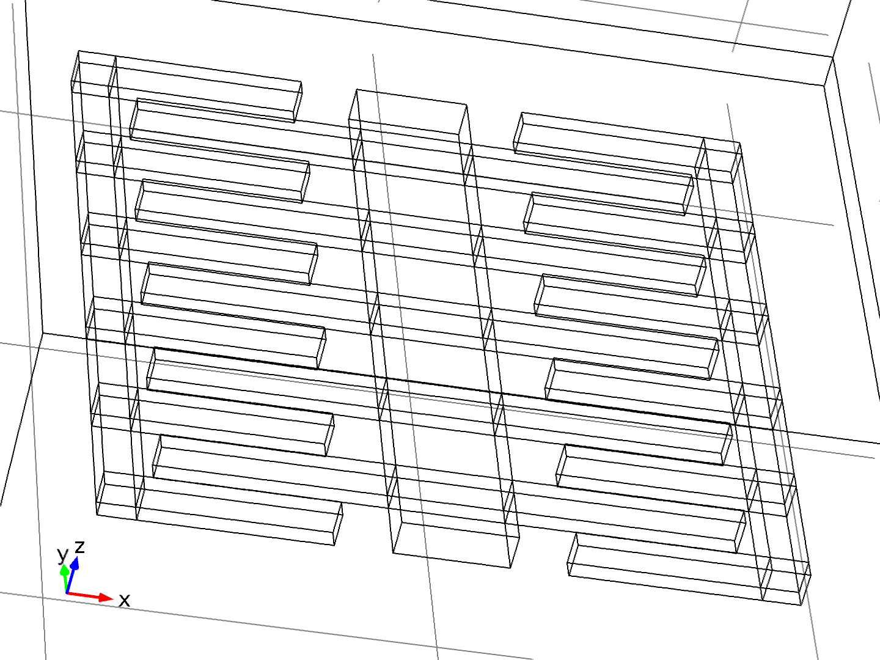

* + 1. simplu

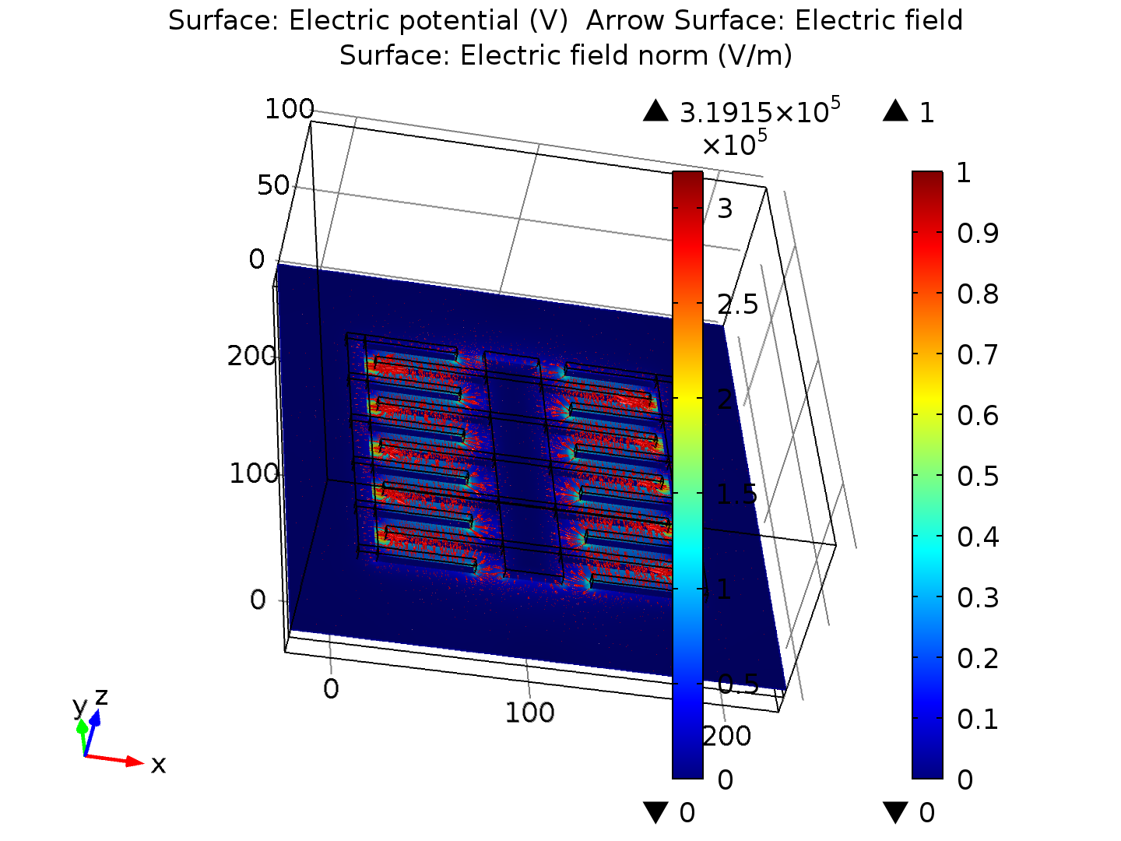

Surface: Electric potential (V) Arrow Surface: Electric field Surface: Electric field norm (V/m)

* + 1. interactiv

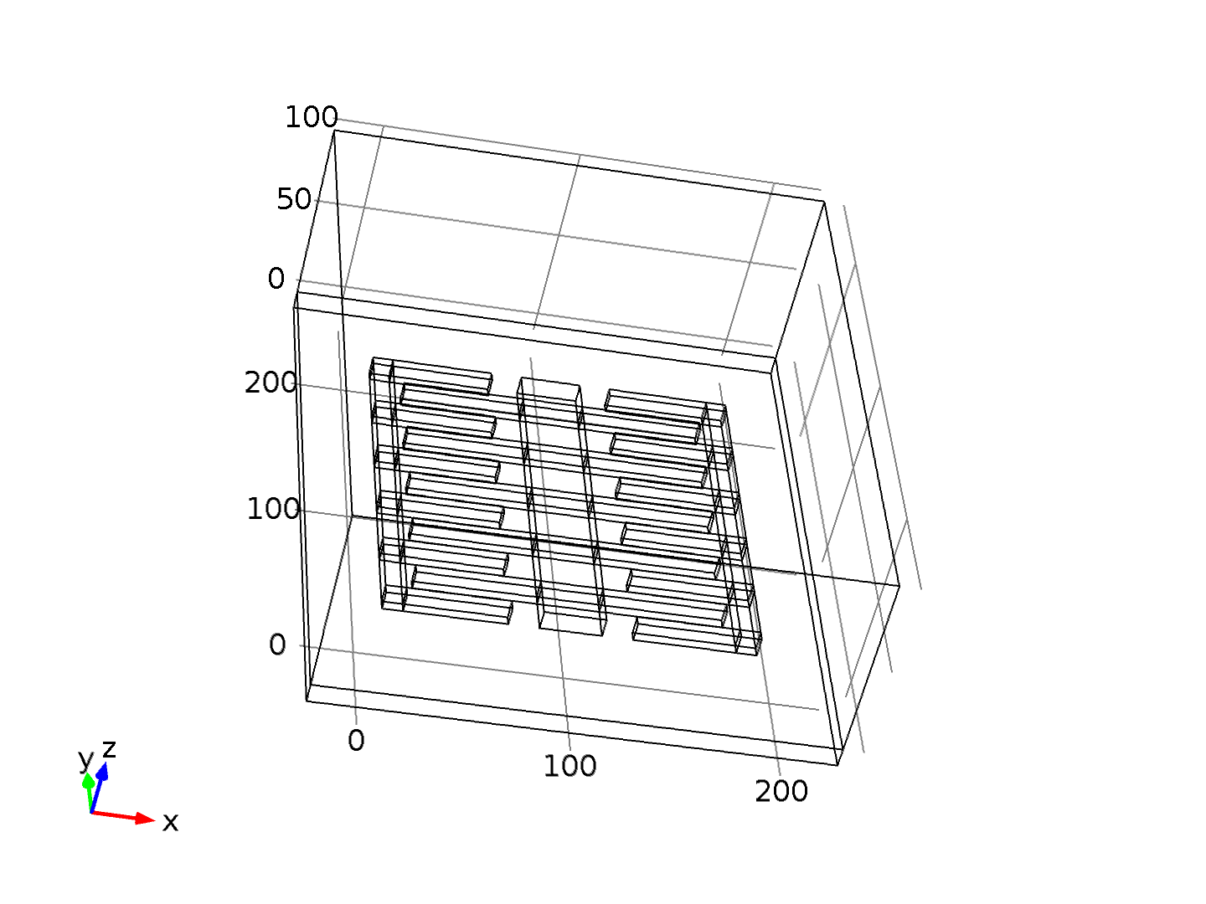

* + 1. 1D Plot Group 4

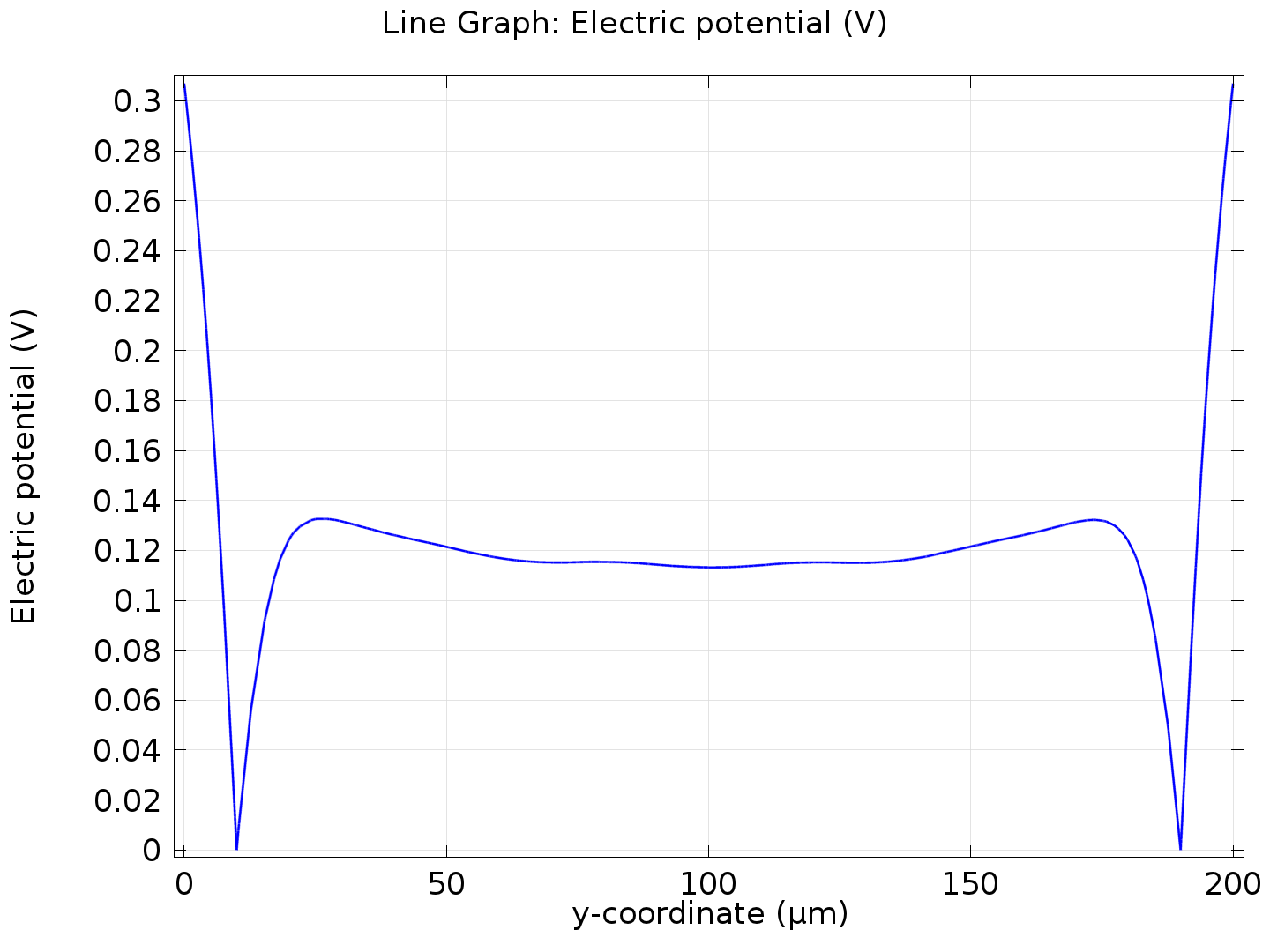

Line Graph: Electric potential (V)

* + 1. 1D Plot Group 5

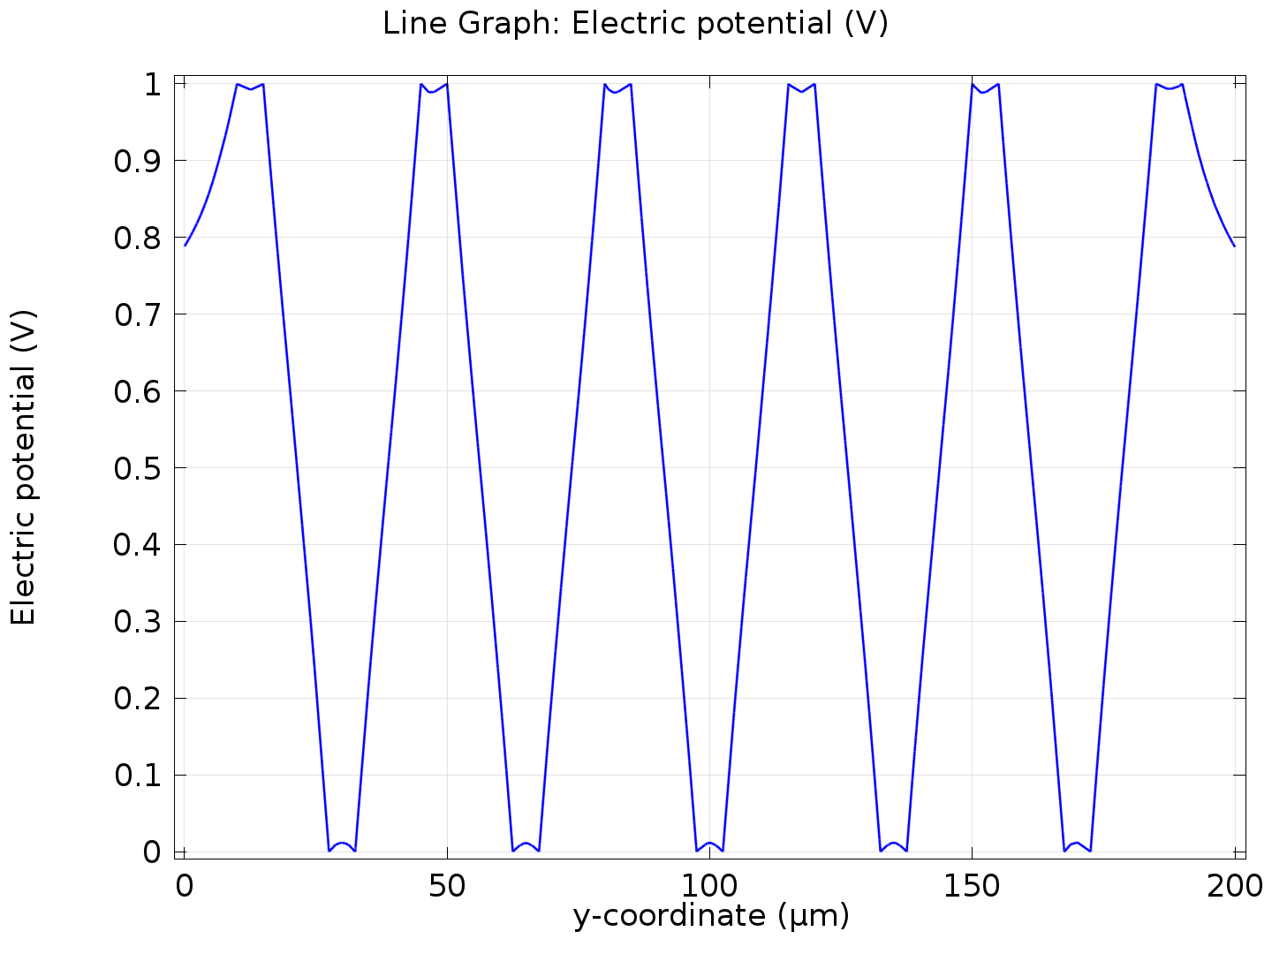

Line Graph: Electric potential (V)

* + 1. 1D Plot Group 6

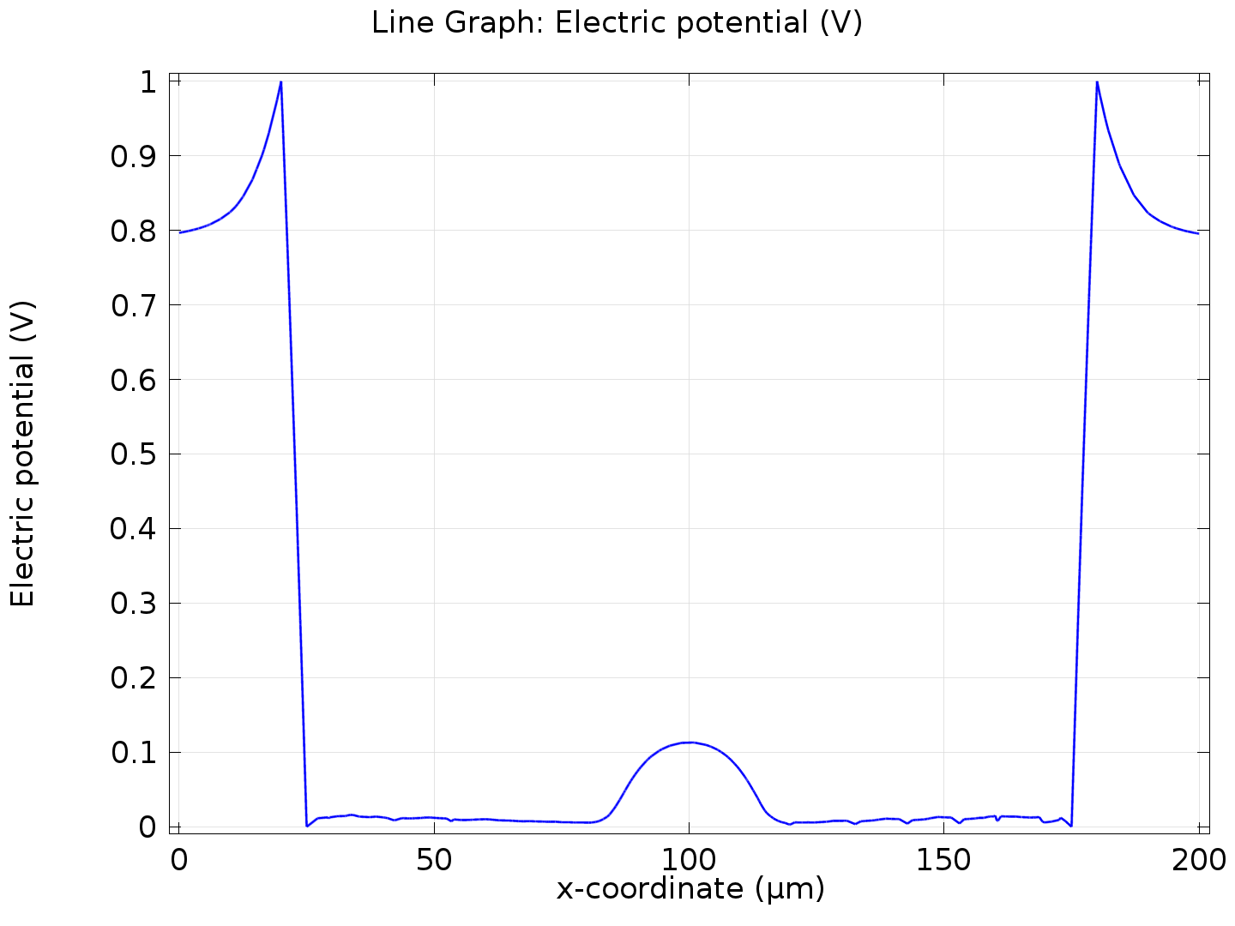

Line Graph: Electric potential (V)

* + 1. simplu 1

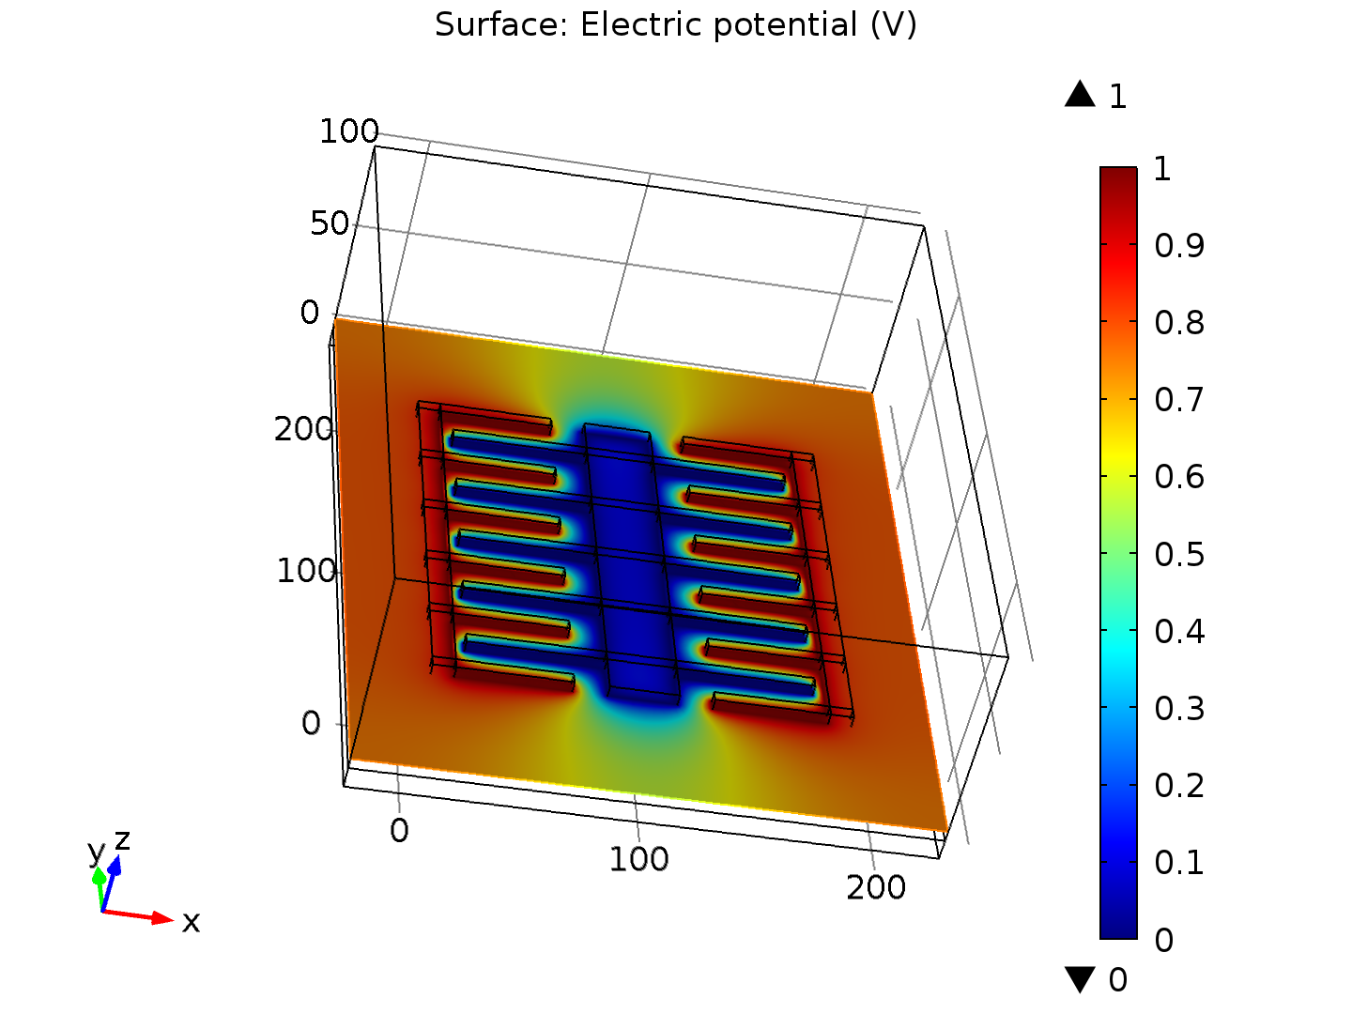

Surface: Electric potential (V)

* + 1. simplu 2

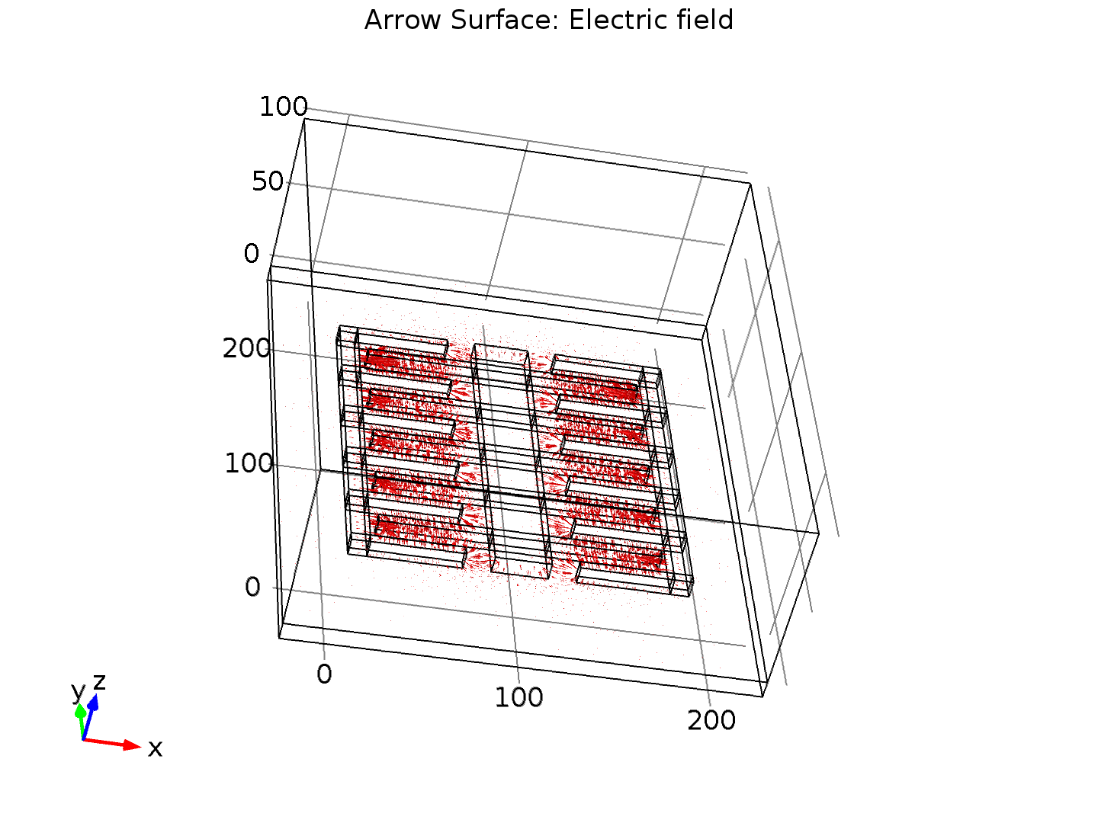

Arrow Surface: Electric field

* + 1. simplu 3

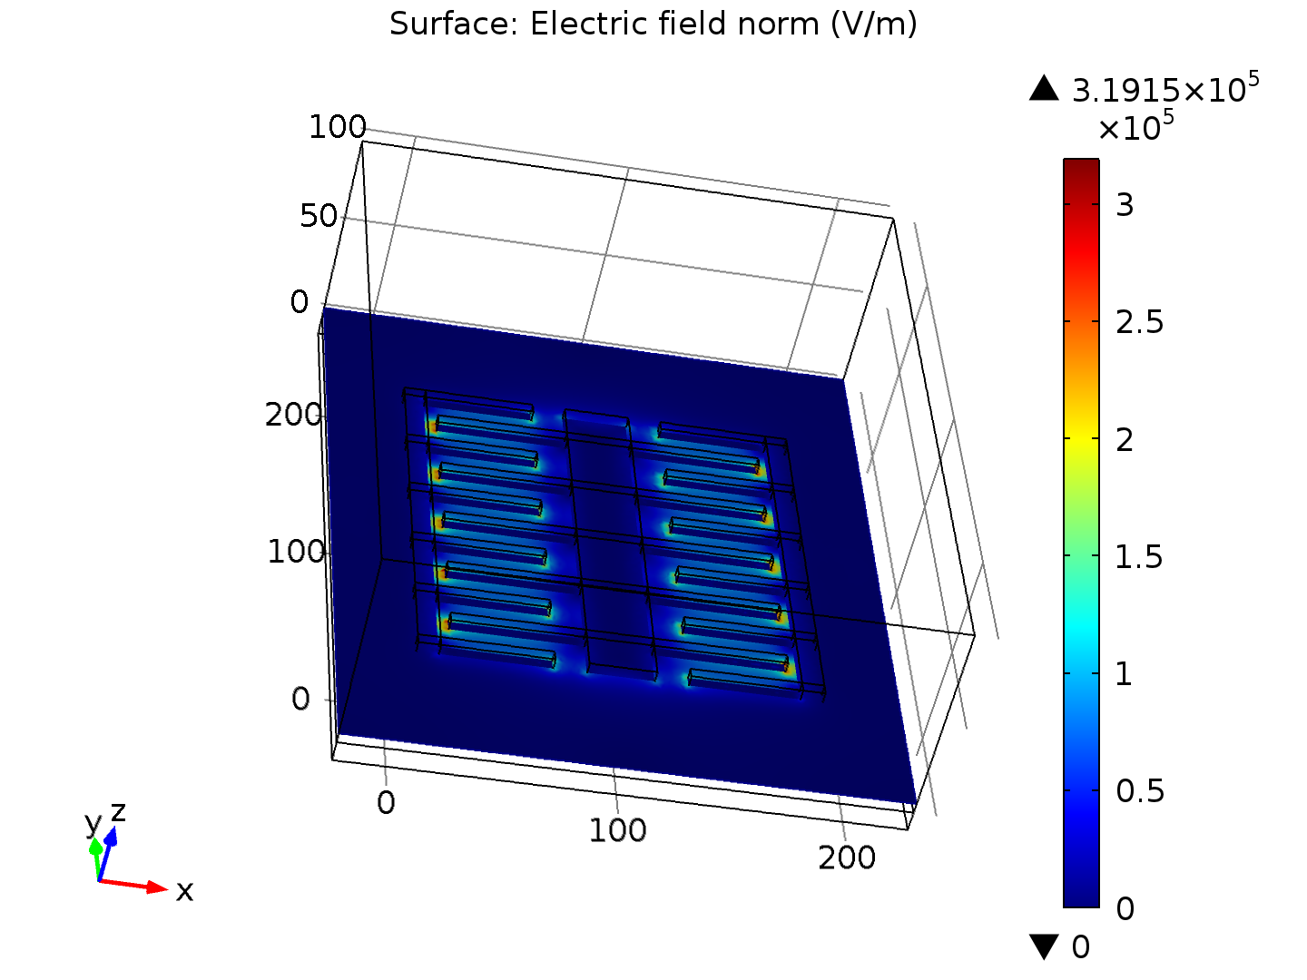

Surface: Electric field norm (V/m)

* + 1. simplu 4

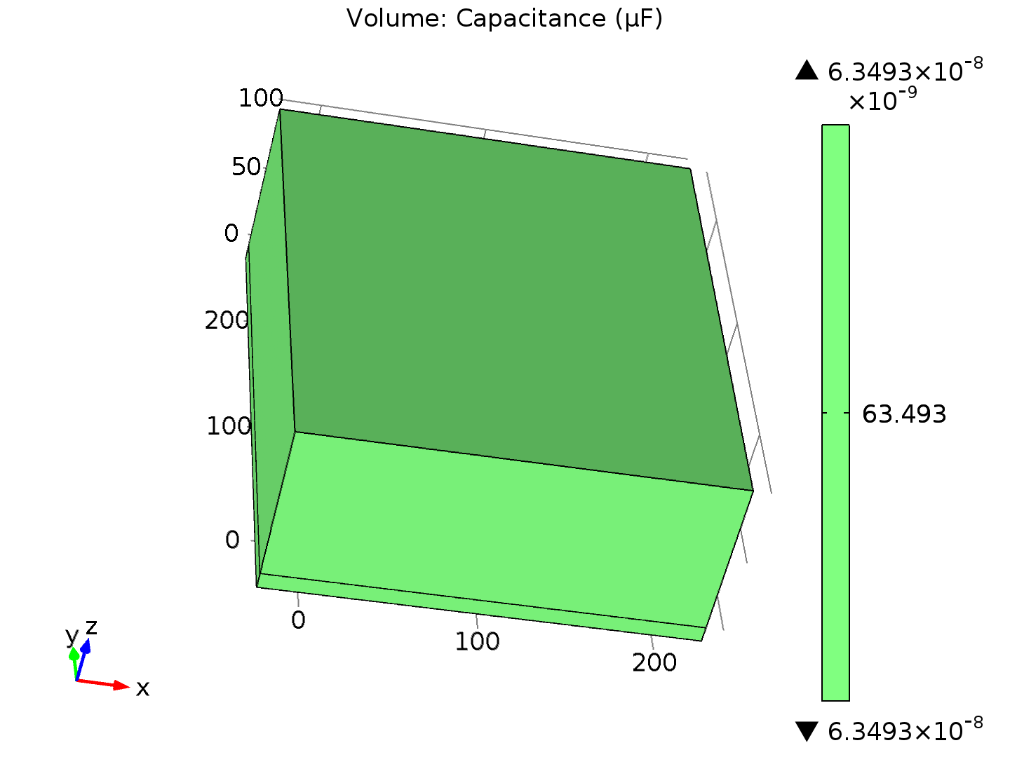

Volume: Capacitance (µF)