## Paypal MicroPayments Rates vs Regular Rates

Micropayments = 5% + $0.05

Regular Rate = 2.9% + $0.30

|  |  |  |
| --- | --- | --- |
| **Merchant Rate** | **Micropayments  5% + $0.05** | **Regular  2.9% +$0.30** |
| Payment size | $2 | $2 |
| Cost to receive payment | $0.15 | $0.36 |
| Total cost to receive 100 payments | $15 | $36 |

## Adaptive Payments API

PayPal Adaptive Payments API info = <https://www.x.com/developers/paypal/documentation-tools/quick-start-guides/adaptive-payments-api>

The Paypal Adaptive Payments API supports four payment scenarios.

*The first two methods appear to involve manual access by the payer*

1. Web Redirect = The default method where applications redirect the sender of the payment to PayPal for approval.
2. Embedded Process = Applications embed the payment authorization process into the application itself.

*These methods are automated*

1. Implicit = Applications act as the sender of the payment and implicitly authorize the payment.

*The party that calls the API is sending the payment*

1. Preapproved = Applications obtain a preapproval from the sender. (More on this below)

*The party calling the API is receiving the payment*

The API caller is a 3rd party application (typically owned by the developer) that is authorized to initiate payments.

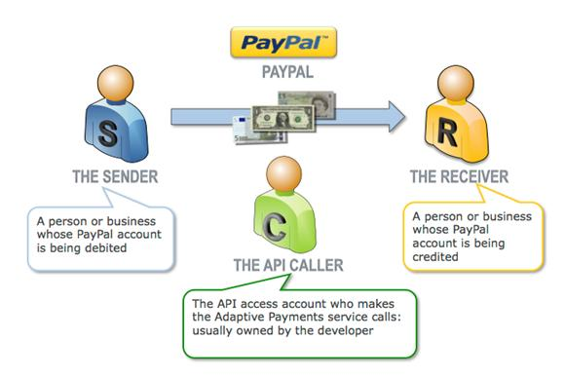

Payments and paypal transaction fees can flow from the sender to multiple recipients. For example a vendor (primary recipient) and the college (secondary recipient) can each receive payments to their own paypal accounts. However, In this case Paypal charges fees for each of the two payment transactions. These fees can be charged to each recipient or only to the vendor.

## Establishing Pre Approval Agreements

<https://cms.paypal.com/cms_content/US/en_US/files/developer/PP_AdaptivePayments.pdf>

Preapproval agreements are stored on Paypal. Paypal has a URL for initiating a preapproval agreement. The approver indicates agreement start and end dates, the maximum amount and the maximum number of payments. Paypal provides a token referencing the agreement which is then used by our server to initiate payments on behalf of the payer.

There is also a URL for cancelling a preapproval agreement.

## Using PayPal Pre-approval agreements in CDS

* All parties involved in Paypal payments would need paypal accounts. Depending on the typical payment amounts the accounts would be established at either the micropayment rate or the regular rate.
* Our servers would need a front end to support the establishment of pre-payment agreements by redirecting to the Paypal API server and then accepting the pre-approval agreement token.
* We would need to be able to store pre-approval agreement tokens and communicate these to the Paypal API server for payment.
* If we also provide for out-of-band invoicing for some vendor relationships then the ‘transaction management service’ must behave differently depending whether the financial exchange is supported by an external agreement or by Paypal.
* We need a form of messaging to handle various fault situations.

**Another use case:** We may also want a browser front-end that enables payment without the need to establish a pre-approval agreement. For example, an exchange between two parties that only interact occasionally – ie the frequency doesn’t warrant either a vendor agreement or a Paypal pre-approval arrangement.