Distributed Systems

Assignment 1:

# Request-Reply Communication

Assignment 2:

Asynchronous Communication and Real-Time Notification

Alin Tcaci

Group: 30441

## 1.Overview

The project requirement is to develop an Energy Management System that consists of a frontend and two microservices design for managing the users and their associated devices.

The Monitoring and Communication Microservice enhances the Energy Management System by integrating real-time monitoring and asynchronous communication features. It includes a message-oriented middleware for data processing and WebSocket integration for real-time notifications.

## 2.Microservices

For each service, we need to include a REST API controller that can handle basic CRUD operations for specific entities, while also making sure data stays consistent. These services are built with the Java Spring Boot framework and are structured using a layered approach, splitting everything into distinct layers like entity, service, repository, and controller.

In the second assignment we created a separate microservices, the monitoring service. Here we transmit via rabbitMQ the maxim energy consumption per hour for each device and the consumption of the simulator devices every 10 minutes (seconds for simulation). Also, every time the limit is exceeded, the client gets notified.

## 2.1.User Microservice

The user controller handles the user management, where each operation works independently and interacts directly with the user database. The corresponding endpoints are:

* /getAllUsers - Fetches all users from the database.
* /getUserById/{id} - Retrieves a specific user by their unique ID.
* /createUser - Adds a new user to the database.
* /updateUserById/{id} - Updates an existing user’s details based on their ID.
* /deleteUserById/{id} - Deletes a user from the database by their ID.
* /getUserByUsername/{username} - Finds a user based on their username.

Each endpoint operates individually, meaning it directly performs actions on the user database without depending on other endpoints.

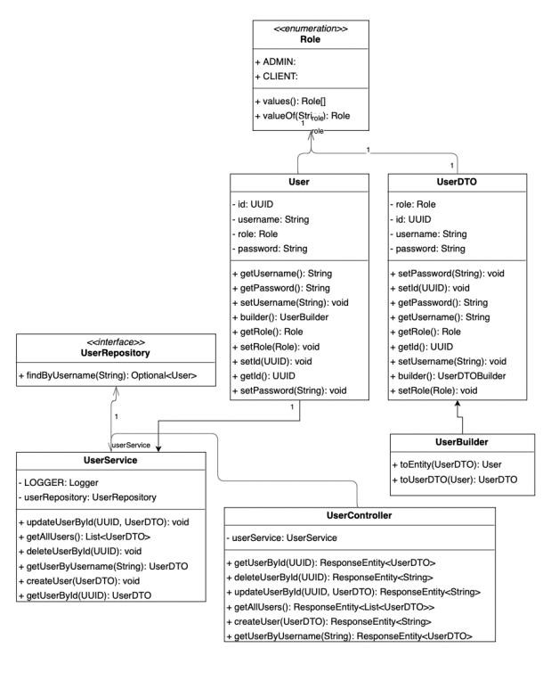

## 2.2.Device Microservice

The device controller handles managing of devices. Each device record includes a userId field, which acts like a foreign key, linking devices to specific users. However, even though the userId allows device data to be associated with users, the user and device services are set up as separate microservices, each with its own database. The association between the user and device will be done in frontend.

The corresponding endpoints are:

* /getAllDevices - Retrieves all devices in the device database.
* /getDeviceById/{id} - Fetches a specific device by its unique ID.
* /getAllDevicesByUserId/{userId} - Retrieves all devices linked to a specific user by userId.
* /createDevice - Adds a new device to the device database.
* /updateDeviceById/{id} - Updates details for an existing device based on its ID.
* /deleteDeviceById/{id} - Removes a specific device by its ID.
* /deleteAllDevicesByUserId/{userId} - Deletes all devices associated with a given userId.

## 3.Frontend

The frontend application is made by using the Angular framework. It has a login page, from where the user will be send to its corresponding Role page. The client role page consists in viewing a list of devices that the user owns. The admin page allows the user to perform CRUD operations on both the users and devices. To communicate with the backend, it uses the bult-in httpService from Angular.

For the second project, every time the limit of consumption is exceeded we notify via web socket the user.

## 4.Doker

Each database, microservice and frontend have a separate container. The setup ensures isolated development for each microservice and consistent deployment across environments.

5.Traefik

The Treelike architecture organizes microservices in a hierarchical structure, improving modularity and scalability. It ensures clear data flow, fault isolation, and the ability to scale individual services independently as demand grows.

**Load Balancer**

A load balancer distributes incoming traffic evenly across multiple service instances, preventing bottlenecks and improving performance. It also ensures high availability by rerouting traffic to healthy instances in case of failures, and supports horizontal scaling.

**Reverse Proxy**

A reverse proxy sits between clients and backend services, improving security by hiding internal services and handling centralized authentication.

