CLOUD COMPUTING
PROJECT 2 REPORT
THE SERVER COMMANDER

Submitted By
Alina Shujaat

Cloud Computing Internship
DecodeLabs

EXECUTIVE SUMMARY
This report documents the successful deployment and configuration of a cloud-based Linux web server on Amazon Web Services (AWS) as part of the DecodeLabs Cloud Computing Internship. The project — The Server Commander — demonstrates end-to-end cloud infrastructure management, from provisioning an EC2 virtual machine and establishing secure SSH connectivity, to installing the Apache (httpd) web server and serving a custom webpage accessible via a public IP address.

LIVE | Welcome to DecodeLabs — successfully hosted and publicly accessible at http://23.22.252.116 via HTTP on port 80.

INTRODUCTION
Cloud computing has transformed how organizations deploy and manage IT infrastructure. By leveraging virtualization, businesses can provision scalable, secure, and remotely accessible servers on demand — eliminating the capital cost of physical hardware while retaining full administrative control.
This project explores foundational cloud system administration skills through a practical hands-on scenario: deploying a functional web server on AWS EC2 using Amazon Linux 2023, covering the full provisioning lifecycle including OS configuration, remote access security, web server setup, and webpage hosting.

PROJECT SCENARIO
A startup company required a dedicated server environment to host its dynamic web application, with full control over the OS stack to manage software, apply patches, and configure services independently.

Role: System Administrator
- Provision a virtual machine on AWS EC2
- Establish encrypted, key-based remote access via SSH
- Install, configure, and validate the Apache (httpd) Web Server
- Deploy a branded custom webpage displaying the company welcome message

OBJECTIVES
- Understand cloud-based virtual server provisioning on AWS
- Launch and configure an EC2 instance with appropriate security settings
- Establish secure SSH connectivity using Instance Connect
- Install and manage Apache httpd on Amazon Linux 2023
- Host and validate a custom HTML webpage on the live server
- Gain practical exposure to Linux system administration workflows

TECHNOLOGIES USED
Technology | Role | Version / Notes
AWS EC2 | Cloud Virtual Machine Hosting | t2.micro — Free Tier, us-east-1c
Amazon Linux 2023 | Server Operating System | Amazon Linux 2023 (HVM)
AWS EC2 Instance Connect | Secure Browser-Based SSH Access | Built-in AWS console SSH
Apache httpd | HTTP Website Hosting | httpd 2.4.66-1.amzn2023.0.1
HTML5 | Custom Webpage Development | Static branded page
AWS Security Groups | Firewall & Network Rules | Port 22 (SSH) & Port 80 (HTTP)

SYSTEM ARCHITECTURE
The deployment follows a single-tier architecture. A client browser communicates over HTTP (port 80) with an Apache httpd server running on an Amazon Linux 2023 EC2 instance in the AWS us-east-1 (N. Virginia) region. Remote administration is performed over SSH using AWS EC2 Instance Connect via the browser.

Layer | Component | Detail
Cloud Platform | AWS EC2 — us-east-1c | Instance ID: i-0560254f15171fc19
Operating System | Amazon Linux 2023 | IP: 23.22.252.116 (Public) / 172.31.21.84 (Private)
Web Server | Apache httpd 2.4.66 | Port 80, enabled via systemd
Content Layer | Custom HTML Page | Served from /var/www/html/index.html

IMPLEMENTATION
Step 1 — Launch EC2 Instance
An EC2 instance named server-commander was provisioned from the AWS Management Console (us-east-1 region) with the following configuration:

Parameter | Value
Instance Name | server-commander
Instance ID | i-0560254f15171fc19
Instance Type | t2.micro (1 vCPU, 1 GB RAM — Free Tier)
Amazon Machine Image | Amazon Linux 2023 (HVM)
Availability Zone | us-east-1c
Public IPv4 Address | 23.22.252.116
Private IPv4 Address | 172.31.21.84
Key Pair | RSA key pair for SSH access
Security Group | launch-wizard-154 (SSH port 22 + HTTP port 80)

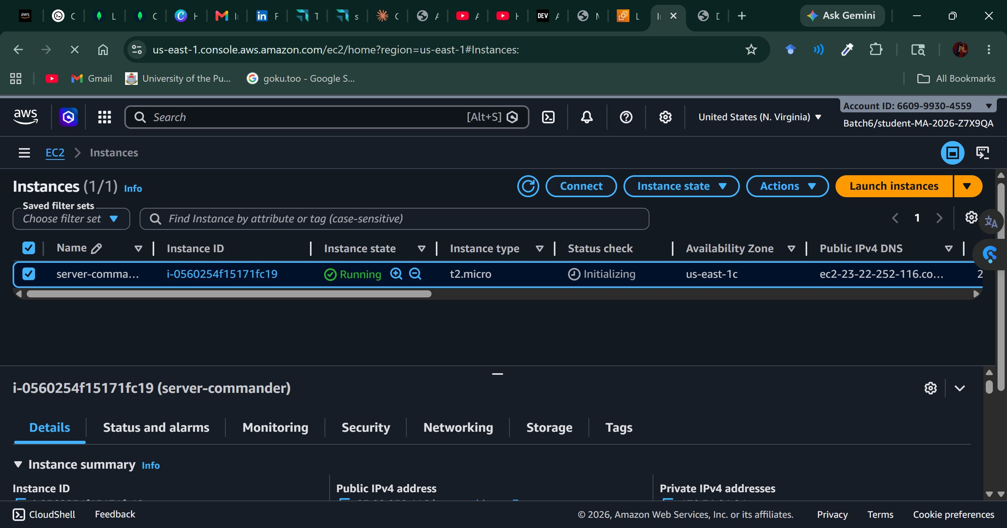
Figure 1 — AWS EC2 Console: server-commander instance in Running state (Instance ID: i-0560254f15171fc19)
Step 2 — Connect via SSH (EC2 Instance Connect)
Secure remote access was established using AWS EC2 Instance Connect, which provides browser-based SSH access without requiring a local PEM key file. The system package index was immediately updated upon connection:

# System update on first login
[ec2-user@ip-172-31-21-84 ~]$ sudo yum update -y

Amazon Linux 2023 Kernel Livepatch repository
Dependencies resolved. Nothing to do.
Complete!

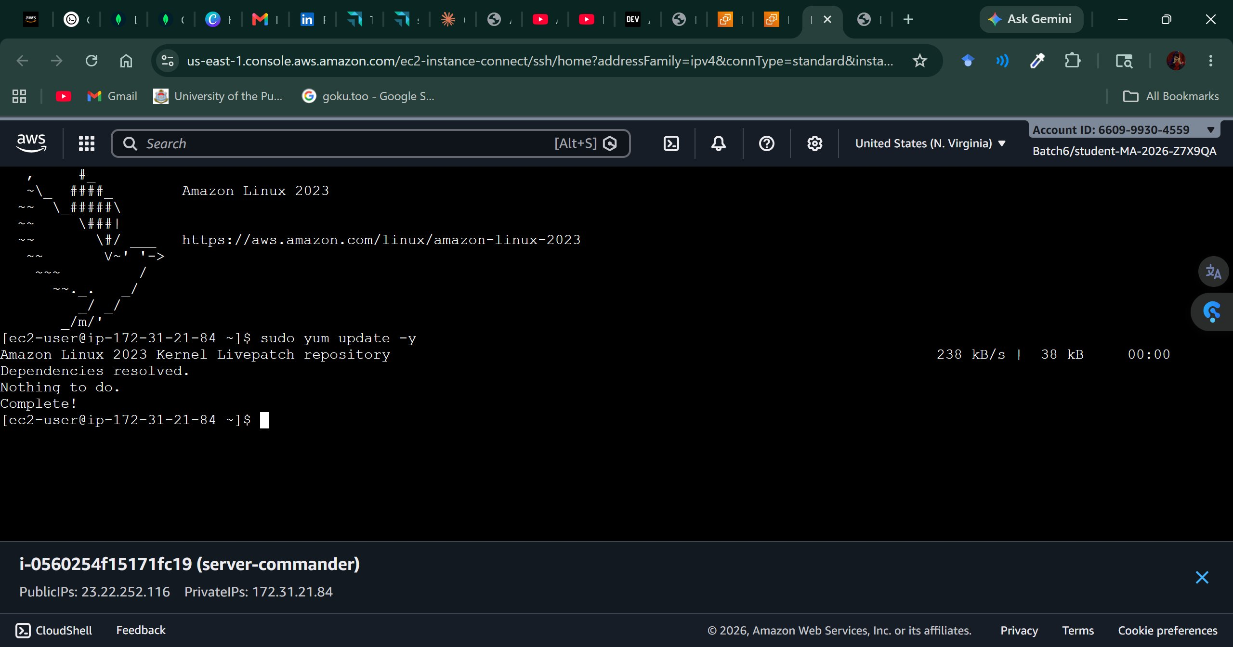
Figure 2 — EC2 Instance Connect: Successful SSH session with sudo yum update completing cleanly
Step 3 — Install Apache (httpd) Web Server
The Apache HTTP Server package (httpd) was installed using the YUM package manager, which resolved all required dependencies automatically:

# Install Apache httpd and all dependencies
[ec2-user@ip-172-31-21-84 ~]$ sudo yum install httpd -y

# Packages installed: httpd 2.4.66, apr, apr-util, apr-util-lmdb,
# generic-logos-httpd, httpd-core, httpd-filesystem, httpd-tools,
# libbrotli, mailcap, apr-util-openssl, mod_http2, mod_lua

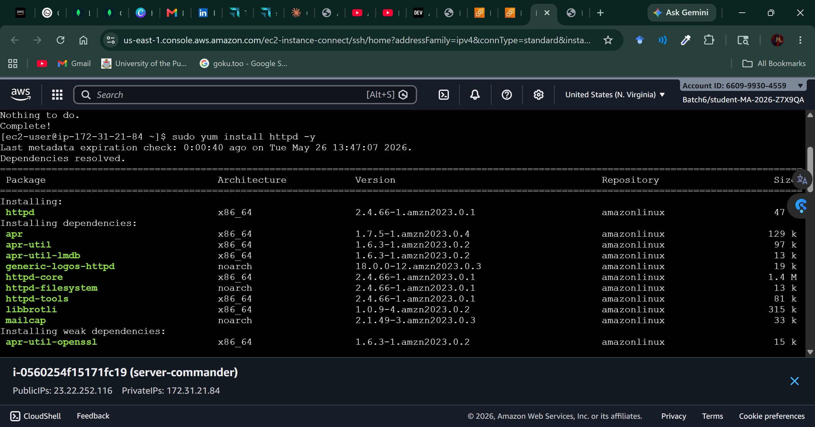
Figure 3 — YUM package manager resolving and installing httpd 2.4.66 with all dependencies
Step 4 — Start & Enable Apache Service
After successful installation, Apache was started immediately and enabled to launch automatically on every system reboot via systemd:

# Start Apache service
[ec2-user@ip-172-31-21-84 ~]$ sudo systemctl start httpd

# Enable Apache to start on boot
[ec2-user@ip-172-31-21-84 ~]$ sudo systemctl enable httpd

# Confirmed: Created symlink
# /etc/systemd/system/multi-user.target.wants/httpd.service
# -> /usr/lib/systemd/system/httpd.service

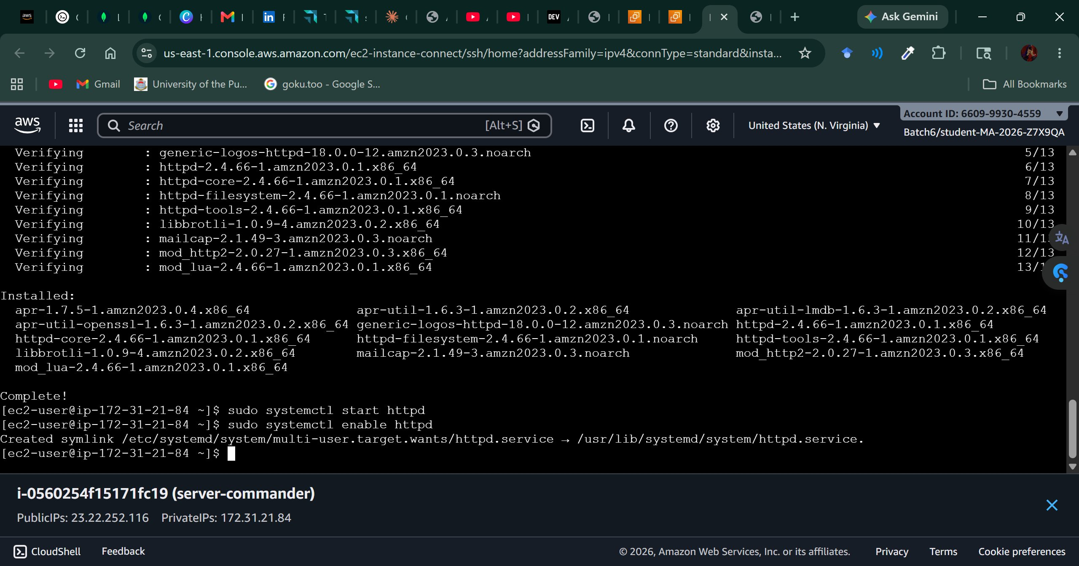
Figure 4 — httpd service started and enabled; systemd symlink created for boot persistence
Step 5 — Configure Security Group
The Security Group (sg-0ecb293a2dc04100d / launch-wizard-154) was configured with two inbound rules to allow remote administration and public web access:

Rule ID | Type | Protocol | Port | Source | Purpose
sgr-0e2844aa2a5d4b4de | SSH | TCP | 22 | 0.0.0.0/0 | Remote server administration
— | HTTP | TCP | 80 | 0.0.0.0/0 | Public webpage accessibility

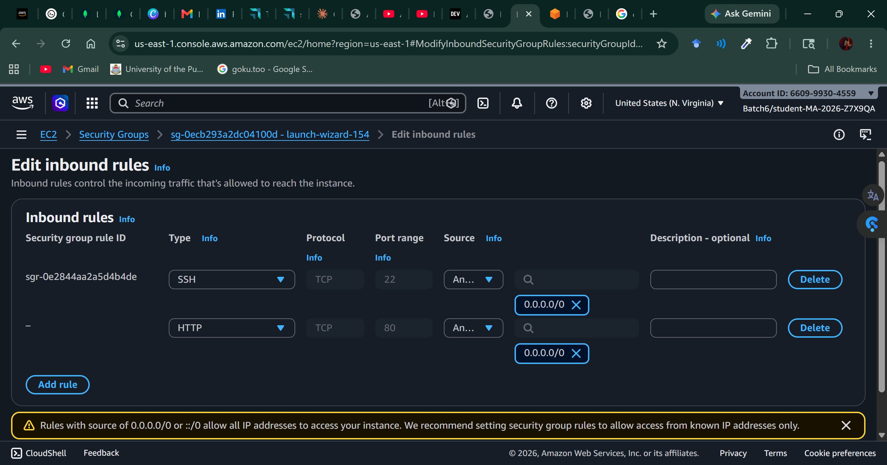
Figure 5 — AWS Security Group inbound rules: SSH (port 22) and HTTP (port 80) configured
Step 6 — Deploy Custom Webpage
The default Apache welcome page was replaced with a custom HTML page served from the Apache web root:

# Edit the default index page
sudo nano /var/www/html/index.html

<!DOCTYPE html>
<html>
<head><title>DecodeLabs</title></head>
<body style="text-align:center; margin-top:100px; font-family:Arial;">
<h1>Welcome to DecodeLabs</h1>
<p>Project 2 - The Server Commander</p>
</body>
</html>

VERIFIED OUTPUT
The custom webpage was accessed by navigating to http://23.22.252.116 in a browser. The page rendered successfully, confirming end-to-end deployment of the cloud web server:

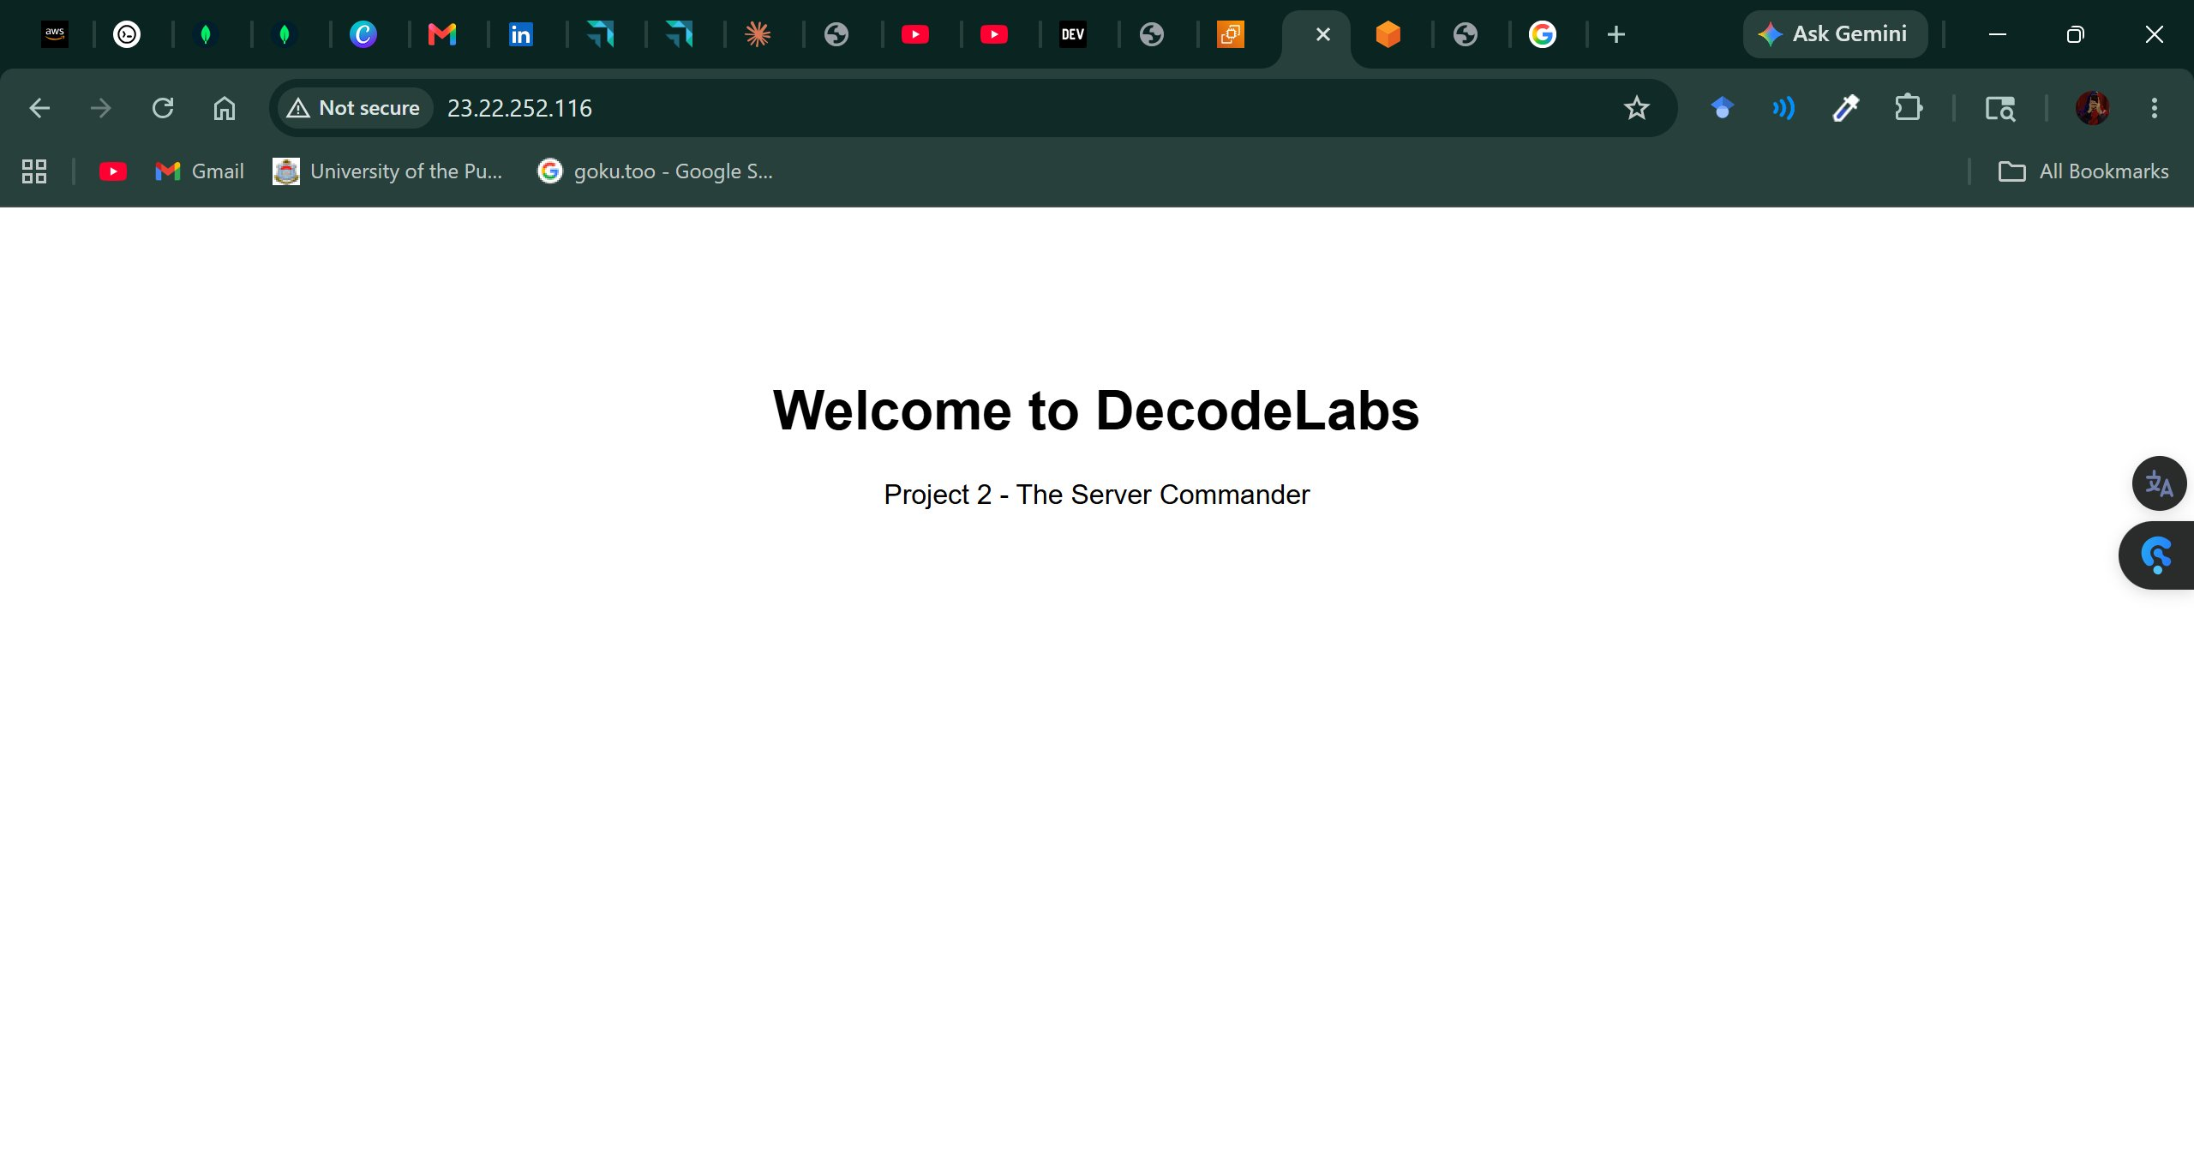
Figure 6 — Live webpage output: "Welcome to DecodeLabs" served at http://23.22.252.116

SUCCESS | Apache httpd serving custom HTML at http://23.22.252.116 — publicly accessible from any browser worldwide.

CHALLENGES & TROUBLESHOOTING
Issue Encountered | Root Cause | Resolution Applied
Webpage inaccessible from browser | HTTP inbound rule missing from Security Group | Added port 80 TCP rule to the Security Group
Apache not serving after install | Service not started post-installation | Ran sudo systemctl start httpd manually
SSH connection refused initially | Wrong IP used / Security Group not saved | Retrieved correct public IP from EC2 console and verified rules

LEARNING OUTCOMES
Skill Area | Competency Acquired
Cloud Infrastructure | Provisioning and configuring AWS EC2 instances via the Management Console
Linux Administration | Package management (yum), service control (systemctl), and file system operations
Network Security | Configuring Security Groups with targeted inbound rules on AWS
Remote Access | Browser-based SSH via EC2 Instance Connect — no local key file required
Web Server Management | Apache httpd installation, service lifecycle control, and content deployment
Troubleshooting | Diagnosing and resolving firewall, service, and connectivity issues
DevOps Fundamentals | End-to-end infrastructure deployment and validation workflow

CONCLUSION
This project successfully demonstrated a complete cloud server deployment lifecycle using AWS EC2 and Amazon Linux 2023. Starting from a blank cloud environment, a virtual machine was provisioned, secured, and transformed into a live web hosting platform — serving a custom branded webpage publicly accessible at http://23.22.252.116.
The experience reinforced the importance of security-first configuration, systematic troubleshooting, and the power of cloud-managed services like EC2 Instance Connect. The skills developed — cloud provisioning, Linux administration, Apache web server management, and AWS security configuration — are directly applicable to real-world DevOps and cloud engineering roles.

REFERENCES
- Amazon Web Services. (2024). Amazon EC2 Documentation. https://docs.aws.amazon.com/ec2/
- Apache Software Foundation. (2024). Apache HTTP Server Documentation. https://httpd.apache.org/docs/
- Amazon Web Services. (2024). Amazon Linux 2023 User Guide. https://docs.aws.amazon.com/linux/al2023/
- The Open Group. (2024). Linux Manual Pages — systemctl, yum, nano. https://man7.org/linux/man-pages/

Prepared By
Alina Shujaat
Cloud Computing Internship | DecodeLabs

