Training Algorithm :Scaled conjugate gradient backpropagation

Link: <https://www.mathworks.com/help/nnet/ref/trainscg.html>

* trainFcn: 'trainscg'
* trainParam: [1x1 struct]
* performFcn: 'crossentropy'
* performParam: [1x1 struct]
* derivFcn: 'defaultderiv'
* divideFcn: 'dividerand'
* divideMode: 'sample'
* divideParam: [1x1 struct]
* trainInd: [1x117 double]
* valInd: [1x50 double]
* testInd: [1x50 double]
* stop: 'Minimum gradient reached.'
* num_epochs: 30
* trainMask: {[2x217 double]}
* valMask: {[2x217 double]}
* testMask: {[2x217 double]}
* best_epoch: 30
* goal: 0
* states: {'epoch' 'time' 'perf' 'vperf' 'tperf' 'gradient' 'val_fail'}
* epoch: [0 1 2 3 4 5 6 7 8 9 10 11 12 13 14 15 16 17 18 19 20 21 22 23 24 25 26 27 28 29 30]
* time: [1x31 double]
* perf: [1x31 double]
* vperf: [1x31 double]
* tperf: [1x31 double]
* gradient: [1x31 double]
* val_fail: [0 0 0 0 0 0 0 0 0 0 1 0 1 0 1 0 1 0 1 0 1 0 1 0 1 0 1 0 1 0 0]
* best_perf: 2.1838e-07
* best_vperf: 2.6877e-05
* best_tperf: 9.7602e-08

Performance :

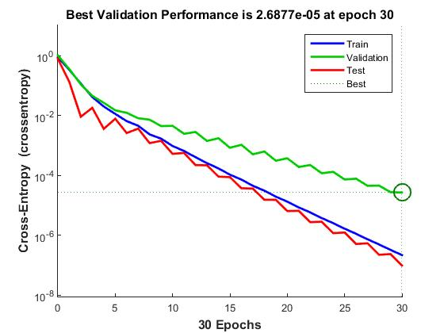

Error Histogram

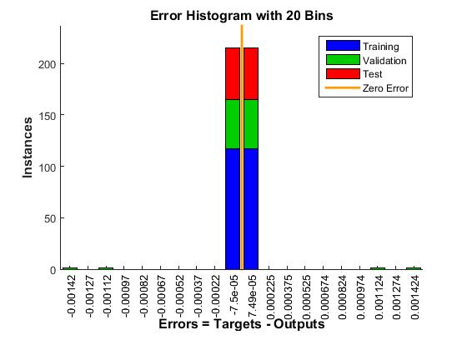

Training State

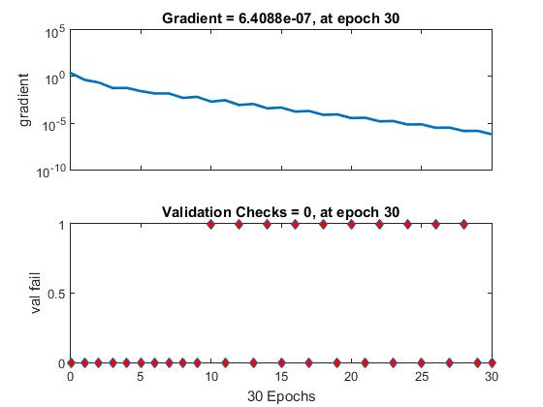

Confusion Matrix

