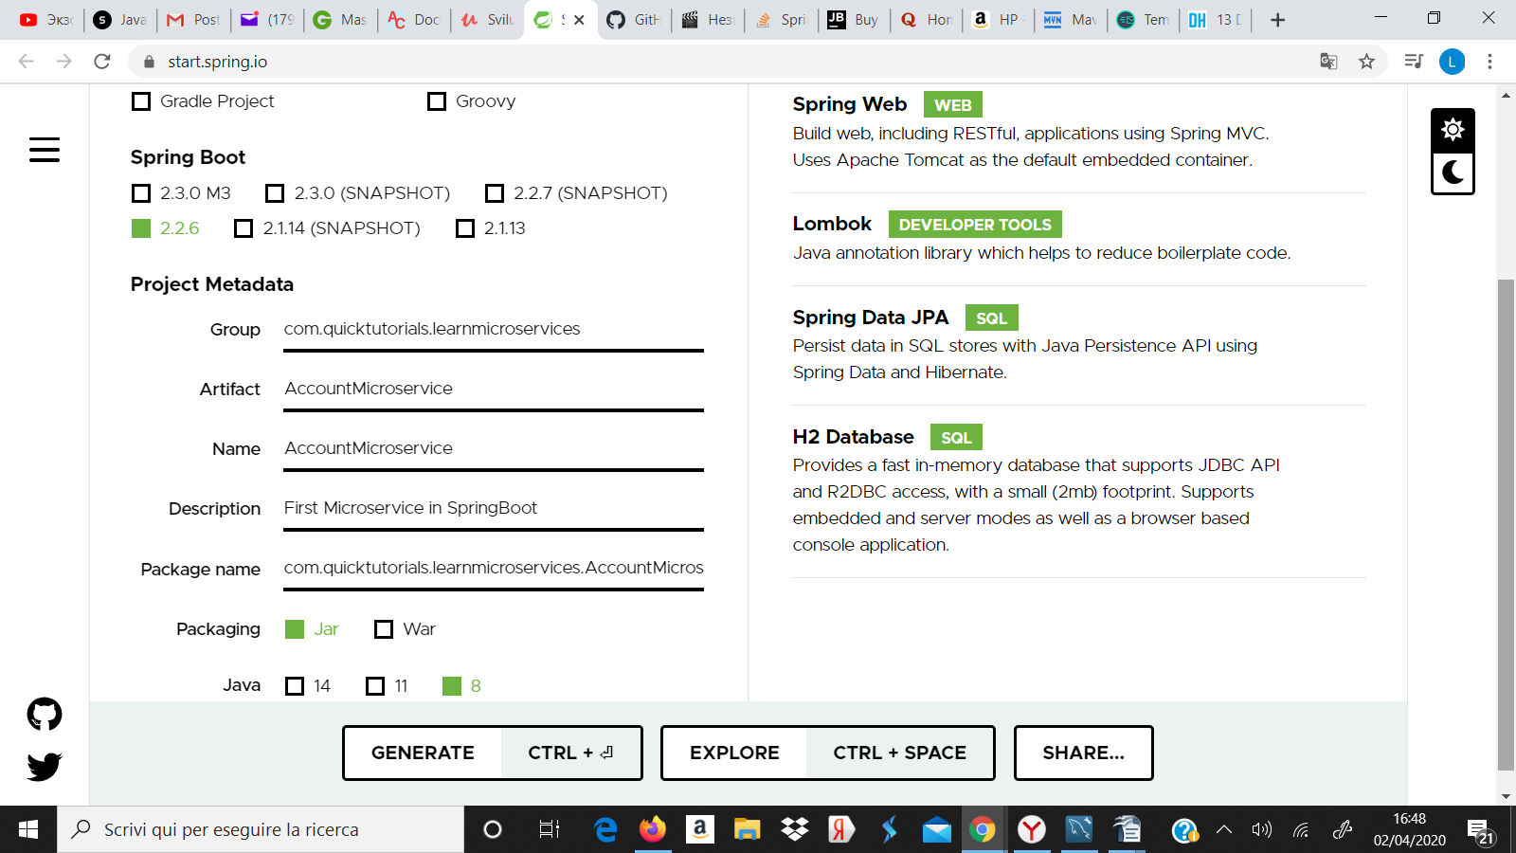

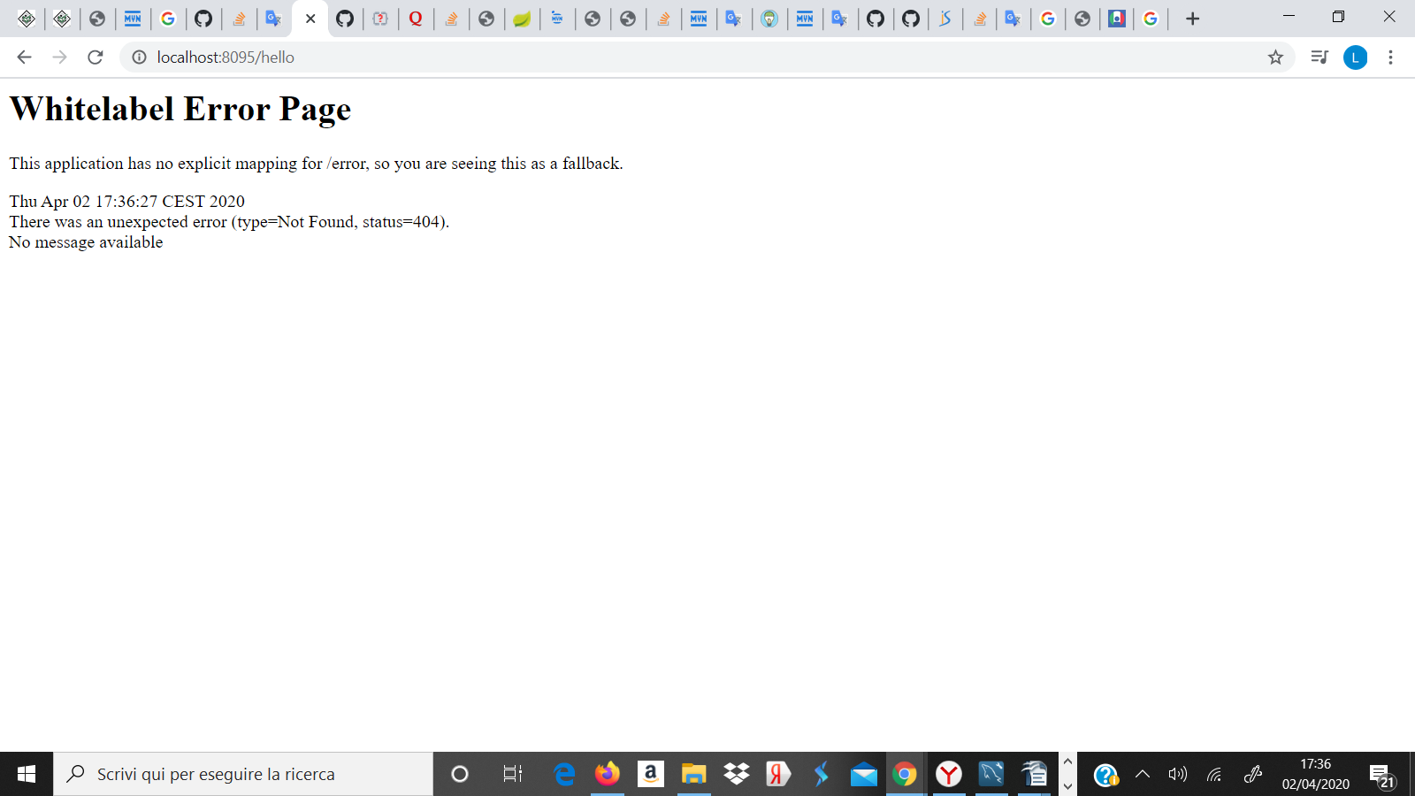

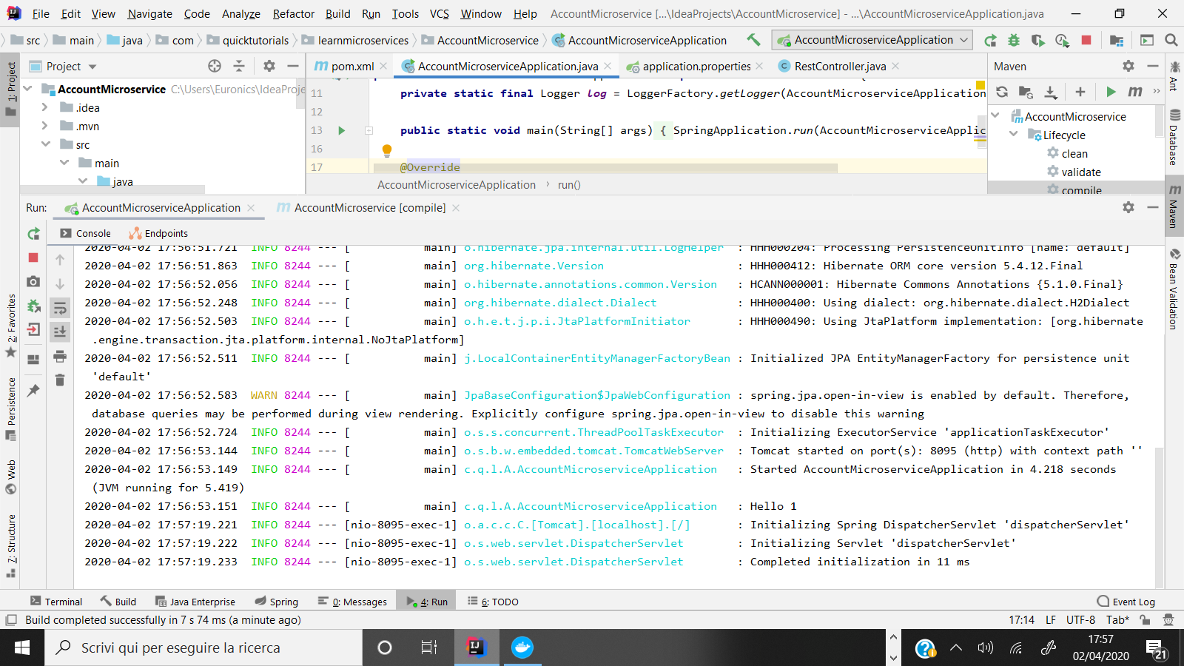

LOG:

"C:\Program Files\Java\jdk-13.0.2\bin\java.exe" -XX:TieredStopAtLevel=1 -noverify -Dspring.output.ansi.enabled=always -Dcom.sun.management.jmxremote -Dspring.jmx.enabled=true -Dspring.liveBeansView.mbeanDomain -Dspring.application.admin.enabled=true "-javaagent:C:\Program Files\JetBrains\IntelliJ IDEA 2019.3.4\lib\idea_rt.jar=59309:C:\Program Files\JetBrains\IntelliJ IDEA 2019.3.4\bin" -Dfile.encoding=UTF-8 -classpath C:\Users\Euronics\IdeaProjects\AccountMicroservice\target\classes;C:\Users\Euronics\.m2\repository\org\springframework\boot\spring-boot-starter-data-jpa\2.2.6.RELEASE\spring-boot-starter-data-jpa-2.2.6.RELEASE.jar;C:\Users\Euronics\.m2\repository\org\springframework\boot\spring-boot-starter-aop\2.2.6.RELEASE\spring-boot-starter-aop-2.2.6.RELEASE.jar;C:\Users\Euronics\.m2\repository\org\springframework\spring-aop\5.2.5.RELEASE\spring-aop-5.2.5.RELEASE.jar;C:\Users\Euronics\.m2\repository\org\aspectj\aspectjweaver\1.9.5\aspectjweaver-1.9.5.jar;C:\Users\Euronics\.m2\repository\org\springframework\boot\spring-boot-starter-jdbc\2.2.6.RELEASE\spring-boot-starter-jdbc-2.2.6.RELEASE.jar;C:\Users\Euronics\.m2\repository\com\zaxxer\HikariCP\3.4.2\HikariCP-3.4.2.jar;C:\Users\Euronics\.m2\repository\org\springframework\spring-jdbc\5.2.5.RELEASE\spring-jdbc-5.2.5.RELEASE.jar;C:\Users\Euronics\.m2\repository\jakarta\activation\jakarta.activation-api\1.2.2\jakarta.activation-api-1.2.2.jar;C:\Users\Euronics\.m2\repository\jakarta\persistence\jakarta.persistence-api\2.2.3\jakarta.persistence-api-2.2.3.jar;C:\Users\Euronics\.m2\repository\jakarta\transaction\jakarta.transaction-api\1.3.3\jakarta.transaction-api-1.3.3.jar;C:\Users\Euronics\.m2\repository\org\hibernate\hibernate-core\5.4.12.Final\hibernate-core-5.4.12.Final.jar;C:\Users\Euronics\.m2\repository\org\jboss\logging\jboss-logging\3.4.1.Final\jboss-logging-3.4.1.Final.jar;C:\Users\Euronics\.m2\repository\org\javassist\javassist\3.24.0-GA\javassist-3.24.0-GA.jar;C:\Users\Euronics\.m2\repository\net\bytebuddy\byte-buddy\1.10.8\byte-buddy-1.10.8.jar;C:\Users\Euronics\.m2\repository\antlr\antlr\2.7.7\antlr-2.7.7.jar;C:\Users\Euronics\.m2\repository\org\jboss\jandex\2.1.1.Final\jandex-2.1.1.Final.jar;C:\Users\Euronics\.m2\repository\com\fasterxml\classmate\1.5.1\classmate-1.5.1.jar;C:\Users\Euronics\.m2\repository\org\dom4j\dom4j\2.1.1\dom4j-2.1.1.jar;C:\Users\Euronics\.m2\repository\org\hibernate\common\hibernate-commons-annotations\5.1.0.Final\hibernate-commons-annotations-5.1.0.Final.jar;C:\Users\Euronics\.m2\repository\org\glassfish\jaxb\jaxb-runtime\2.3.2\jaxb-runtime-2.3.2.jar;C:\Users\Euronics\.m2\repository\org\glassfish\jaxb\txw2\2.3.2\txw2-2.3.2.jar;C:\Users\Euronics\.m2\repository\com\sun\istack\istack-commons-runtime\3.0.8\istack-commons-runtime-3.0.8.jar;C:\Users\Euronics\.m2\repository\org\jvnet\staxex\stax-ex\1.8.1\stax-ex-1.8.1.jar;C:\Users\Euronics\.m2\repository\com\sun\xml\fastinfoset\FastInfoset\1.2.16\FastInfoset-1.2.16.jar;C:\Users\Euronics\.m2\repository\org\springframework\data\spring-data-jpa\2.2.6.RELEASE\spring-data-jpa-2.2.6.RELEASE.jar;C:\Users\Euronics\.m2\repository\org\springframework\data\spring-data-commons\2.2.6.RELEASE\spring-data-commons-2.2.6.RELEASE.jar;C:\Users\Euronics\.m2\repository\org\springframework\spring-orm\5.2.5.RELEASE\spring-orm-5.2.5.RELEASE.jar;C:\Users\Euronics\.m2\repository\org\springframework\spring-context\5.2.5.RELEASE\spring-context-5.2.5.RELEASE.jar;C:\Users\Euronics\.m2\repository\org\springframework\spring-tx\5.2.5.RELEASE\spring-tx-5.2.5.RELEASE.jar;C:\Users\Euronics\.m2\repository\org\springframework\spring-beans\5.2.5.RELEASE\spring-beans-5.2.5.RELEASE.jar;C:\Users\Euronics\.m2\repository\org\slf4j\slf4j-api\1.7.30\slf4j-api-1.7.30.jar;C:\Users\Euronics\.m2\repository\org\springframework\spring-aspects\5.2.5.RELEASE\spring-aspects-5.2.5.RELEASE.jar;C:\Users\Euronics\.m2\repository\org\springframework\boot\spring-boot-starter-web\2.2.6.RELEASE\spring-boot-starter-web-2.2.6.RELEASE.jar;C:\Users\Euronics\.m2\repository\org\springframework\boot\spring-boot-starter\2.2.6.RELEASE\spring-boot-starter-2.2.6.RELEASE.jar;C:\Users\Euronics\.m2\repository\org\springframework\boot\spring-boot\2.2.6.RELEASE\spring-boot-2.2.6.RELEASE.jar;C:\Users\Euronics\.m2\repository\org\springframework\boot\spring-boot-autoconfigure\2.2.6.RELEASE\spring-boot-autoconfigure-2.2.6.RELEASE.jar;C:\Users\Euronics\.m2\repository\org\springframework\boot\spring-boot-starter-logging\2.2.6.RELEASE\spring-boot-starter-logging-2.2.6.RELEASE.jar;C:\Users\Euronics\.m2\repository\ch\qos\logback\logback-classic\1.2.3\logback-classic-1.2.3.jar;C:\Users\Euronics\.m2\repository\ch\qos\logback\logback-core\1.2.3\logback-core-1.2.3.jar;C:\Users\Euronics\.m2\repository\org\apache\logging\log4j\log4j-to-slf4j\2.12.1\log4j-to-slf4j-2.12.1.jar;C:\Users\Euronics\.m2\repository\org\apache\logging\log4j\log4j-api\2.12.1\log4j-api-2.12.1.jar;C:\Users\Euronics\.m2\repository\org\slf4j\jul-to-slf4j\1.7.30\jul-to-slf4j-1.7.30.jar;C:\Users\Euronics\.m2\repository\jakarta\annotation\jakarta.annotation-api\1.3.5\jakarta.annotation-api-1.3.5.jar;C:\Users\Euronics\.m2\repository\org\yaml\snakeyaml\1.25\snakeyaml-1.25.jar;C:\Users\Euronics\.m2\repository\org\springframework\boot\spring-boot-starter-json\2.2.6.RELEASE\spring-boot-starter-json-2.2.6.RELEASE.jar;C:\Users\Euronics\.m2\repository\com\fasterxml\jackson\datatype\jackson-datatype-jdk8\2.10.3\jackson-datatype-jdk8-2.10.3.jar;C:\Users\Euronics\.m2\repository\com\fasterxml\jackson\datatype\jackson-datatype-jsr310\2.10.3\jackson-datatype-jsr310-2.10.3.jar;C:\Users\Euronics\.m2\repository\com\fasterxml\jackson\module\jackson-module-parameter-names\2.10.3\jackson-module-parameter-names-2.10.3.jar;C:\Users\Euronics\.m2\repository\org\springframework\boot\spring-boot-starter-tomcat\2.2.6.RELEASE\spring-boot-starter-tomcat-2.2.6.RELEASE.jar;C:\Users\Euronics\.m2\repository\org\apache\tomcat\embed\tomcat-embed-core\9.0.33\tomcat-embed-core-9.0.33.jar;C:\Users\Euronics\.m2\repository\org\apache\tomcat\embed\tomcat-embed-el\9.0.33\tomcat-embed-el-9.0.33.jar;C:\Users\Euronics\.m2\repository\org\apache\tomcat\embed\tomcat-embed-websocket\9.0.33\tomcat-embed-websocket-9.0.33.jar;C:\Users\Euronics\.m2\repository\org\springframework\boot\spring-boot-starter-validation\2.2.6.RELEASE\spring-boot-starter-validation-2.2.6.RELEASE.jar;C:\Users\Euronics\.m2\repository\jakarta\validation\jakarta.validation-api\2.0.2\jakarta.validation-api-2.0.2.jar;C:\Users\Euronics\.m2\repository\org\hibernate\validator\hibernate-validator\6.0.18.Final\hibernate-validator-6.0.18.Final.jar;C:\Users\Euronics\.m2\repository\org\springframework\spring-web\5.2.5.RELEASE\spring-web-5.2.5.RELEASE.jar;C:\Users\Euronics\.m2\repository\org\springframework\spring-webmvc\5.2.5.RELEASE\spring-webmvc-5.2.5.RELEASE.jar;C:\Users\Euronics\.m2\repository\org\springframework\spring-expression\5.2.5.RELEASE\spring-expression-5.2.5.RELEASE.jar;C:\Users\Euronics\.m2\repository\com\h2database\h2\1.4.200\h2-1.4.200.jar;C:\Users\Euronics\.m2\repository\org\projectlombok\lombok\1.18.12\lombok-1.18.12.jar;C:\Users\Euronics\.m2\repository\jakarta\xml\bind\jakarta.xml.bind-api\2.3.3\jakarta.xml.bind-api-2.3.3.jar;C:\Users\Euronics\.m2\repository\org\springframework\spring-core\5.2.5.RELEASE\spring-core-5.2.5.RELEASE.jar;C:\Users\Euronics\.m2\repository\org\springframework\spring-jcl\5.2.5.RELEASE\spring-jcl-5.2.5.RELEASE.jar;C:\Users\Euronics\.m2\repository\org\jasypt\jasypt\1.9.2\jasypt-1.9.2.jar;C:\Users\Euronics\.m2\repository\io\jsonwebtoken\jjwt\0.7.0\jjwt-0.7.0.jar;C:\Users\Euronics\.m2\repository\com\fasterxml\jackson\core\jackson-databind\2.10.3\jackson-databind-2.10.3.jar;C:\Users\Euronics\.m2\repository\com\fasterxml\jackson\core\jackson-annotations\2.10.3\jackson-annotations-2.10.3.jar;C:\Users\Euronics\.m2\repository\com\fasterxml\jackson\core\jackson-core\2.10.3\jackson-core-2.10.3.jar com.quicktutorials.learnmicroservices.AccountMicroservice.AccountMicroserviceApplication
Java HotSpot(TM) 64-Bit Server VM warning: Options -Xverify:none and -noverify were deprecated in JDK 13 and will likely be removed in a future release.

. ____ _ __ _ _
/\\ / ___'_ __ _ _(_)_ __ __ _ \ \ \ \
( ( )\___ | '_ | '_| | '_ \/ _` | \ \ \ \
\\/ ___)| |_)| | | | | || (_| | ) ) ) )
' |____| .__|_| |_|_| |_\__, | / / / /
=========|_|==============|___/=/_/_/_/
:: Spring Boot :: (v2.2.6.RELEASE)

2020-04-02 19:42:57.380 INFO 3188 --- [ main] c.q.l.A.AccountMicroserviceApplication : Starting AccountMicroserviceApplication on DESKTOP-IVFPA0A with PID 3188 (C:\Users\Euronics\IdeaProjects\AccountMicroservice\target\classes started by Admin in C:\Users\Euronics\IdeaProjects\AccountMicroservice)
2020-04-02 19:42:57.384 INFO 3188 --- [ main] c.q.l.A.AccountMicroserviceApplication : No active profile set, falling back to default profiles: default
2020-04-02 19:42:58.274 INFO 3188 --- [ main] .s.d.r.c.RepositoryConfigurationDelegate : Bootstrapping Spring Data JPA repositories in DEFAULT mode.
2020-04-02 19:42:58.301 INFO 3188 --- [ main] .s.d.r.c.RepositoryConfigurationDelegate : Finished Spring Data repository scanning in 17ms. Found 0 JPA repository interfaces.
2020-04-02 19:42:59.030 INFO 3188 --- [ main] o.s.b.w.embedded.tomcat.TomcatWebServer : Tomcat initialized with port(s): 8095 (http)
2020-04-02 19:42:59.044 INFO 3188 --- [ main] o.apache.catalina.core.StandardService : Starting service [Tomcat]
2020-04-02 19:42:59.044 INFO 3188 --- [ main] org.apache.catalina.core.StandardEngine : Starting Servlet engine: [Apache Tomcat/9.0.33]
2020-04-02 19:42:59.181 INFO 3188 --- [ main] o.a.c.c.C.[Tomcat].[localhost].[/] : Initializing Spring embedded WebApplicationContext
2020-04-02 19:42:59.182 INFO 3188 --- [ main] o.s.web.context.ContextLoader : Root WebApplicationContext: initialization completed in 1740 ms
2020-04-02 19:42:59.331 INFO 3188 --- [ main] com.zaxxer.hikari.HikariDataSource : HikariPool-1 - Starting...
2020-04-02 19:42:59.469 INFO 3188 --- [ main] com.zaxxer.hikari.HikariDataSource : HikariPool-1 - Start completed.
2020-04-02 19:42:59.511 INFO 3188 --- [ main] o.hibernate.jpa.internal.util.LogHelper : HHH000204: Processing PersistenceUnitInfo [name: default]
2020-04-02 19:42:59.615 INFO 3188 --- [ main] org.hibernate.Version : HHH000412: Hibernate ORM core version 5.4.12.Final
2020-04-02 19:42:59.765 INFO 3188 --- [ main] o.hibernate.annotations.common.Version : HCANN000001: Hibernate Commons Annotations {5.1.0.Final}
2020-04-02 19:42:59.930 INFO 3188 --- [ main] org.hibernate.dialect.Dialect : HHH000400: Using dialect: org.hibernate.dialect.H2Dialect
2020-04-02 19:43:00.190 INFO 3188 --- [ main] o.h.e.t.j.p.i.JtaPlatformInitiator : HHH000490: Using JtaPlatform implementation: [org.hibernate.engine.transaction.jta.platform.internal.NoJtaPlatform]
2020-04-02 19:43:00.196 INFO 3188 --- [ main] j.LocalContainerEntityManagerFactoryBean : Initialized JPA EntityManagerFactory for persistence unit 'default'
2020-04-02 19:43:00.269 WARN 3188 --- [ main] JpaBaseConfiguration$JpaWebConfiguration : spring.jpa.open-in-view is enabled by default. Therefore, database queries may be performed during view rendering. Explicitly configure spring.jpa.open-in-view to disable this warning
2020-04-02 19:43:00.411 INFO 3188 --- [ main] o.s.s.concurrent.ThreadPoolTaskExecutor : Initializing ExecutorService 'applicationTaskExecutor'
2020-04-02 19:43:00.859 INFO 3188 --- [ main] o.s.b.w.embedded.tomcat.TomcatWebServer : Tomcat started on port(s): 8095 (http) with context path ''
2020-04-02 19:43:00.865 INFO 3188 --- [ main] c.q.l.A.AccountMicroserviceApplication : Started AccountMicroserviceApplication in 3.97 seconds (JVM running for 5.178)
2020-04-02 19:43:00.867 INFO 3188 --- [ main] c.q.l.A.AccountMicroserviceApplication : Hello 1
2020-04-02 19:43:06.822 INFO 3188 --- [nio-8095-exec-1] o.a.c.c.C.[Tomcat].[localhost].[/] : Initializing Spring DispatcherServlet 'dispatcherServlet'
2020-04-02 19:43:06.822 INFO 3188 --- [nio-8095-exec-1] o.s.web.servlet.DispatcherServlet : Initializing Servlet 'dispatcherServlet'
2020-04-02 19:43:06.832 INFO 3188 --- [nio-8095-exec-1] o.s.web.servlet.DispatcherServlet : Completed initialization in 9 ms

Process finished with exit code -1

