Internet Use and Mental Health in Adolescents
Hours Online vs. the Feeling of Being Addicted
Noam Avizmil, Tomer Golshani, May Mandalaoui, Alina Kozitzyna

1. Introduction
Our research asks how internet use relates to the mental health of adolescents. A common assumption treats “screen time” and “internet addiction” as the same thing, but they are conceptually distinct. The number of hours a person spends online is not the same as the subjective experience of not being able to stop. The distinction matters for what we do about the problem: if raw exposure is the driver, the policy response is to cap time (for example, app-level limits such as Apple Screen Time or institutional guidelines on device use); if the subjective sense of dependency is the driver, the response is psychological—education and healthier-use interventions—regardless of the hours logged. This is precisely the kind of distinction that school health programmes and digital-wellbeing policy need in order to target the right lever.
Prior work has firmly established a link between internet use and internalizing symptoms such as depression and anxiety, and this link is usually stronger for problematic or addictive use than for the simple number of hours (Khalaf et al., 2023; Riehm et al., 2019; Kuss & Griffiths, 2017). However, much of this literature treats “internet use” as a single quantity—typically raw exposure time—and tends to overlook real-world, offline buffers. Earlier studies have also shown that risk is not evenly distributed: for example, gender has been associated with differential risk of internet addiction, and low physical activity has been identified as an independent correlate of both heavier internet use and poorer mental health (Gupta et al., 2018). Failing to control for such confounders biases any estimate of the association we care about.
Our contribution is to decouple quantity from subjective experience within the same models. We separate the amount of use (daily social-media hours) from the perceived loss of control (a validated internet-addiction score), and we ask which one is actually associated with mental health once we control for gender, physical activity, and the quality of offline relationships. Because every mental-health construct here comes from a validated questionnaire rather than an ad-hoc screen-time item, the measurement is more reliable than in much of the prior work. Our data-science questions are:
Exploratory: Among adolescents, what are the associations between mental-health outcomes (depression and loneliness) and digital-behaviour measures (daily hours online vs. perceived addiction), controlling for gender, physical activity, and offline relationship quality? We use linear regression to compare the two digital measures directly.
Predictive — usage: Given all available data—including the subjective sense of being addicted—how well can we forecast the actual amount of social-media use? This reverses the usual direction and tests whether the addiction feeling tracks real behaviour. We use linear regression evaluated on held-out data.
Predictive — depression: Can we predict clinically-significant depression from perceived addiction, hours, and these controls? We use logistic regression evaluated on held-out data.
Severity lens: Do depression and loneliness escalate monotonically across ordered internet-addiction categories? We treat addiction severity as an ordered factor and inspect the outcome gradient across bands.
Hypothesis: Based on the literature above, we expected both digital measures to be positively associated with depression and loneliness, but we expected perceived addiction to be the stronger of the two. We also expected good offline relationships and physical activity to be protective.

2. Data Overview
The data come from a survey of school students ([data source to be confirmed by the authors]). Each row is one student. The file has 819 students with no missing values. Respondents are adolescents aged 13–19 (mean ≈ 15.8), with 534 females and 285 males, drawn from school classes 8–12. We note up front that this is a single convenience sample of school students and does not represent the general population. The relevant feature families are:
Digital behaviour: self-reported daily social-media time (an ordinal bucket from “less than 1 hour” to “more than 4 hours,” coded to numeric midpoints) and a perceived internet-addiction score from the Internet Addiction Test (IAT, range 0–94, mean ≈ 20.5).
Mental-health outcomes: depression, measured with the PHQ-9 (0–27), and loneliness, measured with the UCLA Loneliness Scale. Both are validated instruments.
Control variables: gender, physical activity (whether the student exercises), and offline relationship quality (whether the student rates their friendships as good).
Two points about balance are worth flagging. The IAT severity category is heavily skewed toward the non-addicted band (only one student falls in the most-severe band), so we use the continuous IAT score in all models and treat the categories only as an ordered lens. For the prediction task our target is clinically-significant depression (PHQ-9 ≥ 10), which is well balanced in this sample (301 of 819, 36.8%), so no resampling or class weighting was required.

3. Preprocessing
We split the data into a 70% training set and a 30% test set before any scaling, and computed all preprocessing parameters on the training set only. This ordering matters: scaling the full dataset before splitting would leak the test set’s mean and standard deviation into training and inflate performance. Concretely, we learned the mean and standard deviation of each continuous predictor from the training rows, then applied those training parameters to standardize both the training and test sets. For the logistic task the split is stratified on the depression label so both sets preserve the 36.8% positive rate.
Standardizing the two continuous predictors (hours and IAT) puts their coefficients on the same scale, so the exploratory comparison between them is fair. As feature engineering we also constructed a combined digital-risk profile by crossing high vs. low IAT with high vs. low reported hours; this is reported as a descriptive lens but, because the continuous IAT term already captures the signal, it was not retained in the final models. Guided by prior literature (Gupta et al., 2018), we included gender and physical activity as controls, and added offline relationship quality to test whether good friendships buffer the outcomes.

4. Exploratory Data Analysis
Before modelling we examined the variables and their relationships. The correlation matrix (Figure 1) shows that perceived addiction (IAT) is more strongly associated with depression (r = 0.53) than raw social-media hours are (r = 0.27); the same ordering holds for loneliness (r = 0.31 vs. 0.15). Hours and IAT are themselves moderately correlated (r = 0.53), which is exactly why we later check for multicollinearity rather than assume it away.
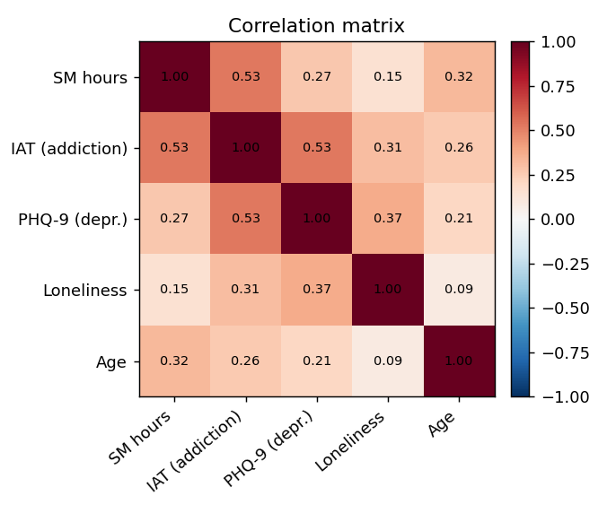
Figure 1. Correlation matrix of the numeric variables.
The outcome and exposure distributions (Figure 2) show a right-skewed PHQ-9 and IAT, and—importantly—a heavily compressed hours variable, where most students report low social-media time. This low variance in the hours measure is a real limitation we return to later.
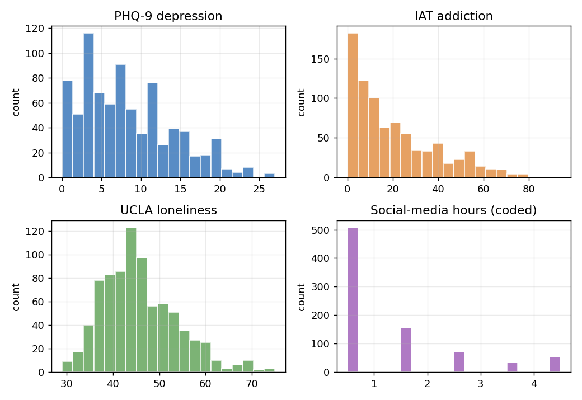
Figure 2. Distributions of depression, addiction, loneliness, and coded social-media hours.
Because the addiction and depression categories are ordinal, we visualize them as ordered factors rather than as bar charts. Figure 3 plots the IAT score across PHQ-9 severity levels using a boxplot with jittered points: addiction scores climb steadily as depression severity escalates, with the distributions shifting upward band by band.
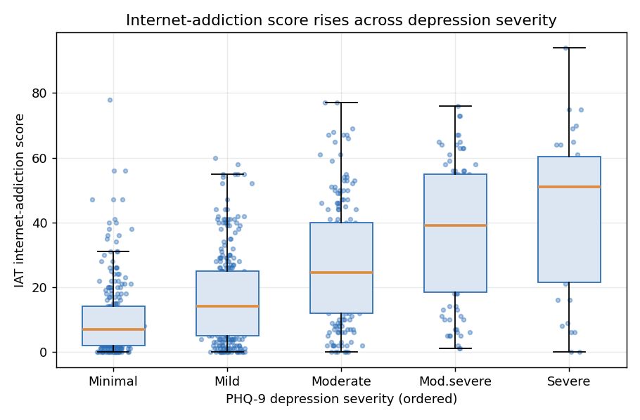
Figure 3. IAT internet-addiction score across ordered PHQ-9 depression severity levels (boxplot + jittered points).

5. Methods and Results
We used linear regression for the continuous outcomes (PHQ-9 depression and UCLA loneliness) and logistic regression for the binary clinically-significant-depression outcome. Each model regresses the outcome on hours, perceived addiction, gender, physical activity, and friendship quality.

5.1 Depression (linear)
The depression model gives an adjusted R² of 0.256. Perceived addiction is by far the dominant predictor (standardized β = 2.82, p < 0.001), while social-media hours is not significant once addiction is in the model (β = −0.07, p = 0.79). Physical activity trends protective (p = 0.12) but does not reach significance. Critically, we ran a Variance Inflation Factor check (car package): all VIFs are between 1.0 and 1.5, well below the conventional threshold of 5. So although hours and IAT are correlated, multicollinearity is not distorting these coefficients—the separation between the two digital measures is real, not an artefact. Figure 4 makes the contrast visible: the fit against perceived addiction is far steeper and tighter than the fit against raw hours.
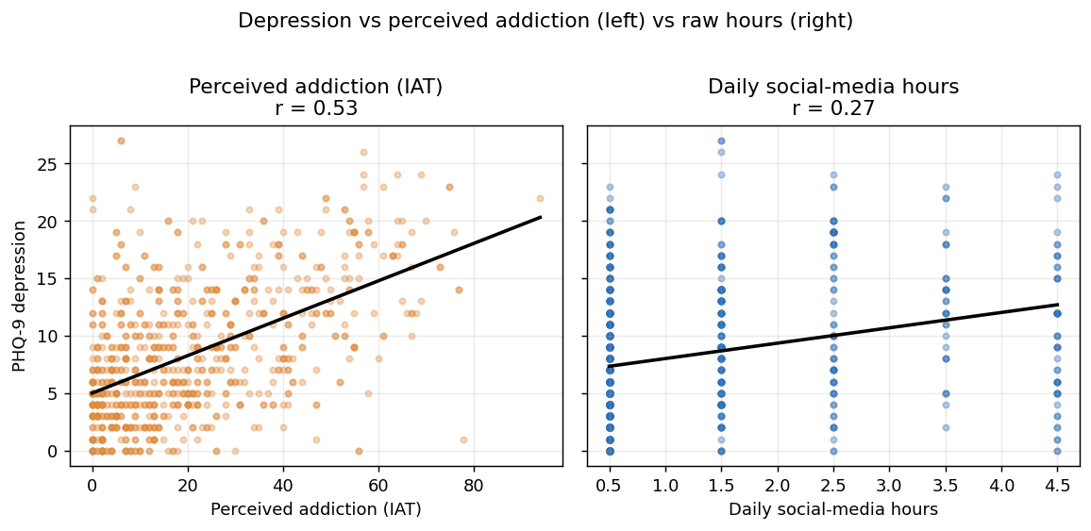
Figure 4. PHQ-9 depression vs. perceived addiction (left) and vs. daily social-media hours (right). The addiction relationship is much stronger.
We confirmed the model assumptions with residual diagnostics (Appendix, Figure 8): residuals are spread evenly around zero and are close to normal.

5.2 Loneliness (linear)
The loneliness model is weaker overall (adjusted R² = 0.087), and we report this rather than hide it. The pattern, however, is consistent: perceived addiction is again the dominant digital predictor (β = 2.56, p < 0.001) and hours is not significant (p = 0.32). Here the protective effect of offline relationships is clear and significant—students who rate their friendships as good score meaningfully lower on loneliness (β = −2.78, p = 0.005)—which matches the buffering hypothesis.

5.3 Predicting clinically-significant depression (logistic)
On the held-out test set the logistic model reached an AUC of 0.78 for predicting PHQ-9 ≥ 10. As in the linear models, perceived addiction is the strongest predictor (odds ratio 2.77 per standard deviation, 95% CI 2.17–3.54, p < 0.001), and hours is not significant once addiction is included (OR 1.02, p = 0.90). Figure 5 shows the ROC curve.
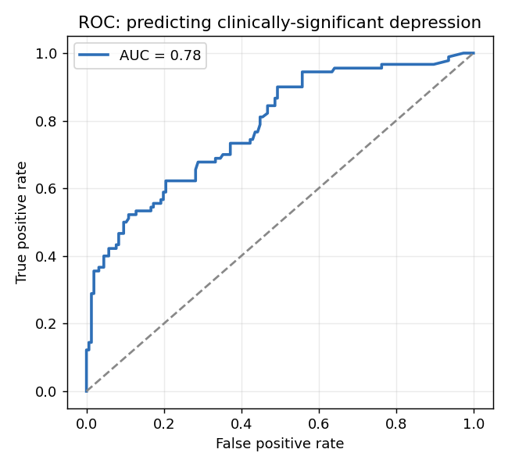
Figure 5. ROC curve for the clinically-significant-depression model on the test set (AUC = 0.78).

5.4 Forecasting usage from the addiction sentiment
We also ran the comparison in reverse: can we forecast how much a student actually uses social media, given everything we know about them—including their subjective sense of being addicted? A linear model predicting social-media hours from perceived addiction plus depression, loneliness, age, gender, physical activity, friendships, bullying, sleep and study time reaches a test R² of 0.29. Perceived addiction is overwhelmingly the strongest forecaster (standardized β = 0.58, p < 0.001); the next contributors are study time (less study, more use), age, and gender. Strikingly, the addiction sentiment on its own already explains R² = 0.28—almost the entire predictable signal—so the full demographic, mental-health and lifestyle context adds little beyond it (Figure 6).
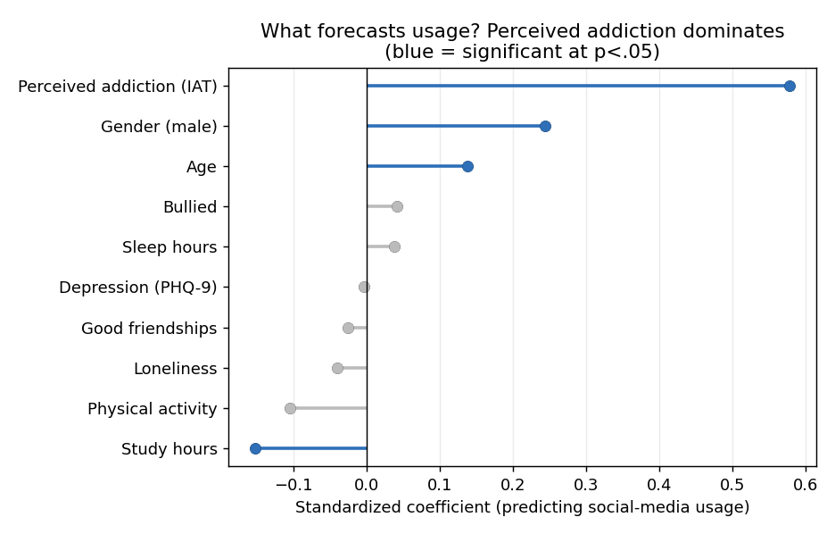
Figure 6. Standardized coefficients for forecasting social-media usage. Perceived addiction dominates; blue = significant at p < .05.
This carries a useful nuance for the central thesis. The feeling of being addicted does track real behaviour—it is the best single forecaster of usage—yet about 70% of the variation in actual hours remains unexplained even with the sentiment and full context. Perceived addiction and raw usage are therefore related but genuinely distinct, which is precisely why one can be tightly tied to mental health while the other is not.

5.5 Severity lens: outcomes across addiction bands
Treating internet-addiction category as an ordered factor, both outcomes escalate monotonically across bands (Figure 7). Mean depression rises from 6.8 in the Normal band to 11.4 (Mild), 15.0 (Moderate), and 22.0 (Severe); mean loneliness rises from 44.4 to 48.3, 51.4, and 67.0. The Severe band contains only one student, so its values are indicative rather than reliable, but the gradient across the populated bands is unambiguous.
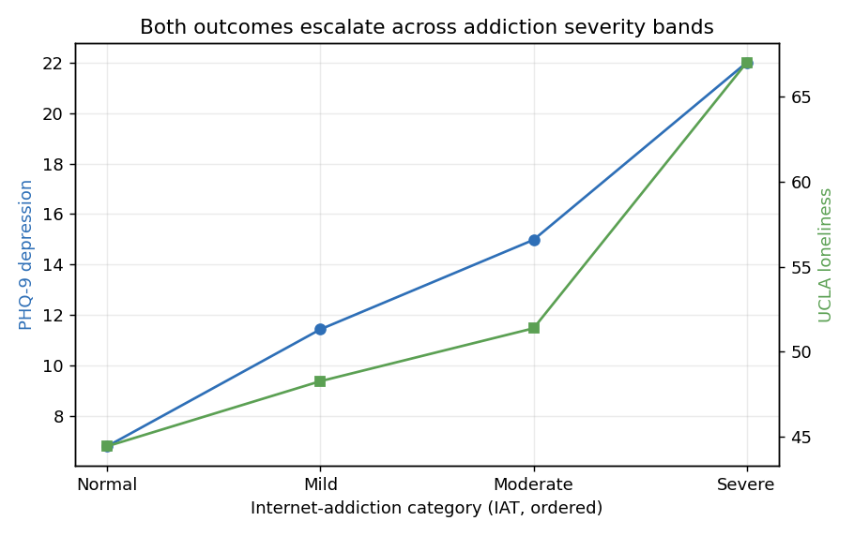
Figure 7. Mean depression and loneliness across ordered internet-addiction categories.
All three lenses converge on the same answer: for these adolescents, the subjective feeling of being addicted is far more strongly associated with poor mental health than the raw number of hours online. The implication is that interventions should target problematic, dependency-style use—not merely time on screen.

6. Limitations and Future Work
Several limitations bound these conclusions. First, the data are cross-sectional and entirely self-reported, so we can speak only of association, not causation, and self-reported hours are a noisy measure. Second, the hours variable is coarse (ordinal buckets) and has little variance—most students report low usage—which limits its statistical power and may partly explain why it is never significant. Third, the sample is a single, non-representative group of school students, so the results should not be generalized to the wider population. Fourth, the most-severe addiction band is essentially empty (n = 1), so claims about extreme addiction are not supported. Finally, important confounders are absent from the data—sleep quality, prior clinical diagnoses, and socioeconomic factors all affect depression and could account for part of the association we observe.
With one more month we would add bootstrap confidence intervals and k-fold cross-validation, and obtain device-measured screen time to replace the self-reported buckets. With three more months we would seek a second, representative dataset to test whether the hours-vs-addiction ordering replicates, and ideally a longitudinal design so that the direction of effect—not only its strength—could be studied.

Appendix
A1. Linear regression coefficients (standardized β with standard error in brackets; *p<.05, **p<.01, ***p<.001).
Predictor | Depression (PHQ-9) | Loneliness (UCLA)
Daily social-media hours | −0.07 [0.25] | −0.40 [0.40]
Perceived addiction (IAT) | 2.82 [0.25]*** | 2.56 [0.40]***
Gender (male) | 0.38 [0.45] | −0.39 [0.73]
Physical activity (yes) | −0.64 [0.41] | 0.27 [0.67]
Good friendships (yes) | −0.78 [0.61] | −2.78 [1.00]**
Adjusted R² | 0.256 | 0.087

A2. Logistic regression for clinically-significant depression (PHQ-9 ≥ 10; train n = 573, test n = 246; test AUC = 0.78). Odds ratios: hours 1.02 (p = .90); perceived addiction 2.77 (95% CI 2.17–3.54, p < .001); gender male 1.10 (p = .66); physical activity 0.88 (p = .51); good friendships 1.64 (p = .097). Pearson correlations with depression: IAT r = 0.53, hours r = 0.27 (both p < .001).
A3. Residual diagnostics for the depression model.
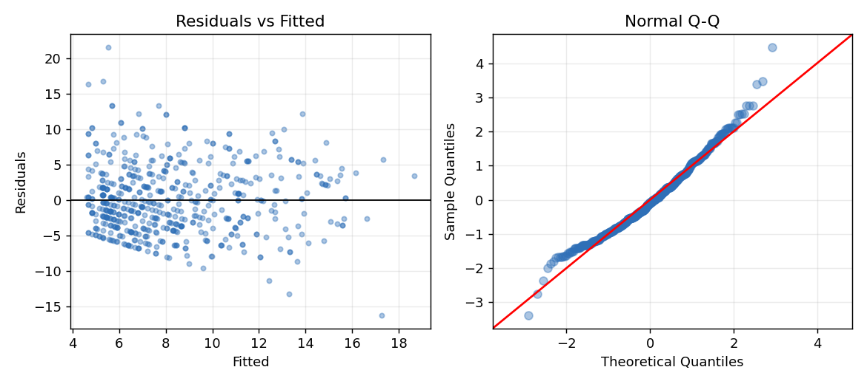
Figure 8. Residuals vs. fitted (left) and Normal Q-Q (right) for the depression model.
A4. Reproducibility. All code is in analysis.R (R; tidyverse, readxl, broom, car, pROC). Running it on data/new_data.xlsx reproduces every number and figure in this report. Code and data: https://github.com/AlinaKozitsyn/DataAnalysisFinal

Bibliography
Gupta, A., et al. (2018). Internet addiction and its association with psychological factors. [Reference details to be verified by the authors.]
Khalaf, A. M., Alubied, A. A., Khalaf, A. M., & Rifaey, A. A. (2023). The impact of social media on the mental health of adolescents and young adults: A systematic review. Cureus, 15(8), e42990.
Kroenke, K., Spitzer, R. L., & Williams, J. B. W. (2001). The PHQ-9: Validity of a brief depression severity measure. Journal of General Internal Medicine, 16(9), 606–613.
Kuss, D. J., & Griffiths, M. D. (2017). Online social networking and addiction: A review of the psychological literature. International Journal of Environmental Research and Public Health, 14(3), 311.
Riehm, K. E., Feder, K. A., Tormohlen, K. N., et al. (2019). Associations between time spent using social media and internalizing and externalizing problems among US youth. JAMA Psychiatry, 76(12), 1266–1273.
Russell, D. W. (1996). UCLA Loneliness Scale (Version 3): Reliability, validity, and factor structure. Journal of Personality Assessment, 66(1), 20–40.
Young, K. S. (1998). Internet addiction: The emergence of a new clinical disorder. CyberPsychology & Behavior, 1(3), 237–244.

