vnv – Verleihen, Dienstleistungen, verschenken

Use-Case Specification: Create new offer or request

Version 1.0

Revision History

|  |  |  |  |
| --- | --- | --- | --- |
| **Date** | **Version** | **Description** | **Author** |
| 10/26/2016 | 1.0 | Creation of Document | Waldemar Merk  Patrick Treyer  Gabriel Zachmann |
|  |  |  |  |
|  |  |  |  |
|  |  |  |  |

Table of Contents

Use-Case Name

Brief Description

Function Point Estimation

Flow of Events

Basic Flow

Special Requirements

Functionality on iOS

Preconditions

Entering the skill system

Postconditions

Save changes

Extension Points

Use-Case Specification: Set Skills

# Use-Case Name

## Brief Description

This use case allows the player/user to distribute 20 skillpoints among his figures. He can put those onto the attack or life points of his figures, raising their attack points by 5 per skillpoint or their life points by 10. Players are only allowed to put a maximum of 5 skillpoints onto one figure.

## Function Point Estimation

This use case was estimated with 242 funciton points.

**Type Count Weight (1,2,3) Result** **Formula**  
User Input 4 1 12 $Count*(2+Weight)$  
User Output 5 1 20 $Count*(3+Weight)$  
User Queries 1 1 3 $Count*(2+Weight)$  
Logic Blocks 8 3 192 $Count*(3+7*Weight)$  
Interfaces Layers 3 1 15 $Count*(3+2*Weight)$  
 **242 FP**

# Flow of Events

## Basic Flow

UML Diagram: <https://drive.google.com/file/d/0B0L4svZA18ZaQ0g4S0pWLUxONW8/view?usp=sharing>

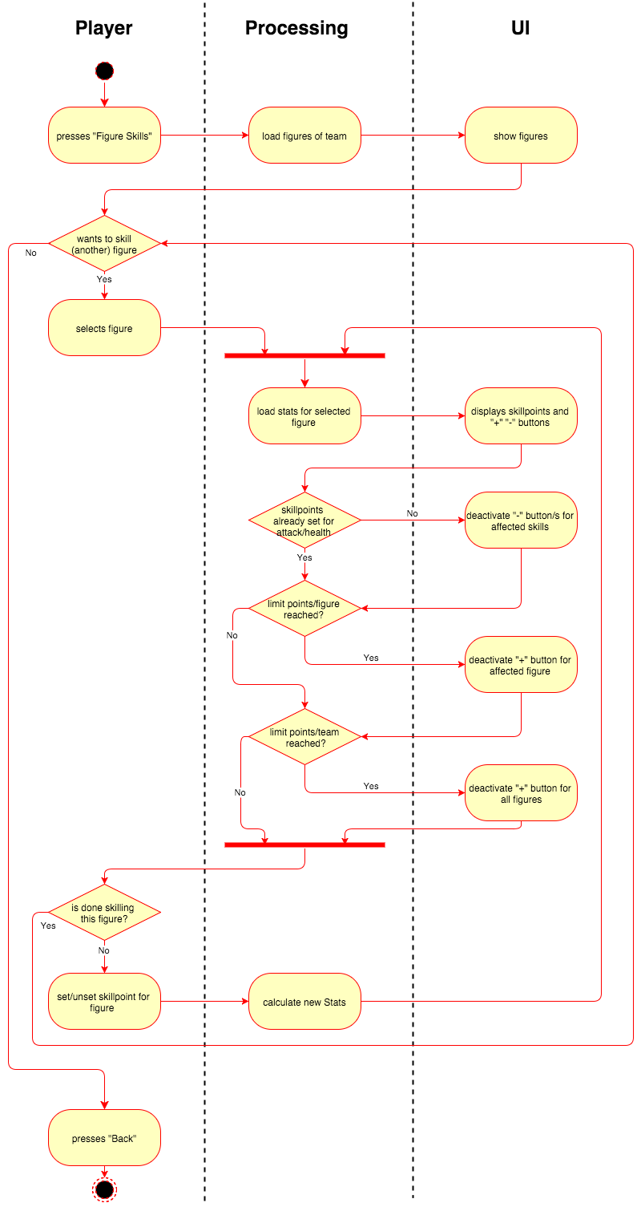

Mock-Up:

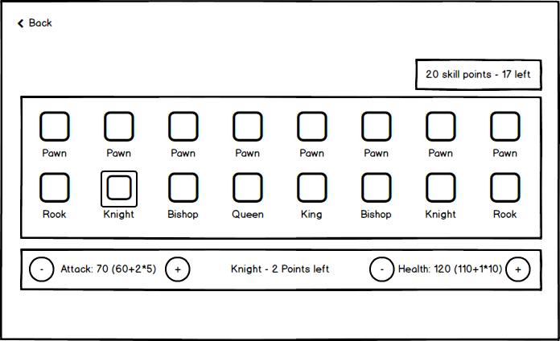

Feature file:

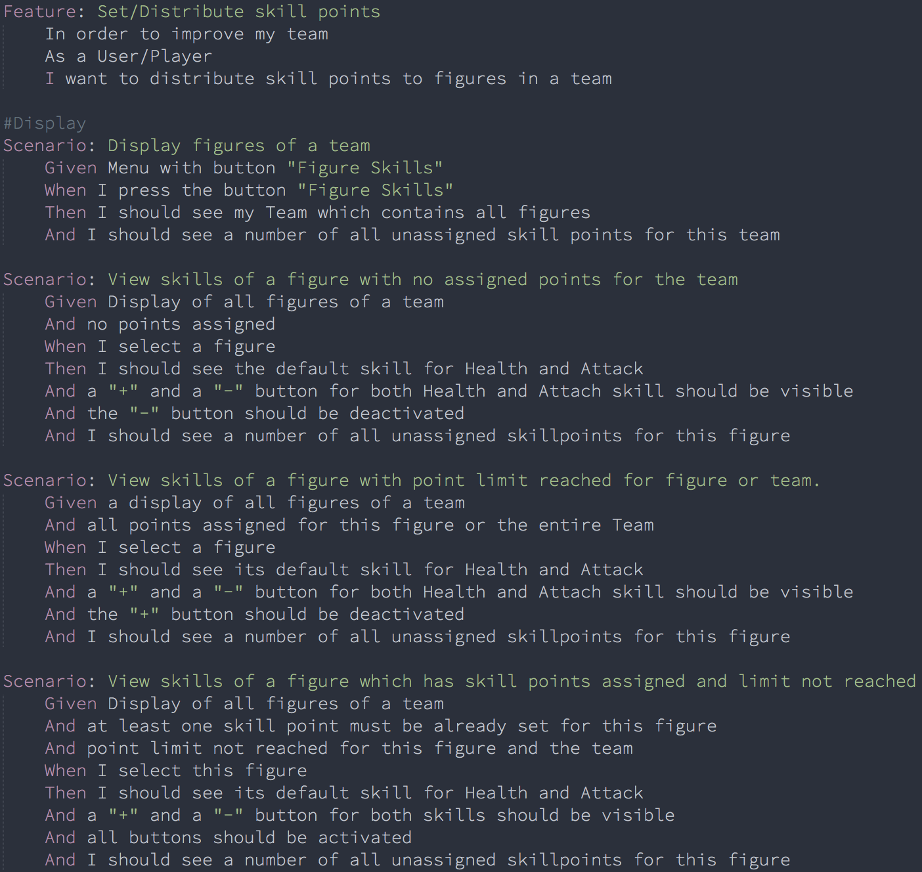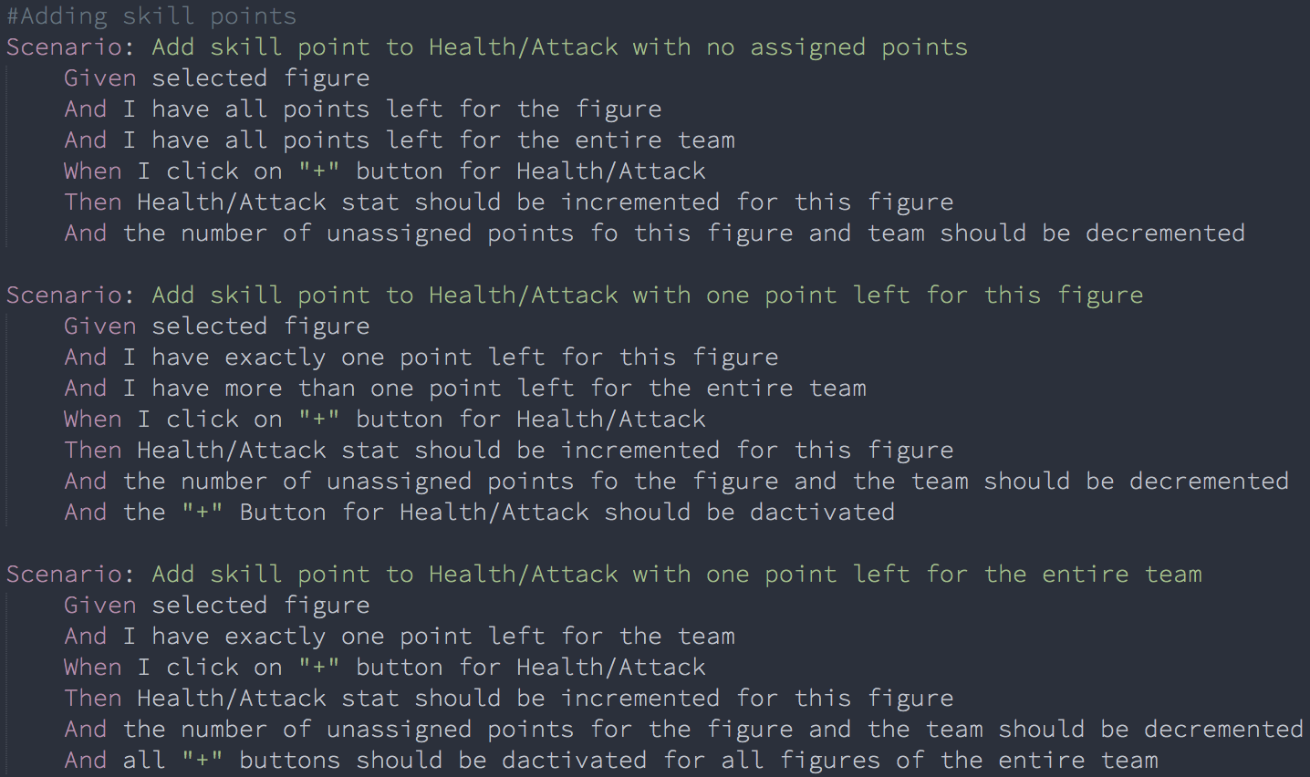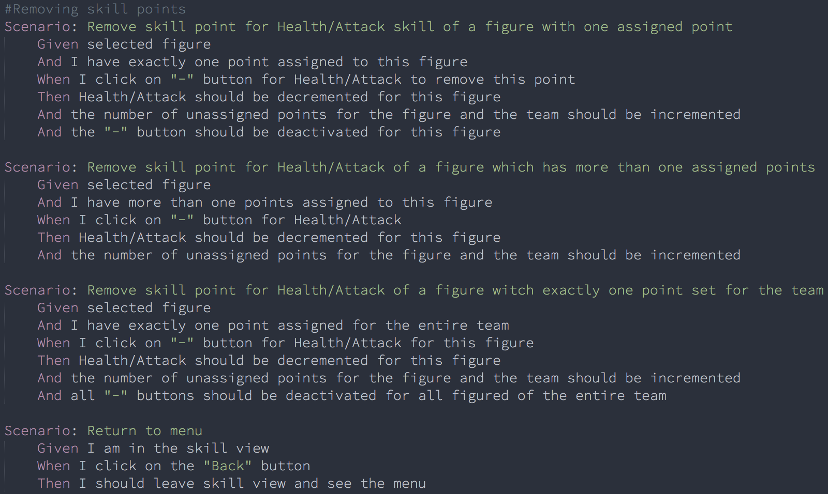

# Special Requirements

## Functionality on iOS

Since this will be a game in form of an iOS Application it is important for every design such as this to be fitting for iPhone and iPad screens.

Right now the game itself is only aimed at iPads but since there are plans to release an iPhone version too, smaller screens should be kept in mind as well.

# Preconditions

## Entering the skill system

To Enter the skill system the user has to have selected a team and press the „Distribute Skillpoints“ button.

# Postconditions

## Save changes

The database must be updated with all changes to the skillpoints and be notified about stat changes for any figure.

# Extension Points

n/a