**MINISTRY OF EDUCATION AND SCIENCE OF THE RUSSIAN FEDERATION**

**St. Petersburg State**

**Electrotechnical University**

**"LETI" named after V.I. Ulyanov (Lenin)**

**Department of BTS**

course project

**in the discipline "Methods of processing biomedical signals and data"**

Topic: Analysis of the alpha rhythm of EEG

Option No. 7-2

|  |  |  |
| --- | --- | --- |
| Student gr. 7501 |  | Popadiina A.O. |
| Teacher |  | Kalinichenko A.N. |

Saint Petersburg

2021

**content**

|  |  |  |
| --- | --- | --- |
|  | Introduction | 3 |
| 1. | Theoretical information | 4 |
| 1.1. | Nature of electroencephalogram | 4 |
| 1.2. | Modified Covariance Method for JMP Valuation | 6 |
| 2. | Design & Analysis | 7 |
| 2.1. | Digital filter design | 7 |
| 2.2.  2.3  2.4  2.5. | Filter difference equation  Filter transfer function  Filter flowchart  On-screen forms | 10  10  10  11 |
| 3. | Analysis of the results obtained | 15 |
|  | Sources | 16 |
|  | APPENDIX No. 1 Filter options | 17 |
|  | APPENDIX No. 2Full text of the program | 18 |
|  |  |  |
|  |  |  |

**introduction**

Diagnosis of electrical activity of the brain - electroencephalogram (EEG) was invented in the 30s of our century. Electroencephalographic examination has found wide application as it is a completely non-invasive procedure that can be used repeatedly in patients, healthy adults and children with almost no risk or restriction.

The founder of the EEG method, Hans Berger, immediately noted high-amplitude oscillations in the range of 8-12 Hz. He called them the alpha rhythm (alpha is the first letter of the Greek alphabet). But although these oscillations were the first to "get a name", their role in the body is still not clearly defined. A very "strong" alpha rhythm occurs in people with severe nervous or mental pathology: the sick brain is trying with all its might to save itself. But he is already so inhibited that he is not able to ensure normal mental activity.

The amplitude of EEG indicators reaches hundreds of micrometers, which is comparable to the noise that inevitably appears during diagnosis. This greatly complicates the work with the detection of EEG rhythms, moreover, the possibility of visual analysis of the EEG by the doctor is extremely inaccurate and limited. The problems listed earlier can be solved by the digital analysis of EEG rhythms.

**1. theoretical information**

**1.1. Nature of electroencephalogram**

A common and well-establishedmethod of functionalexamination of the brain iselectroencephalography. Elektroencephalogram (EEG) is considered as the total bioelectricalcapacity of all neurons involved in a giventime.

When brain cells (neurons) are activated, local current flows occur. The brain's electrical current consists mainly of Na+, K+, Ca++, and Cl- ions, which are pumped through channels in the membranes of neurons in a direction controlled by the membrane potential. The bioelectric current density i associated with neuronal activation creates an electric field that can be measured on the surface of the head or directly on brain tissue.

An internationally standardized system of 10-20 is usually used to record spontaneous EEG. In this system, 21 electrodes are located on the surface of the scalp, as shown in Figure 1.

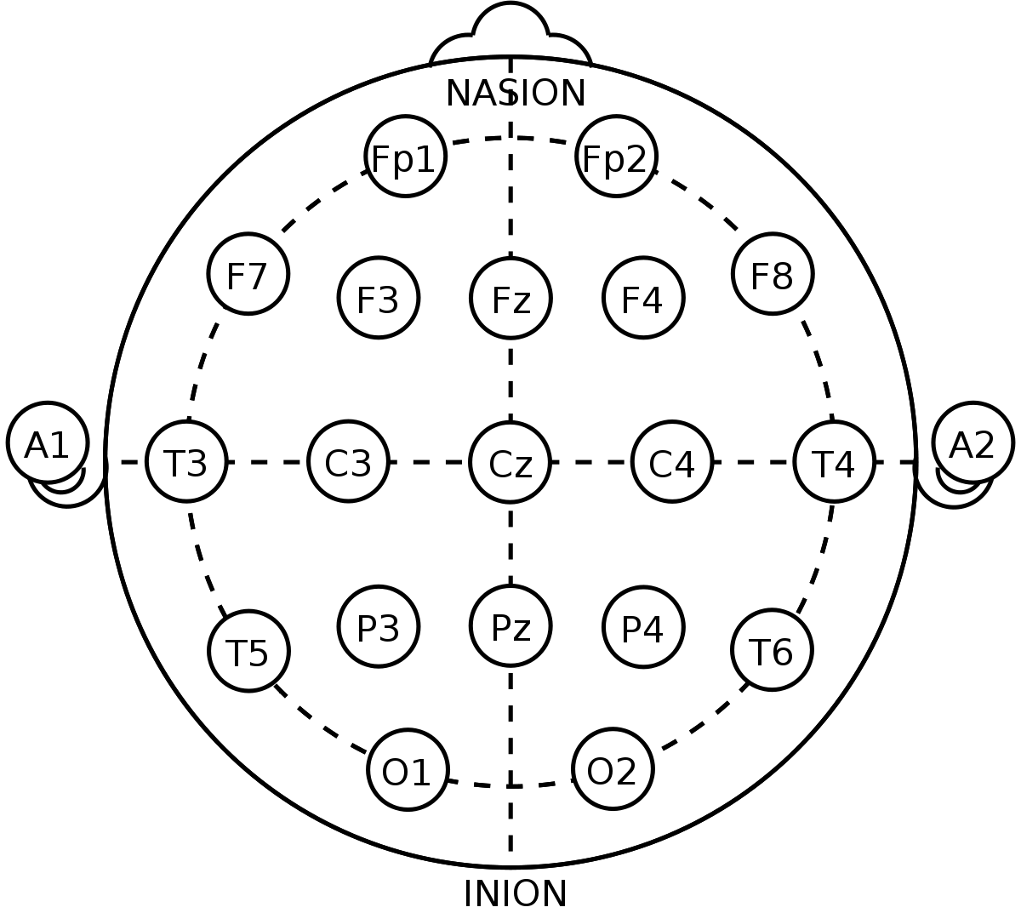

Figure 1. International System 10-20.

Traditionally, in clinical interpretation on the EEG, the rhythmic components of the paznoy amplitude and chastota are distinguished - EEG rhythms (alpha-, beta-, delta- and theta-rhythms (Figure 1). The predominant type of rhythmicactivity of the EEG of a healthy person in thecourseof passive wakefulness is the alpha rhythm. Alpha rhythm - rhythmic oscillations with a frequency of 8-13 Hz and an average amplitude of 30-70 μV, is recorded mainly in the occipital regions with closed eyes in a state of calm wakefulness and the maximum possible muscle relaxation. The rhythm is blocked by light stimulation, concentration of attention and the performance of various cognitive tests.

Table 1. Properties of EEG rhythms

|  |  |  |
| --- | --- | --- |
| **EEG rhythm** | **Frequency, Hz** | **Amplitude, μV** |
| δ (delta) | 0,5 – 3 | 40 – 300 |
| θ (theta) | 4 – 6 | 40 – 300 |
| α (alpha) | 8 – 13 | Up to 100 |
| β (beta) | 14 – 40 | Up to 15 |

Alpha activity usually disappears with the onset of attention (for example, with stress, open eyes, mental arithmetic calculations). In most cases, it is considered as normal. Andthe alpha-range of the EEG traditionally attracts increased attention of researchers, due to its high sensitivity to a variety of external influences and subtle changes in the functional state of the cerebral cortex accompanying sensory, motor, cognitive and mnestic processes.

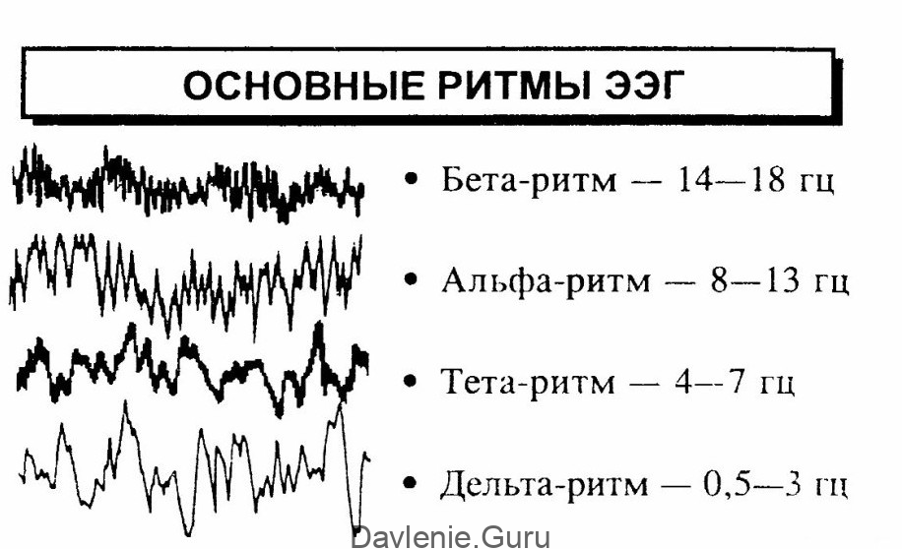

Figure **2**. Basic EEG rhythms.

One of the main parameters of EEG is the amplitude-frequency response (frequency response), on the basis of which EEG rhythms are distinguished, which are widely used to describe and diagnose variousprocesses, as well as SPM, ACF, etc. can be used to identify alpha rhythm. Methods.

The methods of EEG analysis are based on a rather complex mathematical apparatus. In this course project

**1.2.**   **Modified covariance method for estimating SPM.**

Estimation of the spectral power density (SPM) or simply the spectrum of discretized deterministic and random processes is usually performed by a combination of procedures using the Fast Fourier Transform (FFT). This approach to spectral analysis is computationally efficient and provides acceptable results for a large class of signaling processes. However, despite these advantages, the approach based on the calculation of the FFT has a number of fundamental limitations: limitation of frequency resolution, "leakage" in the frequency region, i.e. the energy of the main lobe of the spectral line "leaks" into the side lobes, which leads to the imposition and distortion of the spectral lines of other present signals. Modern digital spectral analysis is the evaluation of SPM based on parametric models of stochastic processes. The use of parametric methods implies the presence of some mathematical model of the analyzed random process. Spectral analysis is reduced in this case to the solution of the optimization problem, that is, the search for such parameters of the model at which it is closest to the actually observed signal.

There are the following types of models: AR-model ("autoregression"), CC-model ("moving average"), ARSS-model. The most common are methods based on the AP model of signal formation. This is due to the simplicity of the model, the convenience of calculations based on it and the fact that this model corresponds well to many real tasks.

The main interest in the methods of parametric spectral estimation is associated with the high resolution achieved with their help in the processing of data sequences containing a very small number of samples.

The modified covariance method is based on minimizing the average squares of linear forward and backward prediction errors. Since the best value of the model order is usually not known in advance, in practice you have to test several orders of the model. If the order of the model is too low, strongly smoothed spectral estimates are obtained, if the resolution is too high, the resolution increases, but false peaks appear in the spectrum.

It is intuitively clear that one should increase the order of the AP model until the calculated prediction error reaches a minimum. Several target criteria have been proposed for choosing the order of the AP model. Akaike proposed two criteria.

**2.**  **design and analysis**

**2.1.**  **Digital filter design**

Table 2. The specified filter parameters.

|  |  |
| --- | --- |
| **Parameter** | **Meaning** |
| Response Type | Bandpass |
| Design Method | FIR, Least-squares |
| Specify order | 22 |
| First Latency Bar Boundary (Fstop1) | 6 Hz |
| First bandwidth boundary (Fpass1) | 8 Hz |
| Second bandwidth boundary (Fpass2) | 13 Hz |
| Second Latency Bar Boundary (Fstop2) | 17 Hz |

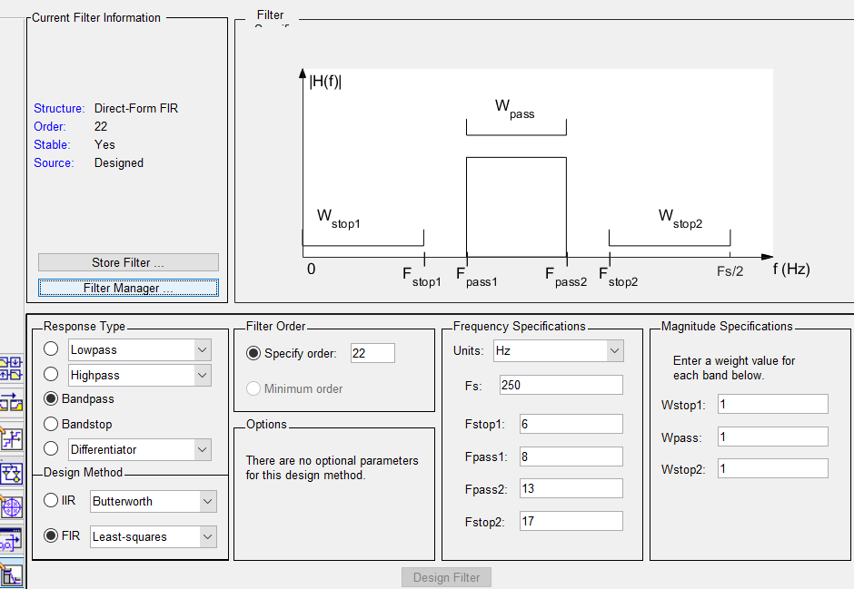

Figure 3. MATLAB utility session 'Filter Designer and Analysis Tool'.

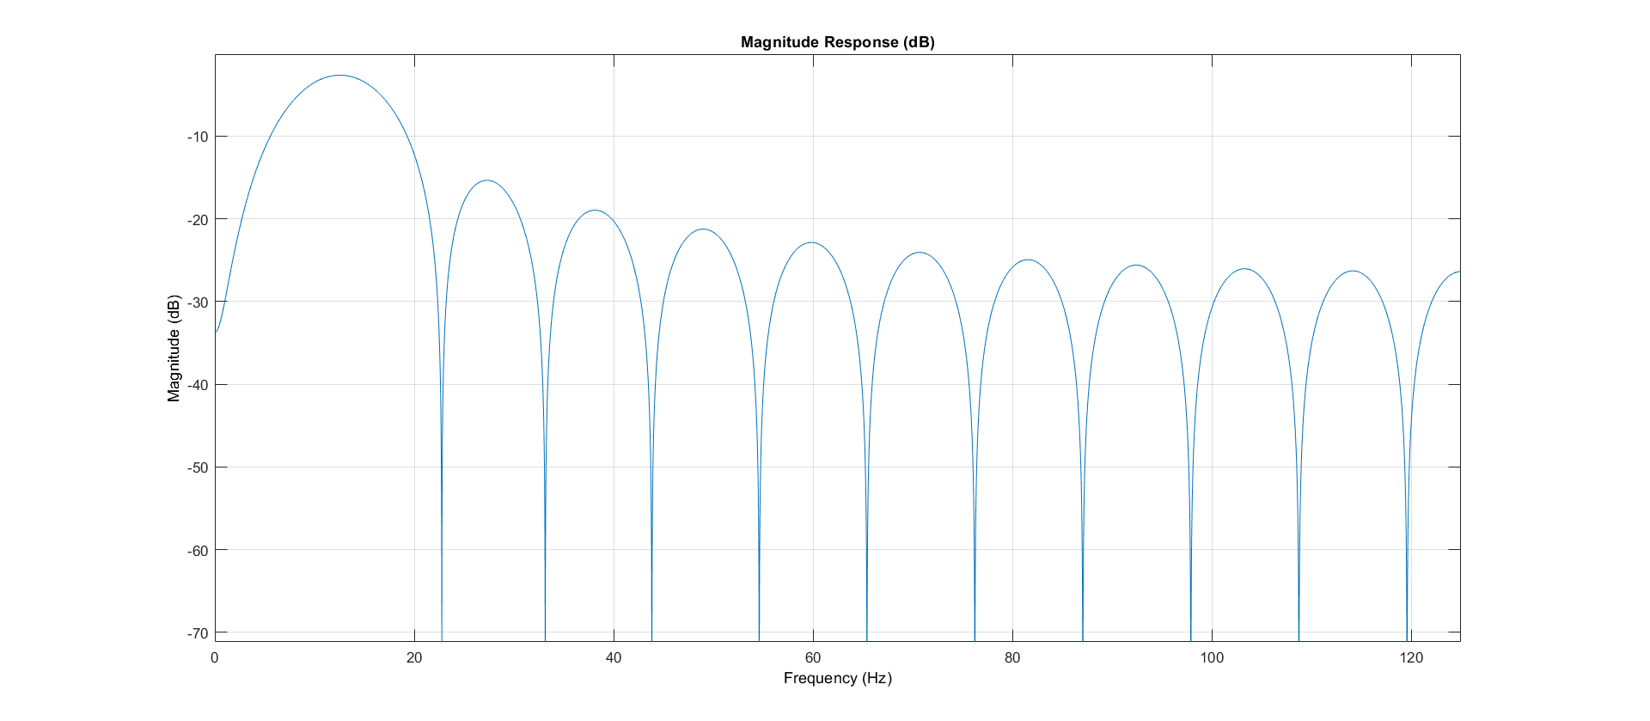

A.

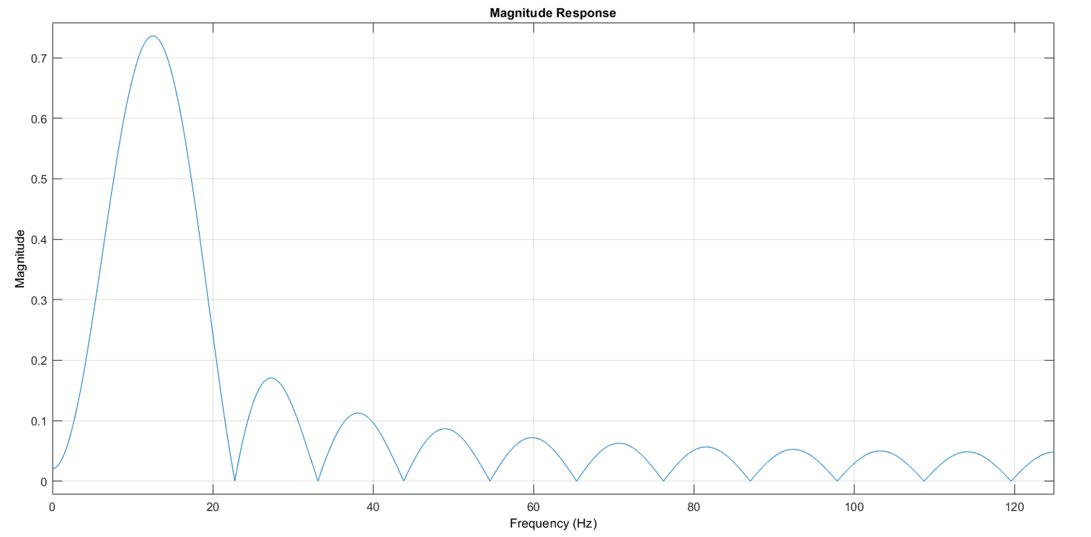

B.

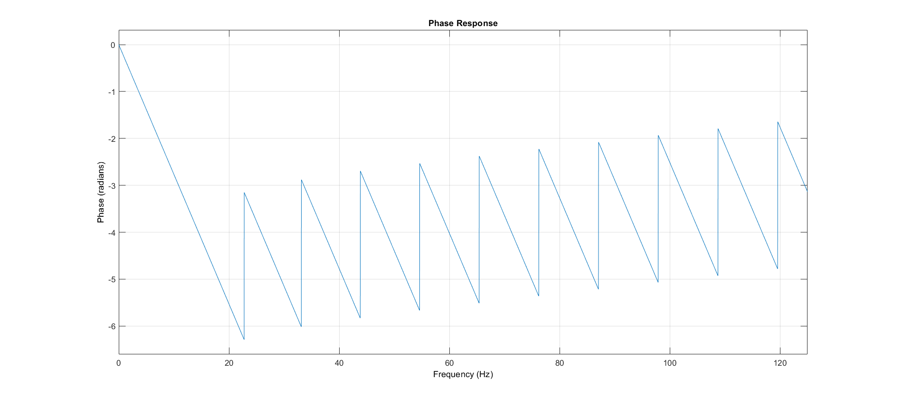

C.

Figure 4. Graphs of the characteristics of the simulated filter: frequency response in logarithmic scale (A), frequency response in linear scale (B), PFR (C).

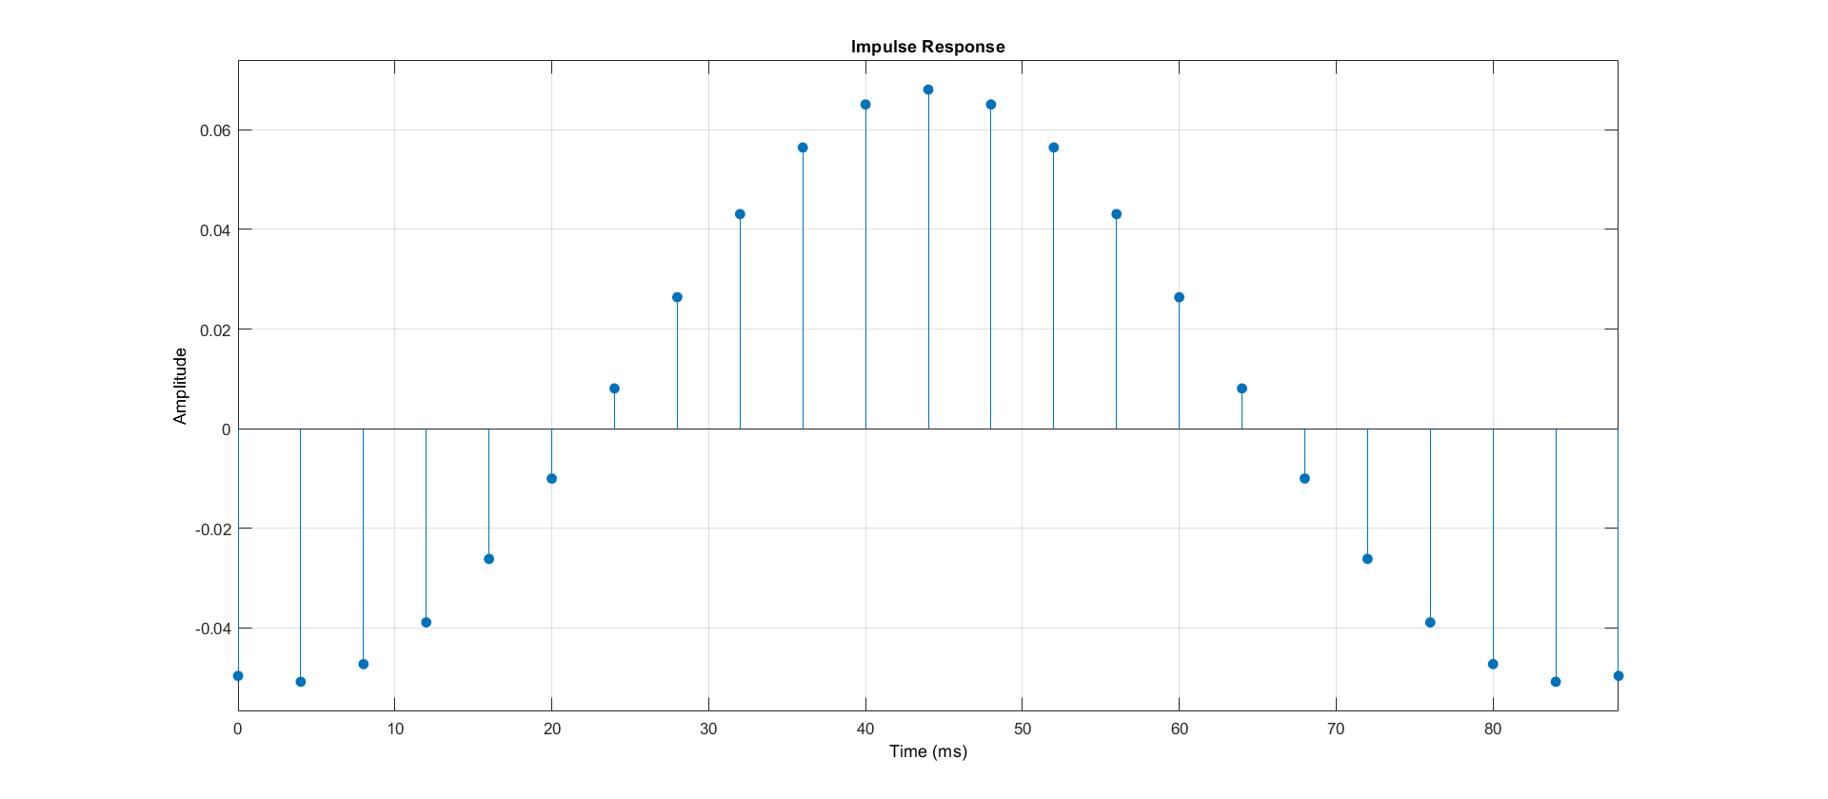

Figure 5. Graph of the pulse characteristic of the filter.

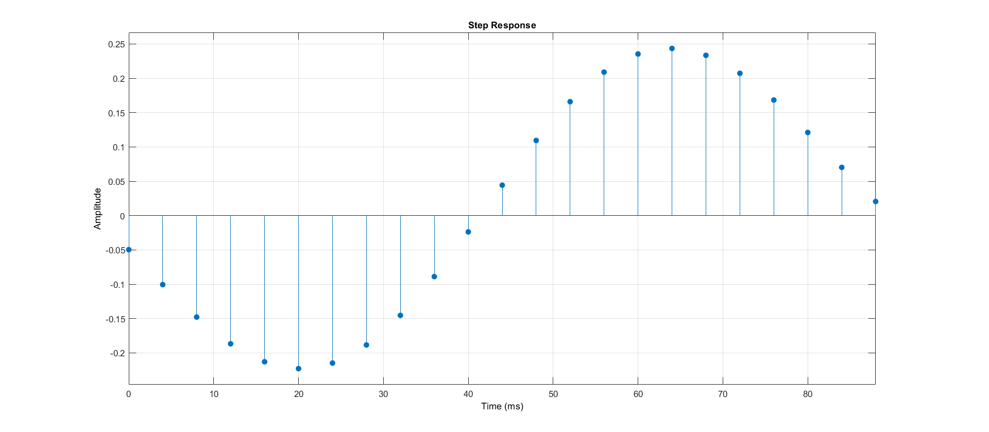

Figure 6. Graph of the transient characteristic of the filter.

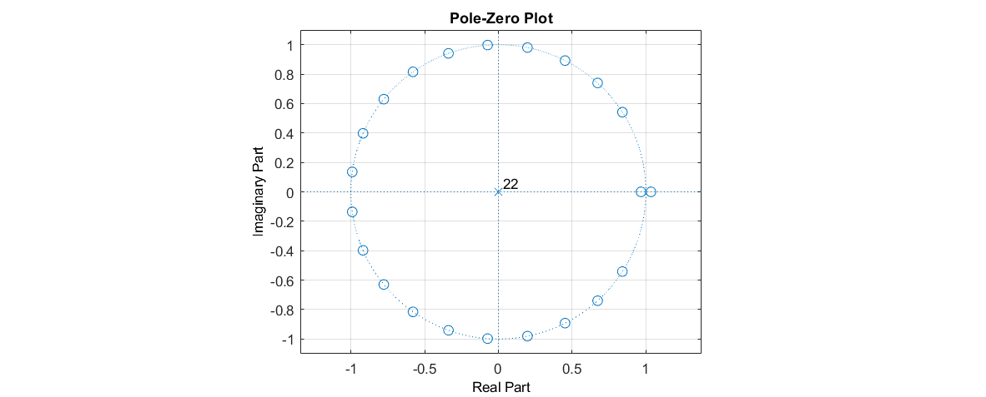

Figure 7. Map of zeros and poles.

**2.** **2. Filter difference equation**



**2.** **3. Gear ratio function of the ROT filter**



**2.** **4. Filter flowchart**

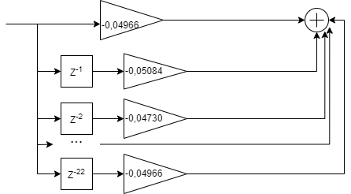

Figure 8. Flowchart of the filter.

**2.** **5. On-screen forms**

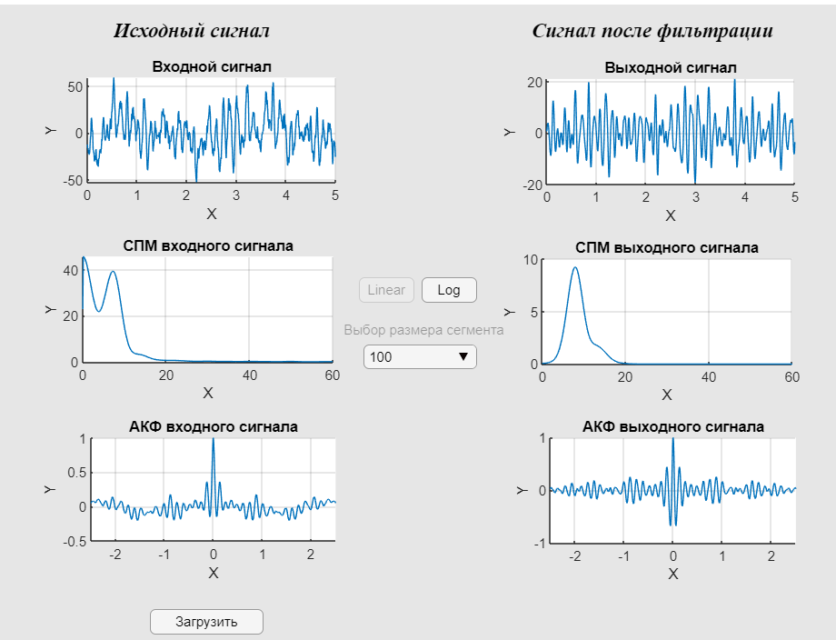

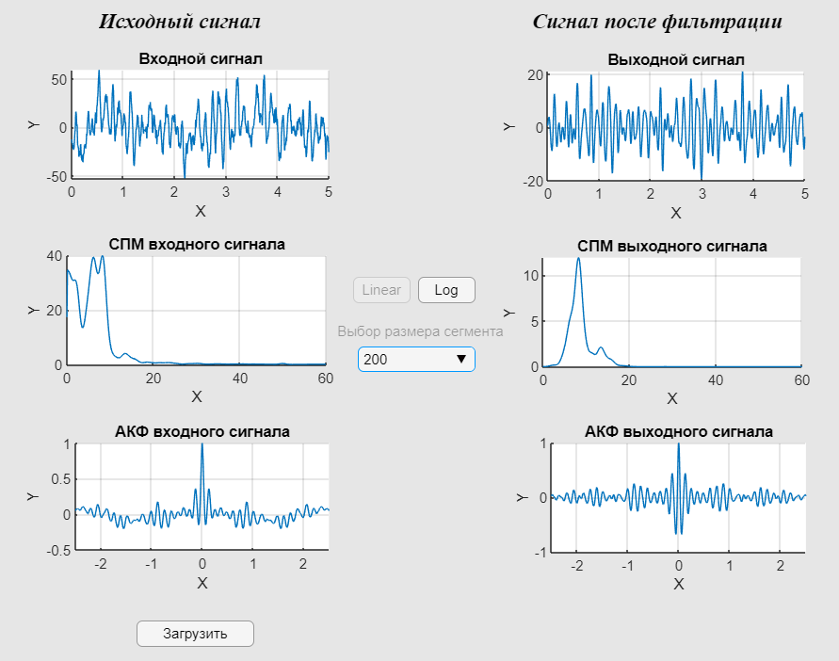

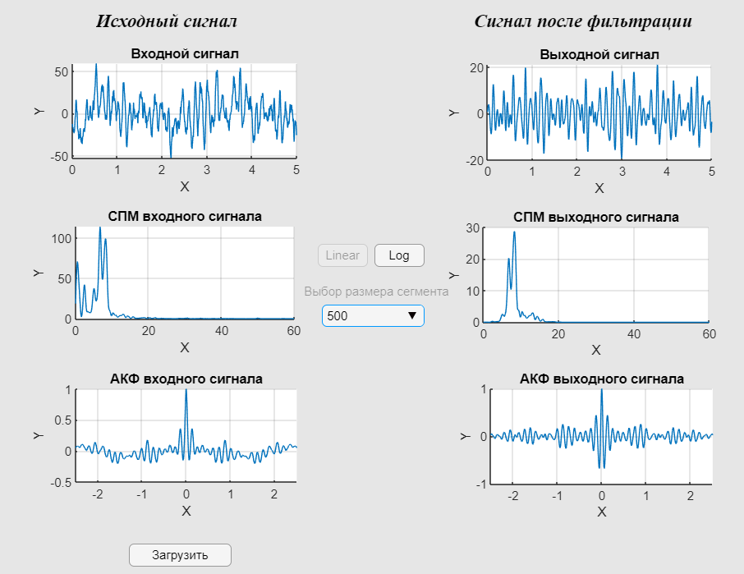

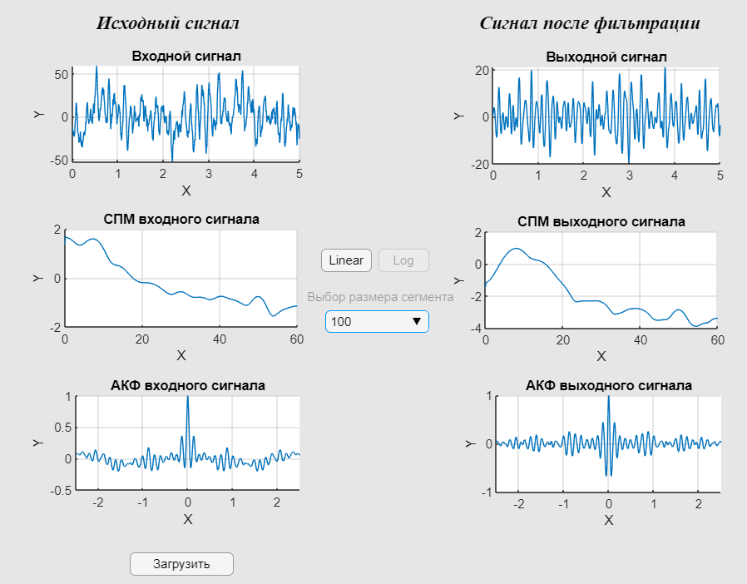

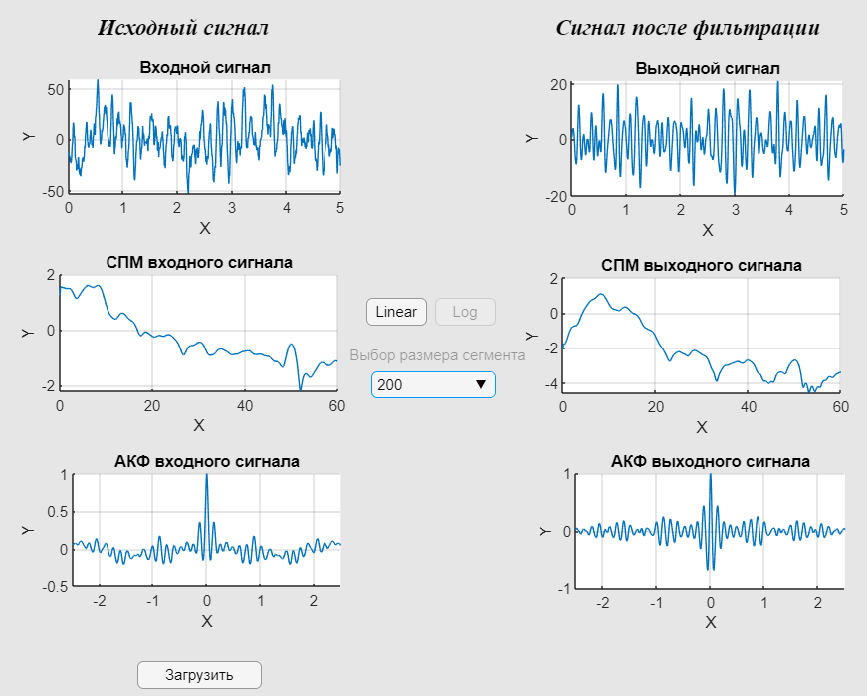

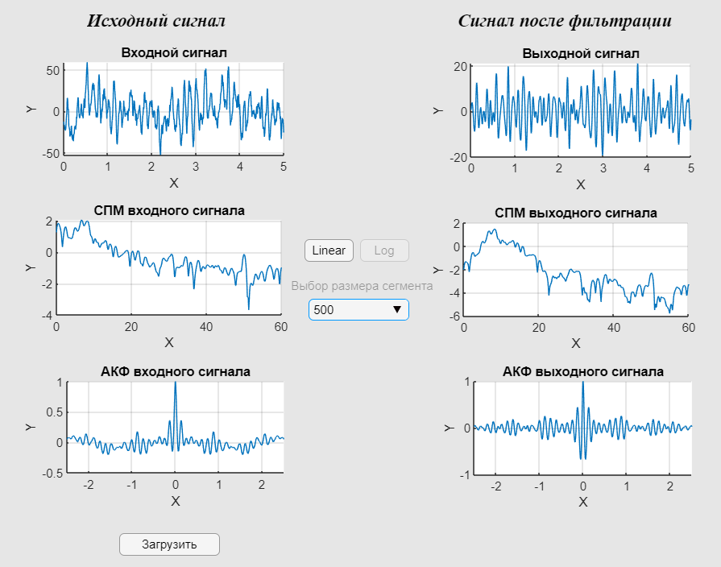

**3. Analysis of the results obtained**

A program has been developed inthe MATLAB "App Designer" utility that allows you to filter the EEG signal, build graphs of the original signals, filtered signals, their ACF and SPM. A modified covariance method was used for SPM.

A model of a kih bandwidth filter was developed, with a minimizationof 22 orders of order according to the SKO with transmittance frequencies from 8 Hz to 13 Hz, which corresponds to the frequencies of manifestation of the rhythm in the EEG signal. α According to the resulting map of zeros and poles, the filter is stable. The frequency response of the filter on the bandwidths is not very smooth, which can cause nonlinear distortion of the signal in the bandwidth. The pulse coefficients coincide with the filter coefficients, which is characteristic of FIR filters.

To estimate the SPM, welch's m etod was used with segment sizes: 100,200,500;70% guaranteed and a Hemming window (set by default when using the pwelch method)

Digital processing of the given signal was αperformed, the rhythm was detected, which can be confirmed by the presence of a peak at frequencies 8-13 of the SPM graph.

**List of sources used**

1. Krivosheev V.I. Modern methods of digital signal processing. Nizhny Novgorod. 2006. – 117 p.

2. Rangayan R.M. Analysis of biomedical signals. Practical approach./ Per. s eng. Ed. by A.P. Nemirko. – M.: FIZMATLIT, 2007. – 440 p.

3. Sergienko A.B., Digital signal processing. SPb.: Piter, 2003. – 604 p.

4. A.P. Nemirko, L.A. Manilo, A.N. Kalinichenko. Mathematical analysis of biomedical signals and data. – M.: FIZMATLIT, 2017. – 246 p.

5. Kondaurova O.Y. VKR / Study of the specificity of the amplitude-frequency characteristics of EEG in craniocerebral injuries. SPB. 2017. – 72 p.

6. T.S. Melnikova, V.V. Sargsyan, I.Y. Gurovich. Characteristics of the alpha rhythm of EEG in the first episode of paranoid schizophrenia.Social and Clinical Psychiatry, 2013, v.23, No. 1

7. Journal "Science and Life" // Archive of the journal URL: https://www. nkj. en/archive/articles/9190/(Accessed 2019-12-01).

**APPENDIX No. 1**

**Filter options**

The text of the fcf file containing the parameters of the developed filter:

% Generated by MATLAB(R) 9,11 and Signal Processing Toolbox 8,7,

% Generated on 01-Mar-2022 200048

% Coefficient Format Decimal

% Discrete-Time FIR Filter (real)

% -------------------------------

% Filter Structure Direct-Form FIR

% Filter Length 23

% Stable Yes

% Linear Phase Yes (Type 1)

Numerator

-0,049660896709698879036842811274254927412

-0,05084433130668881972713535333241452463

-0,047297234308301475125269064392341533676

-0,038919286108898068499151179366890573874

-0,026164242677312085638696714795514708385

-0,010021256704199623180362443974900088506

0,008074270592770105281488213222473859787

0,026391272700972717712986082005954813212

0,043097180756777868360085648191670770757

0,056471301132824176793878478974875179119

0,065109836330213277655332149151945486665

0,068095594579363011300543462311907205731

0,065109836330213277655332149151945486665

0,056471301132824176793878478974875179119

0,043097180756777868360085648191670770757

0,026391272700972717712986082005954813212

0,008074270592770105281488213222473859787

-0,010021256704199623180362443974900088506

-0,026164242677312085638696714795514708385

-0,038919286108898068499151179366890573874

-0,047297234308301475125269064392341533676

-0,05084433130668881972713535333241452463

-0,049660896709698879036842811274254927412

**APPENDIX No. 2**

**program** text

% 9.3 Filtering

% load('2_coefficients.mat');

load('matlab_coef.mat');

Den = 1;

app.y=filter(Num, Den, app.x);

% 9.4 Display of graphs after filtering

plot(app.output,t,app.y);

%set(app.output,'Xlim',[0 app. Fs/2]);

%SPM by input parameters

app.value = app. DropDown.Value;

app.value=str2num(app.value);

nfft = 2048;

app.pxx = pwelch(app.x,app.value,70,nfft);

plot(app. Input_SPM,app.pxx);

set(app. Input_SPM,'Xlim',[0 125]);

%SPM on initial OUTPUT parameters

app.pxy=pwelch(app.y,app.value,70,nfft);

plot(app.output_SPM,app.pxy);

set(app.output_SPM,'Xlim',[0 125]);

%Autocorrelation Rating

app.tcf=-app.tmax+T:T:app.tmax-T;

app.autoX=xcorr(app.x,'coef');

set(app.input_corr,'Xlim',[-2.5 2.5]);

plot(app.input_corr,app.tcf,app.autoX);

app.autoY=xcorr(app.y,'coef');

set(app.output_corr,'Xlim',[-2.5 2.5]);

plot(app.output_corr,app.tcf,app.autoY);

end

% Value changed function: DropDown

function DropDownValueChanged(app, event)

global valuek

nfft = 2048;

if app.helpvalue == 1

valuek = app. DropDown.Value;

valuek=str2num(valuek);

app.pxlin=pwelch(app.x,valuek,70,nfft);

plot(app. Input_SPM,app.pxlin);

set(app. Input_SPM,'Xlim',[0 125]);

app.pylin=pwelch(app.y,valuek,70,nfft);

plot(app.output_SPM,app.pylin);

set(app.output_SPM,'Xlim',[0 125]);

else

valuek = app. DropDown.Value;

valuek=str2num(valuek);

app.pxlin=pwelch(app.x,valuek,70,nfft);

app.pxlin=log10(app.pxlin);

plot(app. Input_SPM,app.pxlin);

set(app. Input_SPM,'Xlim',[0 125]);

app.pylin=pwelch(app.y,valuek,70,nfft);

app.pylin=log10(app.pylin);

plot(app.output_SPM,app.pylin);

set(app.output_SPM,'Xlim',[0 125]);

end

end

% Callback function

function Button_2Pushed(app, event)

% 9.5 PMM

app.pxx=pmcov(app.x,12);

plot(app.output_SPM,app.pxx);

set(app.output_SPM,'Xlim',[0 125]);

end

% Callback function

function SwitchValueChanged(app, event)

app.valueS = app. Switch.Value;

% app.tf=strcmp(app.valueS,'1');

end

% Button pushed function: log

function logButtonPushed(app, event)

.app. Input_SPM. XScale = 'log';

app.output_SPM. XScale = 'log';

%Activation\disactivation of items

app.log.Enable=false;

app.linear.Enable=true;

app.helpvalue=2;

app.valuelog = app. DropDown.Value;

app.valuelog=str2num(app.valuelog);

app.value = app. DropDown.Value;

app.value=str2num(app.value);

nfft = 2048;

app.pxl = pwelch(app.x,app.valuelog,70,nfft)

%app.pxl=pmcov(app.x,app.valuelog);

app.pxl=log10(app.pxl);

plot(app. Input_SPM,app.pxl);

set(app. Input_SPM,'Xlim',[0 125]);

app.pyl = pwelch(app.y,app.valuelog,70,nfft)

%app.pyl=pmcov(app.y,app.valuelog);

app.pyl=log10(app.pyl);

plot(app.output_SPM,app.pyl);

set(app.output_SPM,'Xlim',[0 125]);

%BUILD UAV UAVs

end

% Button pushed function: linear

function linearButtonPushed(app, event)

%Activation\disactivation of items

.app. Input_SPM. XScale = 'linear';

app.output_SPM. XScale = 'linear';

app.log.Enable=true;

app.linear.Enable=false;

app.helpvalue=1;

app.value = app. DropDown.Value;

app.value=str2num(app.value);

nfft = 2048;

app.px = pwelch(app.x,app.value,70,nfft)

% app.px=pmcov(app.x,app.value);

plot(app. Input_SPM,app.px);

set(app. Input_SPM,'Xlim',[0 125]);

app.py = pwelch(app.y,app.value,70,nfft)

%app.py=pmcov(app.y,app.value);

plot(app.output_SPM,app.py);

set(app.output_SPM,'Xlim',[0 125]);