## OLTP Schema

DVD Sales Website, Dell company’s test database

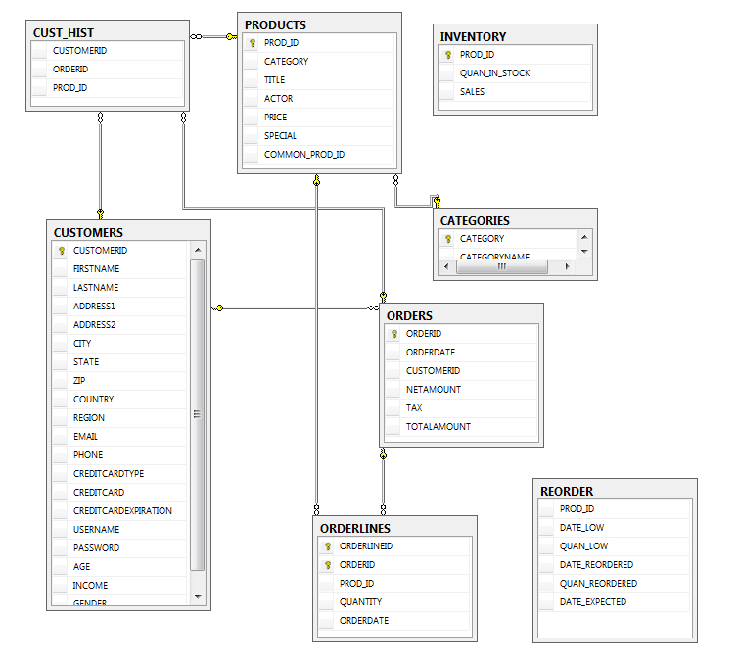

## Tables list

* CUSTOMERS – list of customers
* CUST_HIST – transactions history (not used)
* ORDERS – list of purchases
* ORDERLINES – purchases details
* PRODUCTS – list of products
* INVENTORY – products quantity (in stock, sold) (not used)
* CATEGORIES – products categories
* REORDER – additional orders (in case of absence in stock) (not used)

## Logical model

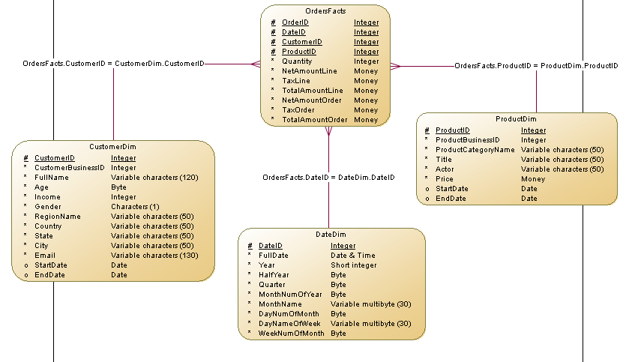

## Physical model

# F:\Physical Model.png

### List of tables

|  |  |
| --- | --- |
| **Name** | **Type** |
| Customer Dim | Dimention |
| DateDim | Dimention |
| ProductDim | Dimention |
| OrdersFacts | Facts Table |

#### CustomerDim Table

#### List of table columns

|  |  |  |  |  |  |
| --- | --- | --- | --- | --- | --- |
| **Name (DW)** | **Data Type (by Power Designer)** | **Data Type (DW)** | **Mandatory (not null)** | **Constraints** | **Name (OLTP)** |
| CustomerID | Integer | Integer | X | Primary Key | CUSTOMERID (Customers table) |
| CustomerBusinessID | Integer | Integer | X |  |  |
| FullName | Variable characters (120) | Variable characters (120) | X |  | FIRSTNAME + LASTNAME (Customers table) |
| Age | Byte | Tinyint | X |  | AGE (Customers table) |
| Income | Integer | Integer | X |  | INCOME (Customers table) |
| Gender | Characters (1) | Characters (1) | X |  | GENDER (Customers table) |
| RegionName | Variable characters (50) | Variable characters (50) | X |  | REGION (code: 1 and 2) (Customers table) |
| Country | Variable characters (50) | Variable characters (50) | X |  | COUNTRY (Customers table) |
| State | Variable characters (50) | Variable characters (50) | X |  | STATE (abbreviations) (Customers table) |
| City | Variable characters (50) | Variable characters (50) | X |  | CITY (Customers table) |
| Email | Variable characters (130) | Variable characters (130) | X |  | EMAIL (Customers table) |
| StartDate | Date | Date |  |  |  |
| EndDate | Date | Date |  |  |  |

#### List of table indexes

|  |  |  |  |  |  |  |  |
| --- | --- | --- | --- | --- | --- | --- | --- |
| Name | Code | Unique | Cluster | Primary | Foreign Key | Alternate Key | Table |
| CUSTOMER DIM _PK | CUSTOMER DIM _PK | X |  | X |  |  | CustomerDim |

#### List of table references

|  |  |  |  |  |  |  |  |
| --- | --- | --- | --- | --- | --- | --- | --- |
| Name | Code | Generate | Table 2 (Child Table) | Table 1 (Parent Table) | Dependent Role | Table 1 -> Table 2 Role Cardinality | Table 2 -> Table 1 Role Cardinality |
| OrdersFacts.CustomerID = CustomerDim.CustomerID | ORDERSFACTS_CUSTOMERID___ CUSTOMER DIM_CUSTOMERID | X | Facts | CustomerDim | Facts -> CustomerDim | 1,n | 1,1 |

#### DateDim Table

#### List of table columns

|  |  |  |  |  |  |
| --- | --- | --- | --- | --- | --- |
| **Name (DW)** | **Data Type (by Power Designer)** | **Data Type (DW)** | **Mandatory (not null)** | **Constraints** | **Name (OLTP)** |
| DateID | Integer | Integer | X | Primary Key |  |
| FullDate | Date & Time | DateTime | X |  | ORDERDATE (Orders table) |
| Year | Short integer | Smallint | X |  |  |
| HalfYear | Byte | Tinyint | X |  |  |
| Quarter | Byte | Tinyint | X |  |  |
| MonthNumOfYear | Byte | Tinyint | X |  |  |
| MonthName | Variable multibyte (30) | Nvarchar (30) | X |  |  |
| DayNumOfMonth | Byte | Tinyint | X |  |  |
| DayNameOfWeek | Variable multibyte (30) | Nvarchar (30) | X |  |  |
| WeekNumOfMonth | Byte | Tinyint | X |  |  |

#### List of table indexes

|  |  |  |  |  |  |  |  |
| --- | --- | --- | --- | --- | --- | --- | --- |
| Name | Code | Unique | Cluster | Primary | Foreign Key | Alternate Key | Table |
| DATEDIM_PK | DATEDIM _PK | X |  | X |  |  | DateDim |

#### List of table references

|  |  |  |  |  |  |  |  |
| --- | --- | --- | --- | --- | --- | --- | --- |
| Name | Code | Generate | Table 2  (Child Table) | Table 1 (Parent Table) | Dependent Role | Table 1 -> Table 2 Role Cardinality | Table 2 -> Table 1 Role Cardinality |
| OrdersFacts.DateID = DateDim.DateID | ORDERSFACTS_DATEID___ DATEDIM _DATEID | X | Facts | DateDim | Facts -> DateDim | 1,n | 1,1 |

#### ProductDim Table

#### List of table columns

|  |  |  |  |  |  |
| --- | --- | --- | --- | --- | --- |
| **Name (DW)** | **Data Type (by Power Designer)** | **Data Type (DW)** | **Mandatory (not null)** | **Constraints** | **Name (OLTP)** |
| ProductID | Integer | Integer | X | Primary Key | PROD_ID (Products table) |
| ProductBusinessID | Integer | Integer | X |  |  |
| ProductCategoryName | Variable characters (50) | Variable characters (50) | X |  | CATEGORYNAME (Categories table) |
| Title | Variable characters (50) | Variable characters (50) | X |  | TITLE (Products table) |
| Actor | Variable characters (50) | Variable characters (50) | X |  | ACTOR (Products table) |
| Price | Money | Money | X |  | PRICE (Products table) |
| StartDate | Date | Date |  |  |  |
| EndDate | Date | Date |  |  |  |

#### List of table indexes

|  |  |  |  |  |  |  |  |
| --- | --- | --- | --- | --- | --- | --- | --- |
| Name | Code | Unique | Cluster | Primary | Foreign Key | Alternate Key | Table |
| PRODUCTDIM_PK | PRODUCTDIM _PK | X |  | X |  |  | ProductDim |

#### List of table references

|  |  |  |  |  |  |  |  |
| --- | --- | --- | --- | --- | --- | --- | --- |
| Name | Code | Generate | Table 2  (Child Table) | Table 1 (Parent Table) | Dependent Role | Table 1 -> Table 2 Role Cardinality | Table 2 -> Table 1 Role Cardinality |
| OrdersFacts.ProductID = ProductDim.ProductID | ORDERSFACTS_PRODUCTID___PRODUCTDIM_PRODUCTID | X | Facts | ProductDim | Facts -> ProductDim | 1,n | 1,1 |

#### OrdersFacts Table

#### List of table columns

|  |  |  |  |  |  |
| --- | --- | --- | --- | --- | --- |
| **Name (DW)** | **Data Type (by Power Designer)** | **Data Type (DW)** | **Mandatory (not null)** | **Constraints** | **Name (OLTP)** |
| OrderID | Integer | Integer | X | Primary Key | ORDERID (Orders table) |
| DateID | Integer | Integer | X | Primary Key, Foreign Key |  |
| CustomerID | Integer | Integer | X | Primary Key, Foreign Key | CUSTOMERID (Customers table) |
| ProductID | Integer | Integer | X | Primary Key, Foreign Key | PROD_ID (Products table) |
| Quantity | Integer | Integer | X |  | QUANTITY (Orderlines table) |
| NetAmountLine | Money | Money | X |  |  |
| TaxLine | Money | Money | X |  |  |
| TotalAmountLine | Money | Money | X |  |  |
| NetAmountOrder | Money | Money | X |  |  |
| TaxOrder | Money | Money | X |  |  |
| TotalAmountOrder | Money | Money | X |  |  |

#### List of table indexes

|  |  |  |  |  |  |  |  |
| --- | --- | --- | --- | --- | --- | --- | --- |
| Name | Code | Unique | Cluster | Primary | Foreign Key | Alternate Key | Table |
| ORDERSFACTS_PK | ORDERSFACTS _PK | X |  | X |  |  | Facts |
| ORDERSFACTS _PRODUCTID___ PRODUCTDIM _PRODUCTID_FK | ORDERSFACTS _PRODUCTID___PRODUCTDIM_PRODUCTID_FK |  |  |  | X |  | Facts |
| ORDERSFACTS _CUSTOMERID___CUSTOMERDIM_CUSTOMERID_FK | ORDERSFACTS _CUSTOMERID___ CUSTOMERDIM _CUSTOMERID_FK |  |  |  | X |  | Facts |
| ORDERSFACTS _DATEID___DATEDIM_DATEID_FK | ORDERSFACTS _DATEID___DATEDIM_DATEID_FK |  |  |  | X |  | Facts |

#### List of table references

|  |  |  |  |  |  |  |  |
| --- | --- | --- | --- | --- | --- | --- | --- |
| Name | Code | Generate | Table 2  (Child Table) | Table 1 (Parent Table) | Dependent Role | Table 1 -> Table 2 Role Cardinality | Table 2 -> Table 1 Role Cardinality |
| OrdersFacts.CustomerID = CustomerDim.CustomerID | ORDERSFACTS_CUSTOMERID___ CUSTOMER DIM_CUSTOMERID | X | Facts | CustomerDim | Facts -> CustomerDim | 1,n | 1,1 |
| OrdersFacts.DateID = DateDim.DateID | ORDERSFACTS_DATEID___ DATEDIM _DATEID | X | Facts | DateDim | Facts -> DateDim | 1,n | 1,1 |
| OrdersFacts.ProductID = ProductDim.ProductID | ORDERSFACTS_PRODUCTID___PRODUCTDIM_PRODUCTID | X | Facts | ProductDim | Facts -> ProductDim | 1,n | 1,1 |