**Assignment 5**

**Sabirova Alina**

**1) Find 2 different dataset on Web (Kaggle, e.t.c). Make sure that you can show me a source to the dataset**

**2) Build 2 dashboard with meaningful insights (choosing a BI tool up to you)**

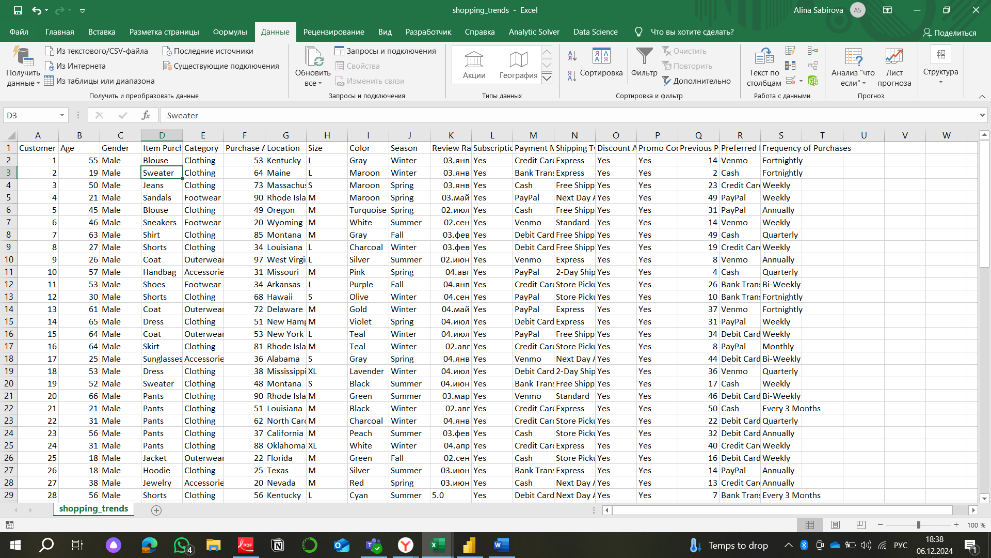

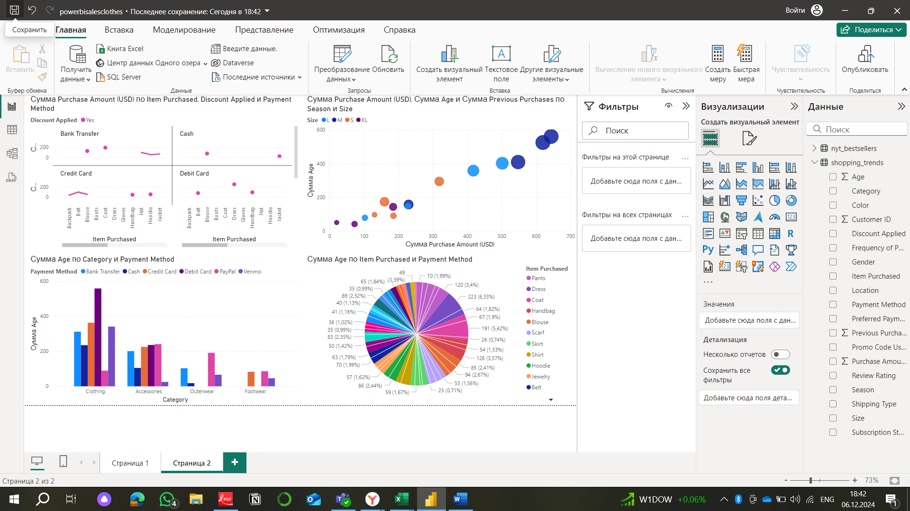

**2.**

