**Report**

**on the**

U1M10.LW.Basic Parallel Execution

**Alina Sadovskaya**

# 2. Oracle Architecture - Parallel execution

## 2.1. Task 01: CREATE Example of Select Parallel execution

Let's create a table and fill it with the necessary data:

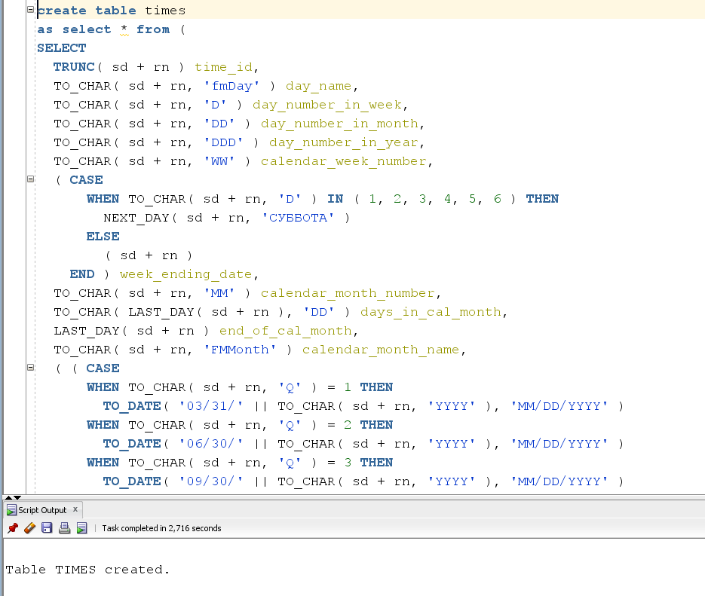

Executing select:

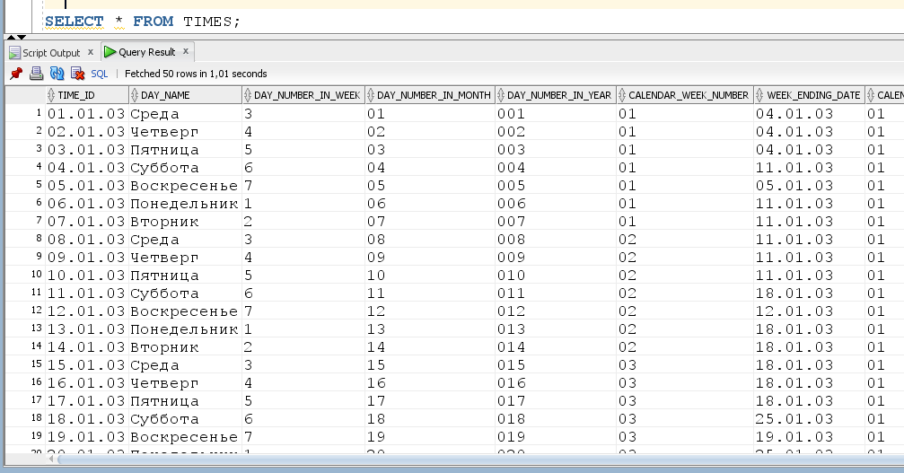

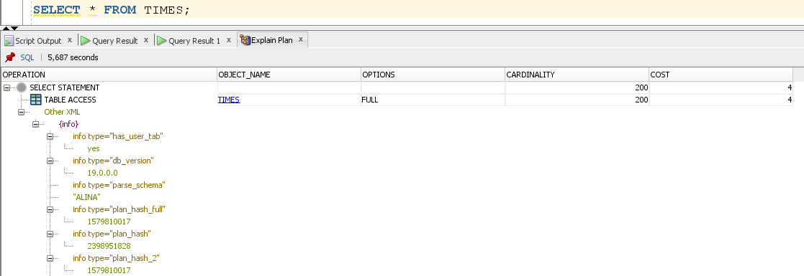

Now we use Parallel execution:

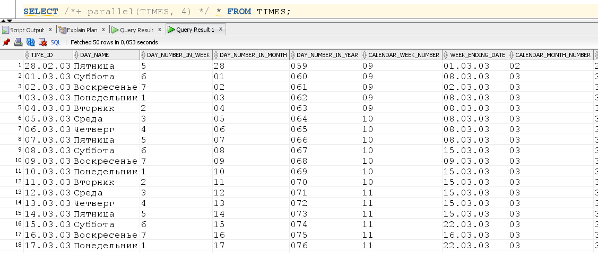

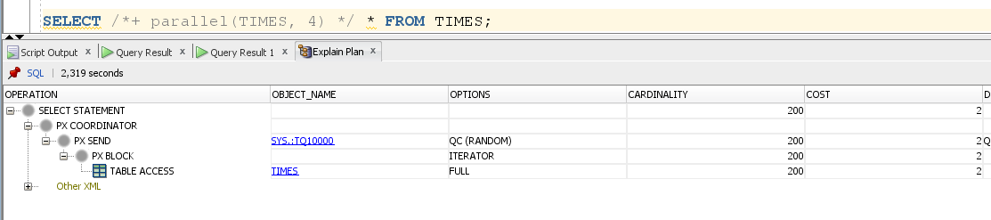

Compare time of the same operations:

|  |  |  |
| --- | --- | --- |
|  | Simple SELECT | SELECT witn PARALLEL execution |
| time of the same operations | 1.101 | 0.053 |

## 2.2. Task 02: CREATE Example of Parallel DML

Let's delete the data without parallelization:

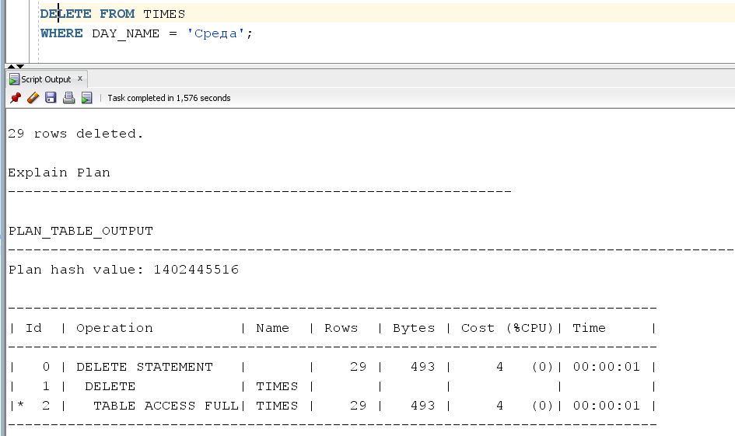

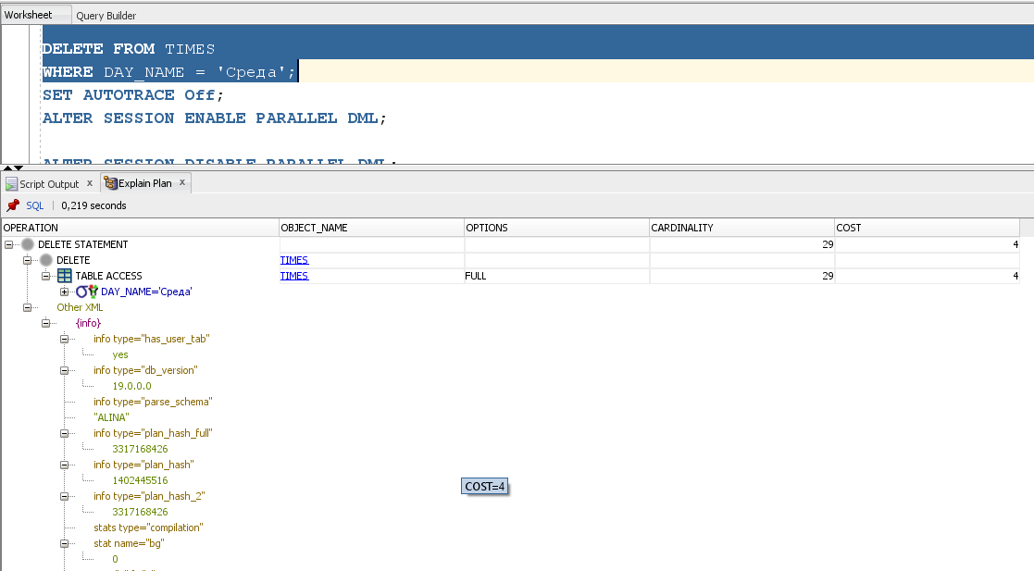

Let's delete the data with parallelization:

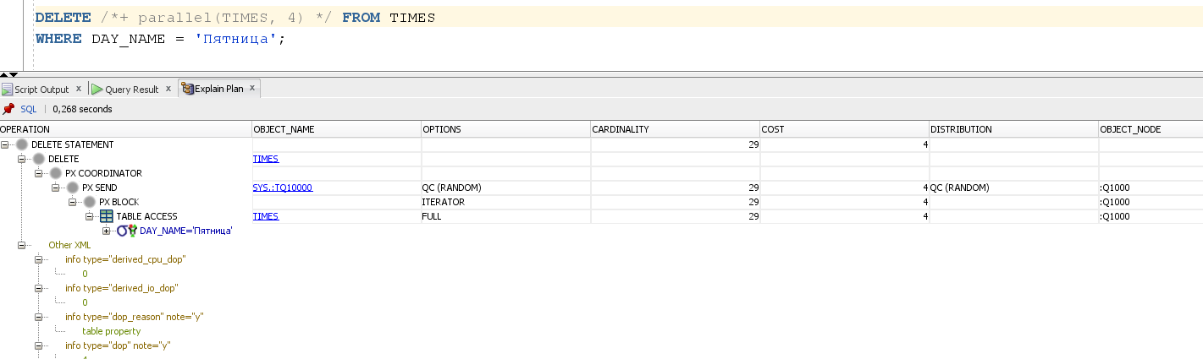

Compare time of the same operations:

|  |  |  |
| --- | --- | --- |
|  | Simple DELETE | DELETE witn PARALLEL execution |
| time of the same operations | 0.219 | 0.268 |

## 

## 2.3. Task 03: CREATE Example of Parallel DDL

Create table TIMES without paralleling:

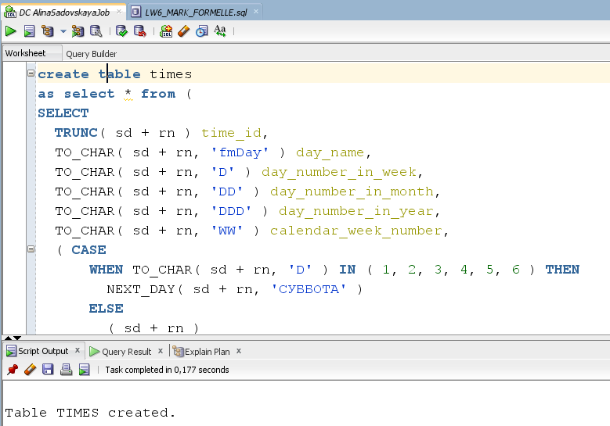

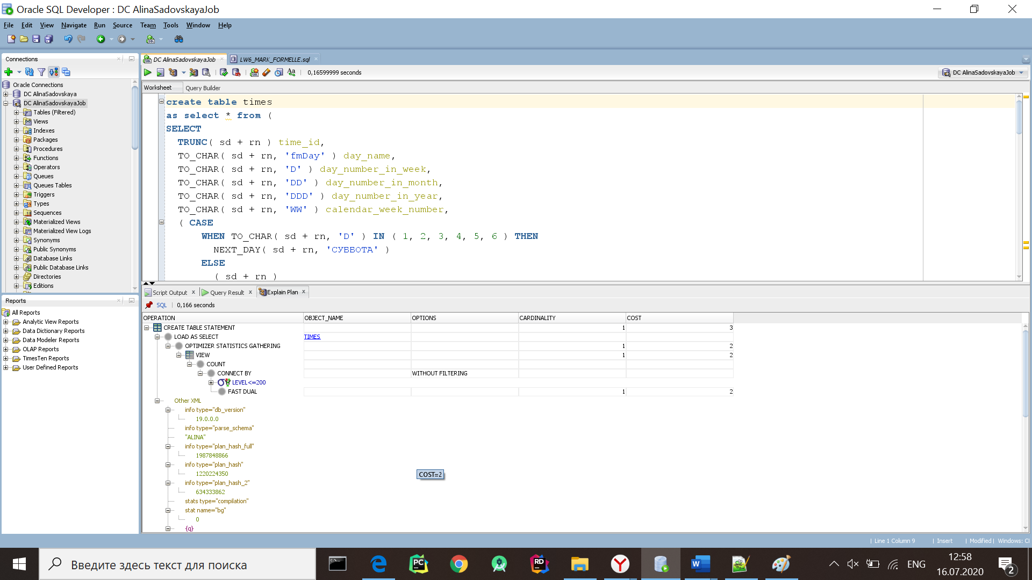

Create table TIMES using paralleling execution:

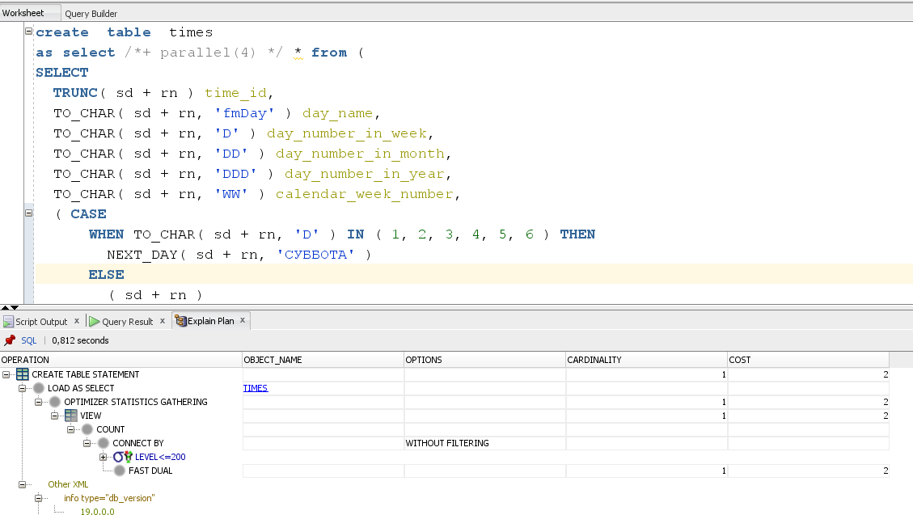

For DDL operations you can use the reserved word **PARALLEL**:

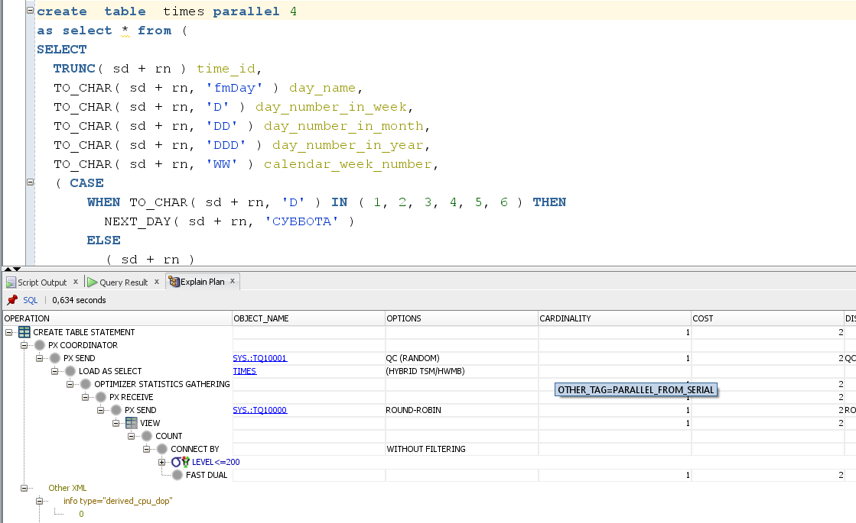

Compare time of the same operations:

|  |  |  |
| --- | --- | --- |
|  | Simple CREATE | CREATE with PARALLEL execution |
| time of the same operations | 0.166 | 0.812 |

The small amount of data, the parallelization does not improve the results. To benefit from parallel query execution, you need to work with a large amount of information.

# 3. Business Task - Parallel execution

## 3.1. Task 03: CREATE Strategy of Parallel execution

In my data warehouse system, the large RETAIL_FACT_Sales, DIM_PRODUCTS, DIM_CUSTOMERS, and DIM_GEN_PERIOD tables must be updated periodically with new or changed data from the production system. I can do this effectively by using parallel DML in conjunction with updatable connection views. This also increases the DDL speed.

The data that needs to be updated will be loaded into the table before the update process begins. This table will contain either new rows or rows that have been updated since the data store was last updated. After all changes are made, the data will be sent for public viewing.