**Report**

**on the**

U1M7.LW.Dimension and Facts Basics

**Alina Sadovskaya**

# 2. Create and populate Dimension of TIME DW – Layer

**Notes:**

To Populate Time dims we used External Resources:

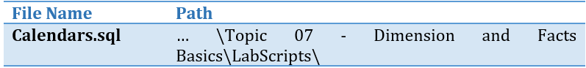

Example of generated data:

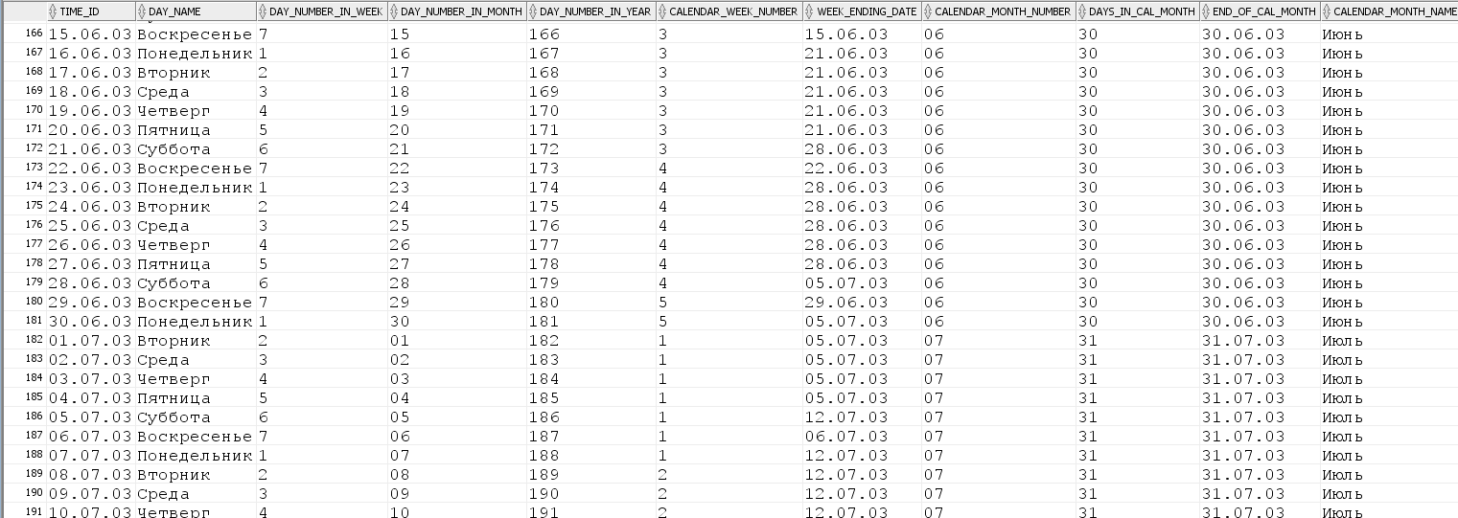

## 2.1. Task 01: CREATE DW.T_DAYS

**The Main Task** is to create Physical diagram and Objects on DW layer:

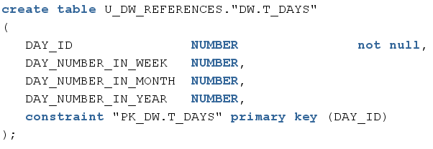

## 2.2. Task 02: CREATE DW.T_WEEKS

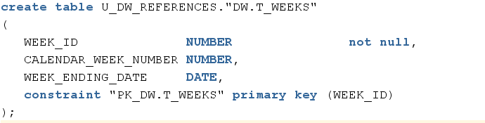

## 2.3. Task 03: CREATE DW.T_MONTHS

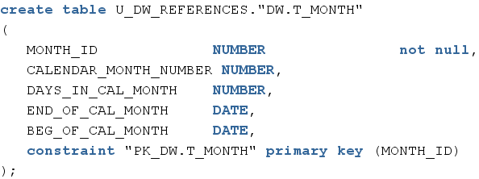

## 2.4. Task 04: CREATE DW.T_QUARTERS

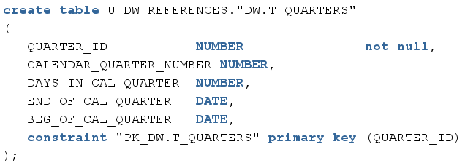

## 2.5. Task 05: CREATE DW.T_YEARS

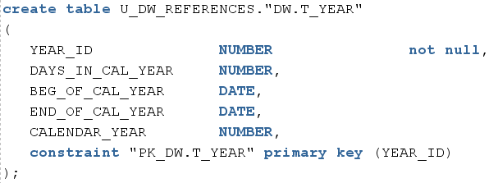

Physical diagram:



How it’s look in SQL Developer:

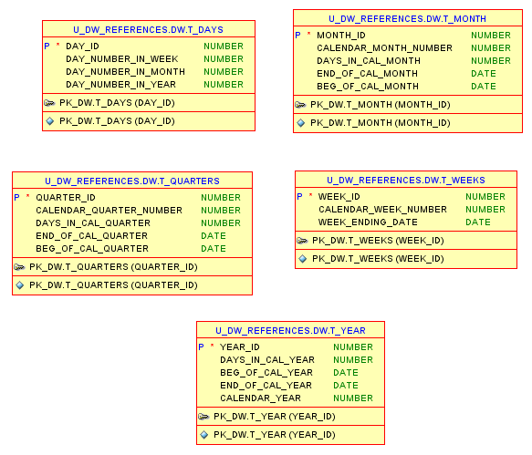

# 3. OLAP – Business analyses task

## 3.1. Task 06 – Solution concept – Add: Chapter Dimensions Types

|  |  |  |  |  |
| --- | --- | --- | --- | --- |
| Name | Type | Size | DW – Merged Dimensions | Descriptions |
| DIM_GEN_TIMES | SCD1 | BIG | DW.T_DAYS, DW.T_WEEKS, DW.T_MONTHS, DW.T_QUARTERS,  DW.T_YEARS | TBD – Example row |
| DIM_GEO_LOCATIONS | SCD1 | SMALL | Geo_id  Geo_group_id  Geo_group_desc  Geo_sub_group_id  Geo_dub_group_desc  Geo_system_code  Geo_system_desc  Geo_region_id  Geo_region_desc  Geo_country_code_a2  Geo_country_code_a3  Geo_country_id  Geo_country_desc | This kind of dimension contains information about all countries, subregions, regions of the world where the company's stores are located. And also enters information on the types of economic development and unions according to the international classification. |
| DIM_CUSTOMER | SCD1 | BIG | customer_id  first_name  last_name  email  phone  age  address  city  country  region | This kind of dimension contains detailed information about clients (including age and address of the residence for informative presentation). |
| DIM_PRODUCT | SCD1 | BIG | PRODUCT_ID  PRODUCT_NAME  PRODUCT_DESCRIPTION  LINE_ID  LINE_NAME  LINE_DESCRIPTION  COLLECTION_ID  SEASON_ID  SEASON  COLLECTION_DESCRIPTION  COLLECTION_DATE  PRODUCT_TYPE_ID  PRODUCT_TYPE  HEIGHT  HIP_GIRTH  COLOR  PRICE | This kind of dimension contains detailed information about the company's products, including the name of an individual product, category and subcategory. To do so, provided the opportunity for dimension Type SCD 2 perfectly partitions history because each detailed version of a dimensional entity is correctly connected to the span of fact table records for which that version is exactly correct |
| DIM_STORE | SCD1 | SMALL | store_id  manager_id  phone  address  city  country  region | Provides information about store including the store's address, it’s phone and information about the Manager |
| DIM_GEN_PERIOD | SCD2 | BIG | period_id  valid_from  valid_to  promotions_id  decription | A specific type of dimension that allows grouping facts based on logic (the duration of product discounts). |
| DIM_PAYMENT_METHODS | SCD1 | SMALL | PAYMENT_METHOD_ID  PAYMENT_METHOD_NAME  BANK_NAME | Provides information about the payment method used |
| DIM_EMPLOYEE | SCD1 | SMALL | employee_id  first_name  last_name  email  phone  store_id  POSITION_NAME  POSITION_GRADE  HIRE_DATE  FIRE_DATE  MANAGER_ID M_FIRST_NAME  M_LAST_NAME  M_POSITION_NAME | Provides information about the company's employees(including theres Manager) |
| DIM_PROMOTIONS | SCD1 | SMALL | PROMOTION_ID  PROMOTION_TYPE_ID  PROMOTION_TYPE  PROMOTION_DESCRIPTION  PROMOTION_ PERCENT PRICE_DECREASING_PERCENT  FREE_UNIT_AMOUNT | provides information about discounts, their description, amount, and so on |
| DIM_DATE | SCD1 | BIG | date_id  full_date  day_name  day_of_month  day_of_week  day_of_quarter  day_of_year  week_of_month  week_of_quarter  week_of_year  month_number  month_name month_of_quarter  month_of_year  quarter_name  quarter_of_year  year_number  firstday_of_month  lastday_of_month  firstday_of_quarter  lastday_of_quarter  firstday_of_year lastday_of_year | These dimention consists days, weeks, months, quarters and so on. |

## 

## 3.2. Task 07 – Solution concept – Add: Chapter Dimensions Hierarchies

**DATE_DIMENSION:**

**Hierarchy DAY-WEEK-MONTH-YEAR**

|  |  |  |  |
| --- | --- | --- | --- |
| Name | LEVEL_CODE | LEVEL_DESC | LEVEL_NATURAL_KEY |
| **DAY** | DAY | Store all day at the week | DAY_OF_WEEK |
| **WEEK** | WEEK | Store all weeks at the month | WEEK_OF_MONTH |
| **MONTH** | MONTH | Store all months at the year | MONTH_OF_YEAR |
| **YEAR** | YEAR | Store all years | YEAR_NUMBER |

**Hierarchy DAY-MONTH- QUARTER -YEAR**

|  |  |  |  |
| --- | --- | --- | --- |
| Name | LEVEL_CODE | LEVEL_DESC | LEVEL_NATURAL_KEY |
| **DAY** | DAY | Store all day at the month | DAY_ OF_MONTH |
| **MONTHS** | MONTH | Store all months at the quarter | MONTH_ OF_ QUARTER |
| **QUARTER** | QUARTER | Store all quarters at the year | QUARTER_ OF_YEAR |
| **YEAR** | YEAR | Store all years | YEAR_NUMBER |

**Hierarchy DAY - QUARTER -YEAR**

|  |  |  |  |
| --- | --- | --- | --- |
| **DAY** | DAY | Store all day at the quarter | DAY_OF_ QUARTER |
| **QUARTER** | QUARTER | Store all quarters at the calendar year | QUARTER_ OF_YEAR |
| **YEAR** | YEAR | Store all years | YEAR_NUMBER |

**CUSTOMER_DIMENSION:**

**Hierarchy PRODUCT–TYPE**

|  |  |  |  |
| --- | --- | --- | --- |
| Name | LEVEL_CODE | LEVEL_DESC | LEVEL_NATURAL_KEY |
| **PRODUCT** | PRODUCT_NAME | Store all possible products for each type. | PRODUCT_ID |
| **TYPE** | PRODUCT_TYPE | Store all product types of our company. | PRODUCT_TYPE _ID |

**Hierarchy PRODUCT–LINE-COLLECTION**

|  |  |  |  |
| --- | --- | --- | --- |
| Name | LEVEL_CODE | LEVEL_DESC | LEVEL_NATURAL_KEY |
| **PRODUCT** | PRODUCT_NAME | Store all possible products for each LINE. | PRODUCT_ID |
| **LINE** | LINE_NAME | Store all possible LINES for each COLLECTIONS. | LINE_ID |
| **COLLECTION** | COLLECTION_NAME | Store all COLLECTIONS of our company. | COLLECTION_ID |

**GEO_LOCATIONS_DIMENSION:**

**Hierarchy COUNTRY – REGION - GEO_GROUP - GEO_SUB_GROUP**

|  |  |  |  |
| --- | --- | --- | --- |
| Name | LEVEL_CODE | LEVEL_DESC | LEVEL_NATURAL_KEY |
| COUNTRIES | GEO_COUNTRY | Store all countries for each region. | GEO_COUNTRY_ID |
| REGIONS | GEO_REGION | Store all regions for each GEO_GROUP . | GEO_REGION_ID |
| GEO_GROUP | GEO_GROUP | Store all regions for each GEO_SUB_GROUP. | GEO_GROUP_ID |
| GEO_SUB_GROUP | GEO_SUB_GROUP | Store all Geo_sub_group of the world. | GEO_SUB_GROUP_ID |

**EMPLOYEE_DIMENSION**

**Hierarchy EMPLOYEE -** **MANAGER**

|  |  |  |  |
| --- | --- | --- | --- |
| Name | LEVEL_CODE | LEVEL_DESC | LEVEL_NATURAL_KEY |
| **EMPLOYEE** | EMPLOYEE | Store all employees for each Manager | EMPLOYEE_ID |
| **MANAGER** | MANAGER | Store all Manager of the company. | MANAGER_ID |

3.3. Task 08 – Solution concept – Add: Chapter Facts

* + Facts Aggregations for table RETAIL_SALES_FACT

|  |  |  |  |  |
| --- | --- | --- | --- | --- |
| Name | Code | Table Name | Additive | Descriptions |
| value of the total sum of products sold | SALE_SUM | RETAIL_FACT _SALES | + | Calculate the total amount of sales in the selected period. |
| value of the total number of products sold | SALES_AMOUNT | RETAIL_FACT _SALES | + | Сalculates the number of sales for a specific period |

* + Facts Aggregations for table FACT_PRODUCT_BALANCES

|  |  |  |  |  |
| --- | --- | --- | --- | --- |
| Name | Code | Table Name | Additive | Descriptions |
| тumber of products in stock | STOCK_VALUE | PRODUCT_FACT_BALANCES | + | Calculate amount of products in stock |
| total cost of the remaining product | TOTAL_PRODUCT_BALANCE | PRODUCT_FACT_BALANCES | + | Сalculate the total cost of the remaining product |