**Report**

**on the**

U1M8.LW.Data Warehouse Architecture

**Alina Sadovskaya**

# 2. Data Warehouse Architecture

## 2.1. Task 01: CREATE Schema of simple Data Warehouse Architecture

|  |  |  |  |
| --- | --- | --- | --- |
| Level Type | Object Name | Tablespace | Desctiption |
| Storage level  SA_* | SA_CUSTOMERS | ts_sa_customers_data_01  (AUTOALLOCATE,  SEGMENT SPACE MANAGEMENT AUTO,  LOGGING,  Size 150M,  Autoextend clause ON next 50M) | Loading from structed files(exp. Xml*). Contains customers, products, discounts, payment method. |
| SA_EMPLOYEES | ts_sa_employees_data_01  (AUTOALLOCATE,  SEGMENT SPACE MANAGEMENT AUTO,  LOGGING,  Size 150M,  Autoextend clause ON next 50M) | Loading from float files. Contains employees, geo_locations, stores. |
| DW - Cleansing Level | DW_CL | ts_DW_CL  (AUTOALLOCATE,  SEGMENT SPACE MANAGEMENT AUTO,  NOLOGGING,  Size 100M,  Autoextend clause ON next 50M) | LOADING from stage level system. Contains all information and prepare it for further usage (cleaning it). |
| DW – Level | DW_DATA | ts_DW_DATA_01  (AUTOALLOCATE,  SEGMENT SPACE MANAGEMENT AUTO,  LOGGING,  Size 150M,  Autoextend clause ON next 50M) | LOADING data from cleansing system. Contains clean information tending to the 3rd normal form ready for preparing star schema. |
| DW– Prepare Star Cleansing Level | SAL_DW_CL | ts_ DW _STR_CLS  (AUTOALLOCATE,  SEGMENT SPACE MANAGEMENT AUTO,  NOLOGGING,  Size 150M,  Autoextend clause ON next 50M) | LOADING data from DW system. Contains views merging objects from DW level. |
| STAR - Cleansing | SAL_CL | ts_SAL_CL  (AUTOALLOCATE,  SEGMENT SPACE MANAGEMENT AUTO,  NOLOGGING,  Size 150M,  Autoextend clause ON next 50M) | LOADING data from DW_CL system. Contains views from previous level but clean any redundancy. |
| STAR – Level | DM_PRODUCT_BALANCES | ts_SA_FCT _BALANCES_01  (AUTOALLOCATE,  SEGMENT SPACE MANAGEMENT AUTO,  NOLOGGING,  Size 150M,  Autoextend clause ON next 50M) | Store information about facts(PRODUCT BALANCES) |
| DM_RETAIL_SALES | ts_SA_FCT _SALES_01  (AUTOALLOCATE,  SEGMENT SPACE MANAGEMENT AUTO,  NOLOGGING,  Size 150M,  Autoextend clause ON next 50M) | Store information about facts(RETAIL SALES) |
| DM_CUSTOMERS | ts_SA_DIM_CUST_01  (AUTOALLOCATE,  SEGMENT SPACE MANAGEMENT AUTO,  NOLOGGING,  Size 150M,  Autoextend clause ON next 50M) | Store information about dim customers. |
| DM_PRODUCTS | ts_SA_DIM_PROD_01  (AUTOALLOCATE,  SEGMENT SPACE MANAGEMENT AUTO,  NOLOGGING,  Size 150M,  Autoextend clause ON next 50M) | Store information about dim products. |
| DM_PROMOTION | ts_SA_DIM_PROM_01  (AUTOALLOCATE,  SEGMENT SPACE MANAGEMENT AUTO,  NOLOGGING,  Size 150M,  Autoextend clause ON next 50M) | Store information about dim promotions. |

## 2.2. Task 02: CREATE Storage Level

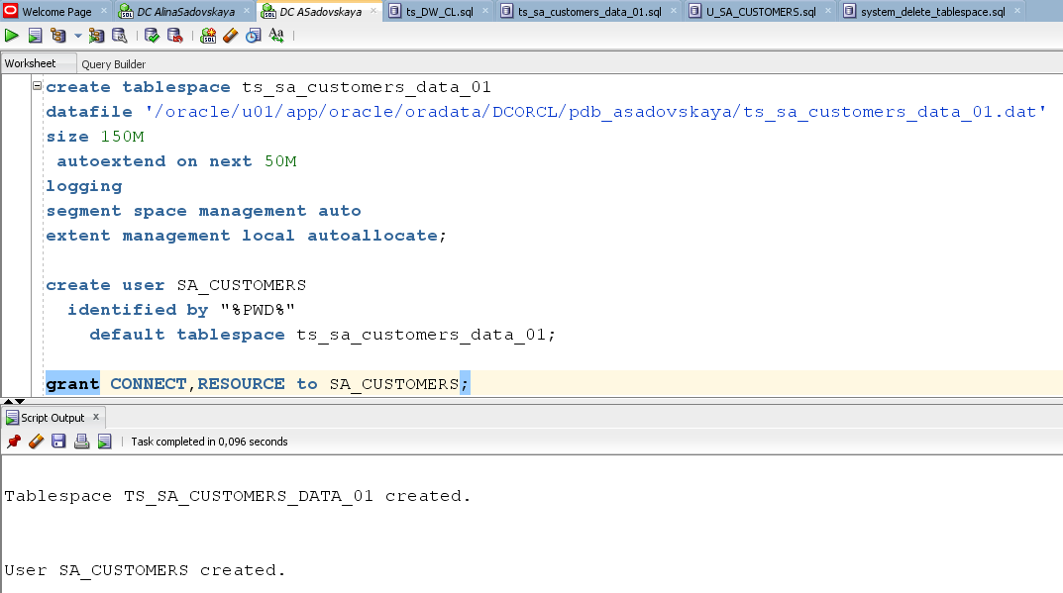

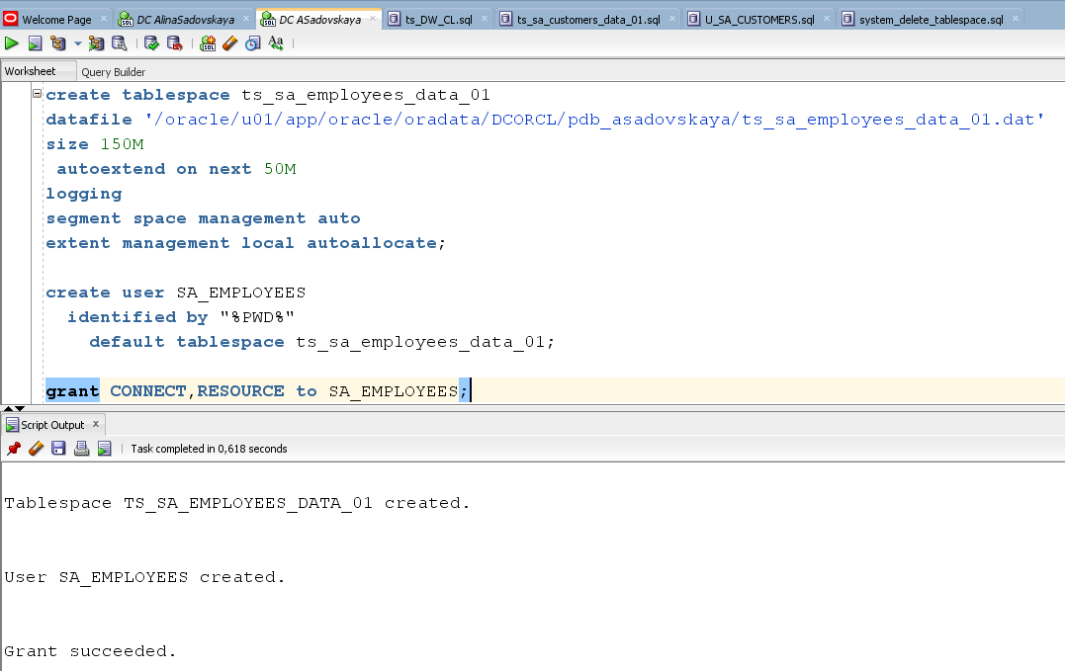

## 

## 2.3. Task 03: CREATE Data warehouse Cleansing Level

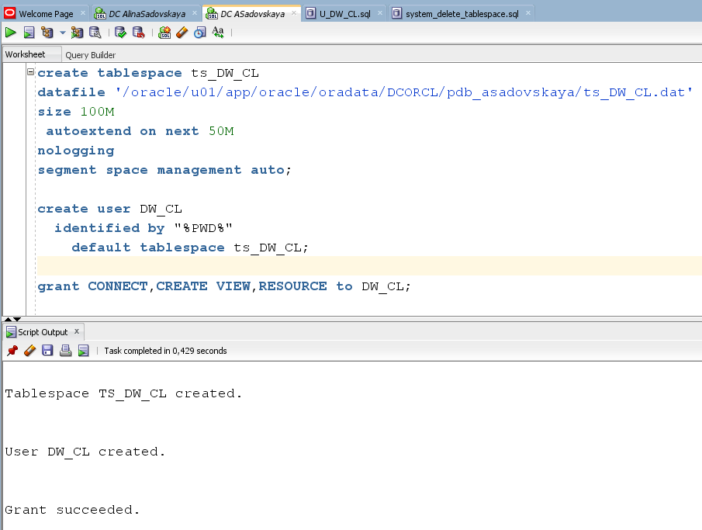

## 2.4. Task 04: CREATE Data warehouse Start Cleansing Level

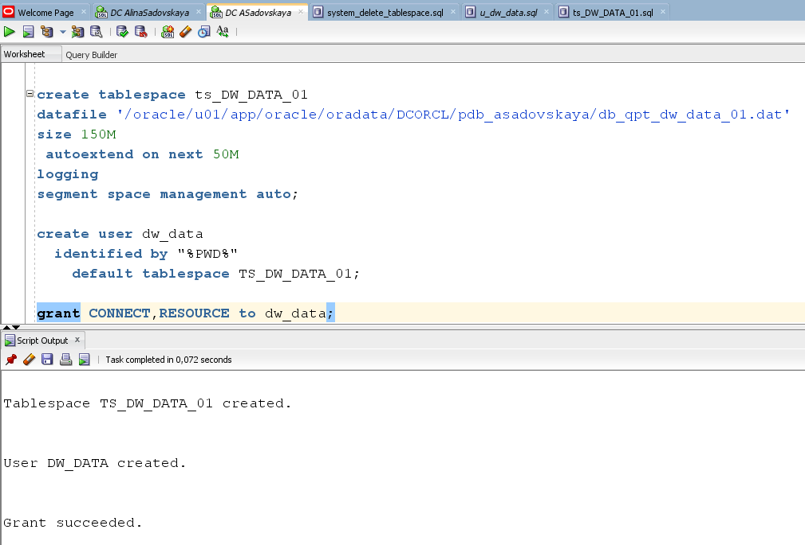

2.5. Task 05: CREATE Start Cleansing Level

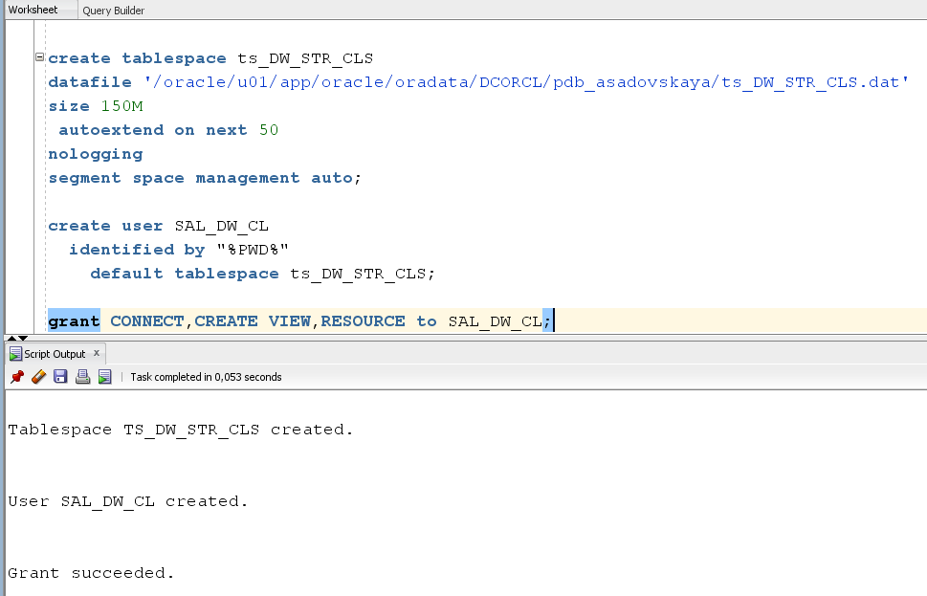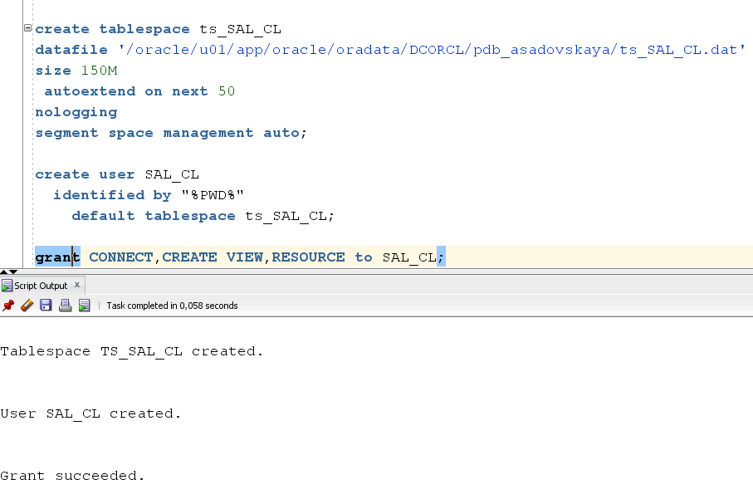

## 2.6. Task 06: CREATE Data warehouse Start Level and Data Marts

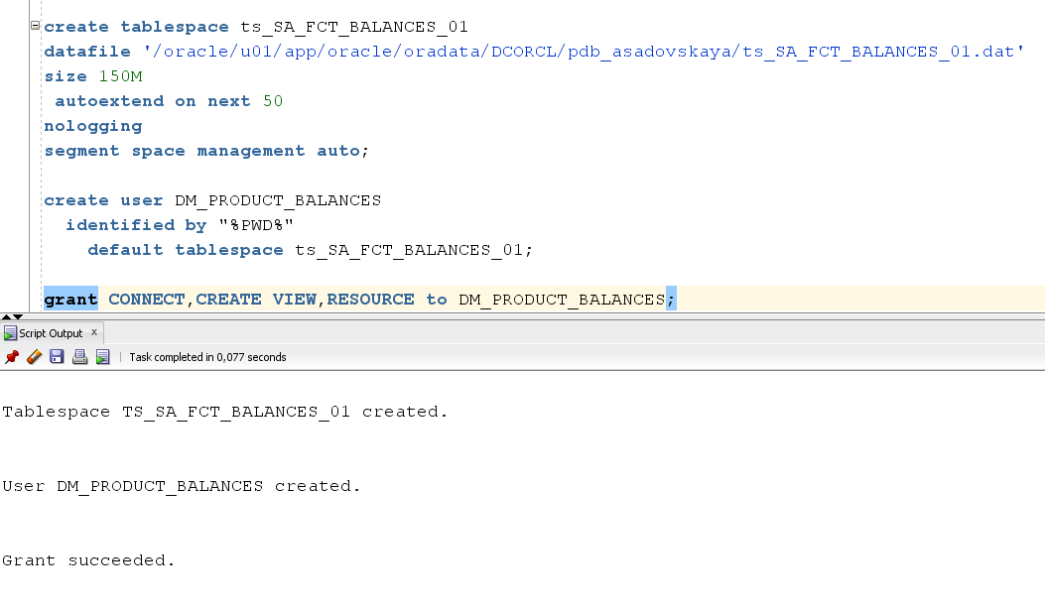

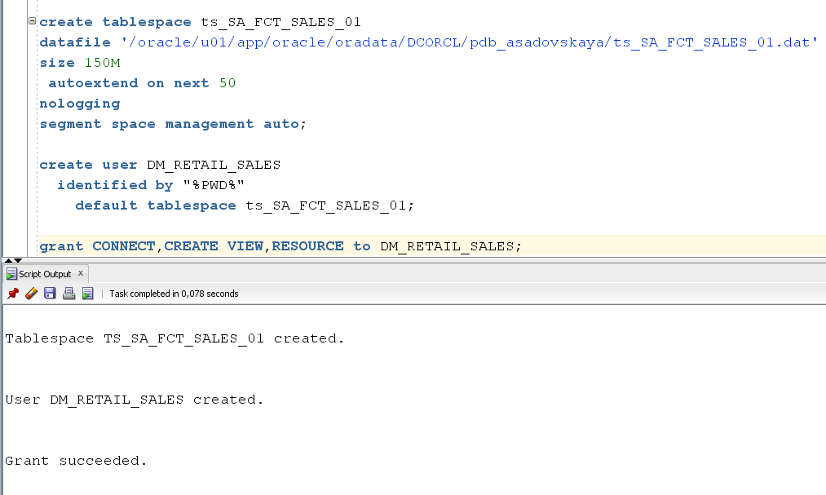

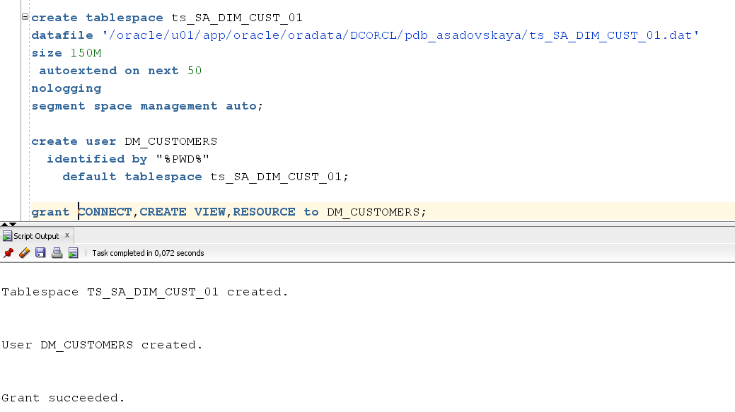

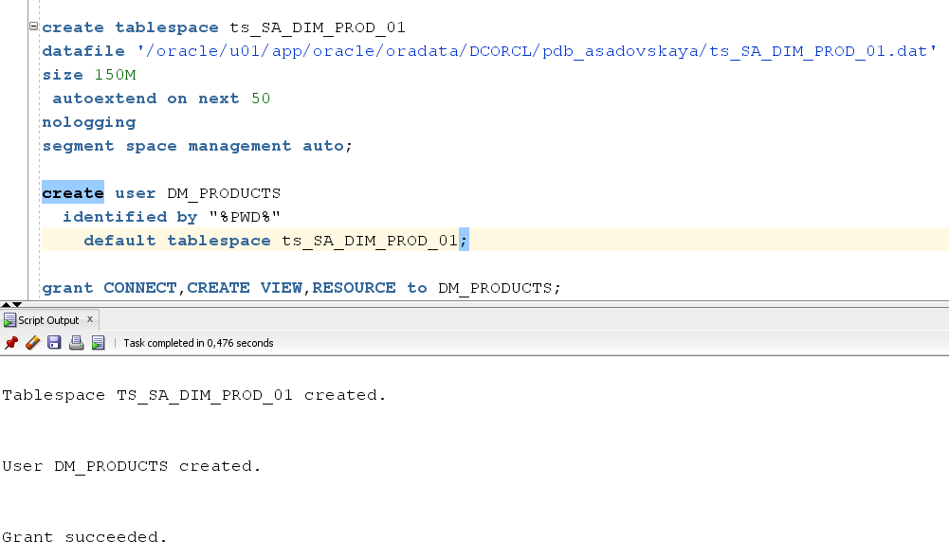

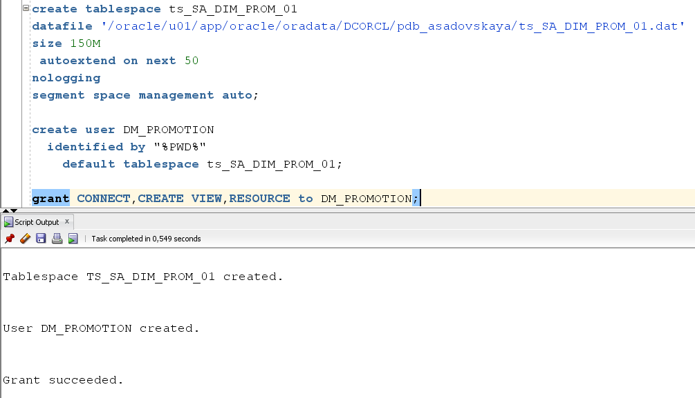

# 3. Star – Business analyses task

3.1. Task 07: CREATE Prepared Star Objects

The code is located in this directory in the "scripts" folder.

## 3.2. Task 08: DataFlow Diagram

DataFlow Diagram to describe refresh process of mine Business STAR:

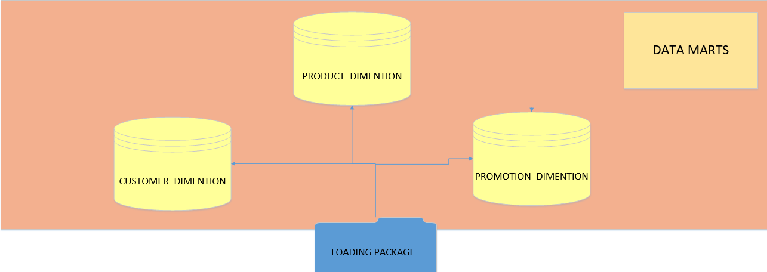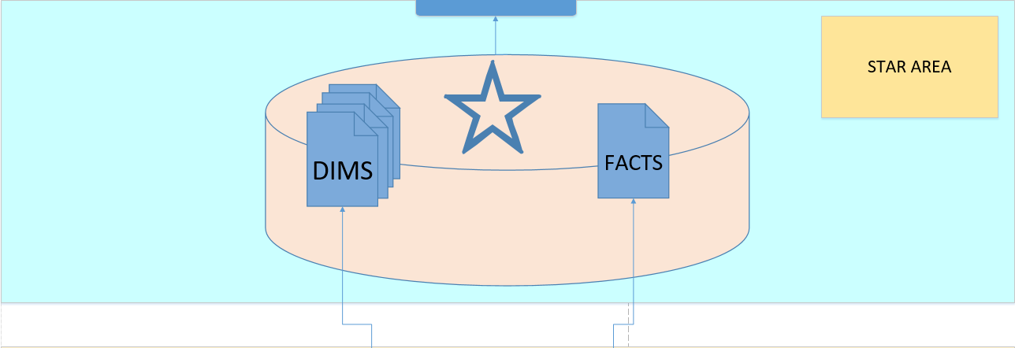

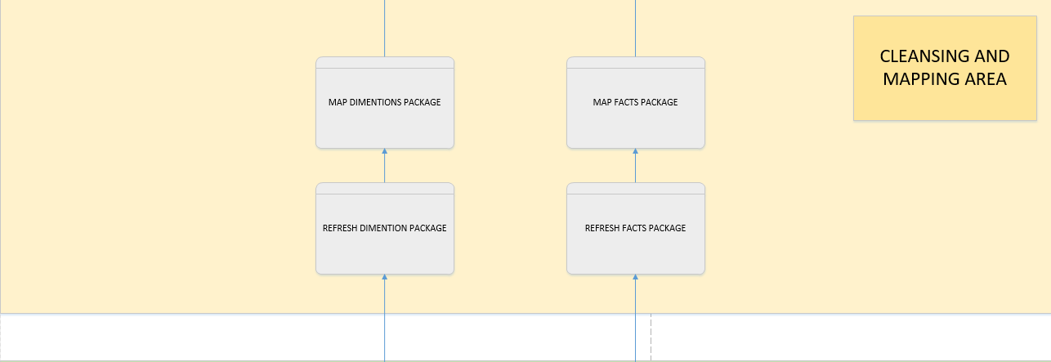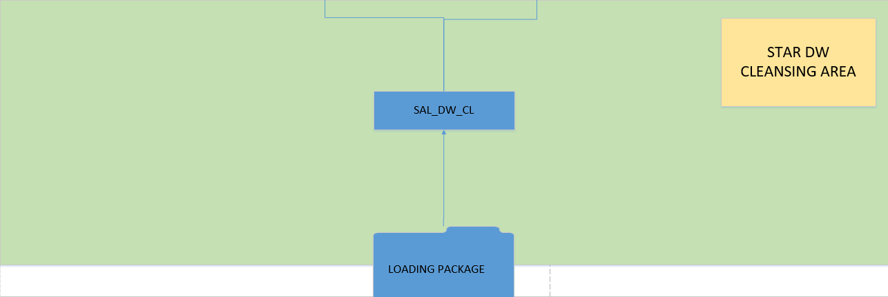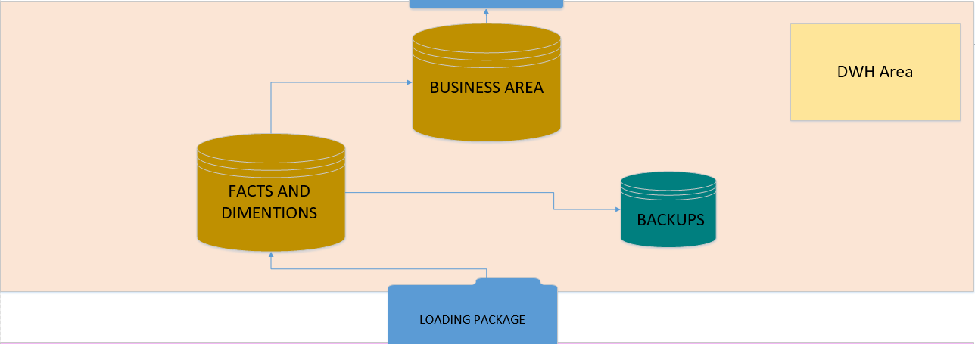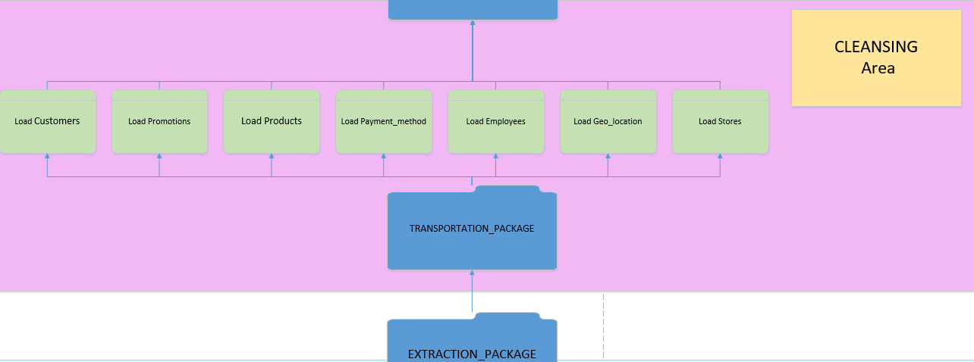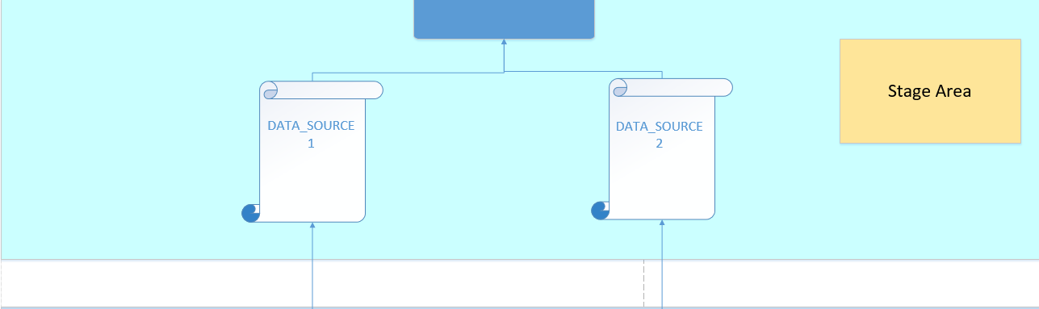

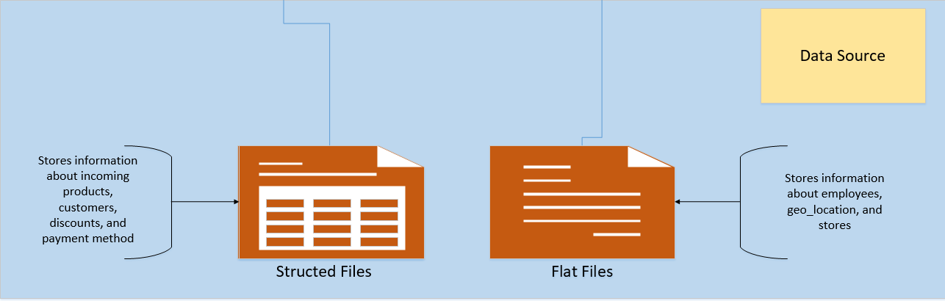

## 3.3. Task 09: Grants Object Privileges

This table describes users and their privileges:

|  |  |
| --- | --- |
| USERS | PRIVILEGES |
| SA_CUSTOMERS | * create tables * create views * push data upstairs (update upper user(DW_CL) |
| SA_EMPLOYEES | * create tables * create views * push data upstairs (update upper user(DW_CL) |
| DW_CL | * create/drop tables/views * Select/ Merge from/with SA views * push it upstairs (update objects ts_DW_DATA_01) |
| DW_DATA | * create/drop tables/views * push it upstairs (update objects ts_DW_STR_CLS) * Select / Merge from/with DW-CL views |
| SAL_DW_CL | * create/drop tables/views * push it upstairs (update objects ts_SAL_CL) * Select from SA-CL views |
| SAL_CL | * create/drop tables/views * push it upstairs (update objects ts_ STR_DATA) * Select/ Merge from /with Contr_DW views |
| DM_PRODUCT_BALANCES | * create/drop tables/views |
| DM_RETAIL_SALES |
| DM_CUSTOMERS |
| DM_PRODUCTS |
| DM_PROMOTION |