**REPORT**

ON THE

U2M1.LW.Core SQL

Alina Sadovskaya

# 2. Data Warehouse Architecture – Storage Layers

## 2.1. Task 01: CREATE Storage Objects

In lab_8 last unit we created the appropriate tablespace and users for the storage layers we need:

|  |  |  |  |
| --- | --- | --- | --- |
| Level Type | Object Name | Tablespace | Desctiption |
| Storage level  SA_* | SA_CUSTOMERS | ts_sa_customers_data_01  (AUTOALLOCATE,  SEGMENT SPACE MANAGEMENT AUTO,  LOGGING,  Size 150M,  Autoextend clause ON next 50M) | Loading from structed files(exp. Xml*). Contains customers, products, promotions. |
| DW - Cleansing Level | DW_CL | ts_DW_CL  (AUTOALLOCATE,  SEGMENT SPACE MANAGEMENT AUTO,  NOLOGGING,  Size 100M,  Autoextend clause ON next 50M) | LOADING from stage level system. Contains all information and prepare it for further usage (cleaning it). |
| DW – Level | DW_DATA | ts_DW_DATA_01  (AUTOALLOCATE,  SEGMENT SPACE MANAGEMENT AUTO,  LOGGING,  Size 150M,  Autoextend clause ON next 50M) | LOADING data from cleansing system. Contains clean information tending to the 3rd normal form ready for preparing star schema. |
| DW– Prepare Star Cleansing Level | SAL_DW_CL | ts_ DW _STR_CLS  (AUTOALLOCATE,  SEGMENT SPACE MANAGEMENT AUTO,  NOLOGGING,  Size 150M,  Autoextend clause ON next 50M) | LOADING data from DW system. Contains views merging objects from DW level. |
| STAR - Cleansing | SAL_CL | ts_SAL_CL  (AUTOALLOCATE,  SEGMENT SPACE MANAGEMENT AUTO,  NOLOGGING,  Size 150M,  Autoextend clause ON next 50M) | LOADING data from DW_CL system. Contains views from previous level but clean any redundancy. |
| STAR – Level | DM_PRODUCT_BALANCES | ts_SA_FCT _BALANCES_01  (AUTOALLOCATE,  SEGMENT SPACE MANAGEMENT AUTO,  NOLOGGING,  Size 150M,  Autoextend clause ON next 50M) | Store information about facts(PRODUCT BALANCES) |
| DM_RETAIL_SALES | ts_SA_FCT _SALES_01  (AUTOALLOCATE,  SEGMENT SPACE MANAGEMENT AUTO,  NOLOGGING,  Size 150M,  Autoextend clause ON next 50M) | Store information about facts(RETAIL SALES) |
| DM_CUSTOMERS | ts_SA_DIM_CUST_01  (AUTOALLOCATE,  SEGMENT SPACE MANAGEMENT AUTO,  NOLOGGING,  Size 150M,  Autoextend clause ON next 50M) | Store information about dim customers. |
| DM_PRODUCTS | ts_SA_DIM_PROD_01  (AUTOALLOCATE,  SEGMENT SPACE MANAGEMENT AUTO,  NOLOGGING,  Size 150M,  Autoextend clause ON next 50M) | Store information about dim products. |
| DM_PROMOTION | ts_SA_DIM_PROM_01  (AUTOALLOCATE,  SEGMENT SPACE MANAGEMENT AUTO,  NOLOGGING,  Size 150M,  Autoextend clause ON next 50M) | Store information about dim promotions. |

|  |  |
| --- | --- |
| USERS | PRIVILEGES |
| SA_CUSTOMERS | * create tables * create views * push data upstairs (update upper user(DW_CL) |
| DW_CL | * create/drop tables/views * Select/ Merge from/with SA views * push it upstairs (update objects ts_DW_DATA_01) |
| DW_DATA | * create/drop tables/views * push it upstairs (update objects ts_DW_STR_CLS) * Select / Merge from/with DW-CL views |
| SAL_DW_CL | * create/drop tables/views * push it upstairs (update objects ts_SAL_CL) * Select from SA-CL views |
| SAL_CL | * create/drop tables/views * push it upstairs (update objects ts_ STR_DATA) * Select/ Merge from /with Contr_DW views |
| DM_PRODUCT_BALANCES | * create/drop tables/views |
| DM_RETAIL_SALES |
| DM_CUSTOMERS |
| DM_PRODUCTS |
| DM_PROMOTION |

Let's create the appropriate tables for the Storage level:

1)CUSTOMER

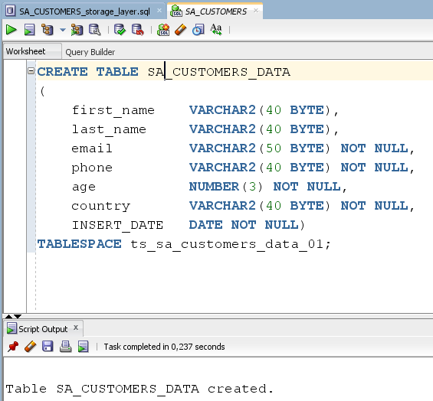

Now I have uploaded data to this table from the generated file “customer.xls”.

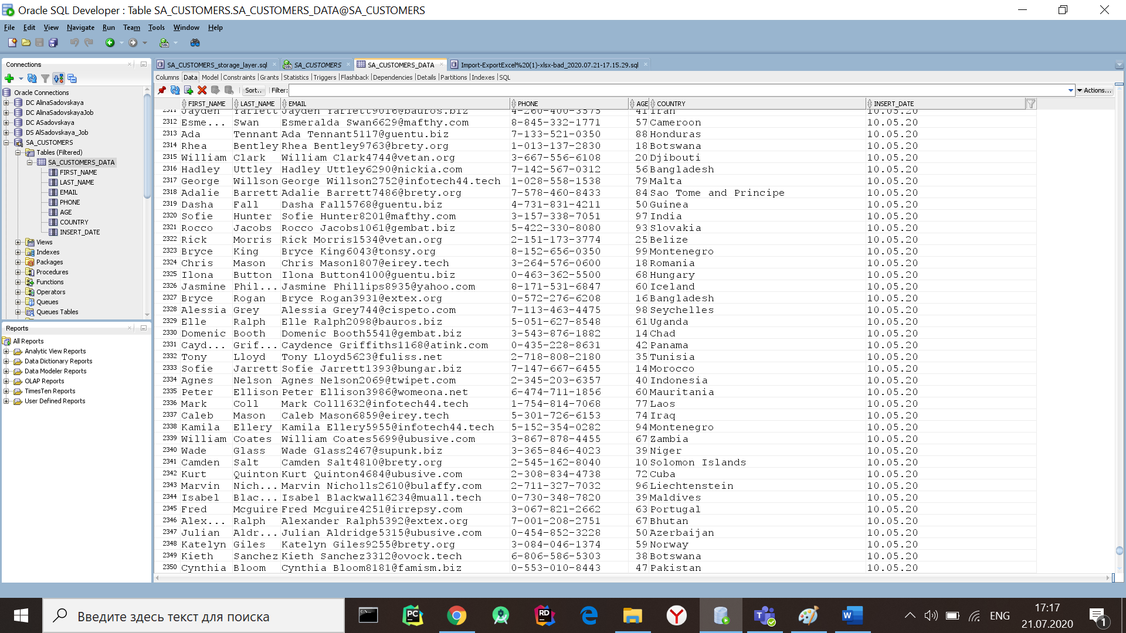

2)STORE

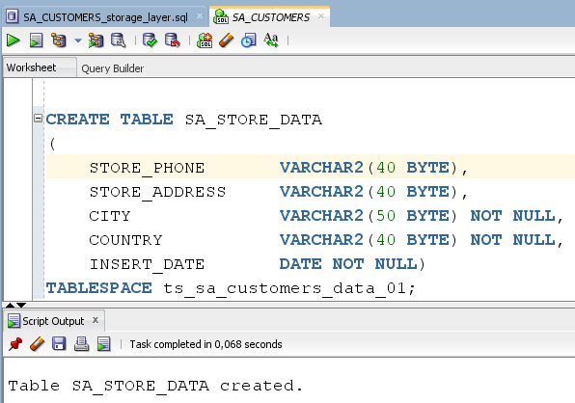

I have uploaded data to this table from the generated file “STORE.xls”.

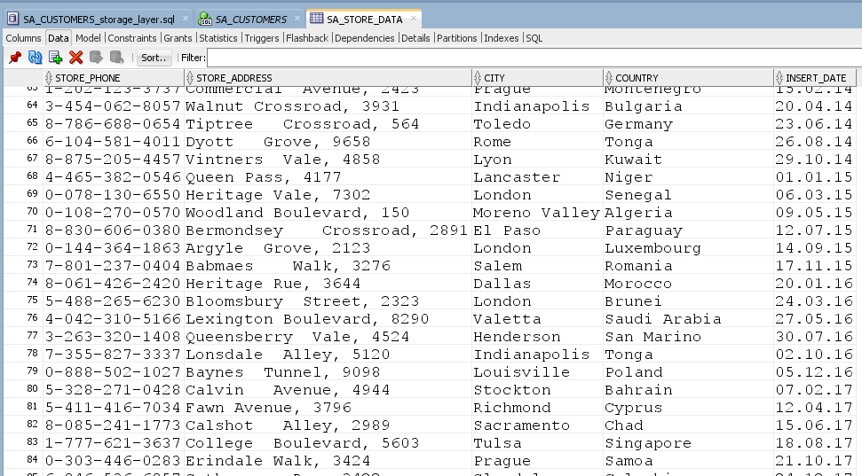

3)PRODUCT

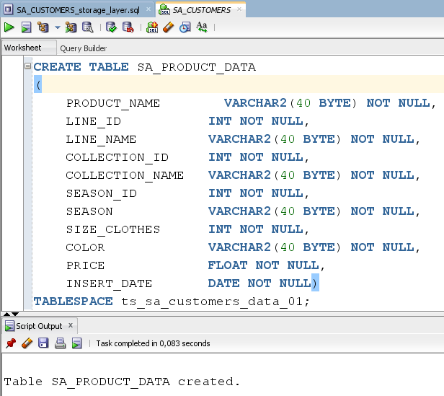

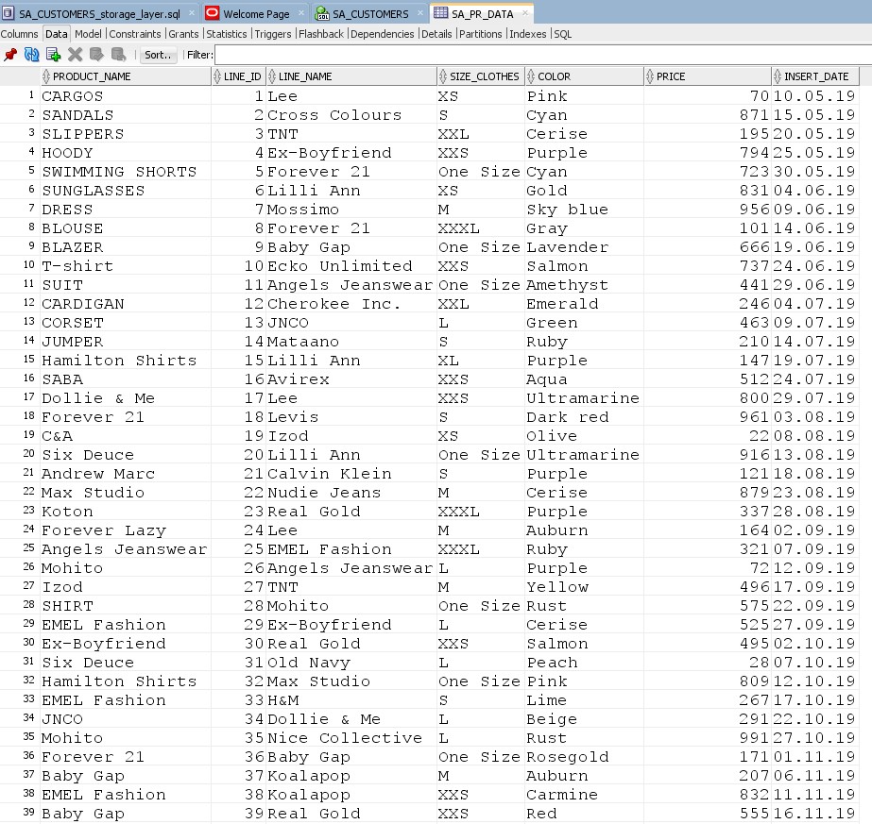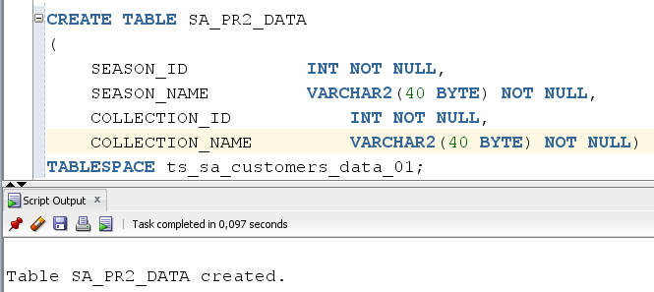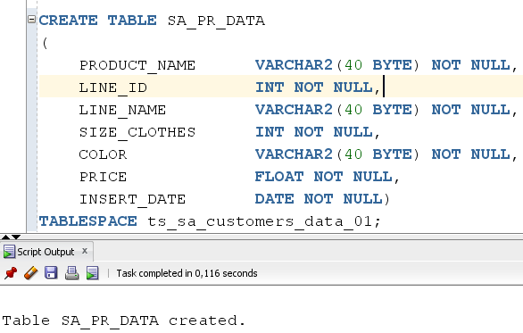Creating two auxiliary tables and using cross join to generate a large amount of data:

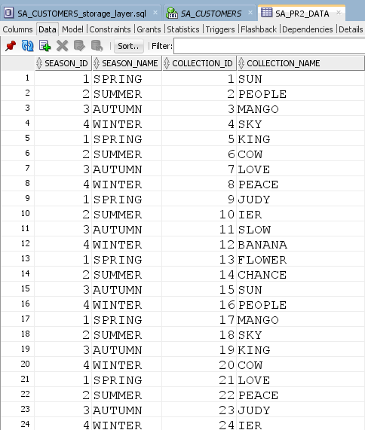

* СROSS JOIN

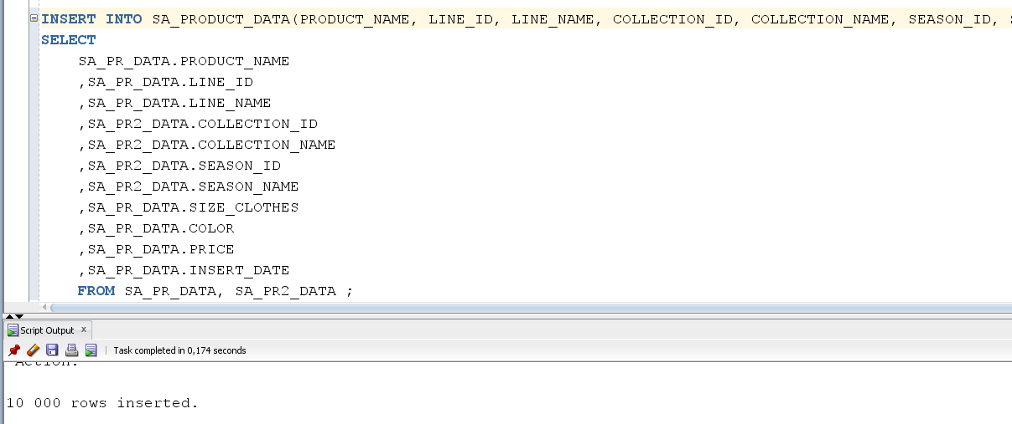

Table after filling in the data:

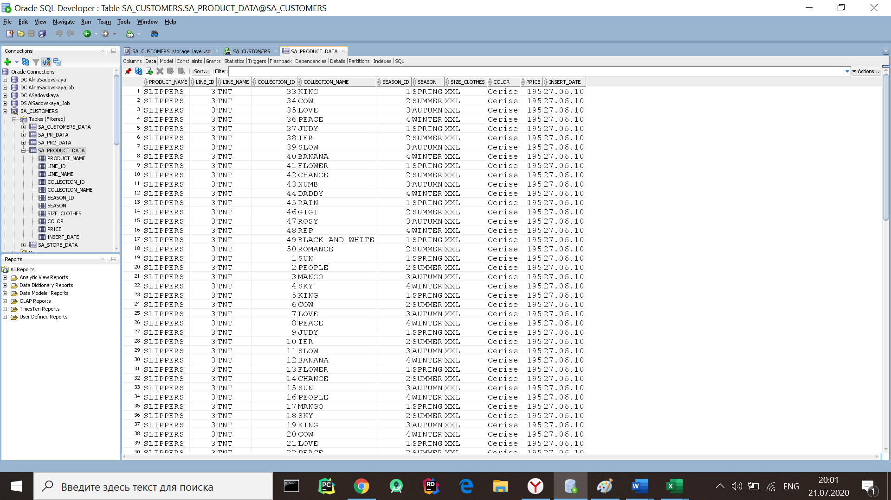

4)promotion

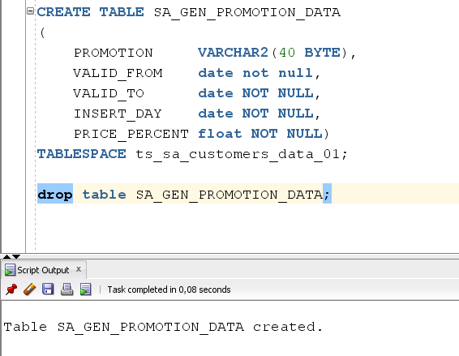

I have uploaded data to this table from the generated file “promotion.xls”.

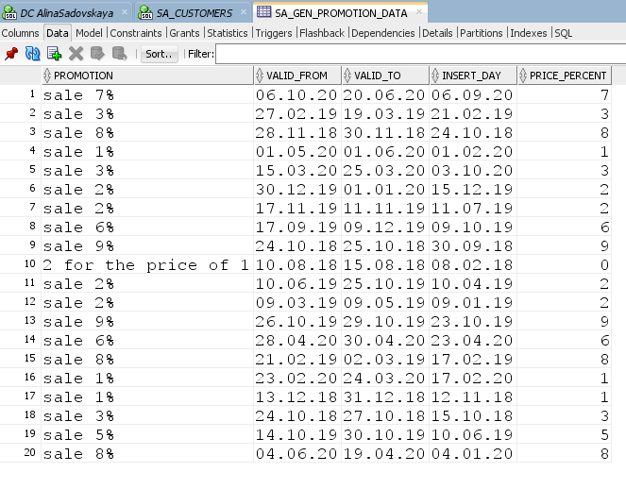

5)Create table SA_PERIOD_DATA, DATE_GEO and upload data from “date_geo.xls”, “period.xls” documents

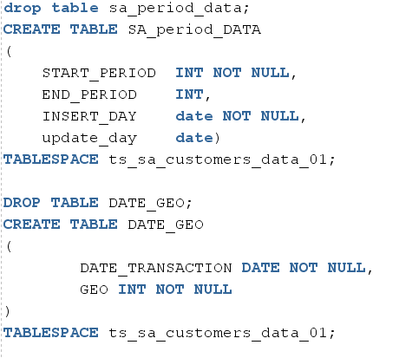

6)Now created table TRANSACTION:

1.

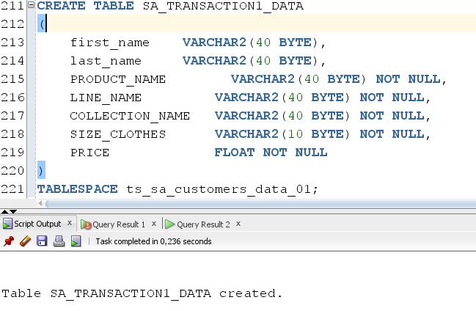

2.

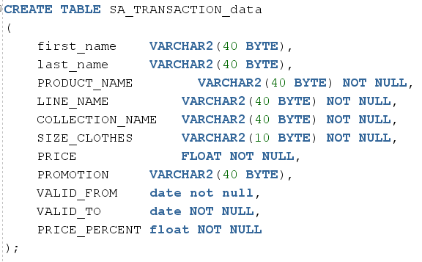

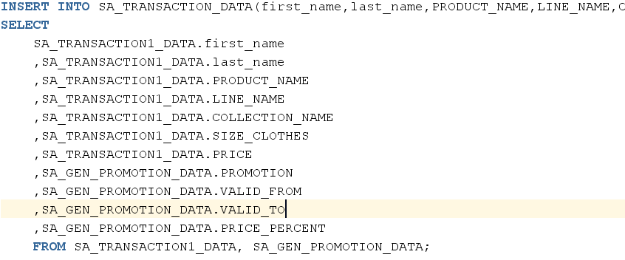

3. Create final table:

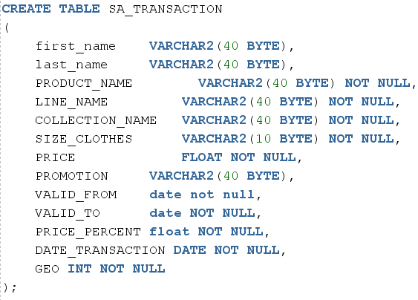

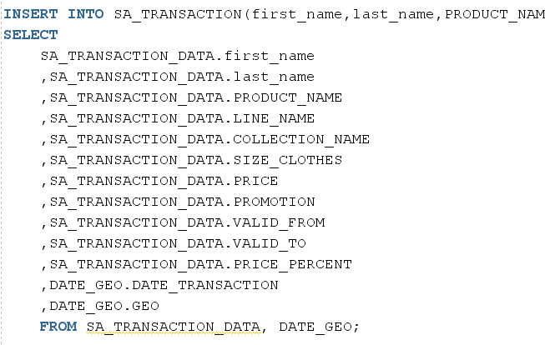



As a result, we got the following transaction table (3 mln rows):

