REPORT ON THE

U2M2.LW.Advanced Grouping

ALINA SADOVSKAYA

# 2. Business analyses tasks – Reports

## CREATE Daily/Monthly Reports Layouts

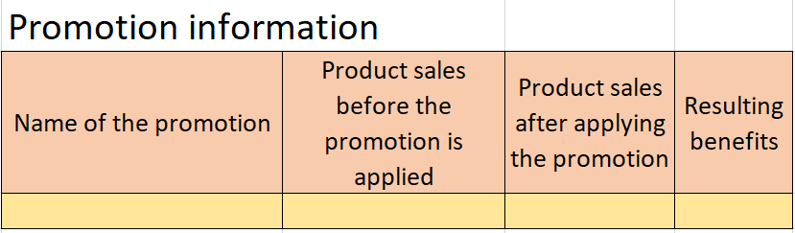

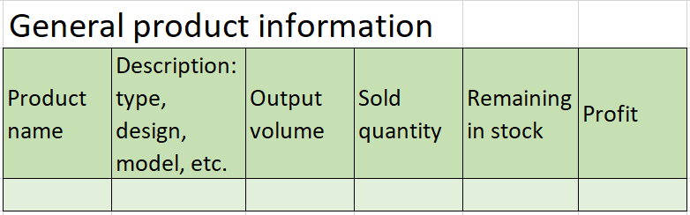

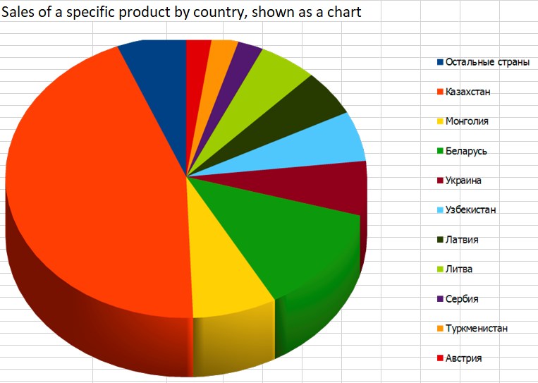

# 3. Advanced Grouping tasks – Reports

## 3.1. Task 03: CREATE Test AdHoc SQL - Daily Reports (CUBE)

Let's build a daily report that reflects the sales amounts for individual product categories and the total sales amount for the entire day.

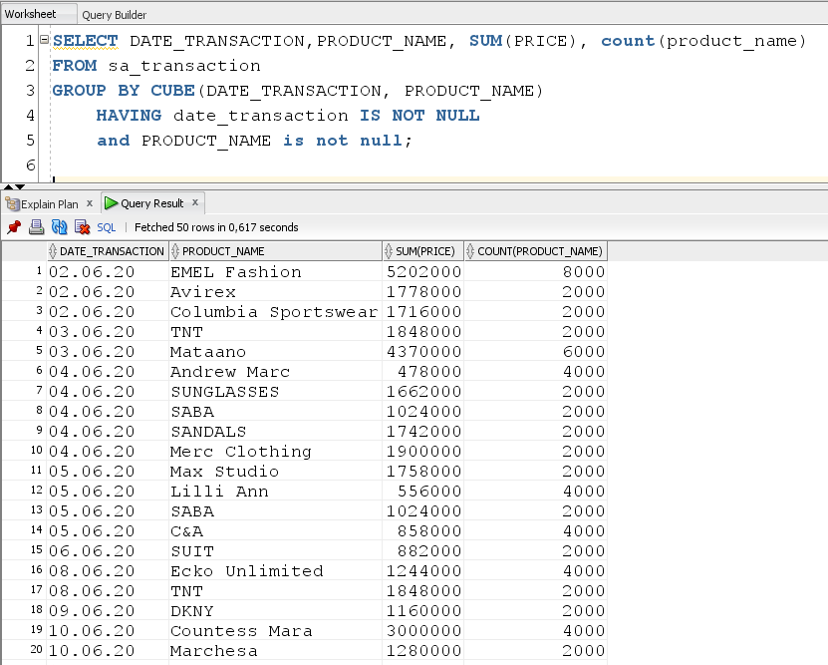

In my case you need to build a report on the shares applied to specific products:

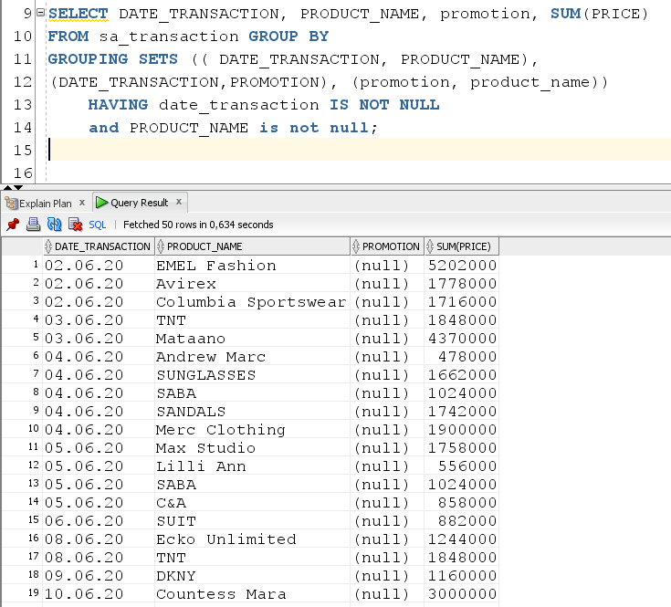

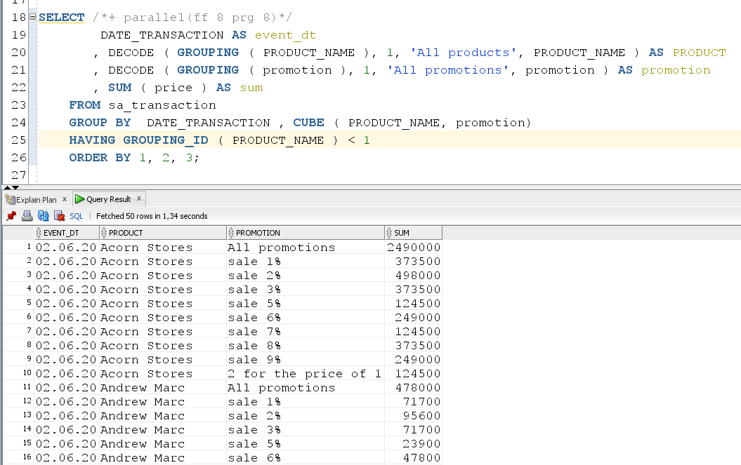

I also had to make a country report:

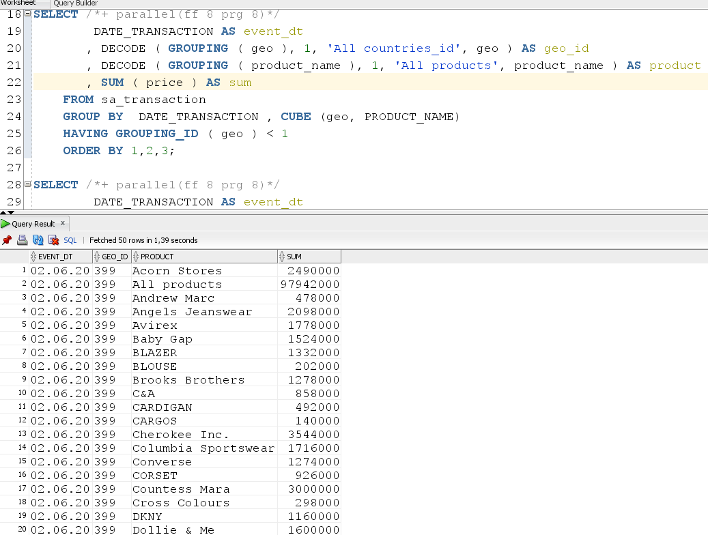

3.2. Task 04: CREATE Test AdHoc SQL - Monthly Reports (ROLLUP & GROUPING SETS)

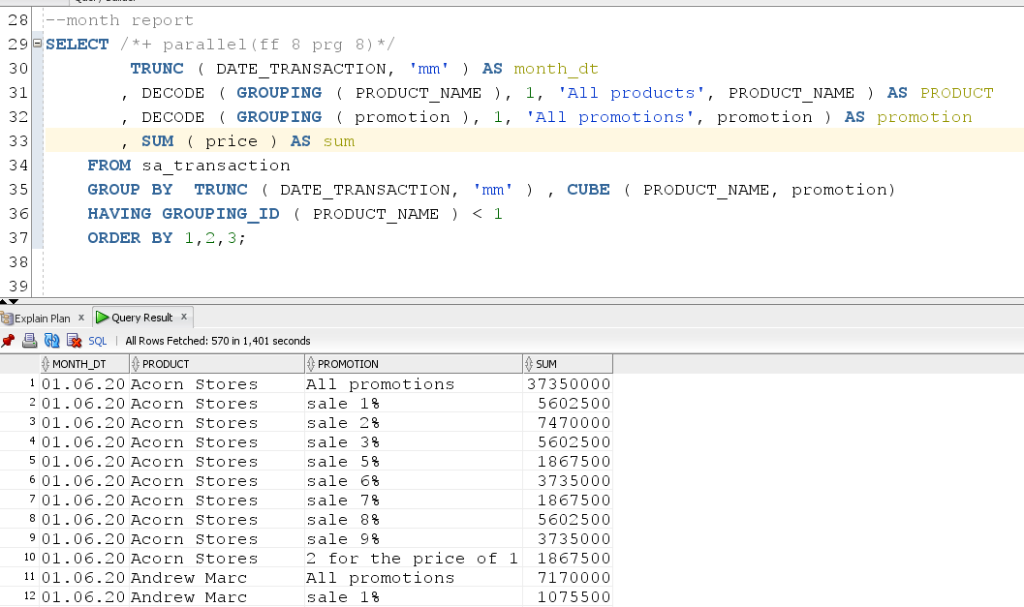

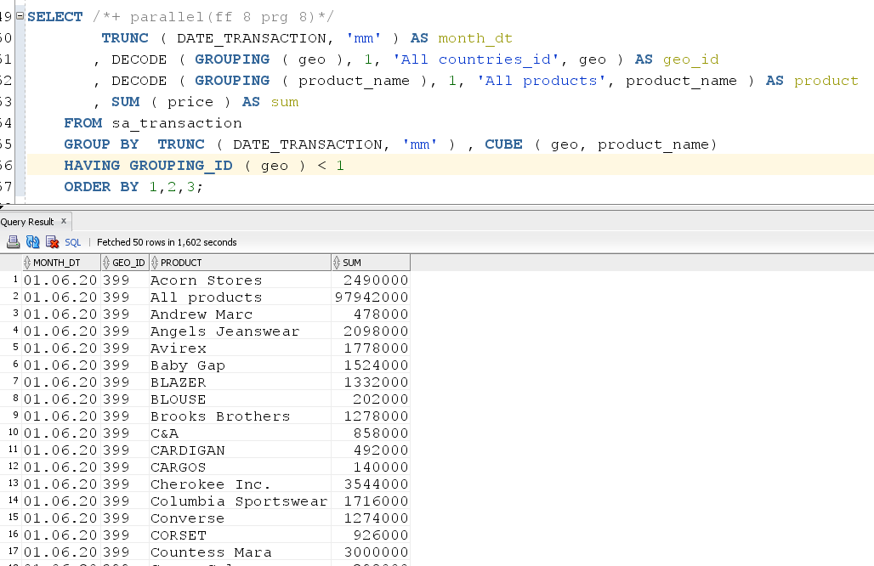

## 3.3. Task 05: CREATE Test AdHoc SQL – ROLLUP by Time

Since we only processed transactions for the period from 02.06.20 to 16.06.2020, the report looks like this. In this report, I did not just output the amount for specific time periods, but also took into account the discount used in a specific offer.

--time report

SELECT DECODE ( GROUPING_ID ( TRUNC ( DATE_TRANSACTION

, 'Year' )

, TRUNC ( DATE_TRANSACTION

, 'Q' )

, TRUNC ( DATE_TRANSACTION

, 'Month' )

, TRUNC ( DATE_TRANSACTION

, 'DDD' ) )

, 7, 'Total for year'

, 15, 'GRANT TOTAL'

, TRUNC ( DATE_TRANSACTION

, 'Year' ) )

AS year

, DECODE ( GROUPING_ID ( TRUNC ( DATE_TRANSACTION

, 'Year' )

, TRUNC ( DATE_TRANSACTION

, 'Q' )

, TRUNC ( DATE_TRANSACTION

, 'Month' )

, TRUNC ( DATE_TRANSACTION

, 'DDD' ) )

, 3, 'Total for quarter'

, TRUNC (DATE_TRANSACTION

, 'Q' ) )

AS quarter

, DECODE ( GROUPING_ID ( TRUNC ( DATE_TRANSACTION

, 'Year' )

, TRUNC ( DATE_TRANSACTION

, 'Q' )

, TRUNC ( DATE_TRANSACTION

, 'Month' )

, TRUNC ( DATE_TRANSACTION

, 'DDD' ) )

, 1, 'Total for month'

, TRUNC ( DATE_TRANSACTION

, 'Month' ) )

AS month

, DECODE ( GROUPING_ID ( TRUNC ( DATE_TRANSACTION

, 'Year' )

, TRUNC ( DATE_TRANSACTION

, 'Q' )

, TRUNC ( DATE_TRANSACTION

, 'Month' )

, TRUNC ( DATE_TRANSACTION

, 'DDD' ) )

, 15, ''

, TRUNC ( DATE_TRANSACTION

, 'DDD' ) )

AS day

, SUM ( price - price_percent*price/100) AS price_with_prom

, COUNT ( * ) AS quantity

FROM sa_transaction

GROUP BY ROLLUP ( TRUNC ( DATE_TRANSACTION

, 'Year' ), TRUNC ( DATE_TRANSACTION

, 'Q' ), TRUNC (DATE_TRANSACTION

, 'Month' ), TRUNC ( DATE_TRANSACTION

, 'DDD' ) );

