REPORT

ON THE

U2M3.LW.Subqueries

ALINA SADOVSKAYA

# 2. Business analyses tasks – Reports

## 2.1. Task 01: Export Geo Location Reference

Let’s creating a tablespace and user for working with the table by location, and granting privileges to the created user so that they can read the data of another user.

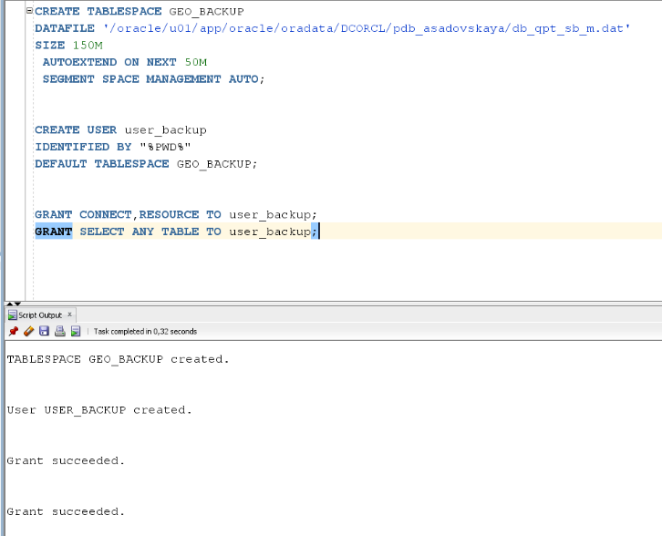

Now create denormalized export table on BackUp schema:

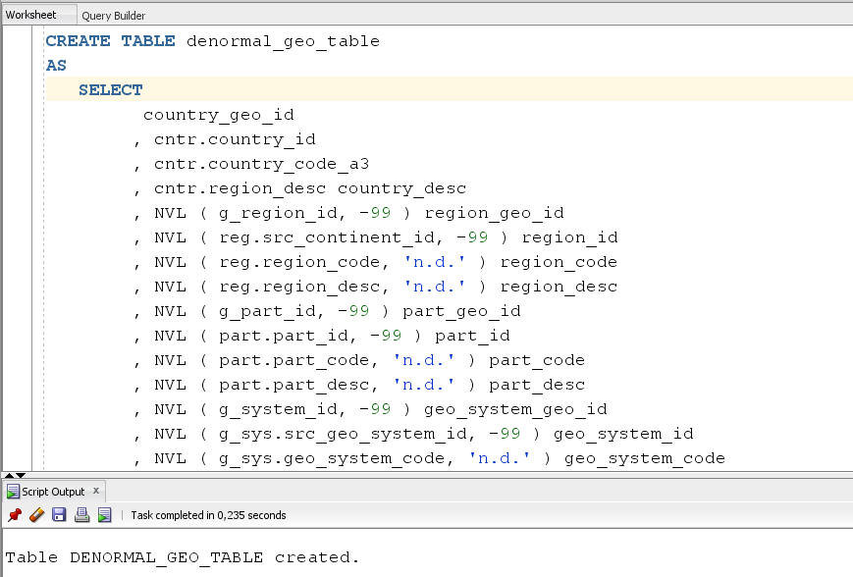

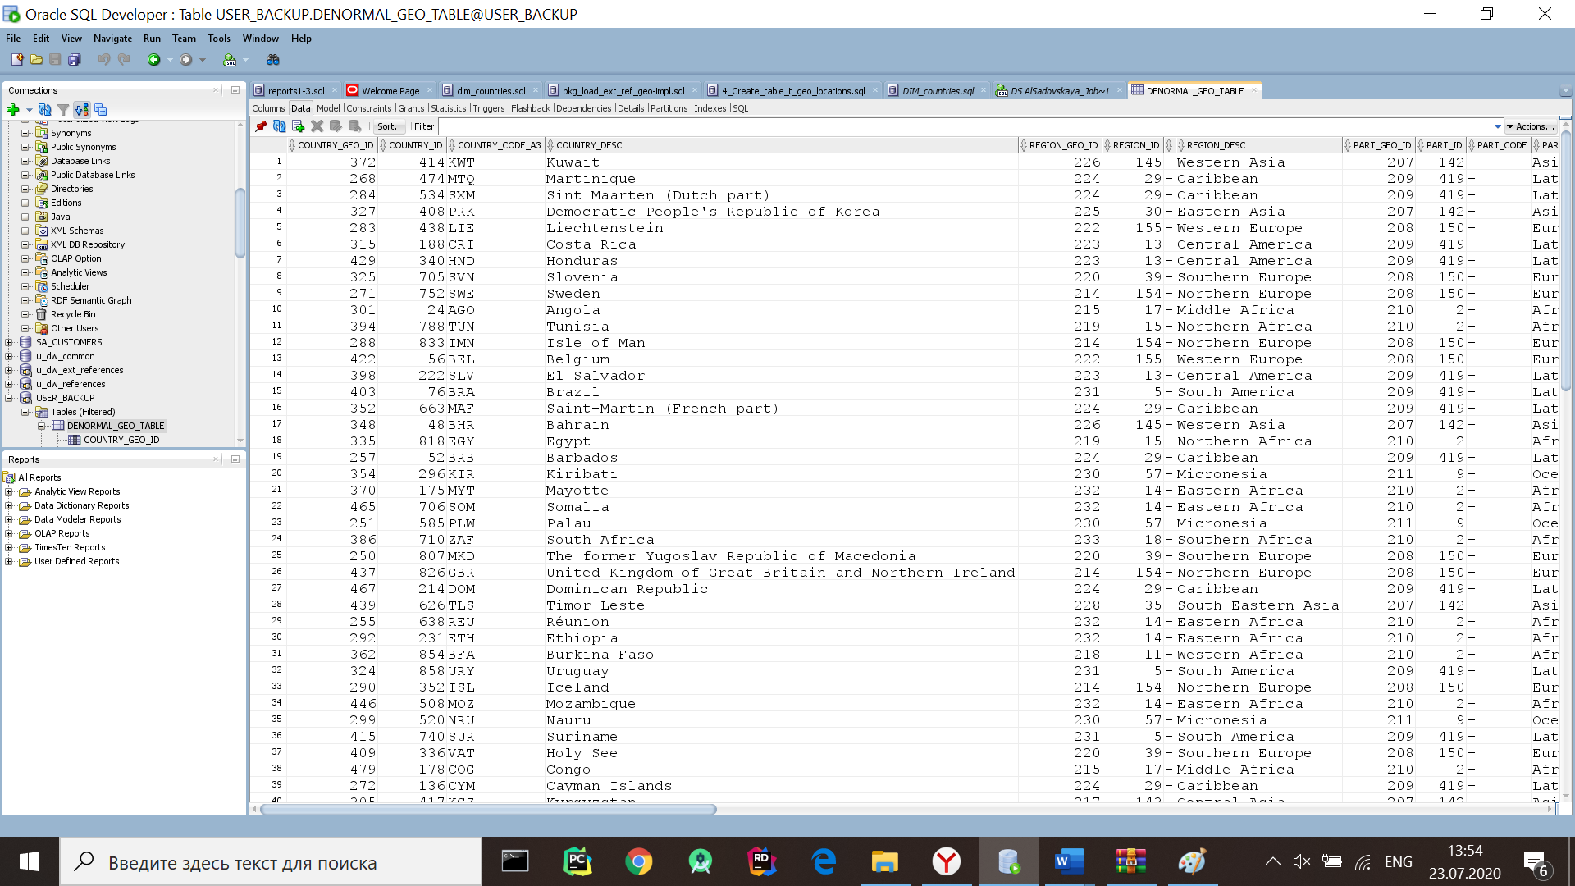

Let's create a GEO_REF table that will contain a geolocation link to the Denormalized table:

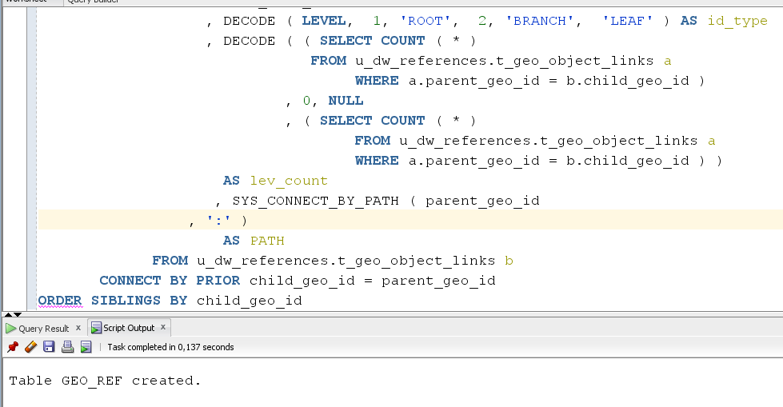 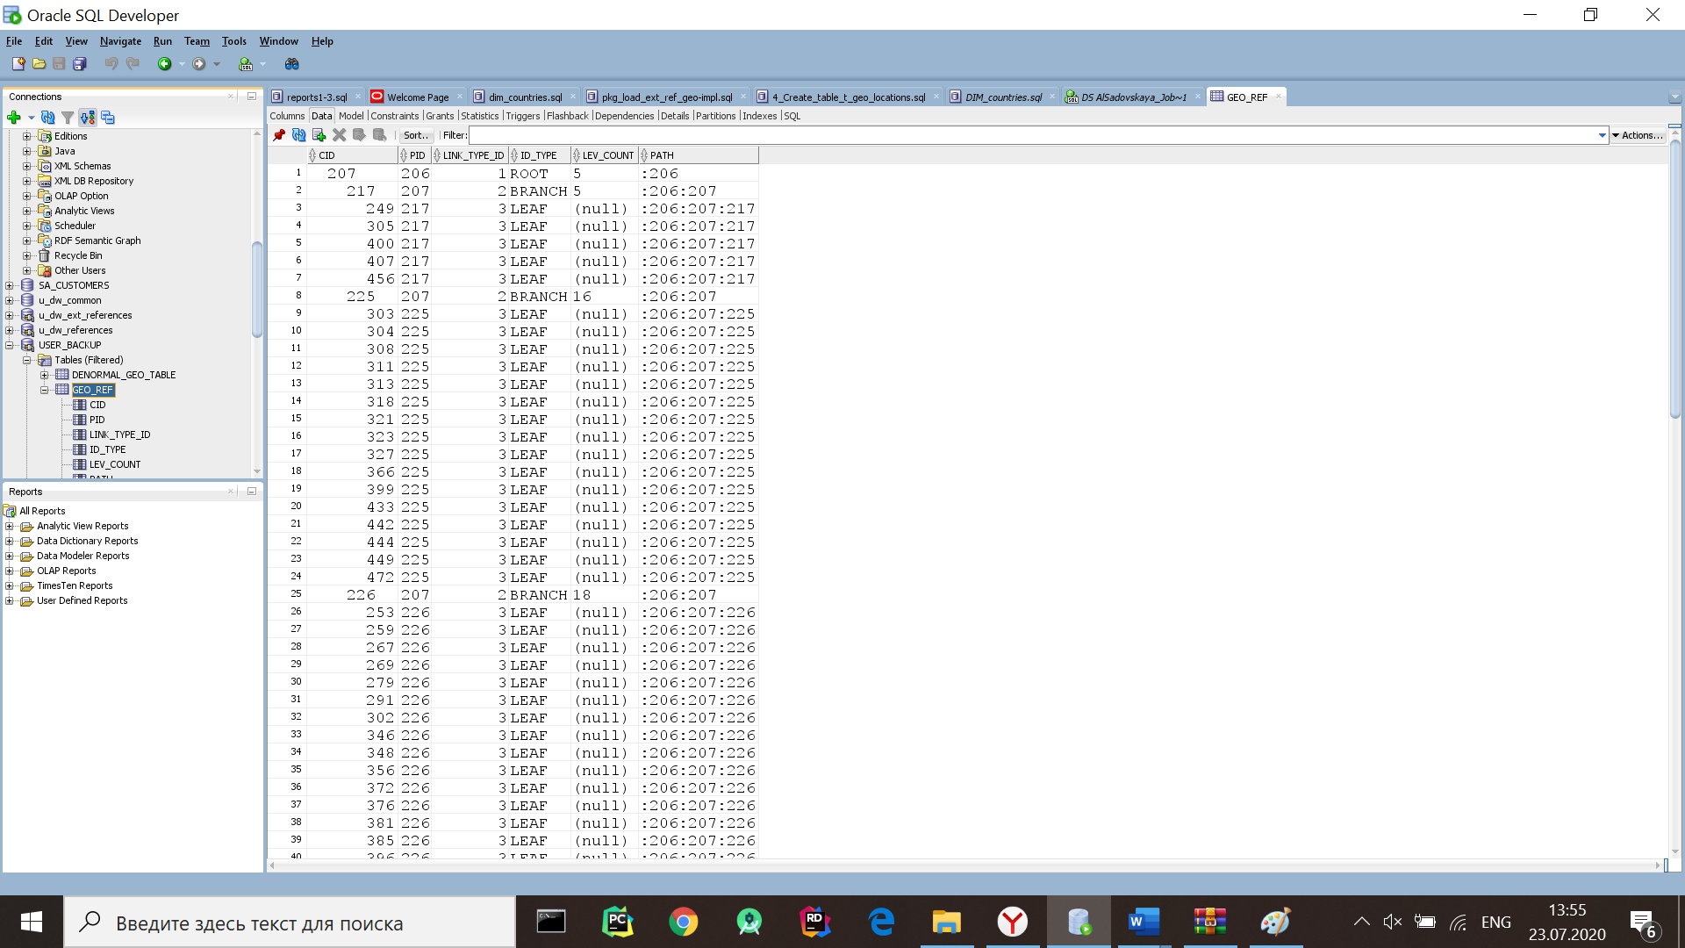

## 2.2. Task 02: Analyze Business hierarch Reference Analyses

If we perform an internal selection (highlighted in red), we get the following table that reflects all the links line - >collection

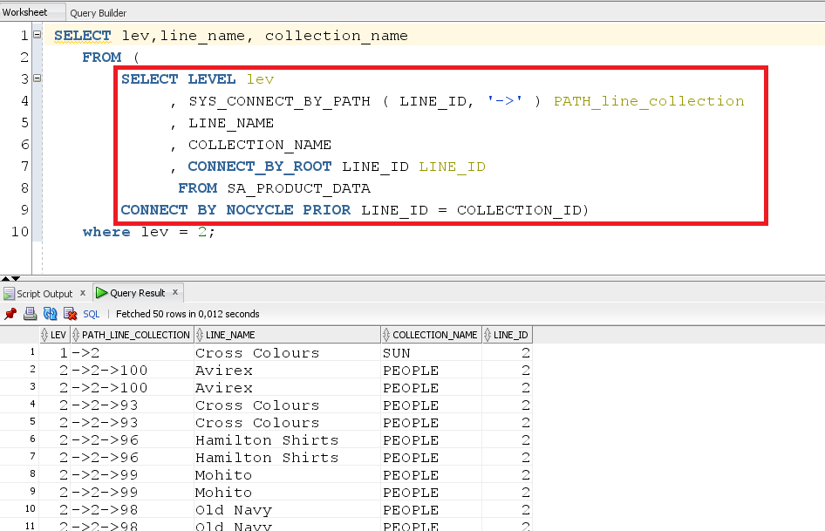

If we execute the entire selection, we get all the line-collection relationships:

