Report

on the

**U2M4.LW.Core PL/SQL**

Alina Sadovskaya

In the first unit in lab 8, we created tablespaces and users for all layers of data passage. The following tablespaces are useful for uploading data to dimention and fact tables:

|  |  |  |  |  |  |
| --- | --- | --- | --- | --- | --- |
| DW - Cleansing Level | DW_CL | | ts_DW_CL  (AUTOALLOCATE,  SEGMENT SPACE MANAGEMENT AUTO,  NOLOGGING,  Size 100M,  Autoextend clause ON next 50M) | | LOADING from stage level system. Contains all information and prepare it for further usage (cleaning it). |
| DW – Level | DW_DATA | | ts_DW_DATA_01  (AUTOALLOCATE,  SEGMENT SPACE MANAGEMENT AUTO,  LOGGING,  Size 150M,  Autoextend clause ON next 50M) | | LOADING data from cleansing system. Contains clean information tending to the 3rd normal form ready for preparing star schema. |
| DW_CL | | * create/drop tables/views * Select/ Merge from/with SA views * push it upstairs (update objects ts_DW_DATA_01) | |
| DW_DATA | | * create/drop tables/views * push it upstairs (update objects ts_DW_STR_CLS) * Select / Merge from/with DW-CL views | |

* Let's create all the necessary tables for the **cleansing area** from the DW_CL user in the ts_DW_CL tablespace:

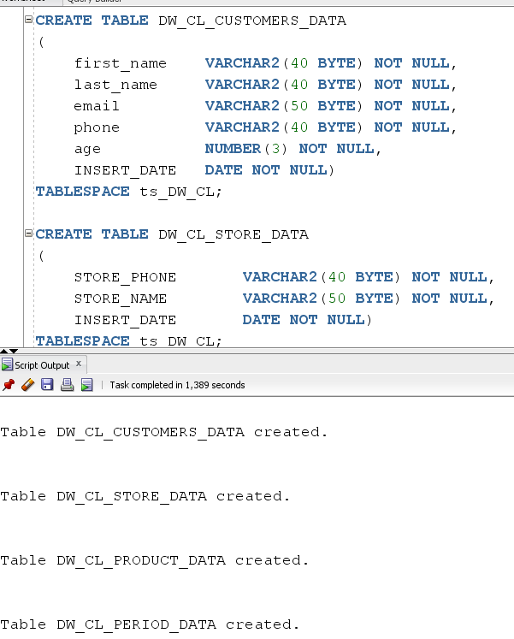

Now let's **write procedures** for moving data from the **SA layer to DW_CL** (in this case, the main task of these procedures is to remove null and invalid values):

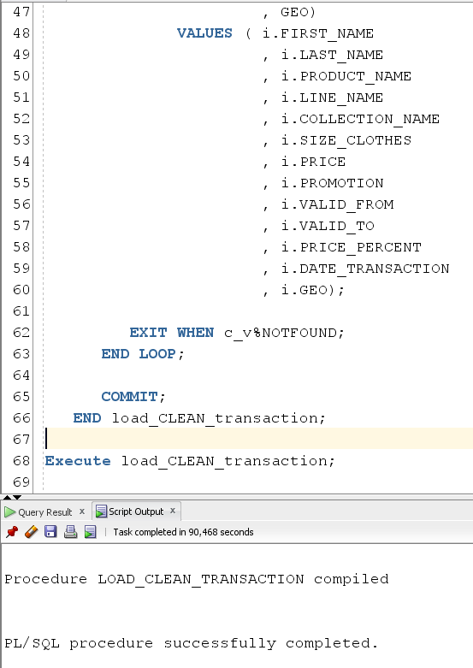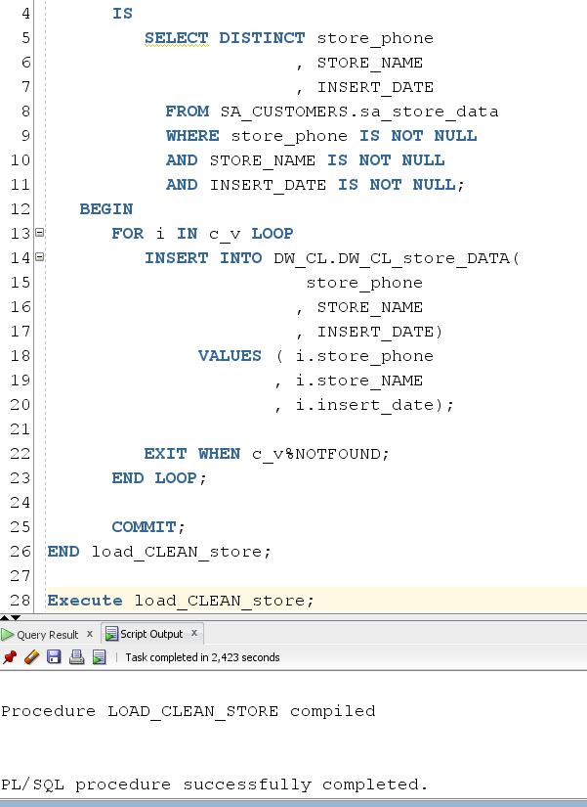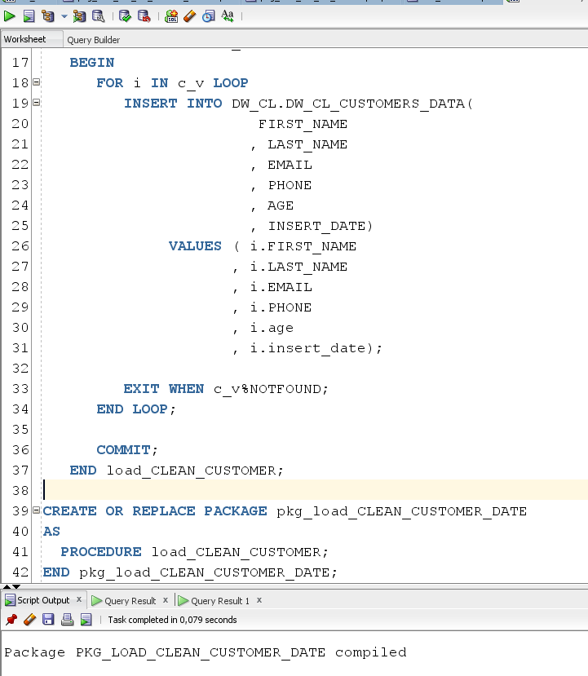

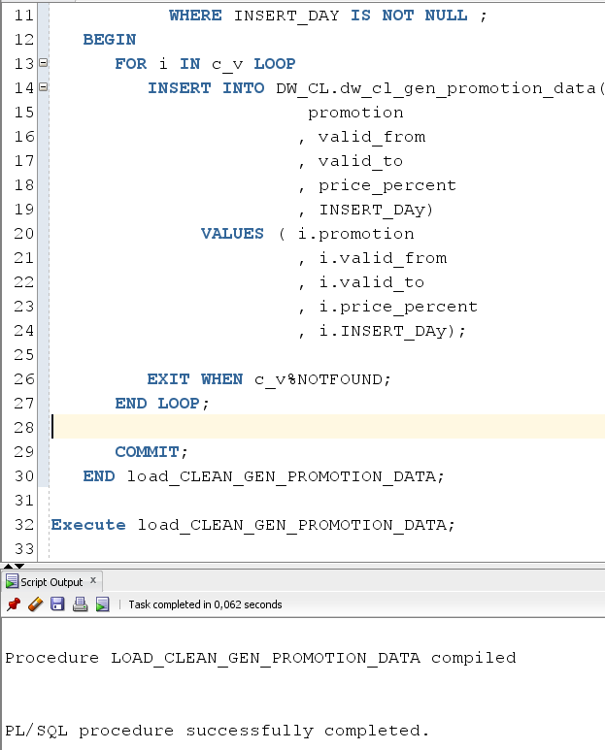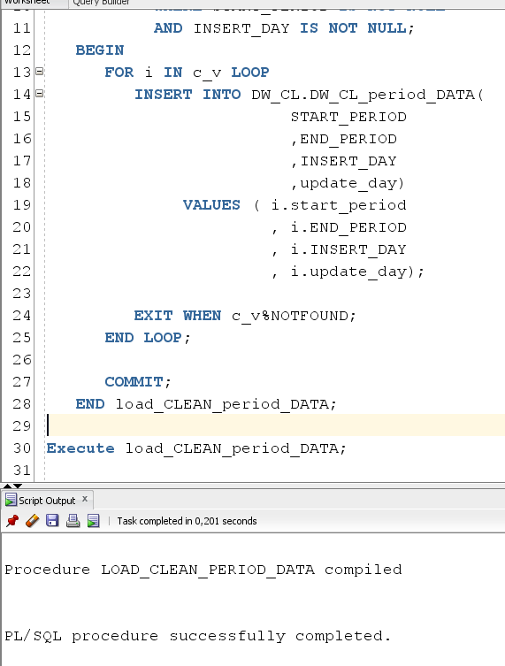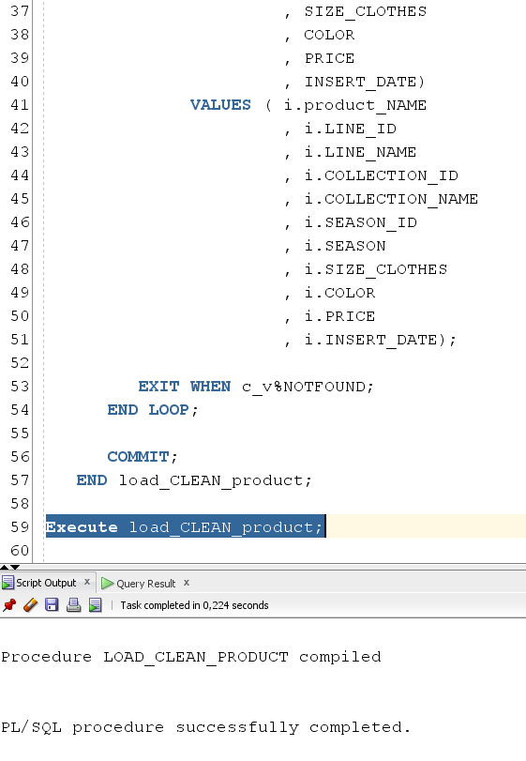

Let's **create packages** with all the necessary procedures and create a script to run them:

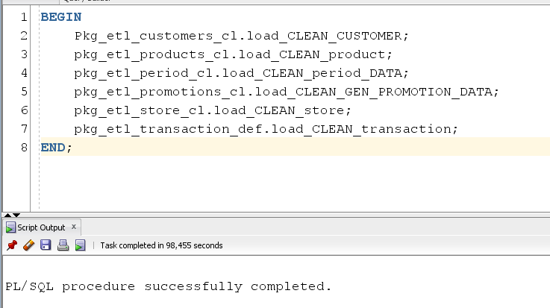

* Let's create all the necessary tables for the **DW** from the DW_DATA user in the ts_DW_DATA_01 tablespace:

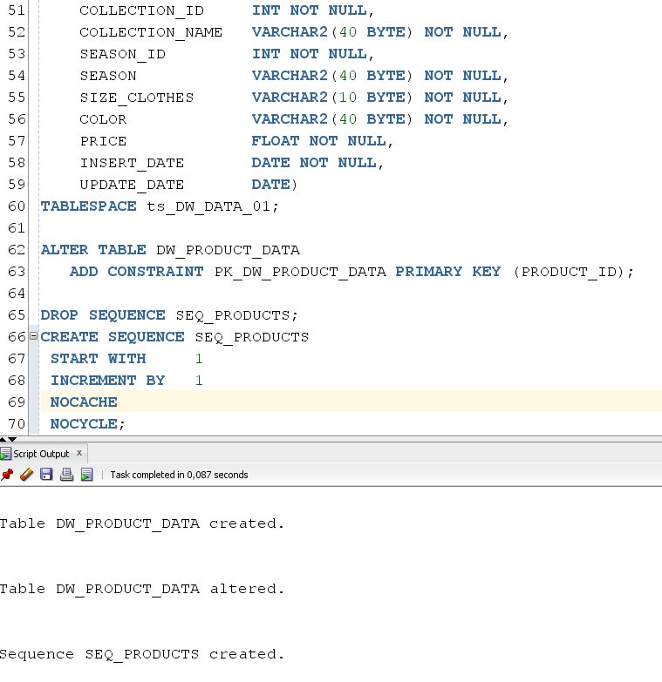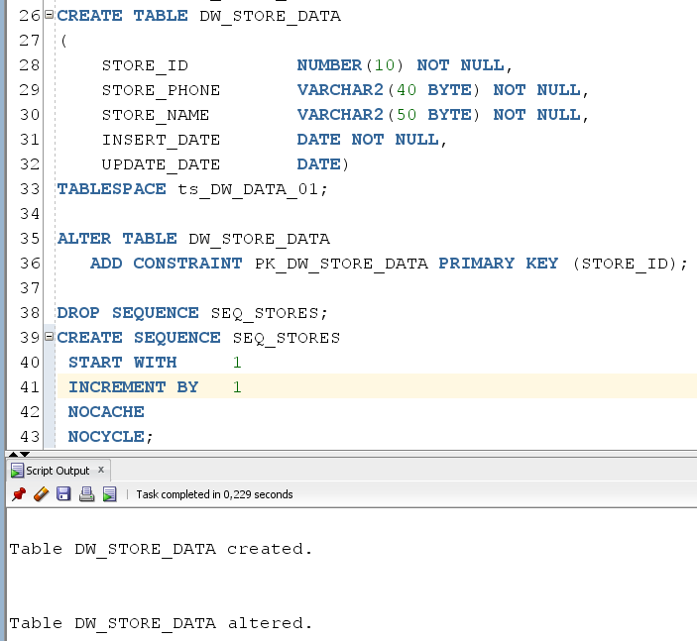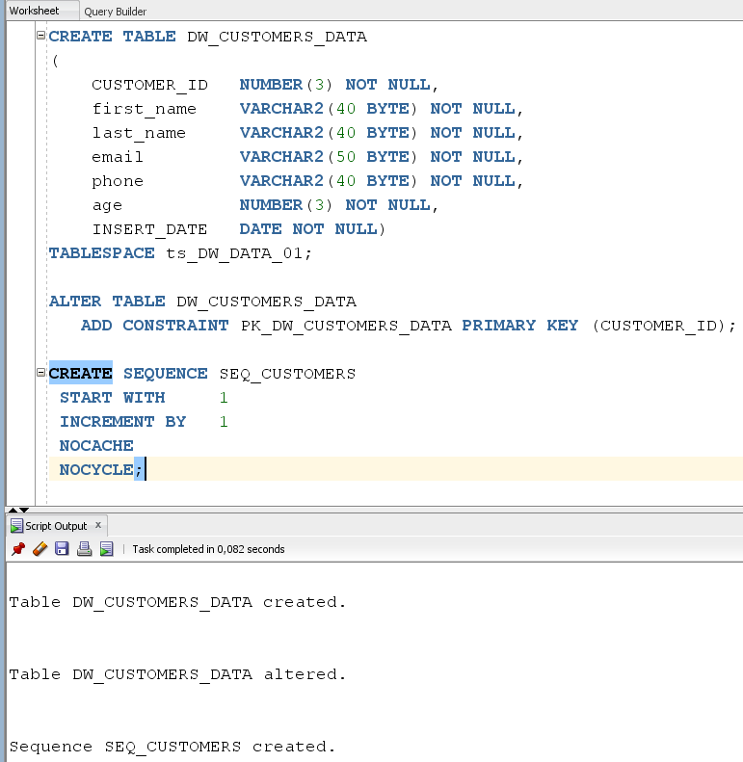

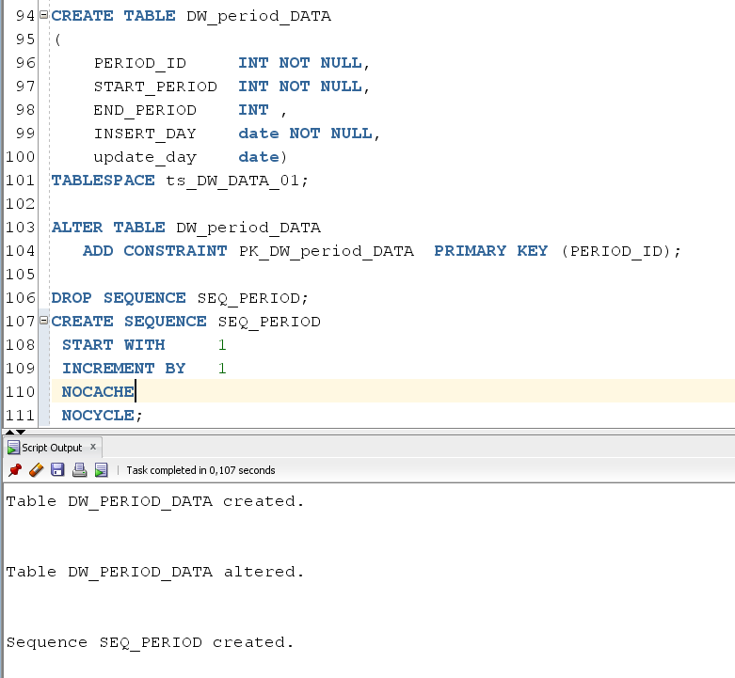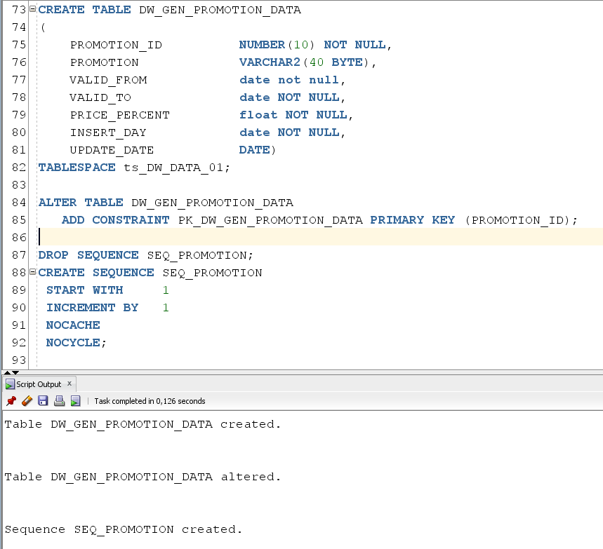

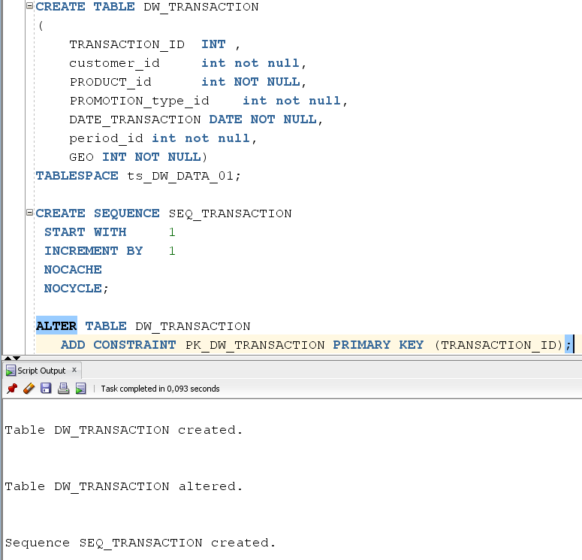

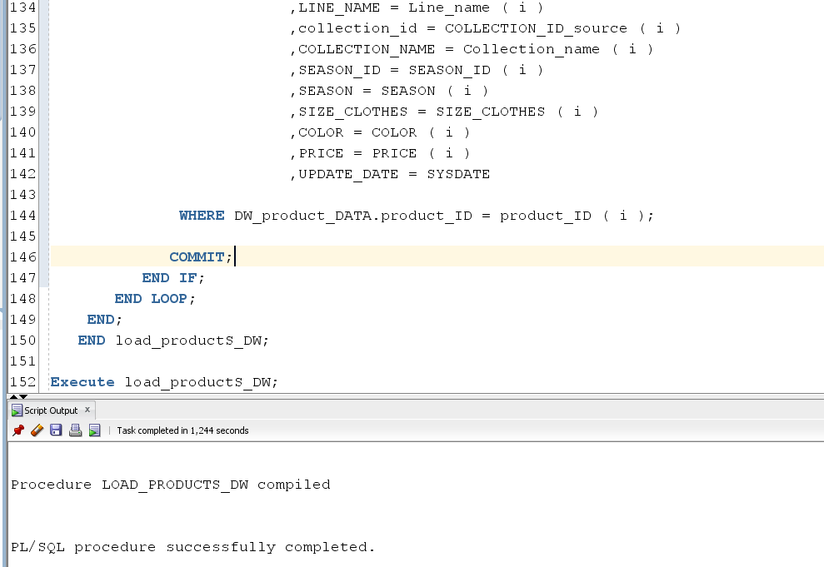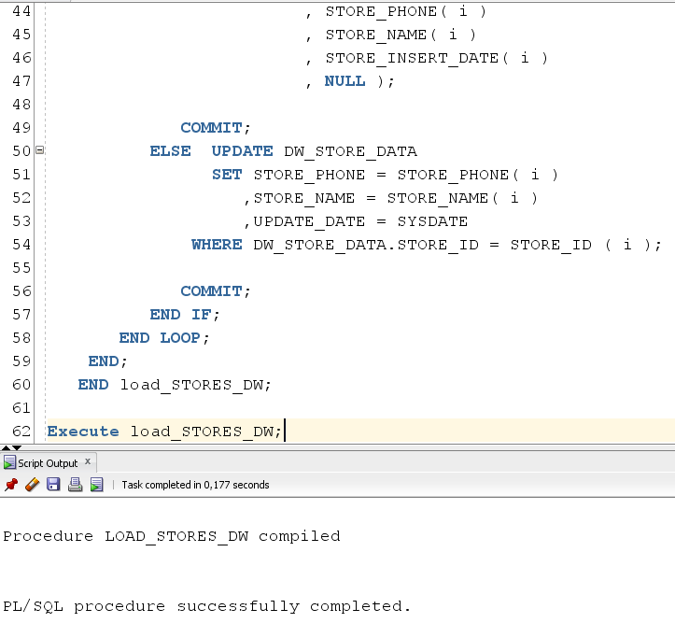Now let's **write procedures** for moving data from the **DW_CL layer to DW** (in this case, the main task of these procedures is to convert natural keys to primary key):



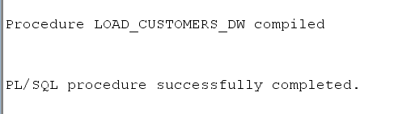

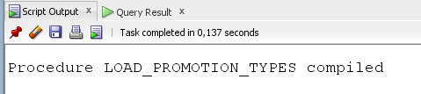

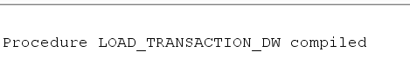

Let's **create packages** with all the necessary procedures and create a script to run them:

