REPORT ON THE U2M5.LW.Advanced SQL, PL/SQL

ALINA SADOVSKAYA

2. Business analyses tasks – Dimensions

2.1. Task 01: Create Packages for Reload Dimension from SA_*

At the star level, we only need information about products and promotions. Therefore, we leave information about customers, periods and stores in the dw_layer.

Now let's fill in our dimensions "dim_gen_promotions_scd" and " dim_products". To do this, create the necessary packages/procedures:

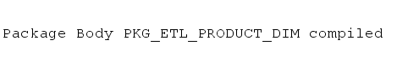



Let's create a script to run procedures from packages:

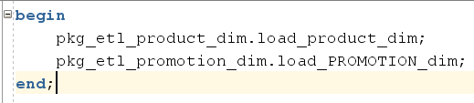

Now let's test the procedures by running all the data through them several times:

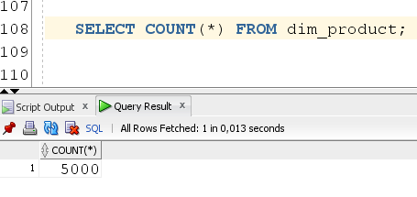

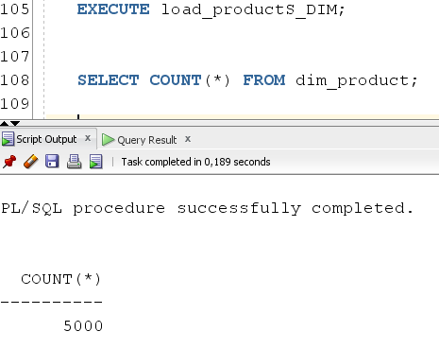

Аs we can see, after several runs of procedures, the number of elements remained the same, which indicates that the procedures are working correctly.

This is what the product table looks like after you fill it in:

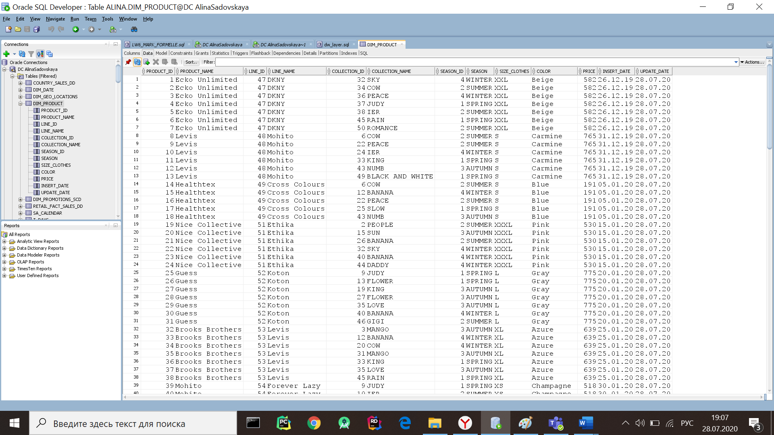

Creating a script for fully transferring information from the sa_* level to dimensions:

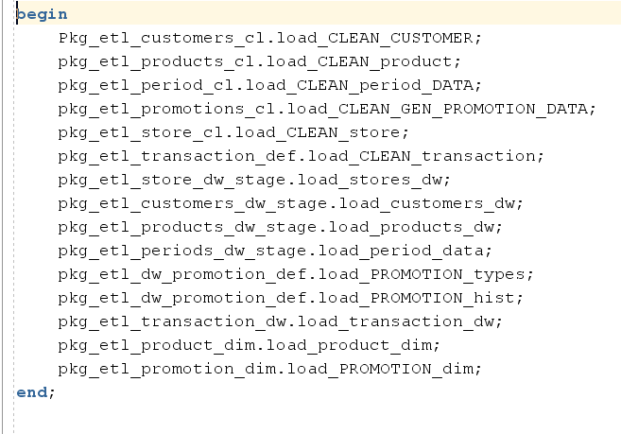

* According to the task, you must use the DBMS_SQL.TO_REFCURSOR function. To use it, redefine the load_PROMOTION_types procedure, which loads data from the cl level to the dw(the code is located in the "business_task\dw\PROMOTIONS\promotion_types_with_TO_REFCURSOR.sql" )

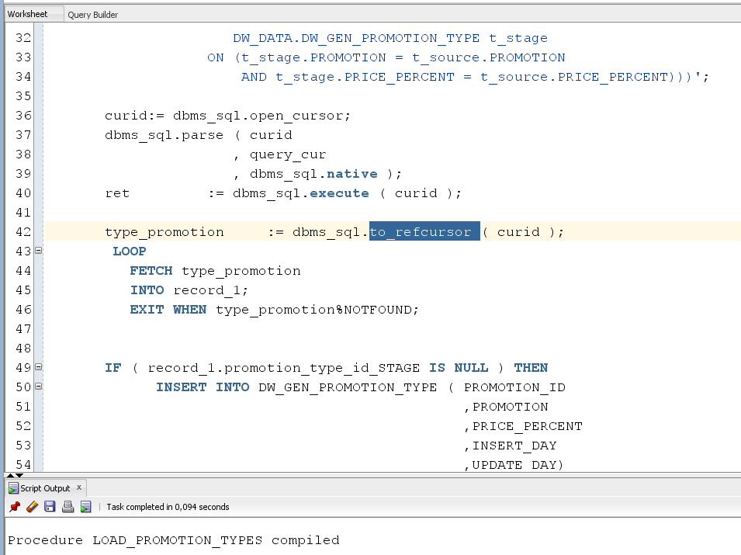

* Using the DBMS_SQL.TO_CURSOR_NUMBER function. To use it, redefine the load_stores_dw procedure, which loads data from the cl level to the dw(the code is located in the "business_task\dw\store\load_stores_with_to_cursor_number.sql" )

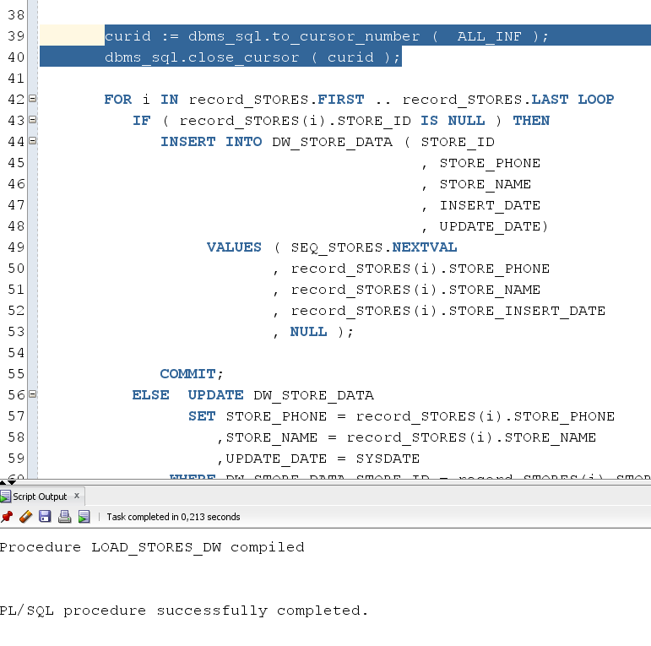

3. Business analyses tasks – Reports

3.1. Task 02: CREATE Monthly/Daily Reports Layouts

In my case, you need to add monthly reports containing information about the product and promotion. Thanks to this report, we will be able to understand what is the trend of buying products when using a particular promotion:

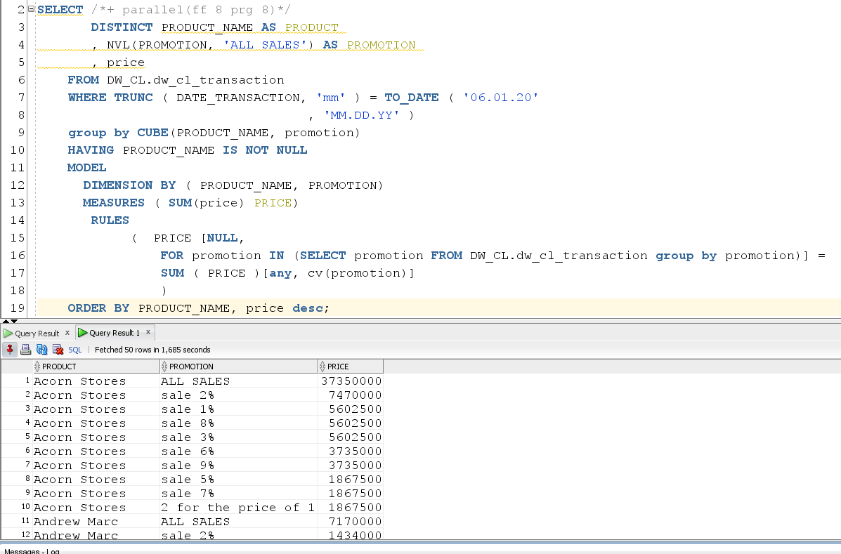

We also need a report containing information about which country products were most in demand:

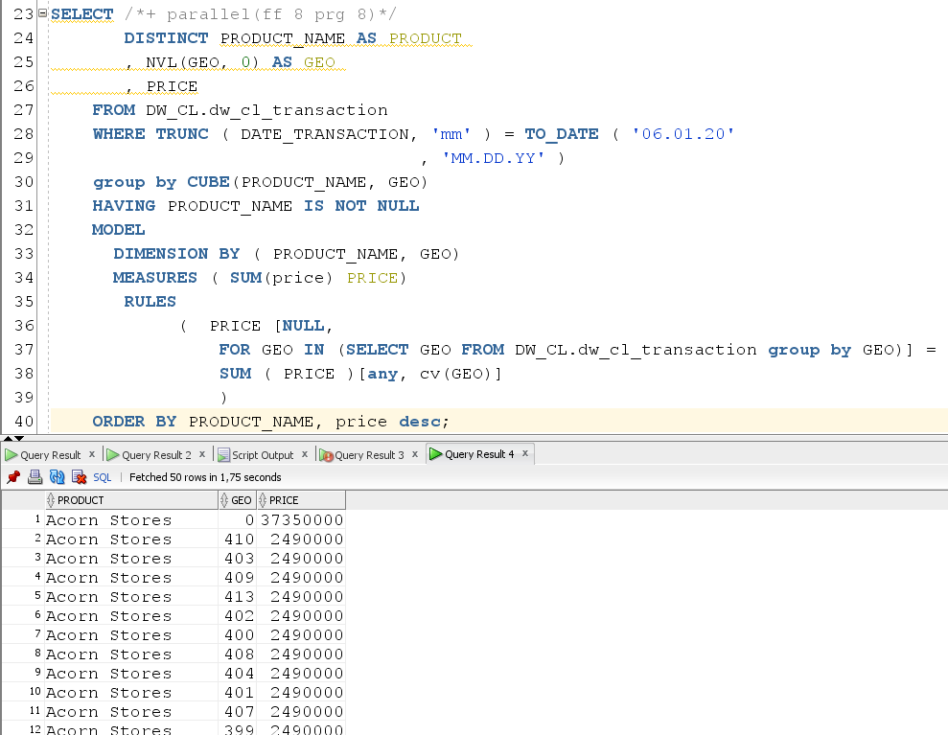

Let's change the query a little to get information about which products were preferred by customers in different countries:

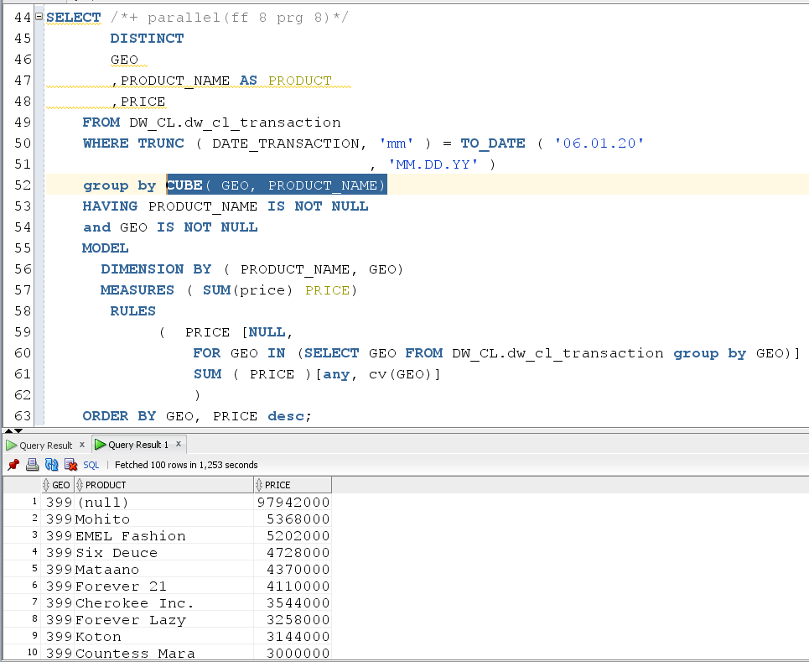

A report for determining how much money was spent when purchasing a product with a certain discount:

