REPORT ON THE U2M6.LW.Analytic Functions

ALINA SADOVSKAYA

2. Analytic Functions - Basic

2.1. Task 01: Create Ad Hoc SQL FIRST_VALUE, LAST_VALUE

**GET THE TOTAL SALES AMOUNTS FOR EACH PRODUCT** ( we have the same data because the data was generated via cross join):

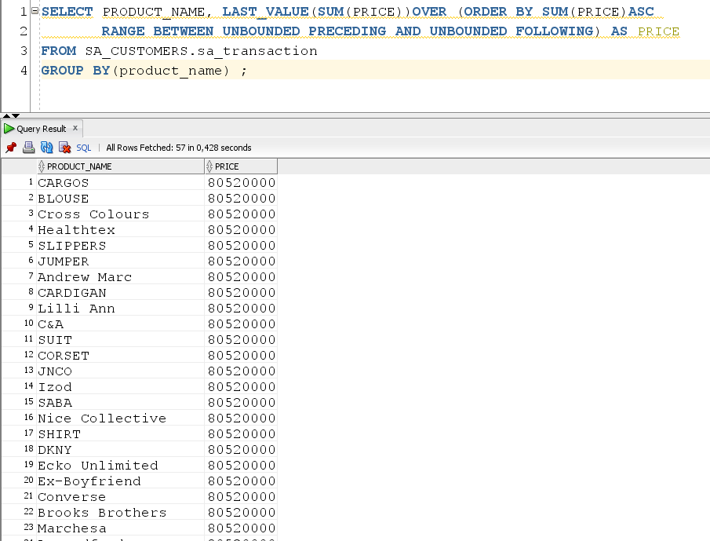

**WE GET INFORMATION ABOUT THE MINIMUM AMOUNT FOR SPECIFIC PRODUCTS PURCHASED BY COUNTRY**( WE HAVE THE SAME DATA BECAUSE THE DATA WAS GENERATED VIA CROSS JOIN)

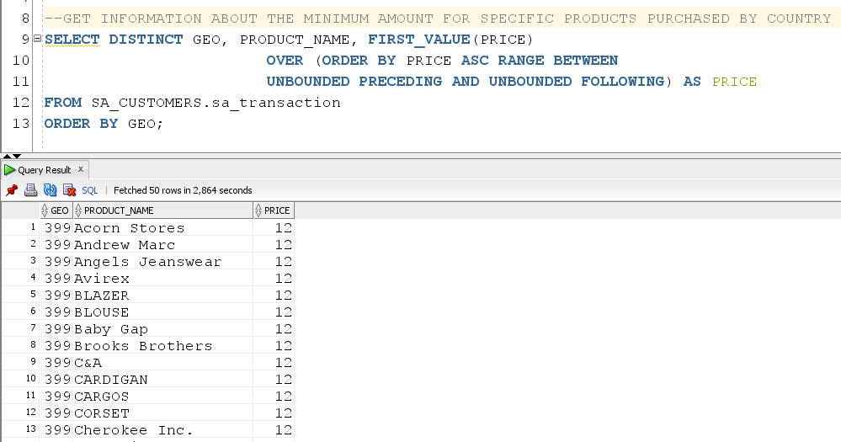

2.2. Task 02: Create Ad Hoc SQL RANK, DENSE_RANK, ROWNUM

The SQL query returns all products purchased with a 0% discount, and then calculates the rank for each unique sales amount. If two products had the same price, the DENSE_RANK function returns the same rank for both products:

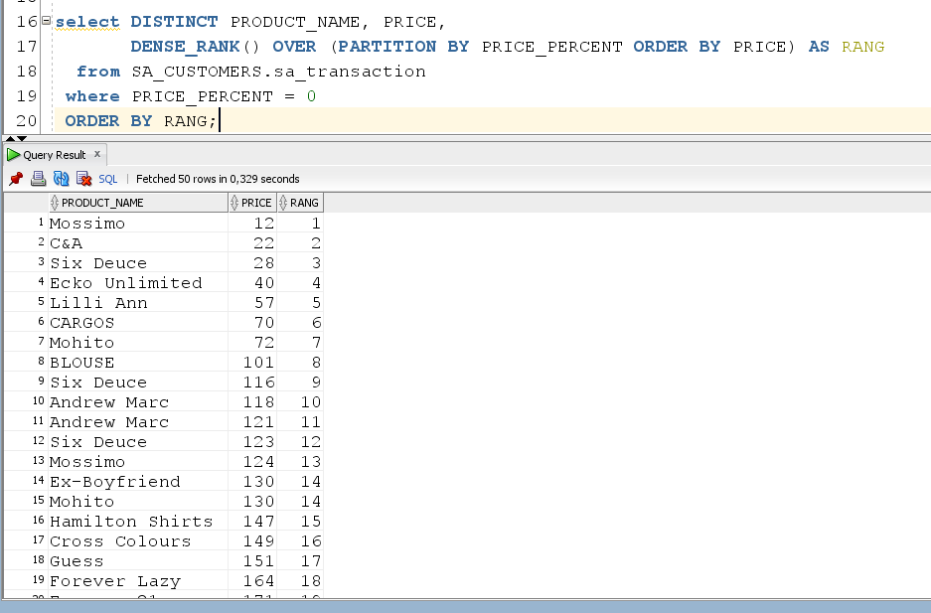

The SQL query returns all products purchased with a 8% discount, and then calculates the rank for each unique sales amount. (the RANK function returns the same rank for both products with the same price)

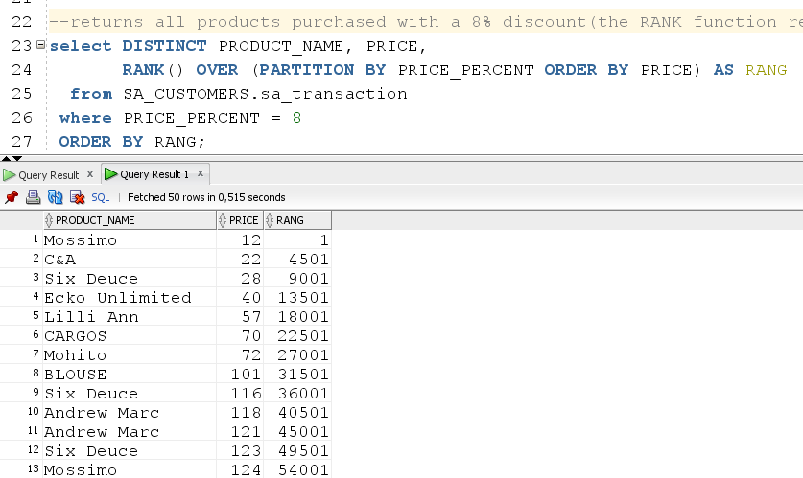

First we calculated the number of products with the maximum price:

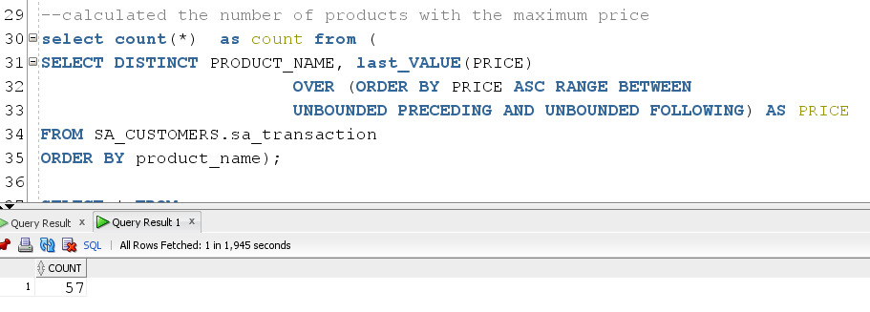

Now we have removed all products with the maximum price:

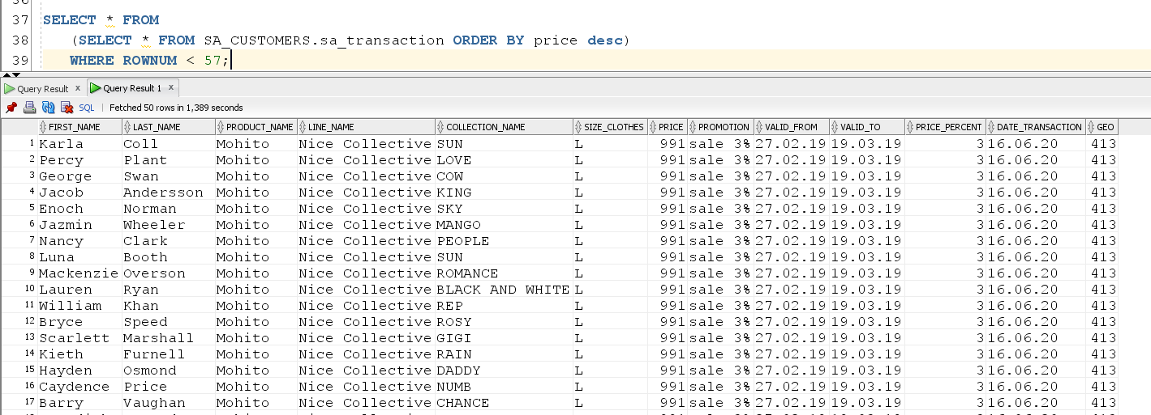

2.3. Task 03: Create Ad Hoc SQL AGGREAGATE FUNCS

Output the maximum price for each product:

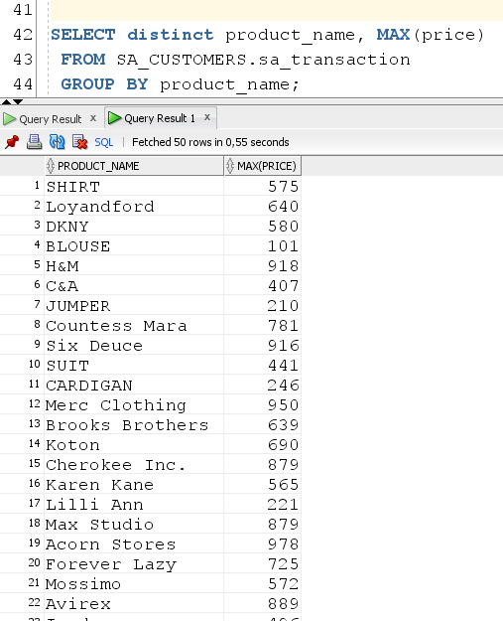

Output the average value for each product:

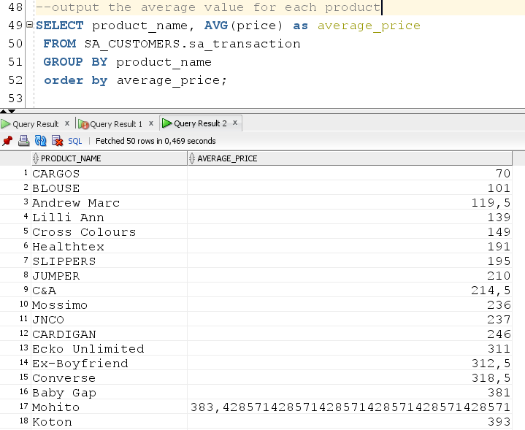

Now we use a window function that outputs the price value for each product and compares it with the average value:

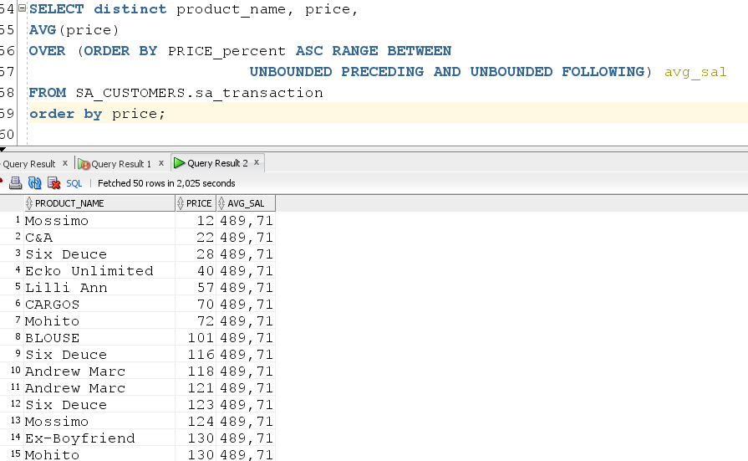

Now we will output the price and maximum discount for each product:

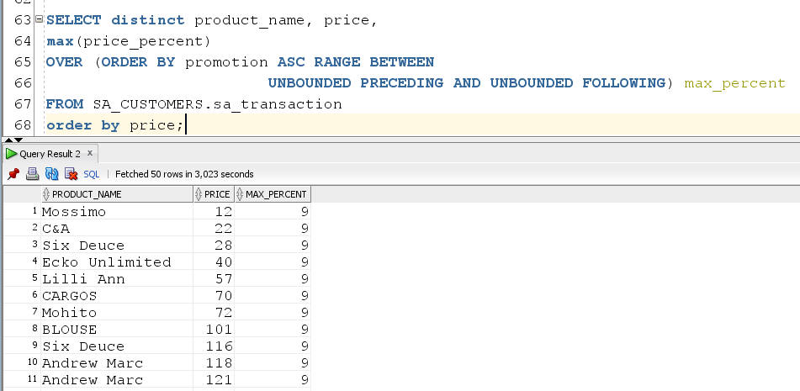

Now output the price and maximum price for each product:

