REPORT ON THE

U2M7.LW.Materialized Views

ALINA SADOVSKAYA

2. Materialized Views- Basic

 To create materialized views, you must assign the appropriate privileges to the user. The script with privilege allocation is located in the "scripts/USERS_GRAND".

2.1. Task 01: Create Materialized Views  - ON DEMAND

Сreating a materialized view for our monthly report on products and promotions, which will refresh on demand:

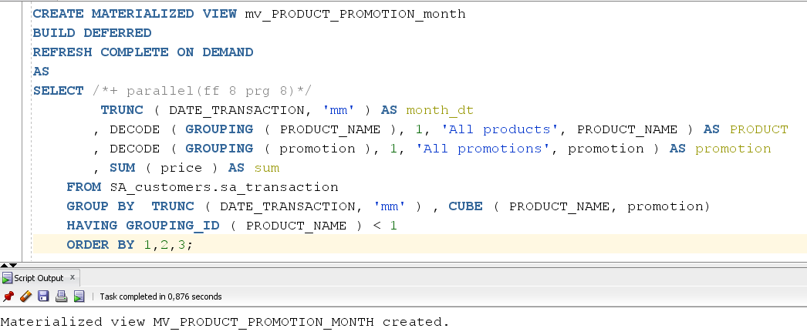

Аfter that let's select data from our view. Аs we can see the view remains empty:

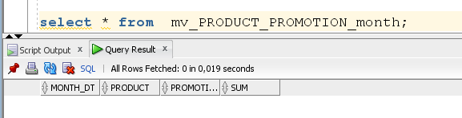

Now let's update our view using the function DBMS_MVIEW.REFRESH:

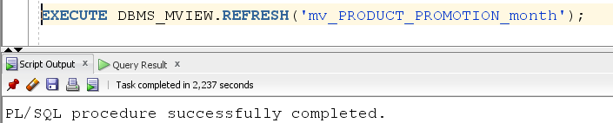

If we now execute select with our view, we will see that it is full:

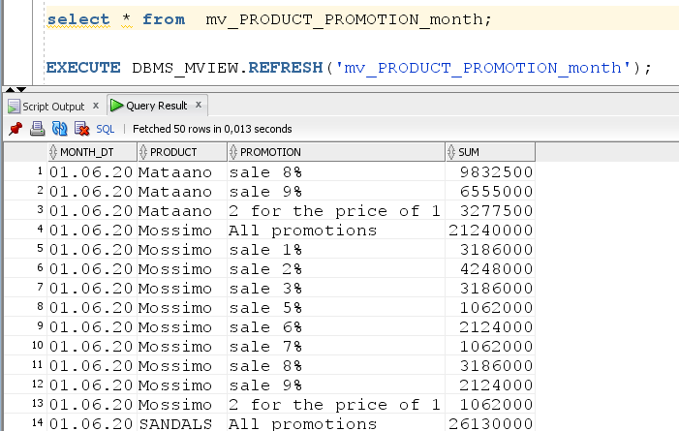

2.2. Task 02: Create Materialized Views  - ON COMMIT

Create a materialized view for our monthly product purchase report by location, which will be updated ON COMMIT. To do this, you need to create MATERIALIZED VIEW LOG ON our transactions table:

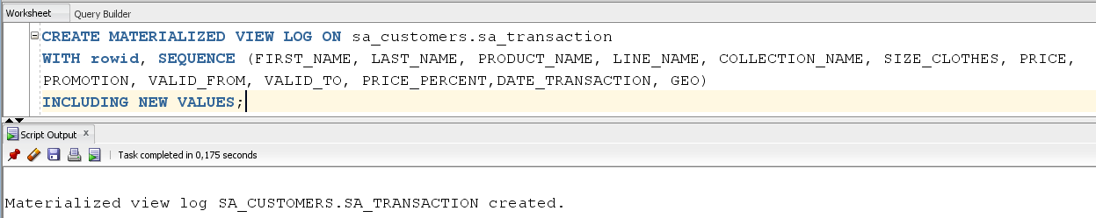

Now creating our materialize view:

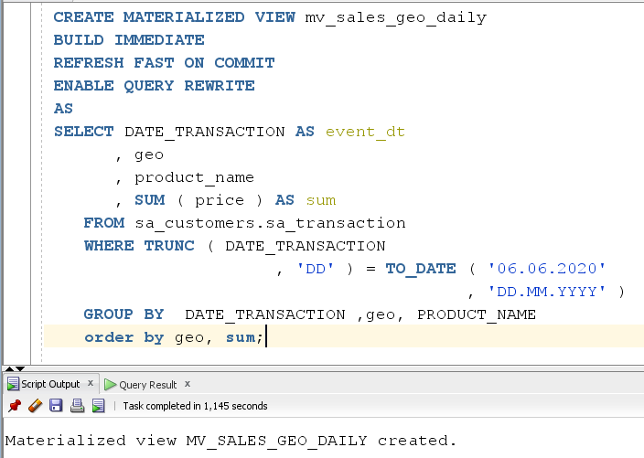

Аfter that let's select data from our view. Аs we can see the view remains is full:

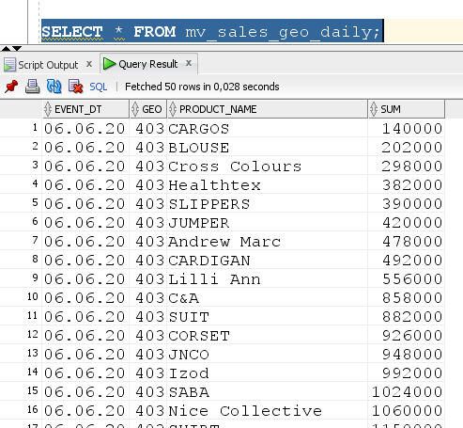

Now let's change the data in our resource table (increase price by 2 times) and commit changes:

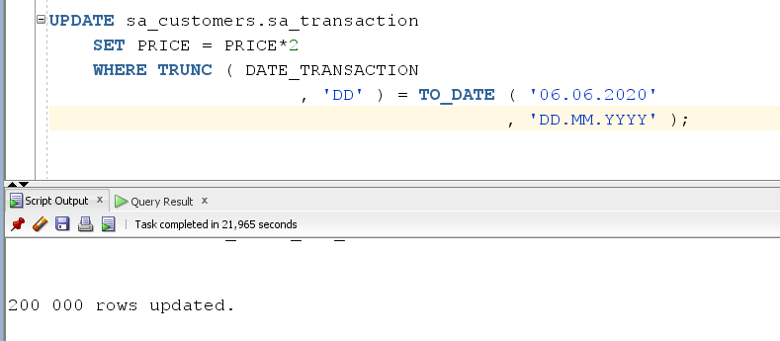

Now let's check our data in the view. as we can see the data has also changed(increase sum by 2 times):

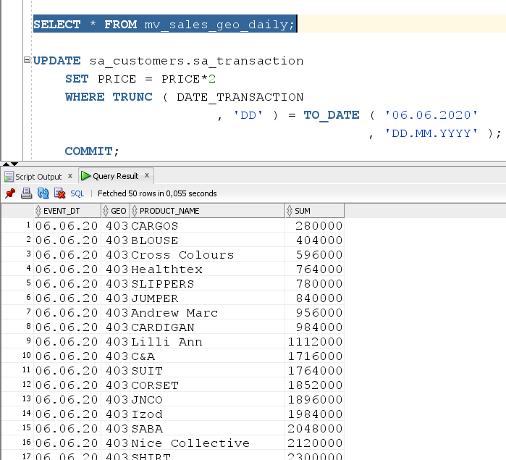

3. Materialized Views- Model Clause

3.1. Task 03: Create Materialized Views - Refreshing at definitive Time moment

Creating a materialized view in which the update will occur at a certain point in time. To do this, we use the Model SQL script that you prepared on LabWork 05(In this case we set an update every minute):

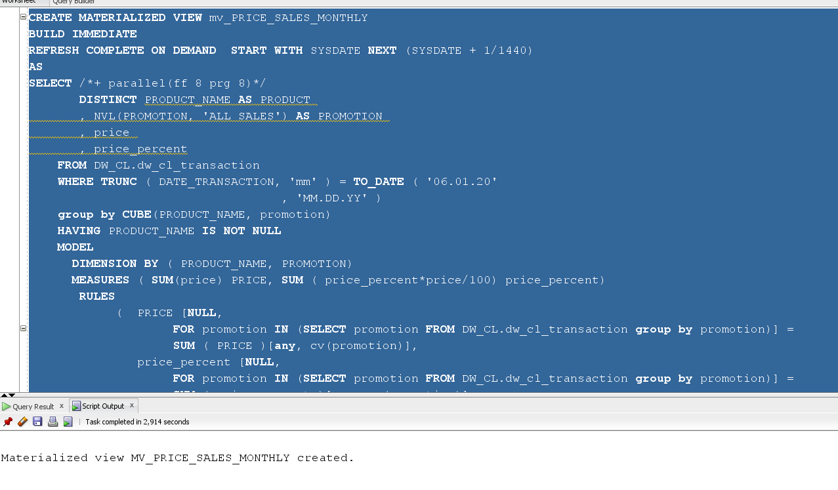

Let's see what data we have saved in our view:

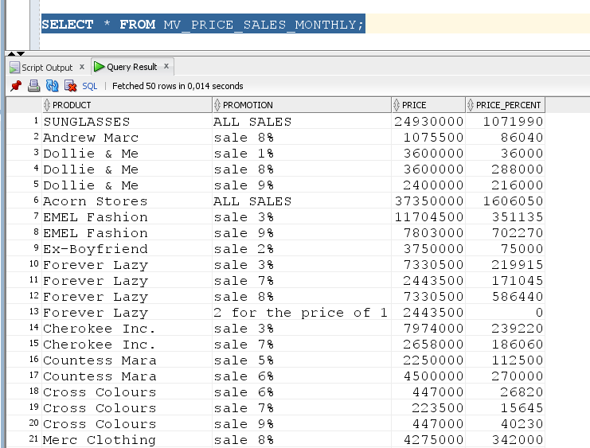

Now let's update our data in the resource table(we will increase the price for a certain product by 2 times):

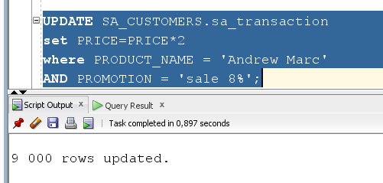

Since we had an update every minute, the data should change after a short time( < 1 minute). Now let's look at our data in the view. As you can see for the product 'Andrew Marc' which was purchased with an 8% discount, the final price increased by 2 times:

