U2.EXIT TASK

Alina Sadovskaya

1. Exit Task

Let's combine all the procedures in one package that load data from the SA level to the star level:

* PRODUCTS:

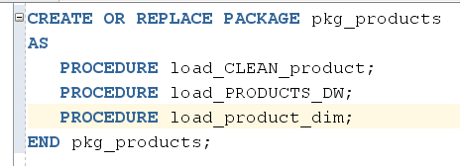

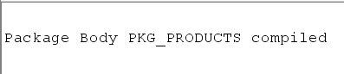

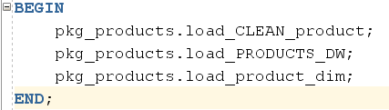

Result table:

CLEANSING AREA:

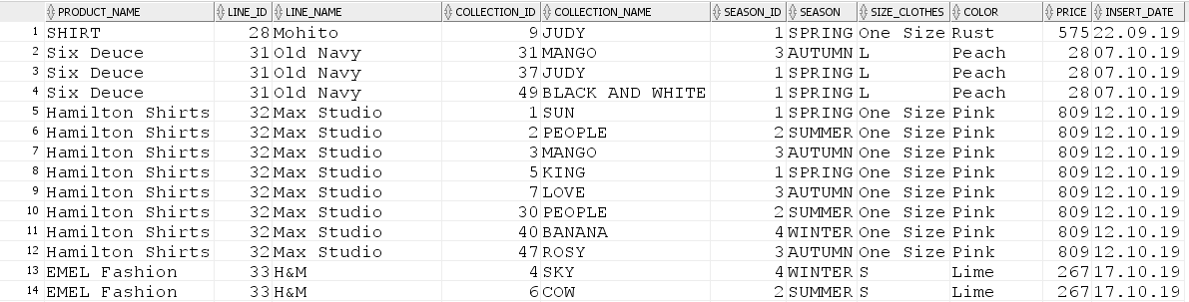

DW LAYER:

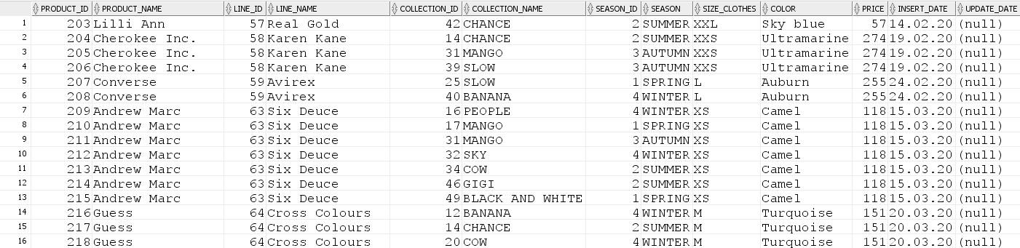

DIM_product:

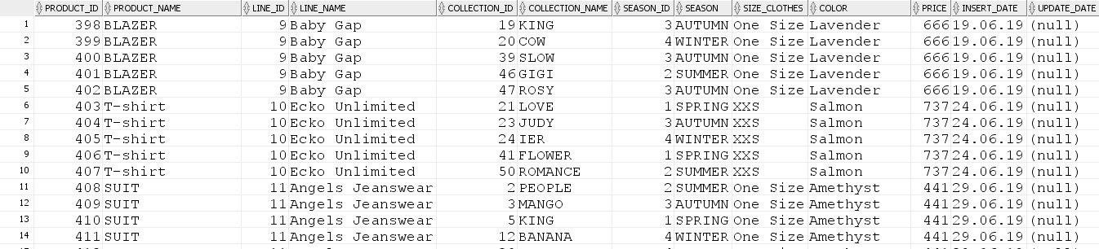

* PROMOTIONS:

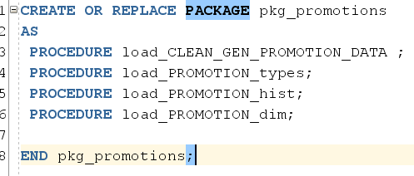

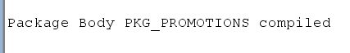

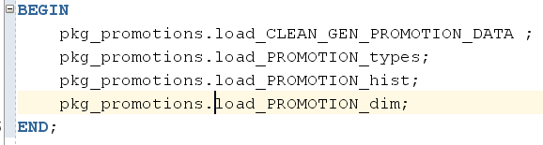

Result table:

CLEANSING AREA:

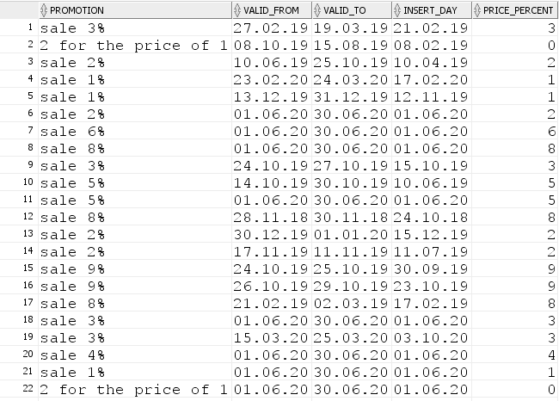

DW LAYER:

Dw_promotion_type:

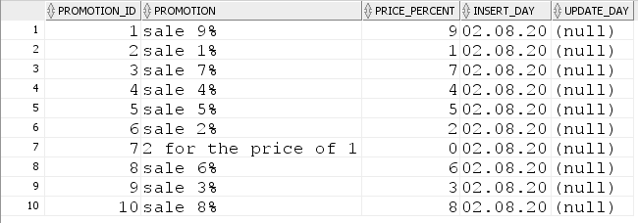

DW_PROMOTION_HIST:

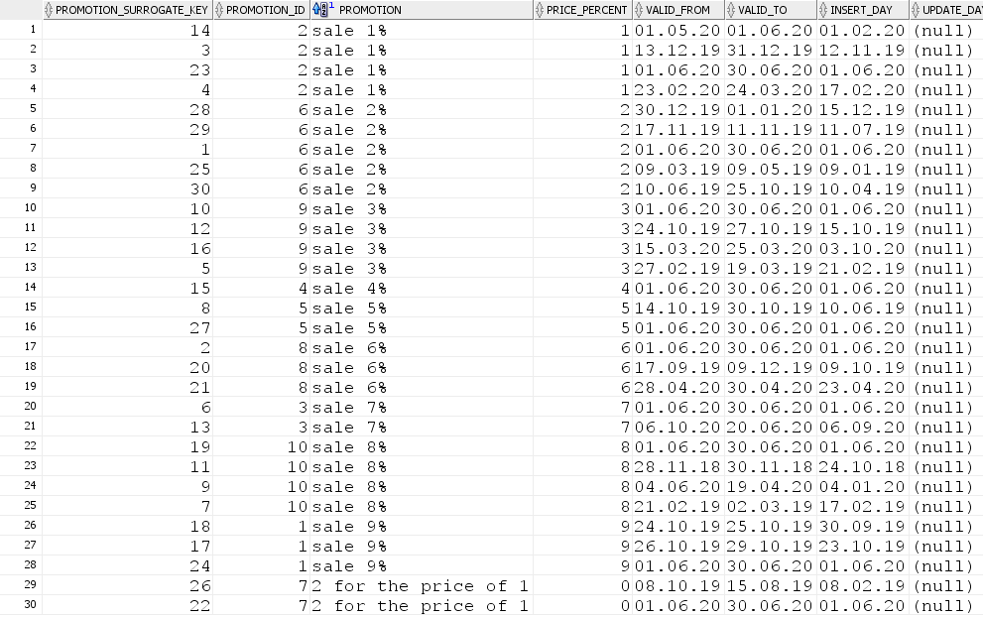

DIM_PROMOTION_SCD:

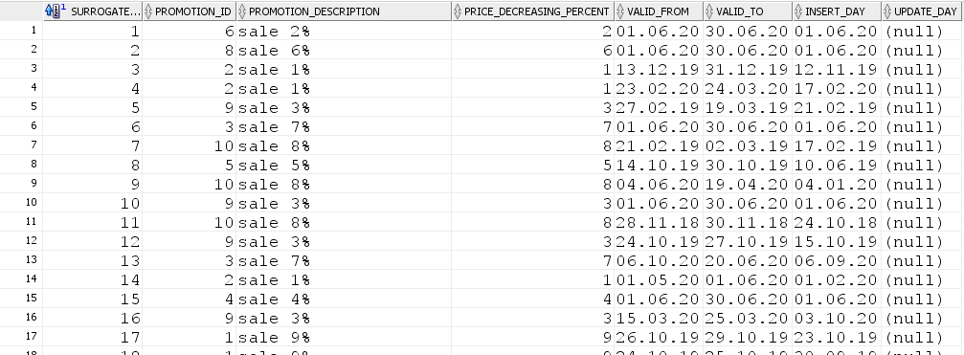

* CUSTOMERS:

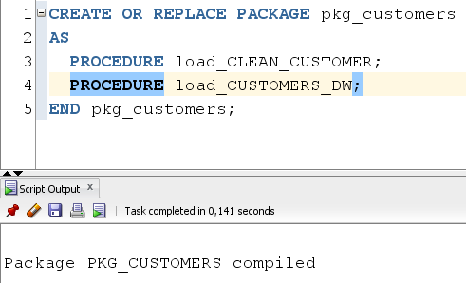



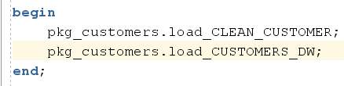

Result table:

CLEANSING LAYER: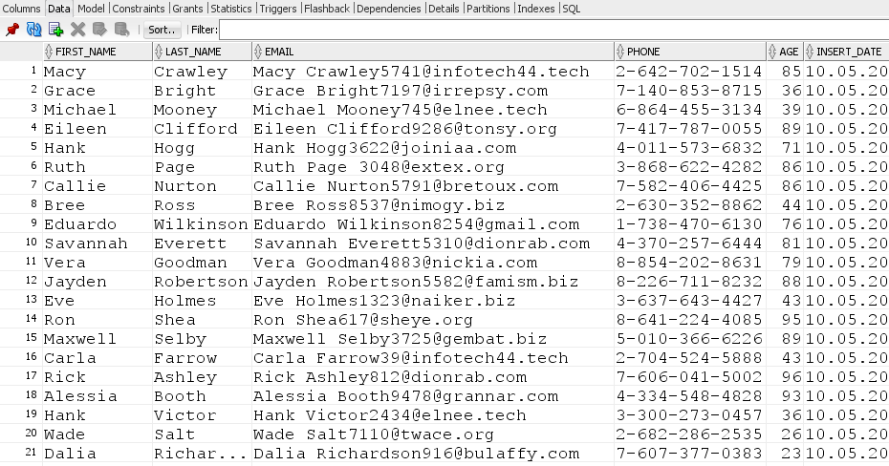

DW LAYER:

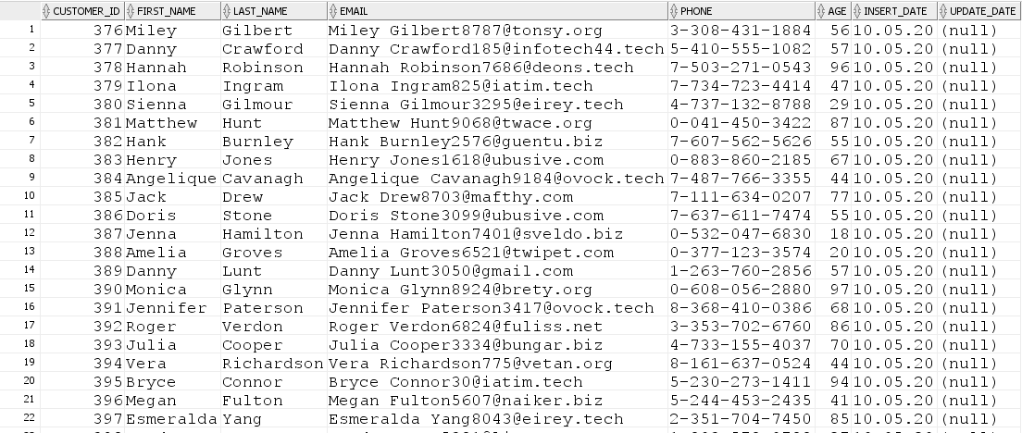

* PERIODS

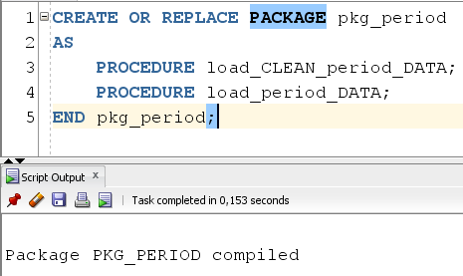



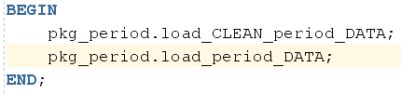

Result table:

CLEANSING AREA:

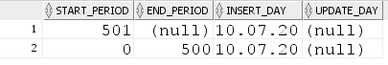

DW LAYER:



* STORES

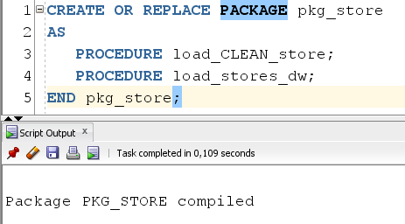



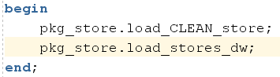

Result table:

CLEANSING AREA:

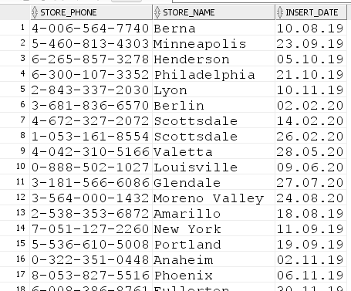

DW LAYER:

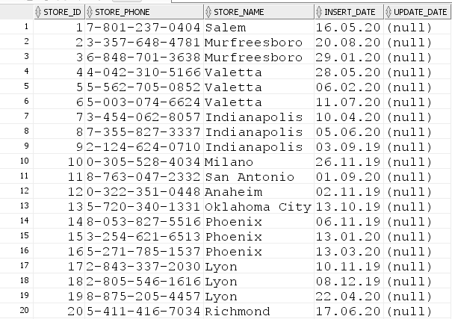

* TRANSACTIONS->FACTS:

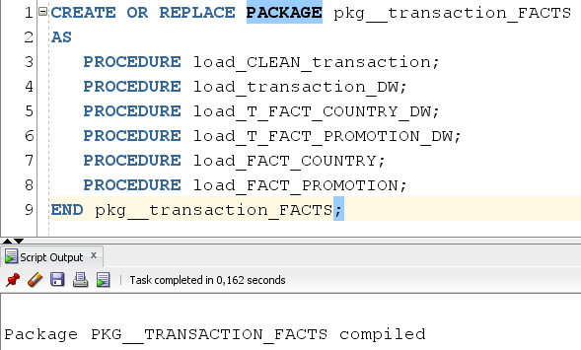



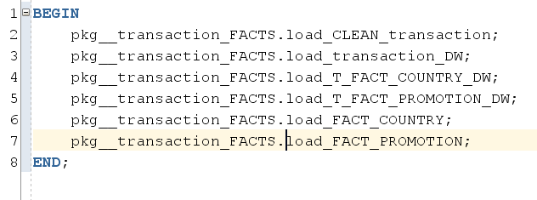

Result table:

CLEANSING AREA:(TRANSACTION)

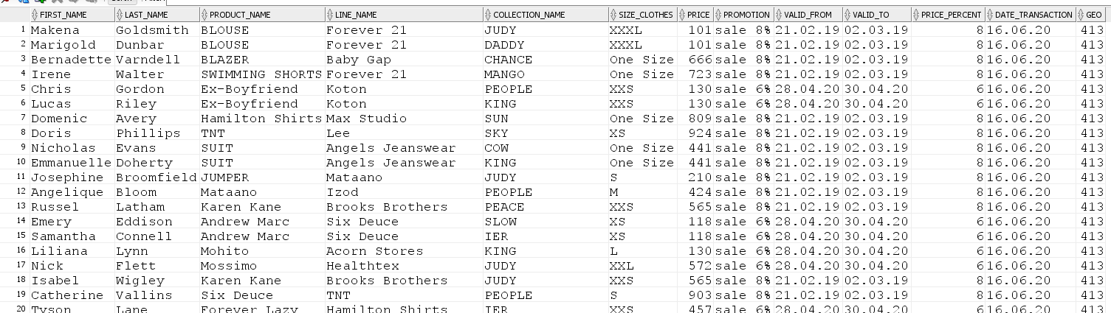

DW LAYER:

TRANSACTION

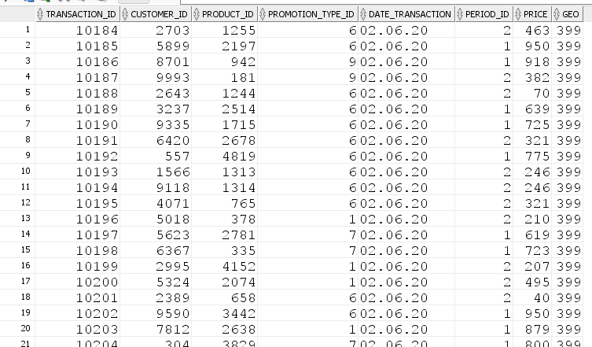

T_COUNTRY_FACT_SALES_DD

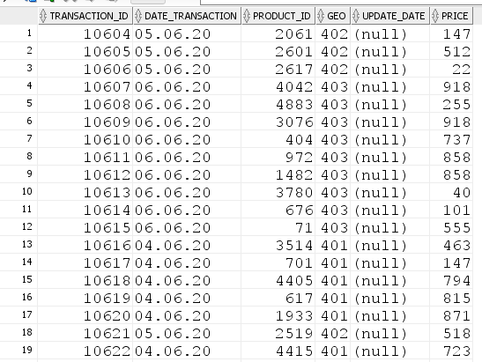

T_RETAIL_FACT_SALES_DD

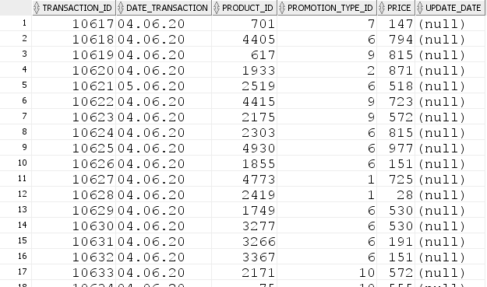

FACT_TABLE:

COUNTRY_FACT_SALES_DD

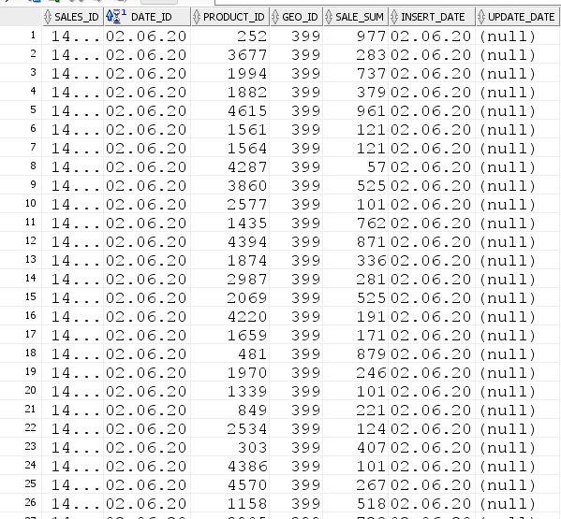

RETAIL_FACT_SALES_DD

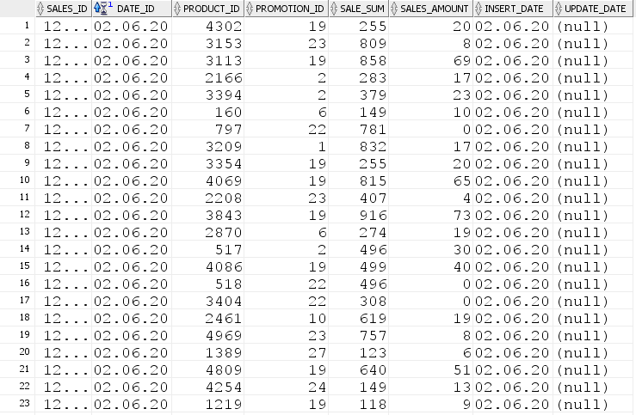

2. Result Task 01: Test Star Data

* Star Solution Scheme (Physical Objects)

COUNTRY_FACT_SALES_DD

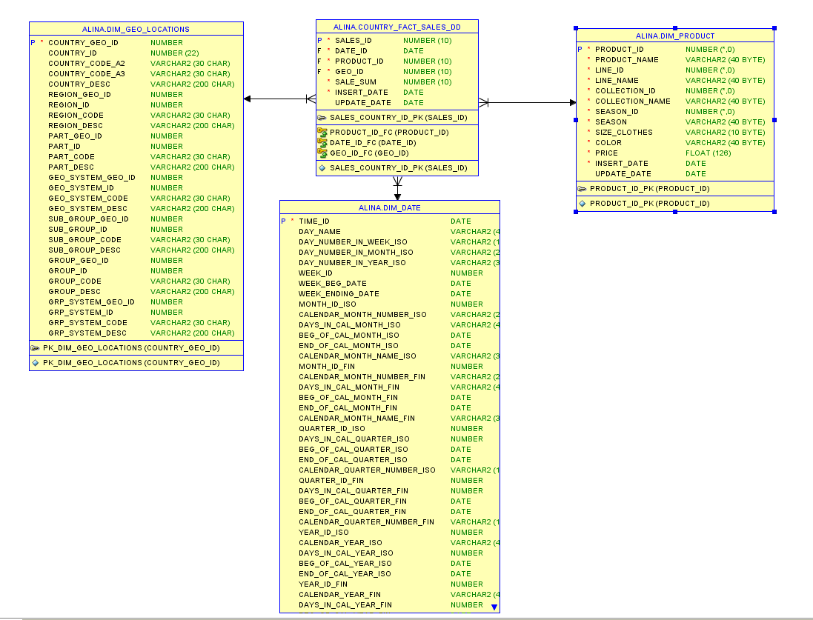

RETAIL_FACT_SALES_DD

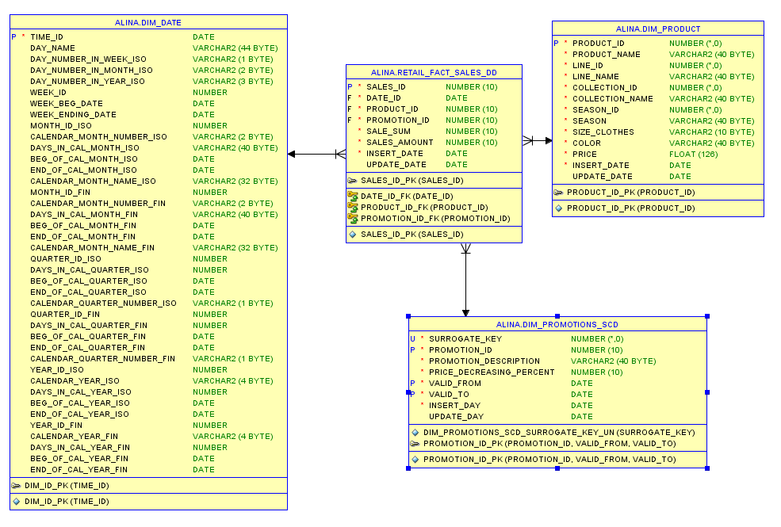

* Statistics for Star Scheme

The statistics which is required by cost based optimizer was gathered using DBMS_STATS package. Result of procedure execution for schema is presented below:

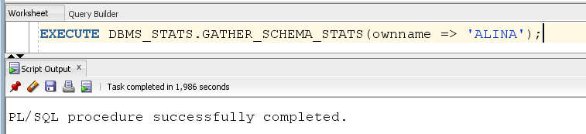

3. Result Task 02: Performance comparison

* ADVANCING GROUPING

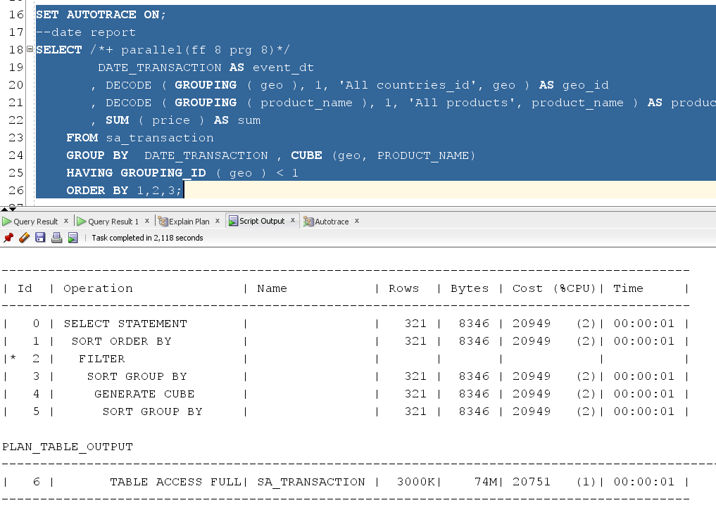

* MODEL CLAUSE

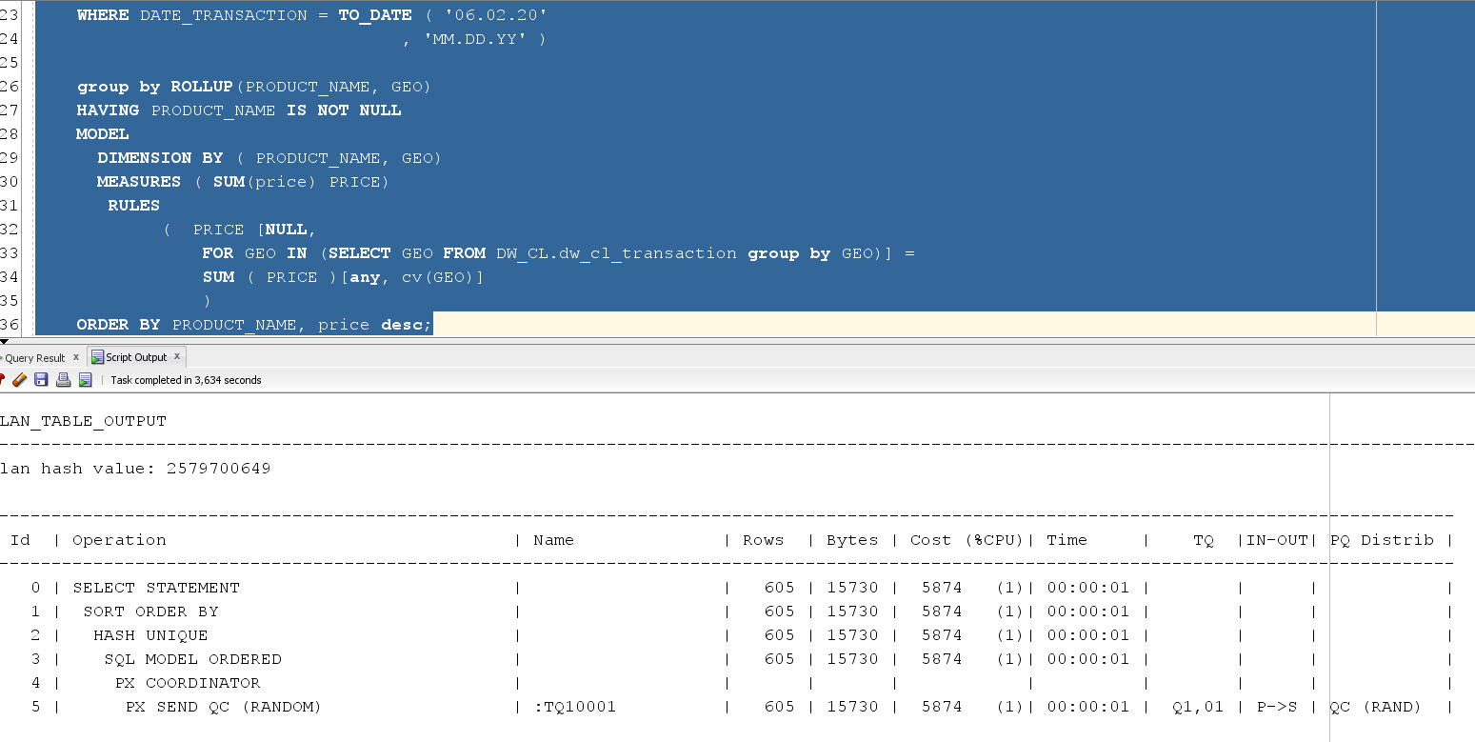

* STAR SCHEMA

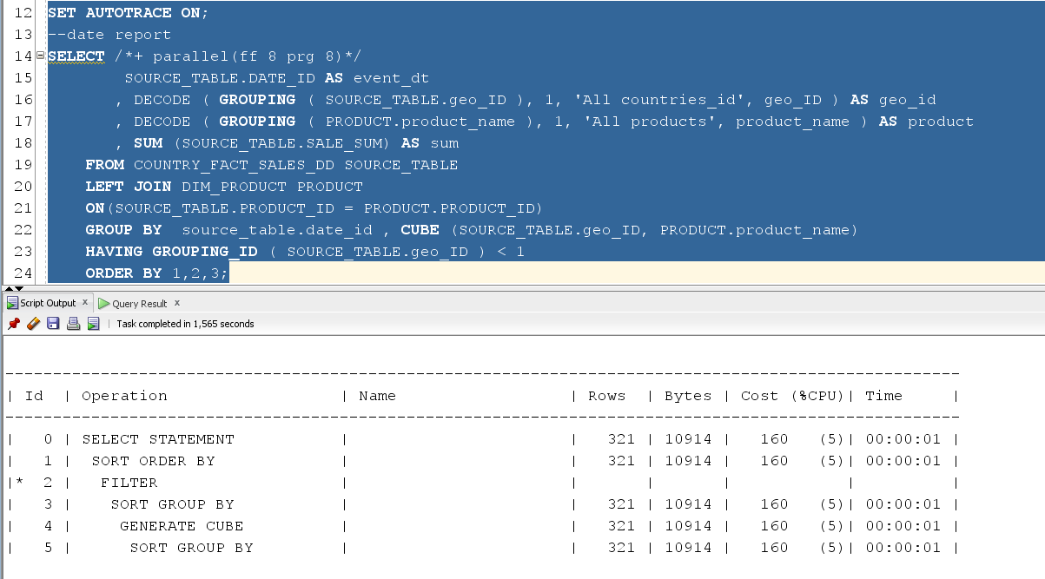

|  |  |  |  |  |  |
| --- | --- | --- | --- | --- | --- |
| № | Source Type | Explain Plan – Statistics (Cost) | | | Time |
| cost | bytes | cardinality |
| 1 | Advancing Grouping (Labwork 02) | 20949 | 8346 | 321 | 126msecs |
| 2 | Model Clause (Labwork 05) | 5874 | 15730 | 605 | 82msecs |
| 3 | Star Schema (Labwork 11) | 160 | 10914 | 321 | 78msecs |

As we can see using the star scheme gives the best performance.