Brainstorming notes for each column (“criteria and their respective marking schemes”) for JB Poline assignment

March 14th 2024
2:30 pm - 5:00 pm

Attendees:
Ryan Huang,
Lydia Hodgins
Rian Fritz Jalandoni
Matthew Schinwald
Alina Tan
Ioan
Monica Cella

Column 1: Data availability and accessibility
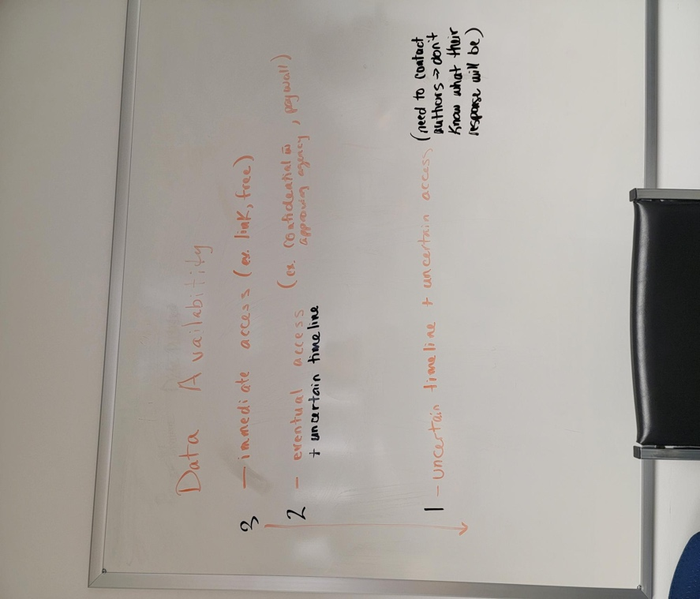

Column 2: Quality of experimental design
Nothing yet…

Column 3: Description of methods and description of sample population/data under study
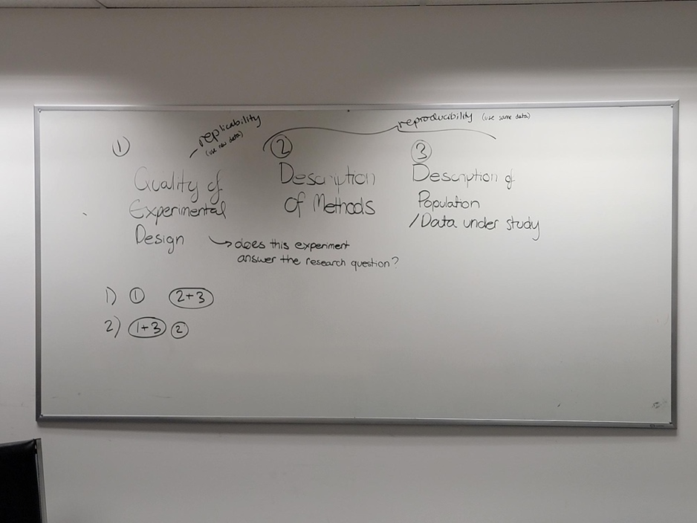
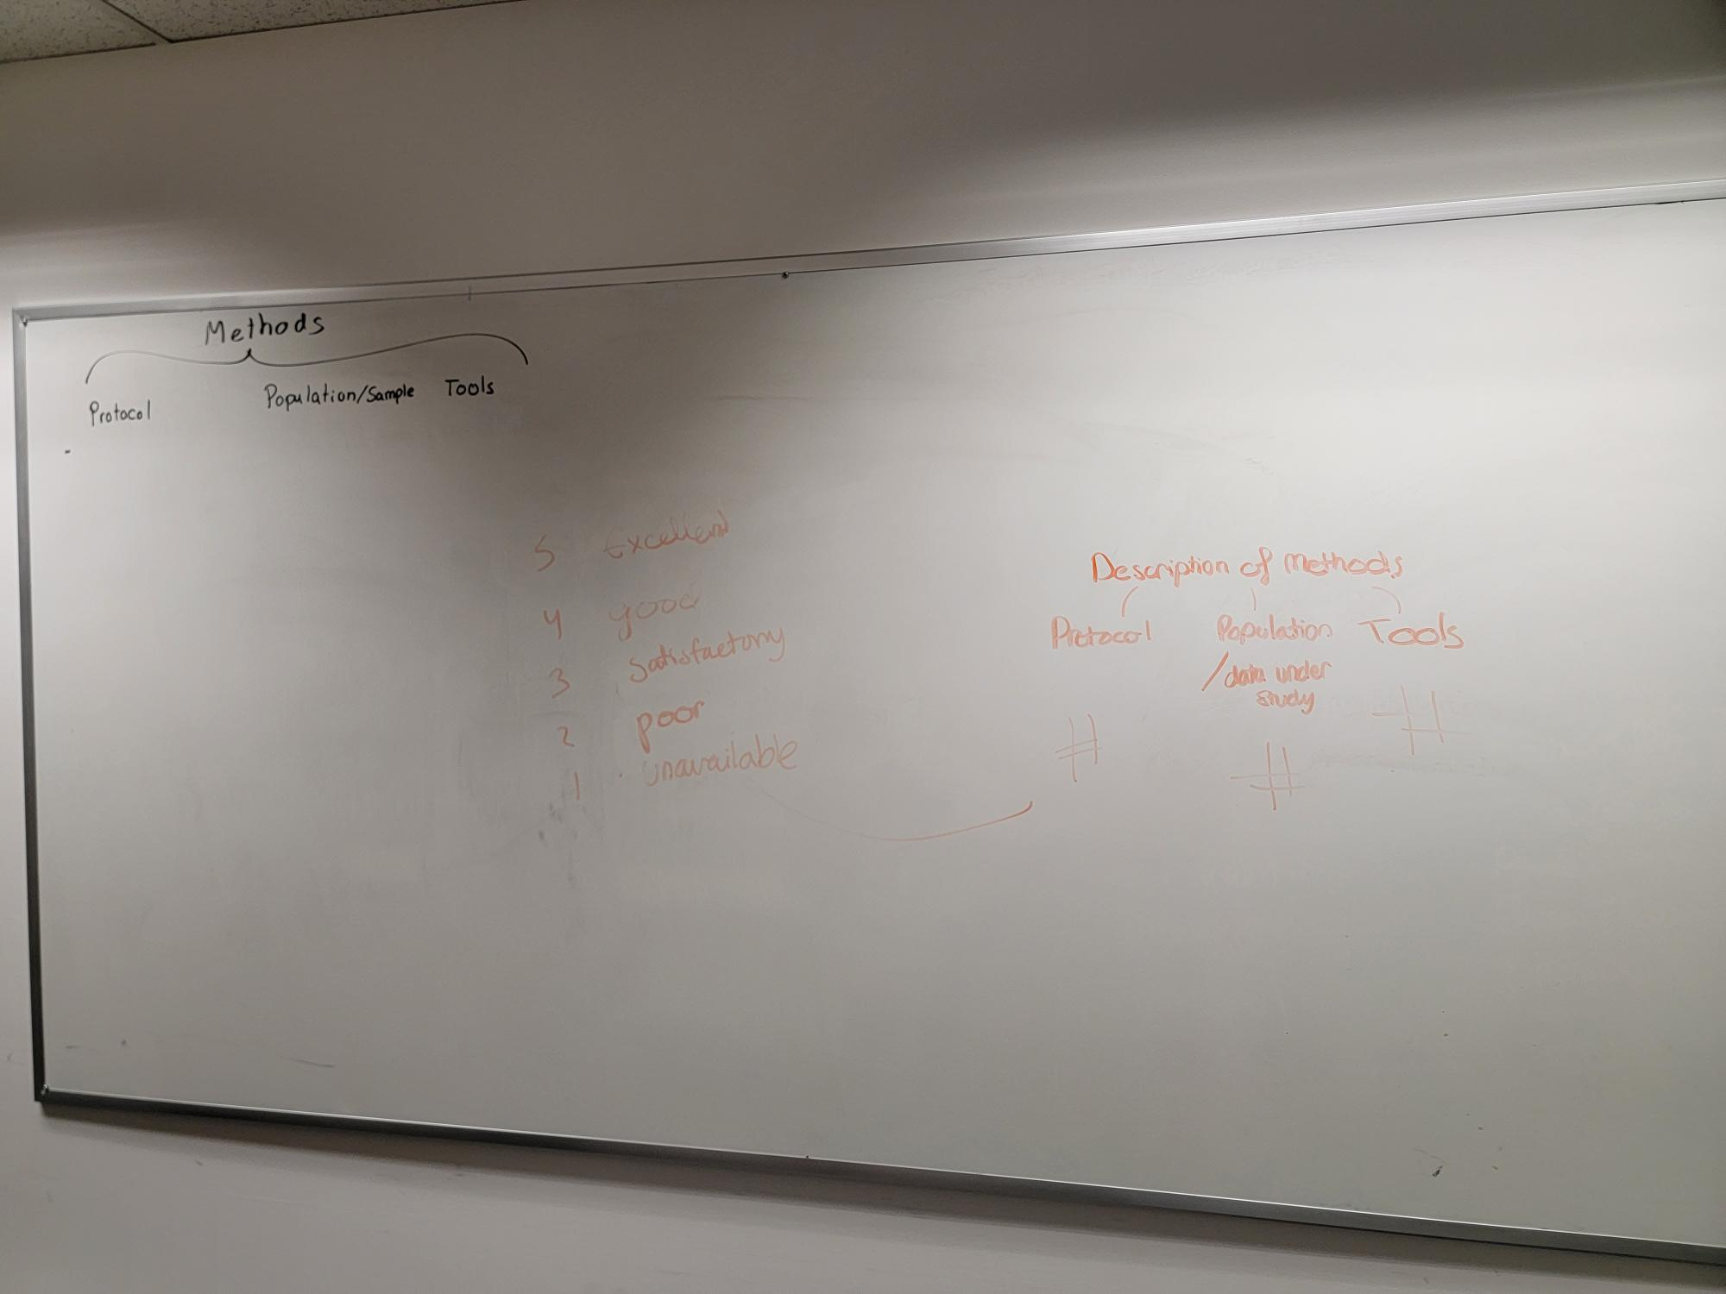

Column 4: Tool accessibility
Nothing yet…

