**4. Exercise #4: Providing suggestions**

Providing suggestion to improve quality or user experience is the extension of software testing job. So why not try that?

Can you tell how user experience can be improved for the following sign in page?

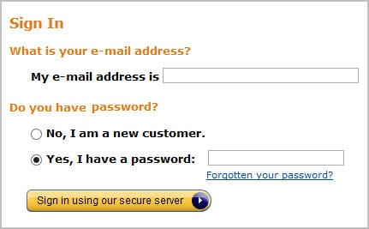

I suggest another approach such:

Is the first time you buy from us?

Yes Sign up Account creation form

No Sign in E-mail address .....................

Password ....................