Exploratory Note 13
Introduction to the Venture Capital Industry and its Participants

INTRODUCTION

Many entrepreneurs want venture capital; however, comparatively few are familiar with the nuances of the VC industry and its participants. How do venture capitalists think? What is their business model? How do they operate? Are they abusive towards entrepreneurs? What else besides money do they bring to the table? Certainly, not all venture capital firms think and/or operate the same way, but as an asset class, there is much that is generalizable. Tonight and next week, we explore VCs in quite a bit of depth.

VENTURE CAPITAL (VC) – CHARACTERISTICS AND PARTICIPANTS

A VC firm has five characteristics:

- A VC is a financial intermediary, meaning that it takes investors’ capital and invests it directly in portfolio companies.
- A VC invests only in private companies. This means that once the investments are made, the companies cannot be immediately traded on a public exchange.
- A VC takes an active role in monitoring and helping the companies in its portfolio.
- A VC’s primary goal is to maximize its financial return by exiting investments through a sale or an initial public offering (IPO).
- A VC invests to fun the internal growth of companies.

Normally, a VC fund is organized as a limited partnership, with the venture capitalist acting as the general partner (GP) of the fund and the investors acting as the limited partners (LPs). Fund lives are normally expected to be ten years, but can run longer.

Partnerships are interesting from a liability standpoint. What is the level of liability exposure for the GP?

What is the level of liability exposure for LPs?

Who normally serve as GPs? What are their backgrounds? Do many careers start in VC?

Who are the LPs?

THE VC BUSINESS MODEL

VC activities can be broken into three main groups: investing, monitoring, and exiting.

Investing

Once a fund is successfully raised, investing begins with GPs prospecting for new opportunities and does not end until a contract has been signed.

What types of investments are going to be of interest to VC firms? Consider a few tests that normally need to be passed:

- Does the venture have a large and addressable market?
- Does the current management have the capabilities to make this business work?

Why are these questions critical?

Is short-run profitability of concern?

Monitoring

Once an investment is made, the VC begins working with the company through board meetings, recruiting, and regular advice to maximize value.

Why is the board important?

Are VCs able to attract talent to startups?

Exiting

VCs are contractually obligated to return capital to their investors. Accordingly, investment exit is a must.

IPOs are the most common. What is an IPO again?

What are the alternatives to IPOs?

Can this push for a liquidity event leave money on the table?

Are most portfolio companies going to be successes or failures from the perspective of the VC fund?

VC INVESTMENT STAGES, MAJOR INDUSTRIES SERVED, AND GEOGRAPHIC PREVALENCE

Major business model aside, VCs are also rather unique in their investment focus when it comes to target stage, industry, and geographical location.

VC Investment by Stage

VCs are normally thought of as very early-stage in focus; however, investments are actually made across a fairly wide spectrum.

- Seed/Startup Stage Financing

This stage is a relatively small amount of capital provided to an inventor or entrepreneur to prove a concept. If the initial steps are successful, this may involve product development, market research, building a management team, and developing a business plan. This is a pre-marketing stage.

- Early Stage Financing

This stage provides financing to companies completing development where products are mostly in testing or pilot production. In some cases, products may have just been made commercially available. Companies may be in the process of organizing, or they may already be in business for three years or less. Usually such firms will have made market studies, assembled the key management, developed a business plan, and are ready to or have already started conducting business. This involves the first round of financing following startup, which includes an institutional venture capital fund. Seed and startup financing tend to involve angel investors more than institutional investors. The networking capabilities of the venture capitalists are used more here than in more advanced stages.

- Expansion (Mid) Stage Financing

This stage involves applying working capital to the initial expansion of a company. The company is now producing and shipping and has growing accounts receivable and inventories. It may or may not be showing a profit. Some of the uses of capital may include further plant expansion, marketing, or development of an improved product. More institutional investors are likely to be included along with initial investors from previous rounds. The VC’s role in this stage involves a switch from a support role to a more strategic role.

- Later Stage

Capital in this stage is provided for companies that have reached a fairly stable growth rate—that is, companies that are not growing as fast as the rates attained in the expansion stages. Again, these companies may or may not be profitable, but are more likely to be profitable than in previous stages of development. Other financial characteristics of these companies include positive cash flow. This also includes companies considering IPOs.

VC Investment by Industry

Traditionally, VC investments have been concentrated in two broad sectors: healthcare and information technology (IT), where the latter sector is defined to include the communications, semiconductor, software, and hardware industries. Why do these investments make sense?

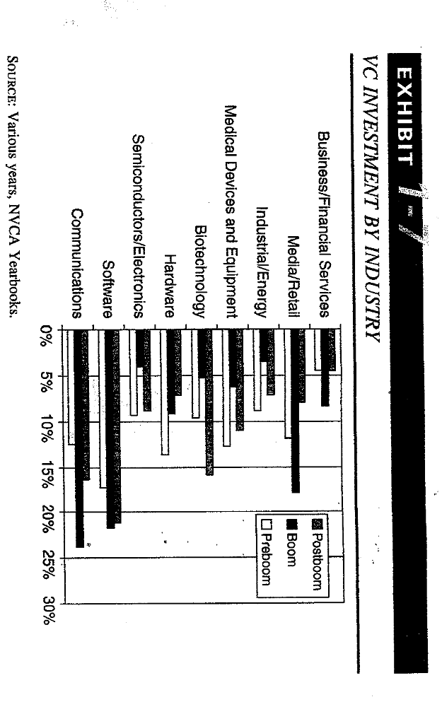

VC Investment by Region

Since the beginnings of the industry, the Silicon Valley area of northern California has remained the epicenter of VC activity, with a consistent share of about one-third of total U.S. VC investments per year.

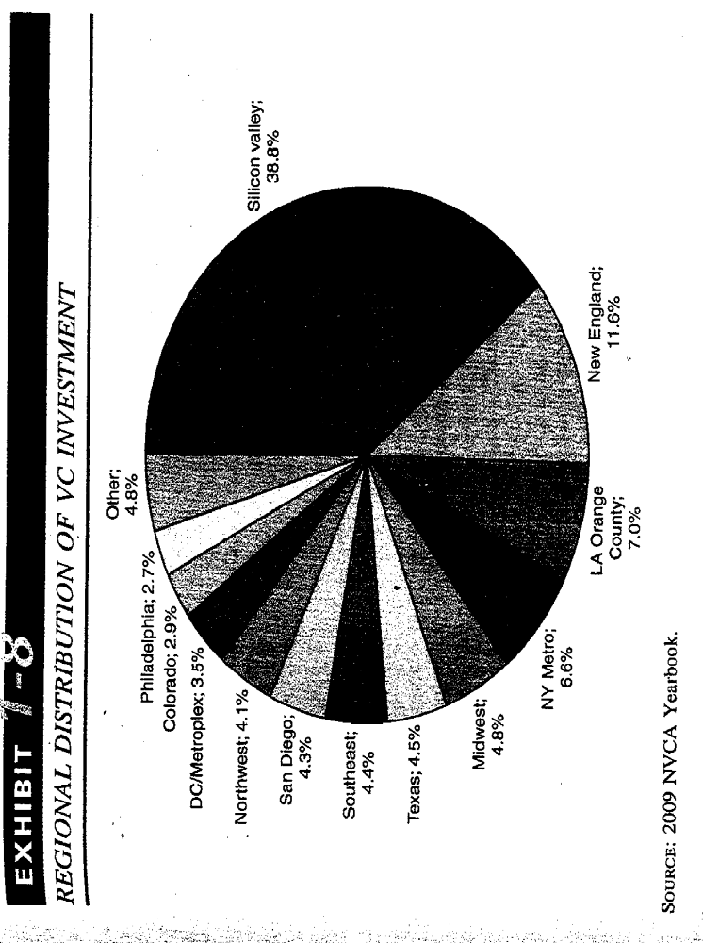
What other geographic areas are notable? Why?

VC INVESTMENT ROUNDS

Institutional financing is provided in rounds, with the first being referred to as a Series A, the second a Series B, etc. Why are staged investments made?

Arguably, the staging of investment is a substitute for intensive monitoring by the VC investor, especially when such monitoring would be expensive. Why?

Staging also allows investors to learn more about the opportunity (thereby reducing uncertainty) before escalating their commitment. Is this logical?

Similarly, staging allows investors to constrain the actions of hold-up entrepreneurs. What constitutes a hold-up entrepreneur and why are they so dangerous for investors?

Looking at things differently, could staging provide bad incentives for entrepreneurs to window dress results to get a new round?

VC COMPENSATION ARRANGEMENTS AND ALIGNMENT OF INTERESTS

VCs are compensated via management fees and carried interest.

Management Fees

VC investing is a long-run business, and investors must often wait many years before enjoying any return of capital. Nevertheless, the expenses of VC investing start immediately: salaries must be paid, the lights must stay on, and due diligence must be performed. Thus, a baseline management fee is necessary.

Typically, GPs charge a fixed fee of 100-200 basis points (1-2%) per year. Sometimes, management fees drop after five years or so (since the investments have largely been made by this point), but not always.

The lifetime management fees for GPs end up being fairly significant. At 200 basis points on 100 million in committed capital, for instance, a total of twenty million will be paid over the ten year fund period. Accordingly, the true investment capital of the firm is only 80 million (total committed capital less lifetime management fees). A 25% lifetime return (non-annualized) is required, therefore, simply to recover fees.

Carried Interest

The carried interest, or carry, is where the real money is to be made for GPs as it is based on the fund’s aggregate profits. For instance, if a fund has 100 million in committed capital and exit proceeds amount to 200 million, then the total profit is 100 million. Commonly, GPs have a 20% claim on profits, so they will take 20 million, leaving 80 million in profits to the LPs. The GPs with the best track records are able to demand more—sometimes as much as 30%.

The timing when it comes to the taking of carried interest varies widely across firms and can get pretty messy. Oftentimes, LPs are paid back 100% of investment capital before carried interest can be collected by GPs. In other cases, LPs are paid back only the cost basis of all realized investments plus management fees and write downs (on unrealized partial losses) known to exist in the portfolio before carried interest can be collected by GPs. Sometimes, minimum returns to LPs (usually around 8-10%) on either committed or invested capital must be paid as well before carried interest can be collected by GPs. In these latter cases, carry claw backs become a possibility if high early fund returns reverse over time.

Are there tax benefits to carried interest?

Compensation and the Alignment of Interests

Should the compensation structure of GPs align their interests with those of their LPs?

LPs generally have restrictive covenants in place which constrain the activities of GPs. For instance, GPs are almost never permitted to make a disproportionately large investment in a single company. At first glance, you might think that the concentration risk of a single very large bet would be too much, but is this really what should matter for LPs? If not, what would?

GPs essentially hold a call option on the value of the fund. Does higher volatility imply higher or lower option values?

Are VC funds generally allowed to utilize debt? Why not? Again, thinking about call options may be helpful.
Frequently, there are restrictions on coinvestment with earlier or later funds by the same partnership. Why could this be a problem?

Similarly, these are often restrictions on personal GP coinvestment. Why could this be a problem?

Does reputational risk help to keep GPs in line with their LPs?

Does the compensation structure of GPs seem to align their interests with those of entrepreneurs?

CONCLUSIONS

This first note has introduced the basics of venture capital. In the two notes which follow, we continue our discussion by evaluating the VC value added (beyond just money) as well as the nature and historical record of VC returns.

