Exploratory Note 15
VC Returns

INTRODUCTION

Do venture capital firms make money for their investors? Though, in the short run, entrepreneurs may not care, in the long run, it is an important question to consider. If the answer is, in fact, a definitive no, then venture capital could prove to be little more than a temporary phenomenon.

INDIVIDUAL INVESTMENT MULTIPLES

Gross value multiples (GVMs) are the exit multiple of the initial investment. Since VC firms are on a fixed time table, an IPO or acquisition (of some kind) is going to be required. Consider below:

First Round GVMs

How do you interpret a multiple of 1x or less?

How do IPOs and acquisitions differ vis-à-vis first round investment multiples?

In results that I do not show, the entirety of first round investments yield nearly 75% failing to return the initial capital invested and fewer than 8% returning more than 10x.

Second Round GVMs

How about for second round investments? See below:

How do the numbers look for both IPOs and acquisitions?

Similar to the first round results, when all investments are considered (data not shown), roughly 75% do not return the initial capital invested and about 9% return more than 10x.

RISK-ADJUSTED VC RETURNS

So far, our thinking in this note has been risk- and time-neutral, but proper thinking demands consideration of both risk and time—and, thus, a pricing model.

The Capital Asset Pricing Model (CAPM)

The CAPM is the dominant theoretical pricing model in finance. It rests on a number of assumptions beyond the scope of this course, but is built on the insight that the appropriate risk premium on an asset will be determined by its contribution to the risk of investors’ overall portfolios.

In its most common form:

Define the specific variables:

This relationship is portrayed graphically as the security market line (SML):

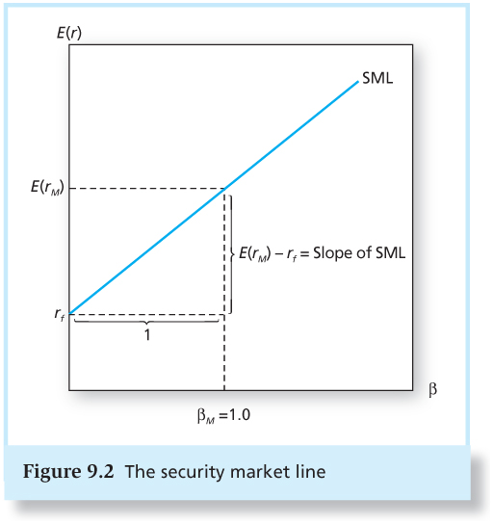

The SML provides a benchmark for the evaluation of investment performance. Given the risk of an investment, as measured by its beta, the SML provides the required rate of return necessary to compensate investors for risk as well as the time value of money.

So, how do historical VC returns stack up against the CAPM in regression form? Consider:

What does alpha measure? Is a positive alpha good or bad?

What is the estimated market beta for VC investments? Does this suggest above- or below-average risk for VC funds?

Pastor-Stambaugh Model (PSM)

Theoretically, the CAPM is a truly beautiful model thanks in large part to its simplicity; however, it has some empirical issues that have brought about a wide number of alternatives. Chief among them is the Pastor-Stambaugh model which adds three variables of interest: size, value, and liquidity. Consider below:

Before delving into the data, why include firm size as a variable? Value (and what does this mean)? And liquidity?

What variables appear to be statistically significant?

Do venture capital firms appear to generate alpha?

What is the joint-hypothesis problem? How does it relate to the above question? Can we say for sure that venture capital firms do or do not outperform the market?

NOTABLE VENTURE CAPITAL FIRMS

Able to beat the market or not, venture capital currently occupies an important place in the start-up community. There is a lot of debate about which firms are truly top-tier; however, the below list introduces quite a few of the best performers.

For more detailed accounts of these firms (which made investments in Facebook, OpenTable, AOL, Amazon.com, Compaq, Electronic Arts, Google, Intuit, Juniper Networks, Netscape, Sun, Symantec, Apple, Cisco, Yahoo, YouTube, TiVo, Netflix, Twitter, and Hotmail), I encourage you to take a look at the fifth chapter of the assigned text.

CONCLUSIONS

Next week, we will continue our discussion of venture capital with sessions on term sheets, preferred stock, and corporate VC activities.

