Exploratory Note 16
Understanding Term Sheets

INTRODUCTION

A VC typically signals its intention to invest by offering a term sheet to the potential portfolio company which is either accepted, sent back with requested changes, or rejected outright. Once accepted, though additional negotiation is to be expected from both sides as the VC dives into its due diligence, the term sheet serves as an anchor for future negotiations between the parties until the investment is closed. This first note of the evening is concerned with helping you to navigate a term sheet—with a heavy emphasis on some of the items which can become problematic.

VC TERM SHEETS

VC contracts are designed to protect the investor from expropriation, which can occur either through negligence (low effort by managers) or malice (stealing or self-dealing). Thus, a term sheet describes the basic structure of a transaction and provides a set of protections against expropriation.

The Basics

The first page or two of a term sheet can generally tell us quite a bit about a proposed offer. Consider:

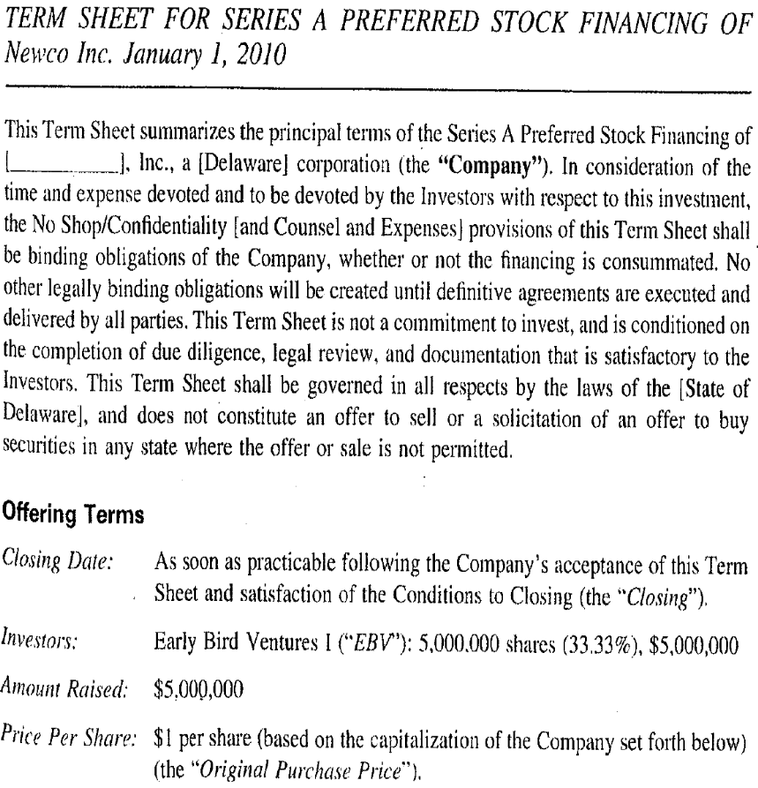

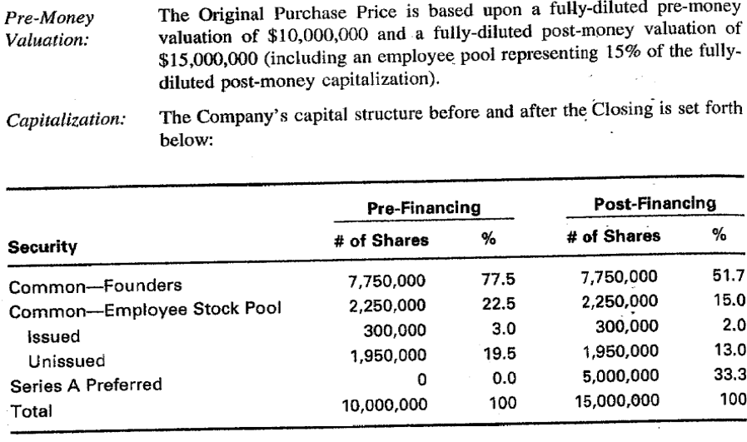

A few items to consider:

What kind of security is being offered in the term sheet? What is the original purchase price (OPP)?

In this case, the investment implies ownership of 33.33 percent of the company on a fully diluted basis (which assumes that all preferred stock is converted and that all options are exercised). All of the investment, $5,000,000.00, is provided at one time per this term sheet. A common alternative structure uses tranches. What is a tranche?

The terms pre-money and post-money valuation are frequently used in early-stage firms. Pre-money valuation equals the price per share times the pre-transaction (fully diluted) share count while post-money valuation equals the price per share times the fully diluted share count. Ostensibly, these terms are analogues to market capitalization. What is market capitalization?

Keep in mind that because both pre- and post-money calculations do not distinguish between preferred and common stock, the results do not necessarily reflect anything about the true market value of the company’s common stock.

The Charter

The Charter, also known as the Certificate of Incorporation, is a public document filed with the state in which the firm is incorporated. In the majority of VC transactions, this state is Delaware. Why?

Among other things, the Charter establishes the rights, preferences, privileges, and restrictions of each class and series of the company’s stock.

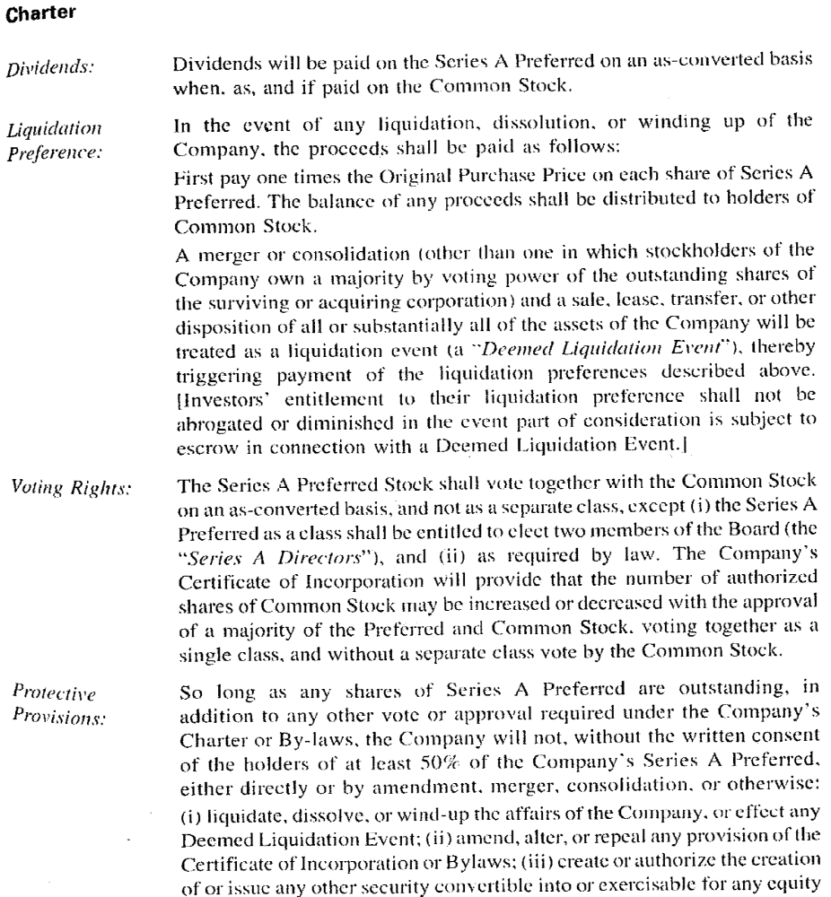

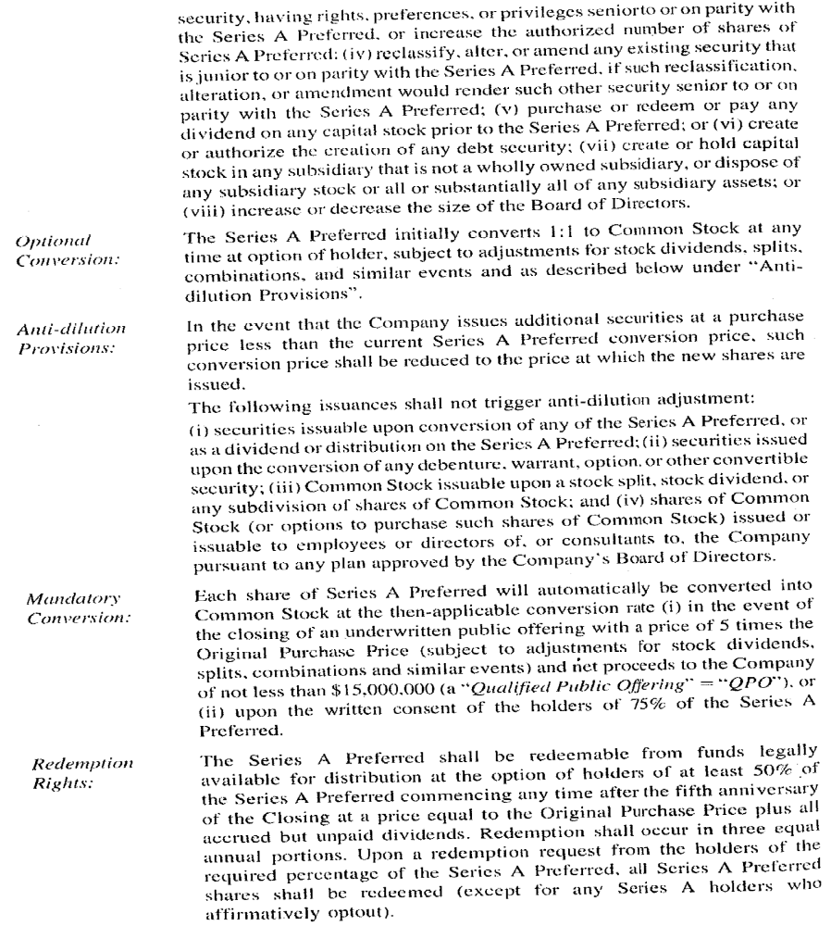

A few items to consider:

The possibility of dividends is mentioned in the Charter. In public companies, preferred stock is usually issued with the promise of consistent cash dividends. Is this the case when it comes to preferred stock issued to VC? If not, why?

Sometimes, accrued cash dividends are to be paid to preferred stock holders. What are accrued dividends and why might accruals be utilized?

Finally, preferred stock might receive stock dividends which add to their total holdings. Such stock is called payment-in-kind (“PIK”). Why would PIK be utilized?

When a company is sold, merged, or shut down—a deemed liquidation event—the proceeds are generally distributed to bondholders, preferred stockholders, and common stockholders, in that order. A liquidation preference tells an investor where he or she stands in the capital structure hierarchy. When there have been multiple rounds of financing, it is common for the latest-round investors to get their money back first. Why?

In some cases, investors insist on liquidation preferences in excess of their original investment—with 2-3x being fairly common. Why?

Early institutional rounds often demand disproportionate board representation. Why?

Additionally, anti-dilution provisions are standard. Why? Are they foolproof?

Redemption rights give conditions under which investors can demand that the company redeem (pay back) their initial investment. In practice, these rights are difficult to enforce and rarely exercised. If exercised, is the firm in question likely doing well or poorly?

Investor Rights Agreement

An example investor rights agreement:

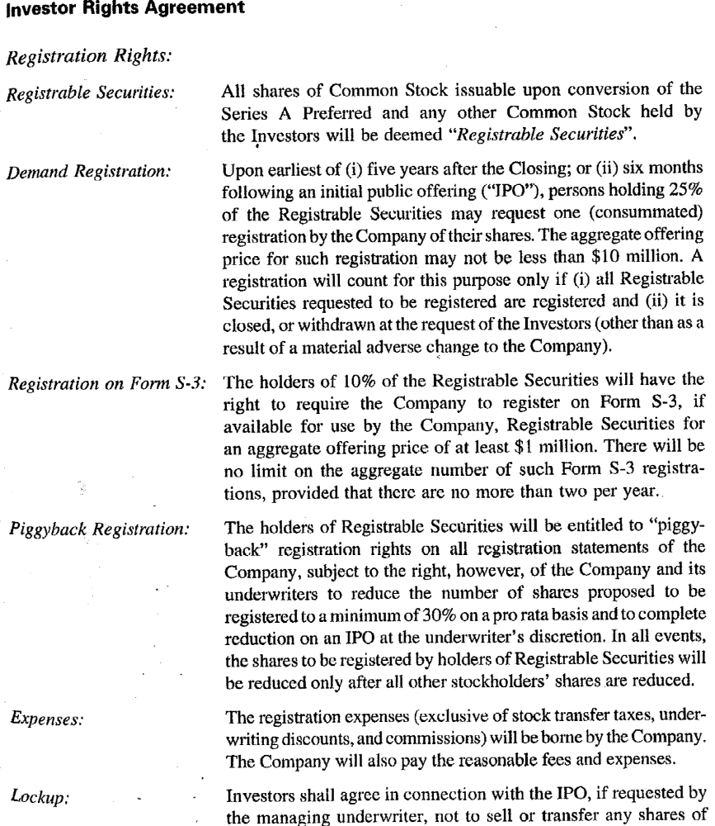

[SPACE INTENTIONALLY LEFT BLANK]

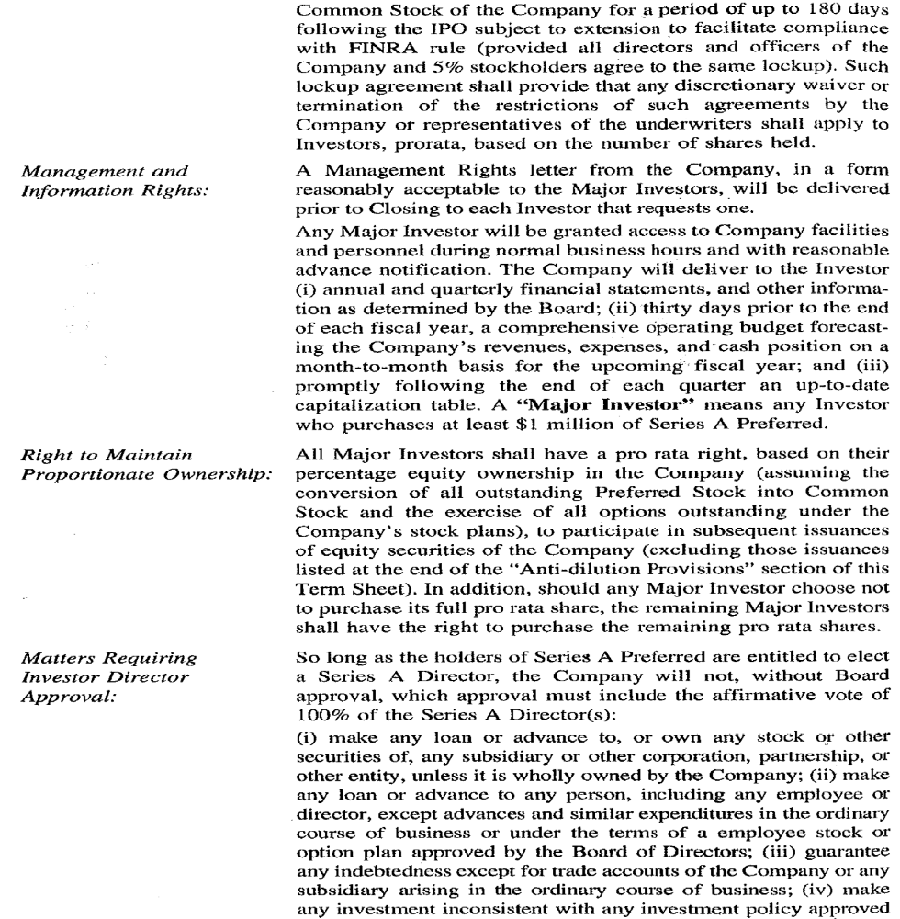

[SPACE INTENTIONALLY LEFT BLANK]

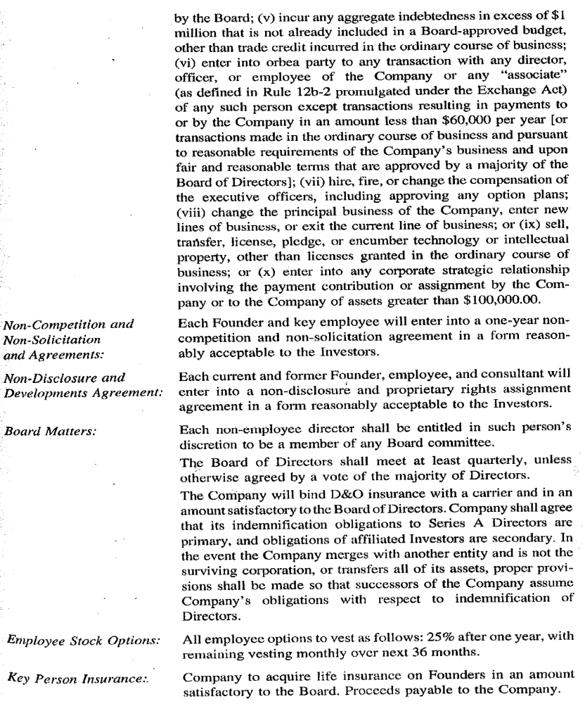

A few items:

Stock purchased in private transactions is restricted. This means that the stock cannot be sold in a public offering. To lose this restriction, a transaction must be registered (requires filing legal documents and disclosing data about the firm to the SEC). Registration is expensive—as such, firms typically want to avoid it unless absolutely necessary. Demand registration rights allow investors to force the company to register a transaction for their shares. S-3 and piggyback registration rights are weaker, but give additional mechanisms for investors to get their shares registered—as long as another transaction is being prepared.
Major investors are normally granted access to company facilities and personnel during normal business hours with sufficient notice. Additionally, it is common for financials to be presented at least annually, if not more frequently.

The right to maintain proportional ownership is important for some investors—especially when matters of control are at stake. If additional rounds of financing are expected, this is an important matter.

Non-competition and non-solicitation requirements for entrepreneurs are critical. Why? How enforceable are they?

Employee stock options generally vest over time. Why is this so important?

Other Items

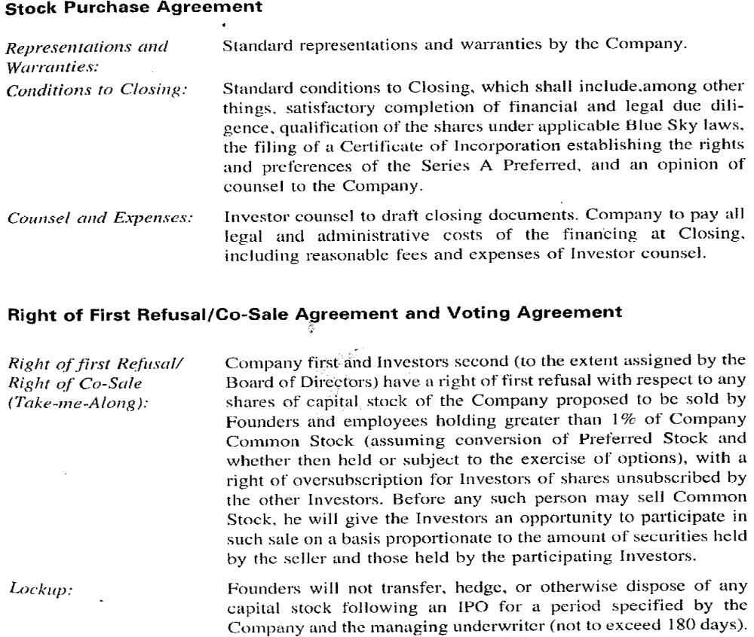

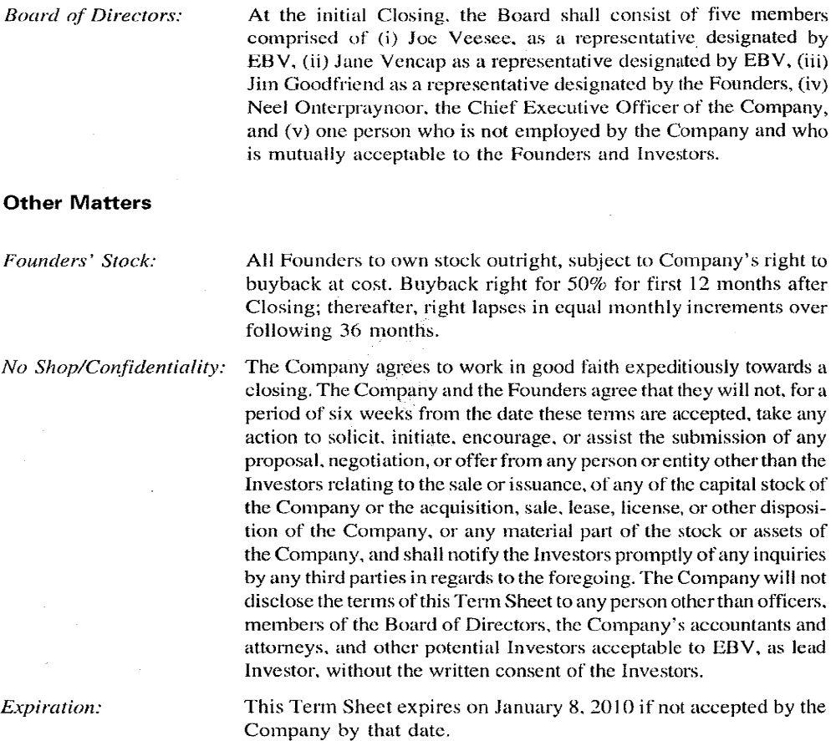

What is a right of first refusal? Why is this necessary?

What is the right of co-sale (or tag-along)? Why is this necessary?

Usually, it is the case that founders’ stock can only be forcefully bought back if the founder is dismissed for cause within a certain period of time after investment. Why are these provisions in place?

CONCLUSIONS

As a preliminary agreement used to anchor the key contractual provisions for a VC investment, the term sheet does not guarantee that a deal will go through; however, it does represent a serious step towards consummation.

