Exploratory Note 17
Preferred Stock – Basics and Conversion

INTRODUCTION

In public markets, the vast majority of equity investments are made with common stock; however, for VC transactions in the United States, nearly all the investments are made with preferred stock. The key characteristics of preferred stock are that it has preference over common stock in liquidation settings and is oftentimes, though not always, convertible to common stock at the option of the holder. This note explores these characteristics in quite some depth and also touches upon anti-dilution matters.

TYPES OF PREFERRED STOCK

Preferred stock comes in four primary forms: redeemable preferred (RP), convertible preferred (CP), participating convertible preferred (PCP), and participating convertible preferred with cap (PCPC).

Redeemable Preferred (RP)

Redeemable preferred (RP) is a bond-like security that is senior to common stock but cannot be converted to common stock. The payoff diagram for RP looks like this:

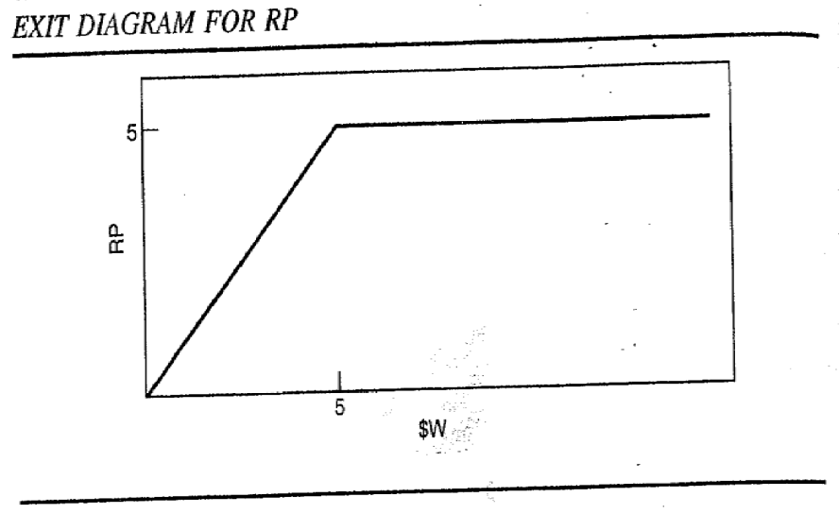

Are VC investors likely to accept RP for an investment in a startup? Why?

Convertible Preferred (CP)

Convertible preferred stock (CP) provides the same downside protection as RP with the additional option of converting to common stock.

In the below diagram, the payoff for RP is shown as a solid black line and the payoff for common stock is shown as a dashed line:

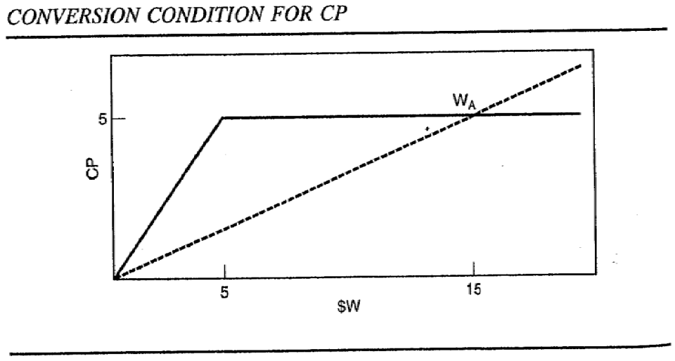

Assuming rational decision-making, the payoff diagram for CP is as follows:

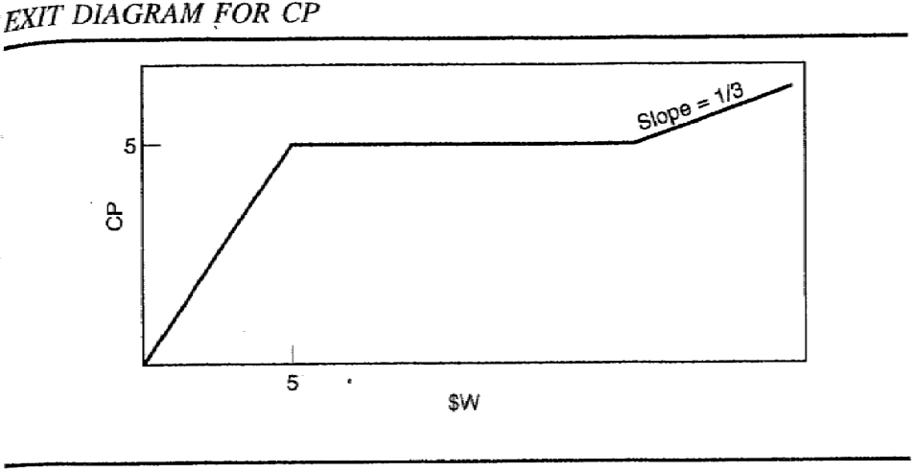

Can you see the advantage of CP over either RP or common stock?

Participating Convertible Preferred (PCP) and Participating Convertible Preferred with Cap (PCPC)

Participating convertible preferred (PCP) stock provides its holder with a combination of the downside protection of RP and the upside potential of CP, with the caveat that the redeemable rights go away upon a qualified public offering.

Sometimes the liquidation return to PCP is capped at some preset multiple of the purchase price: such securities are referred to as participating convertible preferred with cap (PCPC) stock.

ANTI-DILUTION PROVISIONS

Regardless of the precise securities utilized, VC investors typically demand anti-dilution protection. How and why?

Under what conditions do such protections generally apply?

Is it easy to exercise such rights under normal circumstances when they would apply?

CONCLUSIONS

Financial innovation has provided the market with a rich array of securities available to potential investors. These securities are not all the same—and some are much more complicated than others. For a more detailed look, consider taking a deeper dive into Chapter 9 of Venture Capital & the Finance of Innovation.

