Exploratory Note 25

Capital Budgeting Decision Making Tools

**INTRODUCTION**

Entrepreneurs and financial managers have an array of tools available to assist in making optimal capital budgeting decisions. One of these tools, net present value (NPV), is theoretically superior to the others, but practitioners frequently use alternatives like internal rate of return (IRR) and payback period. These three tools—with a heavy emphasis on both their strengths and weaknesses—are the subject of this second exploratory note of the evening.

**NET PRESENT VALUE**

The dominant approach, from a textbook standpoint, to capital budgeting is net present value (NPV). The formula is as follows:



What are the inputs?

What is the logic behind the NPV approach to capital budgeting? What is the decision rule?

For those who are not as familiar with the time value of money, why are the future cash flows discounted? In practice, what would the discount rate typically be for a project of average risk?

What about for a project with above-average risk? For a project with below-average risk?

What are the strengths of NPV? Does it meet all of the necessary criteria of a sound capital budgeting decision making tool? These criteria include:

* The time value of money is taken into consideration
* All cash flows are taken into consideration
* Cash-flows are risk-adjusted
* Projects can be objectively ranked
* Indicates added value to the firm

Though NPV is theoretically sound, does it have any weaknesses when it comes to practice?

***A Basic Corporate Investment Example – Software Development***

A firm is thinking about developing a new piece of software which will facilitate portfolio rebalancing for RIAs, FOs/MFOs, and other wealth managers. Development of the software will cost $1,000,000 (assume that this cost occurs at time 0). If the software is expected to generate $300,000 worth of free cash flow for the firm in each of the next four years before becoming obsolete, would this be a good project for the firm to pursue if it requires a 13% return? Calculate NPV.

***A More Complex Corporate Investment – An Acquisition***

A firm is contemplating acquiring another company in a related but different business. The firm can be acquired for $7,500,000. The cash flow expected to be generated by the firm in the first year after the acquisition is $1,000,000. In the second year, it is expected that this amount will double. In the third year, cash flow growth is expected to drop to 4%. This growth rate is expected to continue for the foreseeable future. Should the firm make the acquisition if its cost of capital (required return in this setting) is 11%? Calculate NPV.

**ALTERNATIVE EVALUATION TECHNIQUES – IRR AND PAYBACK**

Though there are quite a few different tools traditionally utilized in capital budgeting settings, two significant alternatives to NPV exist: internal rate of return (IRR) and payback period.

***Internal Rate of Return (IRR)***

Though NPV is dominant from a textbook point of view, the dominant approach from an applied standpoint is the internal rate of return (IRR):



What are the variables?

What is the logic behind the IRR approach to capital budgeting? What is the decision rule?

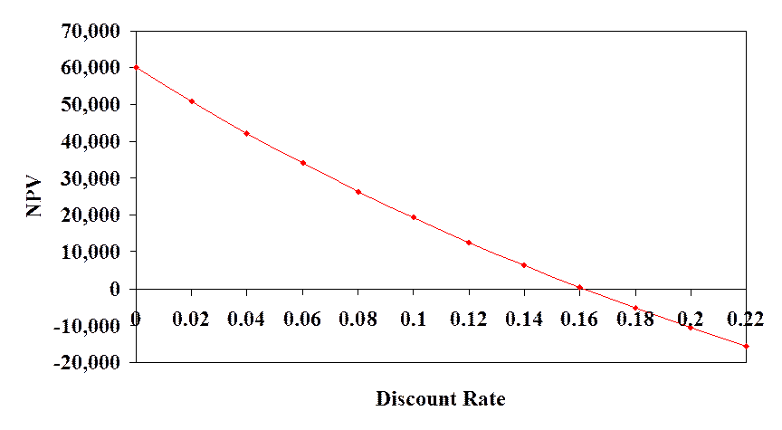

What are the strengths of IRR? Does it meet all five criteria laid out previously?

Strengths aside, IRR has some significant weaknesses. For instance, it can yield multiple answers due to Descartes’ Rule of Signs—thereby making it difficult or impossible to interpret.

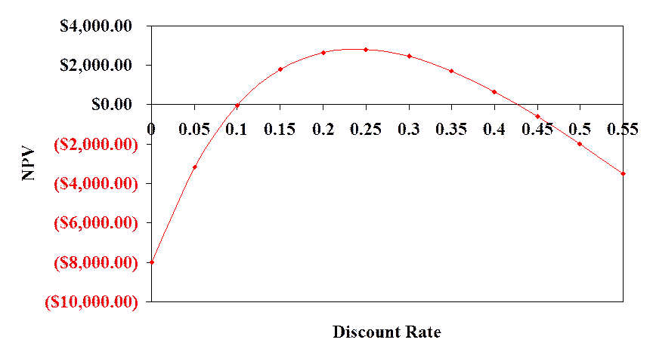

Further, IRR can mislead us when it comes to mutually exclusive projects that have either different timeframes or different initial investment requirements:

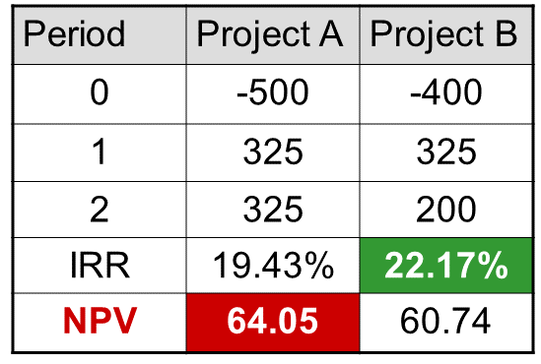

Additionally, IRR assumes reinvestment of positive cash flows at the IRR as opposed to NPV which assumes reinvestment at the WACC. Is this reasonable or is it likely to exaggerate?

***Payback***

Another common approach, in practice, is payback (sometimes referred to as the payback period). What is the logic behind it? What is the decision rule?

What are the strengths of payback? Does it meet all five criteria laid out previously?

What are the weaknesses of payback?

**SOME CONCLUDING THOUGHTS**

Capital budgeting is exceptionally important: if done well, a company will likely prosper; if done poorly, a company will likely fail (or at least underperform). This being said, the tools are all inherently imperfect. Why?

Does this mean that we should not attempt to properly analyze projects? Almost certainly not, but we need to be very careful with the way that we interpret the outputs.