Exploratory Note 28

Introduction to Common Valuation Techniques:

Comparables Analysis, Discounted Cash Flow (DCF) Models, and ROA Approaches

**INTRODUCTION**

How much is a company, or some stake in it, actually worth? Even in the realm of public firms, this is always a difficult, if not impossible, question to answer with any measure of exactness; however, in the context of startups, it is even more difficult. Practitioners, with academic support, typically employ comparables analysis and discounted cash flow (DCF) models in an attempt to arrive at a reasonable estimate—though those with more sophistication might consider real options based approaches as well. This first of two exploratory notes this evening covers these traditional valuation cornerstones while the second note presents two startup-centric alternatives.

**COMPARABLES ANALYSIS**

A straight-forward place to start this note is with comparables analysis, sometimes abbreviated as comps and also known as multiples analysis, method of multiples, and relative valuation. In comparables analysis, a favorite amongst VCs for exit valuation, the main idea is to get the market’s opinion about a company by examining similar firms (even if they are further along). Why is this logical?

As an aside, comparables analysis is common in the real estate business. How is it applied therein?

Practically speaking, there are five stages of comparables analysis: identifying a set of comparable firms; locating the necessary financial information; calculating key statistics, ratios, and trading mutliples; benchmarking the comparable companies; and determining (settling on) a valuation. These are all considered individually in the below sub-sections.

***Identifying Comparable Firms***

Comparables analysis starts with an in-depth study of the firm itself. The following business profile items are critical:

*Sector –*

*Products and Services –*

*Customers and End Markets –*

*Distribution Channels –*

*Geography –*

And the following financial profile items should be fully understood:

*Firm size -*

Firm profitability –

Firm growth profile –

Return on investment –

At this point, it is necessary to identify materially similar firms to allow for meaningful comparision. In a perfect world, comparables will be identical. Is this likely to be the case? Why?

How close is close enough?

Keep in mind, in startup settings, VCs are often using comparables to gauge the value of a firm 5-7 years from the present—that is, they are using them as long-run prediction tools, as opposed to directly comparing the firm in its current stage. Is this risky?

***Locating the Necessary Financial Information***

Once the firm is largely understood and comparable firms have been identified, it is time to gather as much data as possible. Comparables are typically going to be public companies: where can we go to look to find information regarding their financials, etc.?

Is there inherently a problem with using public company information as the basis for the valuation of private firms?

***Calculating Key Statistics, Ratios, and Trading Mutliples***

There are a large number of multiples that practitioners take into consideration; however, due to time constraints, let us focus on six in particular: EV/EBIT; EV/EBITDA; EV/Revenue; Price/Earnings; Price/Book; and EV/Employees.

*EV/EBIT*

What is EV?

What is EBIT?

EV/EBIT is popular because the denominator is often viewed as proportional to a steady-state cash flow measure, in which case the EV/EBIT ratio has an intuitive interpretation as the ratio of firm value to cash flow.

*EV/EBITDA*

What is EBITDA?

What are depreciation and amortization?

Like EBIT, some analysts view EBITDA as a cash flow measure. Although this is true in the short-run (where capital expenditures to replace depreciated equipment can be delayed), it is definitely not true in the long-run. For firms in industries with signficant variation in depreciation practices, this ratio can be quite useful.

*EV/Revenue*

For high growth firms, EV/EBIT and EV/EBITDA are oftentimes not able to yield multiples. Why? This brings us to revenue multiples. Why does such a ratio make sense?

*Price/Earnings (P/E)*

With company level data, we can compute the P/E ratio by dividing net income (earnings) into market capitalization. Earnings only accrue to shareholders—accordingly, the numerator is price instead of EV.

Is this method going to frequently be useless when it comes to small but rapidly growing firms? Why or why not?

*Price/Book (P/B)*

What is the book value of common equity?

If the P/B is below one, what does that suggest might be the best course of action for the equity holders?

*EV/Employees*

Employee growth is often the fastest moving measure of potential firm size; therefore, if certain other multiples are lagging behind, this may prove valuable.

Can this multiple be negative?

These multiples are by means exhaustive. Additional financial information should be considered including much of what we covered during our brief overview of financial statement analysis earlier in the semester—especially when it comes to profitability and leverage. What were some of those ratios? Why do they matter on a relative basis?

***Benchmarking the Comparable Companies***

Basic math out of the way, it is appropriate to establish ranges, means, medians, etc. for consideration. Further, diligent comparables analysis includes an understanding of the unique stories of the comparison firms.

Consider, if a firm is lagging behind in a multiple like EV/EBIT or EV/EBITDA, could there be a legitimate reason? Is this necessarily a point of concern?

On the contrary, might leading in these areas actually be a problem in the long run for rapidly growing firms? Why?

***Determining (Settling on) a Valuation***

The multiples for the comparable companies serve as the basis for deriving an appropriate valuation range for the firm in question.

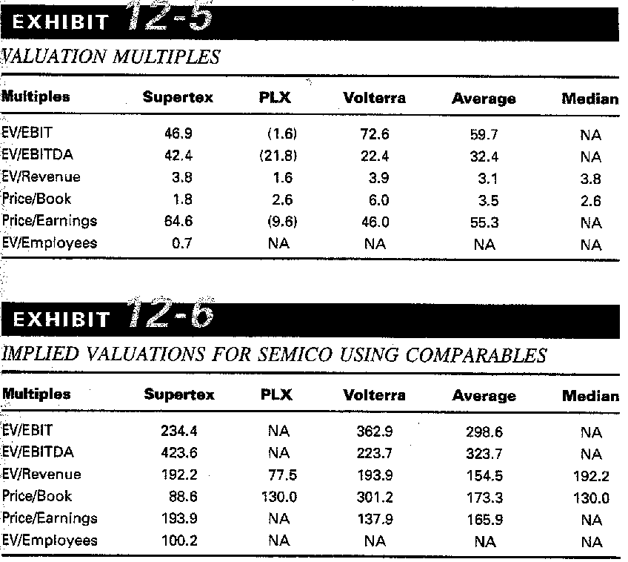

This represents quite a range of possible valuations. Which one is correct?

Once again, in early-stage settings, these estimates oftetimes are made some 5-7 years before a firm is (even remotely) likely to truly reflect its comparables. What problems does this present?

**DISCOUNTED CASH FLOW (DCF) MODELS**

As opposed to comparables analysis, discounted cash flow (DCF) analysis is absolute as opposed to relative. Thinking back to our discussions last week, the DCF framework for firm-level valuation is pretty much identical to the net present value approach for project-level decision-making—with the only major difference typically being that projects are often (though not necessarily) treated as having finite lives while firms are often conceptualized as having infinite lives.

***Cash Flows***

DCF approaches project and aggregate the present value of the totality of the expected future cash flows of a firm.

The standard definition of cash flow is as follows:

*CF = EBIT(1-t) + Depreciation + Amortization – Capital Expenditures – ΔNet Working Capital*

What is EBIT? Why the adjustment for taxes?

Why are depreciation and amortization added back into the equation for cash flow?

Why are capital expenditures and positive changes in net working capital subtracted away from cash flow?

For terminal (or graduation) value, the Gordon Growth Model is appropriate. What is the Gordon Growth Model again? What are the inputs?

What is an appropriate long-term growth rate for cash flows? Are mature firms likely to have higher or lower growth rates in cash flow? Why?

What estimate (or proxy) should serve as the discount rate?

Related to the above question, how do we estimate the cost of debt and the cost of equity, respectively?

A simple example: assume that a firm currently generates $5,000,000 in cash flow and growth in cash flow is expected to be 100% for the next three years, before leveling off at a constant 3%. If the WACC is 10%, what is the value of the firm?

DCF models can get a whole lot more complex than this, but at their core, the fundamentals are always the same.

**REAL OPTIONS ANALYSIS MODELS**

Just as a project can be valued by means of real options analysis (ROA) as we discussed last week, companies can be as well. Though comparables and DCF approaches are static, reality is rather more dynamic. Tonight, I will skip the math in favor of the concepts.

All other things being equal, is there value to embedded optionality at the firm-level? How might it manifest itself? Do either comparables or DCF analysis take this into consideration?

Is there value at the firm-level when it comes to managerial flexibility? Do either comparables or DCF analysis take this into consideration?

Is firm success often a combinative process of interrelated advances and setbacks? Similarly, does project-level knowledge spillover and learning likely affect firm-level value moving forwards? Do either comparables or DCF analysis take this into consideration?

**CONCLUSIONS**

For the past five or six decades, finance—of which valuation is a cornerstone—has attempted to establish itself as a legitimate field of science. Is valuation a science? If not, what are the implications?