Project Management and Risks

  - Project Management Tools

GitHub is used for version control, documentation storage, and tracking individual contributions. Project changes are organized through branches, commits, and pull requests.
YouTrack is used to manage project tasks, assign responsibilities, establish priorities and deadlines, and monitor progress.
GitHub Repository: https://github.com/Alinaa111/diploma_project.git

YouTrack Project: https://qoljet.youtrack.cloud/dashboard?id=177-0

Team Responsibilities

Responsibilities are divided between team members according to the main project activities.
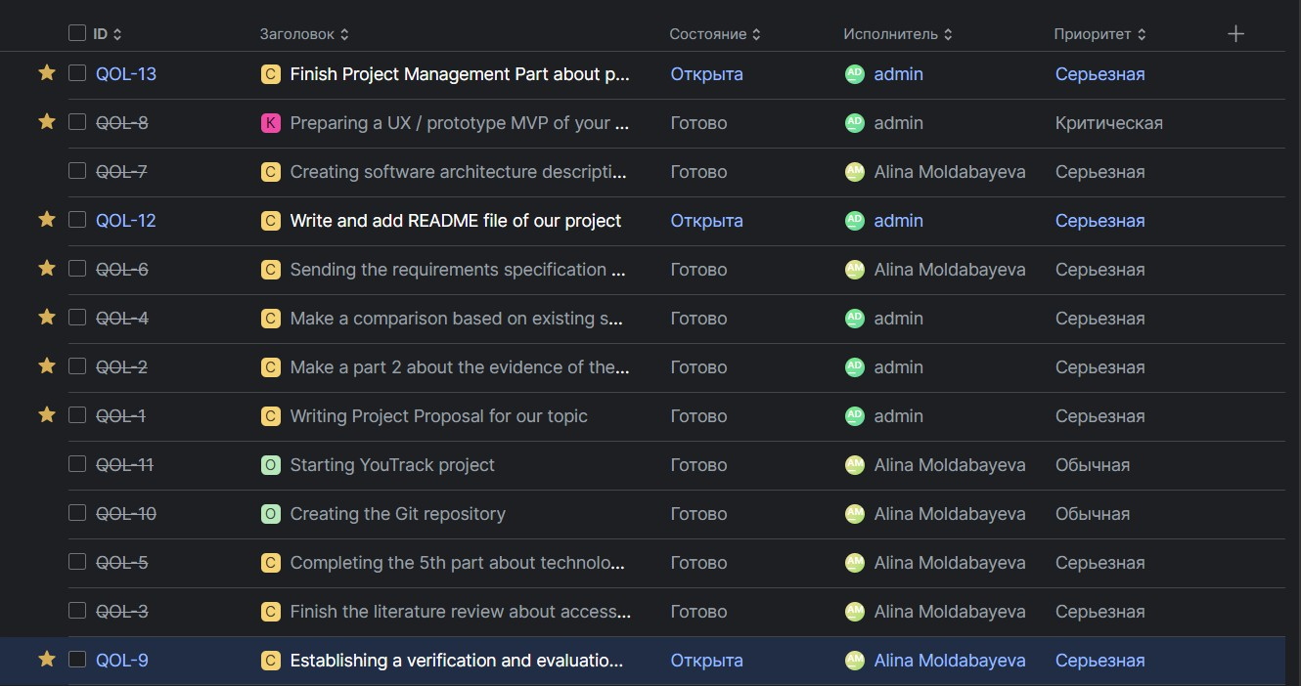

Project Milestones

Milestone | Expected Deliverable
Research and requirements  analysis | Literature review, interviews, requirements specification
Dataset preparation | Collected and annotated facility images
Computer vision  experimentation | Trained model and evaluation results
Application development | Mobile interface, backend, and mapping integration
System testing | Functional tests and computer vision performance  evaluation

Final documentation | Completed diploma report and final presentation

Project Risks

Risk | Possible Impact | Mitigation Strategy
Insufficient dataset size | Reduced model  accuracy | Collect additional images and use appropriate data  augmentation
Poor image quality | Incorrect object  detection | Apply image quality checks and preprocessing
Inconsistent annotations | Unreliable evaluation  results | Use consistent annotation guidelines and review  labels
Model detection errors | Incorrect accessibility  information | Add verification warnings and manual review
Integration difficulties | Delays in application  development | Implement and test components separately before  integration
Time limitations | Incomplete  functionality | Prioritize core features and track progress in  YouTrack

Dependencies

The main project dependencies are:
    - Dataset annotation must be completed before model training and reliable evaluation.
    - The trained computer vision model is required for real AI detection functionality.
    - The backend and data storage are required for saving assessment results.
    - Mapping integration depends on facility location data and application functionality.
    - Final system evaluation depends on the completion of the relevant implementation components.

Current Progress

The project is currently in the research, design, and planning stage. The initial research documentation, requirements, architectural diagrams, and UX prototype are being prepared for the first pre-defense. Further development activities will focus on dataset preparation, computer vision model evaluation, application implementation, and system integration. Project progress and individual contributions will be tracked through GitHub and YouTrack.

