8. UX / Prototype
- Map and facility search
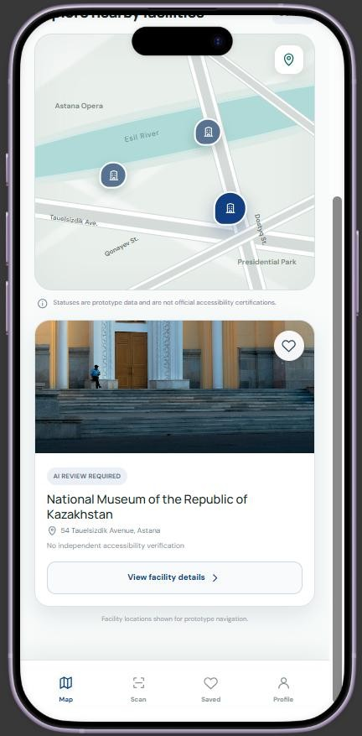

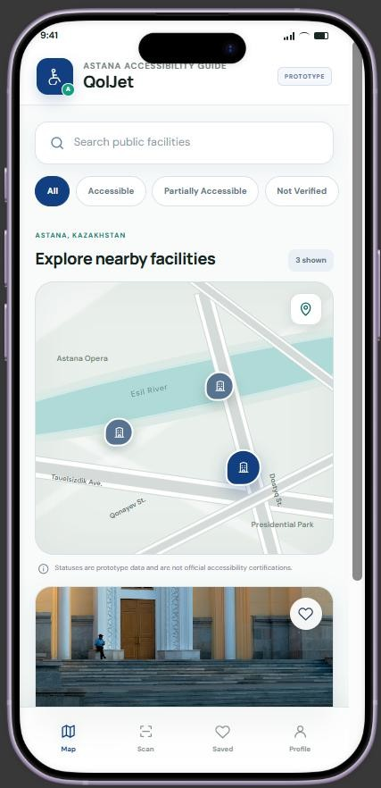
Figure 1. Map and search
Search and filter facilities on the Astana map.

Figure 2. Facility preview
Open a facility card to check details and its status.

Facility details
The facility page presents a reference image, address, and preliminary information about the entrance. Users can open the AI assessment, save a place, or submit a new photo.
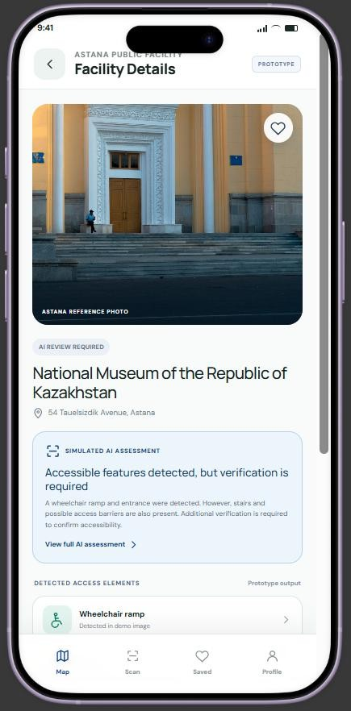
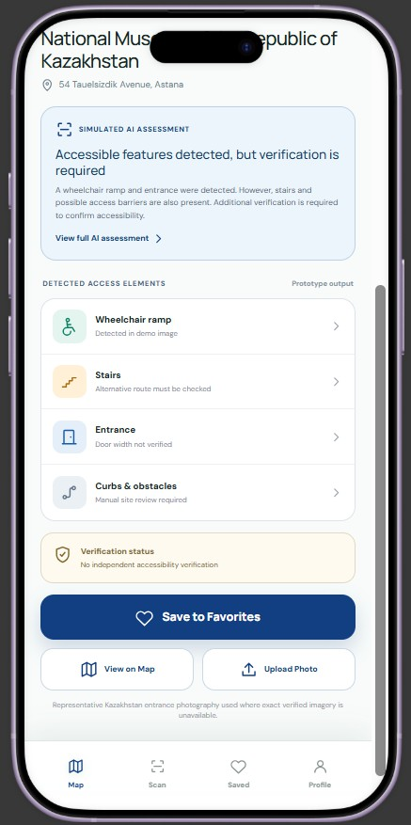

Figure 3. Facility overview
View the location and an initial assessment summary.

Figure 4. Accessibility features
Inspect ramps, stairs, entrances, curbs, and obstacles.

Photo upload and object detection
The Scan tab offers Take Photo and Choose from Gallery options. A sample analysis screen illustrates how the future computer vision model could label visible entrance features using colored bounding boxes.

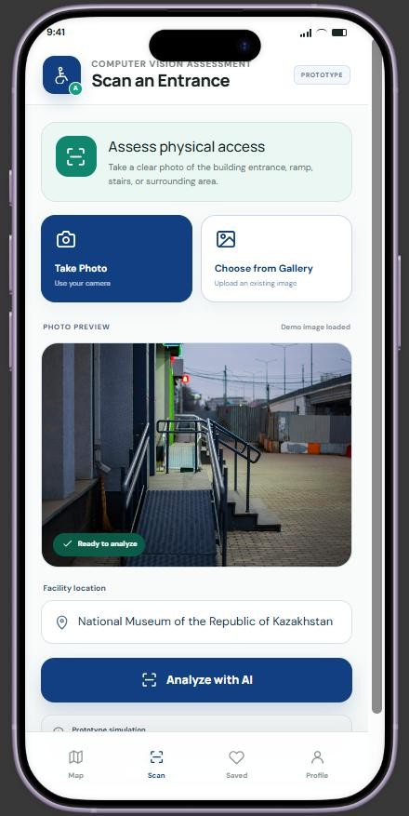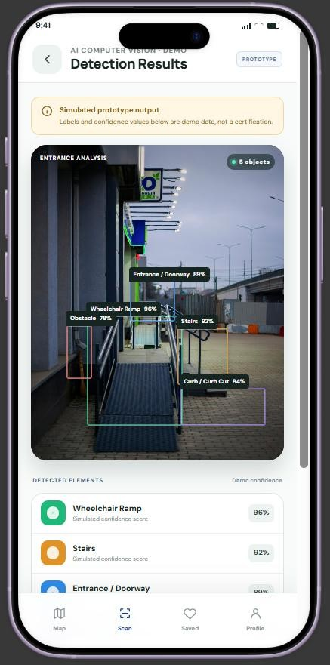

Figure 5. Photo submission
Capture or upload an entrance photo for analysis.

Figure 6. Detection overlay
Illustrative bounding boxes on an entrance photo.

Detection results and AI assessment
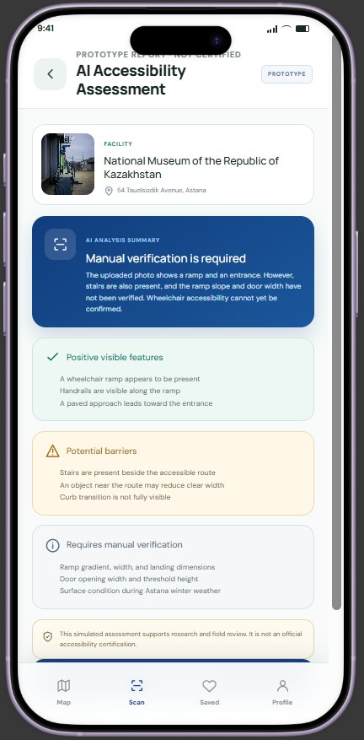
Detection results are presented as a list of identified elements with example confidence values. The assessment summarizes visible positive features, possible barriers, and information requiring physical measurement or manual verification.
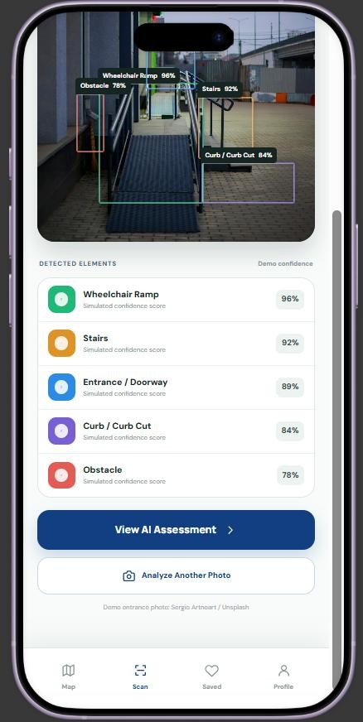

Figure 7. Detection summary
Inspect detected classes and continue to the assessment.

Figure 8. Assessment report
Distinguish observations from unverified accessibility.

Saved places and profile
Saved Places lets users return to selected facilities. The Profile screen shows basic settings and accessibility preferences. Together with the other screens, these sections illustrate the main application navigation.

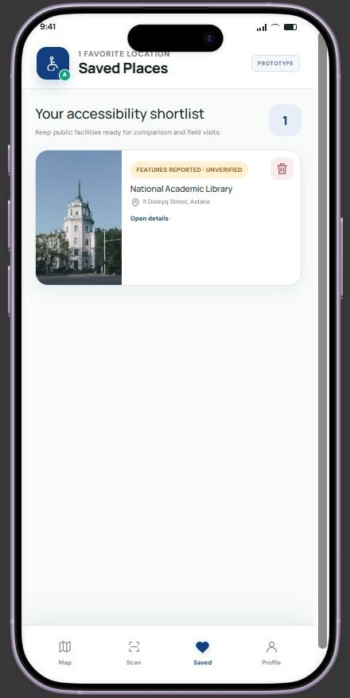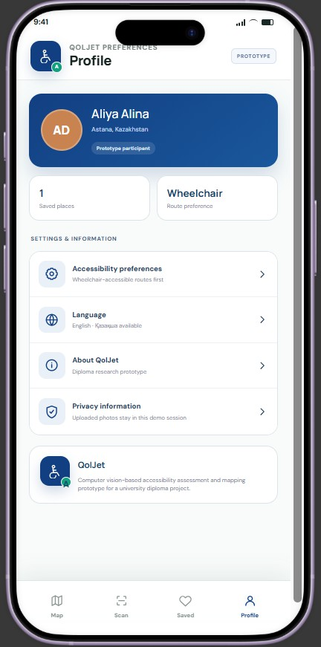

Figure 9. Saved places
Review and open bookmarked facilities.

Figure 10. Profile
View preferences, language, and privacy information.

Prototype status: This is a UI/UX demonstration, not a deployed application. AI bounding boxes, confidence scores, summaries, and accessibility statuses are simulated. They do not represent validated model results or official accessibility certifications.
Figma prototype link:

8. UX / Prototype
- Map and facility search

Figure 1. Map and search
Search and filter facilities on the Astana map.

Figure 2. Facility preview
Open a facility card to check details and its status.

Facility details
The facility page presents a reference image, address, and preliminary information about the entrance. Users can open the AI assessment, save a place, or submit a new photo.

Figure 3. Facility overview
View the location and an initial assessment summary.

Figure 4. Accessibility features
Inspect ramps, stairs, entrances, curbs, and obstacles.

Photo upload and object detection
The Scan tab offers Take Photo and Choose from Gallery options. A sample analysis screen illustrates how the future computer vision model could label visible entrance features using colored bounding boxes.

Figure 5. Photo submission
Capture or upload an entrance photo for analysis.

Figure 6. Detection overlay
Illustrative bounding boxes on an entrance photo.

Detection results and AI assessment
Detection results are presented as a list of identified elements with example confidence values. The assessment summarizes visible positive features, possible barriers, and information requiring physical measurement or manual verification.

Figure 7. Detection summary
Inspect detected classes and continue to the assessment.

Figure 8. Assessment report
Distinguish observations from unverified accessibility.

Saved places and profile
Saved Places lets users return to selected facilities. The Profile screen shows basic settings and accessibility preferences. Together with the other screens, these sections illustrate the main application navigation.

Figure 9. Saved places
Review and open bookmarked facilities.

Figure 10. Profile
View preferences, language, and privacy information.

Prototype status: This is a UI/UX demonstration, not a deployed application. AI bounding boxes, confidence scores, summaries, and accessibility statuses are simulated. They do not represent validated model results or official accessibility certifications.

