7. Architecture and Diagrams
Development of a Computer Vision-Based Application for Assessing and Mapping the Physical Accessibility of Public Facilities for Wheelchair Users
  - Architecture status: proposed / pre-defence

7.1 Architectural scope
The system has TWO evidence paths connected by facility_id: (A) YOLO11 detects visible objects in photos; (B) field inspectors record measured accessibility facts for five categories: entrance, ramp, door, indoor route and toilet. Reviewers validate records before public display. Detection alone is not a measurement or an accessibility certification.

7.2 System context diagram
Figure 7.1 identifies human actors, the proposed system boundary, and external mapping and field-record sources.
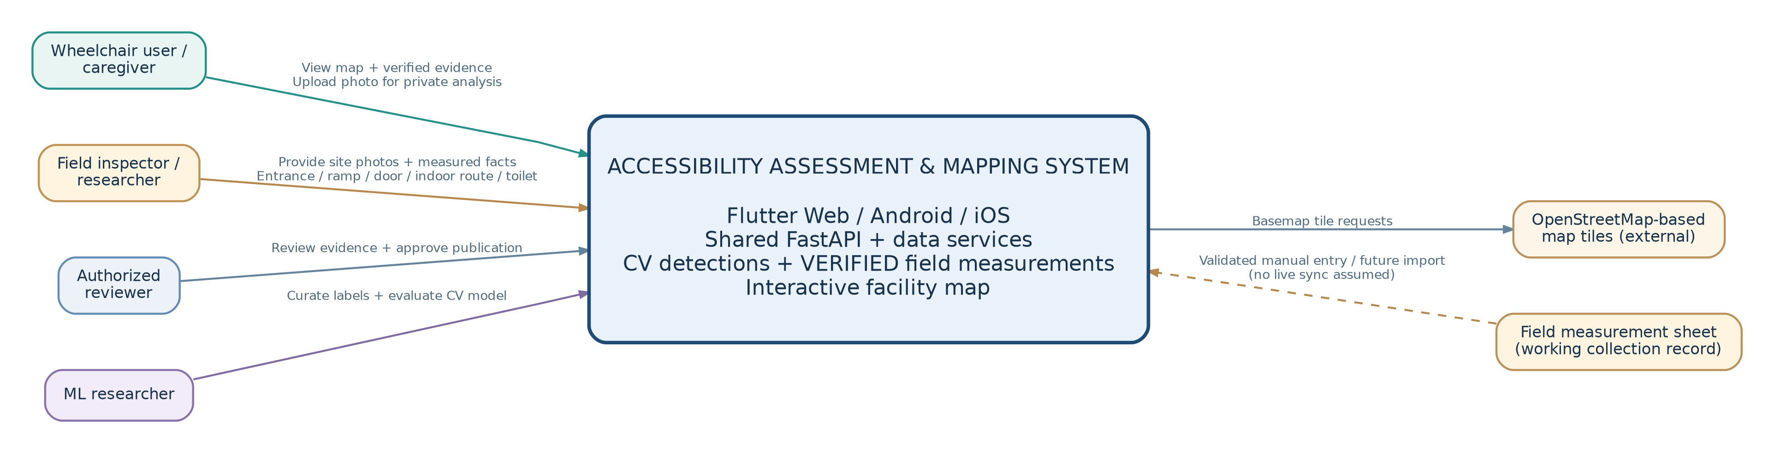
Figure 7.1. Context and boundaries. The measurement sheet is a working field-collection artifact, not a confirmed live integration with the application. Transfer to the database is planned after validation.
Actors and responsibilities: visitors browse and privately analyze photographs; field inspectors record site measurements; reviewers authorize publication; ML researchers train and evaluate the five-class detector. The external tile provider supplies only basemap imagery.

7.3 UML use case diagram
Roles are defined by responsibilities; one team member may perform multiple roles. A visitor can analyze a private photo; only reviewed facility evidence appears on the public map.
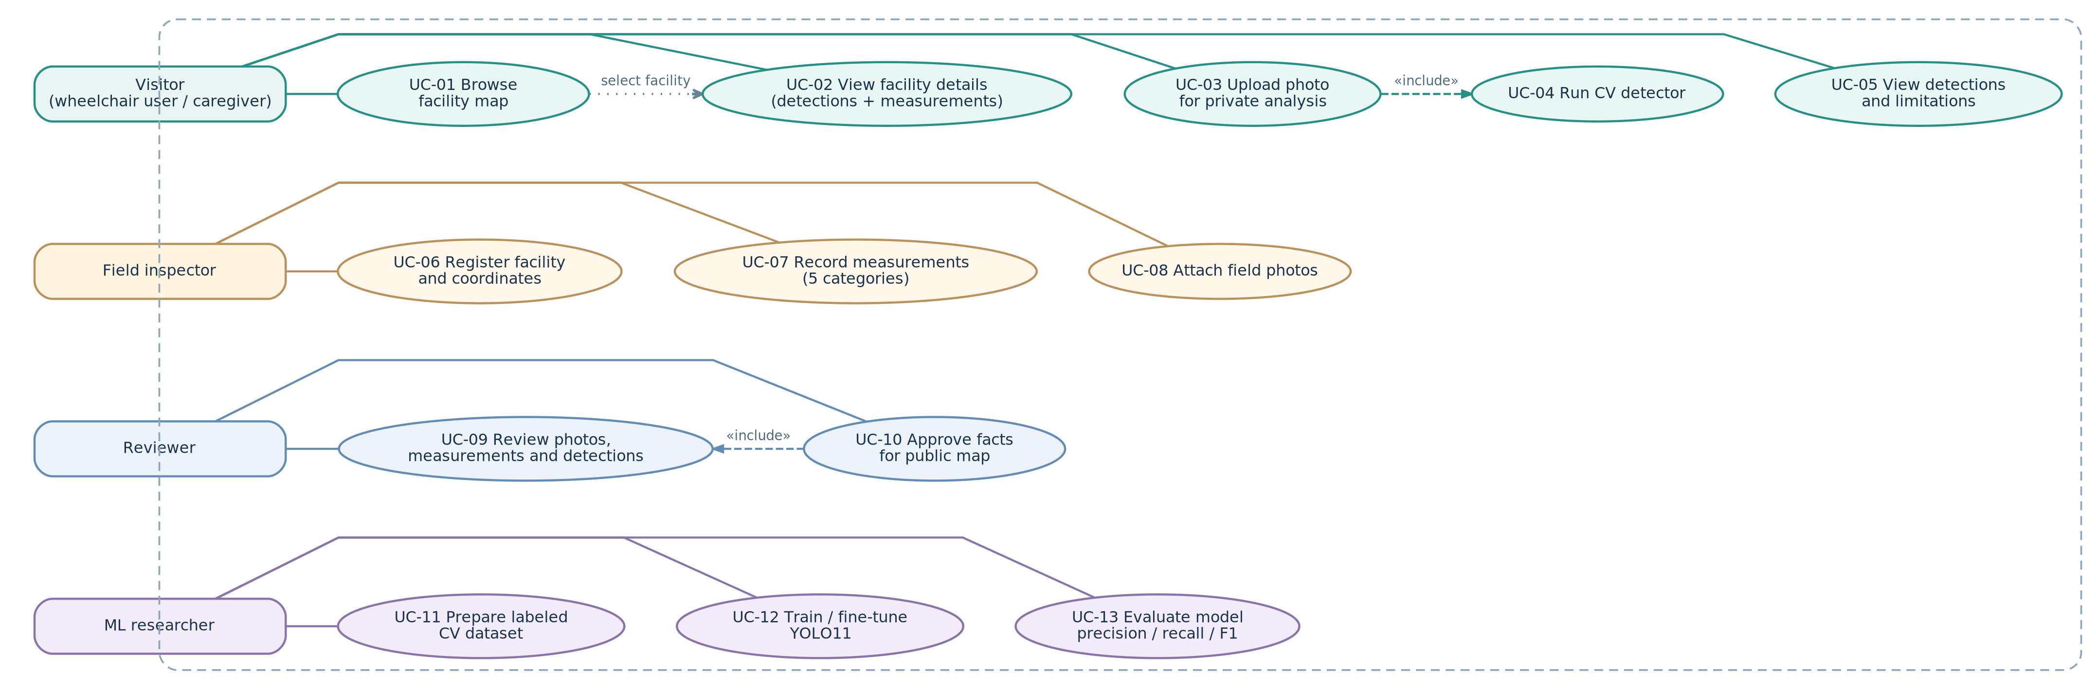
Figure 7.2. UC-07 captures manually measured facts in five categories; UC-04 only detects the five separately defined visual object classes. The UML «include» links indicate mandatory subflows: upload runs analysis; approval requires review.
Interaction rule: viewing a facility may show both approved photo detections and approved measurements, each with its source, date and review state. The two are not interchangeable.
Use-case relationship | Meaning
UC-03 «include» UC-04 | A valid private photo upload triggers CV inference; it does not publish the photo.
UC-10 «include» UC-09 | Before a fact becomes public, an authorized reviewer checks the underlying evidence.
UC-01 -> UC-02 | Selecting a facility on the map opens its approved detailed information.
UC-07 vs UC-04 | Field measurements and CV object detections are separate workflows connected by facility_id.

7.4 Component diagram (draft)
One Flutter codebase targets Web, Android and iOS. One FastAPI backend separates read-only facility services, private image analysis, structured measurement records and reviewer-only publication. PostgreSQL/PostGIS links evidence to geographic locations.
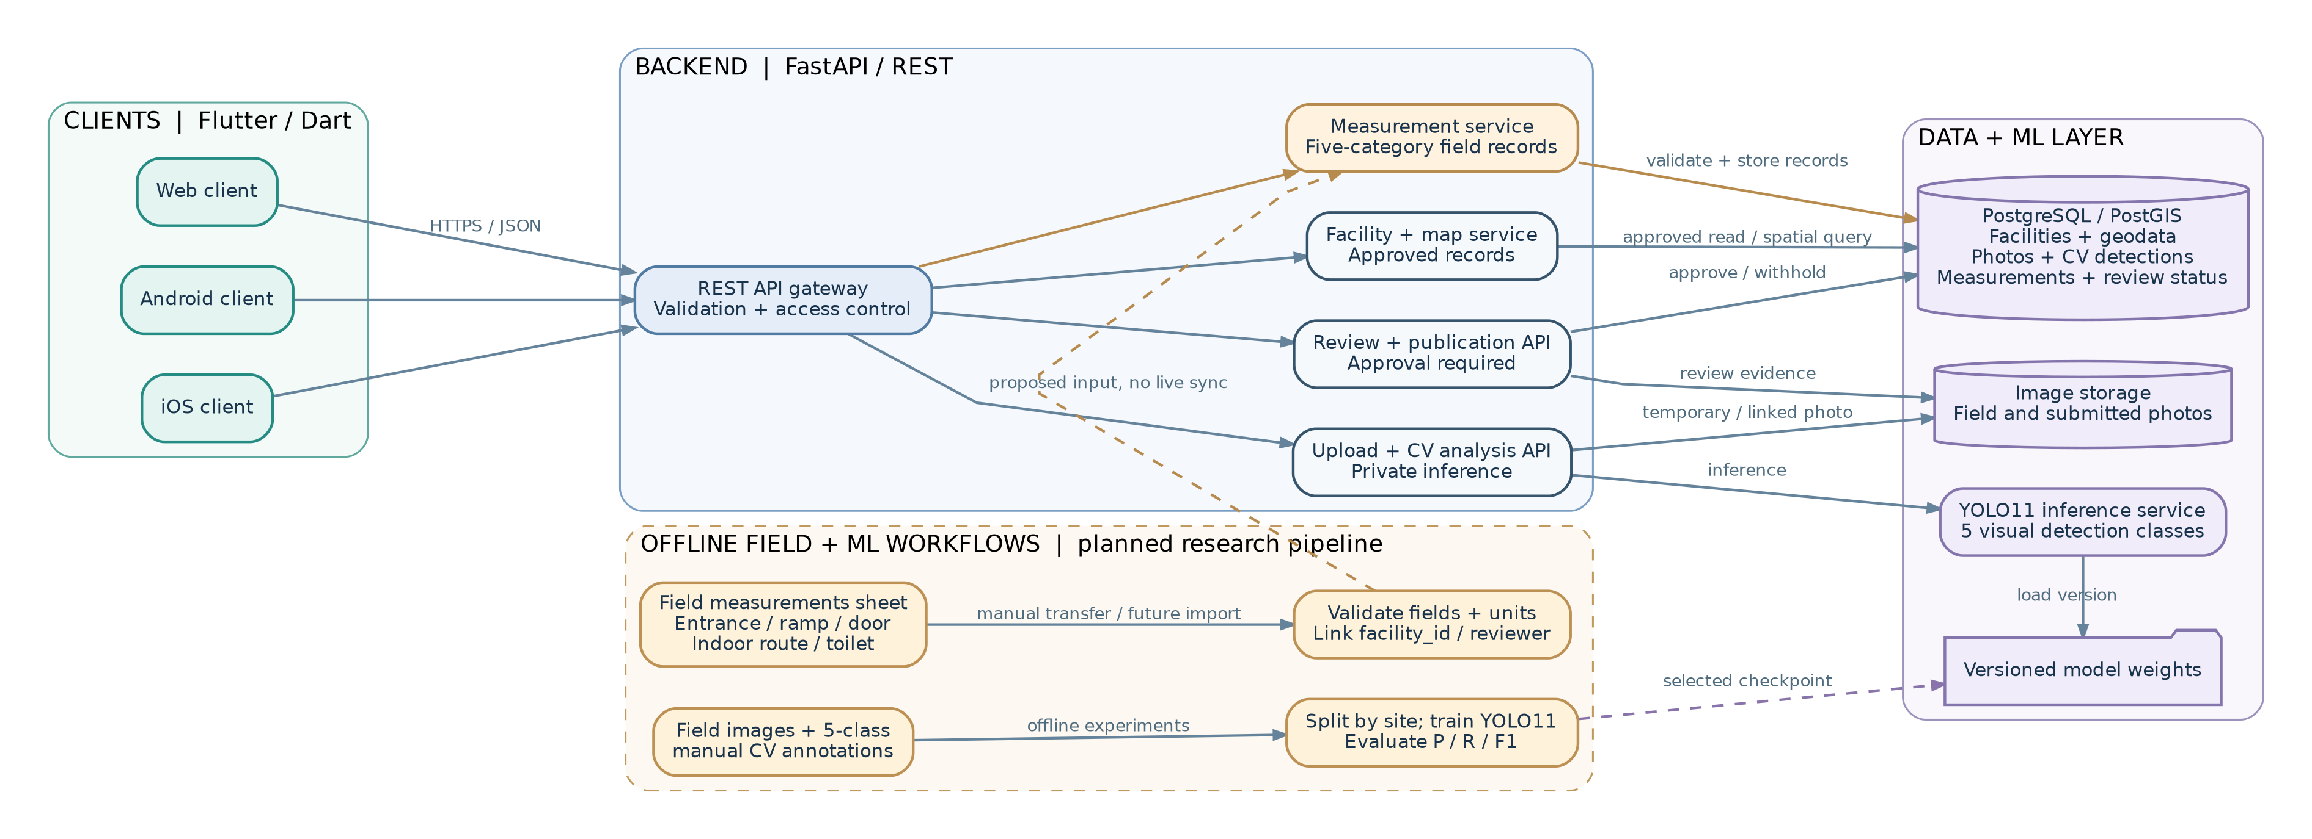
Figure 7.3. Yellow nodes represent manually collected measurements and offline research inputs; purple nodes represent model inference and persisted data. Dashed links are planned transfer/deployment activities, not completed live integration. Flutter retrieves basemap tiles directly from the external provider shown in Figure 7.1.
Interface / relationship | Purpose and data transferred
Flutter -> FastAPI -> YOLO11 | Private uploaded photo -> class, bounding boxes, confidence, model version.
Field sheet -> measurement service | Reviewed entrance / ramp / door / indoor route / toilet records; values and units retained.
Review service -> PostGIS -> Facility API | Approved photos, visual cues and measured facts published under the same facility_id.
Flutter map widget -> tile provider | Basemap image tiles only; accessibility records do not come from OpenStreetMap tiles.

7.5 Data model and relationships
Entity | Required architecture fields (proposed) | Key relation / rule
Facility | facility_id; name; type; coordinates; publication state | 1 facility -> many photos, detections and measurement records
Photo | photo_id; facility_id; file reference; captured_at; source; review status | Photos may be privately analyzed; public display requires approval
CV detection | detection_id; photo_id; class; bbox; confidence; model_version | Generated by YOLO11; no dimensional measurement is inferred
Field measurement | measurement_id; facility_id; category; recorded value or observation; unit when relevant; source/date; verification status | Category ∈ {entrance, ramp, door, indoor route, toilet}; exact sheet columns not yet confirmed
Review action | review_id; evidence_id/type; reviewer; decision; timestamp | Only approved facts are published and provenance is retained
ML evaluation | run_id; dataset version; weights; split; P/R/F1; error examples | Kept separate from public-facing facility records

7.6 Main operational scenarios
Scenario | Data flow | Expected result / safeguard
S1 Browse facility | Flutter -> GET facility/map API -> PostGIS -> Flutter + map tiles | Facility page shows approved CV cues and approved field measurements with evidence dates.
S2 Analyze photo | Flutter -> POST photo -> FastAPI validation -> YOLO11 -> UI | Bounding boxes + confidence; private results do not become public automatically.
S3 Record five categories | Field inspector -> sheet/manual entry -> validation -> measurement records | Entrance, ramp, door, indoor route, toilet linked to facility_id; values/units preserved.
S4 Review & publish | Reviewer -> photos + measurements + detections -> decision -> DB | Only verified records appear on map; unreviewed data stays private.
S5 Develop CV model | Field images -> manual 5-class labeling -> site-level split -> train -> test | Per-class precision, recall, F1 and FP/FN; no training labels made from measurement values.

7.7 Requirements-to-architecture traceability
Requirements | Components / evidence | How alignment is checked
FR-01, FR-09–FR-11 | Facility API, PostGIS, photo records, review API | Map displays only approved records referenced by valid facility_id.
FR-02–FR-05, FR-13–FR-14 | Offline labeled images, YOLO11, test manifest, metrics | Five visual class definitions; location-separated split and evaluation.
FR-06–FR-08, FR-12 | Flutter upload, FastAPI, YOLO11, result view | Image validation and detection output contract.
FR-10, FR-15–FR-16 | Map UI and facility details on Web/Android/iOS | Show reviewed data and photo-only limitation on all clients.
FR-20 (new P1) | Field sheet/measurement API / PostGIS | All five measurement categories have a facility-linked record structure.
FR-21 (new P1) | Reviewer workflow / public detail UI | Only approved measured facts are displayed with source/date/units.
NFR-04–NFR-07 | Validation, access controls, provenance, model versioning | Unauthorized edits blocked; no orphan or unreviewed public records.

7.8 Critical distinctions and limitations
Computer Vision classes (from the model plan): ramp, stairs, entrance/doorway, curb/curb cut, and route obstacle. Field measurement categories (from the team’s clarification): entrance, ramp, door, indoor route, and toilet. These sets overlap conceptually but are not equivalent. A toilet record, for example, is collected and reviewed manually; this specification does not claim toilet detection by YOLO11.
The field measurement spreadsheet is still in progress. Its exact columns, measurement units, numerical observations, and any regulatory pass/fail thresholds were not accessible for verification during this revision.
Three readable architecture diagrams plus editable DOT/SVG source files; coherent proposed entities and flows; alignment with requirements; honest status of features not yet implemented. No automatic wheelchair route planning or automatic certification is in scope.

