**Projects Dashboard :**

Web application to keep track of the current projects being developed. Every employee has a dashboard where he can update his project status, description about the project and related documents.

**Project Details:**

The application has two modules:

1. Admin module
2. Employee Module

**Admin Module :**

Functionalities under Admin module :

* Add a new Employee.
* Project Documents
* Admin Dashboard
* View project details

**Employee Module:**

* Employee Dashboard.
* Employee profile
* Add project details
* Update project details.
* Project Documents.

**Progress of the the application :**

**Admin Module :**

* Admin Dashboard page I shows progress of all the current projects in form of a bar graph.
* It also display count of projects in progress ,completed and not yet started.
* Displays a table which shows the last updated date of the project and project stage

**Admin Dashboard page :**

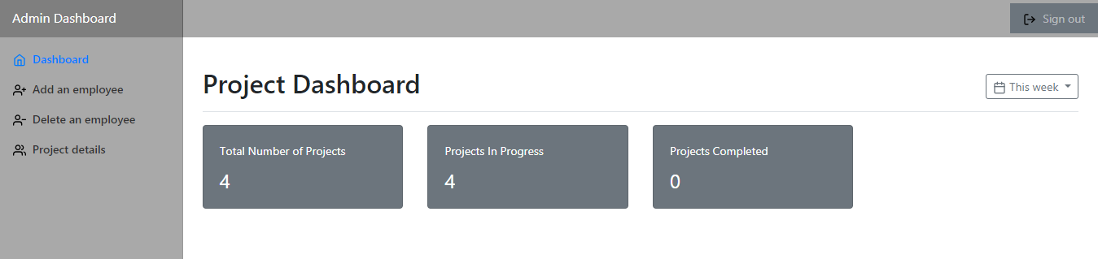

**Project Progress Graph:**

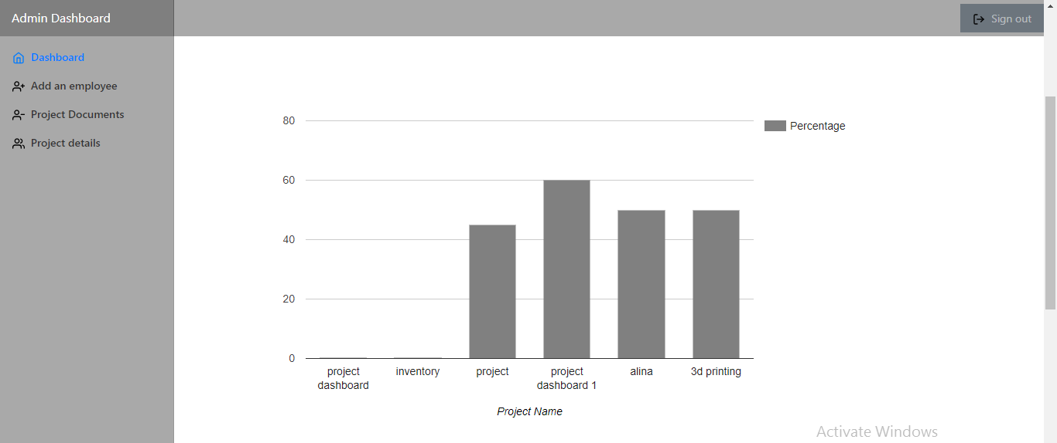

* The above graph shows the progress of each project and dynamically updates the percentage completed of the project.

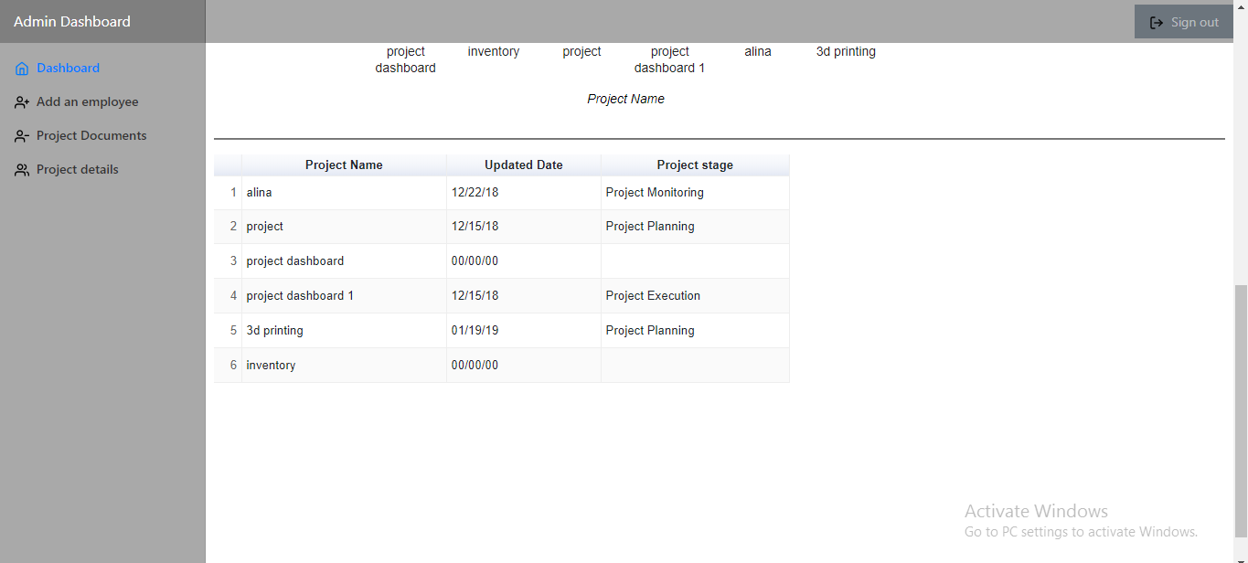

**Add Employee Page :**

* It allows the admin to add new employees and their details like name, wsuid, and role that could be either an employee or admin.

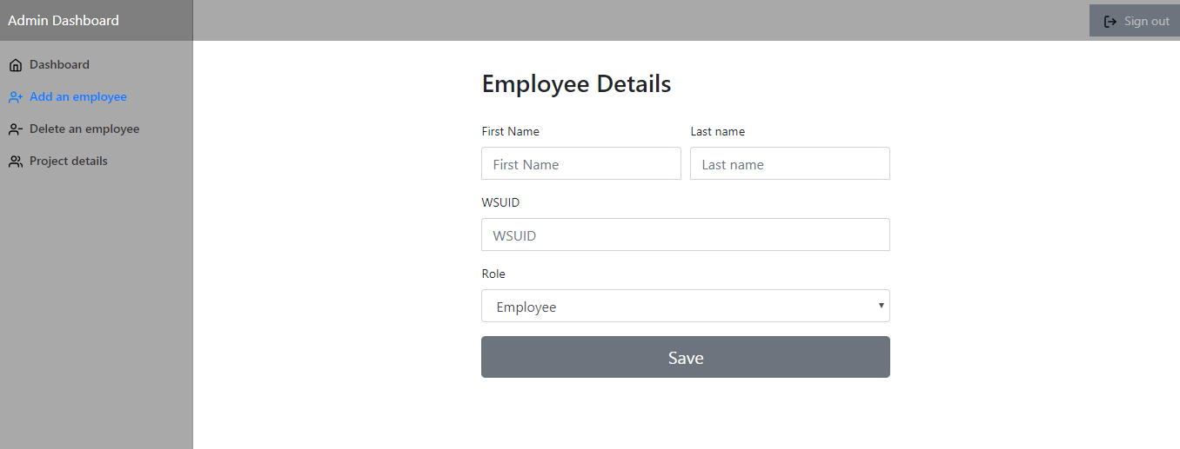

**Project Details Page:**

* This page display the details of all the projects added by employee in form of a table.
* The details are dynamically updated.

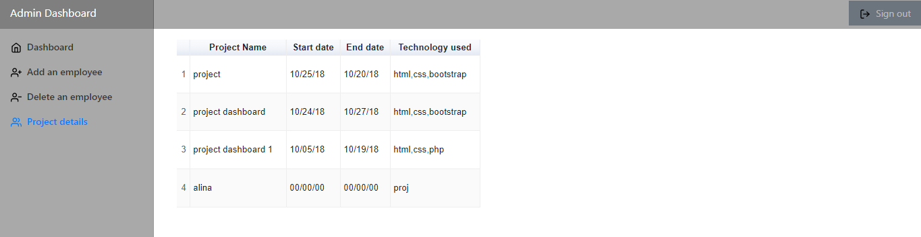

Project Documents page:

* This pages shows table of uploaded project documents and its description.
* The documents can be downloaded in the individual system.

**Project Documents page:**

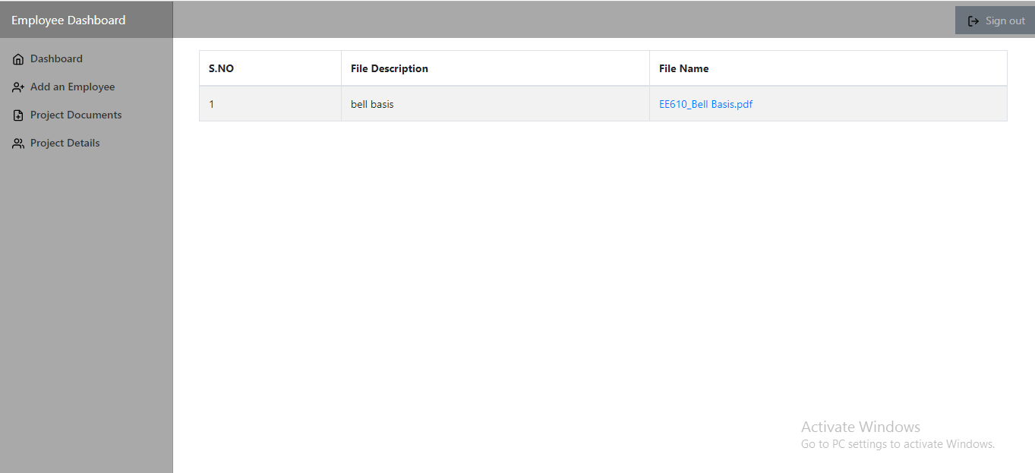

**Employee Module :**

**Employee Dashboard :**

* Employee dashboard displays the project progress of that particular employee who has logged in.
* In the below page the graph shows only the projects of the logged in employee.
* It also displays the count of projects, completed projects and in progress projects of the particular employee.

Employee Dashboard:

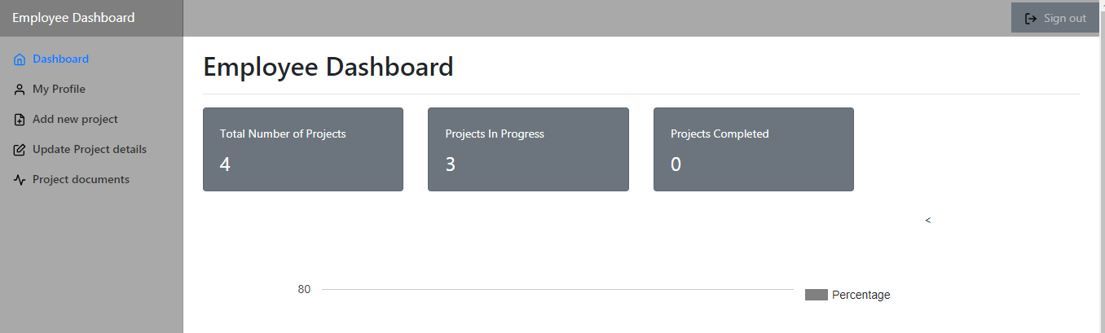

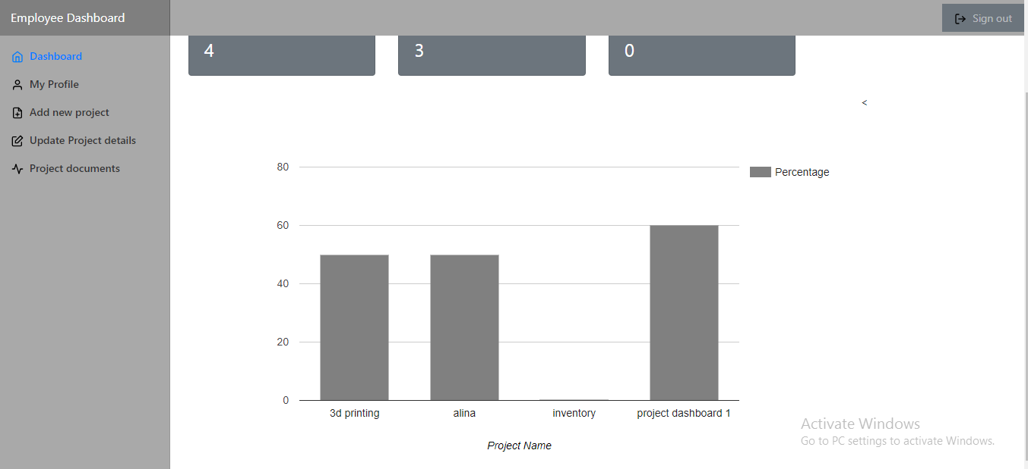

**Profile Page :**

* This page takes the employee details and displays the information.
* After the first login, the details will be already displayed when employee logins the next time.

**Profile page While logging first time**:

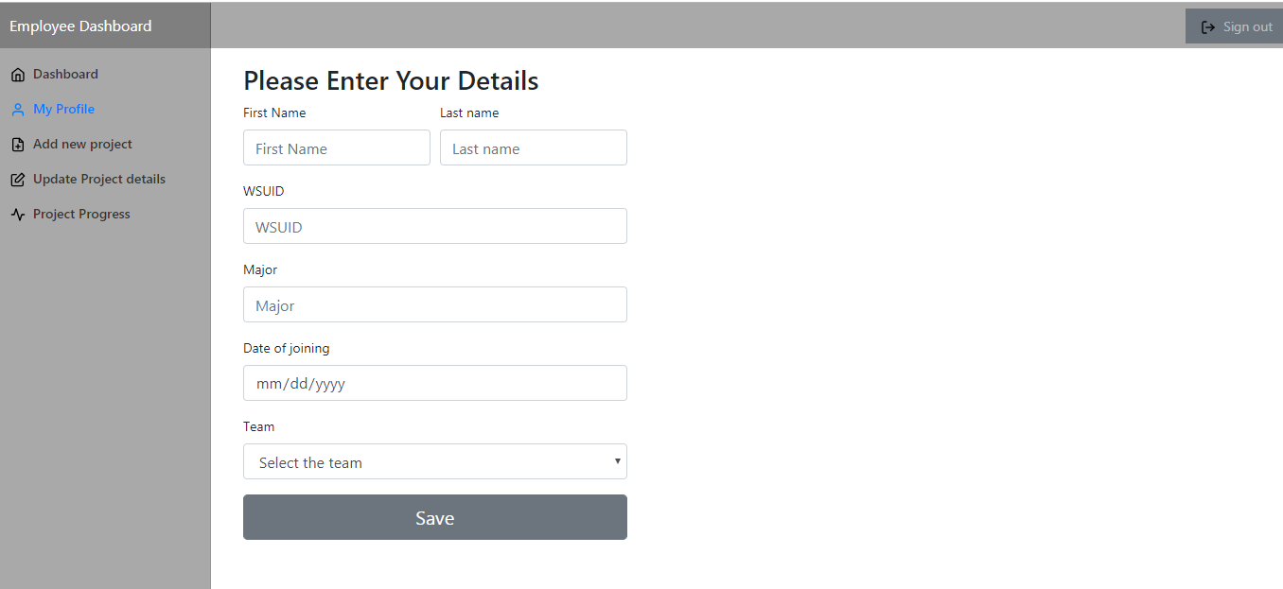

**Profile Page while logging second time:**

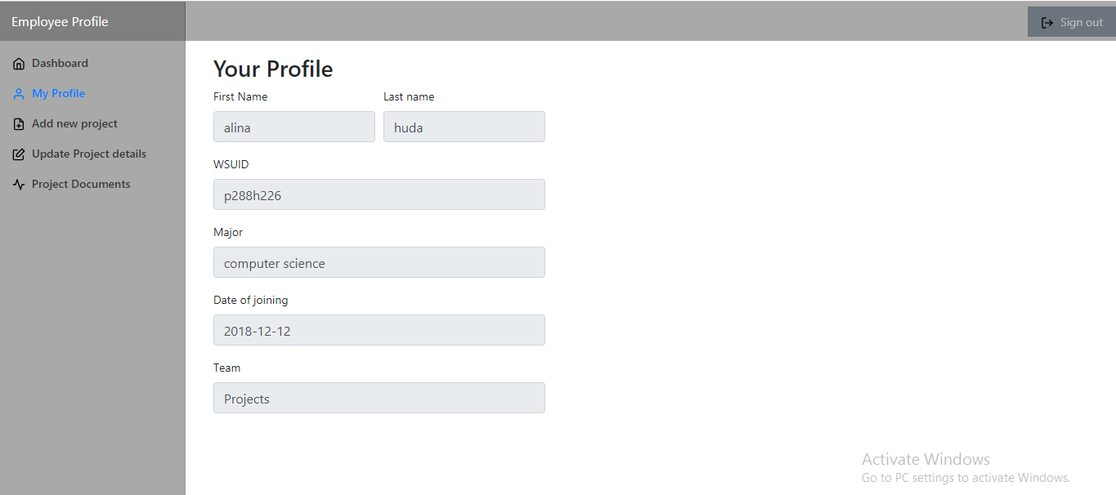

**Add Project Page :**

* This page is used to add new project by the employee .
* The Employee gets and option to

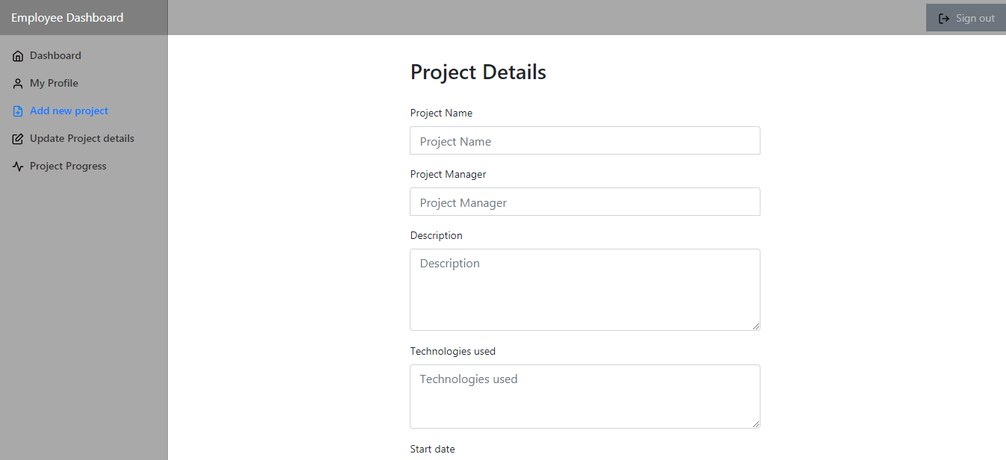

**Upload files option:**

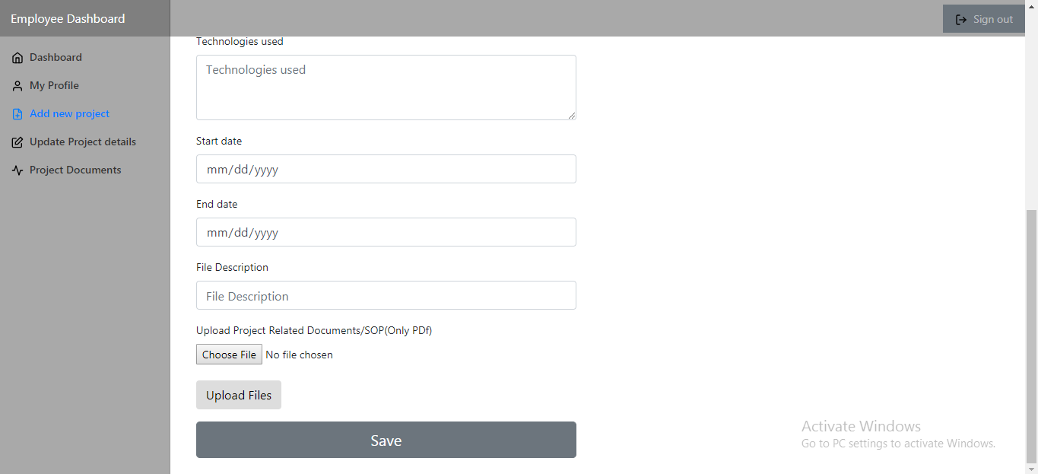

**Update Project Details Page:**

* This page is used to update the percentage completed of a particular project.
* Project stage can also be updated.

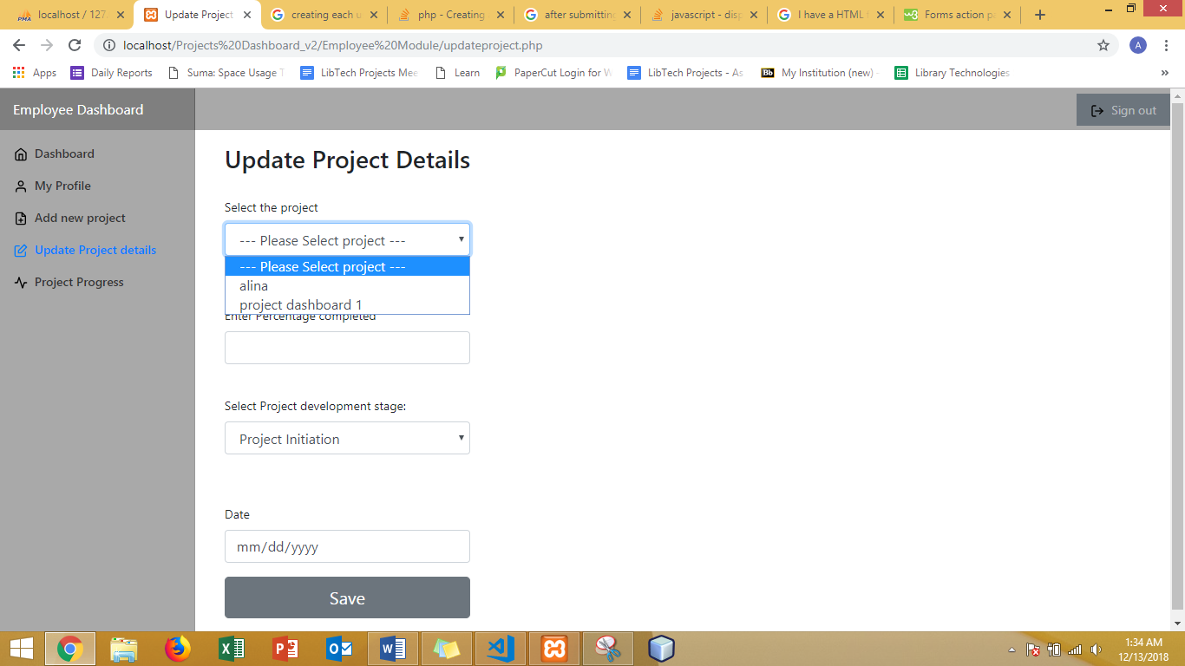

* It displays the projects of that particular employee.

**Project Documents Page:**

* Employee can view and download the project related documents uploaded by all the other employees.

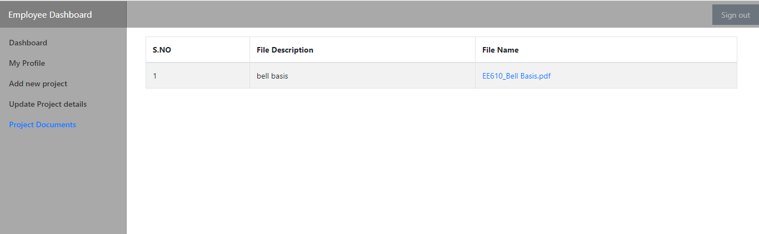

**Database (PhpMyAdmin):**

* All the user entered data is stored in the phpMyAdmin admin which runs on Maria Db server.

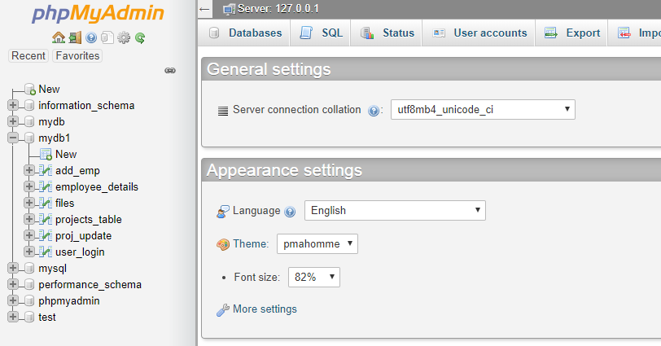

* This application has 5 tables that stores employee information , project information which is dynamically updated by user input.
* The data updated in these tables will be used to dynamically update the graphs and table.

**Implementation :**

* This application was developed using bootstrap , css , html5 for the frontend development
* For backend data storing, phpMyAdmin database which uses MariaDB server.
* All the data inserting and retrieving from the database was done using SQL
* Server side development was done using core PHP. All the dynamic content of the website is generated using PHP.
* XAMPP web server was used to host the website locally and test it.
* Google charts API was used to create interactive and dynamic graphs to display the progress of the projects.
* Visual studio code was used to develop the application.

**Problems Faced:**

* Compatibility issues with XAMPP and sql server , therefore phpMyAdmin was not getting connected.
* Google charts API error while trying to retrieve the data from database using php.
* Displaying the projects of the respective employee using session variable .

**Percentage Completed :**

Admin Module : 100%

Employee Module : 100%