**CT Lung Pipeline for Great Lakes**

***Overview:***

The CTlung Pipeline is an automated processing tool, designed to be run either fully locally or on the Great Lakes HPC (GL). It includes multiple steps, individually selectable from the GUI.

Notes for GL: Some local processing is still necessary: step (1) and (2) below. The save directory MUST be set to a location on Turbo storage for GL to be able to access it. The username input should be the user’s uniquename, allowing SLURM to notify via email of completion of the process.

***Pipeline Components:***

1. Data Loading and Preprocessing *(local)*
   1. Load data from input files (DICOM)
   2. Check orientation and permute if necessary
   3. Check Exp/Ins and swap if necessary
   4. Save images as .nii
2. Lung Segmentation *(local)*
   1. YACTA, including airways if selected
3. Airways
   1. Reads YACTA results from CSV file
4. ScatNet
   1. Generates AT map for passing into the vessels analysis
5. Vessels
6. Unreg Statistics
   1. Threshold analysis on individual EXP/INS images
7. Image Coregistration
   1. Elastix warping registration
   2. Option to save Jacobian map
8. PRM
   1. Both 10-region and 5-region analyses
9. tPRM
   1. Runs localized tPRM analysis and interpolates and saves to Exp geometry

***Pipeline Procedure***

1. Run local script: Main_Pipeline_GL
   1. Options: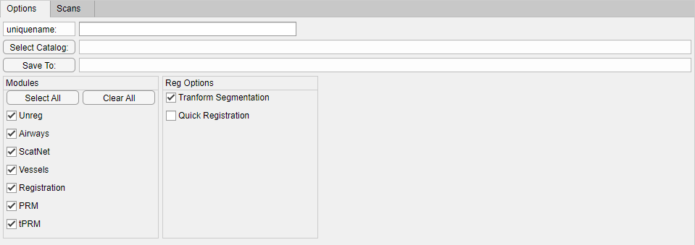
      1. Input your uniquename (e.g. cgalban)
      2. Select DICOM catalog
      3. Select folder for saving results (folders will be generated here to contain case results) **MUST BE ON TURBO**
      4. Select pipeline options
   2. Scans: 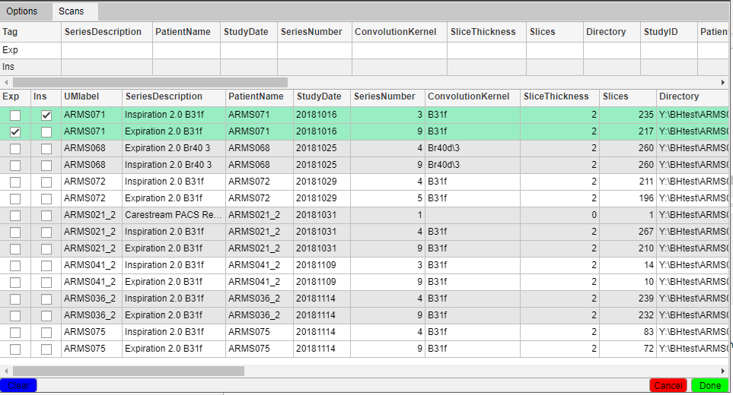
      1. Select scans for processing
      2. Adjust names if desired (UMlabel
      3. When finished click the green Done button
   3. Local processing:
      1. Read DICOM, determine Exp/Ins, save as .nii
      2. Run YACTA segmentation
   4. GL command copied to clipboard
      1. Function inputs and sbatch .sh file are saved on Turbo: ../GreatLakes/temp
      2. Sbatch .sh file name: <username>_<function_name>_<timestamp>.sh
         1. Username = your uniquename
         2. Function_name = the function being processed on GL (e.g. Main_Pipeline_GL_sub)
         3. Timestamp = yyyyMMddHHmmss
      3. Command: “cd /nfs/turbo/umms-cgalban/GreatLakes/temp && sbatch <filename>” , where <filename> is the Sbatch .sh file
2. Run script on GL
   1. Log onto GL through PuTTY using your lvl 1 password (greatlakes.arc-ts.umich.edu)
   2. Paste (two mouse button click) or type command into window and hit enter
   3. Email upon completion of the SBATCH task will be sent to the uniquename provided in the GUI