Name: TUMUKUNDE Aline

Id: 23676

Mobile Programming Assignment

Tab Navigation for Home Screen

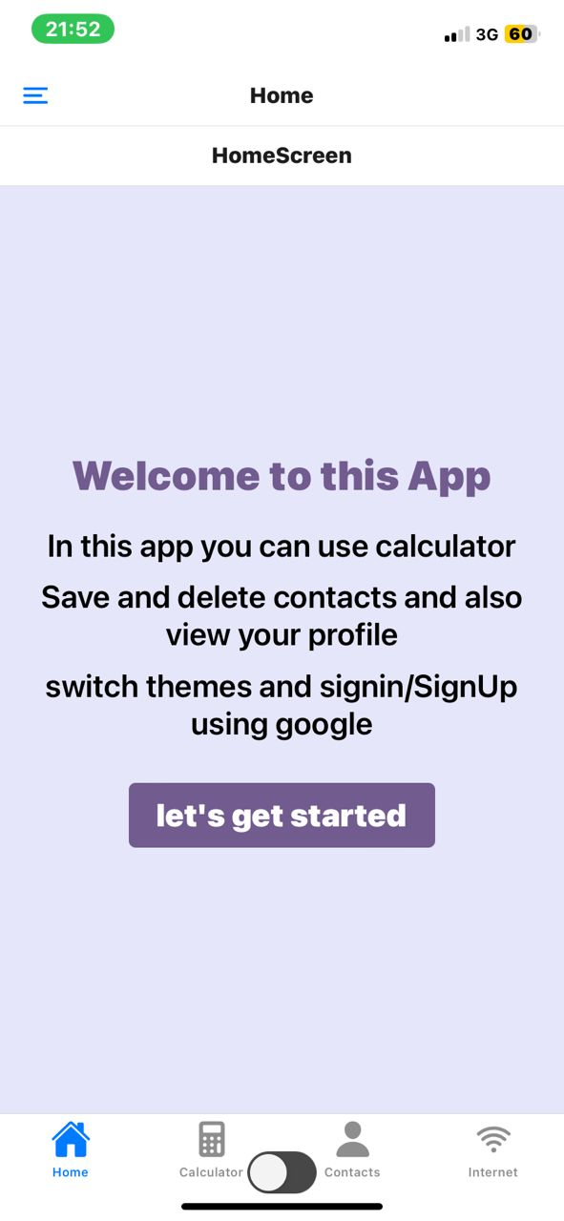

Tab Navigation for Calculator Screen where you can perform arithmetic Operation

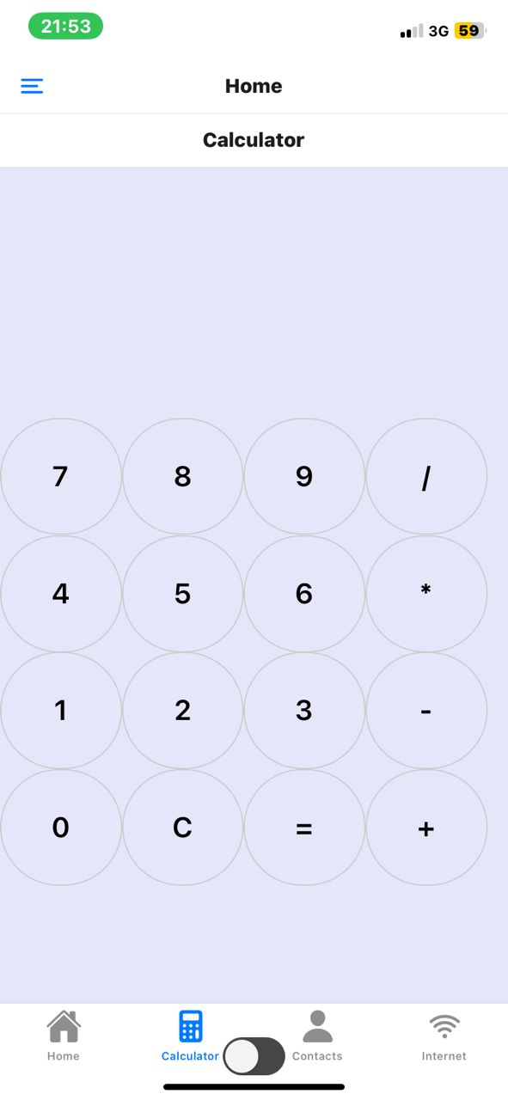

Tab Navigation for Contact Screen where you can add contacts and delete contacts

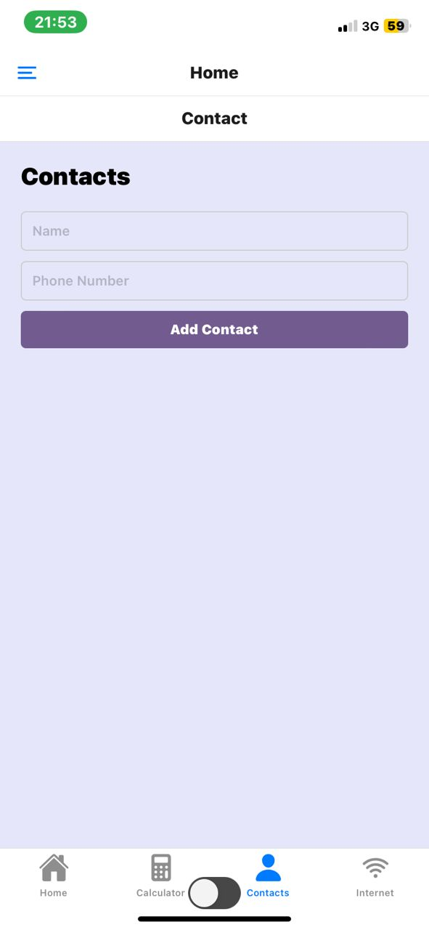

This is drawer Navigation Navigation containing home, profile, calculator, contacts, AsyncStorage and authentication that allow user to signin and signup using google.

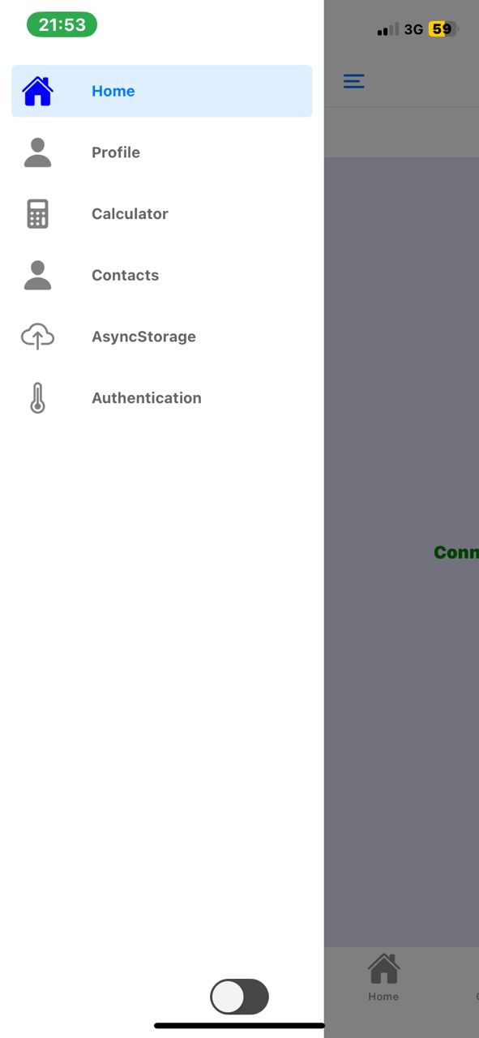`

Detecting Internet connectivity and toast a message in case of change

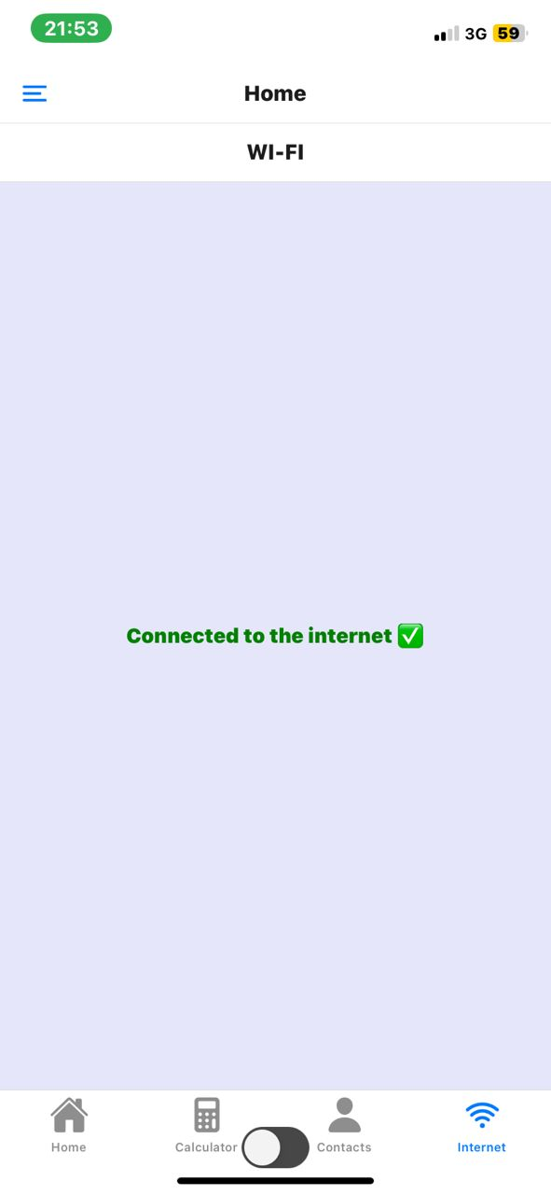

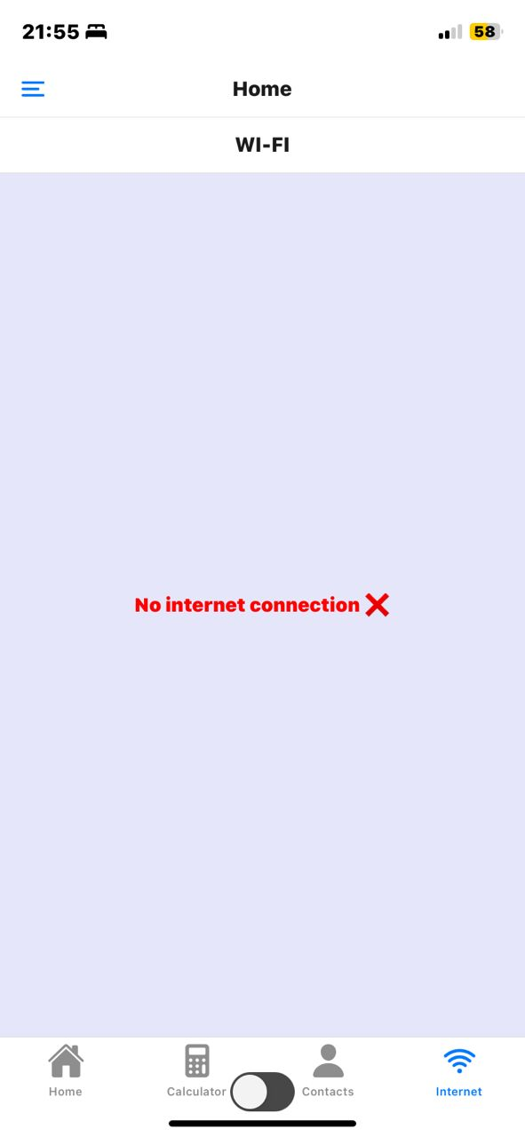

You can use different themes such as Light and dark

