1. Employee Index page, which contains links to all the other pages and actions  
   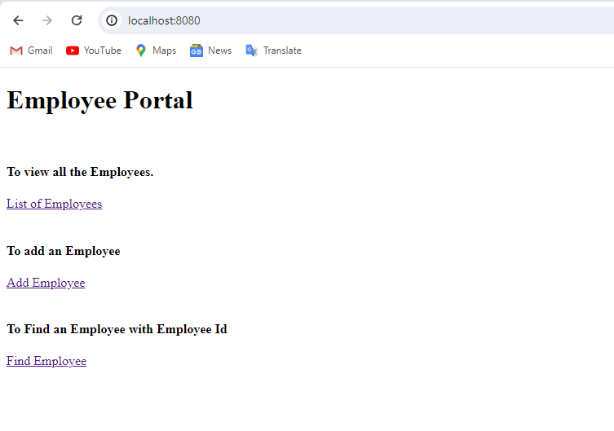
2. On Click of display Employee it leads to display employee page with all the employees listed in table format  
   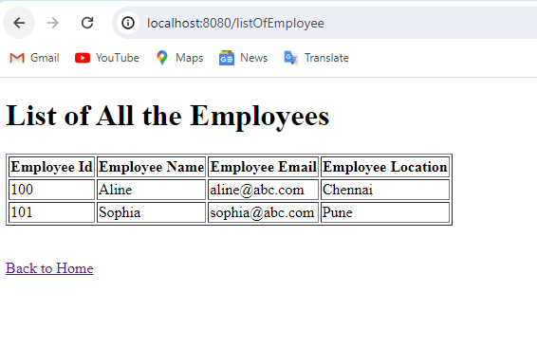
3. On click on Add employee the user is given a form to enter the employee details to add.  
   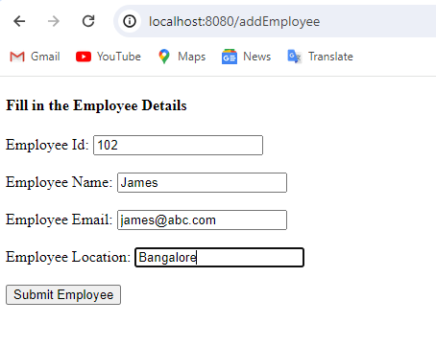
4. On clicking on Submit Employee the employee is successfully added and the page will return to display employee page where you can see the newly added employee details  
   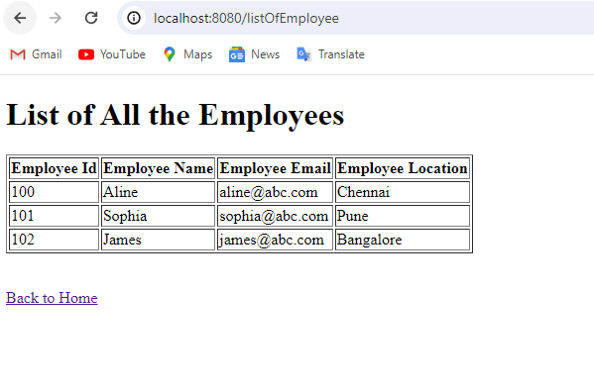
5. To find an employee click on the link and enter the employee id to search  
   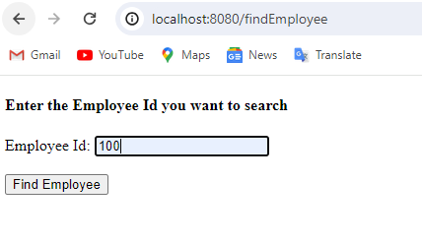
6. Click on Find employee it will display the details of the employee  
   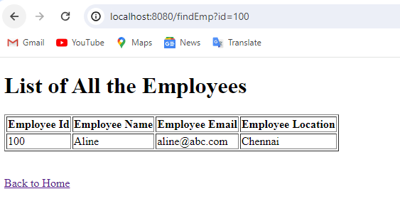
7. When you search for an invalid employee Id   
   