1. Fix the bug in below snippet  
   Answer:  
   <html lang="en">

    <head>

        <title>Document guvi</title>

    </head>

    <body>

        <div>

            Lorem ipsum dolor sit amet consectetur adipisicing elit.

            <div>

                Guvi Geek Network

            </div>

        </div>

    </body>

</html>

Output Snippet:

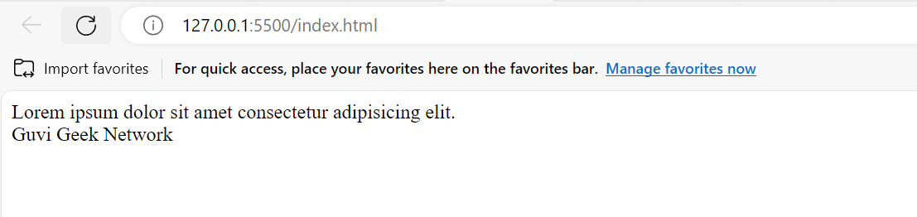

1. Try the below one

Answer:

<html lang="en">

    <head>

        <title>Document guvi</title>

    </head>

    <body>

        <div>

            Lorem ipsum dolor sit amet consectetur adipisicing elit.

            <div>

                Guvi Geek Network

            </div>

        </div>

    </body>

</html>

Output Snippet:

1. Design a contact us form with all fields as required.

Answer:

<!DOCTYPE html>

<html>

<head>

<meta name="viewport" content="width=device-width, initial-scale=1">

<style>

    input[type=text], select, textarea {

  width: 100%;

  padding: 12px;

  border: 1px solid #ccc;

  border-radius: 4px;

  box-sizing: border-box;

  margin-top: 6px;

  margin-bottom: 16px;

  resize: vertical;

}

</style>

</head>

<body>

<h3>Contact Form</h3>

<div class="container">

  <form>

    <label for="fname">First Name</label>

    <input type="text" id="fname" name="firstname" placeholder="Your name..">

    <br>

    <label for="lname">Last Name</label>

    <input type="text" id="lname" name="lastname" placeholder="Your last name..">

    <br>

    <label for="pno">Phone Number</label>

    <input type="text" id="pno" name="pno" placeholder="Your Phone Number..">

    <br>

    <label for="email">Email</label>

    <input type="text" id="email" name="email" placeholder="Your Email..">

    <br>

    <label for="country">Country</label>

    <select id="country" name="country">

      <option value="australia">Australia</option>

      <option value="canada">Canada</option>

      <option value="india">India</option>

      <option value="usa">USA</option>

    </select>

    <br>

    <label for="comment">Comment</label>

    <textarea id="comment" name="comment" placeholder="Give your comments.." style="height:200px"></textarea>

    <br>

    <input type="submit" value="Submit">

  </form>

</div>

</body>

</html>

Output snippet:

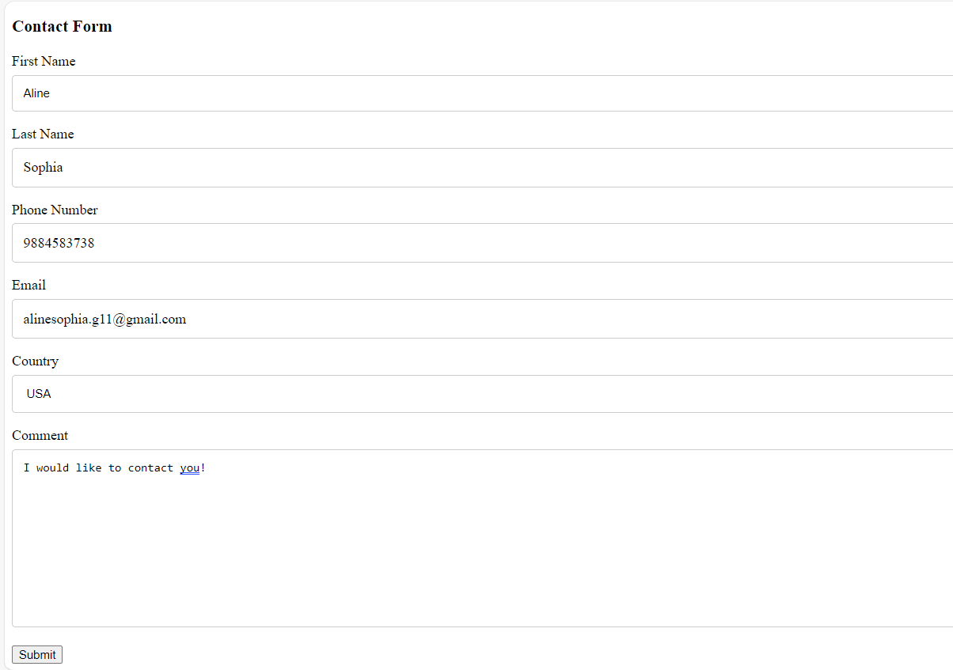

1. Use certain html elements to display the following in html page

Answer:

<!DOCTYPE html>

<html>

<head>

<meta name="viewport" content="width=device-width, initial-scale=1">

<style>

</style>

</head>

<body>

<div class="container">

  <ul>

    <li>Programming Language</li>

        <ul>

            <li>JavaScript</li>

                <ol type="a">

                    <li>Angular</li>

                    <li>React</li>

                    <li>Vue.js</li>

                </ol>

            <li>Python</li>

                <ol type="a">

                    <li>Django Framework</li>

                    <li>Flask Framework</li>

                </ol>

            <li>Java</li>

                <ol type="a">

                    <li>Spring</li>

                    <li>Maven</li>

                    <li>Hibernate</li>

                </ol>

        </ul>

    <li>Database</li>

        <ul>

            <li>MySQL</li>

            <li>MongoDB</li>

            <li>Casandra</li>

        </ul>

  </ul>

</div>

</body>

</html>

Output Snippet:

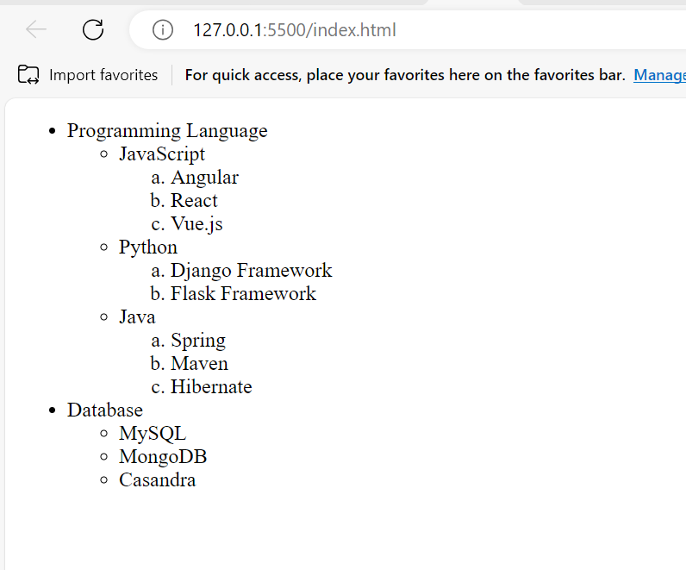

5.Create an element that helps you to open the <https://google.com> in separate new tab  
Answer:

<!DOCTYPE html>

<html>

<head>

<meta name="viewport" content="width=device-width, initial-scale=1">

<style>

</style>

</head>

<body>

<div class="container">

  <a href="https://www.google.com" target="_blank">Open Google</a>

</div>

</body>

</html>

Output Snippet:

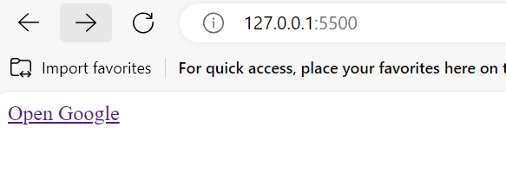

6.In a form add two radio buttons with grouping them for employee type (salaried and own business)

Answer:

<!DOCTYPE html>

<html>

<head>

<meta name="viewport" content="width=device-width, initial-scale=1">

<style>

</style>

</head>

<body>

<div class="container">

  <form action="">

        <label for="emp">Employee Type</label>

        <input type="radio" id="salaried" name="salaried" value="salaried">

        <label for="salaried">Salaried</label>

        <input type="radio" id="business" name="business" value="business">

        <label for="business">Own Business</label>

  </form>

</div>

</body>

</html>

Output Snippet:

8. Use the table tag to design a given image.

Answer:

<!DOCTYPE html>

<html>

<head>

<style>

table {

  font-family: arial, sans-serif;

  border-collapse: collapse;

  width: 100%;

}

td, th {

  border: 1px solid #dddddd;

  text-align: center;

  padding: 8px;

}

h2{

    text-align: center;

}

</style>

</head>

<body>

<h2>Health Chart</h2>

<table>

  <tr>

    <th>State of Health</th>

    <th colspan="2">Fasting Value</th>

    <th colspan="1">After Eating</th>

  </tr>

  <tr>

    <th></th>

    <th>Minimum</th>

    <th>Maximum</th>

    <th>2 hrs after Eating</th>

</tr>

  <tr>

    <td>Healthy</td>

    <td>70</td>

    <td>100</td>

    <td>less than 140</td>

  </tr>

  <tr>

    <td>pre-Diabetes</td>

    <td>101</td>

    <td>126</td>

    <td>140-200</td>

  </tr>

  <tr>

    <td>Diabetes</td>

    <td>More than 126</td>

    <td>N/A</td>

    <td>More than 200</td>

  </tr>

</table>

</body>

</html>

Output Snippet:

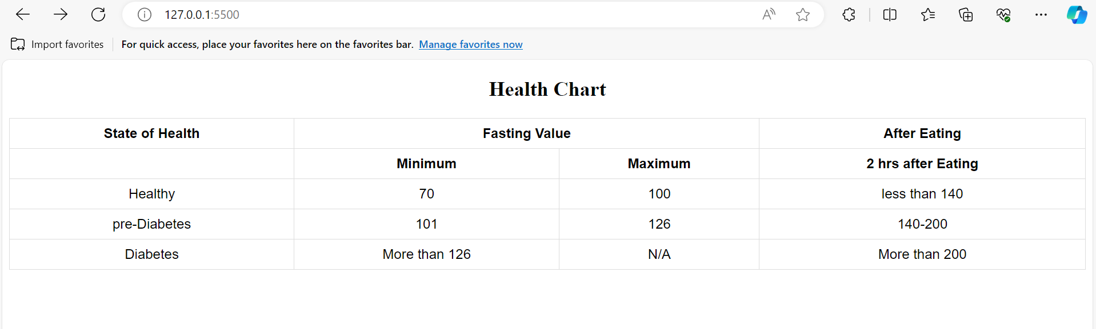

9. Write html input tag snippets to show default values for all form elements

Answer:

<!DOCTYPE html>

<html>

<head>

<meta name="viewport" content="width=device-width, initial-scale=1">

<style>

</style>

</head>

<body>

<div class="container">

    <form action="">

        <label for="fname">First name:</label><br>

        <input type="text" id="fname" name="fname" value="Default"><br><br>

        <label for="cars">Choose a car:</label>

        <select id="cars" name="cars">

            <option value="volvo">Volvo</option>

            <option value="saab">Saab</option>

            <option value="fiat">Fiat</option>

            <option value="audi" selected>Audi</option>

        </select><br>

        <label for="comment">Comment</label>

        <textarea name="message" rows="3" cols="30">The cat was playing in the garden.

            </textarea><br>

        <button type="button" onclick="alert('Hello World!')">Click Me!</button><br>

        <input type="submit" value="Submit">

      </form>

</div>

</body>

</html>

Output Snippet:

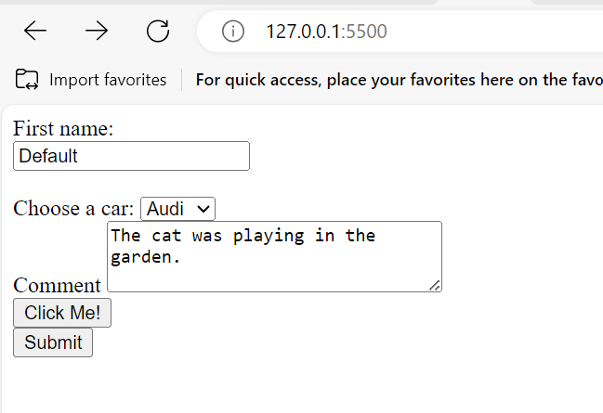

10. In your html page add the below line and highlight it without using any css

Answer:

<!DOCTYPE html>

<html>

<head>

</head>

<body>

<p><mark>"HTML & CSS is awesome"</mark></p>

</body>

</html>

Output Snippet:

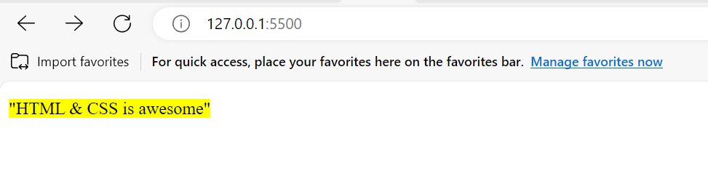

11.Create an HTML page which should contain all type of html input elements

Answer:

<!DOCTYPE html>

<html>

<head>

</head>

<body>

<label for="name">name</label><br>

<input type="text"><br>

<label for="email">Email</label><br>

<input type="email"><br>

<label for="password">Password</label>

<input type="password">

<input type="button" value="Click"><br>

<label for="radio">Image</label>

<input type="radio"><br>

<label for="checked">Checked</label>

<input type="checkbox"><br>

<label for="search">Search</label>

<input type="search"><br>

<label for="color">Color</label>

<input type="color"><br>

<label for="num">Number</label>

<input type="number"><br>

<label for="date">Date</label>

<input type="date"><br>

<label for="time">Time</label>

<input type="time"><br>

<label for="week">Week</label>

<input type="week"><br>

<label for="reset">Reset</label>

<input type="reset"><br>

<label for="range">Range</label>

<input type="range"><br>

<label for="file">File</label>

<input type="file">

<br>

</body>

</html>

Output Snippet:

